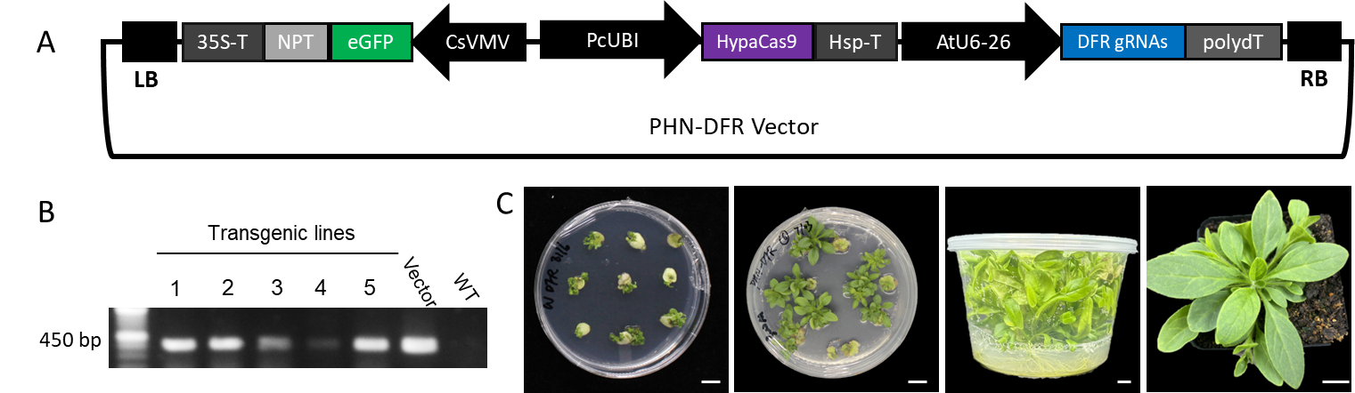
Supplementary Fig. 1. CRISPR/Cas9-mediated editing of the DFR gene in Petunia × hybrida ‘Carmine Velour’. (A) Schematic diagram of the CRISPR/Cas9 construct used for gene editing. The binary vector includes: a neomycin phosphotransferase (NPT) selectable marker fused with an enhanced green fluorescent protein (eGFP) reporter driven by the 35S promoter; a codon-optimized HypaCas9 driven by the Petroselinum crispum ubiquitin promoter (PcUBI) with a CsVMV enhancer; and a gRNA cassette targeting the DFR gene under the control of the AtU6-26 promoter. (B) PCR-based validation of transgene insertion by amplification of the GFP fragment. A 450-bp GFP-specific band was detected in transgenic lines 1–5 and the vector positive control, but not in the wild-type (WT) negative control. (C) Regeneration workflow of gene-edited plants. From left to right: callus formation on selection medium, shoot regeneration, shoot proliferation in tissue culture, and an acclimatized edited plant growing in soil. Scale bars, 1 cm.

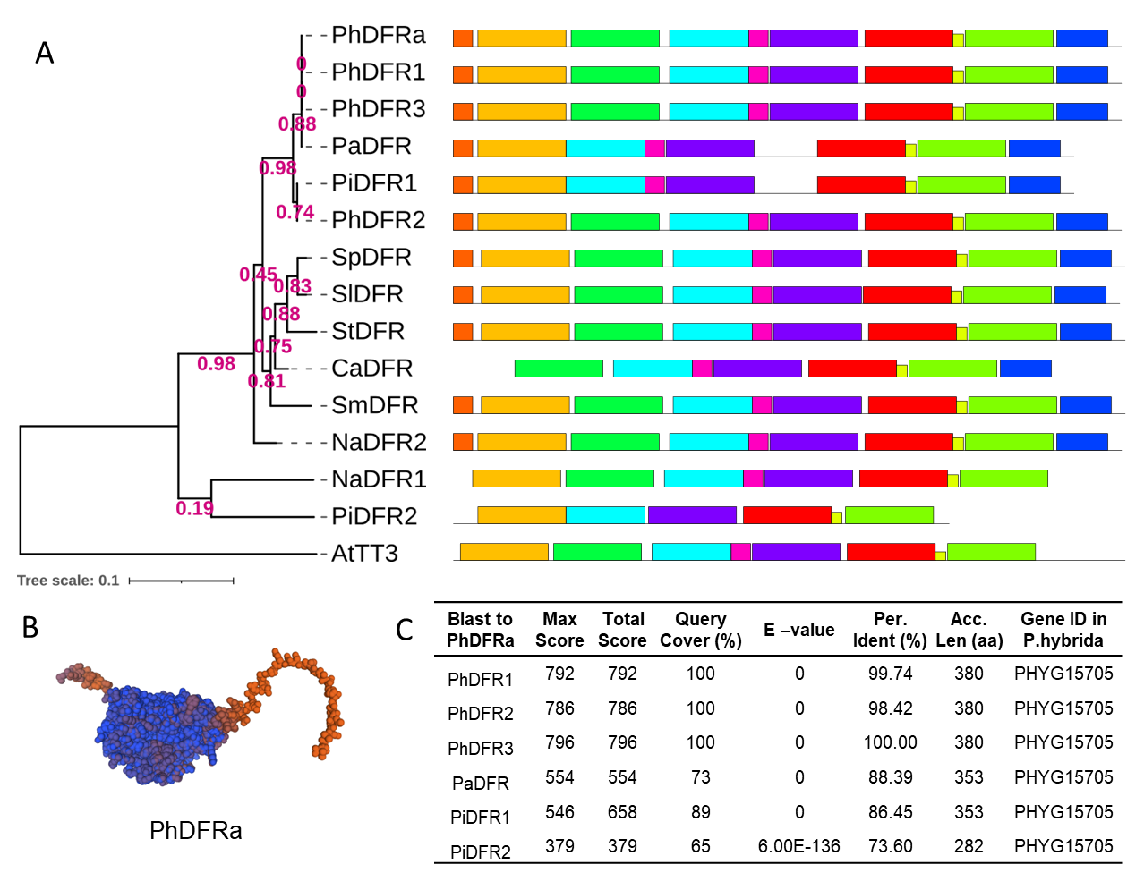
Supplementary Fig. 2. Phylogenetic and structural analysis of DFR homologs associated with anthocyanin biosynthesis. (A) Phylogenetic tree of DFR proteins reported to function in anthocyanin biosynthesis across representative species, including multiple annotated DFR-like sequences from Petunia. The tree highlights the relationship among petunia DFR homologs and places the anthocyanin-related petunia DFR within the broader evolutionary context of characterized DFR proteins. Bootstrap support values are indicated at major nodes. (B) Predicted three-dimensional structure of the petunia DFR protein generated using SWISS-MODEL. The model illustrates the overall fold of the deduced DFR protein and supports its structural similarity to functionally characterized DFR enzymes involved in flavonoid biosynthesis. (C) Domain architecture and sequence comparison of petunia DFR candidates. All queried petunia DFR versions showed the highest similarity to PhDFR in BLAST analysis, indicating that these sequences correspond to the same anthocyanin-associated DFR homolog. Combined with the phylogenetic analysis, these results support the conclusion that Petunia hybrida contains a major DFR copy associated with anthocyanin biosynthesis.
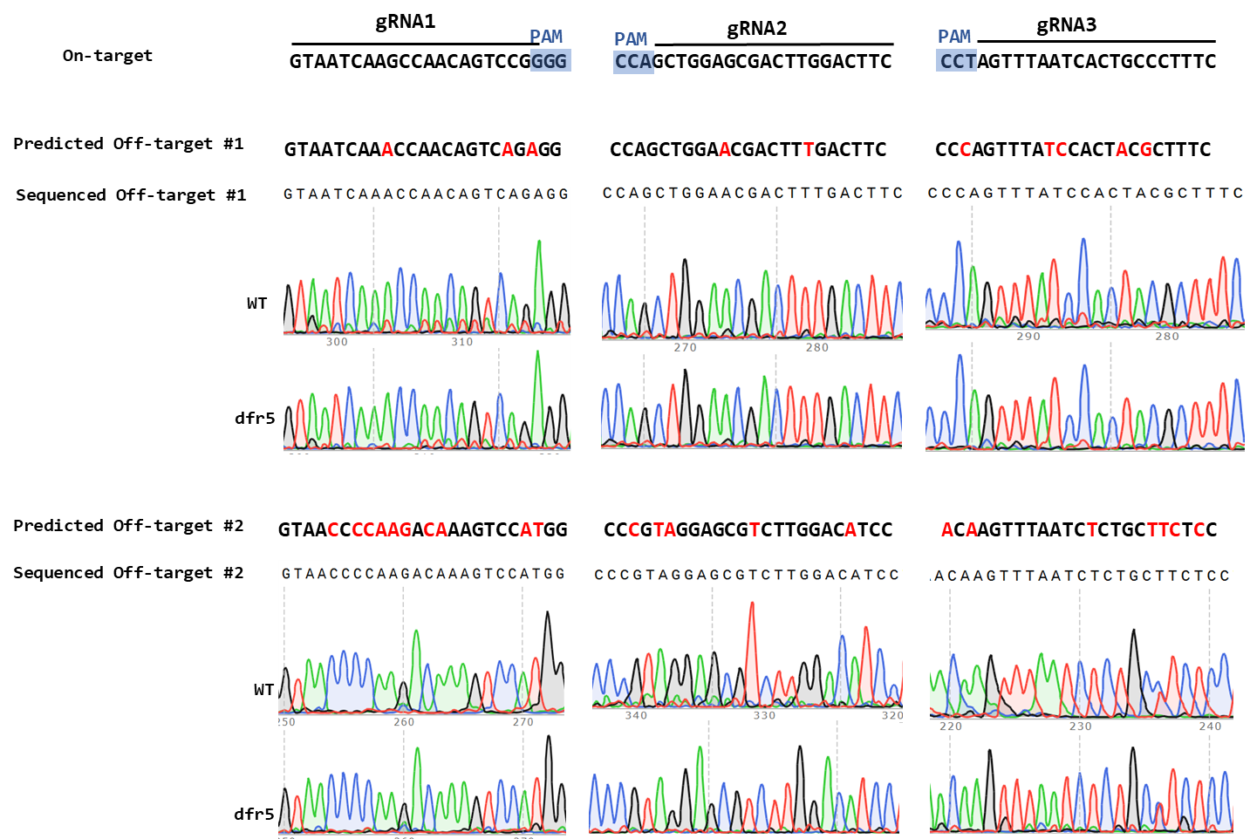
Supplementary Fig. 3. Sequencing analysis of predicted off-target sites for the three guide RNAs targeting DFR in Petunia × hybrida ‘Carmine Velour’. Two candidate off-target sites are shown for each of gRNA1, gRNA2, and gRNA3. Candidate loci were predicted using CRISPOR based on the available P. inflata and P. axillaris reference genomes, because no complete P. hybrida reference genome was available. The two predicted loci for gRNA1 were Peinf101Scf00590:2126655–2126677 (off-target #1) and Peaxi162Scf01392:26433–26455 (off-target #2); for gRNA2, Peinf101Ctg13770592:3665-3687 (off-target #1) and Peaxi162Scf00016:2363429-2363451 (off-target #2); and for gRNA3, Peinf101Scf00071:1456734–1456756 (off-target #1) and Peaxi162Scf00720:106168–106190 (off-target #2). For each candidate site, the predicted off-target sequence is aligned with the corresponding gRNA target sequence, with mismatched nucleotides highlighted in red and PAM sequences highlighted in blue. Representative Sanger sequencing chromatograms of PCR amplicons from wild type (WT) and the edited line dfr-5 are shown below each candidate locus. No sequence differences were detected between WT and dfr-5 at any of the examined loci, indicating no detectable off-target editing under the conditions tested.
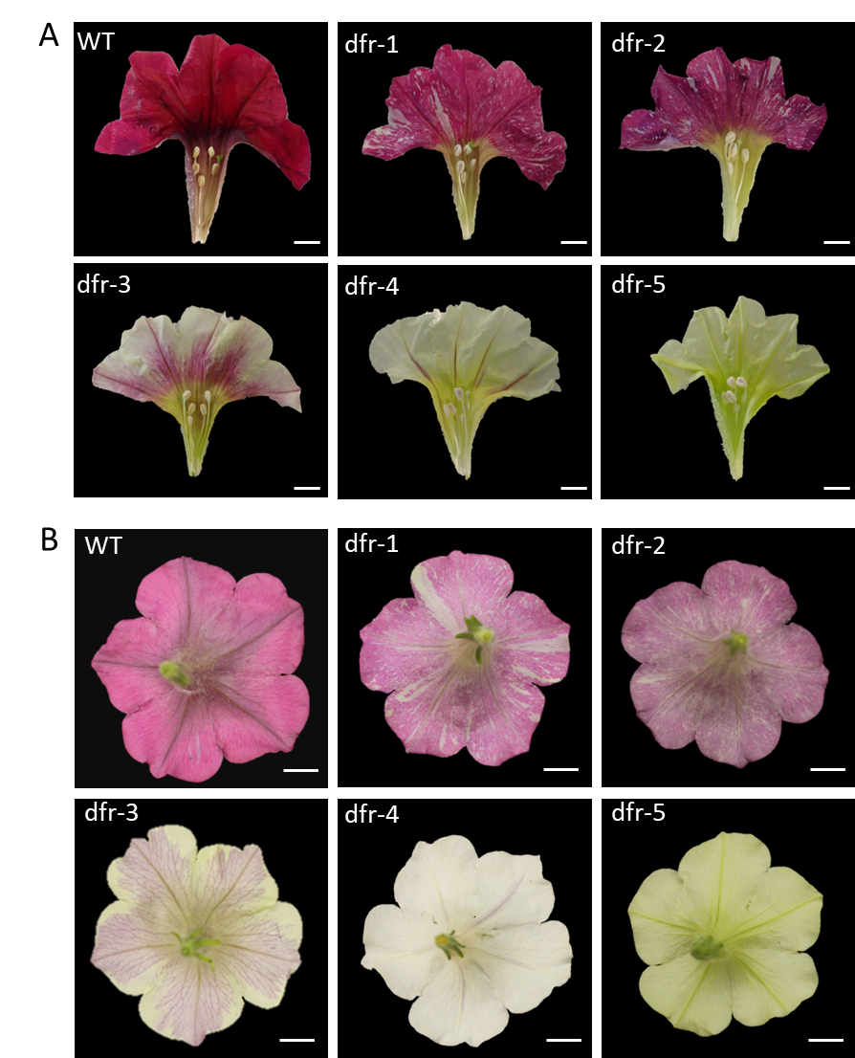
Supplementary Fig. 4. DFR editing leads to a range of anthocyanin pigmentation loss in Petunia × hybrida ‘Carmine Velour’ flowers. (A) Dissected flower corollas showing the adaxial (inner) surface from wild-type (WT) and DFR-edited lines (dfr-1 to dfr-5). (B) View of intact flowers from the abaxial (outer) side, displaying pigmentation patterns on the reverse surface of the corolla. Reduced anthocyanin pigmentation is observed across the edited lines relative to WT, consistent with altered anthocyanin biosynthesis. Scale bars = 1 cm.

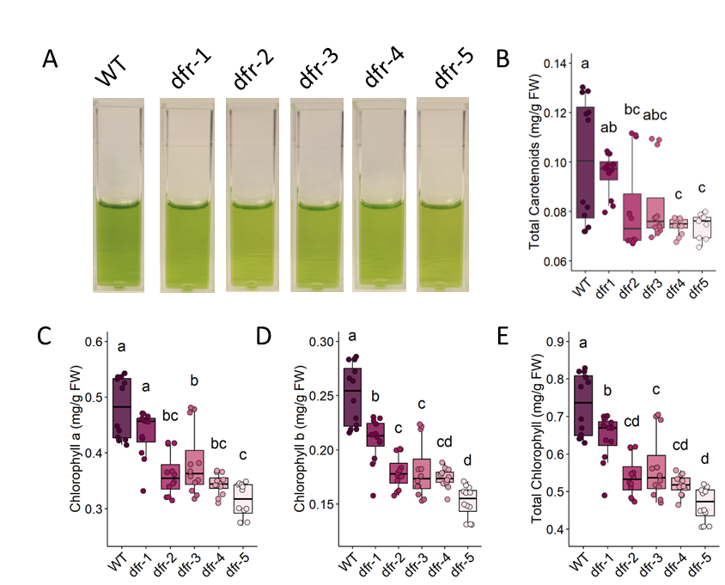

Supplementary Fig. 5. Leaf carotenoid and chlorophyll contents in petunia WT and dfr mutant lines. (A) Carotenoid extracts from leaves of wild-type (WT) and dfr mutants (dfr-1 to dfr-5) displayed yellow-green coloration. (B)Total carotenoid content (mg g⁻¹ FW). WT accumulated the highest carotenoid levels, whereas all dfr mutants exhibited reduced carotenoid content, with dfr-4 and dfr-5 showing the lowest levels. (C) Chlorophyll a content (mg g⁻¹ FW). All dfr mutants displayed significantly reduced chlorophyll relative to WT, with dfr-5 showing the greatest reduction. (D) Chlorophyll b content (mg g⁻¹ FW). Chlorophyll b followed a similar trend, with each dfr line accumulating significantly less than WT, and dfr-5 exhibiting the lowest levels. (E) Total chlorophyll (mg g⁻¹ FW). Consistent with the decreases observed for chlorophyll a and b, total chlorophyll content was significantly reduced in all dfr mutants compared with WT. For panels (B-E), each point represents one plotted measurement obtained from at least three biological replicates. Box plots show the median, interquartile range, and full data distribution. Statistical significance was assessed using one-way ANOVA followed by Tukey’s HSD test; different letters indicate significant differences among genotypes (P < 0.05).
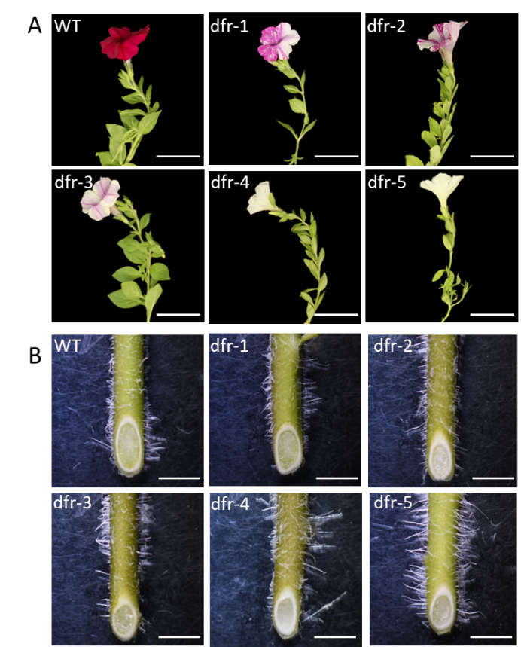
Supplementary Fig. 6. DFR knockout alters floral pigmentation, but stem morphology and cross-sectional anatomy remain unaffected. (A) Representative lateral views of flowering shoots from WT and dfr mutants (dfr-1 to dfr-5). Floral pigmentation is reduced to varying extents across the mutants relative to WT, consistent with graded loss of DFR-mediated anthocyanin biosynthesis. In contrast, overall shoot architecture, internode length, and leaf morphology remain comparable across genotypes. Scale bars, 5 cm. (B) Transverse sections of young stems show indistinguishable anatomy among WT and all dfr mutants. Vascular organization, cortical thickness, and overall stem diameter are unaffected by DFR disruption. Images captured under a stereomicroscope. Scale bars, 5 mm.

Supplementary Table 1. Primer sequences used in this study.
Primer name | Forward primer sequence (5'-3') | Reverse primer sequence (5'-3') | Purpose
DFR-1 | GCTACTGTTCGTGATCCT | CCTTTATACATATCCTCCAAAGTG | Target region sequencing
DFR-2 | CTTGGCTTGTCATGAGAC | TCCAAATGCACATATTGACC | Target region sequencing
gRNA1-1 | CCTCTGTGCAATTACATATGTC | TGAAATCCAAGTCACTCC | Off-target validation
gRNA1-2 | CTCGGTCGTGTCAAATCAG | GTGTGCCAGTGTCATCGT | Off-target validation
gRNA2-1 | GATTCCTAATGCTAGGTGGA | AGGCTGTCAAGGAGTATG | Off-target validation
gRNA2-2 | CATCAATTTGCTAGGCAAG | TGCTGAGTATCCTTCTAGC | Off-target validation
gRNA3-1 | GATGAGGATGGTGATGTGAA | ATAGGAAGTAACTAGTCCACAG | Off-target validation
gRNA3-2 | AGTGCCTGCTAACCATAA | GTTCATATGGTTGACACTTG | Off-target validation
F3’5’H_q | CCACCTAATGCAGGTGCCA | GGCACGAACATTTGCCCAATTC | qRT-PCR
CHIA_q | CTCGGTCGAGTTCTTTAGGGA | CAATTCTCCGCCACCTTCTC | qRT-PCR
CHSA_q | GCAGGCGCGATCATTATAGG | CGGAGATGGCCATCAATAGCAC | qRT-PCR
F3’H_q | GTTTCGACGCGTTCTTGACT | TCCCTCCATCATTATCCGCA | qRT-PCR
ANS_q | GCGCACTGACTTTCATCCTC | AATGGTGTCCCCTATGTGCA | qRT-PCR
FLS_q | TAGAGGCAGCTGGTGGTGA | GGAGGCCTTGGACTTCATTTGG | qRT-PCR
CHLH_q | GTTCTCTTGAGTTCATGCCAGG | GCATAACTCCTTCGTTTGGCAA | qRT-PCR
PORA_q | CCTGGCTGCATTGCAACA | CTTTGTTCCAGCTCCAGTAGAC | qRT-PCR
EF1α_q | CCTGGTCAAATTGGAAACGG | CAGATCGCCTGTCAATCTTGG | qRT-PCR
GFP | ACAAGTTCAGCGTGTCCG | TCACCTTGATGCCGTTCT | Transgene insertion validation
This table lists the primer sequences used for target-region sequencing, off-target validation, qRT-PCR, and transgene-insertion validation. All sequences are shown in the 5′–3′ orientation.

