Atomic Fact-Checking Increases Clinician Trust in Large Language Model Recommendations for Oncology Decision Support:
A Randomized Controlled Trial
Lisa C. Adams¹, Linus Marx², Erik Thiele Orberg^{3,4}, Keno Bressem⁵, Sebastian Ziegelmayer¹, Denise Bernhardt², Markus Graf¹, Marcus R. Makowski¹, Stephanie E. Combs^{2,6}, Florian Matthes⁷, Jan C. Peeken^{2,6}

1 Department of Diagnostic and Interventional Radiology, TUM University Hospital Rechts der Isar, TUM School of Medicine and Health, Technical University of Munich, Munich, Germany
2 Department of Radiation Oncology, TUM University Hospital Rechts der Isar, TUM School of Medicine and Health, Technical University of Munich, Munich, Germany
3 Department of Internal Medicine III: Hematology and Clinical Oncology, University Hospital Regensburg, University of Regensburg, Regensburg, Germany
4 Bavarian Cancer Research Center (BZKF), Regensburg, Germany
5 Institute for Cardiovascular Radiology and Nuclear Medicine, TUM University Hospital, German Heart Center Munich, TUM School of Medicine and Health, Technical University of Munich, Munich, Germany
6 German Consortium for Translational Cancer Research (DKTK), Partner Site Munich, Munich, Germany
7 Department of Computer Science; TUM School of Computation Information and Technology; Technical University of Munich, Garching, Germany

Corresponding Author: Jan C. Peeken, MD PhD
Email: jan.peeken@tum.de
Address: Department of Radiation Oncology, TUM School of Medicine and Health, TUM University Hospital Rechts der Isar, Munich, Germany

Supplementary Material
Supplementary Table 1 | Detailed Results by Specialty and Experimental Group
Specialty | Group | n | Mean (SD) | 95% CI | Proportion Trusting, % | 95% CI
Radiology | G1: Recommendation only | 34 | 2.47 (0.95) | 2.40-2.54 | 13.6 | 11.3-16.3
Radiology | G2: + Explanation | 27 | 2.82 (0.96) | 2.74-2.90 | 23.1 | 19.8-26.7
Radiology | G3: + Source citation | 40 | 2.88 (0.93) | 2.81-2.94 | 24.2 | 21.4-27.2
Radiology | G4: + Explanation + Source | 28 | 2.95 (0.95) | 2.88-3.03 | 27.6 | 24.1-31.3
Radiology | G5: Atomic fact-checking | 31 | 3.74 (0.85) | 3.68-3.81 | 63.9 | 60.1-67.5
Radiology | Pooled G1-G4 | 129 | 2.77 (0.97) | 2.74-2.81 | 21.9 | 20.4-23.5
Radiation Oncology | G1: Recommendation only | 17 | 3.13 (1.00) | 3.03-3.24 | 35.0 | 30.2-40.1
Radiation Oncology | G2: + Explanation | 15 | 3.15 (1.05) | 3.04-3.27 | 37.1 | 32.0-42.6
Radiation Oncology | G3: + Source citation | 21 | 3.47 (0.93) | 3.38-3.55 | 50.3 | 45.7-55.0
Radiation Oncology | G4: + Explanation + Source | 16 | 3.61 (0.90) | 3.51-3.71 | 56.0 | 50.6-61.2
Radiation Oncology | G5: Atomic fact-checking | 16 | 4.10 (0.73) | 4.02-4.18 | 81.8 | 77.4-85.6
Radiation Oncology | Pooled G1-G4 | 69 | 3.35 (0.99) | 3.30-3.40 | 45.0 | 42.5-47.6
Medical Oncology | G1: Recommendation only | 21 | 2.34 (0.95) | 2.26-2.43 | 11.8 | 9.1-15.1
Medical Oncology | G2: + Explanation | 22 | 2.66 (0.93) | 2.58-2.74 | 18.6 | 15.3-22.4
Medical Oncology | G3: + Source citation | 26 | 2.85 (0.95) | 2.77-2.93 | 24.9 | 21.5-28.7
Medical Oncology | G4: + Explanation + Source | 22 | 2.89 (0.95) | 2.80-2.98 | 25.1 | 21.4-29.3
Medical Oncology | G5: Atomic fact-checking | 20 | 3.65 (0.79) | 3.57-3.72 | 58.1 | 53.3-62.7
Medical Oncology | Pooled G1-G4 | 91 | 2.70 (0.97) | 2.65-2.74 | 20.4 | 18.7-22.3
Overall | G1: Recommendation only | 72 | 2.59 (1.01) | 2.54-2.64 | 18.1 | 16.3-20.1
Overall | G2: + Explanation | 64 | 2.84 (0.99) | 2.79-2.90 | 24.9 | 22.6-27.2
Overall | G3: + Source citation | 87 | 3.01 (0.97) | 2.97-3.05 | 30.7 | 28.6-32.9
Overall | G4: + Explanation + Source | 66 | 3.09 (0.98) | 3.04-3.14 | 33.6 | 31.2-36.2
Overall | Pooled G1-G4 | 289 | 2.89 (1.01) | 2.86-2.91 | 26.9 | 25.8-28.1
Overall | G5: Atomic fact-checking | 67 | 3.80 (0.82) | 3.76-3.84 | 66.5 | 63.9-68.9
Shows mean trust scores, SDs, 95% CIs, and proportion expressing trust for each specialty-by-group combination.
Abbreviations: CI, confidence interval; SD, standard deviation. Trust was defined as a rating of 4 (mostly trust) or 5 (completely trust) on the 5-point Likert scale. Values represent per-participant summary statistics (means and proportions computed per participant across their 21 case ratings, then aggregated), which differ from the per-rating statistics reported in Table 2.

Supplementary Table 2 | Comprehensive Subgroup Analysis Summary
Category | Subgroup | n (Control) | n (AFC) | Cohen's d | 95% CI | P value | Interaction P
Primary analysis | Overall | 289 | 67 | 0.94 | 0.88-1.00 | <.001 | —
Medical specialty | Radiology | 129 | 31 | 1.03 | 0.94-1.11 | <.001 | .18
Medical specialty | Radiation Oncology | 69 | 16 | 0.80 | 0.69-0.90 | <.001
Medical specialty | Medical Oncology | 91 | 20 | 1.01 | 0.91-1.11 | <.001
Clinical experience | Resident/Fellow | 30 | 8 | 1.41 | 1.24-1.58 | <.001 | .003
Clinical experience | 1-5 years | 75 | 14 | 1.02 | 0.91-1.13 | <.001
Clinical experience | 5-10 years | 88 | 16 | 1.01 | 0.91-1.11 | <.001
Clinical experience | 11-20 years | 79 | 22 | 0.77 | 0.67-0.86 | <.001
Clinical experience | >20 years | 17 | 7 | 0.62 | 0.43-0.82 | <.001
Cancer type | Prostate | 289 | 67 | 0.91 | 0.78-1.05 | <.001 | .07
Cancer type | Breast | 289 | 67 | 1.10 | 0.97-1.24 | <.001
Cancer type | Lung | 289 | 67 | 0.87 | 0.72-1.02 | <.001
Cancer type | Colorectal | 289 | 67 | 1.00 | 0.87-1.15 | <.001
Cancer type | Kidney | 289 | 67 | 0.99 | 0.84-1.14 | <.001
Cancer type | Liver | 289 | 67 | 0.79 | 0.64-0.94 | <.001
Cancer type | Lymphoma | 289 | 67 | 0.94 | 0.80-1.08 | <.001
AI familiarity | Never heard of AI in medicine | 14 | 3 | 0.26 | -0.00-0.53 | .06 | .02
AI familiarity | Heard, never used | 36 | 8 | 0.97 | 0.78-1.16 | <.001
AI familiarity | Research use only | 49 | 8 | 1.05 | 0.93-1.18 | <.001
AI familiarity | Clinical use <1×/month | 58 | 12 | 0.91 | 0.79-1.04 | <.001
AI familiarity | Clinical use 1-4×/month | 22 | 6 | 0.81 | 0.61-1.02 | <.001
AI familiarity | Regular clinical use (>4×/month) | 110 | 30 | 1.01 | 0.92-1.09 | <.001
LLM usage frequency | Never | 61 | 17 | 0.91 | 0.80-1.03 | <.001 | <.001
LLM usage frequency | Monthly or less | 46 | 8 | 0.98 | 0.84-1.12 | <.001
LLM usage frequency | Weekly | 104 | 26 | 0.88 | 0.79-0.97 | <.001
LLM usage frequency | Daily | 78 | 16 | 1.04 | 0.93-1.15 | <.001
Practice setting | Academic medical center | 160 | 38 | 1.03 | 0.91-1.05 | <.001 | .12
 | Community practice | 129 | 29 | 0.85 | 0.78-0.95 | <.001
 | — | — | — | — | — | —
Geographic region | Not available in dataset | — | — | — | — | — | —
 | — | — | — | — | — | —
 | — | — | — | — | — | —
Sensitivity analysis | Primary analysis | 289 | 67 | 0.94 | 0.88-1.00 | <.001 | —
Sensitivity analysis | Excluding extreme responders | 289 | 64 | 1.07 | 0.93-1.21 | <.001
Sensitivity analysis | Complete case analysis | 289 | 67 | 0.95 | 0.88-1.00 | <.001
Sensitivity analysis | Excluding Radiology | 160 | 36 | 0.88 | 0.81-0.95 | <.001
Sensitivity analysis | Excluding Radiation Oncology | 220 | 51 | 1.02 | 0.96-1.09 | <.001
Sensitivity analysis | Excluding Medical Oncology | 198 | 47 | 0.91 | 0.84-0.98 | <.001
Alternative effect measure | Cohen's d | 289 | 67 | 0.94 | 0.88-1.00 | <.001 | —
Alternative effect measure | Hedges' g | 289 | 67 | 0.94 | 0.88-1.00 | <.001
Alternative effect measure | Glass's Δ | 289 | 67 | 0.91 | 0.85-0.97 | <.001
Alternative effect measure | Mean difference | 289 | 67 | 0.91 | 0.86-0.96 | <.001
Alternative effect measure | Relative risk (trust) | 289 | 67 | 2.47 | 2.33-2.61 | <.001
Alternative effect measure | Odds ratio (trust) | 289 | 67 | 5.37 | 4.74-6.08 | <.001
Alternative effect measure | Number needed to treat | 289 | 67 | 2.53 | 2.37-2.72 | —
Effect sizes (Cohen’s d) with 95% CIs for all prespecified subgroups.
Abbreviations: AFC, atomic fact-checking; CI, confidence interval; LLM, large language model. Cohen's d effect size benchmarks: 0.2 = small, 0.5 = medium, 0.8 = large. Interaction P values test whether the AFC effect differs significantly across subgroup levels. Practice setting subgroups subdivide "community practice" (Table 1) into community hospitals and private practices. All P values are two-sided.
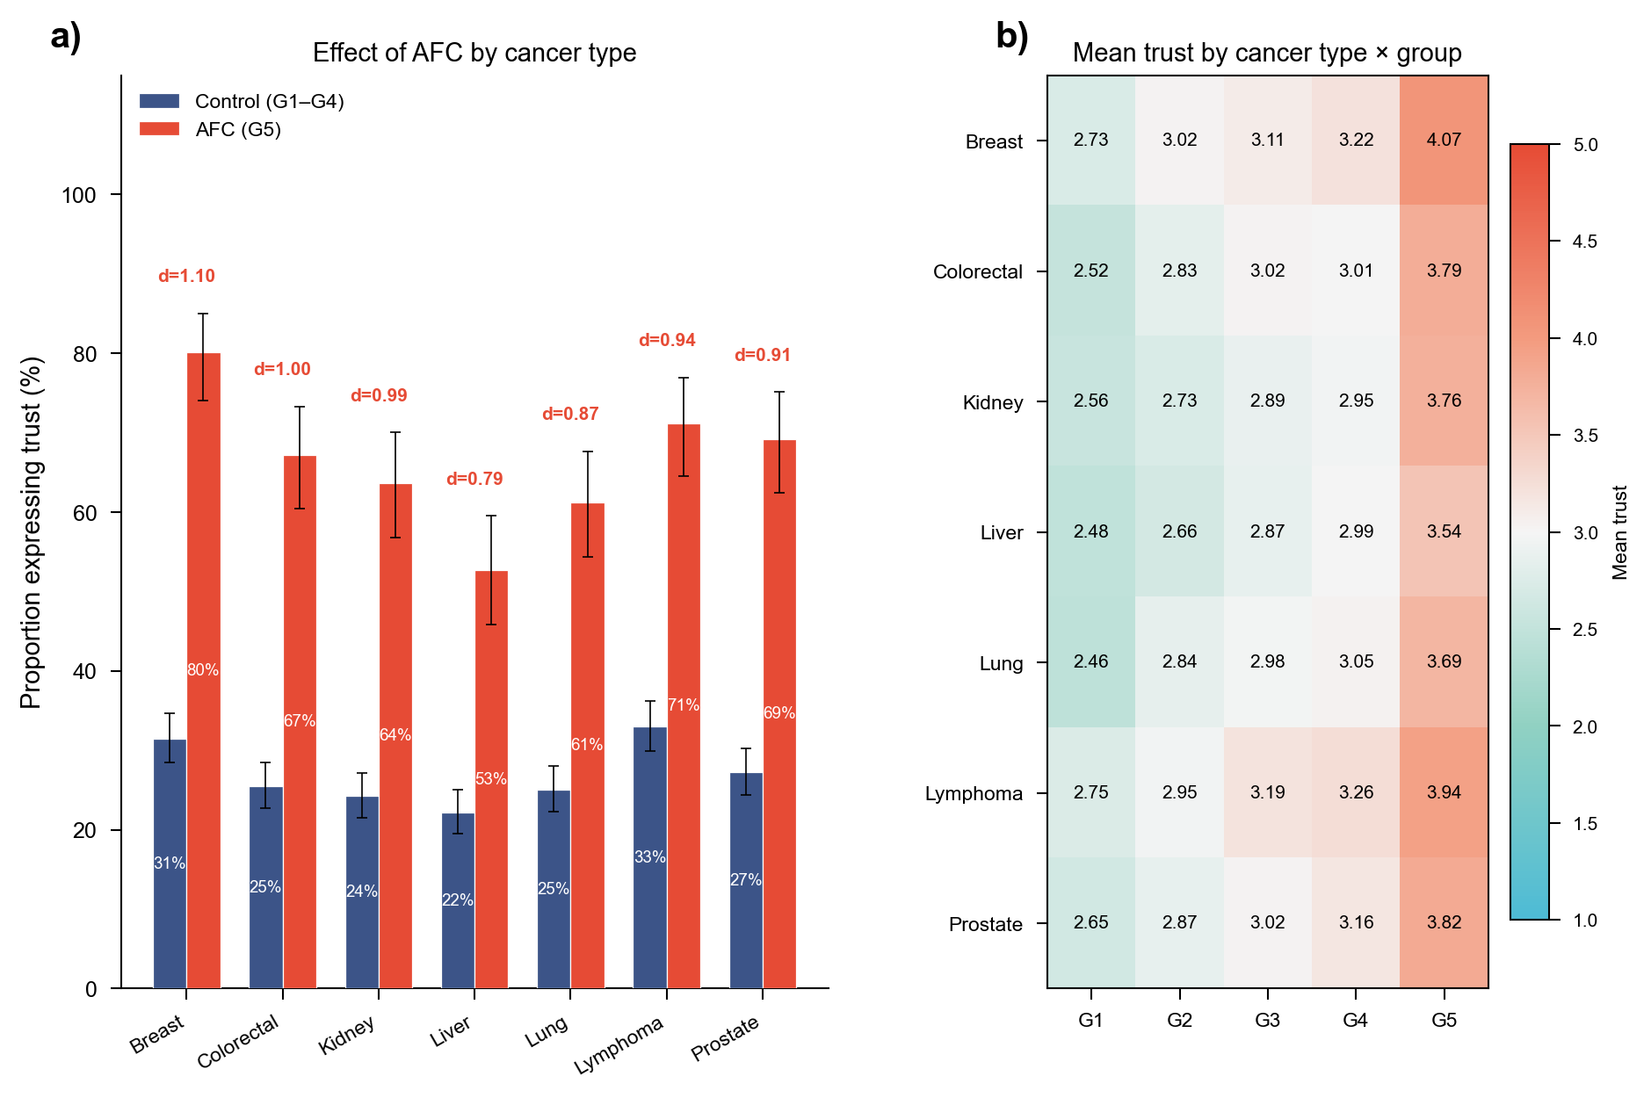
Supplementary Fig. 1 | Effect of atomic fact-checking by cancer type. a Grouped bars compare the proportion of ratings expressing trust (score ≥ 4) between control (Groups 1-4, blue) and AFC (Group 5, red) conditions across seven cancer types. Error bars indicate 95% Wilson score confidence intervals. Cohen's d values are shown above each pair. Effect sizes ranged from d = 0.79 (liver) to d = 1.10 (breast), with all cancer types showing large effects (all P < .001). b Heatmap of mean trust scores (1-5) for each cancer type × experimental group combination. The color scale ranges from teal (low trust) to red (high trust). Groups 1-4 show progressively increasing trust across cancer types, while Group 5 (AFC) consistently achieves the highest trust scores (3.5-4.1).
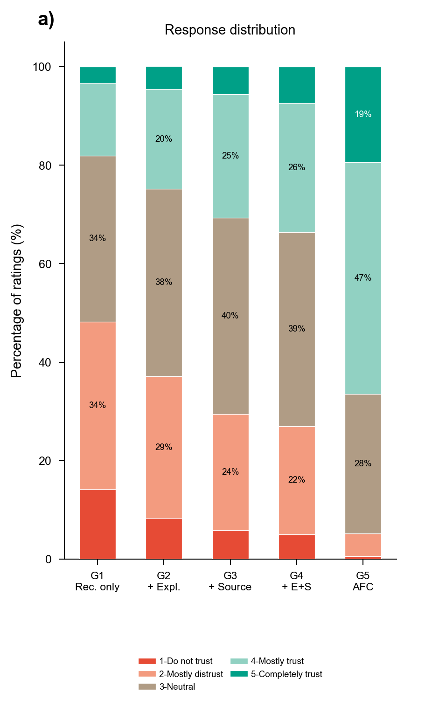
Supplementary Fig. 2 | Distribution of trust ratings across experimental groups. Stacked bars show the percentage of ratings at each trust level (1-5) for each group. Percentages ≥ 15% are labelled. Groups 1-4 show approximately symmetric distributions centered around scores 2-3, while Group 5 (AFC) shows pronounced rightward shift with 47% of ratings at score 4 (mostly trust) and 19% at score 5 (completely trust).
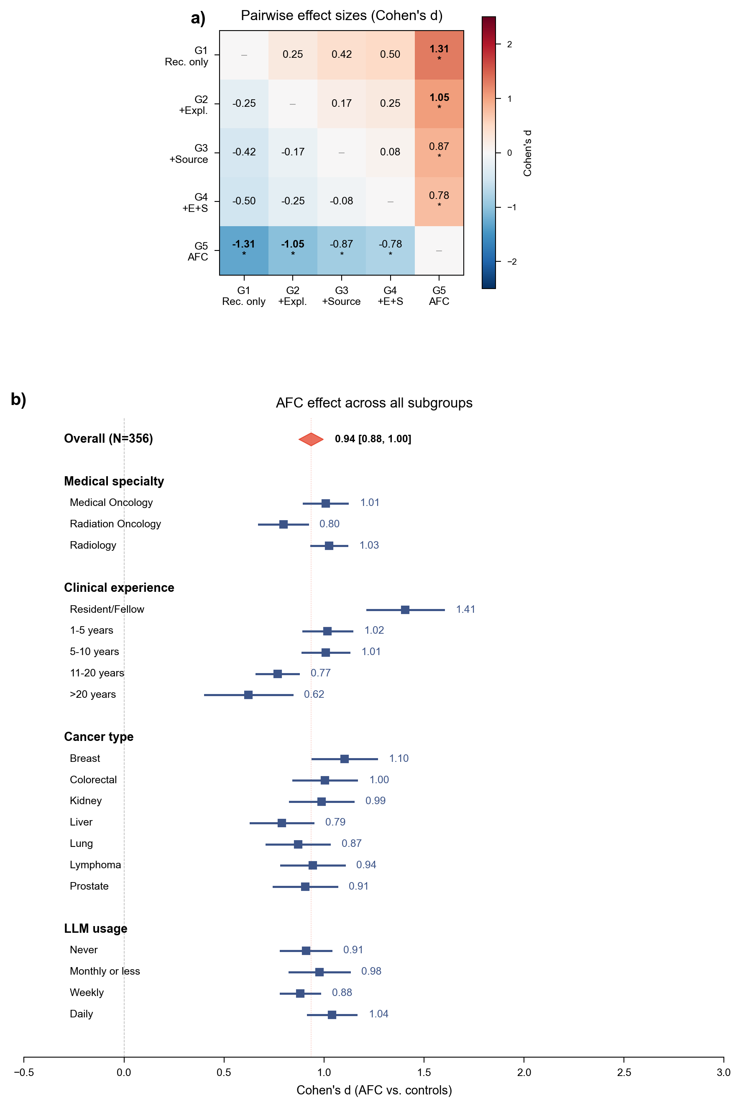
Supplementary Fig. 3 | Pairwise comparisons and subgroup forest plot. a Heatmap of pairwise Cohen's d between all five experimental groups. The color scale ranges from dark blue (column group higher) through white (no difference) to dark red (row group higher). Comparisons among Groups 1-4 show small-to-medium effects (|d| = 0.08-0.50); all Group 5 (AFC) comparisons show large effects (d = 0.78-1.31). * indicates |d| > 0.7. b Forest plot of Cohen's d (AFC vs. pooled controls) across all prespecified subgroups. The overall effect (red diamond) was d = 0.94 [95% CI, 0.88-1.00]. All subgroups showed positive effects, organized by medical specialty, clinical experience, cancer type, and LLM usage.

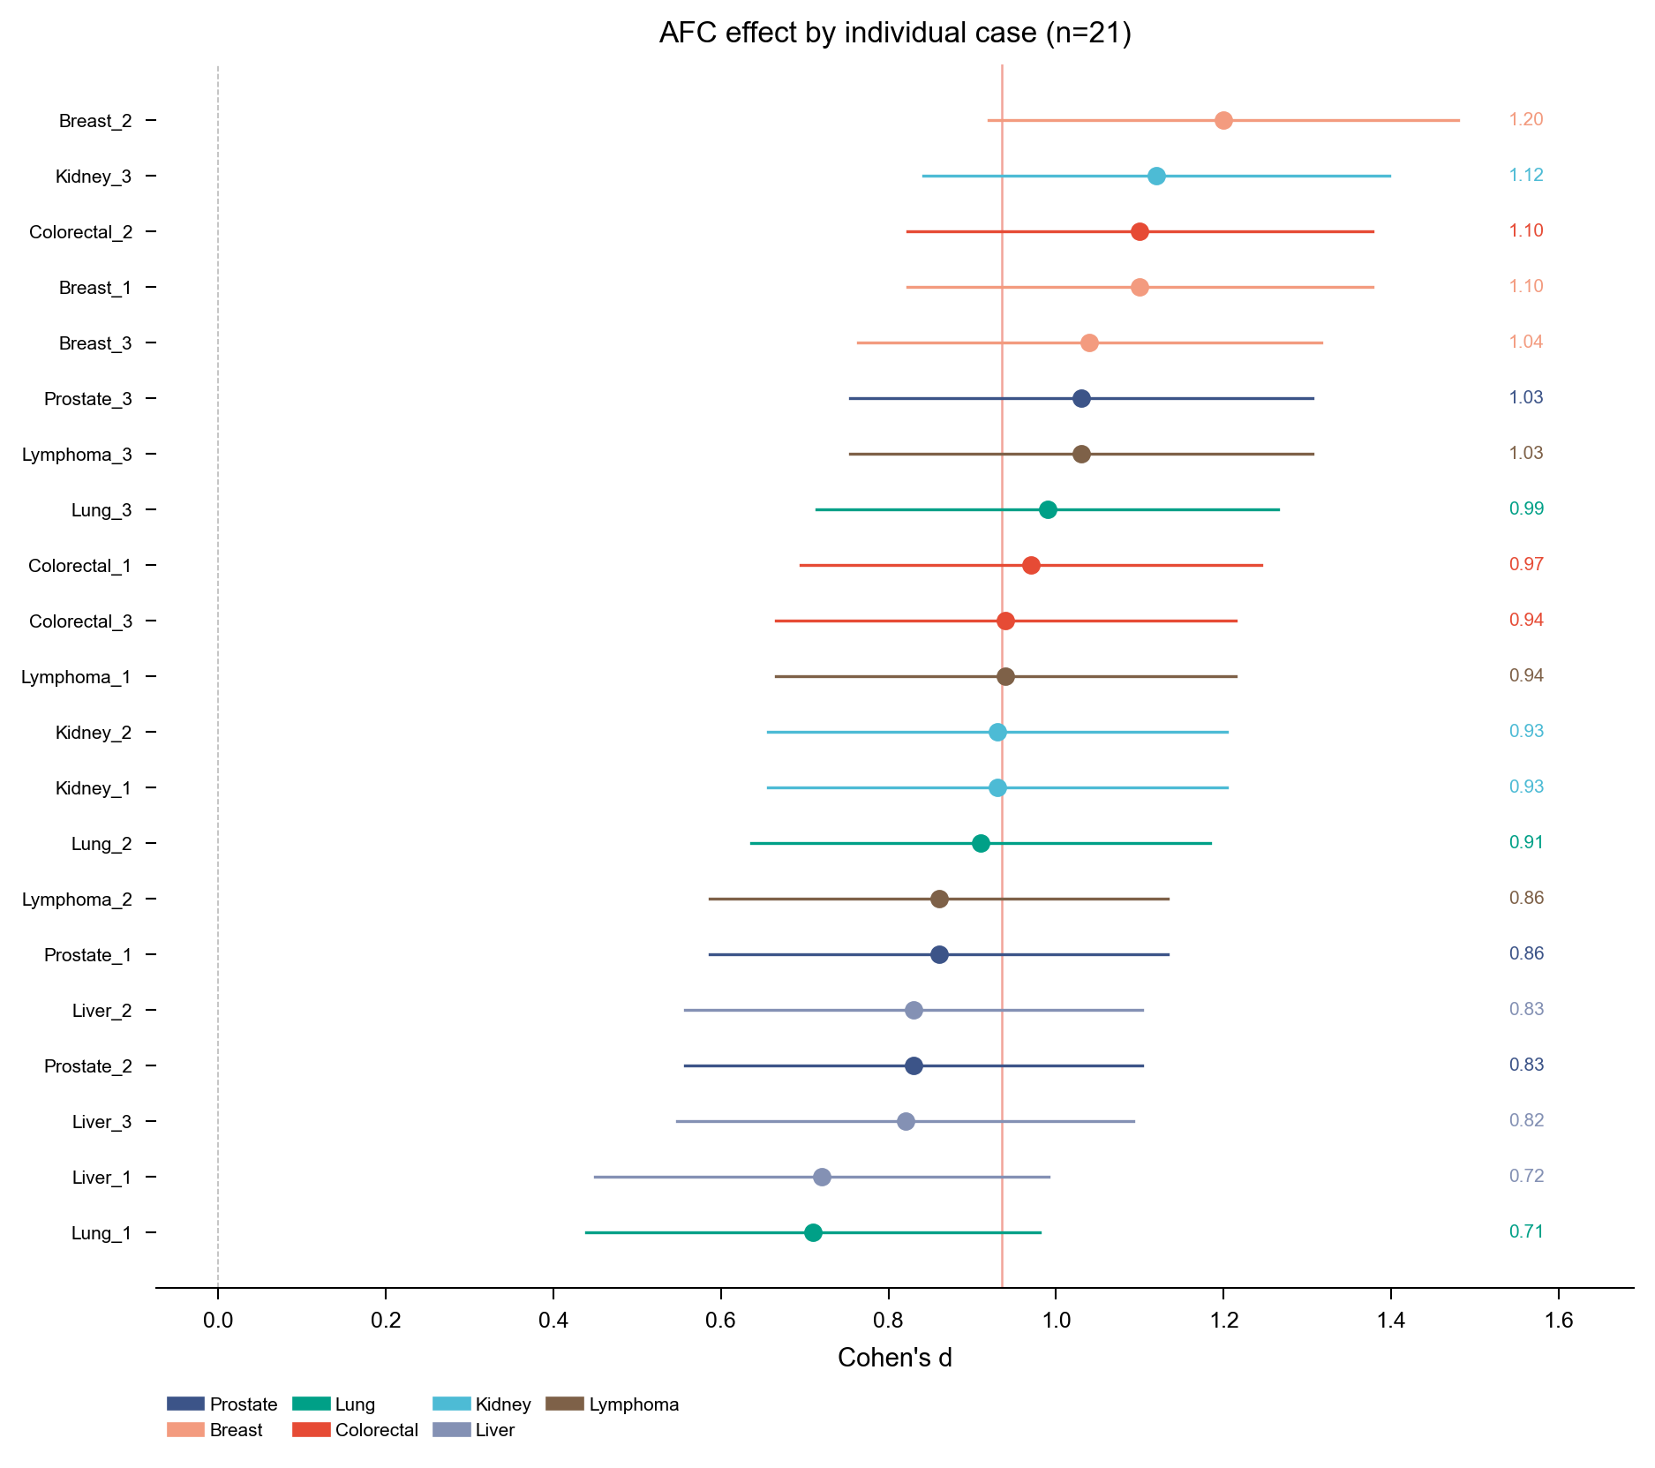
Supplementary Fig. 4 | AFC effect by individual clinical case (n = 21). Forest plot showing Cohen's d for each of 21 clinical cases, sorted by effect size and color-coded by cancer type. All 21 cases showed positive effects, with point estimates ranging from d = 0.71 to d = 1.20. The vertical red line indicates the overall pooled effect (d = 0.94). Confidence intervals are 95% CIs. The consistent positivity across all cases demonstrates the robustness of the AFC effect across diverse clinical scenarios.
Supplementary Data 1 | Case vignettes
The case vignettes are shared in a separate file “Supplementary_Data_1.xlsx” divided into separate sheets by specialties.

