Supplementary Information
for

Nutrient–Pesticide Coupling Enables Proxy-Based Detection of Neonicotinoids in Complex Water Systems

Manish Kumar^{1, 2*}, Priyansha Gupta¹, Shiwangi Dogra¹, Siddhant Dash³, M. Sandoval-Reyes¹, Futoshi Kurisu⁴

¹Escuela de Ingeniería y Ciencias, Tecnologico de Monterrey, Campus Monterey, Monterrey, 64849, Nuevo Leon, Mexico
²Sustainability Cluster, School of Advance Engineering, UPES, Dehradun, Uttarakhand 248007, India
³Department of Civil Engineering, School of Engineering and Sciences, SRM University AP, Amaravati, 522240, Andhra Pradesh, India
⁴RECWET, the University of Tokyo, Bunkyo-ku, Tokyo, Japan

*Corresponding author:
Manish Kumar [ORCID:0000-0002-3351-7298]
Escuela de Ingeniería y Ciencias, Tecnologico de Monterrey, Campus Monterey, Monterrey 64849, Nuevo Leon, Mexico
E-mail address: manish.env@gmail.com manish@tec.mx
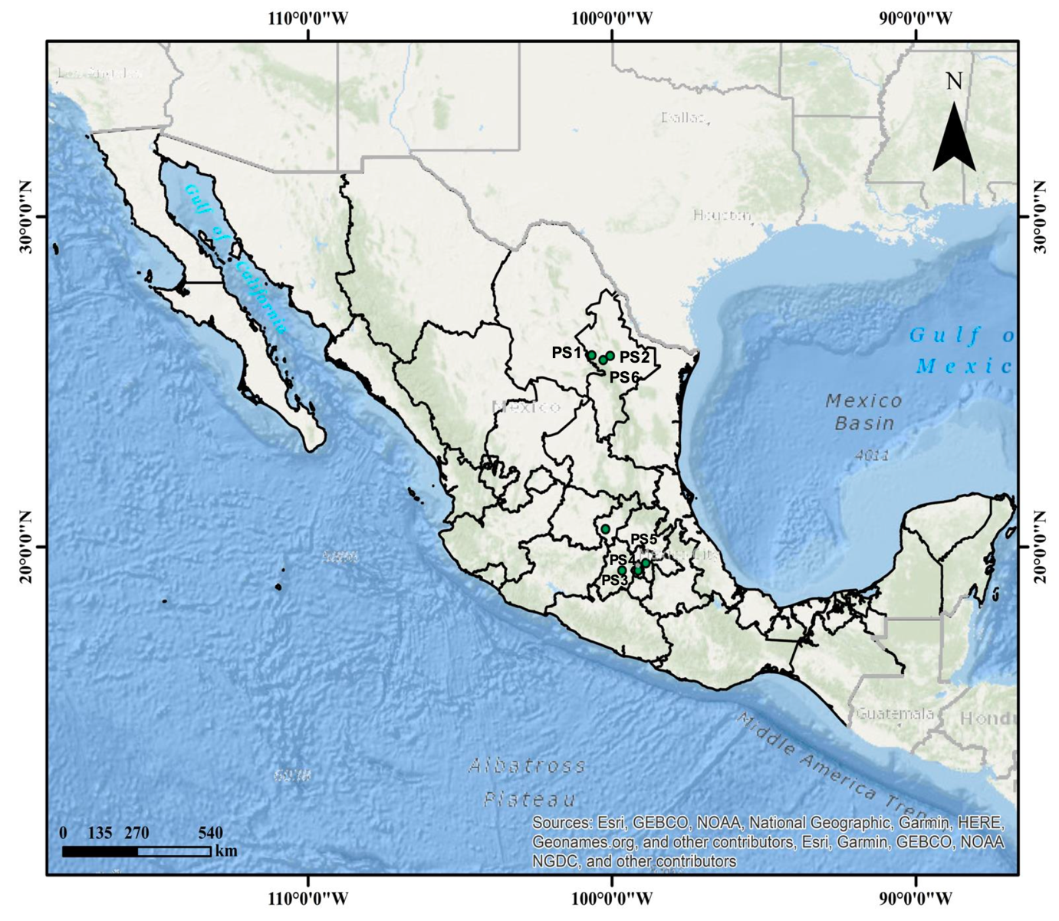

Fig. S1. Study area and sampling locations across Mexico. Map showing the geographic distribution of sampling sites (PS1–PS7) across northern and central Mexico, encompassing river systems, wastewater effluents, and groundwater environments. Sites PS1, PS2, and PS6 are located in Nuevo León (Pesquería River and WWTP), PS3–PS5 are situated within the Río Lerma basin in Estado de México, and PS7 represents a groundwater site in Querétaro. The selected locations capture a gradient of agricultural, industrial, municipal, and relatively low-impact hydrogeological settings.

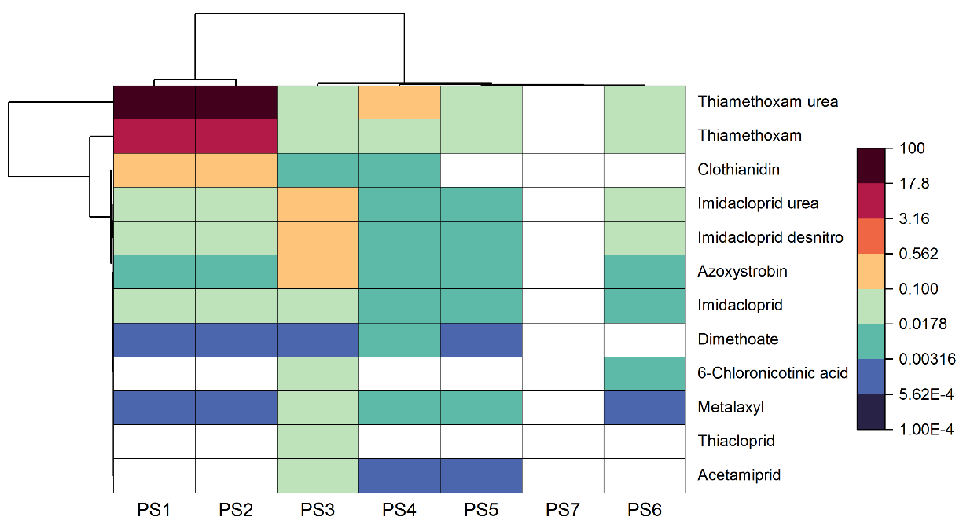
a)

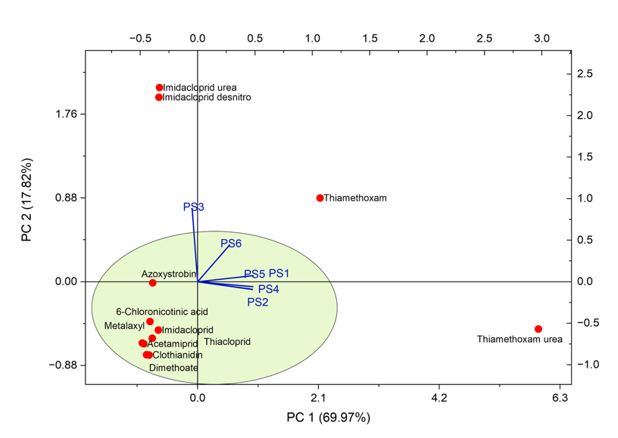

b)

Fig. S2 a) Hierarchical cluster heatmap depicting the occurrence patterns of antibiotics, pharmaceuticals, and personal care products (APPCPs) across sampling locations (PS1–PS7). b) Distinct clustering reflects heterogeneous contaminant profiles associated with mixed urban and wastewater inputs, contrasting with the pesticide-dominated patterns.
Compound | PNEC (ng/L) | RQ_PS1 | RQ_PS2 | RQ_PS3 | RQ_PS4 | RQ_PS5 | RQ_PS6
Acetamiprid | 37 | 0 | 0 | 0.00054054 | 2.7027E-05 | 2.7027E-05 | 0
Clothianidin | 10 | 0.0533 | 0.0498 | 0.0005 | 0.0006 | 0 | 0
Dinotefuran | 78 | 0 | 0 | 0 | 0 | 0 | 0
Imidacloprid | 6.8 | 0.00897059 | 0.00764706 | 0.00338235 | 0.00117647 | 0.00088235 | 0.00102941
Imidacloprid desnitro | 6870 | 5.968E-06 | 5.6769E-06 | 5.4585E-05 | 1.1645E-06 | 8.7336E-07 | 2.9112E-06
Imidacloprid olefin | 160 | 0 | 0 | 0 | 0 | 0 | 0
Imidacloprid urea | 14800 | 2.7027E-06 | 2.5676E-06 | 2.6014E-05 | 6.0811E-07 | 3.3784E-07 | 1.5541E-06
Thiacloprid | 10 | 0 | 0 | 0.0022 | 0 | 0 | 0
Thiamethoxam | 40 | 0.1179 | 0.121775 | 0.000675 | 0.001975 | 0.00085 | 0.002425
Thiamethoxam urea | 40 | 0.516575 | 0.560425 | 0.0014 | 0.00735 | 0.00145 | 0.000825
6-Chloronicotinic acid | 42200 | 0 | 0 | 5.6872E-07 | 0 | 0 | 3.0806E-07
6-Chloronicotinic aldehyde | 42200 | 0 | 0 | 0 | 0 | 0 | 0
6-Chloro-N-methylnicotinamide | 200 | 0 | 0 | 0 | 0 | 0 | 0
Azoxystrobin | 200 | 0.00003 | 0.000025 | 0.00055 | 0.000025 | 0.000025 | 0.000015
Picoxystrobin | 72 | 0 | 0 | 0 | 0 | 0 | 0
Pyraclostrobin | 200 | 0 | 0 | 0 | 0 | 0 | 0
Trifloxystrobin | 270 | 0 | 0 | 0 | 0 | 0 | 0
Metalaxyl | 100000 | 0.00000001 | 0.00000002 | 0.00000025 | 0.00000008 | 0.00000004 | 0.00000001
Dimethoate | 70 | 1.4286E-05 | 1.4286E-05 | 2.8571E-05 | 5.7143E-05 | 2.8571E-05 | 0
Indoxacarb | 420 | 0 | 0 | 0 | 0 | 0 | 0
Sulfoxaflor | 7970 | 0 | 0 | 0 | 0 | 0 | 0

Table S1. Ecological risk characterization of detected pesticides based on Predicted No-Effect Concentrations (PNECs).

Table S2. Ecological risk characterization of detected APPCPs based on PNECs values.

Compound | PNEC (ng/L) | RQ_PS1 | RQ_PS2 | RQ_PS3 | RQ_PS4 | RQ_PS5 | RQ_PS6 | RQ_PS7
Ampicillin | 250 | 0 | 0 | 0 | 0 | 0 | 0 | 0
Azithromycin | 9.4 | 0.0013883 | 0.00039362 | 0.01171383 | 0.00785532 | 0.00620638 | 0.00040638 | 0
Ciprofloxacin | 64 | 0.00059578 | 0.00085359 | 0.00067344 | 0 | 0.00172156 | 0.00175359 | 0
Clarithromycin | 120 | 0.00011042 | 3.0167E-05 | 0.000956 | 0.00063933 | 0.00047383 | 3.1833E-05 | 1.6417E-06
Clinafloxacin | 64 | 0 | 0 | 0 | 0 | 0 | 0 | 0
Erythromycin | 1000 | 0.00000355 | 0.00000202 | 0.00002092 | 0.00000764 | 0.00000654 | 0 | 0
Lincomycin | 1000 | 0.0000091 | 0.00000558 | 0.00013301 | 0.00003741 | 0.00013136 | 0.00001556 | 0
Ofloxacin | 120 | 0.00115842 | 0.00084325 | 0.00010633 | 3.7167E-05 | 0.00192958 | 0.00083367 | 5.2333E-05
Sarafloxacin | 120 | 0 | 0 | 0 | 0 | 0 | 9.4167E-06 | 0
Sulfachlorpyridazine | 590 | 0 | 0 | 4.2153E-05 | 0 | 0 | 0 | 0
Sulfadiazine | 590 | 0 | 4.9661E-06 | 7.0661E-05 | 1.9339E-05 | 0.00014522 | 1.2424E-05 | 0
Sulfamerazine | 590 | 0 | 5.678E-06 | 0 | 0 | 0 | 0 | 0
Sulfamethazine | 590 | 0 | 1.178E-05 | 2.7186E-05 | 2.1915E-05 | 0 | 3.4746E-06 | 0
Sulfamethiazole | 590 | 0 | 0 | 0 | 0 | 9.5593E-06 | 0 | 0
Sulfamethoxazole | 590 | 0.00031888 | 0.0016358 | 0.00278247 | 0.000815 | 0.00058054 | 0.01815307 | 0
Sulfanilamide | 590 | 7.1254E-05 | 0.00034149 | 0.00027656 | 0.00019273 | 6.9712E-05 | 0.00032773 | 0.0002488
Trimethoprim | 1758000 | 3.4317E-08 | 4.335E-08 | 4.0046E-09 | 2.4061E-09 | 2.6974E-08 | 2.7675E-07 | 0
Acetaminophen | 100000 | 5.95E-08 | 0 | 3.49E-07 | 4.48E-08 | 0 | 6.75E-08 | 0
Caffeine | 500000 | 1.4001E-06 | 6.928E-07 | 3.4857E-06 | 4.2748E-07 | 3.202E-08 | 6.534E-08 | 0
Carbamazepine | 500000 | 1.9324E-07 | 2.0368E-07 | 4.805E-07 | 6.392E-08 | 1.293E-07 | 6.476E-08 | 0
Cotinine | 100000 | 1.4117E-06 | 8.299E-07 | 1.0644E-05 | 3.3E-08 | 1.668E-06 | 1.09E-08 | 4.97E-09
Dehydronifedipine | 100000 | 8.98E-09 | 8.69E-09 | 0 | 0 | 0 | 3.7E-08 | 0
Diphenhydramine | 100000 | 2.25E-08 | 8.97E-09 | 4.25E-09 | 5.21E-09 | 2.2E-08 | 2.66E-07 | 6.55E-08
Phenazone | 100000 | 3.781E-07 | 1.2502E-06 | 1.325E-07 | 4.81E-08 | 2.091E-07 | 5.369E-07 | 0
Sucralose | 440000 | 8.1188E-05 | 7.2571E-05 | 3.487E-05 | 2.9141E-05 | 2.4297E-05 | 6.9507E-05 | 0
Thiabendazole | 1000 | 0.00001165 | 0.00001496 | 0.00002095 | 0.00010074 | 0.00000517 | 0.00000384 | 1.52E-07

