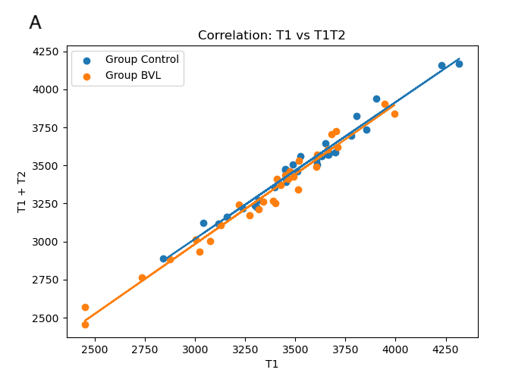
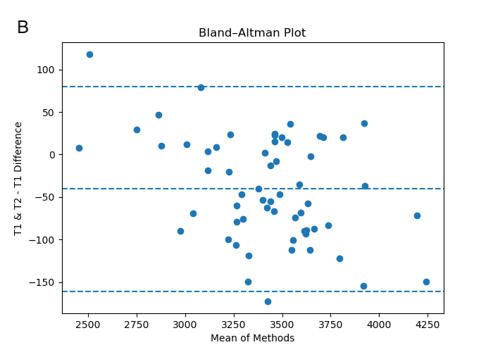
Figure S1 – A – correlation plot between two modalities of hippocampal volume evaluation using FreeSurfer, both axes show hippocampal volume in mm³; B – Bland-Altman plot showing the difference in volumes between methods (mm³) as a function of the total volume, showing a slight systematic difference between methods (<50 mm³). Note : Datasets analyzed using different modalities were not compared between them in the study.

