Supplementary Figures:
Supplementary Figure 1
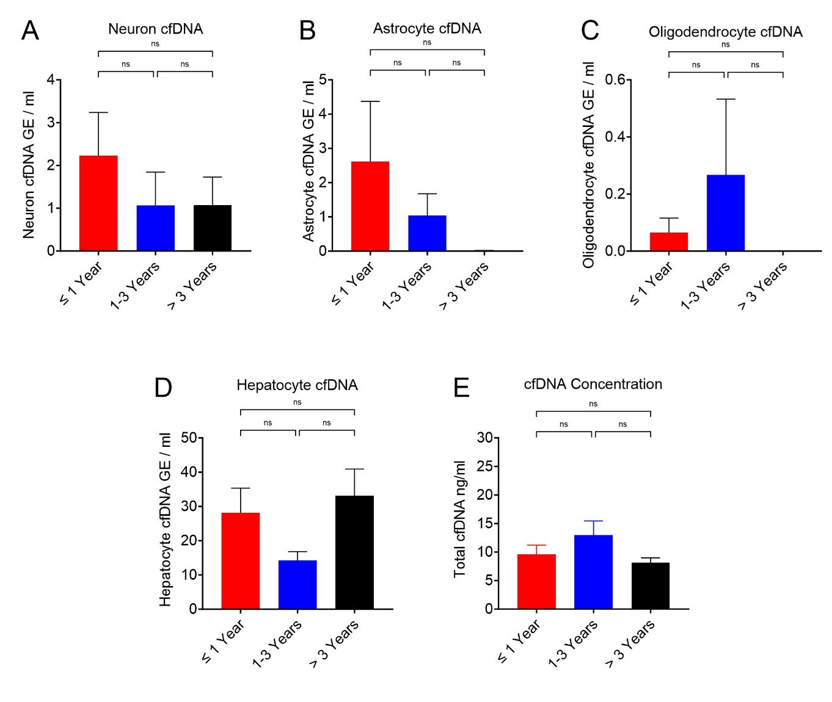

Supplementary Figure 1. Baseline tissue-specific cfDNA levels prior to anesthesia. Baseline (pre-induction) concentrations of circulating cfDNA markers stratified by age group: ≤1 year, 1–3 years, and >3 years. (A-D) Quantification of neuron-, astrocyte-, oligodendrocyte-, and hepatocyte-derived cfDNA (GE/ml). (E) Total cfDNA Concentration (ng/ml). Statistics: Data are presented as Mean ± SEM. No statistically significant differences in baseline levels were observed between age groups for any marker (One-way ANOVA with Tukey’s multiple comparisons test; ns, p>0.01).

Supplementary Figure 2
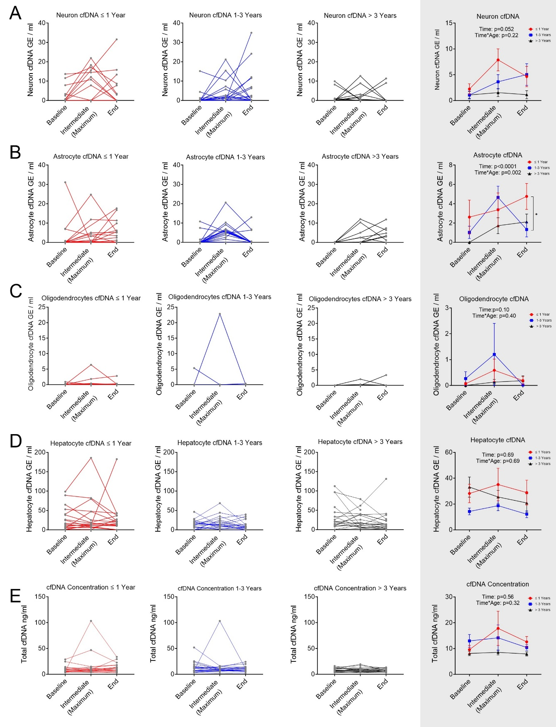

Supplementary Figure 2. Perioperative dynamics of tissue-specific and total cell-free DNA – based on the maximum rather than average intraoperative data. (A-D) Concentration of cfDNA derived from neurons, astrocytes, oligodendrocytes, and hepatocytes (Genome Equivalents [GE]/ml). (E) Total cfDNA concentration (ng/ml). Timepoints: Baseline (pre-induction), maximum intraoperative (intraoperative maximum value), and end of surgery. Left Panels (unshaded): Individual patient trajectories stratified by age: infants ≤1 year (red), toddlers 1–3 years (blue), and children >3 years (black). Right Panels (shaded): Summary data presented as mean ± SEM shows the pooled data for each age group. Statistics: Repeated measures ANOVA on log-transformed data. (B) Astrocyte markers exhibited significant Time (p<0.0001) and Time × Age interaction (p=0.002) effects. Post-hoc Scheffé analysis: Infants ≤1 year vs >3 years (p=0.006). (A, C, D, E) No significant main effects or interactions were observed.

Supplementary Figure 3
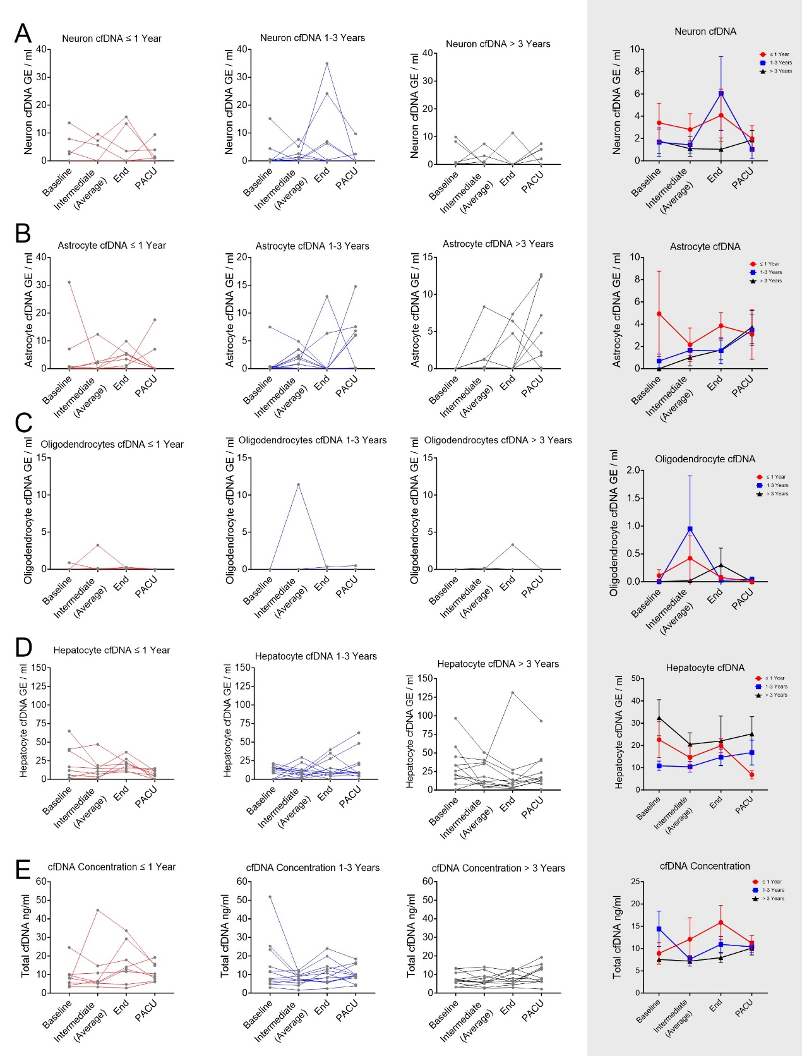

Supplementary Figure 3. Perioperative dynamics of tissue-specific and total cell-free DNA. Longitudinal quantification of brain-derived markers in a sub-cohort of patients (n=31). (A-D) Concentration of cfDNA derived from neurons, astrocytes, oligodendrocytes, and hepatocytes (Genome Equivalents [GE]/ml). (E) Total cfDNA concentration (ng/ml). Timepoints: Baseline (pre-induction), Intermediate (intraoperative average), End of surgery, and PACU (Post-Anesthesia Care Unit, approx. 1 hour post-surgery). Left Panels (unshaded): Individual patient trajectories stratified by age: infants ≤1 year (red), toddlers 1–3 years (blue), and children >3 years (black). Right Panels (shaded): Summary data presented as mean ± SEM shows the pooled data for each age group.

Supplementary File 4 STROBE Statement—Checklist of items that should be included in reports of cross-sectional studies
Stohl et al: Brain-derived cell-free DNA as a marker for neuroapoptosis following prolonged general anesthesia in infants and children: results of the BRAIN study.

 |  |  | Item No |  |  | Recommendation |  |  |  |  |  |  |  |  |  | Page  No
Title and abstract |  |  | 1 |  |  |  | (a) Indicate the study’s design with a commonly used term in the title or the abstract |  |  |  |  |  | Abstract |  |  | 3
 |  |  |  |  |  |  | (b) Provide in the abstract an informative and balanced summary of what was done and what was found |  |  |  |  |  | Abstract |  |  | 3
Introduction
Background/rationale |  |  | 2 |  |  |  | Explain the scientific background and rationale for the investigation being reported |  |  | Introduction |  |  |  |  |  | 4
Objectives |  |  | 3 |  |  |  | State specific objectives, including any prespecified hypotheses |  |  | End of Introduction |  |  |  |  |  | 5
Methods
Study design |  |  | 4 |  |  |  | Present key elements of study design early in the paper |  |  | On-line methods – Study Design |  |  |  |  |  | 13
Setting |  |  | 5 |  |  |  | Describe the setting, locations, and relevant dates, including periods of recruitment, exposure, follow-up, and data collection |  |  | On-line methods – Study Population |  |  |  |  |  | 13-14
Participants |  |  | 6 |  |  |  | (a) Give the eligibility criteria, and the sources and methods of selection of participants |  |  | On-line methods – Study Population |  |  |  |  |  | 13-14
Variables |  |  | 7 |  |  |  | Clearly define all outcomes, exposures, predictors, potential confounders, and effect modifiers. Give diagnostic criteria, if applicable |  |  | On-line methods – Outcomes and cfDNA Analysis |  |  |  |  |  | Clinical 14; cfDNA 16
Data sources/ measurement |  |  | 8* |  |  |  | For each variable of interest, give sources of data and details of methods of assessment (measurement). Describe comparability of assessment methods if there is more than one group |  |  | On-line methods – Sample Collection and cfDNA Analysis |  |  |  |  |  | 15-16
Bias |  |  | 9 |  |  |  | Describe any efforts to address potential sources of bias |  | On-line methods – Design Considerations including average versus maximum intraoperative samples |  |  |  |  |  |  | 16-17
Study size |  |  | 10 |  |  |  | Explain how the study size was arrived at |  | On-line methods – Sample Size justification |  |  |  |  |  |  | 18
Quantitative variables |  |  | 11 |  |  |  | Explain how quantitative variables were handled in the analyses. If applicable, describe which groupings were chosen and why |  |  | On-line methods – Statistical Analysis |  |  |  |  |  | 16-18
Statistical methods |  |  | 12 |  |  |  | (a) Describe all statistical methods, including those used to control for confounding |  |  | On-line methods – Statistical Analysis |  |  |  |  |  | 16-18
 |  |  |  |  |  |  | (b) Describe any methods used to examine subgroups and interactions |  |  | On-line methods – Statistical Analysis |  |  |  |  |  | 16-18
 |  |  |  |  |  |  | (c) Explain how missing data were addressed |  |  | On-line methods – Statistical Analysis |  |  |  |  |  | Bottom 17
 |  |  |  |  |  |  | (d) If applicable, describe analytical methods taking account of sampling strategy |  |  | Not applicable |  |  |  |  |  | NA
 |  |  |  |  |  |  | (e) Describe any sensitivity analyses |  |  | On-line methods – Statistical Analysis – secondary analysis comparing maximum intraop vs average intraop |  |  |  |  |  | 17
Results
Participants | 13* |  |  | (a) Report numbers of individuals at each stage of study—eg numbers potentially eligible, examined for eligibility, confirmed eligible, included in the study, completing follow-up, and analysed |  |  |  |  |  | We had almost no patients refuse to enrol; the only limitation in practice was the availability of a research anesthesiologist to draw blood; hence no purpose served by a flow diagram. |  |  |  |  |  | NA
 |  |  |  | (b) Give reasons for non-participation at each stage |  |  |  |  |  |  |  |  |  |  |  | NA
 |  |  |  | (c) Consider use of a flow diagram |  |  |  |  |  |  |  |  |  |  |  | NA
Descriptive data |  | 14* |  | (a) Give characteristics of study participants (eg demographic, clinical, social) and information on exposures and potential confounders |  |  |  |  |  |  |  | Results – Demographics |  |  |  | 5-6 and Table 1
 |  |  |  | (b) Indicate number of participants with missing data for each variable of interest |  |  |  |  |  | Results – Data Completeness |  |  |  |  |  | Top 7
Outcome data |  | 15* |  | Report numbers of outcome events or summary measures |  |  |  |  |  | Results – cfDNA Findings |  |  |  |  |  | 7-9
Main results |  | 16 |  | (a) Give unadjusted estimates and, if applicable, confounder-adjusted estimates and their precision (eg, 95% confidence interval). Make clear which confounders were adjusted for and why they were included |  |  |  |  |  |  |  | Results – confounding variables |  |  |  | 7-9
 |  |  |  | (b) Report category boundaries when continuous variables were categorized |  |  |  |  |  | The only example was age group >3 (where we stated age was 3-45) |  |  |  |  |  | 14
 |  |  |  | (c) If relevant, consider translating estimates of relative risk into absolute risk for a meaningful time period |  |  |  |  |  | Not relevant |  |  |  |  |  | NA
Other analyses |  | 17 |  | Report other analyses done—eg analyses of subgroups and interactions, and sensitivity analyses |  |  |  |  |  | Results – secondary analysis comparing maximum intraop vs average intraop |  |  |  |  |  | 6-8
Discussion
Key results |  | 18 |  | Summarise key results with reference to study objectives |  |  |  |  |  | Discussion – Principal Findings |  |  |  |  |  | 9
Limitations |  | 19 |  | Discuss limitations of the study, taking into account sources of potential bias or imprecision. Discuss both direction and magnitude of any potential bias |  |  |  |  |  |  |  |  |  | Discussion Limitations |  | 12
Interpretation |  | 20 |  | Give a cautious overall interpretation of results considering objectives, limitations, multiplicity of analyses, results from similar studies, & other relevant evidence |  |  |  |  |  |  |  |  |  |  | Discussion Conclusion | 13
Generalisability |  | 21 |  | Discuss the generalisability (external validity) of the study results |  |  |  |  |  | Discussion |  |  |  |  |  | 13
Other information
Funding |  |  |  |  | 22 |  |  | Give the source of funding and the role of the funders for the present study and, if applicable, for the original study on which the present article is based |  |  |  |  |  |  |  | 2

*Give information separately for exposed and unexposed groups.

Note: An Explanation and Elaboration article discusses each checklist item and gives methodological background and published examples of transparent reporting. The STROBE checklist is best used in conjunction with this article (freely available on the Web sites of PLoS Medicine at http://www.plosmedicine.org/, Annals of Internal Medicine at http://www.annals.org/, and Epidemiology at http://www.epidem.com/). Information on the STROBE Initiative is available at www.strobe-statement.org.

Supplementary File 5 CONTROL POPULATION DEMOGRAPHICS

Pediatric Cardiac Surgery Cohort: Demographics Summary
Summary statistics
Values are presented as mean ± SD for continuous variables and n (%) for categorical variables. STS-EACTS is presented as a categorical parameter.

Overall cohort characteristics
Variable | Summary
Number of patients | 13
Age at surgery (Op Age, days) | 461.8 ± 1104.6
Sex | Male: 6/13 (46.2%); Female: 7/13 (53.8%)
Weight at surgery (Op Wt) | 6673.1 ± 5911.2
Duration of CPB | 61.7 ± 23.1
Duration of XCLMP | 25.8 ± 19.8
PO O₂Sat | 85.5 ± 10.8

Diagnosis
Diagnosis | n (%)
TGA + VSD | 1 (7.7%)
TOF | 3 (23.1%)
Unbalanced AVC with TAPVR | 2 (15.4%)
VSD | 3 (23.1%)
HLHS | 2 (15.4%)
HRV | 2 (15.4%)

Surgical procedure
Surgical procedure | n (%)
ASO + VSD repair | 1 (7.7%)
TOF repair | 2 (15.4%)
RVPAC | 1 (7.7%)
VSD repair | 3 (23.1%)
Norwood | 1 (7.7%)
Glenn | 3 (23.1%)
BTT shunt | 2 (15.4%)

STS-EACTS category
STS-EACTS category | n (%)
1 | 3 (23.1%)
2 | 5 (38.5%)
3 | 1 (7.7%)
4 | 3 (23.1%)
5 | 1 (7.7%)
Brain Metastasis Cohort: Demographics Summary
Summary statistics
Values are presented as mean ± SD for continuous variables and n (%) for categorical variables.

Overall cohort characteristics
Variable | Summary
Number of patients | 29
Age (yrs) | 59.3 ± 10.7
Sex | Male: 11/29 (37.9%); Female: 18/29 (62.1%)

Diagnosis
Primary tumor | n (%)
Lung | 8 (27.6%)
Breast | 7 (24.1%)
Melanoma | 6 (20.7%)
Ovary | 2 (6.9%)
Thyroid | 1 (3.4%)
Pancreas | 1 (3.4%)
Colon | 1 (3.4%)
Uterus | 1 (3.4%)
Esophagus | 1 (3.4%)
Endometrium | 1 (3.4%)

See below for individual data
Gender | Age | Primary Tumor | Other metastasis
M | 65 | Lung | Bone
F | 65 | Breast | Bone
F | 35 | Breast | Bone
F | 61 | Breast | Bone, lung, thyroid
F | 58 | Thyroid | Brain, lymph node, lung and later bone
F | 46 | Breast | Liver
M | 66 | Pancreas | Liver, bone
F | 69 | Breast | Liver, lung, bone
F | 54 | Breast | Liver, soft tissue, lung
M | 76 | Melanoma | Lung
F | 68 | Colon | Lung
F | 58 | Melanoma | Lung, gall bladder
F | 65 | Breast | Lung, lymph node
F | 60 | Lung | Mediastinal and pleural
M | 66 | Melanoma | Skin
M | 50 | Melanoma | Skin
F | 54 | Ovarian
M | 44 | Lung
F | 64 | Ovarian
F | 62 | Lung
F | 53 | Lung
M | 73 | Lung
M | 57 | Lung
M | 68 | Lung
M | 33 | Melanoma
F | 67 | Uterus
F | 63 | Melanoma
M | 48 | Esophagus
F | 74 | Endometrium

