Oehring D, Buckhurst PJ, Purslow C, Buckhurst H (2026). Empirical quantification of asymmetric globe retraction during non-contact tonometry: independent validation and a novel correction method. Ophthalmic and Physiological Optics. [DOI pending]

Supplementary Methods. Separation of whole eye movement from true corneal deformation in Corvis ST deformation matrices

Corvis ST data structure and notation
The Corvis ST acquires a high-speed Scheimpflug sequence during an air puff event, typically 140 images over approximately 30 ms at about 4330 images per second [1]. The device exports anterior and posterior corneal surface position matrices, each of size $T×N$, where $T$ denotes the number of frames and $N$ denotes the number of lateral spatial samples.
Let
- $t∈\{0,1,…,T-1\}$ denote frame index, with sampling interval $Δt$ (ms).
- $x∈\{x_{1},…,x_{N}\}$ denote the lateral coordinate along the horizontal meridian (mm), with $x=0$ at the corneal apex.
- $A(t,x)$ and $P(t,x)$ denote the measured anterior and posterior surface vertical positions at time $t$ and lateral position $x$.
- The neutral axis (mid-surface) is
$$N(t,x)=\frac{A(t,x)+P(t,x)}{2},$$
and the local thickness is
$$h(t,x)=A(t,x)-P(t,x).$$
A baseline frame $t_{0}$ is required. In routine processing, $t_{0}=0$ is used as the undeformed reference (first acquired frame). Displacements are defined relative to the baseline as
$$u(t,x)=N(t,x)-N(t_{0},x).$$
The measured displacement $u(t,x)$ contains at least two separable components:
- Whole eye movement (WEM). Translation of the globe in the axial direction, and apparent tilt due to small rotations and/or lateral tracking errors.
- True corneal deformation. Local deformation of the cornea driven by the air puff, after removing WEM.
The need to separate a corneal component from an extra corneal or orbital component has been explicitly recognised in Corvis-based analyses. For example, Vellara et al. (2015) describe that in vivo response includes not only corneal stiffness but also the movement of the orbit and adnexal tissues [2]. They further define and quantify a maximum corneal deformation component and a maximum orbital deformation component.

General decomposition model

Additive decomposition
We model the measured displacement as
$$u(t,x)=d(t)+θ(t)x+c(t,x)+ε(t,x),$$
where
- $d(t)$ is the axial translation of the whole globe at time $t$.
- $θ(t)$ is a tilt term (units of displacement per mm) capturing first order rotation or residual tracking effects along the analysed meridian.
- $c(t,x)$ is the true corneal deformation field.
- $ε(t,x)$ is residual noise and model mismatch.
The estimated WEM field is then
$$\hat{w}(t,x)=\hat{d}(t)+\hat{θ}(t)x,$$
and the corrected corneal deformation is
$$\hat{c}(t,x)=u(t,x)-\hat{w}(t,x).$$

This is consistent with how the Corvis ST distinguishes between deformation amplitude, deflection amplitude, and whole-eye movement. The Corvis ST handbook defines deflection amplitude as the difference between deformation amplitude and whole eye movement, and describes whole eye movement as depending on tissues behind the eye, including sclera and orbital fat. A recent clinical study similarly states that WEM is measured as the difference between deformation amplitude and deflection amplitude [3].

Peripheral region assumption
All separation methods below rely on a key empirical assumption: in the far periphery, the measured vertical displacement during the air puff is dominated by rigid globe motion, with substantially smaller true corneal deformation than in the central and paracentral region.
This assumption underpins published methods that use the left and right image borders or peripheral points to estimate the eyeball displacement component, then remove it to isolate corneal deformation [4-9]. A practical instrument-specific interpretation also supports that WEM is evaluated away from the corneal centre. For example, one study notes WEM was measured at a distance of 4 mm from the corneal centre [3]. This motivates edge or far peripheral selection for estimating $d(t)$ and $θ(t)$.

Reconstruction of corrected anterior and posterior surfaces
Once $\hat{w}(t,x)$ is estimated on the neutral axis displacement, the corrected neutral axis position is
$$N^{corr}(t,x)=N(t,x)-\hat{w}(t,x).$$
To preserve corneal thickness dynamics independent of the rigid body correction, the corrected anterior and posterior surfaces are reconstructed as
$$A^{corr}(t,x)=N^{corr}(t,x)+\frac{h(t,x)}{2},P^{corr}(t,x)=N^{corr}(t,x)-\frac{h(t,x)}{2}.$$
This procedure ensures that WEM removal preserves the cornea's global position while retaining local thickness changes implied by the paired anterior and posterior surface trajectories.

Whole eye movement separation models
Below, $x$ denotes the lateral coordinate (mm). Let the spatial index set be $X=\{x_{1},…,x_{N}\}$. Define an edge region set of points
$$E(w)=\{x_{1},…,x_{w}\}∪\{x_{N-w+1},…,x_{N}\},$$
where $w$ is the number of samples per side used to estimate WEM.
Two summaries are used repeatedly:
- Left edge mean displacement:
$$u_{L}(t)=\frac{1}{w}\sum_{k=1}^{w}{u(t,}x_{k})$$
- Right edge mean displacement:
$$u_{R}(t)=\frac{1}{w}\sum_{k=N-w+1}^{N}{u(t,}x_{k})$$
Also define mean edge positions:
$${\overset{ˉ}{x}}_{L}=\frac{1}{w}\sum_{k=1}^{w}{x_{k}},{\overset{ˉ}{x}}_{R}=\frac{1}{w}\sum_{k=N-w+1}^{N}{x_{k}}.$$

Method 01: Traditional edge averaging (Device specific WEM) - Translation only

Physical model
The entire globe translates axially by $d(t)$. Any tilt or rotation within the meridional plane is assumed to be negligible.

Estimation
For each frame $t$,
$$\hat{d}(t)=\frac{u_{L}(t)+u_{R}(t)}{2},\hat{θ}(t)=0.$$
Thus,
$$\hat{w}\left(t,x\right)=\hat{d}\left(t\right).$$

Parameter choice
- Edge width $w$ is fixed a priori.

Verification
Residual WEM in the periphery is assessed by the edge residual (Section 3). Large edge residuals indicate that translation only is insufficient, usually because tilt and asymmetric motion are present.
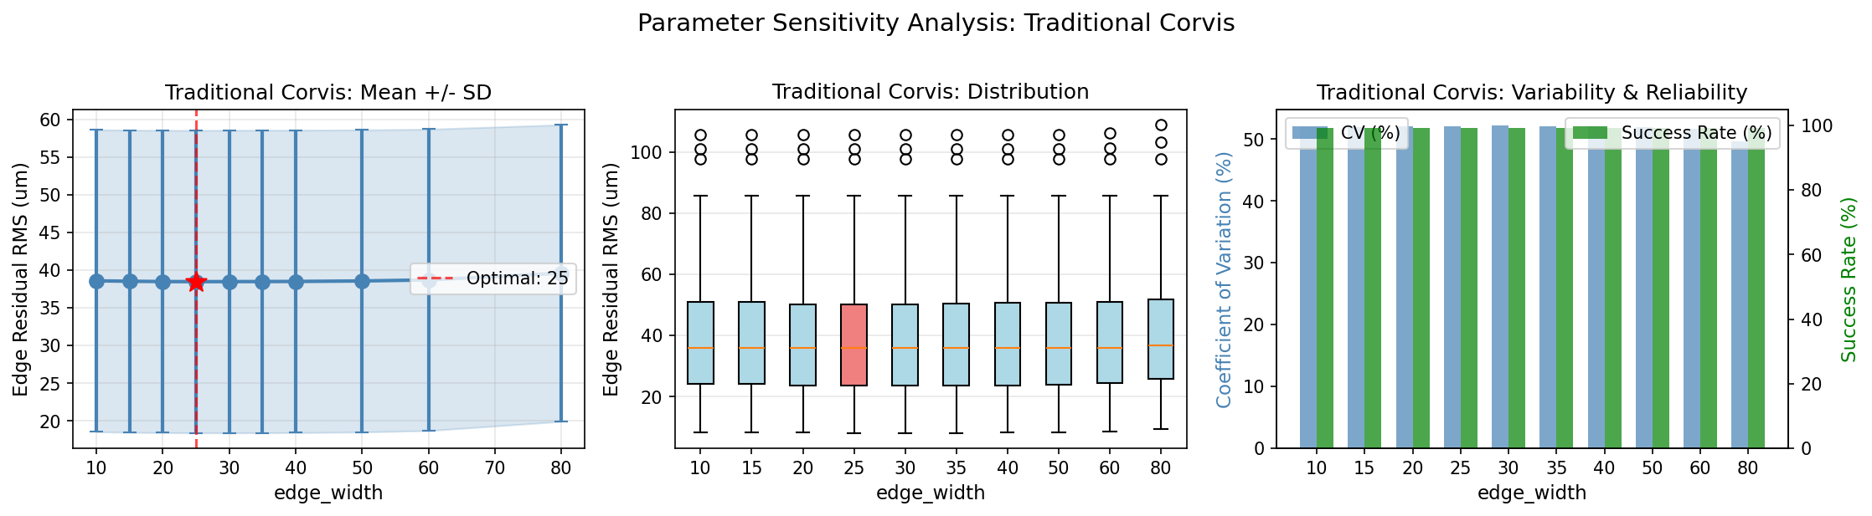

Relation to literature
This is a simplified special case of border-based separation models that use peripheral displacement as an estimate of eyeball displacement [4].

Method 02: Two-edge linear regression - Translation plus tilt

Physical model
WEM is modelled as an affine field $d(t)+θ(t)x$. This captures translation and first-order tilt. Tilt is relevant because corneal motion analysis may be confounded by rotation. Vellara et al. (2015) note that corneal apex tracking can be affected by rotation and that a true apex cannot be followed without tracking, which motivates accounting for tilt-like effects [2].

Estimation from two edge means
Solve the two equation system
$$u_{L}(t)=d(t)+θ(t){\overset{ˉ}{x}}_{L},u_{R}(t)=d(t)+θ(t){\overset{ˉ}{x}}_{R}.$$
This yields closed form estimates
$$\hat{θ}(t)=\frac{u_{R}(t)-u_{L}(t)}{{\overset{ˉ}{x}}_{R}-{\overset{ˉ}{x}}_{L}},\hat{d}(t)=u_{L}(t)-\hat{θ}(t){\overset{ˉ}{x}}_{L}.$$
Therefore
$$\hat{w}(t,x)=\hat{d}(t)+\hat{θ}(t)x.$$

Optional temporal smoothing
Because $u_{L}(t)$ and $u_{R}(t)$ are averages of noisy measurements, $\hat{d}(t)$ and $\hat{θ}(t)$ can be smoothed in time to reduce noise amplification. For example, a Savitzky Golay filter of window length $L$ and polynomial degree $p$ replaces $\hat{d}(t)$ with a local polynomial estimate $\tilde{d}(t)$, and similarly for $θ(t)$.

Parameter choice
- Fixed $w$, fixed smoothing parameters $L$ and $p$.
- $L$ must be odd and $L<T$.

Verification
Edge residuals should be reduced relative to Method 01. Additionally, $∣\hat{θ}(t)∣$ should remain within physiologically plausible bounds. Excessive $θ$ usually indicates edge contamination by corneal deformation or tracking artefacts.
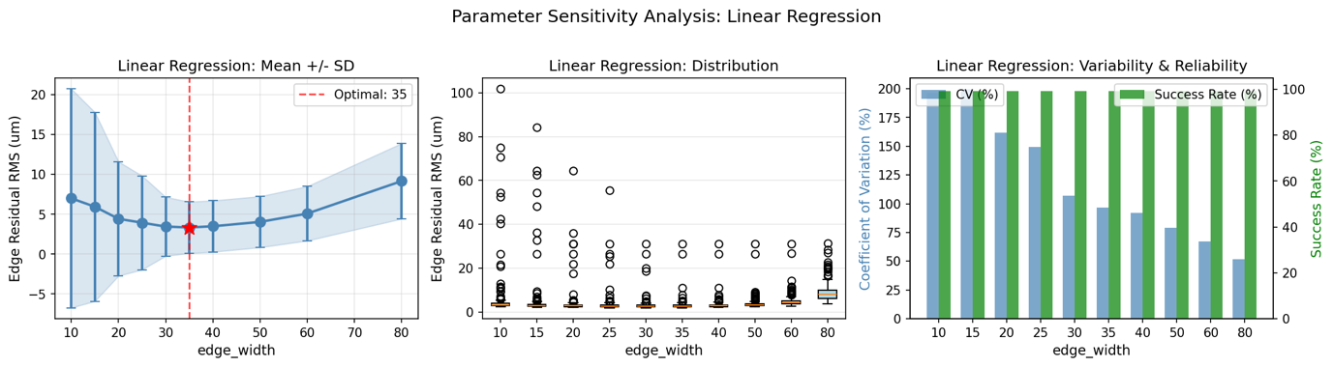

Relation to literature
Border or edge based linear separation is widely used. Koprowski et al. (2014) describe separating eyeball displacement from corneal deformation based on analysis of the visible contour at the left and right borders [4]. Vellara et al. (2015) used algorithms attributed to Koprowski to separate corneal and orbital deformation components [2].

Method 03: Robust peripheral regression

Physical model
The same affine WEM model $d(t)+θ(t)x$ is assumed. The distinction is that estimation uses many peripheral points and down weights outliers caused by peripheral corneal deformation, edge detection errors, or occasional tracking glitches.

Estimation
Let $E(w)$ denote all peripheral samples. For each frame $t$, estimate $\left(d(t),θ(t)\right)$ from the robust regression problem
$$(\hat{d}(t),\hat{θ}(t))=arg⁡\underset{d,θ}{min⁡}\sum_{x∈E(w)}{ρ \text{⁣}}\left(u(t,x)-d-θx\right),$$
where $ρ(⋅)$ is a robust loss. Implemented options include:
- Huber regression
$$ρ(r)=\left\{\begin{matrix}\frac{1}{2}r^{2}, & ∣r∣≤δ \\ δ(∣r∣-\frac{1}{2}δ), & ∣r∣>δ\end{matrix}\right.$$
This corresponds to squared loss near the origin and absolute loss for large residuals.
- RANSAC regression
An iterative consensus method that repeatedly fits the model to random subsets, classifies inliers by a residual threshold, and refits using the consensus set.
- IRLS with Tukey biweight
An iteratively reweighted least squares scheme where weights depend on the scaled residuals, using Tukey’s biweight norm.

Parameter choice
- Fixed edge width $w$.
- Huber parameter $ϵ$ or $δ$, RANSAC residual threshold, or Tukey tuning constant $c$. Default robust constants are commonly used in robust statistics and implemented in standard software libraries.

Verification
Edge residual RMS should decrease relative to Method 02 when peripheral outliers exist.
RANSAC inlier fraction provides an internal diagnostic. Very low inlier fractions suggest the periphery is substantially deforming or the edge region is poorly chosen.
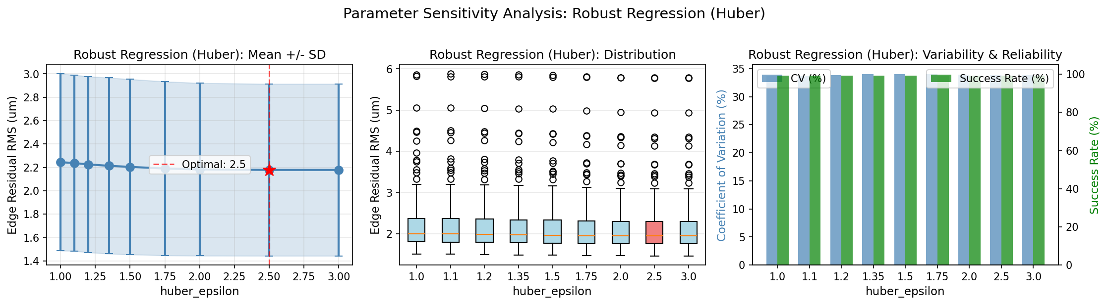

Relation to literature
Robust regression itself is a general statistical technique. Its specific use for Corvis WEM estimation is a methodological adaptation, motivated by the presence of outliers in peripheral deformation profiles. The underlying WEM decomposition remains consistent with border based separation approaches.

Method 04: Adaptive edge regression

Physical model
The affine WEM model is retained. The innovation is that the width of the edge region $E(w)$ is estimated from the data rather than fixed.

Motivation
The spatial extent of true corneal deformation varies between eyes and across time. A fixed $w$ may include deforming tissue in some cases, biasing $\hat{d}(t)$ and $\hat{θ}(t)$. Adaptive selection aims to identify the boundary beyond which deformation is small enough to approximate rigid motion.

Adaptive edge width selection
Compute a deformation magnitude profile at a reference frame $t^{\text{\backslash *}}$, typically near maximum deformation (for example highest concavity).
Define the central index $x=0$ as the apex, and compute a central reference amplitude
$$u_{max}(t^{\text{\backslash *}})=\underset{x∈X}{max⁡}∣u(t^{\text{\backslash *}},x)∣.$$
Choose a threshold fraction $α∈(0,1)$, and define the boundary as the first location from each edge where
$$∣u(t^{\text{\backslash *}},x)∣>αu_{max}(t^{\text{\backslash *}}).$$
Let $w_{L}$ and $w_{R}$ be the number of points from left and right edges that remain below threshold. Then set
$$w=min⁡(w_{L},w_{R}),$$
subject to bounds $w_{min}≤w≤w_{max}$.
With $w$ thus determined, estimate $\hat{d}(t),\hat{θ}(t)$ using Method 02.

Parameter choice
- $α$ controls how conservatively the periphery is defined.
- $w_{min}$ and $w_{max}$ prevent unstable fits due to too few points, and avoid selecting overly large regions.

Verification
- Compare edge residual RMS with fixed $w$ methods.
- Inspect stability of $w$ across measurements and across $t^{\text{\backslash *}}$ choices.
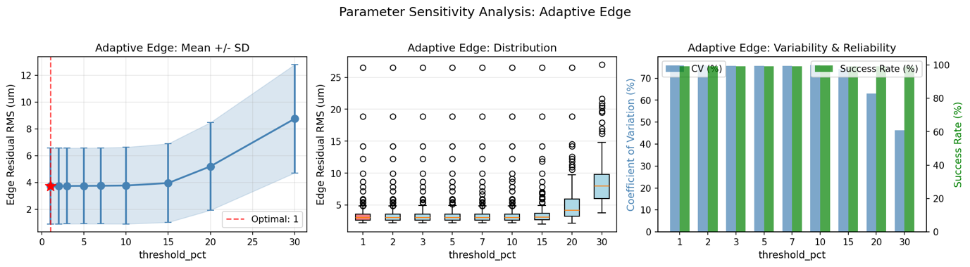

Relation to literature
The concept of using peripheral points away from the deforming centre is consistent with device definitions and studies that measure WEM at several millimetres from the centre. The specific adaptive boundary selection is a methodological extension aimed at reducing peripheral contamination.

Method 05: Edge region alignment by optimisation

Physical model
Again $w(t,x)=d(t)+θ(t)x$. Unlike Method 02, which uses edge means, this method uses all peripheral points and estimates parameters by directly minimising a frame-wise alignment cost.

Estimation
For each frame $t$, define residuals on the peripheral set $E(w)$
$$r(t,x)=u(t,x)-d-θx.$$
Estimate parameters by least squares
$$(\hat{d}(t),\hat{θ}(t))=arg⁡\underset{d,θ}{min⁡}\sum_{x∈E(w)}{r(t,x})^{2}.$$
This can be solved analytically as ordinary least squares on the design matrix $\left[1 , x\right]$. The optimisation formulation is equivalent, and enables straightforward extension to bounded or regularised variants if needed.

Parameter choice
- Fixed $w$.
- Optional smoothing of $\hat{d}(t)$ and $\hat{θ}(t)$ in time.

Verification
- Edge residual RMS is expected to be comparable to Method 02 or slightly improved if edge means are noisy.
- Sensitivity to localised edge artefacts is reduced relative to using only edge means.
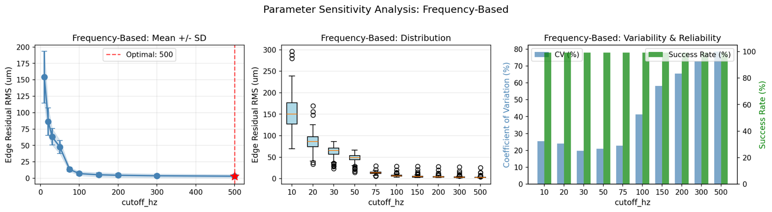

Relation to literature
This remains within the class of border-based affine separation models.

Method 06: Frequency-based WEM separation

Physical model
This method exploits the empirical separation of temporal scales. WEM tends to evolve relatively slowly across the measurement window, whereas corneal deformation can exhibit faster components.
Koprowski et al. (2015) explicitly separate eyeball displacement from corneal deformation and then remove slowly changing deformation by morphological opening to expose rapidly changing corneal deformations [9]. They report frequency components of corneal changes in the range 150 to 500 Hz after separating eyeball displacement. This supports a time scale-based approach, although any chosen cut-off must be validated empirically for the dataset and preprocessing.

Estimation
- Obtain raw affine estimates ${\hat{d}}_{raw}(t)$, ${\hat{θ}}_{raw}(t)$ using Method 02.
- Apply a low pass filter to isolate the slow component:
$$\hat{d}(t)=L_{f_{c}}({\hat{d}}_{raw}(t)),\hat{θ}(t)=L_{f_{c}}({\hat{θ}}_{raw}(t)),$$
where $L_{f_{c}}$ is a low pass operator with cut off frequency $f_{c}$.
A standard choice is a zero phase Butterworth filter:
- Design a digital low pass filter with order $m$ and cut off $f_{c}$ normalised by the Nyquist frequency $f_{s}/2$, where $f_{s}=1/Δt$.
- Apply forward and backward filtering to avoid phase distortion.
- Construct $\hat{w}(t,x)=\hat{d}(t)+\hat{θ}(t)x$ and compute $\hat{c}(t,x)$.

Parameter choice
- $f_{c}$ is selected to preserve slow WEM while excluding faster corneal components. A conservative constraint is $f_{c}<150$ Hz, given the reported higher frequency corneal components after eyeball displacement separation [9].
- Filter order $m$ is set to balance roll off and ringing.

Verification
- Inspect power spectral density of ${\hat{d}}_{raw}(t)$ and confirm that the filtered component captures the dominant low frequency energy.
- Ensure edge residual RMS remains low after filtering.
- Verify that the corrected corneal deformation retains expected central deformation magnitude.
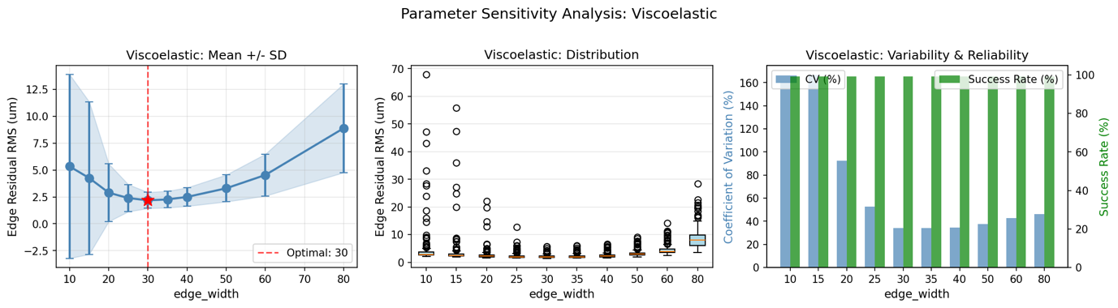

Relation to literature
This is conceptually aligned with separating low frequency and rapidly changing components in Corvis derived waveforms, as described by Koprowski et al (2015).

Method 07: Viscoelastic WEM model fitting - Kelvin Voigt validation

Aim and physical interpretation
This method treats the WEM waveform as the output of a simple linear viscoelastic element driven by the air puff force. It is intended to provide a physically interpretable parameterisation of globe motion, and to act as a model-based validity check for the estimated WEM waveform.
The literature supports the principle that ocular response includes damping and stiffness elements associated with the fixation of the ocular globe by muscles and surrounding tissues. A finite element analysis study explicitly introduces damping for fixation of the ocular globe, and reports “muscle spring and damping constants” describing displacement due to whole eye movement [1].
This method differs from Vellara et al. (2015), which uses the separation of corneal and orbital deformation components and then computes corneal energy dissipation from the force-displacement relationship of the pure corneal component. They do not present a spring dashpot identification for WEM.

Model
Let $F(t)$ be the air puff force time profile. Let $z(t)$ denote the estimated WEM translation signal, for example $z(t)=\hat{d}(t)$ from Method 02.
A Kelvin Voigt model is
$$F(t)=kz(t)+c\dot{z}(t),$$
where $k$ is an effective stiffness and $c$ is an effective viscous damping coefficient.
Discrete time approximation with $\dot{z}(t)≈(z(t)-z(t-1))/Δt$ gives
$$F(t)≈kz(t)+c\frac{z(t)-z(t-1)}{Δt}.$$

Estimation
Parameters $\left(k , c\right)$ are estimated by least squares:
$$(\hat{k},\hat{c})=arg⁡\underset{k,c}{min⁡}\sum_{t∈T_{fit}}{{\left[F(t)-kz(t)-c\dot{z}(t)\right]}^{2}},$$
over a fitting window $T_{fit}$ that excludes early baseline frames and optionally focuses on the main loading phase.
The effective time constant can be reported as $τ=\hat{c}/\hat{k}$.

Parameter choice
Fitting window $T_{fit}$ and any force scaling are chosen based on signal quality.
$Δt$ is known from the acquisition.

Verification
Model residual RMS and $R^{2}$ between $F(t)$ and $\hat{k}z(t)+\hat{c}\dot{z}(t)$ provide a physical plausibility check. Poor fit indicates that the estimated WEM signal is inconsistent with a simple linear viscoelastic response, or that the assumed force profile is mismatched.

Relation to literature
This approach is consistent with prior modelling that introduces spring and damping representations for whole eye motion in air puff deformation modelling [1]. Broader viscoelastic modelling of corneal and ocular response to air puff measurements has also been developed using linear viscoelastic and standard linear solid type models [10].

Method 08: Adaptive edge plus viscoelastic fitting
This method combines:
- Adaptive selection of edge width $w$ as in Method 04.
- Affine WEM estimation $\left(\hat{d}(t),\hat{θ}(t)\right)$.
- Kelvin Voigt fitting to the translation component $z(t)=\hat{d}(t)$ as in Method 07.
The principal purpose is to reduce edge contamination, then assess whether the resulting WEM waveform admits a reasonable low order viscoelastic description.
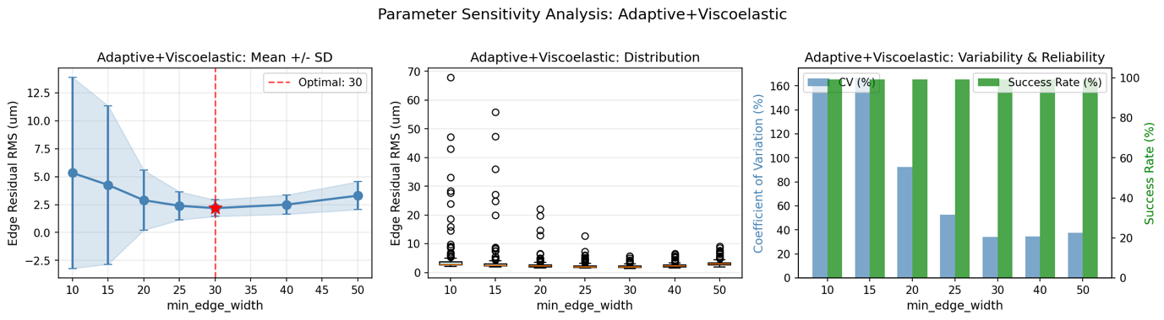

Method 09: Adaptive edge plus robust regression
This method combines:
- Adaptive selection of edge width $w$ as in Method 04.
- Robust affine regression on the selected edge region as in Method 03.
This hybrid is intended for cases where both the peripheral boundary must be learned from the data and the remaining peripheral samples include outliers.
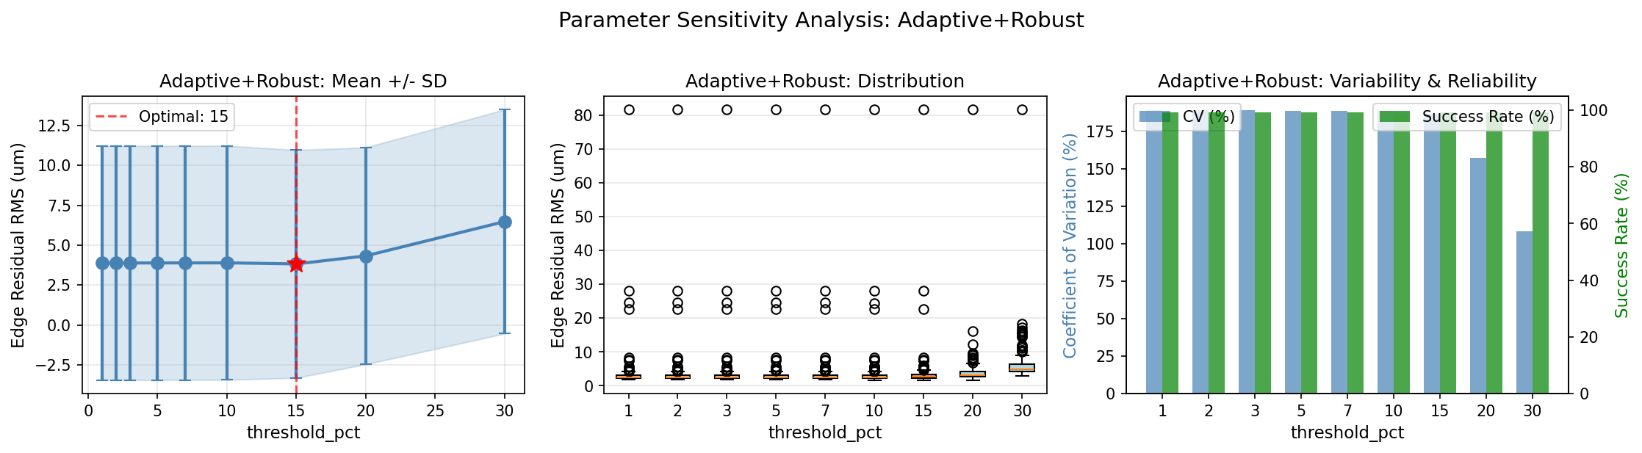

Verification metrics and automated quality control

Peripheral residual metrics
After correction, the corrected corneal deformation field should be small in the far periphery if the peripheral region is largely rigid motion. Define corrected deformation $\hat{c}(t,x)$. Define left and right edge residual RMS values
$${RMS}_{L}=\sqrt{\frac{1}{Tw}\sum_{t=0}^{T-1}{\sum_{k=1}^{w}{\overset{^}{c}}}(t,x_{k})^{2}},{RMS}_{R}=\sqrt{\frac{1}{Tw}\sum_{t=0}^{T-1}{\sum_{k=N-w+1}^{N}{\overset{^}{c}}}(t,x_{k})^{2}}.$$
A combined residual is
$${RMS}_{edge}=\frac{{RMS}_{L}+{RMS}_{R}}{2}.$$
Low ${RMS}_{edge}$ indicates minimal residual WEM in the corrected deformation signal.

WEM waveform metrics
Define the WEM translation waveform as $z(t)=\hat{d}(t)$, and optionally the apex WEM as $z_{apex}(t)=\hat{w}(t,0)=\hat{d}(t)$.
Key parameters include:
- Peak WEM magnitude:
$${WEM}_{max}=\underset{t}{max⁡}∣z(t)∣.$$
- Time to peak:
$$t_{max}=arg⁡\underset{t}{max⁡}∣z(t)∣,{TTWEM}_{max}=t_{max}Δt.$$
Clinically, WEM is expected to peak around the second applanation and later than maximum corneal deflection. This provides a physiological plausibility check.

Consistency with device-level parameters
Where the Corvis RawData sheet includes device derived WEM and deflection amplitude, a direct verification can be performed by comparing
- The extracted $z(t)$ to the device WEM signal.
- The central corrected deformation $\hat{c}(t,0)$ to device deflection amplitude.
Device documentation defines deflection amplitude as the deformation amplitude minus the whole-eye movement. This supports use of device curves as an external check, subject to differences in coordinate definitions and proprietary processing.

Method selection criterion
If multiple WEM separation methods are computed for each measurement, selection can be automated by a scalar objective, for example:
$$J=λ_{1}{RMS}_{edge}+λ_{2}\underset{t}{max⁡}∣\hat{θ}(t)∣+λ_{3}Φ,$$
where $Φ$ penalises implausible WEM peak timing, excessive oscillations, or poor model fit for the viscoelastic method. Weights $λ_{i}$ are chosen to prioritise minimal residual WEM in the corrected deformation, while preserving stable and physically plausible WEM.

Notes on interpretation and relation to existing definitions
- Relation to MCD and MOD: Vellara et al. (2015) define maximum corneal deformation (MCD) as the maximum of the corneal deformation component and maximum orbital deformation (MOD) as the maximum of the orbital component [2]. In the present framework, ${WEM}_{max}$ is analogous to MOD, and ${max⁡}_{t,x}∣\hat{c}(t,x)∣$ is analogous to MCD.
- WEM as a biomarker: Recent work supports that WEM can reflect biomechanical properties of tissues behind the cornea. For example, one study concludes that WEM is a potentially useful parameter reflecting biomechanical properties behind the cornea in myopia [3]. This motivates careful isolation of WEM rather than treating it purely as a nuisance term.
- Limitations: All affine WEM models assume that rigid body motion within the imaging plane can be approximated by translation and a first-order tilt term. Larger rotations, torsion, and out-of-plane motion can violate this assumption. Vellara et al. (2015) highlight that corneal rotation can affect apex tracking, emphasising the need for careful interpretation when tilt and tracking errors are present [2].

References
1. Kling, S., et al., Corneal viscoelastic properties from finite-element analysis of in vivo air-puff deformation. PLoS One, 2014. 9(8): p. e104904.
2. Vellara, H.R., et al., Quantitative Analysis of Corneal Energy Dissipation and Corneal and Orbital Deformation in Response to an Air-Pulse in Healthy Eyes. Invest Ophthalmol Vis Sci, 2015. 56(11): p. 6941–7.
3. Yang, Y., et al., Potential dynamic corneal response parameters for myopia: relationships between axial length with whole eye movement at the first and second applanations and the highest concavity. BMC Ophthalmol, 2024. 24(1): p. 382.
4. Koprowski, R., et al., Selected parameters of the corneal deformation in the Corvis tonometer. Biomed Eng Online, 2014. 13: p. 55.
5. Boszczyk, A., H. Kasprzak, and A. Jozwik, Eye retraction and rotation during Corvis ST 'air puff' intraocular pressure measurement and its quantitative analysis. Ophthalmic Physiol Opt, 2017. 37(3): p. 253–262.
6. Jannesari, M., P. Mosaddegh, and M. Kadkhodaei, Numerical and clinical investigation on the material model of the cornea in Corvis tonometry tests. Mechanics of Time-Dependent Materials, 2019. 23: p. 373–384.
7. Jannesari, M., et al., Assessment of corneal and fatty tissues biomechanical response in dynamic tonometry tests by using inverse models. Acta Bioeng Biomech, 2018. 20(1): p. 39–48.
8. Boszczyk, A., H. Kasprzak, and J. Przezdziecka-Dolyk, Novel Method of Measuring Corneal Viscoelasticity Using the Corvis ST Tonometer. J Clin Med, 2022. 11(1).
9. Koprowski, R., et al., Quantitative assessment of responses of the eyeball based on data from the Corvis tonometer. Comput Biol Med, 2015. 58: p. 91–100.
10. Ávila, F.J., et al., A Comprehensive Study on Elasticity and Viscosity in Biomechanics and Optical Properties of the Living Human Cornea. Photonics, 2024. 11(6): p. 524.

