Supplemental Appendix
Manual adjustment of suicide and behavioral health call rates in 2020q3 and 2020q4
In late 2020, Mesa showed an unusual change in trends among its behavioral health and suicide 911 call data. Behavioral health-related calls peaked for a five-month period, and suicide-related calls dipped in the same five-month period by roughly the same proportion. Call trends of both types are shown below in Figure S1. The change occurred directly after a August, 2020 MPD policy change that expanded the categorization of behavioral health calls. We suspect the policy may have influenced some 911 call takers to categorize certain calls as behavioral health that they previously had categorized as suicide. Mesa changed its CAD tracking system beginning January, 2021, which may have prompted the reversion back to traditional call categorization. As such, we do not think the raw counts of behavioral health and suicide calls reflect a genuine change in the nature of 911 calls happening during 2020q3 and 2020q4.
Figure S1. Trends of Mesa's suicide and behavioral health 911 calls by month without manual imputation, January 2018 - June, 2022

To adjust for the suspected data issue, we assumed that the excess behavioral health call counts were suicide call counts. We took the mean of behavioral health call counts in the non-affected months and imputed it for behavioral health call counts of August – December 2020. We subtracted that imputed mean from the raw behavioral health counts to determine the excess behavioral health counts during those months. We then added the excess behavioral health call counts to the raw suicide call counts for each of the affected months. After translating the monthly counts to the quarterly counts, we reassigned 181 behavioral health calls to the suicide category in 2020q3 and reassigned 360 behavioral health calls to the suicide category in 2020q4.
We ran the synthetic control analyses in two other ways to determine whether the manual imputation impacted the results. First, we ran the synthetic control analysis on suicide call rates without the two quarters in question (2020q3 and 2020q4): the magnitude of the effect size was smaller, where the difference between Mesa and synthetic Mesa ranging from -15.37 to -40.93 after the first posttreatment quarter. The difference was not statistically significant in any of the posttreatment quarters, though the effect in Mesa was larger than those of all but two placebo estimates in 2022q3 (p=.10). Second, we ran the synthetic control analyses without any imputation, accepting the raw values as real counts of suicide and behavioral health call counts: the magnitude of the effect size was much smaller, where the difference between Mesa and synthetic Mesa ranging from -5.28 to -21.64 after the first posttreatment quarter. The difference was not statistically significant in any of the posttreatment quarters. As such, if the raw, unimputed data accurately represented a dramatic drop in suicide-related 911 calls in 2020q3 and 2020q4, the synthetic control analysis does not suggest there was an effect after embedding a 988 counselor at the 911 center. We do not think the raw, unimputed data is a genuine reflection of suicidality in Mesa, but we report the raw results here for the sake of transparency.
Robustness check: non-suicide call rates
We ran a subsequent synthetic control test with non-suicide related calls to determine whether the Mesa’s declining suicide call rate was associated with broader factors of decreasing 911 calls. Mesa’s non-suicide call rate did not appear to decrease after embedding the 988 counselor at the 911 center. The weights were: Cary=.631, Everett=.02, Miami=.326, and Tacoma=.023. The pre-treatment absolute difference between Mesa and synthetic Mesa stayed within 600 calls per 100,000 people. If Mesa’s non-suicide call rate fell below that of its synthetic control after the intervention, we may suspect that the post-intervention drop in police response rate was due to other exogenous factors that affected all of Mesa’s 911 calls.
Figure S2. Synthetic control analysis of Mesa’s non-suicide call rate per 100,000 people after embedding a 988 counselor in a 911 emergency communications center.
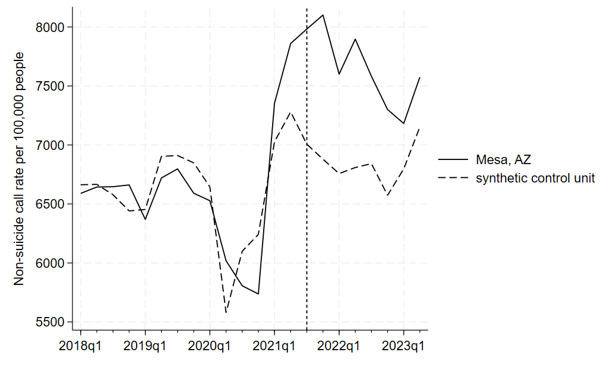
Figure S2 shows that Mesa’s 911 non-suicide call rate increased relative to synthetic Mesa after the embedded counselor intervention. Post-intervention, Mesa had a higher non-suicide call rate than synthetic Mesa by 975-1221 calls per 100,000 people. The difference between Mesa and synthetic Mesa fell within the normal distribution of placebo estimates; the standardized p-values did not fall below .35. This synthetic control analysis suggests there was no reason to suspect that Mesa’s non-suicidal call rate changed in a meaningful way after the intervention. These placebo tests are not formal mechanisms of accepting a null hypothesis. However, this analysis gives us less reason to believe that there were general drops of 911 call usage that influenced the decline of Mesa’s suicide call rate.
Robustness check: dropping cities with unusually low suicide call rates
Some of the 911 centers could have been tracking different types of suicide call data, as there were not often detailed descriptions of each 911 call type. For example, some may only track suicide attempts, rather than incidents of suicidal ideation. Suicide attempts are rarer than incidents of suicidal ideation, would likely have less variance over time, and would not be appropriate for 988 routing. Cities that only track suicide attempts would likely not be appropriate donor sites for the synthetic control model. While we do not have much information on how each city used their suicide call category; they may have simply had lower rates of suicidal ideation. Alternatively, one might assume that cities with unusually low suicide call rates may instead be tracking suicide attempts. We ran a synthetic control model that drops outlier cities with unusually low suicide call rates per 100,000 people. We defined such an outlier as a city that averaged under 10 suicide calls per quarter per 100,000 people. There were four outliers: College Station (1.1 per 100k), Boston (2.4), Chula Vista (2.8), and Cary (6.9).
When running the synthetic control analysis after dropping the four lowest outliers, the magnitude of the effect size was identical to that of the original model. This is understandable, as none of the four outlier cities were included in the original synthetic control model. However, because there were fewer placebos with which to compare Mesa against, the standardized p-values changed. Instead of comparing against 20 placebo estimates, Mesa’s effect compared to 16. Mesa’s difference was greater than all placebos in 2022q4 (p<.01), greater than all but one placebo in 2021q4 and 2022q3 (p=.0625), and greater than all but two placebos in 2022q2 and 2023q1 (p=.125). Thus, dropping the unusually low outliers had no impact on the estimated effect size of Mesa’s intervention. After removing cities with potential counts of suicidal attempts, rather than counts of suicidal incidents, we interpret these results to mean the co-located counselor still influenced Mesa’s suicidal call rate, but we are less able to rule out that the effect was due to chance.
Robustness check: dropping individual observations from the model
To check whether one of the donor sites was particularly influential in the synthetic control analysis of suicide call rates, we ran subsequent synthetic control models that dropped one of the donor sites, repeating the process for every donor site. Mesa’s suicide call rate was lower than synthetic Mesa in all the robustness check analyses after the first post-intervention quarter. The magnitude of the effect size in each of the dropped observation models were similar those in the original model. The effect sizes in the dropped observation models ranged from 13.33 to 20.74 in 2021q3, from -20.59 to -35.64 in 2021q4; from -32.49 to -39.25 in 2022q1, from -30.11 to -41.58 in 2022q2, from -40.31 to -51.04 in 2022q3, from -38.37 to -47.96 in 2022q4, from -38.95 to -63.01 in 2023q1 and from -27.76 to -44.64 in 2023q2.
The standardized p-values in the post-intervention quarters changed in some of the dropped observation models. For each of the dropped cities, table S1 shows the number of post treatment quarters where the Mesa’s effect was greater than all placebos (p<.01), greater than all but one placebo (p=.053), and greater than all but two placebos (p=.105).
Table S1. Robustness check showing the synthetic control results of placebo estimates after dropping individual cities
 | Mesa’s effect greater than all placebos |  | Mesa’s effect greater than all but one placebo |  | Mesa’s effect greater than all but two placebos
Dropped city | # of quarters | p-value | # of quarters | p-value | # of quarters | p-value
None | 1 | <.01 | 2 | 0.05 | 2 | 0.1
Boston | 1 | <.01 | 2 | 0.053 | 2 | 0.105
Cary | 1 | <.01 | 1 | 0.053 | 3 | 0.105
Chandler | 1 | <.01 | 4 | 0.053 | 0 | 0.105
Charlotte | 1 | <.01 | 2 | 0.053 | 2 | 0.105
Chula Vista | 1 | <.01 | 2 | 0.053 | 2 | 0.105
College Station | 1 | <.01 | 1 | 0.053 | 3 | 0.105
Everett | 0 | <.01 | 1 | 0.053 | 0 | 0.105
Fort Lauderdale | 1 | <.01 | 4 | 0.053 | 2 | 0.105
Hartford | 1 | <.01 | 2 | 0.053 | 2 | 0.105
Irving | 1 | <.01 | 2 | 0.053 | 2 | 0.105
Lincoln | 1 | <.01 | 2 | 0.053 | 3 | 0.105
Los Angeles | 1 | <.01 | 2 | 0.053 | 2 | 0.105
Miami | 1 | <.01 | 1 | 0.053 | 3 | 0.105
Nashville | 2 | <.01 | 3 | 0.053 | 1 | 0.105
New Orleans | 0 | <.01 | 2 | 0.053 | 3 | 0.105
Norman | 1 | <.01 | 1 | 0.053 | 1 | 0.105
San Francisco | 0 | <.01 | 3 | 0.053 | 3 | 0.105
Seattle | 0 | <.01 | 2 | 0.053 | 4 | 0.105
St Petersburg | 1 | <.01 | 1 | 0.053 | 3 | 0.105
Tacoma | 1 | <.01 | 2 | 0.053 | 2 | 0.105

Mesa’s suicide call rate was lower than synthetic Mesa’s in all robustness analyses by a similar magnitude. Mesa’s suicide call rate was greater than all placebos (p<.01) for at least one post-treatment quarter in all but four of the dropped individual observation models. Mesa’s suicide call rate was greater than all but one placebo (p=.53) in at least one post-treatment quarter in all of the dropped observation models. We find the results to be adequately robust.

