Supplementary Tables
Table S1 Codes and explanations according to the Norwegian Classification of Radiological Procedures (NCRP) system.
Code | Description
SKX0AA | X-ray Overview Urinary Tract
SKX0CA | X-ray Urography
SKX0DA | X-ray micturition cystourethrography
SKX0FA | X-ray of the urinary tract with measurement of glomerular filtration rate
KXFF00 | Uroflowmetry
SKX0AD | CT urinary tract
SKX0BD | CT Kidneys and upper urinary tract
SKX0BA | X-ray Pyelography
SKX0AK | Ultrasound of the urinary tract
SKA0BK | Ultrasound of the kidneys
SKCOAK | Ultrasound of the urinary bladder
TKA0AN | Nuclear Medicine (NM) scintigraphy of the kidneys
TKA0BN | NM Renography

Table S2 Overview of the number of urinary tract examinations for the various examination codes for the years from 2013 to 2022. CT= Computed Tomography; UT= Urinary Track; US=Ultrasound; NM = Nuclear Medicine; GFR = Glomerular filtration rate.
Examination | NCRP-code | 2013 | 2014 | 2015 | 2016 | 2017 | 2018 | 2019 | 2020 | 2021 | 2022 | Total | Percent
CT urinary tract (UT) | SKX0AD | 23,023 | 34,299 | 32,353 | 35,591 | 36,768 | 37,076 | 38,157 | 32,529 | 33,053 | 32,375 | 335,224 | 44.8
US of the UT | SKX0AK | 30,876 | 31,880 | 32,757 | 31,196 | 29,380 | 28,485 | 28,146 | 24,721 | 25,981 | 24,249 | 287,671 | 38.5
CT Kidneys and upper UT | SKX0BD | 5,991 | 5,486 | 7,019 | 6,254 | 6,460 | 6,838 | 7,073 | 7,272 | 8,179 | 9,162 | 69,734 | 9.3
X-ray Overview UT | SKX0AA | 4149 | 3838 | 2916 | 2098 | 1417 | 1038 | 737 | 367 | 324 | 247 | 17,131 | 2.3
X-ray Pyelography | SKX0BA | 1,198 | 1,117 | 1,230 | 1,533 | 1,488 | 1,405 | 1,396 | 1,306 | 1,250 | 1,091 | 13,014 | 1.7
X-ray micturition cystourethrography | SKX0DA | 898 | 996 | 1,050 | 1,072 | 1,020 | 989 | 852 | 748 | 759 | 562 | 8,946 | 1.2
Ultrasound of the kidneys | SKA0BK | 11 | 4 | 8 | 26 | 33 | 441 | 1,165 | 1,162 | 1,371 | 1,251 | 5,472 | 0.7
NM Renography | TKA0BN | 756 | 684 | 763 | 646 | 602 | 569 | 375 | 283 | 219 | 165 | 5,062 | 0.7
NM scintigraphy of the kidneys | TKA0AN | 686 | 707 | 559 | 500 | 517 | 522 | 443 | 405 | 407 | 311 | 5,057 | 0.7
Uroflowmetry | KXFF00 | 168 | 154 | 0 | 0 | 0 | 322 | 0 | 0 | 0 | 0 | 644 | 0.1
X-ray of UT with GFR measurement | SKX0FA | 2 | 1 | 1 | 1 | 0 | 2 |  | 7 | 0 | 0 | 14 | 0
Total | All codes | 67,758 | 79,166 | 78,656 | 78,917 | 77,685 | 77,687 | 78,344 | 68,800 | 71,543 | 69,413 | 747,969 | 100

Supplementary Figure
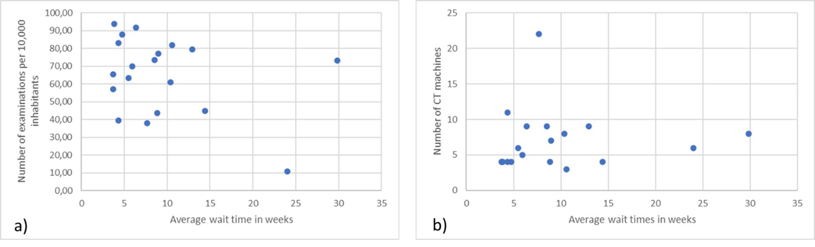
Figure S1 Scatter plot of number of CTs of the urinary tract per 10,000 inhabitants (a) and number of CT machines (b) versus average wait time in weeks for the various hospital trusts

