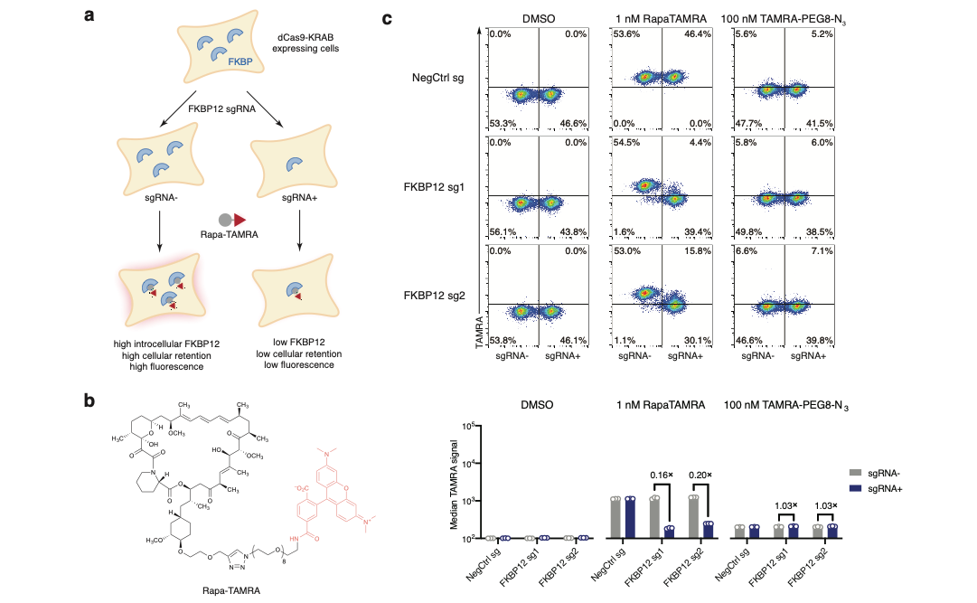
Extended Data Figure 1. FKBP12-Rapamycin interaction contributes to cellular accumulation of a fluorescent analog of RapaLink-1. a, Illustration of the flow cytometry-based assay to assess cellular accumulation of TAMRA compounds. b, Structure of a fluorescent probe Rapa-TAMRA. c, FKBP12 knockdown decreases cellular retention of Rapa-TAMRA, but not TAMRA-PEG8-N3. See Supplementary Information for gating strategy.
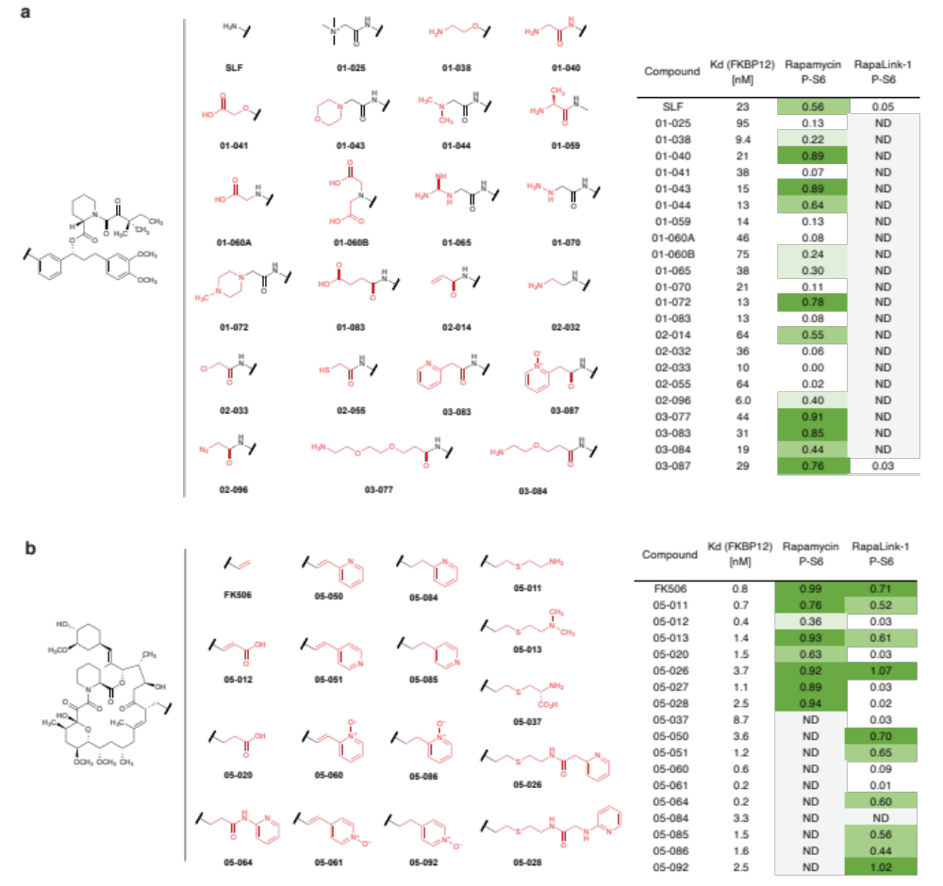
Extended Data Figure 2. Structures polar FKBP12 ligands synthesized (a, SLF derivatives; b, FK506 derivatives). Listed in the table are their affinity to recombinant FKBP12 (fluorescence polarization assay) and their efficacy of blocking mTOR inhibition by rapamycin or RapaLink-1 (assessed by western blot analysis of p-S6 level after treatment of MCF7 cells with a combination of 10 nM Rapamycin/Rapalink + 10 µM candidate compound for 24 h. P-S6 level is quantified as fraction of DMSO control). ND, not determined.
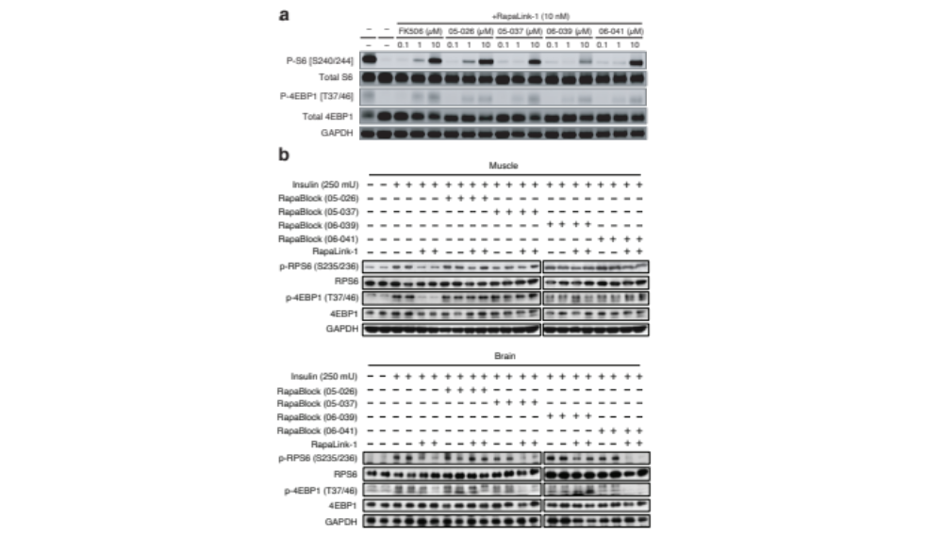
Extended Data Figure 3. Four candidate RapaBlock molecules were evaluated in cells (a) and in vivo (b).
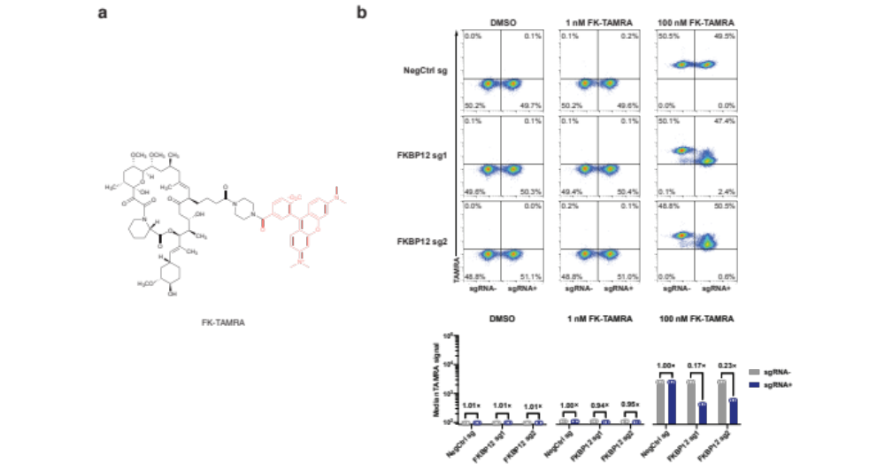
Extended Data Figure 4. (Related to Extended Data Figure 1) FKBP12-FK506 interaction contributes to cellular accumulation of a fluorescence analog of FK506. a, Structure of a fluorescent probe FK-TAMRA. b, FKBP12 knockdown decreases cellular retention of FK-TAMRA. See Supplementary Information for gating strategy.
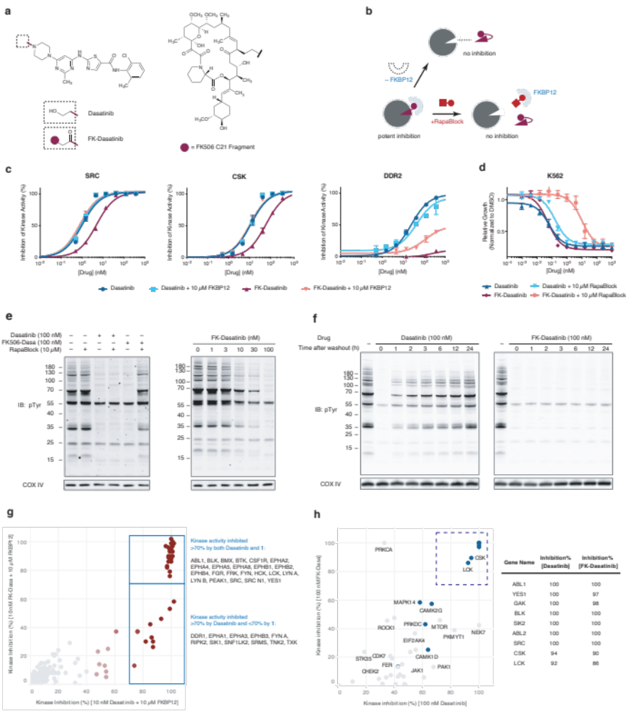
Extended Data Figure 5. FK-Dasatinib is a FKBP12-dependent Src family kinase inhibitor with long cellular retention time. a, Structures of Dasatinib and FK-Dasatinib. b, Proposed working model for FKBP-dependent kinase inhibitors. c, Inhibition of Src, Csk and DDR2 kinases by Dasatinib and FK-Dasatinib in the absence or presence of supplemented 10 µM recombinant FKBP12 protein. Data is the average of two replicates. d, Inhibition of K562 cell proliferation by Dasatinib and FK-Dasatinib, in the presence or absence of 10 µM RapaBlock. Data is the average of three replicates. e, Jurkat cells were stimulated with anti-CD3 antibody (OKT3) in the presence of dasatinib, FK-dasatinib, and/or RapaBlock and analyzed by immunoblot. f, Jurkat cells were pulse-treated with Dasatinib (100 nM) or FK-Dasatinib (100 nM) for 1 h, then drugs were washed out and cells were incubated in drug-free media for various amounts of time, stimulated with anti-CD3 antibody (OKT3) for 5 min and analyzed by immunoblot. g, inhibition of 476 purified kinases by Dasatinib (10 nM) or FK-Dasatinib (10 nM) in the presence of 10 µM recombinant FKBP12 protein. h, kinase profiling of Dasatinib (100 nM Dasatinib) or FK-Dasatinib (100 nM) in Jurkat cells using the covalent occupancy probe XO44. See Supplementary Information for experimental details.
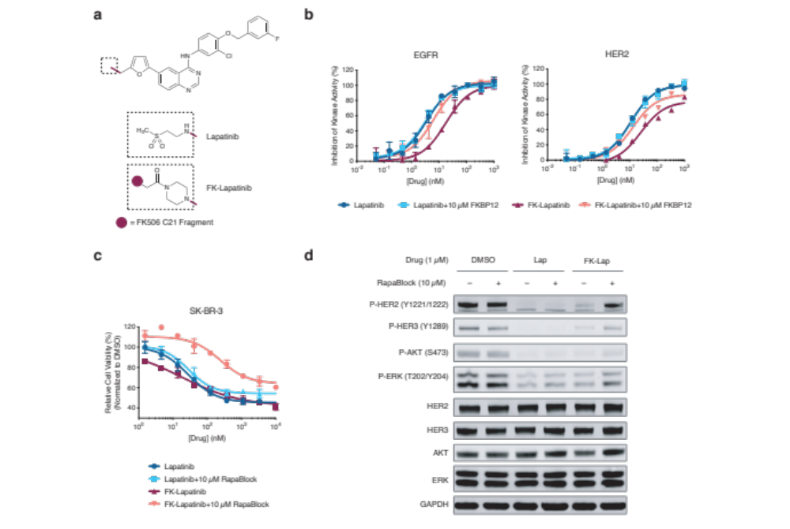
Extended Data Figure 6. FK-Lapatinib is a FKBP12-dependent EGFR/HER2 kinase inhibitor. a, Chemical structures of Lapatinib and FK-Lapatinib. b, Inhibition of EGFR and HER2 kinase activity by Lapatinib and FK-Lapatinib in the absence or presence of supplemented 10 µM recombinant FKBP12 protein. Data is the average of two replicates. c, Inhibition of proliferation of SK-BR3 cells by lapatinib and FK-lapatinib in the presence of absence of 10 µM RapaBlock. Data is the average of three replicates. d, SK-BR3 cells were treated with Lapatinib, FK-Lapatinib, and/or RapaBlock for 1 h and analyzed by immunoblot.
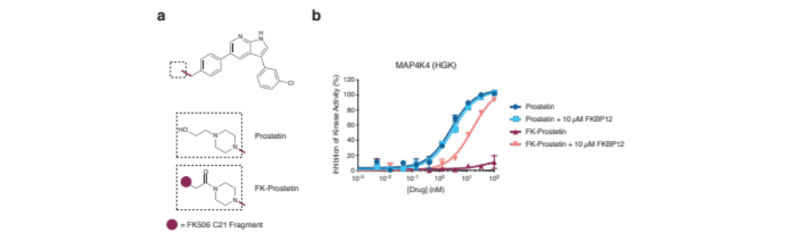
Extended Data Figure 7. FK-Prostetin is a FKBP12-dependent MAP4K4(HGK) kinase inhibitor. a, Chemical structures of Prostetin and FK-Prostetin. b, Inhibition of MAP4K4(HGK) kinase activity by Lapatinib and FK-Lapatinib in the absence or presence of supplemented 10 µM recombinant FKBP12 protein. Data is the average of two replicates.

Extended Data Figure 8. Exemplary bioluminescence images of mice bearing intracranial glioblastoma xenografts. ﻿U87MG cells expressing firefly luciferase were injected intracranially into BALB/c^{nu/nu} mice. After tumor establishment, mice were sorted into four groups and treated by i.p. injections every 5 days of vehicle, RapaBlock (1 mg/kg), RapaBlock (40 mg/kg), or a combination of RapaLink-1 and RapaBlock (1 mg/kg and 40 mg/kg, respectively). Bioluminescence imaging of tumor-bearing mice was obtained at days shown (day 0 was start of treatment), using identical imaging conditions.

