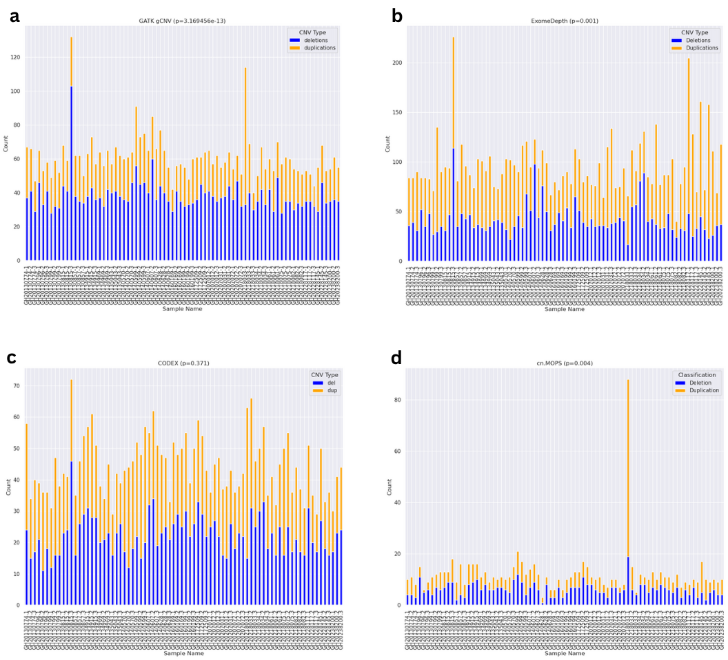
Figure S2: Stacked barplots of deletions and duplications detected in each sample by the four tools: (a) GATK gCNV, (b) ExomeDepth, (c) CODEX and (d) cn.MOPS. The p-value beside each tool’s name was calculated using a paired Wilcoxon signed-rank test, indicating bias towards detecting either deletions or duplications. The x-axis represents the sample IDs and the y axis represent the number of detected CNVs.

