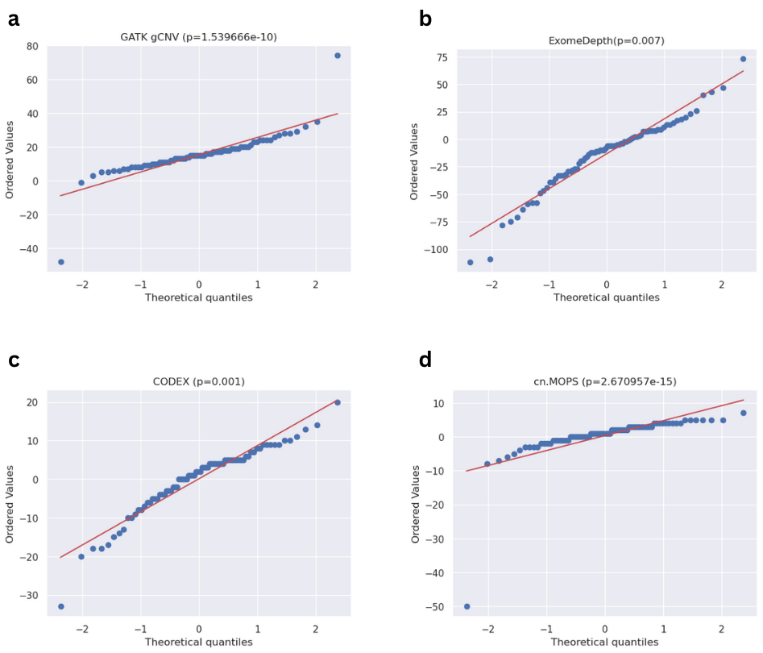

Figure S1: Normality tests using Q-Q plots for each of the four tools: (a) GATK gCNV, (b) ExomeDepth, (c) CODEX and (d) cn.MOPS. The p-value beside each tool’s name was calculated using shapiro-wilk test to confirm normality for the paired data (duplications and deletions) for each tool.

