Supporting information

Hierarchical Cotton Pulp Fiber - Microfibrillated Cellulose Separator for Long-Cycle-Life Aqueous Zinc-Ion Batteries
Shuai Dingª, Xiaoquan Zhu^{a,*}, Qingtao Ma^{b}, Yujie Jingª, Lihong Jiangª, Huimin Zhouª, Aoxuan Wang^{c,*}, Xin Xia^{a,*}
ª College of Textile and Clothing, Xinjiang Key Laboratory of Intelligent and Green Textile, Xinjiang University, Urumqi 830046, P. R. China
^{b} State Key Laboratory of Chemistry and Utilization of Carbon Based Energy Resources, College of Chemistry, Xinjiang University, Urumqi, Xinjiang 830017, P. R. China
^{c} School of Chemical Engineering and Technology, Tianjin University, Tianjin 300350, P.R. China
Corresponding author E-mail: zhuxiaoquan89@163.com (X. Zhu), aoxuanwang@tju.edu.cn
(A. Wang) and xjxiaxin@xju.edu.cn (X. Xia)

- Experimental section
1.1 Preparation of ammonium vanadium bronze nanobelts. The NH₄V₄O₁₀ nanobelts were synthesized under hydrothermal conditions. All of the chemical reagents used in this experiment were analytical grade without further purification. In a typical procedure, NH₄VO₃(1.1699 g) was dissolved in 80℃ deionized water to form a light yellow solution. H₂C₂O₄(1.3507 g) solid powders were directly added to the solution under continuous stirring until the solid was completely dissolved. A clear black-green solution was formed and the resultant system was then transferred into a Teflon-lined autoclave with a stainless steel shell. The autoclave was kept at 140℃ for 48 h and then allowed to cool down to room temperature. The black-green precipitate was collected and washed several times with distilled water. The final product was dried at 110℃ for 5 h in the argon atmosphere (Zhang et al. 2006).

1.2 Electrochemical measurements
70 wt.% NH₄V₄O₁₀, 20 wt.% Super P conductive carbon, and 10 wt.% polyvinylidene fluoride dispersed in N-methyl-2-pyrrolidone were mixed homogeneously and then pasted onto a Ti foil (~50 μm in thickness). After drying in an oven and cutting, cathode pieces were obtained. For electrochemical measurements, CR2032-type coin cells were used. The Zn||NH₄V₄O₁₀ batteries were assembled by using NH₄V₄O₁₀ cathode, zinc metal anode, and 2 M ZnSO₄ aqueous electrolyte. Two types of separators including CPF-MFC separator, GF separator, were used for comparison. The mass loadings of NH₄V₄O₁₀ in the cathodes were 2 mg cm⁻². As for the electrolyte dosage, approximately 0.15 mL electrolyte was added into each coin cell. The specific capacities of these batteries were calculated based on the mass of cathode active materials (Zhou et al. 2022).
2. Supplementary figures
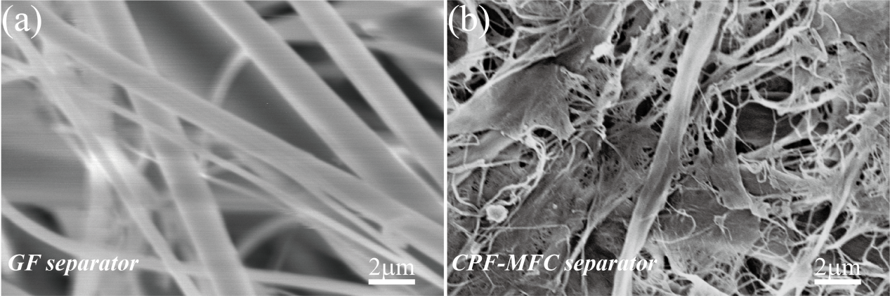
Fig. S1 SEM images of (a) GF separator and (b) CPF-MFC separator.

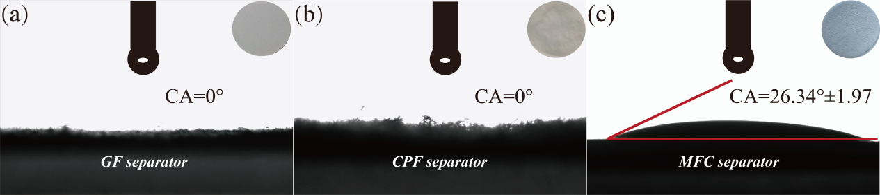
Fig. S2 Contact angle measurements of different fiber surfaces: (a) GF separator; (b) CPF separator;(c) MFC separator

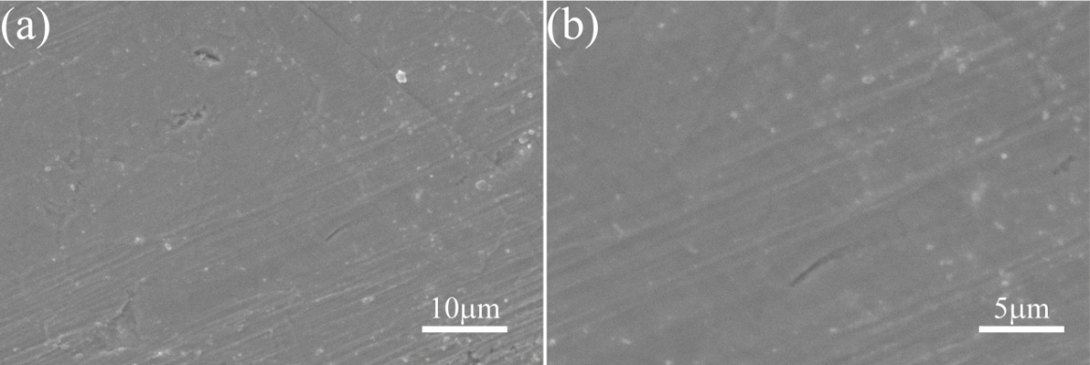
Fig. S3 (a, b) top-view SEM images of the pristine Zn electrode.

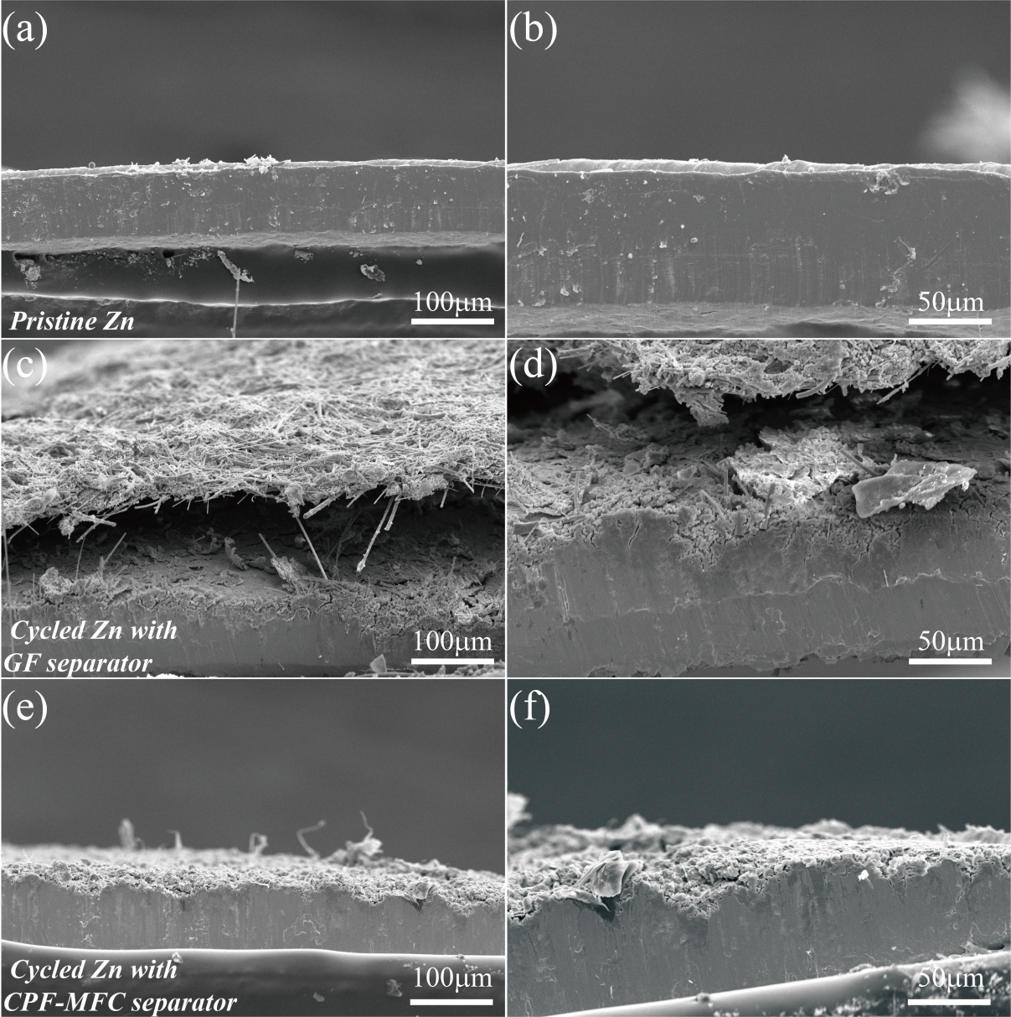
Fig. S4 Cross-sectional SEM images of (a, b) the pristine Zn electrode, (c, d) the Zn electrode with the GF separator after the measurements in Fig. 6a, and (e, f) the Zn electrode with the CPF-MFC separator after the measurements in Fig. 6a.

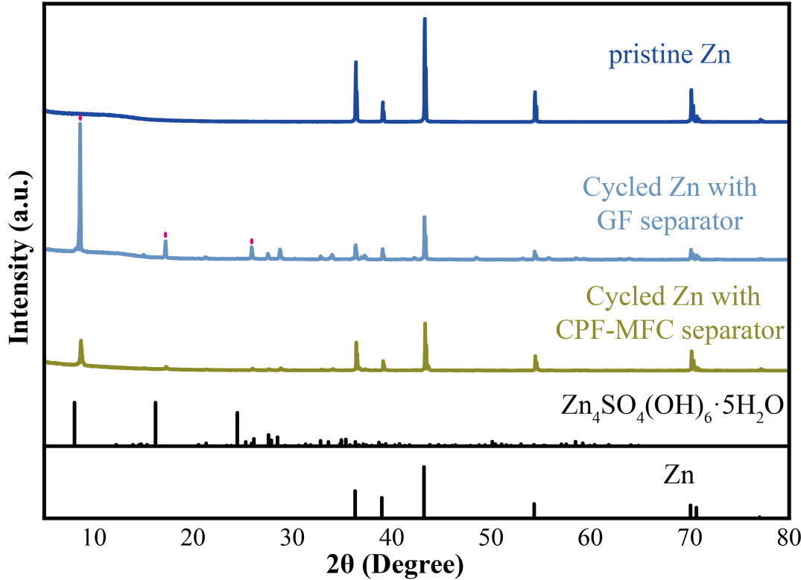
Fig. S5 XRD patterns of the pristine Zn electrode and Zn electrodes with different separators after the measurements in Fig. 5a.

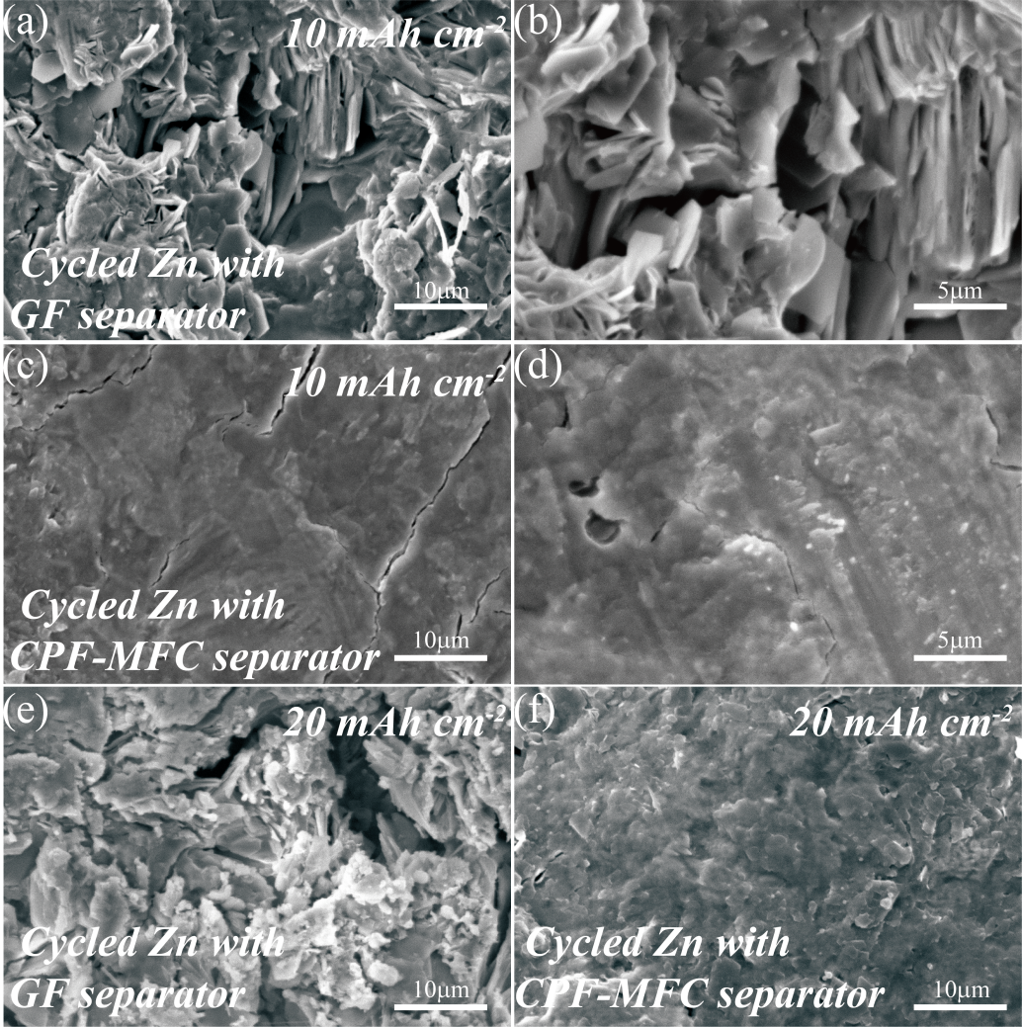
Fig. S6 Top-view SEM images of the Zn electrodes at the states A and B (illustrated in Fig. 3h): (a, b) at state A with the GF separator, (c, d) at state A with the CPF-MFC separator, (e) at state B with the GF separator, and (f) at state B with the CPF-MFC separator.

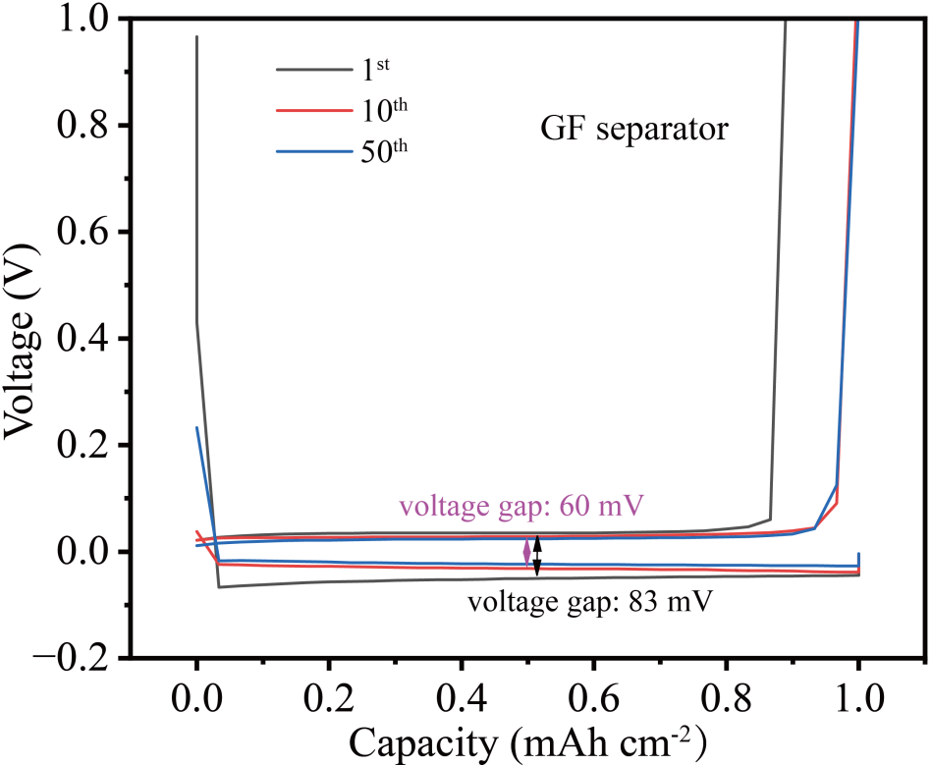
Fig. S7 Voltage-capacity profiles of the Zn||Cu cell with the GF separator.

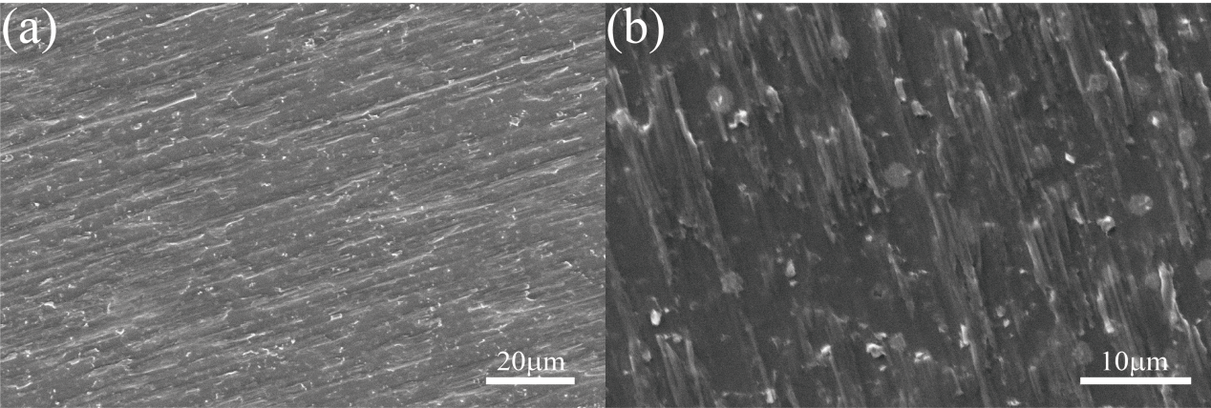
Fig. S8 SEM images of the pristine Cu foam.

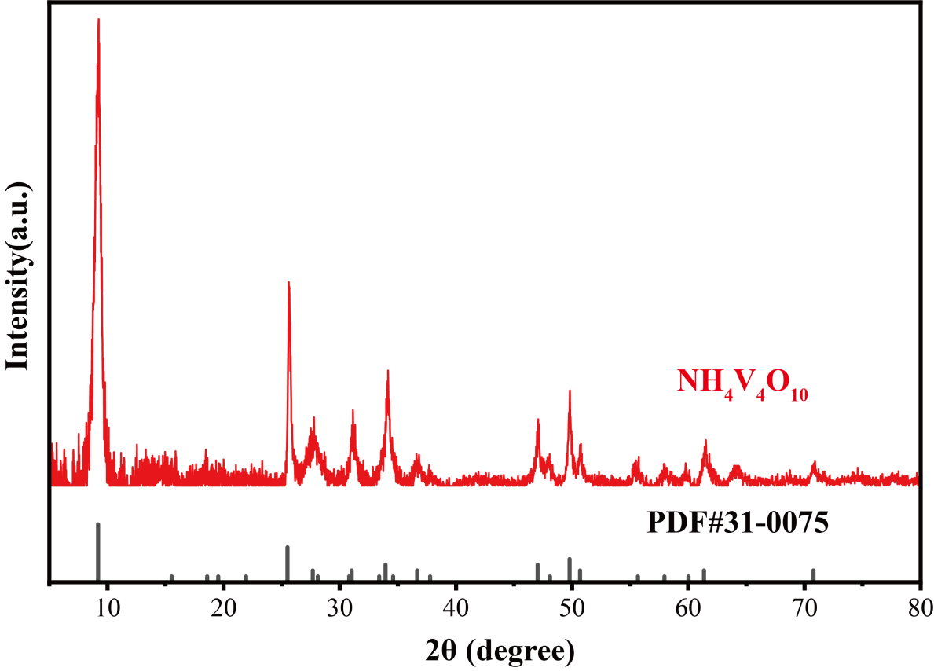
Fig. S9 XRD patterns of NH₄V₄O₁₀.

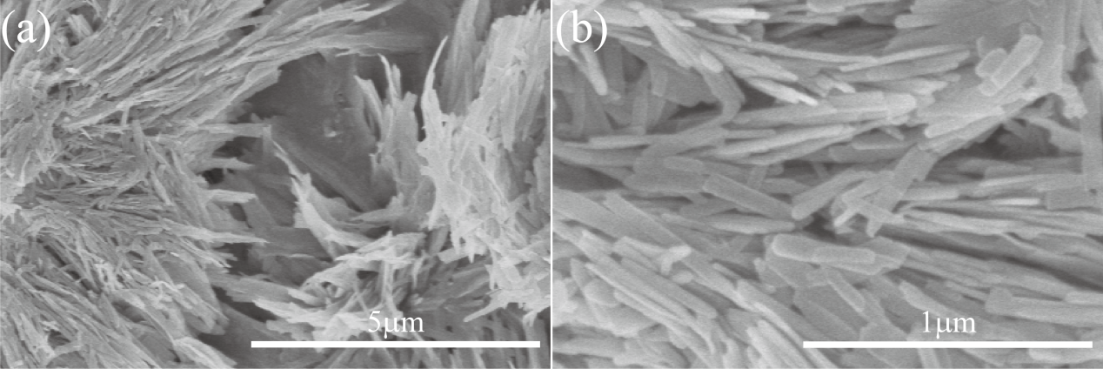
Fig. S10 SEM images of NH₄V₄O₁₀.

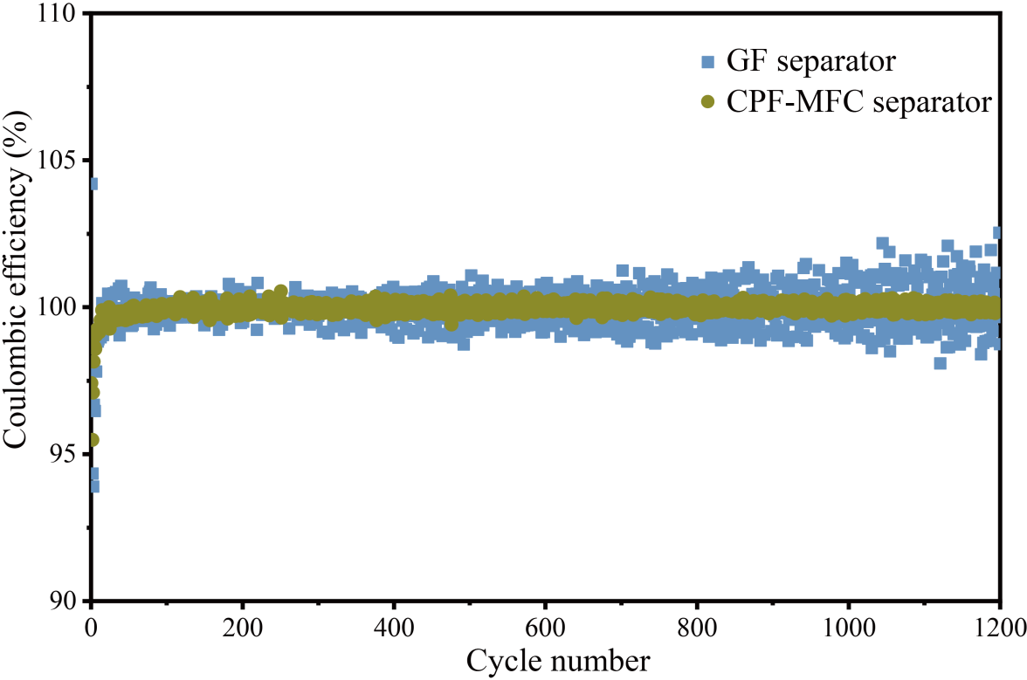
Fig. S11 CE values of Zn||NH₄V₄O₁₀ batteries with different separators at 1 A g⁻¹ .

Zhang K-F, Zhang G-Q, Liu X et al (2006) Large scale hydrothermal synthesis and electrochemistry of ammonium vanadium bronze nanobelts. J. Power Sources 157:528-532. https://doi.org/10.1016/j.jpowsour.2005.07.043
Zhou W, Chen M, Tian Q et al (2022) Cotton-derived cellulose film as a dendrite-inhibiting separator to stabilize the zinc metal anode of aqueous zinc ion batteries. Energy Storage Mater. 44:57-65. https://doi.org/10.1016/j.ensm.2021.10.002

