Supplementary material: Carbon-costed diets require redistribution to ensure equitable access to sustainable diets

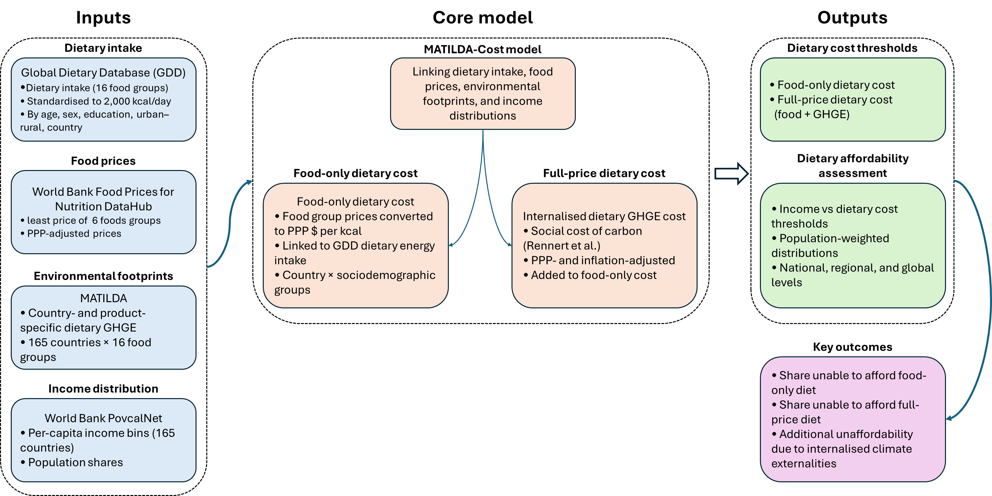
Supplementary Figure 1. Overview of the MATILDA-Cost framework.
The framework integrates dietary intake data, country-specific food prices, environmental footprint coefficients, and income distributions to estimate food-only and full-price dietary costs. Monetised diet-related greenhouse gas emissions are added to food costs to derive full-price dietary costs. Dietary affordability is assessed by comparing dietary cost thresholds with population-weighted income distributions at national, regional, and global levels.

Supplementary Table 1. Healthy Diet Basket content by food group, by kcal and grams of reference food
Food Group | Min Number of Food Items Selected for Cost of Healthy Diet | Total Energy Content (kcal)
Starchy staples | 1 | 160
Vegetables | 3 | 110
Fruits | 2 | 160
Animal source foods | 2 | 300
Legumes, nuts, and seeds | 1 | 300
Oils and fats | 1 | 300

Supplementary Table 2. Population unable to afford food-only and full-price dietary costs by world region
Region | Total population (millions) | Population unable to afford food-only diet (millions) | Population unable to afford food-only diet (%) | Population unable to afford full-price dietary cost (millions) | Population unable to afford full-price dietary cost (%)
Caribbean | 13.6 | 7.0 | 52% | 6.4 | 47%
Central Asia | 32.1 | 8.4 | 26% | 6.4 | 20%
Eastern Africa | 356.2 | 258.0 | 72% | 225.0 | 63%
Eastern Asia | 1406.0 | 281.0 | 20% | 169.0 | 12%
Eastern Europe | 255.6 | 5.9 | 2% | 3.5 | 1%
Melanesia | 0.9 | 0.4 | 45% | 0.3 | 33%
Middle Africa | 196.2 | 138.0 | 70% | 122.0 | 62%
Northern Africa | 117.1 | 41.0 | 35% | 34.5 | 29%
Polynesia | 0.2 | 0.0 | 19% | 0.0 | 15%
South America | 0.6 | 0.0 | 6% | 0.0 | 3%
South-eastern Asia | 582.4 | 146.0 | 25% | 88.5 | 15%
Southern Africa | 62.3 | 25.9 | 42% | 21.0 | 34%
Southern Asia | 1876.0 | 704.0 | 38% | 492.0 | 26%
Southern Europe | 16.6 | 0.9 | 5% | 0.6 | 3%
Western Africa | 376.4 | 174.0 | 46% | 133.0 | 35%
Western Asia | 160.4 | 33.4 | 21% | 28.3 | 18%
Global | 5453.0 | 2220.0 | 41% | 1830.0 | 34%

Supplementary Table 3. Social cost of diet-related GHGE and share of GDP, by country (2018)
Country | Social cost of diet-related GHGE  (million 2018 PPP int$) | GDP  (billion 2018 PPP int$) | Social cost as % of GDP
Albania | 13.2 | 39.1 | 0.03%
Switzerland | 908.0 | 600.1 | 0.15%
United States of America | 32,300.0 | 21,000.1 | 0.16%
Hungary | 594.0 | 310.1 | 0.19%
Denmark | 639.0 | 330.1 | 0.19%
Ireland | 886.0 | 420.1 | 0.21%
United Arab Emirates | 1,540.0 | 720.1 | 0.21%
Luxembourg | 163.0 | 71.1 | 0.23%
France | 8,030.0 | 3,100.1 | 0.26%
Norway | 964.0 | 370.1 | 0.26%
Germany | 12,400.0 | 4,700.1 | 0.26%
Austria | 1,340.0 | 500.1 | 0.27%
Czech Republic | 1,190.0 | 440.1 | 0.27%
Canada | 5,250.0 | 1,900.1 | 0.28%
Italy | 7,470.0 | 2,600.1 | 0.29%
Belgium | 1,730.0 | 600.1 | 0.29%
Iceland | 60.6 | 20.1 | 0.30%
Republic of Korea | 7,110.0 | 2,300.1 | 0.30%
Sweden | 1,640.0 | 540.1 | 0.30%
United Kingdom | 9,860.0 | 3,100.1 | 0.32%
Cyprus | 114.0 | 36.1 | 0.32%
Spain | 6,310.0 | 1,900.1 | 0.33%
Netherlands | 3,510.0 | 1,000.1 | 0.35%
Bahamas | 50.3 | 14.1 | 0.36%
Dominica | 3.8 | 1.1 | 0.37%
Slovakia | 650.0 | 170.1 | 0.38%
Kuwait | 904.0 | 220.1 | 0.41%
Australia | 5,440.0 | 1,300.1 | 0.43%
Poland | 5,860.0 | 1,200.1 | 0.48%
Slovenia | 390.0 | 80.1 | 0.49%
Turkey | 11,400.0 | 2,300.1 | 0.49%
Antigua and Barbuda | 11.7 | 2.1 | 0.53%
Greece | 1,710.0 | 320.1 | 0.53%
Finland | 1,460.0 | 270.1 | 0.54%
Oman | 945.0 | 170.1 | 0.54%
Grenada | 10.2 | 2.1 | 0.55%
Portugal | 1,990.0 | 360.1 | 0.55%
Japan | 30,400.0 | 5,300.1 | 0.57%
Saudi Arabia | 10,700.0 | 1,800.1 | 0.60%
Ukraine | 3,340.0 | 540.1 | 0.62%
Egypt | 8,300.0 | 1,300.1 | 0.64%
Chile | 3,070.0 | 480.1 | 0.64%
Gabon | 226.0 | 34.1 | 0.66%
Malaysia | 6,150.0 | 910.1 | 0.67%
Trinidad and Tobago | 267.0 | 39.1 | 0.69%
Romania | 3,930.0 | 570.1 | 0.69%
Maldives | 75.9 | 10.1 | 0.73%
Lebanon | 971.0 | 130.1 | 0.74%
Jamaica | 234.0 | 30.1 | 0.77%
Algeria | 4,550.0 | 580.1 | 0.78%
Cabo Verde | 33.2 | 4.1 | 0.82%
New Zealand | 1,750.0 | 210.1 | 0.84%
Mauritius | 252.0 | 30.1 | 0.85%
Mexico | 22,500.0 | 2,600.1 | 0.86%
Israel | 3,140.0 | 360.1 | 0.88%
India | 82,400.0 | 9,200.1 | 0.89%
China, mainland | 209,000.0 | 23,000.1 | 0.91%
Bulgaria | 1,480.0 | 160.1 | 0.92%
Lithuania | 944.0 | 100.1 | 0.92%
Iran (Islamic Republic of) | 12,200.0 | 1,300.1 | 0.92%
Saint Vincent and the Grenadines | 14.3 | 2.1 | 0.93%
Serbia | 1,220.0 | 130.1 | 0.95%
Estonia | 465.0 | 49.1 | 0.95%
Panama | 1,300.0 | 140.1 | 0.96%
Georgia | 562.0 | 56.1 | 1.00%
Botswana | 369.0 | 36.1 | 1.02%
Russian Federation | 44,100.0 | 4,200.1 | 1.04%
Republic of Moldova | 338.0 | 32.1 | 1.05%
Argentina | 12,700.0 | 1,100.1 | 1.16%
Thailand | 16,200.0 | 1,300.1 | 1.20%
Costa Rica | 1,280.0 | 110.1 | 1.20%
Tunisia | 1,680.0 | 140.1 | 1.20%
Latvia | 704.0 | 57.1 | 1.22%
Libya | 1,620.0 | 130.1 | 1.25%
Morocco | 3,580.0 | 280.1 | 1.26%
Côte d'Ivoire | 1,710.0 | 140.1 | 1.26%
Kazakhstan | 6,120.0 | 480.1 | 1.29%
Dominican Republic | 2,520.0 | 190.1 | 1.30%
Sao Tome and Principe | 11.2 | 1.1 | 1.35%
Uruguay | 1,150.0 | 83.1 | 1.39%
Belarus | 2,650.0 | 190.1 | 1.40%
North Macedonia | 498.0 | 35.1 | 1.43%
Angola | 3,750.0 | 260.1 | 1.45%
Azerbaijan | 2,230.0 | 150.1 | 1.47%
Eswatini | 147.0 | 10.1 | 1.47%
Namibia | 391.0 | 25.1 | 1.54%
Iraq | 7,530.0 | 480.1 | 1.55%
Ghana | 2,780.0 | 170.1 | 1.64%
Nigeria | 24,200.0 | 1,500.1 | 1.65%
Ecuador | 3,470.0 | 210.1 | 1.67%
Armenia | 653.0 | 38.1 | 1.71%
Philippines | 15,700.0 | 910.1 | 1.72%
Turkmenistan | 1,720.0 | 96.1 | 1.80%
Indonesia | 56,900.0 | 3,100.1 | 1.85%
Jordan | 1,830.0 | 95.1 | 1.93%
South Africa | 15,900.0 | 780.1 | 2.03%
Croatia | 2,460.0 | 120.1 | 2.07%
Congo | 637.0 | 31.1 | 2.08%
Kyrgyzstan | 643.0 | 31.1 | 2.09%
Samoa | 27.8 | 1.1 | 2.12%
Viet Nam | 20,500.0 | 960.1 | 2.13%
Suriname | 232.0 | 11.1 | 2.16%
Afghanistan | 1,940.0 | 89.1 | 2.18%
El Salvador | 1,260.0 | 57.1 | 2.20%
Bangladesh | 20,400.0 | 900.1 | 2.28%
Sri Lanka | 7,210.0 | 310.1 | 2.35%
Timor-Leste | 107.0 | 5.1 | 2.36%
Montenegro | 325.0 | 13.1 | 2.46%
Pakistan | 28,200.0 | 1,100.1 | 2.50%
Kenya | 5,700.0 | 220.1 | 2.58%
Guatemala | 4,610.0 | 170.1 | 2.75%
Papua New Guinea | 1,030.0 | 37.1 | 2.79%
Uzbekistan | 7,590.0 | 260.1 | 2.88%
Zimbabwe | 1,780.0 | 60.1 | 2.96%
Djibouti | 162.0 | 5.1 | 2.96%
Brazil | 95,000.0 | 3,200.1 | 2.98%
Senegal | 1,650.0 | 54.1 | 3.07%
Rwanda | 818.0 | 27.1 | 3.08%
Burkina Faso | 1,310.0 | 42.1 | 3.08%
Mauritania | 739.0 | 24.1 | 3.14%
Syrian Arab Republic | 2,150.0 | 68.1 | 3.19%
Colombia | 24,100.0 | 750.1 | 3.22%
Cambodia | 3,140.0 | 91.1 | 3.44%
Nepal | 3,870.0 | 110.1 | 3.48%
Sudan | 6,510.0 | 190.1 | 3.51%
Haiti | 1,260.0 | 35.1 | 3.60%
Belize | 133.0 | 4.1 | 3.68%
Uganda | 3,660.0 | 96.1 | 3.81%
Nicaragua | 1,450.0 | 38.1 | 3.82%
Mali | 2,100.0 | 55.1 | 3.82%
Guyana | 382.0 | 10.1 | 3.87%
Gambia | 224.0 | 6.1 | 4.10%
Benin | 1,520.0 | 37.1 | 4.15%
Cameroon | 4,290.0 | 99.1 | 4.31%
Bolivia (Plurinational State of) | 5,370.0 | 120.1 | 4.33%
Peru | 18,400.0 | 420.1 | 4.41%
Solomon Islands | 79.8 | 2.1 | 4.51%
Chad | 1,630.0 | 36.1 | 4.53%
Paraguay | 4,220.0 | 91.1 | 4.65%
Bosnia and Herzegovina | 2,350.0 | 50.1 | 4.66%
Vanuatu | 43.3 | 1.1 | 4.69%
Lao People's Democratic Republic | 2,510.0 | 53.1 | 4.71%
Togo | 842.0 | 17.1 | 4.93%
Honduras | 2,780.0 | 55.1 | 5.05%
Guinea | 1,840.0 | 36.1 | 5.08%
Lesotho | 294.0 | 6.1 | 5.11%
Cuba | 5,450.0 | 100.1 | 5.45%
Myanmar | 18,600.0 | 290.1 | 6.38%
Zambia | 4,250.0 | 62.1 | 6.87%
Malawi | 1,760.0 | 25.1 | 6.95%
Mongolia | 2,800.0 | 40.1 | 7.08%
Ethiopia | 16,800.0 | 240.1 | 7.12%
United Republic of Tanzania | 12,000.0 | 150.1 | 7.91%
Liberia | 716.0 | 9.1 | 8.05%
Tajikistan | 2,380.0 | 29.1 | 8.34%
Sierra Leone | 1,710.0 | 20.1 | 8.57%
Guinea-Bissau | 416.0 | 4.1 | 10.52%
Democratic Republic of the Congo | 10,400.0 | 94.1 | 10.99%
Niger | 3,590.0 | 28.1 | 12.69%
Venezuela (Bolivarian Republic of) | 13,200.0 | 100.1 | 12.96%
Madagascar | 5,720.0 | 43.1 | 13.45%
Yemen | 2,920.0 | 22.1 | 13.50%
Burundi | 1,380.0 | 10.1 | 14.18%
Mozambique | 5,460.0 | 38.1 | 14.20%
Central African Republic | 2,190.0 | 4.1 | 49.55%

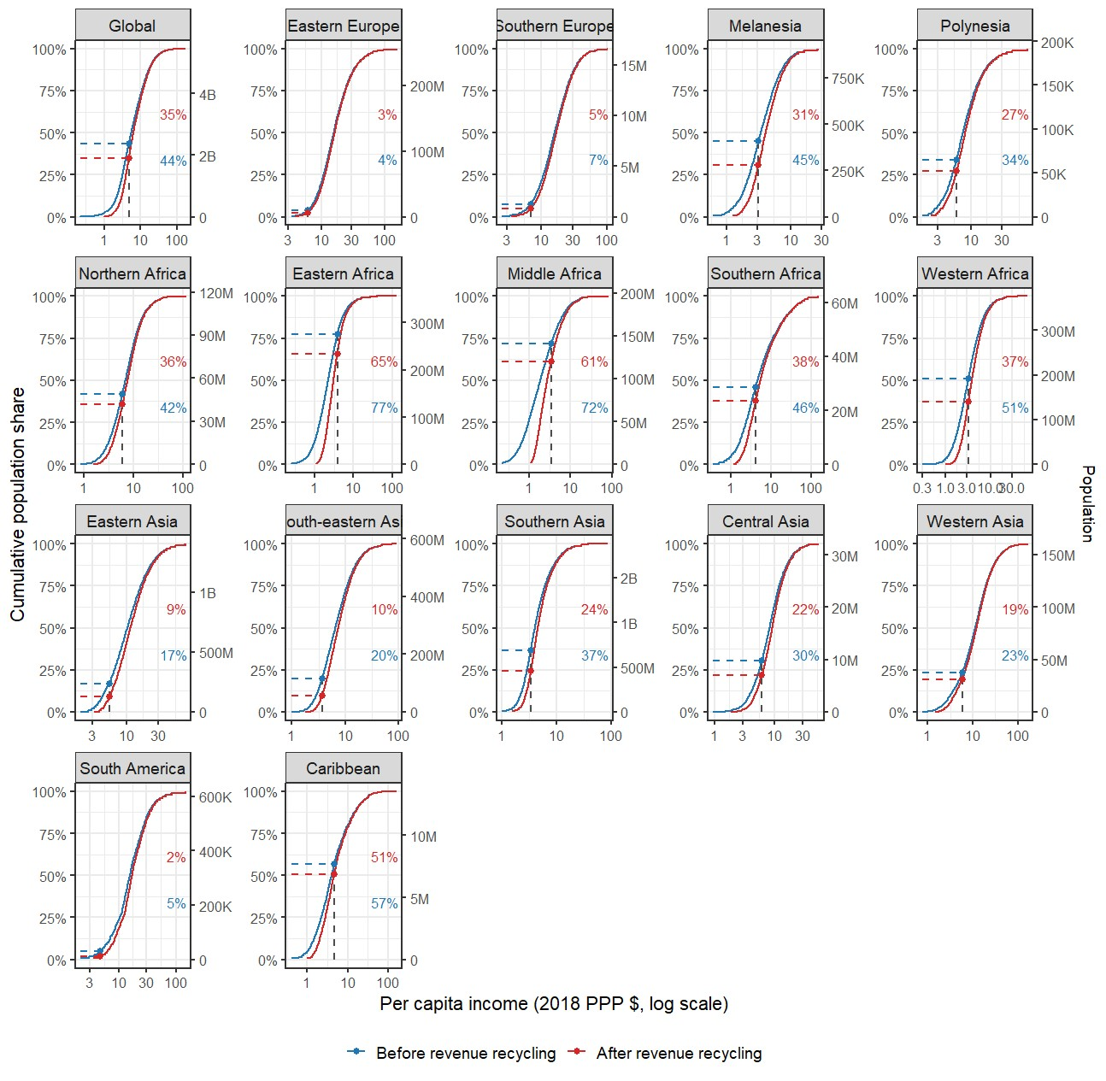

Supplementary Figure 2. Cumulative population income distributions before and after equal per-capita revenue recycling, and the share of the population unable to afford the food-only dietary cost, by world region.
Each panel shows the cumulative distribution function (CDF) of per-capita consumption-based income for a world region under two scenarios: before revenue recycling (blue) and after equal per-capita redistribution of dietary carbon pricing revenues (red). The vertical dashed line indicates the food-only dietary cost threshold for the respective region (2018 PPP $). Horizontal dashed lines and percentage labels indicate the share of the regional population whose income falls below this threshold under each scenario, reflecting the reduction in dietary unaffordability attributable to revenue recycling. Secondary y-axes show absolute population size. Revenue recycling is simulated as an equal per-capita cash transfer financed by the full social cost of diet-related greenhouse gas emissions.

