Extracting biological motif patterns for multiple RNA modifications using direct RNA sequencing

Supplementary Information

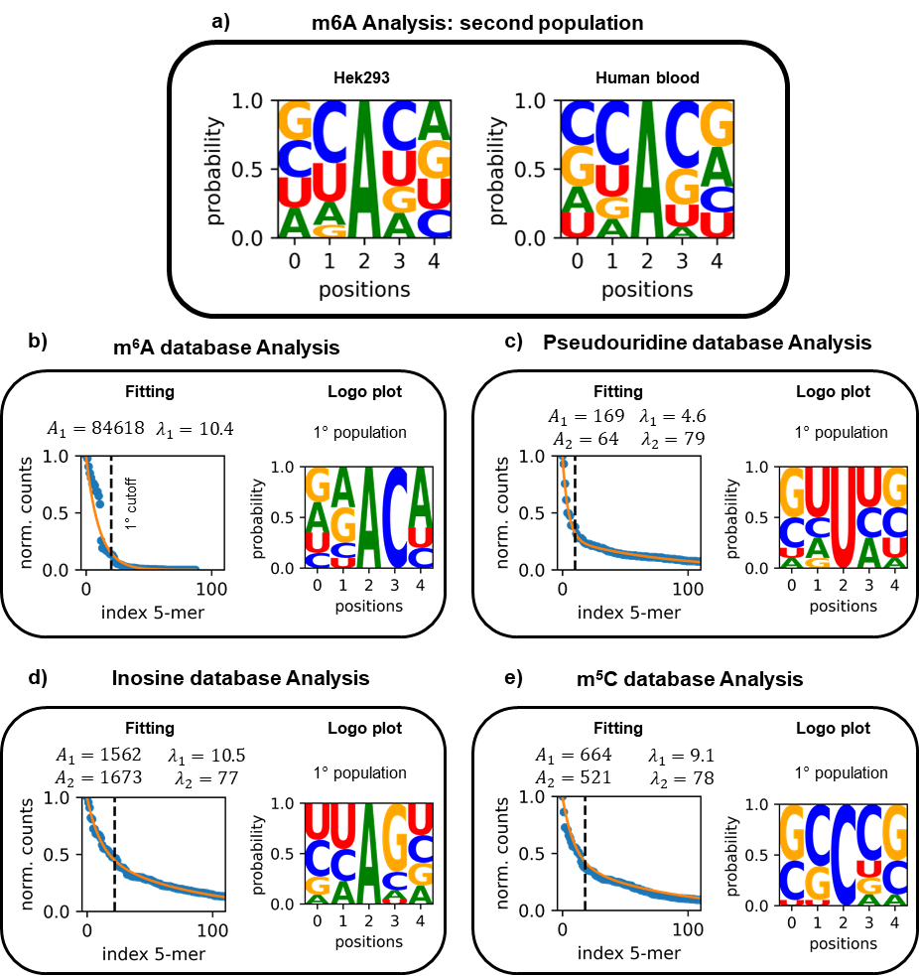
SI 1. Second population and database analysis
SI Figure 1: a) logo plot for the m⁶A second population obtained by the population analysis done on Hek293T and Human blood samples. Fitting and logo plot m⁶A (b), Pseudouridine (c), Inosine (d) and m⁵C (e) obtained using our method on the Atlas and RMbase V3 databases. It is possible to observe that top and bottom logo plots, except for the m⁶A, have similar random patters.
Here, we present the analysis performed on the second m⁶A population—that is, the low-frequency population - in both HEK293T and human blood samples (Supplementary Fig. 1a). This second population displays a markedly more random sequence logo, where DRACH motifs are not well represented.
We also applied our method for the analysis of sites reported in the m⁵C-Atlas, m⁶A-Atlas V2, Ψ-Atlas and RMbase V3 databases^{1–4} to derive a possible 5-mer sequence logos. The analysis revealed that only the m⁶A database could be accurately described by a single exponential fit (SupplementaryI Figure 1b), whereas Ψ, I and m⁵C sites require a double exponential model (SI Figure 1c-e). The logo plot of the first m⁶A population clearly recapitulates canonical DRACH motifs, while the other RNA modification types exhibit largely random sequence patterns (Supplementary Fig. 1c–e), similar to what is observed for the second m⁶A population derived from Dorado sites (Supplementary Fig. 1a). Moreover, the fitted amplitudes (A₁ and A₂) obtained from the double-exponential model show comparable magnitudes (A₁ ≈ A₂; Supplementary Fig. 1c–e), indicating the absence of a clearly dominant population in the signal. These results again highlight the importance of large, high-throughput datasets of validated modification sites for robust statistical analysis.
The database-derived logo plots do not reveal any distinct sequence pattern comparable to the well-defined DRACH motif. However, as discussed in the main text, these logos were generated from relatively small datasets compared to the number of available m⁶A motifs. The observed random patterns resemble those seen for the second, low-frequency m⁶A population, possibly reflecting a limited representation of high-frequency (first-population) modifications in these databases.
Below, we provide the values obtained from the global double-exponential fitting (see Eq. 1 in the Methods section of the main text) performed for each RNA modification type (m⁶A, Ψ, I, and m⁵C) and for each replicate. As described in the main text, the analysis included two HEK293T samples (HEK293T_A and HEK293T_B) and three human blood samples (Blood_A, Blood_B, and Blood_C). The tables report the fitted parameters: the maximum amplitudes (A₁ and A₂), the decay constants (λ₁ and λ₂), and the calculated cutoff index values (see Methods for details).

Table SI 1: Results for global double exponential fit for m6A. For each replica, we report the value for the Maximum amplitudes A1 and A2, the decay index λ1 and λ2 and the calculated cutoff index value obtained from the analysis.

Samples | A₁ | A₂ | λ₁ | λ₂ | Cutoff index
Hek293T_A | 22801 | 3756 | 7.5 | 65.4 | 13
Hek293T_B | 34026 | 5385 | 7.5 | 65.4 | 13
Blood_A | 9000 | 842 | 4.2 | 34 | 8
Blood_B | 22422 | 2555 | 4.2 | 34 | 8
Blood_C | 15238 | 1237 | 4.2 | 34 | 8

Samples | A₁ | A₂ | λ₁ | λ₂ | Cutoff index
Hek293T_A | 14036 | 2524 | 7.2 | 42.2 | 14
Hek293T_B | 20920 | 3730 | 7.2 | 42.2 | 14
Blood_A | 2109 | 678 | 2.6 | 14.6 | 7
Blood_B | 5990 | 1818 | 2.6 | 14.6 | 7
Blood_C | 4381 | 1017 | 2.6 | 14.6 | 7
Table SI 2: Results for double exponential fit for Pseudouridine. For each replica, we report the value for the Maximum amplitudes A1 and A2, the decay index λ1 and λ2 and the calculated cutoff index value obtained from the analysis.

Samples | A₁ | A₂ | λ₁ | λ₂ | Cutoff index
Hek293T_A | 3181 | 421 | 3.1 | 40 | 6
Hek293T_B | 4629 | 621 | 3.1 | 40 | 6
Blood_A | 1033 | 341 | 2.8 | 36.2 | 6
Blood_B | 3030 | 969 | 2.8 | 36.2 | 6
Blood_C | 2258 | 273 | 2.8 | 36.2 | 6
Table SI 3: Results for double exponential fit for Inosine. For each replica, we report the value for the Maximum amplitudes A1 and A2, the decay index λ1 and λ2 and the calculated cutoff index value obtained from the analysis.

Table SI 4: Results for double exponential fit for m5C. For each replica, we report the value for the Maximum amplitudes A1 and A2, the decay index λ1 and λ2 and the calculated cutoff index value obtained from the analysis.

Samples | A₁ | A₂ | λ₁ | λ₂ | Cutoff index
Hek293T_A | 4598 | 1179 | 1.5 | 48 | 4
Hek293T_B | 6990 | 1918 | 1.5 | 48 | 4
Blood_A | 1019 | 669 | 6.2 | 59.4 | 12
Blood_B | 1892 | 1058 | 6.2 | 59.4 | 12
Blood_C | 1060 | 653 | 6.2 | 59.4 | 12

m6A motifs |  | Ψ motifs |  | Inosine motifs |  | m5C motifs
Hek293T | Blood | Hek293T | Blood | Hek293T | Blood | Hek293T | Blood
GGACA  (36461) | GGACU  (25567) | UUUUU  (21504) | CUUUG  (7582) | CAAGG  (4800) | UUAUU  (3673) | GACUG  (8893) | UGCAG  (2968)
GGACU  (35927) | GGACA  (19118) | CUUUG  (21218) | CUUUU  (5741) | GCAUU  (4510) | CUAUU  (3088) | GACAG  (4883) | CGCAG  (2806)
GAACU  (30573) | GAACU  (15097) | CUUUU  (20835) | CUUUA  (3553) | ACAUU  (3841) | CAAGG  (2448) | GACUU  (2529) | CGCGG  (2791)
AGACU  (27810) | AGACU  (15054) | CCUUU  (20745) | CUUUC  (2874) | UUAUU  (1841) | ACAUU  (2101) | GACUC  (2475) | GACUG  (2510)
GGACC  (26179) | GGACC  (12577) | CCUUC  (17578) | UUUUU  (2478) | CUAUU  (1830) | GCAUU  (1924) | - | GGCGG  (2235)
AAACU  (22534) | UGACU  (10800) | UUUUG  (13956) | UUUUG  (1457) | GCAGC  (1209) | GUAUU  (1391) | - | CACGG  (1942)
UGACU  (22041) | GGACU  (7706) | UUUUA  (13876) | UUUUA  (1254) | - | - | - | GGCAG  (1890)
GAACA  (20545) | AGACA  (5677) | CUUUA  (12880) | - | - | - | - | AACUG  (1654)
AGACA  (16505) | - | CUUUC  (11250) | - | - | - | - | CACAG  (1583)
AAACA  (11744) | - | UUUUC  (8458) | - | - | - | - | UGCGG  (1540)
GGACG  (11581) | - | CCUUG  (7106) | - | - | - | - | GACAG  (1386)
UGACA  (9693) | - | CUUGC  (5855) | - | - | - | - | CACCG  (1290)
AGACC  (8601) | - | CCUUA  (5712) | - | - | - | - | -
- | - | CAUUG  (5661) | - | - | - | - | -
Table SI 5: 5-mer sequences extracted from the cutoff index obtained from the population analysis. The table shows the motifs that occur with high frequency (first population) for each RNA modification type (m6A, pseudouridine, Inosine and m6C) and for the samples (Hek293T and human blood) here studied. The 5-mer motifs are sorted by count detection, where the value of detect sites from Dorado+Modkit for each 5-mer is indicated below in bracket.

References
1. Xuan, J. et al. RMBase v3.0: decode the landscape, mechanisms and functions of RNA modifications. Nucleic Acids Res. 52, D273–D284 (2024).
2. Liang, Z. et al. m6A-Atlas v2.0: updated resources for unraveling the N6-methyladenosine (m6A) epitranscriptome among multiple species. Nucleic Acids Res. 52, D194–D202 (2024).
3. Wang, X. et al. Ψ-Atlas: an integrated atlas for pseudouridine epitranscriptome. 2025.06.06.656536 Preprint at https://doi.org/10.1101/2025.06.06.656536 (2025).
4. Ma, J. et al. m5C-Atlas: a comprehensive database for decoding and annotating the 5-methylcytosine (m5C) epitranscriptome. Nucleic Acids Res. 50, D196–D203 (2022).

