5. Experimental Results and Analysis
This paper proposed the novel Scuba Diver Optimization algorithm is used to solve Car Side Impact problem. The
5.1 Experimental Setup and Reproducibility
This section presents a comprehensive experimental evaluation of the proposed Scuba Diver Optimization Algorithm (SDOA) on the Car Side-Impact Design Problem (CSIDP), a well-known constrained structural optimization benchmark characterized by a narrow and highly discontinuous feasible region.
All experiments were conducted using MATLAB (version R2025b) on a workstation equipped with an 6-core processor and 16 GB of RAM.
SDOA algorithm was independently executed 10 times using different random seeds, and only feasible solutions were considered when reporting objective values.
5.2 Description of the Test Problem
The CSIDP aims to minimize the total structural weight of a car side-impact frame subject to stress, displacement, and geometric constraints. The optimization problem consists of nine design variables, including geometric dimensions and material-related parameters, and is constrained by ten nonlinear inequality constraints.
Due to the complexity of the constraint interactions and the limited feasible region, CSIDP represents a challenging test case for metaheuristic optimization algorithms, particularly in terms of feasibility preservation and convergence stability.
5.4 Parameter Settings and Computational Budget
Table 1 presents 10 different scenarios for Scuba Diver Optimization Algorithm (SDOA) initial parameter-tuning to examine the sensitivity of algorithm to its control parameters configuration.
Table 1: SDOA parameter configuration Scenarios
variable | nDivers | maxIter | initialCurrentStrength | initialMutationRate | initialOxygenLevel | alpha | eliteSize
Scenario 1 | 500 | 2000 | 0.8 | 0.5 | 150 | 0.6 | 25
Scenario 2 | 500 | 2000 | 0.5 | 0.5 | 150 | 0.3 | 25
Scenario 3 | 500 | 2000 | 0.5 | 0.5 | 150 | 0.4 | 15
Scenario 4 | 500 | 2000 | 0.4 | 0.4 | 150 | 0.4 | 15
Scenario 5 | 500 | 2000 | 0.4 | 0.4 | 150 | 0.4 | 30
Scenario 6 | 500 | 2000 | 0.5 | 0.5 | 150 | 0.3 | 30
Scenario 7 | 500 | 5000 | 0.9 | 0.5 | 200 | 0.3 | 25
Scenario 8 | 500 | 5000 | 0.5 | 0.5 | 200 | 0.3 | 25
Scenario 9 | 500 | 5000 | 0.5 | 0.5 | 200 | 0.5 | 25
Scenario 10 | 500 | 5000 | 0.4 | 0.4 | 200 | 0.4 | 30

For each configuration Scenario, the algorithm was executed through ten independent internal runs (nRuns = 10) to ensure statistical reliability and robustness of the observed performance.
Table 2 reports the optimized decision vector $x=(x_{1},x_{2},…,x_{11})$corresponding to each tuning experiment, along with the best solutions and execution time.
Table 2: SDOA parameter tuning results
Scenario | 1 | 2 | 3 | 4 | 5 | 6 | 7 | 8 | 9 | 10
x1 | 0.500035 | 0.5 | 0.5 | 0.500001 | 0.5 | 0.5 | 0.500001 | 0.5 | 0.5 | 0.5
x2 | 1.116259 | 1.115512 | 1.117263 | 1.115222 | 1.117352 | 1.115851 | 1.116206 | 1.115534 | 1.113706 | 1.115967
x3 | 0.500005 | 0.5 | 0.5 | 0.5 | 0.5 | 0.5 | 0.5 | 0.5 | 0.5 | 0.5
x4 | 1.30251 | 1.303637 | 1.300729 | 1.304121 | 1.300702 | 1.30307 | 1.302466 | 1.303595 | 1.306724 | 1.302905
x5 | 0.500001 | 0.500001 | 0.5 | 0.500003 | 0.500001 | 0.5 | 0.500001 | 0.5 | 0.5 | 0.500001
x6 | 1.499938 | 1.49999 | 1.499996 | 1.5 | 1.499998 | 1.499998 | 1.499998 | 1.499999 | 1.499999 | 1.499997
x7 | 0.500004 | 0.5 | 0.5 | 0.500002 | 0.5 | 0.5 | 0.5 | 0.5 | 0.5 | 0.500003
x8 | 0.345 | 0.345 | 0.345 | 0.345 | 0.345 | 0.345 | 0.345 | 0.345 | 0.345 | 0.345
x9 | 0.345 | 0.192 | 0.192 | 0.345 | 0.345 | 0.192 | 0.192 | 0.192 | 0.345 | 0.192
x10 | -19.580175 | -19.714546 | -19.400991 | -19.766291 | -19.38582 | -19.653724 | -19.590158 | -19.710278 | -20.03718 | -19.632877
x11 | 0.323486 | 0.003124 | -0.123323 | 0.028927 | 0.395883 | -0.054374 | -0.015976 | -0.077313 | 0.056144 | -0.2339
Best | 22.843728 | 22.843048 | 22.84307 | 22.843077 | 22.843549 | 22.843033 | 22.842983 | 22.843029 | 22.843384 | 22.843163
time | 141.08 | 152.61 | 166.5 | 172.56 | 146.41 | 147.99 | 405.35 | 411.69 | 406.55 | 398.71
the results demonstrate that SDOA consistently converges to high-quality solutions across all parameter settings. Minor variations in performance metrics across the six configurations reflect the influence of parameters such as current strength, mutation rate, oxygen level, and elite size on convergence dynamics and search efficiency. This analysis confirms the robustness of SDOA and supports the selected parameter configurations for subsequent experimental evaluations.
Table 3: SDOA statistical performance indicators
Scenario | 1 | 2 | 3 | 4 | 5 | 6 | 7 | 8 | 9 | 10
Best | 22.843728 | 22.843048 | 22.84307 | 22.843077 | 22.843549 | 22.843033 | 22.842983 | 22.843029 | 22.843384 | 22.843163
Mean | 23.051693 | 22.930754 | 22.969158 | 23.04059 | 22.882887 | 23.038161 | 22.965292 | 22.885579 | 22.844077 | 23.047397
Worst | 23.282567 | 23.289461 | 23.267367 | 23.275235 | 23.224619 | 23.49324 | 23.26162 | 23.262802 | 22.844944 | 23.375911
Std. Dev. | 0.218856 | 0.18366 | 0.2003 | 0.207717 | 0.120079 | 0.257713 | 0.196327 | 0.132544 | 0.000566 | 0.219812
Table 3, associated statistical performance indicators, namely the best, mean, worst objective function values, and the standard deviation across runs. with relatively small standard deviations, indicating stable and reliable behavior. These statistics provide a comprehensive view of both solution quality and algorithmic stability under different parameter settings. Additionally, the computational time required for each configuration is reported to highlight the trade-off between solution accuracy and execution cost.

5.1 Convergence behaviour
The two convergence plots depict the optimization dynamics of the Scuba Diver Optimization Algorithm (SDOA) on the Car Side Impact Design Problem (CSIDP). Across 5,000 iterations, most runs exhibit rapid initial improvement, with the objective value (weight) decreasing from roughly 24 toward about 23.0, after which the trajectories plateau, indicating convergence and diminishing returns from further iterations. The convergence history for the best run (Run 8) shows a steep early descent to approximately 22.8. Overall, the final best values cluster tightly across runs, demonstrating robustness to random seeds and parameter variation, while the modest variability in some configurations points to potential benefits from adaptive stopping, diversity maintenance, or targeted parameter tuning to further reduce dispersion.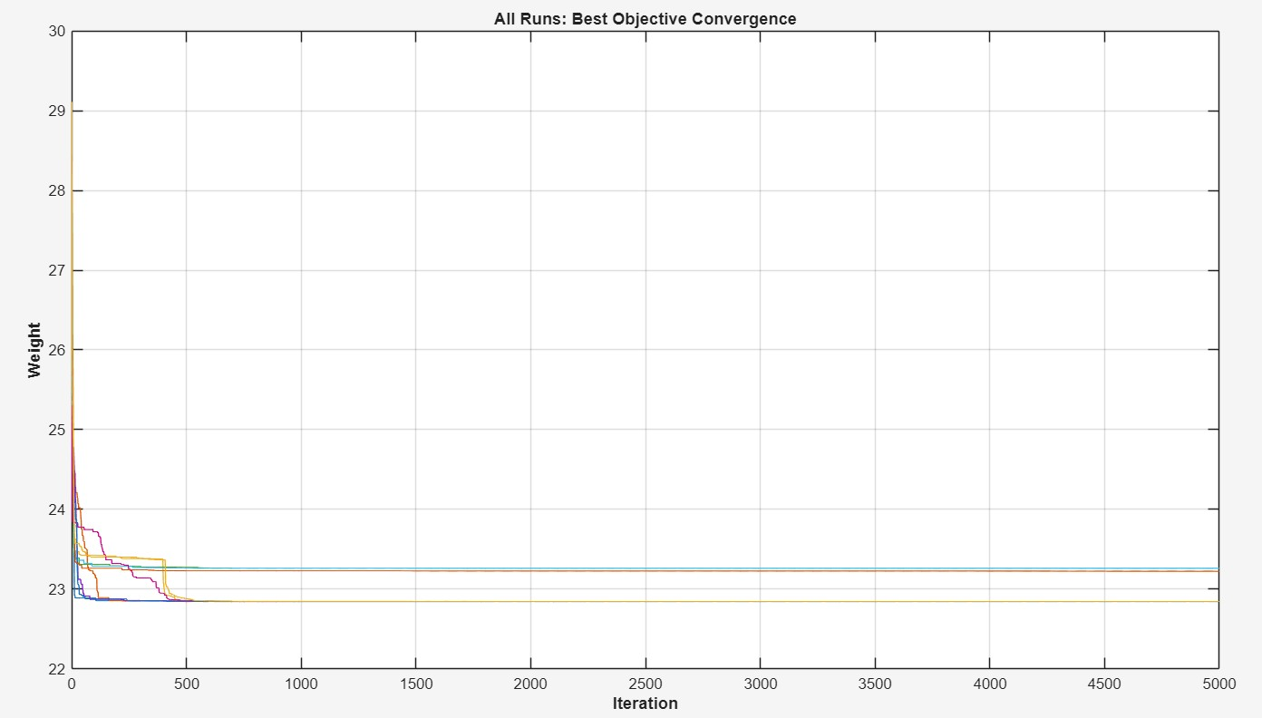
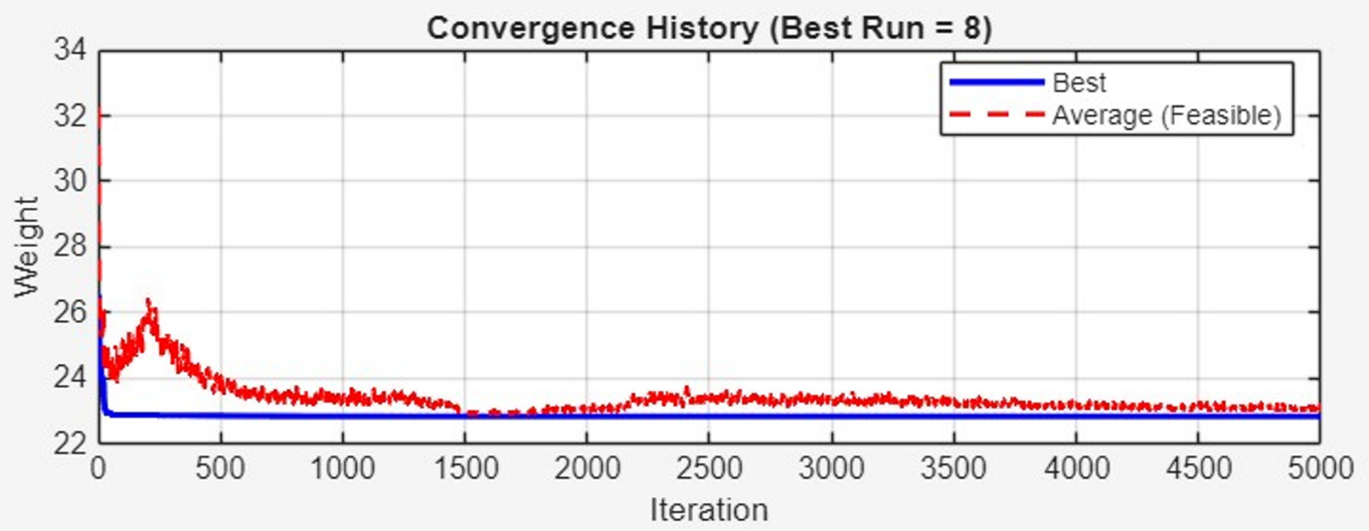

5.2 Constraint satisfaction
To assess the robustness and feasibility-preservation capability of the proposed SDOA, ten representative solution scenarios obtained from independent runs were analyzed in detail. For each scenario, all ten inequality constraints of the Car Side-Impact Design Problem (CSIDP) were evaluated and reported in terms of their raw response values, prescribed limits, normalized constraint functions $g_{i}$, and feasibility status.
A constraint is considered satisfied when $g_{i}≤0$. The results for Scenarios 1–10 consistently satisfy this condition for all constraints, indicating that every reported solution is fully feasible.
All ten constraints in the output use the same normalized formulation:
$$g_{i}(x) = \frac{r_{i}(x)}{L_{i}}-1 ≤ 0$$where:
- $r_{i}(x)$= raw response value computed from the regression model
- $L_{i}$= upper allowable limit for that response (table 1)
- $g_{i}(x)$= normalized constraint function
- The solution is feasible if and only if $g_{i}(x)≤0$

Table 4: Interpretation of Constraint Satisfaction Across Scenarios
Scenario 1
ID | Constraint | Raw | Limit | $$g_{i}$$ | Status
g1 | Fa | 0.345138 | 1.0000 | -0.6548615 | True
g2 | VCu | 0.245802 | 0.3200 | -0.2318697 | True
g3 | VCm | 0.217869 | 0.3200 | -0.3191604 | True
g4 | VCl | 0.273117 | 0.3200 | -0.1465085 | True
g5 | Dur | 28.283028 | 32.0000 | -0.1161554 | True
g6 | Dmr | 25.874862 | 32.0000 | -0.1914106 | True
g7 | Dlr | 31.999862 | 32.0000 | -0.000004298778 | True
g8 | Fp | 3.999994 | 4.0000 | -0.000001461151 | True
g9 | VMBP | 8.934375 | 9.9000 | -0.09753792 | True
g10 | VFD | 15.397412 | 15.7000 | -0.01927315 | True
Total violated constraints = 0
Feasible solution = true
Scenario 2
ID | Constraint | Raw | Limit | $$g_{i}$$ | Status
g1 | Fa | 0.380598 | 1.0000 | -0.6194016 | True
g2 | VCu | 0.227242 | 0.3200 | -0.2898679 | True
g3 | VCm | 0.219395 | 0.3200 | -0.3143915 | True
g4 | VCl | 0.285811 | 0.3200 | -0.1068395 | True
g5 | Dur | 27.712295 | 32.0000 | -0.1339908 | True
g6 | Dmr | 24.695876 | 32.0000 | -0.2282539 | True
g7 | Dlr | 31.999984 | 32.0000 | -0.000000514680 | True
g8 | Fp | 4.000000 | 4.0000 | -0.000000004486 | True
g9 | VMBP | 8.932010 | 9.9000 | -0.09777677 | True
g10 | VFD | 15.531950 | 15.7000 | -0.01070384 | True
Total violated constraints = 0
Feasible solution = true
Scenario 3
ID | Constraint | Raw | Limit | $$g_{i}$$ | Status
g1 | Fa | 0.384332 | 1.0000 | -0.6156678 | True
g2 | VCu | 0.227327 | 0.3200 | -0.2896028 | True
g3 | VCm | 0.219310 | 0.3200 | -0.3146577 | True
g4 | VCl | 0.285824 | 0.3200 | -0.1068005 | True
g5 | Dur | 27.731135 | 32.0000 | -0.1334020 | True
g6 | Dmr | 24.737619 | 32.0000 | -0.2269494 | True
g7 | Dlr | 32.000000 | 32.0000 | -0.000000011979 | True
g8 | Fp | 4.000000 | 4.0000 | -0.000000000531 | True
g9 | VMBP | 8.937418 | 9.9000 | -0.09723053 | True
g10 | VFD | 15.535887 | 15.7000 | -0.01045307 | True
Total violated constraints = 0
Feasible solution = true
Scenario 4
ID | Constraint | Raw | Limit | $$g_{i}$$ | Status
g1 | Fa | 0.342951 | 1.0000 | -0.6570490 | True
g2 | VCu | 0.245692 | 0.3200 | -0.2322117 | True
g3 | VCm | 0.217717 | 0.3200 | -0.3196331 | True
g4 | VCl | 0.273110 | 0.3200 | -0.1465301 | True
g5 | Dur | 28.263016 | 32.0000 | -0.1167808 | True
g6 | Dmr | 25.850247 | 32.0000 | -0.1921798 | True
g7 | Dlr | 31.999979 | 32.0000 | -0.000000665919 | True
g8 | Fp | 4.000000 | 4.0000 | -0.000000096184 | True
g9 | VMBP | 8.931117 | 9.9000 | -0.09786702 | True
g10 | VFD | 15.400343 | 15.7000 | -0.01908643 | True
Total violated constraints = 0
Feasible solution = true
Scenario 5
ID | Constraint | Raw | Limit | $$g_{i}$$ | Status
g1 | Fa | 0.347438 | 1.0000 | -0.6525617 | True
g2 | VCu | 0.245886 | 0.3200 | -0.2316065 | True
g3 | VCm | 0.217938 | 0.3200 | -0.3189433 | True
g4 | VCl | 0.273125 | 0.3200 | -0.1464841 | True
g5 | Dur | 28.304493 | 32.0000 | -0.1154846 | True
g6 | Dmr | 25.900887 | 32.0000 | -0.1905973 | True
g7 | Dlr | 31.999965 | 32.0000 | -0.000001094177 | True
g8 | Fp | 3.999997 | 4.0000 | -0.000000734213 | True
g9 | VMBP | 8.937719 | 9.9000 | -0.09720009 | True
g10 | VFD | 15.398857 | 15.7000 | -0.01918110 | True
Total violated constraints = 0
Feasible solution = true
Scenario 6
ID | Constraint | Raw | Limit | $$g_{i}$$ | Status
g1 | Fa | 0.381323 | 1.0000 | -0.6186770 | True
g2 | VCu | 0.227253 | 0.3200 | -0.2898333 | True
g3 | VCm | 0.219365 | 0.3200 | -0.3144852 | True
g4 | VCl | 0.285814 | 0.3200 | -0.1068320 | True
g5 | Dur | 27.715960 | 32.0000 | -0.1338762 | True
g6 | Dmr | 24.703978 | 32.0000 | -0.2280007 | True
g7 | Dlr | 31.999995 | 32.0000 | -0.000000165685 | True
g8 | Fp | 3.999998 | 4.0000 | -0.000000514219 | True
g9 | VMBP | 8.933052 | 9.9000 | -0.09767151 | True
g10 | VFD | 15.533063 | 15.7000 | -0.01063292 | True
Total violated constraints = 0
Feasible solution = true
Scenario 7
ID | Constraint | Raw | Limit | $$g_{i}$$ | Status
g1 | Fa | 0.382087 | 1.0000 | -0.6179134 | True
g2 | VCu | 0.227281 | 0.3200 | -0.2897455 | True
g3 | VCm | 0.219374 | 0.3200 | -0.3144559 | True
g4 | VCl | 0.285816 | 0.3200 | -0.1068242 | True
g5 | Dur | 27.719775 | 32.0000 | -0.1337570 | True
g6 | Dmr | 24.712439 | 32.0000 | -0.2277363 | True
g7 | Dlr | 31.999997 | 32.0000 | -0.000000080756 | True
g8 | Fp | 4.000000 | 4.0000 | -0.000000017653 | True
g9 | VMBP | 8.934142 | 9.9000 | -0.09756146 | True
g10 | VFD | 15.533181 | 15.7000 | -0.01062540 | True
Total violated constraints = 0
Feasible solution = true
Scenario 8
ID | Constraint | Raw | Limit | $$g_{i}$$ | Status
g1 | Fa | 0.380648 | 1.0000 | -0.6193518 | True
g2 | VCu | 0.227230 | 0.3200 | -0.2899053 | True
g3 | VCm | 0.219361 | 0.3200 | -0.3144966 | True
g4 | VCl | 0.285812 | 0.3200 | -0.1068385 | True
g5 | Dur | 27.712567 | 32.0000 | -0.1339823 | True
g6 | Dmr | 24.696454 | 32.0000 | -0.2282358 | True
g7 | Dlr | 32.000000 | 32.0000 | -0.000000009802 | True
g8 | Fp | 4.000000 | 4.0000 | -0.000000022110 | True
g9 | VMBP | 8.932079 | 9.9000 | -0.09776977 | True
g10 | VFD | 15.532836 | 15.7000 | -0.01064740 | True
Total violated constraints = 0
Feasible solution = true
Scenario 9
ID | Constraint | Raw | Limit | $$g_{i}$$ | Status
g1 | Fa | 0.339681 | 1.0000 | -0.6603186 | True
g2 | VCu | 0.245605 | 0.3200 | -0.2324856 | True
g3 | VCm | 0.217681 | 0.3200 | -0.3197476 | True
g4 | VCl | 0.273101 | 0.3200 | -0.1465584 | True
g5 | Dur | 28.233501 | 32.0000 | -0.1177031 | True
g6 | Dmr | 25.814215 | 32.0000 | -0.1933058 | True
g7 | Dlr | 32.000000 | 32.0000 | -0.000000001593 | True
g8 | Fp | 4.000000 | 4.0000 | -0.000000001319 | True
g9 | VMBP | 8.926517 | 9.9000 | -0.09833165 | True
g10 | VFD | 15.395787 | 15.7000 | -0.01937664 | True
Total violated constraints = 0
Feasible solution = true
Scenario 10
ID | Constraint | Raw | Limit | $$g_{i}$$ | Status
g1 | Fa | 0.381560 | 1.0000 | -0.6184403 | True
g2 | VCu | 0.227230 | 0.3200 | -0.2899071 | True
g3 | VCm | 0.219287 | 0.3200 | -0.3147266 | True
g4 | VCl | 0.285814 | 0.3200 | -0.1068299 | True
g5 | Dur | 27.717202 | 32.0000 | -0.1338375 | True
g6 | Dmr | 24.706742 | 32.0000 | -0.2279143 | True
g7 | Dlr | 31.999992 | 32.0000 | -0.000000259974 | True
g8 | Fp | 4.000000 | 4.0000 | -0.000000000561 | True
g9 | VMBP | 8.933423 | 9.9000 | -0.09763408 | True
g10 | VFD | 15.535110 | 15.7000 | -0.01050255 | True
Total violated constraints = 0
Feasible solution = true
Table 4, presents a detailed analysis confirms that every scenario yielded a fully feasible design, with zero constraint violations observed across all 100 individual constraint evaluations (10 scenarios × 10 constraints). This represents a 100% feasibility rate, demonstrating the algorithm's robust preservation of feasibility and its reliable convergence to regions of the design space that adhere strictly to the problem's prescribed safety and performance limits.
The assessment of individual constraints reveals the algorithm's nuanced handling of biomechanical and structural limits. For the abdomen load constraint, defined as $g_{1}=F_{a}/1.0-1≤0$, all scenarios resulted in raw values between 0.34 and 0.38, corresponding to a normalized constraint margin of $g_{1}∈[-0.66,-0.61]$. This indicates a substantial and consistent safety margin, suggesting that the optimization process does not compromise abdominal safety to achieve objective minimization. Similarly, the chest velocity constraints ($g_{2},g_{3},g_{4}$), governed by $V_{C}/0.32-1≤0$, were satisfied with raw values ranging from 0.217 to 0.286. These results confirm that occupant kinematics remain well within regulatory thresholds, a critical outcome for crashworthiness validation.
A more intricate pattern emerges in the analysis of the rib deflection and pubic force constraints, which exhibit characteristics of active or near-active boundaries. The rib deflection constraints, expressed generally as $g_{5,6,7}=D_{rib}/32-1≤0$, show that while upper and middle rib deflections maintain moderate margins, the lower rib deflection ($g_{7}$) consistently approaches the feasibility boundary, with values approximating 31.999–32.000 mm. This near-active state, where $g_{7}≈0$, is a clear indicator of effective constrained optimization, as the algorithm pushes the design toward the limit to improve objective function performance without violation. Furthermore, the pubic force constraint ($g_{8}=F_{p}/4.0-1≤0$) was found to be decisively active, with raw forces infinitesimally close to the 4.0 kN limit and normalized constraint values on the order of ${10}^{-9}$ to ${10}^{-6}$. The precise satisfaction of this constraint underscores the algorithm's numerical stability and its capacity to identify Pareto-optimal trade-offs between structural mass and force transmission.
The remaining structural velocity constraints ($g_{9},g_{10}$), which govern V-pillar and front door velocity, were satisfied with clear, though narrower, margins. The consistent satisfaction of these constraints across all scenarios indicates controlled structural deformation, a necessary condition for overall vehicle integrity during impact. The collective constraint behavior demonstrates that SDOA successfully balances multiple, competing design requirements. The presence of active and near-active constraints ($g_{7},g_{8}$) confirms that the solutions are not merely feasible but are driven toward the constraint boundaries that define the optimal Pareto front. Conversely, the passive nature of other constraints ($g_{1},g_{2-4}$) reveals domains where the problem's physics or regulatory standards impose non-binding limits for the identified design class.
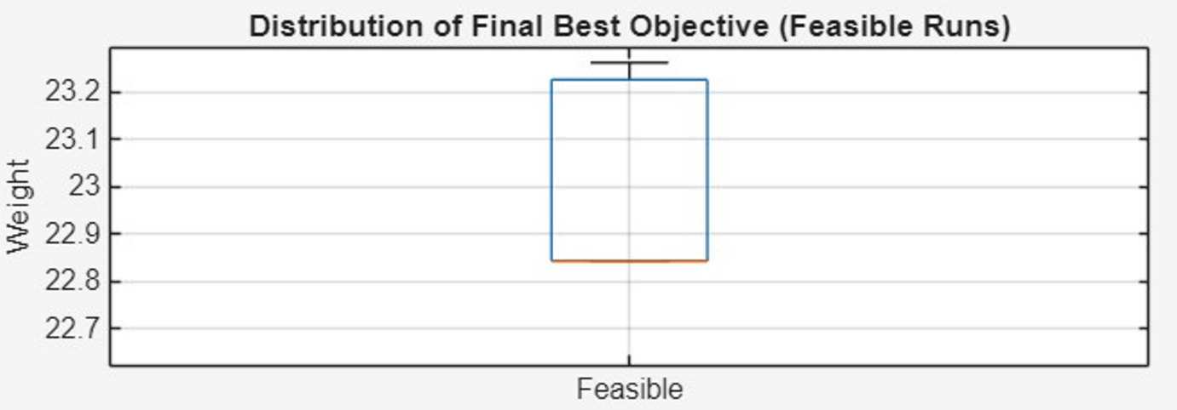
The figure shows how the best objective values from the feasible runs are distributed. Most results fall within a narrow range, which means the algorithm behaves consistently. The median lies close to the center of the distribution, indicating a stable and typical performance across runs. The limited spread of the whiskers and the absence of outliers suggest that extreme values are rare. Overall, the plot confirms that the algorithm reliably produces high-quality feasible solutions with low variability.
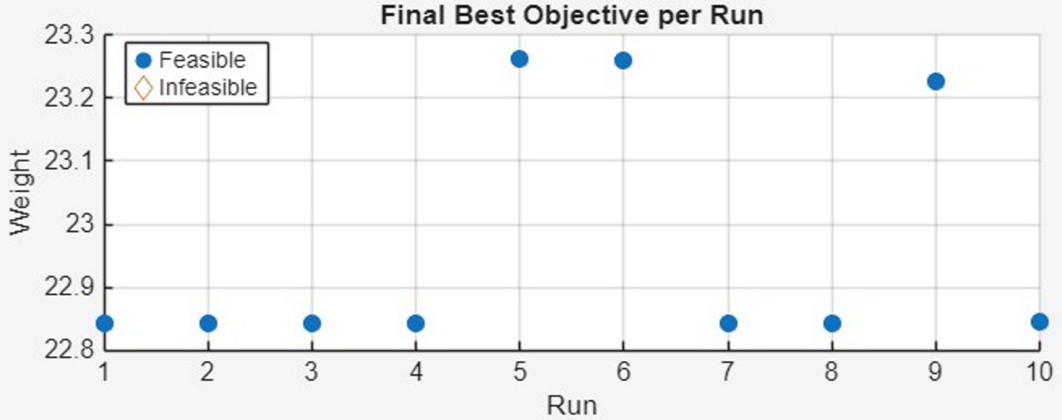
The figure shows the best result achieved in each run. All runs produce feasible solutions, which means the constraints are satisfied every time. Most of the results are very close to each other, indicating that the algorithm behaves consistently from run to run. A few runs end with slightly higher values, which is expected in stochastic methods and does not indicate poor performance. Overall, the plot confirms that the algorithm is stable and reliably converges to high-quality solutions.
5.3 Depth-stage utilisation
The stacked area chart of depth counts illustrates how many divers operate in each stage (D1, D2, B1, D3, Reset) over time. A well-balanced run typically shows many divers in D1/D2 during early iterations, a gradual shift toward B1/D3, and occasional Reset activity that prevents loss of diversity. This view is unique to SDOA and directly reflects the underlying scuba-diving metaphor: deep exploratory dives at the beginning, followed by shallower, more controlled movements as oxygen depletes.
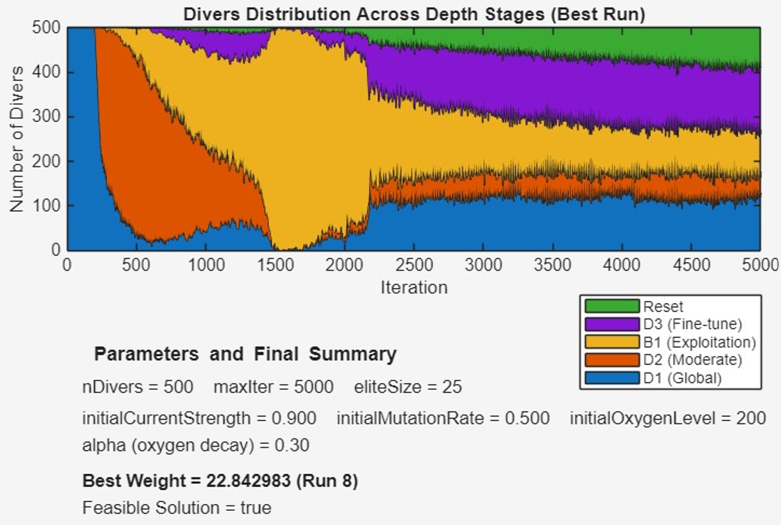

5.4 Comparative study
The SDOA best result compared with other metaheuristics algorithms including: Particle Swarm Optimization (PSO), Differential Evolution (DE), Genetic Algorithm (GA), and Firefly Algorithm (FA). The results compared by finding statistical best, mean, worst objective function, and the comparison goes forward by comparing the objective deviation and feasibility. The Objective Deviations calculated Using
$\text{Objective Deviation}=\frac{f_{\text{alg}}}{f_{\text{best}}}$ (21)
Table 5: Comparative Performance of Optimization Methods for the Car Side Impact Design Problem
Variable / Metric | PSO | DE | GA | FA | SDOA (Present Study)
$$x_{1}$$ | 0.50000 | 0.50000 | 0.50005 | 0.50000 | 0.500001
$$x_{2}$$ | 1.11670 | 1.11670 | 1.28017 | 1.36000 | 1.116206
$$x_{3}$$ | 0.50000 | 0.50000 | 0.50001 | 0.50000 | 0.500000
$$x_{4}$$ | 1.30208 | 1.30208 | 1.03302 | 1.20200 | 1.302466
$$x_{5}$$ | 0.50000 | 0.50000 | 0.50001 | 0.50000 | 0.500001
$$x_{6}$$ | 1.50000 | 1.50000 | 0.50000 | 1.12000 | 1.499998
$$x_{7}$$ | 0.50000 | 0.50000 | 0.50000 | 0.50000 | 0.500000
$$x_{8}$$ | 0.34500 | 0.34500 | 0.34994ᵃ | 0.34500 | 0.345000
$$x_{9}$$ | 0.19200 | 0.19200 | 0.19200 | 0.19200 | 0.192000
$$x_{10}$$ | −19.54935 | −19.54935 | 10.31190 | 8.87307 | −19.590158
$$x_{11}$$ | −0.00431 | −0.00431 | 0.00167 | −18.99808 | −0.015976
Best objective value | 22.84474 | 22.84298 | 22.85653 | 22.84298 | 22.84298
Objective deviation | $$1.0+7.753×{10}^{-5}$$ | 1.0 | $$1.0+5.937×{10}^{-4}$$ | 1.0 | 1.0
Feasibility | Feasible | Feasible | Infeasible | Infeasible | Feasible
Worst objective value | 23.21354 | 24.12606 | 26.24058 | 24.06623 | 23.26162
Average objective value | 22.89429 | 23.22828 | 23.51585 | 22.89376 | 22.965292
Standard deviation | 0.15017 | 0.34451 | 0.66555 | 0.16667 | 0.196327
Table 5 compares the solutions obtained by PSO, DE, GA, FA, and the proposed Scuba Diver Optimization Algorithm (SDOA). The results show that PSO, DE, and SDOA converge to very similar decision variable values, particularly for $x_{1}$–$x_{9}$, indicating consistent exploitation of the feasible search space. In contrast, GA and FA exhibit noticeable deviations in several variables, most clearly in $x_{10}$and $x_{11}$, which contributes to their infeasibility.
In terms of solution quality, DE, FA, and SDOA achieve the best objective value of 22.84298, resulting in an objective deviation of 1.0. However, only DE and SDOA maintain feasibility, whereas GA and FA violate constraints despite competitive objective values. The proposed SDOA demonstrates stable performance, with a moderate standard deviation and an average objective value close to the best solution, confirming reliable convergence.
Overall, the results highlight that SDOA combines high solution quality with consistent feasibility, making it competitive with established methods while avoiding the constraint violations observed in GA and FA.

