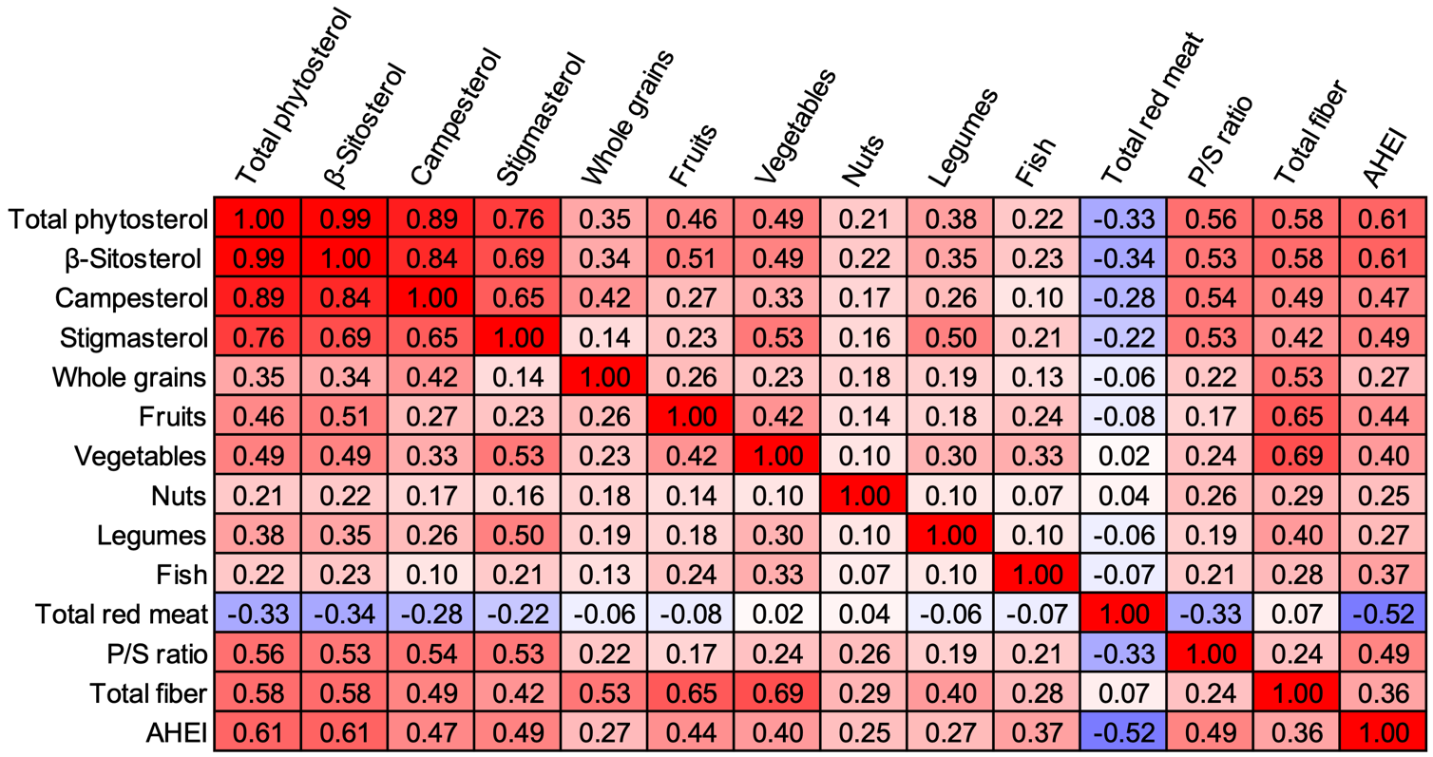

Figure S1. Pearson correlation between phytosterol intake and various foods and nutrients. P/S ratio, ratio of polyunsaturated to saturated fat intake; AHEI, Alternate Healthy Eating Index.

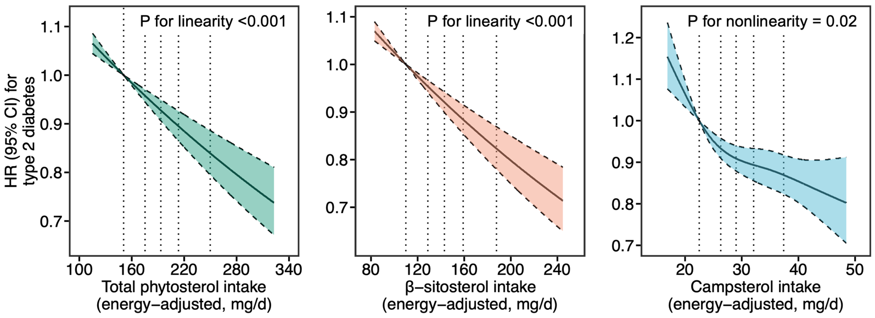

Figure S2. Dose response relationship between phytosterol intake and T2D risk. The reference levels were set to the median intake values of the first quintile. The vertical dotted lines indicate median values of each quintile. The solid line indicates HRs, and the dashed lines depict 95% CI. Data from three cohorts were pooled. Results were stratified by cohort, age, and calendar year, and multivariable-adjusted models were further adjusted for body mass index, race, family history of diabetes, menopausal status and postmenopausal hormone use (NHS and NHS2 only), multivitamin use, smoking status, alcohol drinking, physical activity, baseline history of hypertension, baseline history of hypercholesterolemia, intakes of total energy and trans fat, ratio of polyunsaturated to saturated fat intake, and glycemic load.

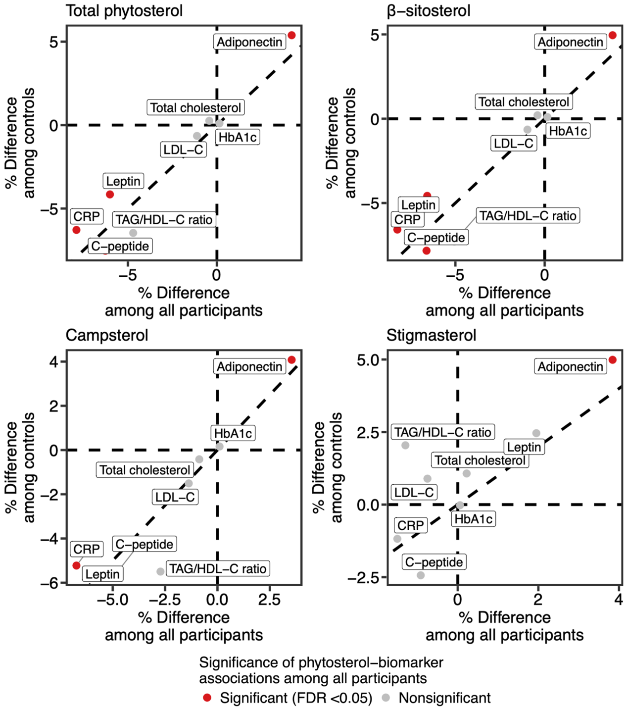

Figure S3. Sensitivity analysis of association between phytosterol intake and plasma metabolic biomarkers among controls. Results were adjusted for age at blood draw, sex, fasting status, body mass index, race, menopausal status and postmenopausal hormone use (NHS and NHS2 only), multivitamin use, smoking status, alcohol drinking, physical activity, baseline history of hypertension, baseline history of hypercholesterolemia, intakes of total energy and trans fat, ratio of polyunsaturated to saturated fat intake, and glycemic load.

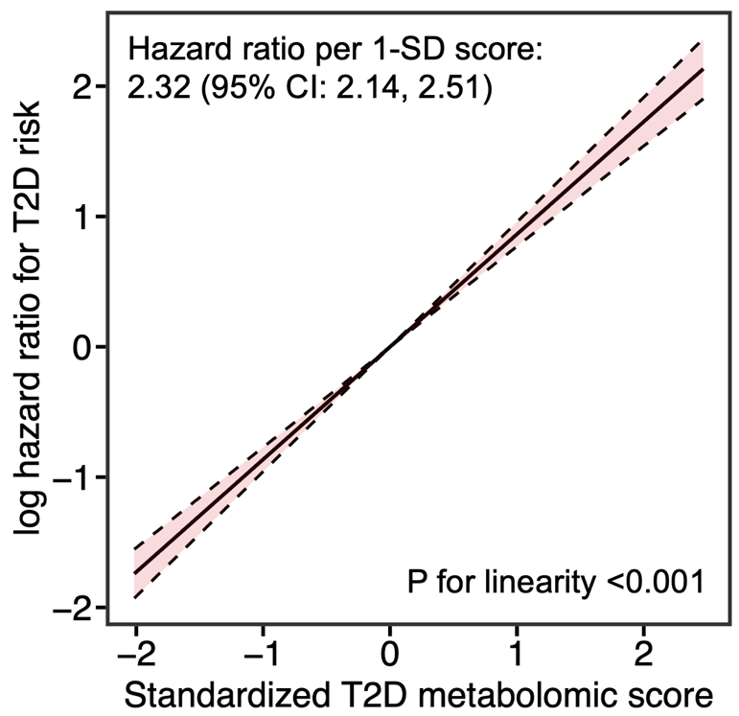

Figure S4. Association between the metabolomics score and risk of type 2 diabetes. The solid line indicates log hazard ratios estimated by multivariable-adjusted Cox regression, and the dashed lines depict 95% CI. Results were stratified by case-control status, endpoint for the original case-control substudies, and cohort, and were adjusted for age at blood draw, fasting status, body mass index, race, menopausal status and postmenopausal hormone use (NHS and NHS2 only), multivitamin use, smoking status, alcohol drinking, physical activity, baseline history of hypertension, baseline history of hypercholesterolemia, intakes of total energy, and Alternate Healthy Eating Index.

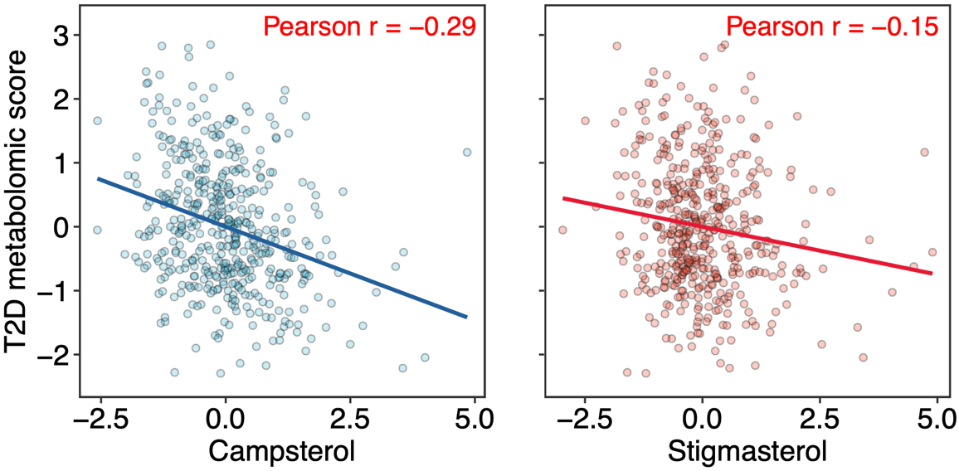

Figure S5. Correlation between intake of campsterol and stigmasterol and T2D metabolomic score in the microbiome subdataset.

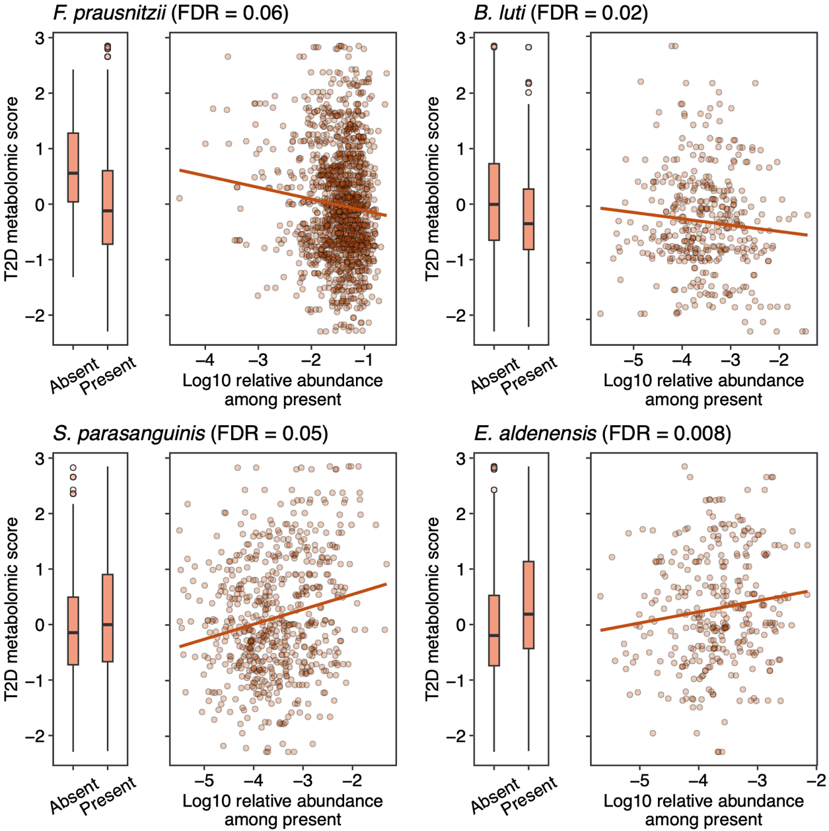

Figure S6. Representative dose-response associations between microbial species and T2D metabolomic score.

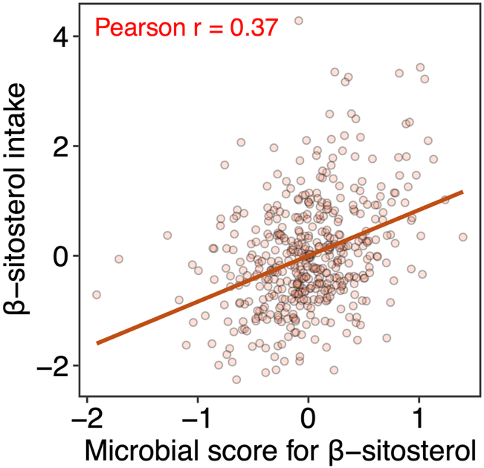

Figure S7. Correlation between intake microbial score for β-sitosterol intake and the actual intake.

