Supplementary information
Table S1 Definitions and formulae for derived indices evaluated in feature selection.
Table S2 Generalized variance inflation factor (GVIF) analysis for multivariable models in the CHARLS cohort..
Table S3 Schoenfeld residual test results of the multivariate-adjusted Cox regression model in the CHARLS cohort.
Table S4 Sensitivity analysis of the association between CTI-related indices and incident CMM in the complete-case population in the CHARLS cohort.
Table S5 Sensitivity analysis of the association between CTI-related indices and incident CMM excluding participants with a follow-up duration < 2 years in the CHARLS cohort.
Table S6 Sensitivity analysis of the association between CTI-related indices and incident CMM by redefining hypertension as ≥130/80 mmHg in the CHARLS cohort.
Table S7 Sensitivity analysis of the association between CTI-related indices and incident CMM with additional adjustment for depressive symptoms and grip strength in the CHARLS cohort.
Fig. S1 Feature selection using Least Absolute Shrinkage and Selection Operator (LASSO) regression in the CHARLS cohort. (A) Cross-validation plot for the optimal tuning parameter selection; (B) LASSO coefficient profiles of the candidate features.
Fig. S2 Schoenfeld residual plots for testing the proportional hazards assumption in the CHARLS cohort.
Fig. S3 Cumulative incidence curves of incident CMM stratified by quartiles of CTI-WHtR and CTI-WC in the CHARLS and ELSA cohorts.
Fig. S4 Cumulative incidence function (CIF) plots for incident CMM accounting for competing risks in the CHARLS cohort. (A) CTI-WHtR; (B) CTI-WC.
Fig. S5 Weighted quantile sum (WQS) regression analysis evaluating the joint effect and individual weights of components within CTI-WHtR for incident CMM in the CHARLS cohort.
Fig. S6 Weighted quantile sum (WQS) regression analysis evaluating the joint effect and individual weights of components within CTI-WC for incident CMM in the CHARLS cohort.
Fig. S7 Mediation analyses of CTI-WC and new-onset CMM via SBP, and ePWV in the CHARLS cohort.

Table S1 Definitions and formulae for derived indices evaluated in feature selection.

TG: triglycerides ; HDL-C:high-density lipoprotein cholesterol ;WC:waist circumference;
FPG: fasting_plasma_glucose
Index | Formula
ABSI  (A Body Shape Index) | $$ABSI =\frac{WC(cm)}{BMI^{\frac{2}{3}}×{Height}^{\frac{1}{2}}(cm)}$$
WWI  ((Weight-Adjusted Waist Index) | $$WWI =\frac{WC(cm)}{√Weight(kg)}$$
BMI  (Body Mass Index) | $$BMI=\frac{Weight\left(kg\right)}{{Height}^{2}(cm)}$$
RFM  (Relative Fat Mass) | Male: $RFM= 64 - 20 ×\left(\frac{ Height\left(m\right)}{WC(m)}\right)$  Female： $RFM=76 - 20 ×\left(\frac{ Height\left(m\right)}{WC(m)}\right)$
TyHGB (Triglyceride/HDL-C–Glucose–Body Mass Index Index) | $$TyHGB = \frac{TG\left(mg/dL\right)}{HDL-C (mg/dL)} + 0.7× FPG (mg/dL) + 0.1 ×BMI$$
CI (Conicity Index) | $$CI =\frac{WC\left(m\right)}{0.109×√\frac{Weight\left(kg\right)}{Height\left(m\right)}}$$
CVAI  (Chinese Visceral Adiposity Index) | Male:$CVAI = -267.93 + 0.68×Age + 0.03×BMI + 4.0×WC - 22.0×log10\left(\frac{TG}{88.57}\right)- 16.32×log10\left(\frac{HDL}{38.66}\right)$  Female: $CVAI =-187.32 + 1.71×Age + 4.32×BMI + 1.12×WC - 39.76×log10\left(\frac{TG}{88.57}\right)- 11.66×log10\left(\frac{HDL}{38.66}\right)$
TyG-WHtR | $$TyG-WHtR=TyG×WHtR$$
TyG-WC | $$TyG-WC=TyG×WC$$
TyG-ABSI | $$TyG-ABSI=TyG×ABSI$$
TyG–WWI | $$TyG-WWI=TyG×WWI$$
TyG- BMI | $$TyG- BMI=TyG× BMI$$
TyG- RFM | $$TyG- RFM=TyG× RFM$$
TyG- CI | $$TyG- CI=TyG×CI$$
TyG- CVAI | $$TyG- CVAI=TyG×CVAI$$
CTI-ABSI | $$CTI-ABSI=CTI×ABSI$$
CTI–WWI | $$CTI-WWI=CTI×WWI$$
CTI - BMI | $$CTI-BMI=CTI×BMI$$
CTI - RFM | $$CTI-RFM=CTI×RFM$$
TyG- CI | $$CTI-CI=CTI×CI$$
TyG- CVAI | $$CTI-CVAI=CTI×CVAI$$

Table S2 Generalized variance inflation factor (GVIF) analysis for multivariable models in the CHARLS cohort..
Variable Name | GVIF | Df | GVIF^(1/(2*Df))
Age | 1.6265 | 1 | 1.2754
Sex | 2.4178 | 1 | 1.5549
Education | 1.2804 | 2 | 1.0637
Marital_status | 1.0102 | 1 | 1.0051
Smoking | 1.9515 | 1 | 1.3970
Alcohol use | 1.4567 | 1 | 1.2069
Hypertension | 1.0569 | 1 | 1.0280
eGFR | 1.5004 | 1 | 1.2249
LDL | 1.0797 | 1 | 1.0245
HDL | 1.0478 | 1 | 1.0236

Table S3 Schoenfeld residual test results of the multivariate-adjusted Cox regression model in the CHARLS cohort.
Variable | χ2 | P value
Age | 1.35 | 0.246
Gender | 0.01 | 0.917
Education level | 1.66 | 0.435
Marital status | 0.35 | 0.554
Smoking status | 0.00 | 0.976
Alcohol consumption | 3.35 | 0.067
Hypertension | 0.06 | 0.813
LDL-C | 0.13 | 0.716
HDL-C | 0.69 | 0.406
Kidney disease | 3.82 | 0.051
CTI-WHtR (Main Exposure) | 2.65 | 0.104
Global Test | 19.27 | 0.082

Table S4 Sensitivity analysis of the association between CTI-related indices and incident CMM in the complete-case population within the CHARLS cohort.
 | Model 1 |  | Model 2 |  | Model 3
Characteristic | HR (95% CI) | P-value | HR (95% CI) | P-value | HR (95% CI) | P-value
Continuous CTI-WHtR | 1.90 (1.78-2.03) | <0.001 | 1.88 (1.75-2.02) | <0.001 | 1.78 (1.64-1.94) | <0.001
Quartile CTI-WHtR
Q1 (Ref.) | 1.00 |  | 1.00 |  | 1.00
Q2 | 1.71 (1.22-2.39) | 0.002 | 1.73 (1.23-2.42) | 0.001 | 1.63 (1.16-2.29) | 0.005
Q3 | 3.27 (2.41-4.44) | <0.001 | 3.25 (2.39-4.42) | <0.001 | 2.83 (2.06-3.90) | <0.001
Q4 | 6.22 (4.66-8.31) | <0.001 | 6.13 (4.56-8.24) | <0.001 | 4.86 (3.51-6.74) | <0.001
P for trend |  | <0.001 |  | <0.001 |  | <0.001
Continuous CTI-WC | 1.90 (1.77-2.03) | <0.001 | 1.89 (1.77-2.02) | <0.001 | 1.83 (1.68-1.99) | <0.001
Quartile CTI-WC
Q1 (Ref.) | 1.00 |  | 1.00 |  | 1.00
Q2 | 1.61 (1.15-2.25) | 0.005 | 1.61 (1.15-2.25) | 0.005 | 1.54 (1.10-2.16) | 0.012
Q3 | 3.16 (2.34-4.28) | <0.001 | 3.12 (2.30-4.22) | <0.001 | 2.81 (2.05-3.86) | <0.001
Q4 | 5.98 (4.50-7.95) | <0.001 | 5.88 (4.42-7.83) | <0.001 | 4.85 (3.52-6.69) | <0.001
P for trend |  | <0.001 |  | <0.001 |  | <0.001
Continuous TyG-WHtR | 1.88 (1.75-2.01) | <0.001 | 1.87 (1.74-2.01) | <0.001 | 1.77 (1.63-1.93) | <0.001
Quartile TyG-WHtR
Q1 (Ref.) | 1.00 |  | 1.00 |  | 1.00
Q2 | 1.84 (1.31-2.57) | <0.001 | 1.88 (1.35-2.64) | <0.001 | 1.75 (1.24-2.45) | 0.001
Q3 | 3.49 (2.57-4.75) | <0.001 | 3.56 (2.61-4.86) | <0.001 | 3.05 (2.21-4.21) | <0.001
Q4 | 6.07 (4.53-8.13) | <0.001 | 6.14 (4.55-8.28) | <0.001 | 4.75 (3.41-6.60) | <0.001
P for trend |  | <0.001 |  | <0.001 |  | <0.001
Continuous TyG-WC | 1.87 (1.74-2.00) | <0.001 | 1.88 (1.75-2.01) | <0.001 | 1.82 (1.67-1.98) | <0.001
Quartile TyG-WC
Q1 (Ref.) | 1.00 |  | 1.00 |  | 1.00
Q2 | 1.63 (1.17-2.26) | 0.004 | 1.64 (1.18-2.27) | 0.003 | 1.57 (1.12-2.18) | 0.008
Q3 | 3.13 (2.32-4.21) | <0.001 | 3.10 (2.30-4.18) | <0.001 | 2.70 (1.98-3.69) | <0.001
Q4 | 5.57 (4.20-7.38) | <0.001 | 5.56 (4.19-7.37) | <0.001 | 4.47 (3.26-6.13) | <0.001
P for trend |  | <0.001 |  | <0.001 |  | <0.001
Model 1: was unadjusted.;
Model 2: was adjusted for age and sex;
Model 3: was adjusted for age, sex, educational level, marital status, smoking status, drinking status, hypertension, eGFR, LDL-C, and HDL-C.

Table S5 Sensitivity analysis excluding participants with follow-up duration <2 years within the CHARLS cohort.
 | Model 1 |  | Model 2 |  | Model 3
Characteristic | HR (95% CI) | P-value | HR (95% CI) | P-value | HR (95% CI) | P-value
Continuous CTI-WHtR | 1.78 (1.65-1.92) | <0.001 | 1.76 (1.63-1.90) | <0.001 | 1.59 (1.45-1.74) | <0.001
Quartiles of CTI-WHtR
Q1 (Ref.) | 1.00 |  | 1.00 |  | 1.00
Q2 | 1.43 (1.00-2.05) | 0.053 | 1.43 (1.00-2.06) | 0.051 | 1.30 (0.90-1.87) | 0.162
Q3 | 3.08 (2.24-4.25) | <0.001 | 3.05 (2.21-4.21) | <0.001 | 2.48 (1.77-3.47) | <0.001
Q4 | 5.18 (3.82-7.02) | <0.001 | 5.06 (3.70-6.91) | <0.001 | 3.60 (2.55-5.09) | <0.001
P for trend |  | <0.001 |  | <0.001 |  | <0.001
Continuous CTI-WC | 1.78 (1.65-1.91) | <0.001 | 1.77 (1.64-1.91) | <0.001 | 1.63 (1.48-1.78) | <0.001
Quartiles of CTI-WC
Q1 (Ref.) | 1.00 |  | 1.00 |  | 1.00
Q2 | 1.31 (0.92-1.86) | 0.129 | 1.31 (0.92-1.87) | 0.127 | 1.20 (0.84-1.71) | 0.314
Q3 | 2.55 (1.86-3.48) | <0.001 | 2.53 (1.85-3.46) | <0.001 | 2.12 (1.53-2.94) | <0.001
Q4 | 4.84 (3.61-6.48) | <0.001 | 4.75 (3.55-6.36) | <0.001 | 3.48 (2.50-4.86) | <0.001
P for trend |  | <0.001 |  | <0.001 |  | <0.001
Continuous TyG-WHtR | 1.76 (1.63-1.90) | <0.001 | 1.75 (1.62-1.89) | <0.001 | 1.57 (1.43-1.73) | <0.001
Quartiles of TyG-WHtR
Q1 (Ref.) | 1.00 |  | 1.00 |  | 1.00
Q2 | 1.72 (1.21-2.44) | 0.002 | 1.75 (1.24-2.49) | 0.002 | 1.55 (1.09-2.21) | 0.016
Q3 | 2.92 (2.11-4.03) | <0.001 | 2.97 (2.14-4.11) | <0.001 | 2.33 (1.66-3.27) | <0.001
Q4 | 5.03 (3.71-6.83) | <0.001 | 5.07 (3.70-6.93) | <0.001 | 3.47 (2.45-4.91) | <0.001
P for trend |  | <0.001 |  | <0.001 |  | <0.001
Continuous TyG-WC | 1.75 (1.62-1.88) | <0.001 | 1.76 (1.63-1.90) | <0.001 | 1.61 (1.47-1.77) | <0.001
Quartiles of TyG-WC
Q1 (Ref.) | 1.00 |  | 1.00 |  | 1.00
Q2 | 1.18 (0.84-1.66) | 0.332 | 1.19 (0.85-1.67) | 0.321 | 1.08 (0.76-1.52) | 0.677
Q3 | 2.36 (1.75-3.19) | <0.001 | 2.36 (1.75-3.19) | <0.001 | 1.89 (1.38-2.60) | <0.001
Q4 | 4.17 (3.15-5.53) | <0.001 | 4.17 (3.15-5.53) | <0.001 | 2.95 (2.14-4.06) | <0.001
P for trend |  | <0.001 |  | <0.001 |  | <0.001
Model 1: was unadjusted.;
Model 2: was adjusted for age and sex;
Model 3: was adjusted for age, sex, educational level, marital status, smoking status, drinking status, hypertension, eGFR, LDL-C, and HDL-C.

Table S6 Sensitivity analysis redefining hypertension as ≥130/80 mmHg within the CHARLS cohort.
 | Model 1 |  | Model 2 |  | Model 3
Characteristic | HR (95% CI) | P-value | HR (95% CI) | P-value | HR (95% CI) | P-value
Continuous CTI-WHtR | 1.86 (1.75-1.98) | <0.001 | 1.84 (1.73-1.97) | <0.001 | 1.66 (1.54-1.80) | <0.001
Quartiles of CTI-WHtR
Q1 (Ref.) | 1.00 |  | 1.00 |  | 1.00
Q2 | 1.62 (1.19-2.19) | 0.002 | 1.62 (1.19-2.20) | 0.002 | 1.45 (1.06-1.97) | 0.019
Q3 | 3.20 (2.43-4.22) | <0.001 | 3.17 (2.40-4.18) | <0.001 | 2.50 (1.87-3.34) | <0.001
Q4 | 5.87 (4.52-7.62) | <0.001 | 5.75 (4.40-7.50) | <0.001 | 3.96 (2.94-5.33) | <0.001
P for trend |  | <0.001 |  | <0.001 |  | <0.001
Continuous CTI-WC | 1.86 (1.74-1.97) | <0.001 | 1.85 (1.74-1.97) | <0.001 | 1.70 (1.58-1.84) | <0.001
Quartiles of CTI-WC
Q1 (Ref.) | 1.00 |  | 1.00 |  | 1.00
Q2 | 1.45 (1.07-1.95) | 0.016 | 1.45 (1.07-1.95) | 0.017 | 1.31 (0.97-1.78) | 0.080
Q3 | 2.97 (2.27-3.89) | <0.001 | 2.94 (2.25-3.84) | <0.001 | 2.37 (1.78-3.14) | <0.001
Q4 | 5.44 (4.23-7.01) | <0.001 | 5.34 (4.14-6.88) | <0.001 | 3.81 (2.85-5.07) | <0.001
P for trend |  | <0.001 |  | <0.001 |  | <0.001
Continuous TyG-WHtR | 1.84 (1.73-1.96) | <0.001 | 1.83 (1.72-1.96) | <0.001 | 1.65 (1.53-1.79) | <0.001
Quartiles of TyG-WHtR
Q1 (Ref.) | 1.00 |  | 1.00 |  | 1.00
Q2 | 1.59 (1.18-2.15) | 0.002 | 1.62 (1.20-2.19) | 0.002 | 1.44 (1.06-1.95) | 0.020
Q3 | 3.12 (2.38-4.10) | <0.001 | 3.19 (2.43-4.20) | <0.001 | 2.47 (1.85-3.28) | <0.001
Q4 | 5.45 (4.22-7.05) | <0.001 | 5.51 (4.23-7.17) | <0.001 | 3.70 (2.76-4.97) | <0.001
P for trend |  | <0.001 |  | <0.001 |  | <0.001
Continuous TyG-WC | 1.82 (1.71-1.94) | <0.001 | 1.84 (1.73-1.96) | <0.001 | 1.69 (1.56-1.83) | <0.001
Quartiles of TyG-WC
Q1 (Ref.) | 1.00 |  | 1.00 |  | 1.00
Q2 | 1.52 (1.13-2.04) | 0.005 | 1.52 (1.13-2.04) | 0.005 | 1.38 (1.02-1.86) | 0.034
Q3 | 2.90 (2.23-3.79) | <0.001 | 2.90 (2.22-3.78) | <0.001 | 2.27 (1.72-3.01) | <0.001
Q4 | 5.12 (3.98-6.58) | <0.001 | 5.11 (3.97-6.57) | <0.001 | 3.54 (2.66-4.69) | <0.001
P for trend |  | <0.001 |  | <0.001 |  | <0.001
Model 1: was unadjusted.;
Model 2: was adjusted for age and sex;
Model 3: was adjusted for age, sex, educational level, marital status, smoking status, drinking status, hypertension, eGFR, LDL-C, and HDL-C.

Table S7 Sensitivity analysis with additional adjustment for depressive symptoms and grip strength within the CHARLS cohort.
 | Model 1 |  | Model 2 |  | Model 3
Characteristic | HR (95% CI) | P-value | HR (95% CI) | P-value | HR (95% CI) | P-value
Continuous CTI-WHtR | 1.86 (1.75-1.98) | <0.001 | 1.84 (1.73-1.97) | <0.001 | 1.76 (1.63-1.91) | <0.001
Quartiles of CTI-WHtR
Q1 (Ref.) | 1.00 |  | 1.00 |  | 1.00
Q2 | 1.62 (1.19-2.19) | 0.002 | 1.62 (1.19-2.20) | 0.002 | 1.52 (1.12-2.07) | 0.008
Q3 | 3.20 (2.43-4.22) | <0.001 | 3.17 (2.40-4.18) | <0.001 | 2.74 (2.05-3.66) | <0.001
Q4 | 5.87 (4.52-7.62) | <0.001 | 5.75 (4.40-7.50) | <0.001 | 4.63 (3.45-6.23) | <0.001
P for trend |  | <0.001 |  | <0.001 |  | <0.001
Continuous CTI-WC | 1.86 (1.74-1.97) | <0.001 | 1.85 (1.74-1.97) | <0.001 | 1.81 (1.68-1.95) | <0.001
Quartiles of CTI-WC
Q1 (Ref.) | 1.00 |  | 1.00 |  | 1.00
Q2 | 1.45 (1.07-1.95) | 0.016 | 1.45 (1.07-1.95) | 0.017 | 1.38 (1.02-1.87) | 0.040
Q3 | 2.97 (2.27-3.89) | <0.001 | 2.94 (2.25-3.84) | <0.001 | 2.61 (1.97-3.46) | <0.001
Q4 | 5.44 (4.23-7.01) | <0.001 | 5.34 (4.14-6.88) | <0.001 | 4.47 (3.35-5.95) | <0.001
P for trend |  | <0.001 |  | <0.001 |  | <0.001
Continuous TyG-WHtR | 1.84 (1.73-1.96) | <0.001 | 1.83 (1.72-1.96) | <0.001 | 1.75 (1.62-1.89) | <0.001
Quartiles of TyG-WHtR
Q1 (Ref.) | 1.00 |  | 1.00 |  | 1.00
Q2 | 1.59 (1.18-2.15) | 0.002 | 1.62 (1.20-2.19) | 0.002 | 1.49 (1.10-2.02) | 0.010
Q3 | 3.12 (2.38-4.10) | <0.001 | 3.19 (2.43-4.20) | <0.001 | 2.71 (2.04-3.61) | <0.001
Q4 | 5.45 (4.22-7.05) | <0.001 | 5.51 (4.23-7.17) | <0.001 | 4.31 (3.22-5.77) | <0.001
P for trend |  | <0.001 |  | <0.001 |  | <0.001
Continuous TyG-WC | 1.82 (1.71-1.94) | <0.001 | 1.84 (1.73-1.96) | <0.001 | 1.80 (1.67-1.95) | <0.001
Quartiles of TyG-WC
Q1 (Ref.) | 1.00 |  | 1.00 |  | 1.00
Q2 | 1.52 (1.13-2.04) | 0.005 | 1.52 (1.13-2.04) | 0.005 | 1.45 (1.07-1.95) | 0.015
Q3 | 2.90 (2.23-3.79) | <0.001 | 2.90 (2.22-3.78) | <0.001 | 2.52 (1.90-3.33) | <0.001
Q4 | 5.12 (3.98-6.58) | <0.001 | 5.11 (3.97-6.57) | <0.001 | 4.23 (3.19-5.61) | <0.001
P for trend |  | <0.001 |  | <0.001 |  | <0.001
Model 1: was unadjusted.;
Model 2: was adjusted for age and sex;
Model 3: was adjusted for age, sex, educational level, marital status, smoking status, drinking status, hypertension, eGFR, LDL-C, and HDL-C.

Fig. S1 Feature selection using Least Absolute Shrinkage and Selection Operator (LASSO) regression in the CHARLS cohort. (A) Cross-validation plot for the optimal tuning parameter selection; (B) LASSO coefficient profiles of the candidate features.
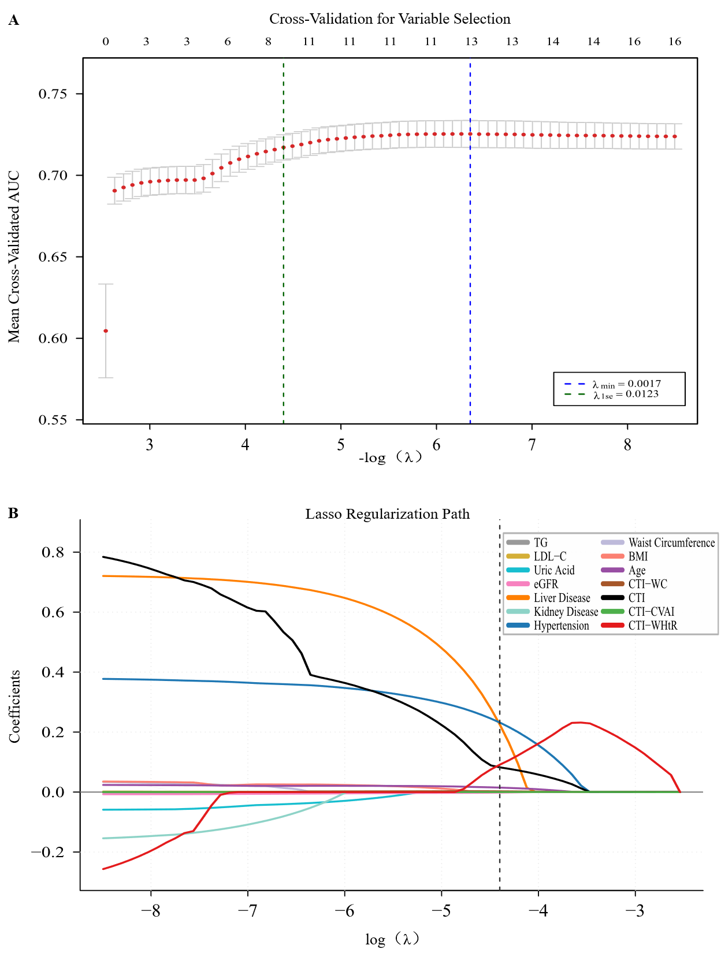

Fig. S2 Schoenfeld residual plots for testing the proportional hazards assumption in the CHARLS cohort.
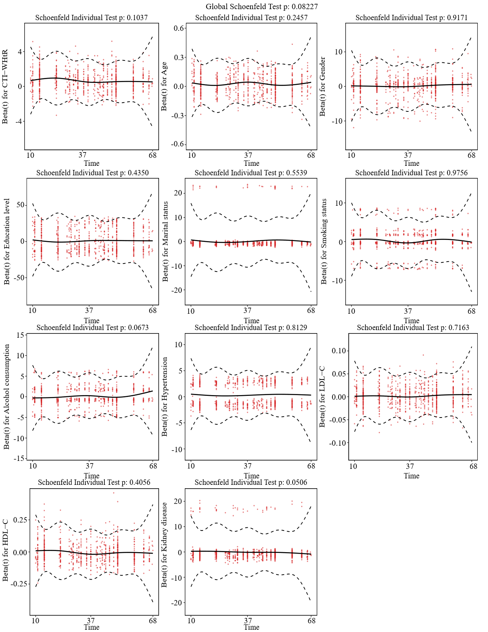

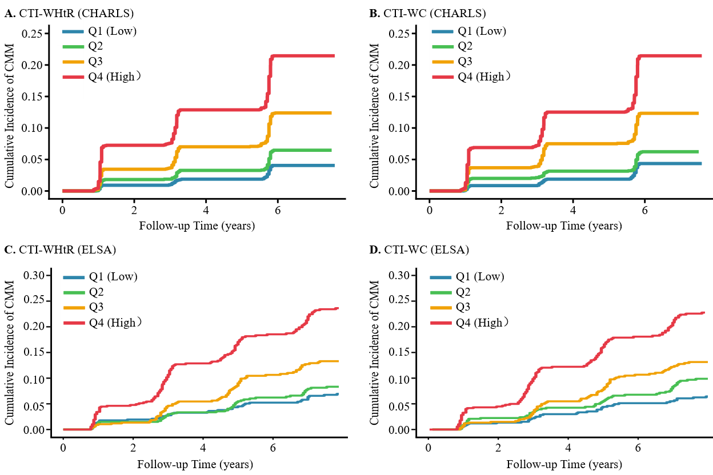
Fig. S3 Cumulative incidence curves of incident CMM stratified by quartiles of CTI-WHtR and CTI-WC in the CHARLS and ELSA cohorts.

Fig. S4 Cumulative incidence function (CIF) plots for incident CMM accounting for competing risks in the CHARLS cohort. (A) CTI-WHtR; (B) CTI-WC.
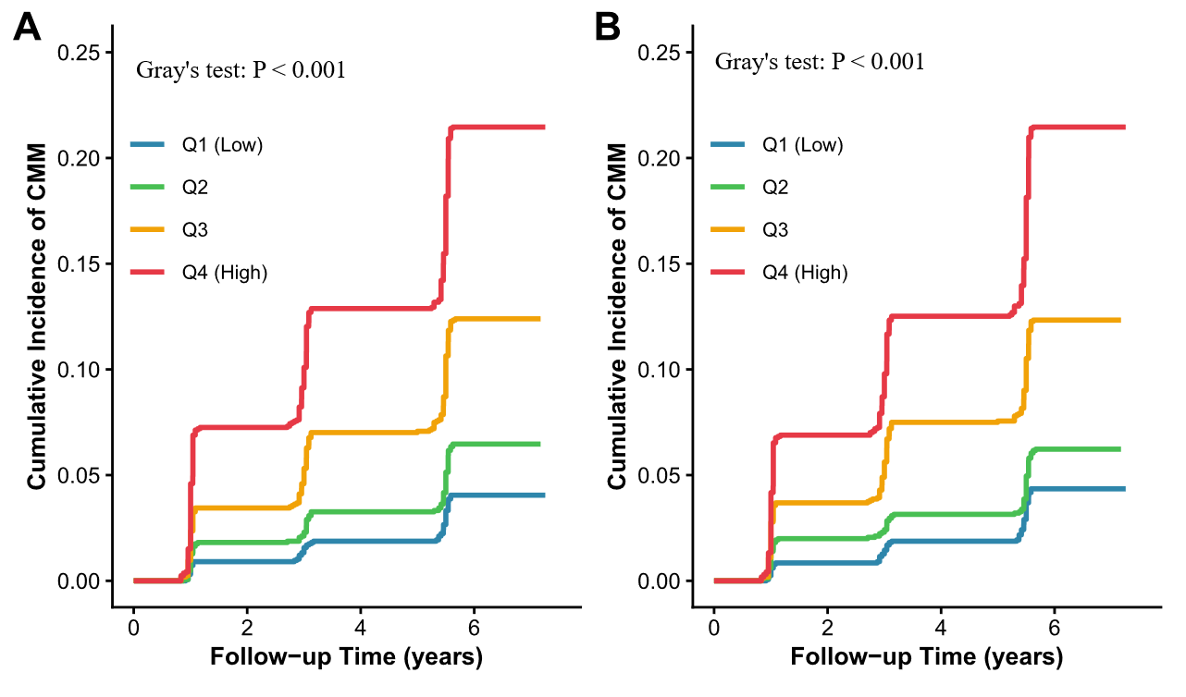
Fig. S5 Weighted quantile sum (WQS) regression analysis evaluating the joint effect and individual weights of components within CTI-WHtR for incident CMM in the CHARLS cohort.
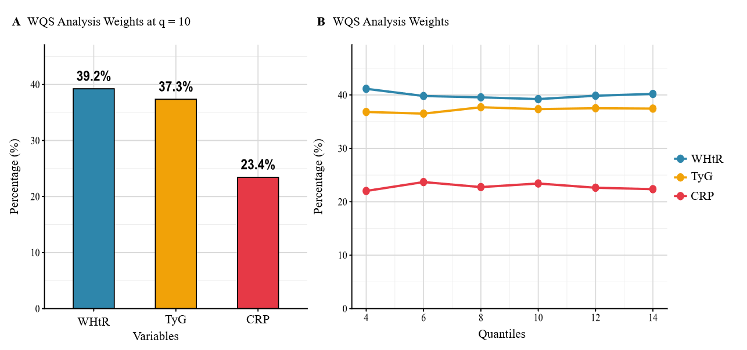

Fig. S6 Weighted quantile sum (WQS) regression analysis evaluating the joint effect and individual weights of components within CTI-WC for incident CMM in the CHARLS cohort.
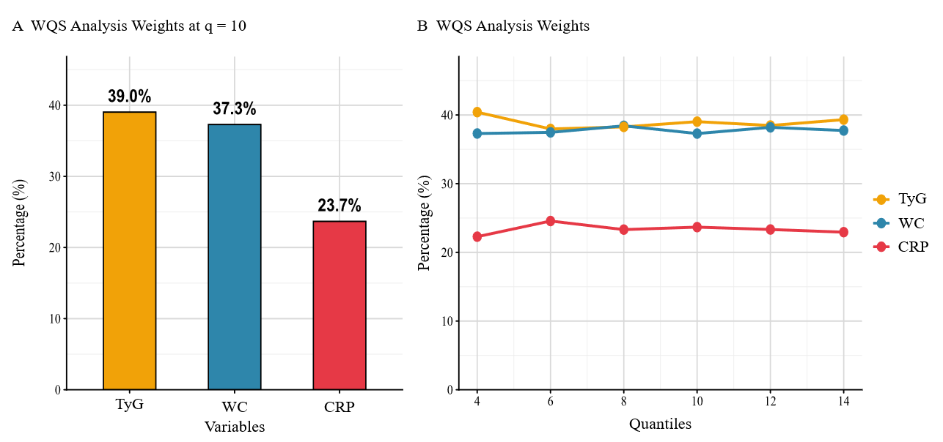

Fig. S7 Mediation analyses of CTI-WC and new-onset CMM via SBP, and ePWV in the CHARLS cohort.
