Table 1. Clinicopathological characteristics according to preoperative chemoradiotherapy
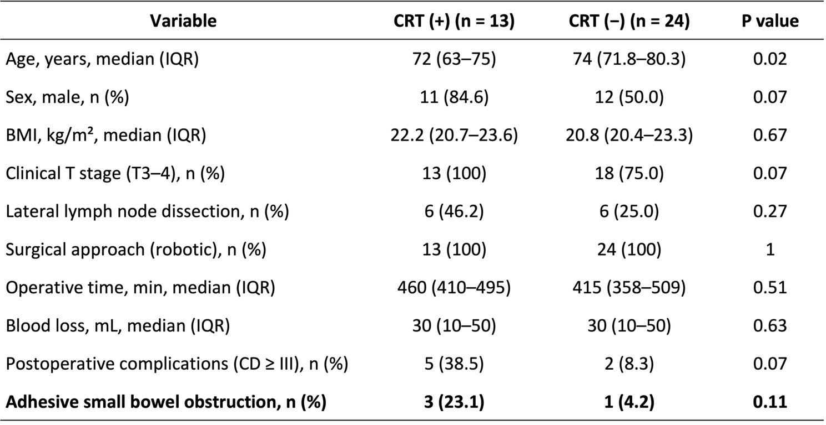
Values are presented as median (interquartile range) or number (%).
CRT, chemoradiotherapy; CD, Clavien–Dindo; ASBO, adhesive small bowel obstruction.

Table 2. Clinical characteristics and management of patients with adhesive small bowel obstruction after abdominoperineal resection
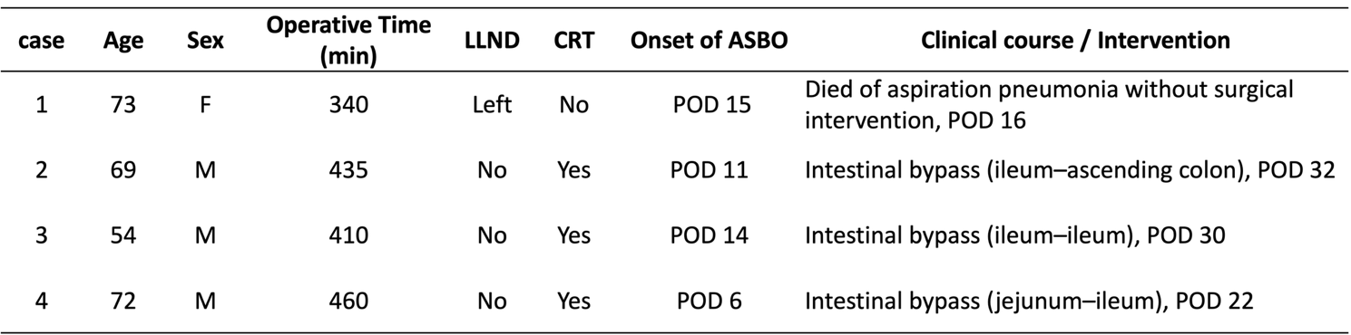
ASBO, adhesive small bowel obstruction; LLND, lateral lymph node dissection; CRT, chemoradiotherapy; POD, postoperative day. All surgically treated cases required intestinal bypass due to severe pelvic adhesions, and adhesiolysis was considered unsafe.

