Supplementary Figures

Supplementary Figure S1. Kaplan-Meier curve for progression free survival (PFS) stratified by ASP cut off 0.30 over full follow up. Higher ASP (> 0.30; n =71) showed shorter median PFS (9.6 months) versus ASP ≤ 0.30 (n =109; median 24.7 months); log-rank p = 0.0017.
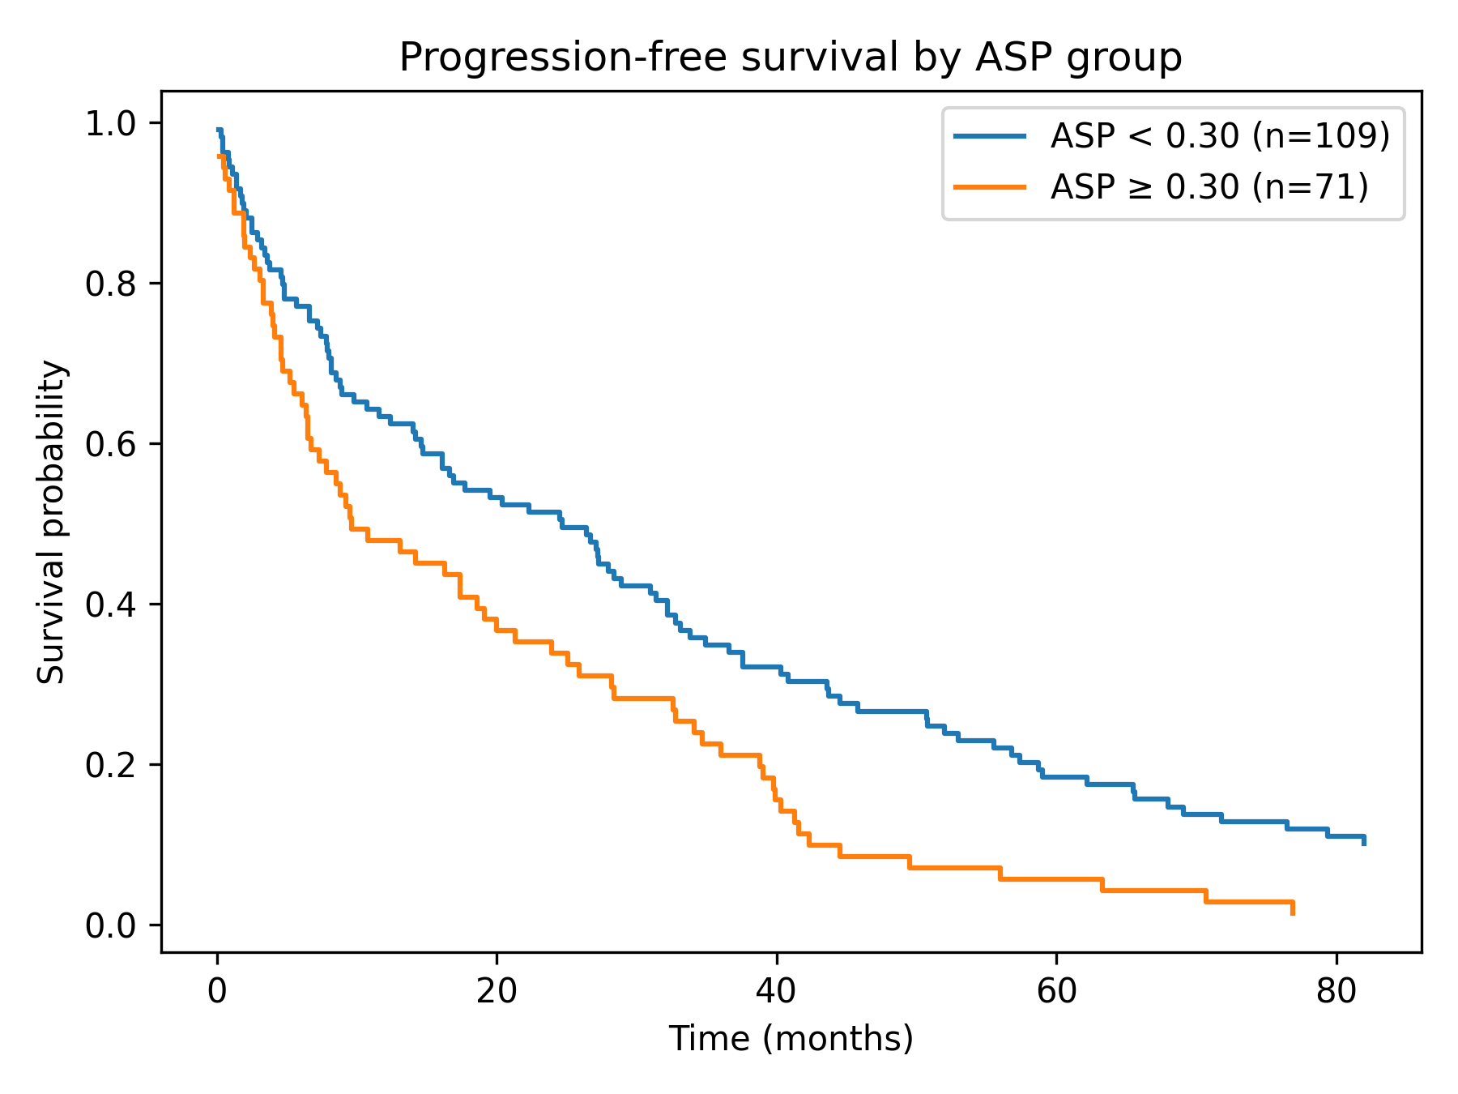
Supplementary Figure S2. Kaplan-Meier curve for overall survival (OS) stratified by ASP cut off 0.30 over full follow up. Higher ASP (> 0.30; n =71) showed shorter median OS (10.8 months) versus ASP ≤0.30 (n =109; median 28.2 months); log-rank p=0.00011.
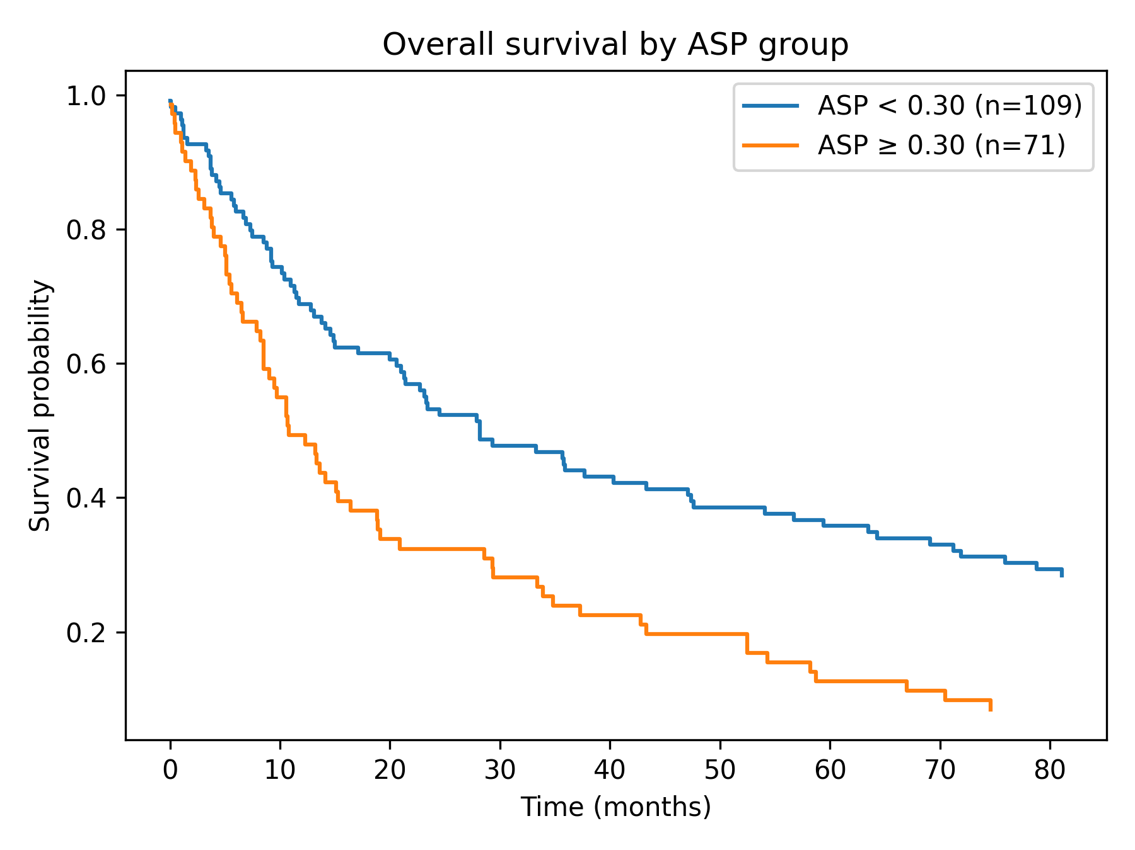
Supplementary Figure S3. Calibration of the baseline metastasis prediction model. Observed event rates are plotted against mean predicted risk across deciles of predicted probability; the diagonal line indicates perfect calibration. Calibration intercept 0.00, calibration slope 1.00, and Brier score 0.117.
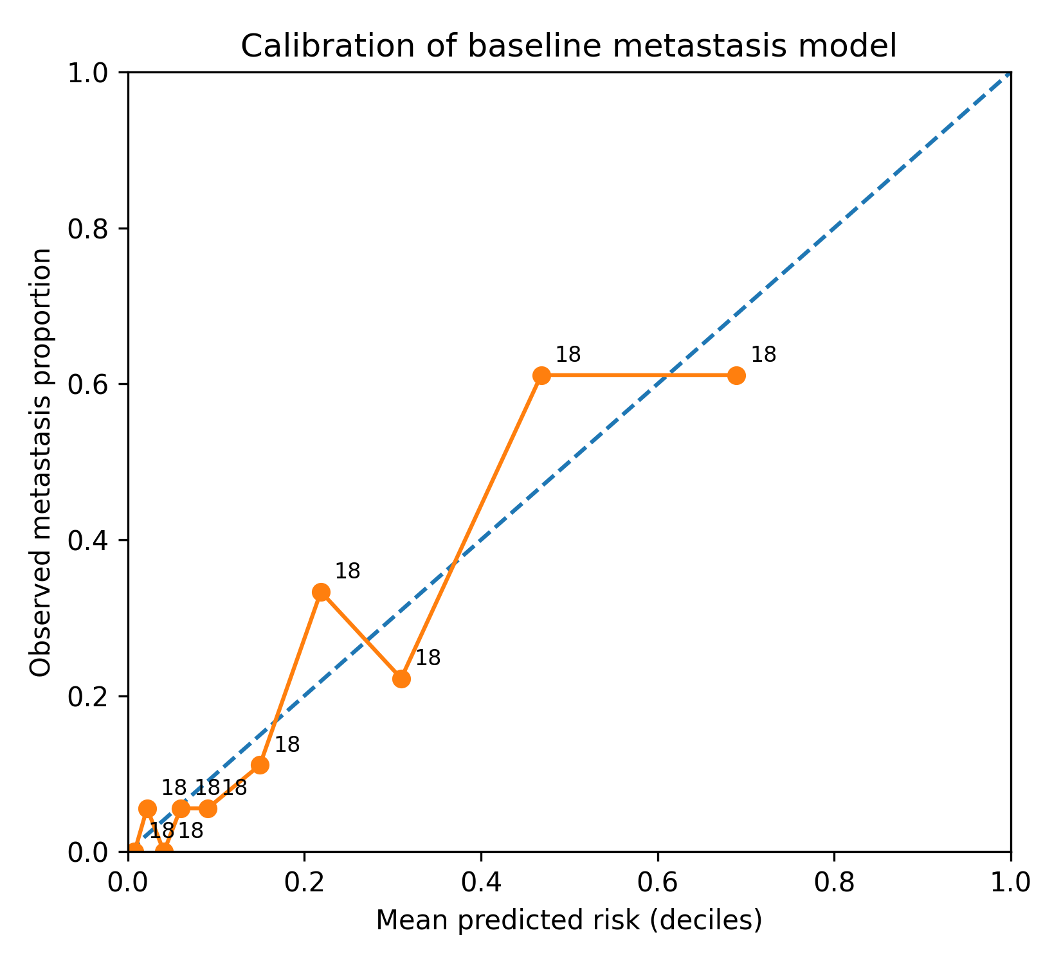
Supplementary Figure S4. Clinically interpretable risk curve for baseline metastasis prediction. Smoothed observed event rate is plotted against predicted risk across the spectrum of model predicted probabilities; the diagonal line indicates perfect agreement.
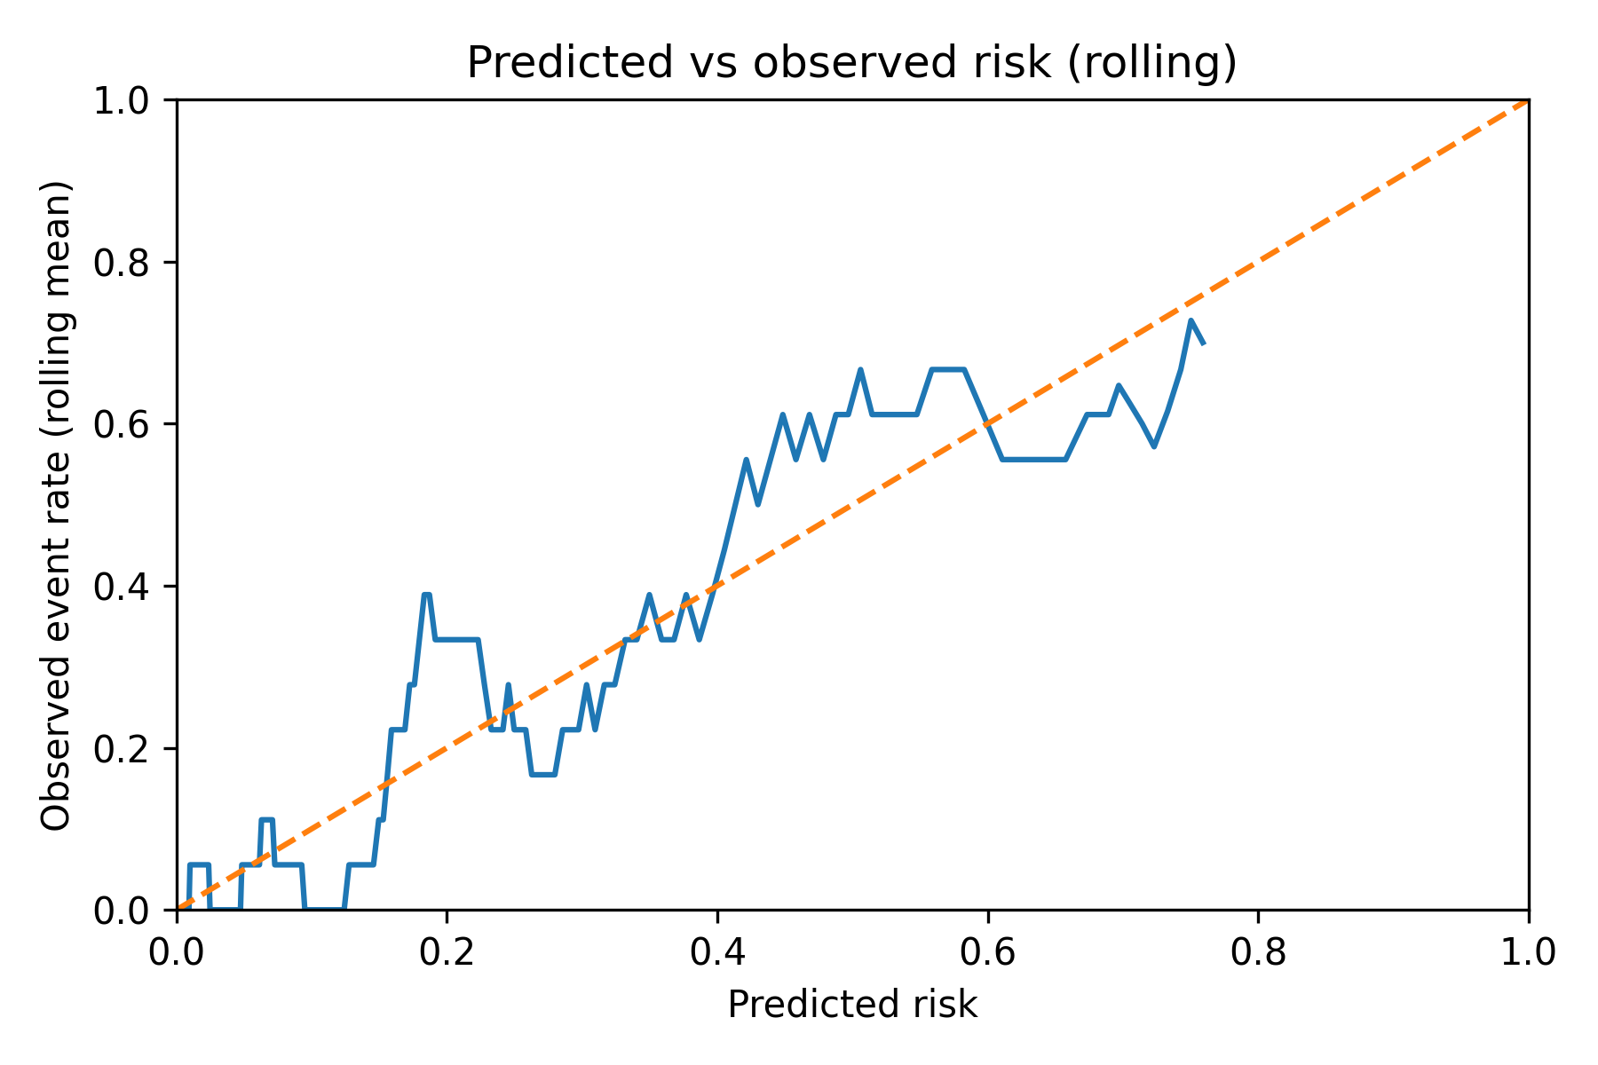

Supplementary Figure S5. Receiver operating characteristic (ROC) curve for baseline tumour asphericity (ASP) for discrimination of de novo metastatic disease at presentation. ASP yielded an AUC of 0.804. The optimal cut point by the Youden index was 0.287 (sensitivity 86.5%, specificity 65.7%). A rounded threshold of ASP 0.30 (ASP > 0.30 vs ASP ≤ 0.30) was used for dichotomised Kaplan-Meier analyses and subgroup comparisons.
