Supplementary Figure material
Figure 1. Stability assessment of expected influence via case-dropping bootstrap (Four groups)
Note. The Entire sample(A),High-Difficulty Profile(B);Moderate-Difficulty Profile (C), Low-Difficulty Profile(D),
A:The Entire sample | B:High-Difficulty Profile
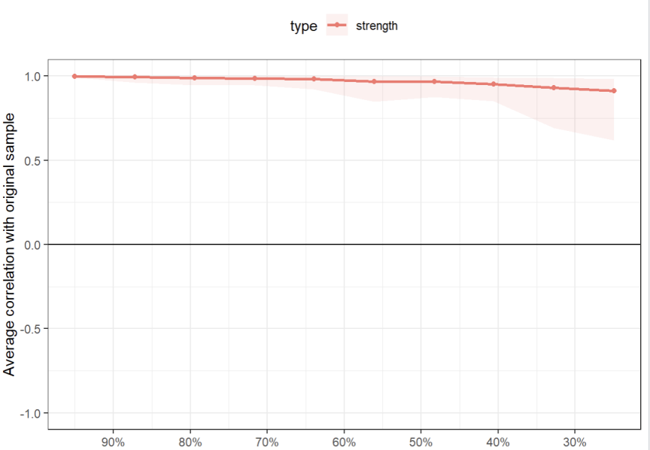 | 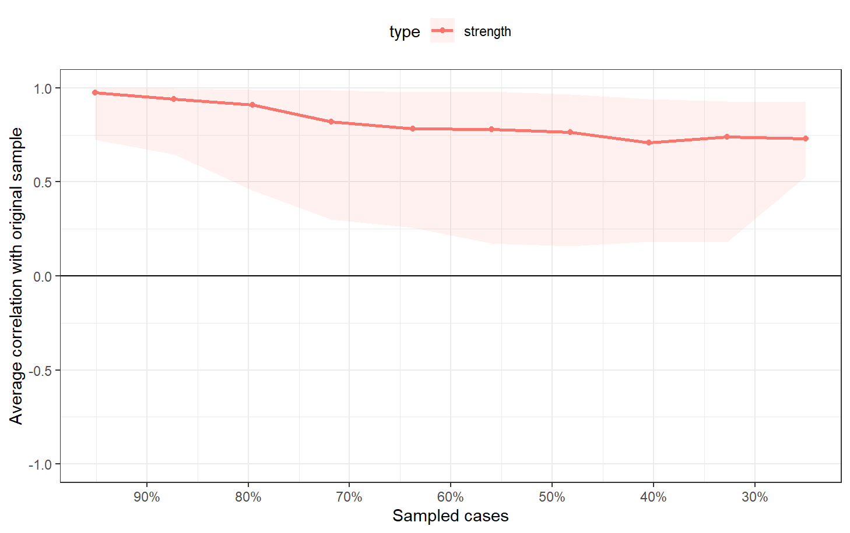
C:Moderate-Difficulty Profile | D:Low-Difficulty Profile
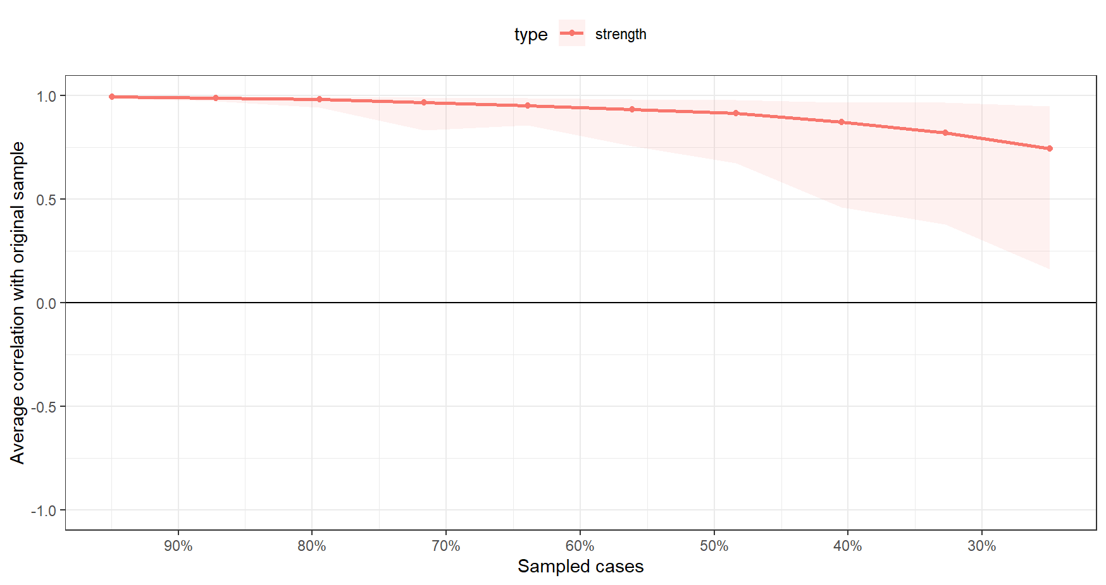 | 