Phase-selective SEI formation dynamics in Si–graphite composite electrodes

Inho Kim^{1,2#}, Sunggyu Yoon^{1,2#}, Daehyun Kim^{3#}, Seoung-Bum Son⁴, Sung-Jin Chang⁵, Haesun Park³*, Minkyu Kim^{1,2}*

¹Department of Chemistry, Inha University, 100 Inha-ro, Michuhol-gu, Incheon, 22212, Republic of Korea
²Department of Chemistry and Chemical Engineering, Inha University, 100 Inha-ro, Michuhol-gu, Incheon, 22212, Republic of Korea
³School of Integrative Engineering, Chung-Ang University, 84 Heukseok-ro, Dongjak-gu, Seoul 06974, Republic of Korea
⁴Chemical Science and Engineering Division, Argonne National Laboratory, 9700 South Cass Avenue, Lemont, IL 60439, USA
⁵Center for Analysis and Evaluation, National Nanofab Center, Daejeon 34141, Republic of Korea
#These authors contributed to this work equally
*Corresponding Author: minkyu.kim@inha.ac.kr (Minkyu Kim), parkh@cau.ac.kr (Haesun Park)

Table S1. Quantitative distribution of surface species obtained from XPS analysis corresponding to Figure 1c. Numbers denote the relative contribution (%) of each deconvoluted component in the C 1s and F 1s spectra for Gr_W.FEC, Si_W.FEC, and Si10_W.FEC electrodes after the first lithiation. The quantitative results correspond to Fig. 1c. Carbon species include Li_{x}C_{y}, C–C/C–H, C–O, C=O, O–C=O, and OCOO, while fluorine species consist of LiF and Li_{x}PO_{y}F_{z}.
 | Carbon species |  |  |  |  |  | Fluorine species
 | Li_{x}C_{y} | C–C/C–H | C–O | C=O | O–C=O | OCOO | LiF | Li_{x}PO_{y}F_{z}
Gr_W.FEC | 49.06 |  |  |  |  |  | 50.94
Gr_W.FEC | 1.43 | 31.16 | 7.16 | 1.86 | 3.24 | 4.20 | 26.85 | 24.09
Si_W.FEC | 67.69 |  |  |  |  |  | 32.31
Si_W.FEC | 4.72 | 41.26 | 6.52 | 1.15 | 5.40 | 8.64 | 26.98 | 5.33
Si10_W.FEC | 81.79 |  |  |  |  |  | 18.21
Si10_W.FEC | 3.29 | 58.47 | 2.32 | 8.20 | 3.65 | 5.86 | 9.13 | 9.07

Figure S1. The evolution of I_{Si} (brown line) and I_{Graphite} (gray line) as a function of voltage for the Si10_R_cell under different conditions during first lithiation at a C-rate of 0.033 C; a) W.O.FEC, b) W.FEC. Blue line indicates applied current.

Figure S2. Effective C-rate vs. voltage profiles of Si10_R cells, along with differential capacity (dQ/dV) curves during the a) second lithiation under W.O.FEC, b) second lithiation under W.FEC, c) third lithiation under W.O.FEC, and d) third lithiation under W.FEC conditions.

Figure S3. Differential (column) and cumulative (line) intensity of particle size distribution measured by particle size analysis (PSA).

Table S2. Brunauer-Emmett-Teller (BET) surface area, total pore volume, and average pore size of the electrode materials obtained from N₂ adsorption-desorption analysis
 | BET surface area (m²/g) | Pore volume (cm³/g) | Pore size (Å)
Si | 61.9258 | 0.246732 | 159.372
Graphite | 1.1722 | 0.004388 | 149.733

Figure S4. Comparison of current densities for Si (brown line) and graphite (gray line) components under two different electrolyte conditions: a) W.O.FEC, and b) W.FEC. The measured current densities were obtained by normalizing the currents shown in Fig. S1 with respect to the particle surface area (Table S2). Dashed lines indicate the expected values assuming uniform current distribution between Si and graphite.
Table S3. Quantitative distribution of surface species obtained from XPS analysis corresponding to Fig. 3e. Numbers denote the relative contribution (%) of each deconvoluted component in the C 1s and F 1s spectra for Gr_R_W.O.FEC, Si_R_W.O.FEC, Gr_R_W.FEC, and Si_R_W.FEC electrodes after the first lithiation. The quantitative results correspond to Figure 3e. Carbon species include Li_{x}C_{y}, C–C/C–H, C–O, C=O, O–C=O, and OCOO, while fluorine species consist of LiF and Li_{x}PO_{y}F_{z}
 | Carbon species |  |  |  |  |  | Fluorine species
 | Li_{x}C_{y} | C–C/C–H | C–O | C=O | O–C=O | OCOO | LiF | Li_{x}PO_{y}F_{z}
Gr_R_W.O.FEC | 90.30 |  |  |  |  |  | 9.70
Gr_R_W.O.FEC | 3.06 | 54.93 | 2.60 | 1.79 | 4.63 | 23.29 | 8.61 | 1.09
Si_R_W.O.FEC | 88.18 |  |  |  |  |  | 11.82
Si_R_W.O.FEC | 4.81 | 57.28 | 5.01 | 1.53 | 4.65 | 14.90 | 10.01 | 1.81
Gr_R_W.FEC | 87.03 |  |  |  |  |  | 12.97
Gr_R_W.FEC | 4.74 | 60.75 | 5.14 | 2.06 | 2.98 | 11.36 | 9.97 | 3.00
Si_R_W.FEC | 50.61 |  |  |  |  |  | 49.39
Si_R_W.FEC | 2.54 | 32.61 | 7.59 | 1.44 | 2.48 | 3.96 | 30.45 | 18.94

Figure S5. a–c) Normalized C⁻ ion intensities plotted as a function of normalized sputtering depth for the harvested graphite electrodes (Gr_W.O.FEC, Gr_W.FEC, and Gr_R_W.FEC). d–f) Normalized Si⁻ ion intensities plotted as a function of normalized SEI-layer depth for the harvested Si electrodes (Si_W.O.FEC, Si_W.FEC, and Si_R_W.FEC). The normalized intensities of C⁻ and Si⁻ ions were obtained by dividing the intensity of each detected species by the total intensity of all observed species. For both C⁻ and Si⁻ signals, the sputtering depth at which the normalized intensity reached 80% of its maximum value was designated as a normalized sputtering depth of 1.0, and all profiles were plotted up to a total normalized sputtering depth of 2.0.

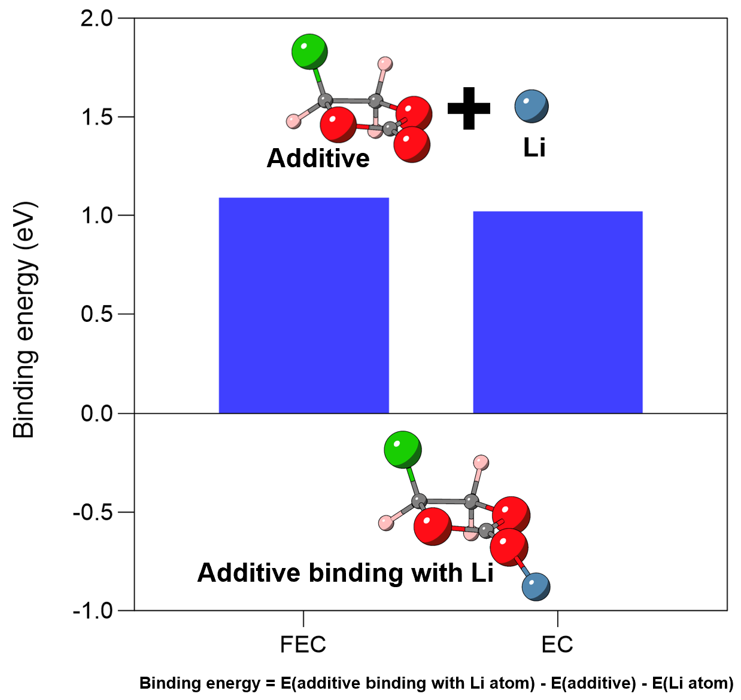
Figure S6. Binding Energy of FEC and EC with a Li atom (Binding energy (E_{bind}) = E_{total} – E_{addi} -E_{Li atom}, where E_{total} and E_{Li} are the energies of additive binding with Li atom and the isolated Li atom)
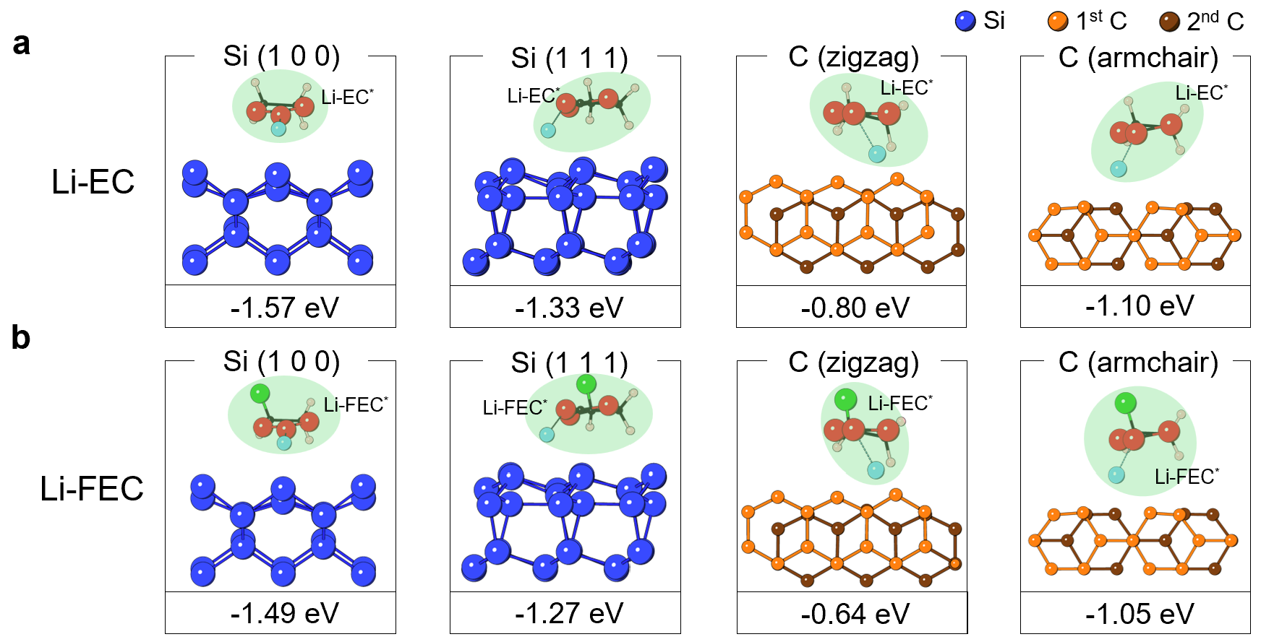
Figure S7. Calculated adsorption energies of Li-ion–coordinated electrolyte components on Si (100), Si (111), C (zigzag), and C (armchair) surfaces: (a) Li–EC and (b) Li–FEC.

Figure S8. Bader analysis of charge transfer between Li-ion–coordinated electrolyte components and anode surfaces, compiled based on electron: a) Li-EC, b) Li-FEC. In Bader analysis, the charge of Li ion was excluded due to reversible Li insertion/extraction paths; only reduction of EC and FEC were considered.

Table S4. Quantitative distribution of surface species obtained from XPS analysis corresponding to Figure 6e. Numbers denote the relative contribution (%) of each deconvoluted component in the C 1s and F 1s spectra for Gr_R_W.VC.FEC and Si_R_W.VC.FEC electrodes after the first lithiation. The quantitative results correspond to Figure 6e. Carbon species include Li_{x}C_{y}, C–C/C–H, C–O, C=O, O–C=O, and OCOO, while fluorine species consist of LiF and Li_{x}PO_{y}F_{z}.
 | Carbon species |  |  |  |  |  | Fluorine species
 | Li_{x}C_{y} | C–C/C–H | C–O | C=O | O–C=O | OCOO | LiF | Li_{x}PO_{y}F_{z}
Gr_R_W.VC.FEC | 69.02 |  |  |  |  |  | 30.98
Gr_R_W.VC.FEC | 14.29 | 2.96 | 11.06 | 15.22 | 23.65 | 1.85 | 27.28 | 3.69
Si_R_W.VC.FEC | 69.62 |  |  |  |  |  | 30.38
Si_R_W.VC.FEC | 13.04 | 2.80 | 10.49 | 14.36 | 26.82 | 2.09 | 28.22 | 2.16

Figure S9. Effective C-rate vs. voltage profiles (top) and dQ/dV curves (bottom) of the Si10_R_W.VC cell during the first lithiation.

Figure S10. Differential capacity vs. voltage (dQ/dV) curves of Si10_R_cell with W.O.FEC, W.FEC, W.VC, and W.VC.FEC conditions.

Supplementary Note I
To emulate the component-resolved electrochemical behavior of composite cathodes in the RDA platform, two cathode-analog RDA cells were prepared. R_LFP30_cell was designed to model a LiFePO₄ (LFP) / LiNiO₂ (LNO) blended cathode (30/70 wt%) using the RDA configuration, while R_Bimodal50_cell was built to represent a LiNi_{0.6}Co_{0.1}Mn_{0.3}O₂ (NCM631) bimodal cathode composed of polycrystalline large (PL) and single-crystalline small (SS) particles (50/50 wt%). After the first charge under the FEC-containing electrolyte, each component electrode was harvested from its respective RDA cell and labeled as LFP_R_W.FEC and LNO_R_W.FEC (from R_LFP30_cell), and PL_R_W.FEC and SS_R_W.FEC (from R_Bimodal50_cell).
The RDA results (Fig. S11a,b) show that the effective C-rate and current partitioning between the components differ markedly, indicating that electrochemical reactions in blended or bimodal cathodes proceed non-uniformly across the constituent phases. Consistent with this asymmetric current distribution, XPS analyses (Fig. S11c–e, Table S5) reveal that CEI formation is likewise phase-selective and asymmetric. In the LFP/LNO blended system (R_LFP30_cell), the LNO_R_W.FEC electrode exhibits a noticeably higher fraction of LiF species than LFP_R_W.FEC, suggesting that FEC decomposition preferentially occurs on the LNO surface. A similar trend is observed for the NCM631 bimodal electrode, where PL_R_W.FEC develops a more fluorine-rich CEI than SS_R_W.FEC, characterized by a higher F-ratio and LiF concentration.

Figure S11. a–b) Effective C-rate vs. voltage profiles, along with differential capacity (dQ/dV) curves during the first charge under the W.FEC condition: a) R_LFP30_cell, replicating the electrochemical behavior of the LFP/LNO blended cathode (30 wt%:70 wt%). b) R_Bimodal50_cell, replicating the electrochemical behavior of the LiNi_{0.6}Co_{0.1}Mn_{0.3}O₂ bimodal cathode composed of polycrystalline large (PL) and single-crystalline small (SS) particles (50 wt%: 50 wt%). c) C 1s spectra of LFP_R_W.FEC, LNO_R_W.FEC, PL_R_W.FEC, and SS_R_W.FEC. Peaks are deconvoluted into Li_{x}C_{y}, C–C/C–H, C–O, C=O, O–C=O, OCOO components. d) F 1s spectra of LFP_R_W.FEC, LNO_R_W.FEC, PL_R_W.FEC, and SS_R_W.FEC. Peaks are deconvoluted into LiF, C–F species. e) Quantitative distributions of surface species derived from C 1s (bottom) and F 1s (top) regions. The stacked bars show the total contributions from C- and F-related signals, with colors corresponding to the deconvoluted components in panels (c) and (d). Numbers denote the relative contribution of each species, while bracketed values indicate F-ratio.

Table S5. Quantitative distribution of surface species obtained from XPS analysis corresponding to Figure S11e. Numbers denote the relative contribution (%) of each deconvoluted component in the C 1s and F 1s spectra for LFP_R_W.FEC, LNO_R_W.FEC, PL_R_W.FEC, and SS_R_W.FEC electrodes after the first charge. The quantitative results correspond to Figure S11e. Carbon species include Li_{x}C_{y}, C–C/C–H, C–O, C=O, O–C=O, and OCOO, while fluorine species consist of LiF and C–F
 | Carbon species |  |  |  |  |  | Fluorine species
 | Li_{x}C_{y} | C–C/C–H | C–O | C=O | O–C=O | OCOO | LiF | C–F
LFP_R_W.FEC | 80.91 |  |  |  |  |  | 19.09
LFP_R_W.FEC | 2.37 | 34.54 | 14.81 | 14.73 | 4.39 | 10.07 | 0.71 | 18.38
LNO_R_W.FEC | 78.87 |  |  |  |  |  | 21.13
LNO_R_W.FEC | 3.17 | 41.33 | 11.06 | 11.39 | 1.91 | 10.01 | 7.35 | 13.78
PL_R_W.FEC | 76.10 |  |  |  |  |  | 23.90
PL_R_W.FEC | 2.52 | 38.03 | 12.60 | 10.78 | 3.74 | 8.43 | 9.76 | 14.15
SS_R_W.FEC | 79.50 |  |  |  |  |  | 20.50
SS_R_W.FEC | 2.48 | 38.80 | 12.60 | 12.26 | 4.38 | 8.97 | 6.21 | 14.29

