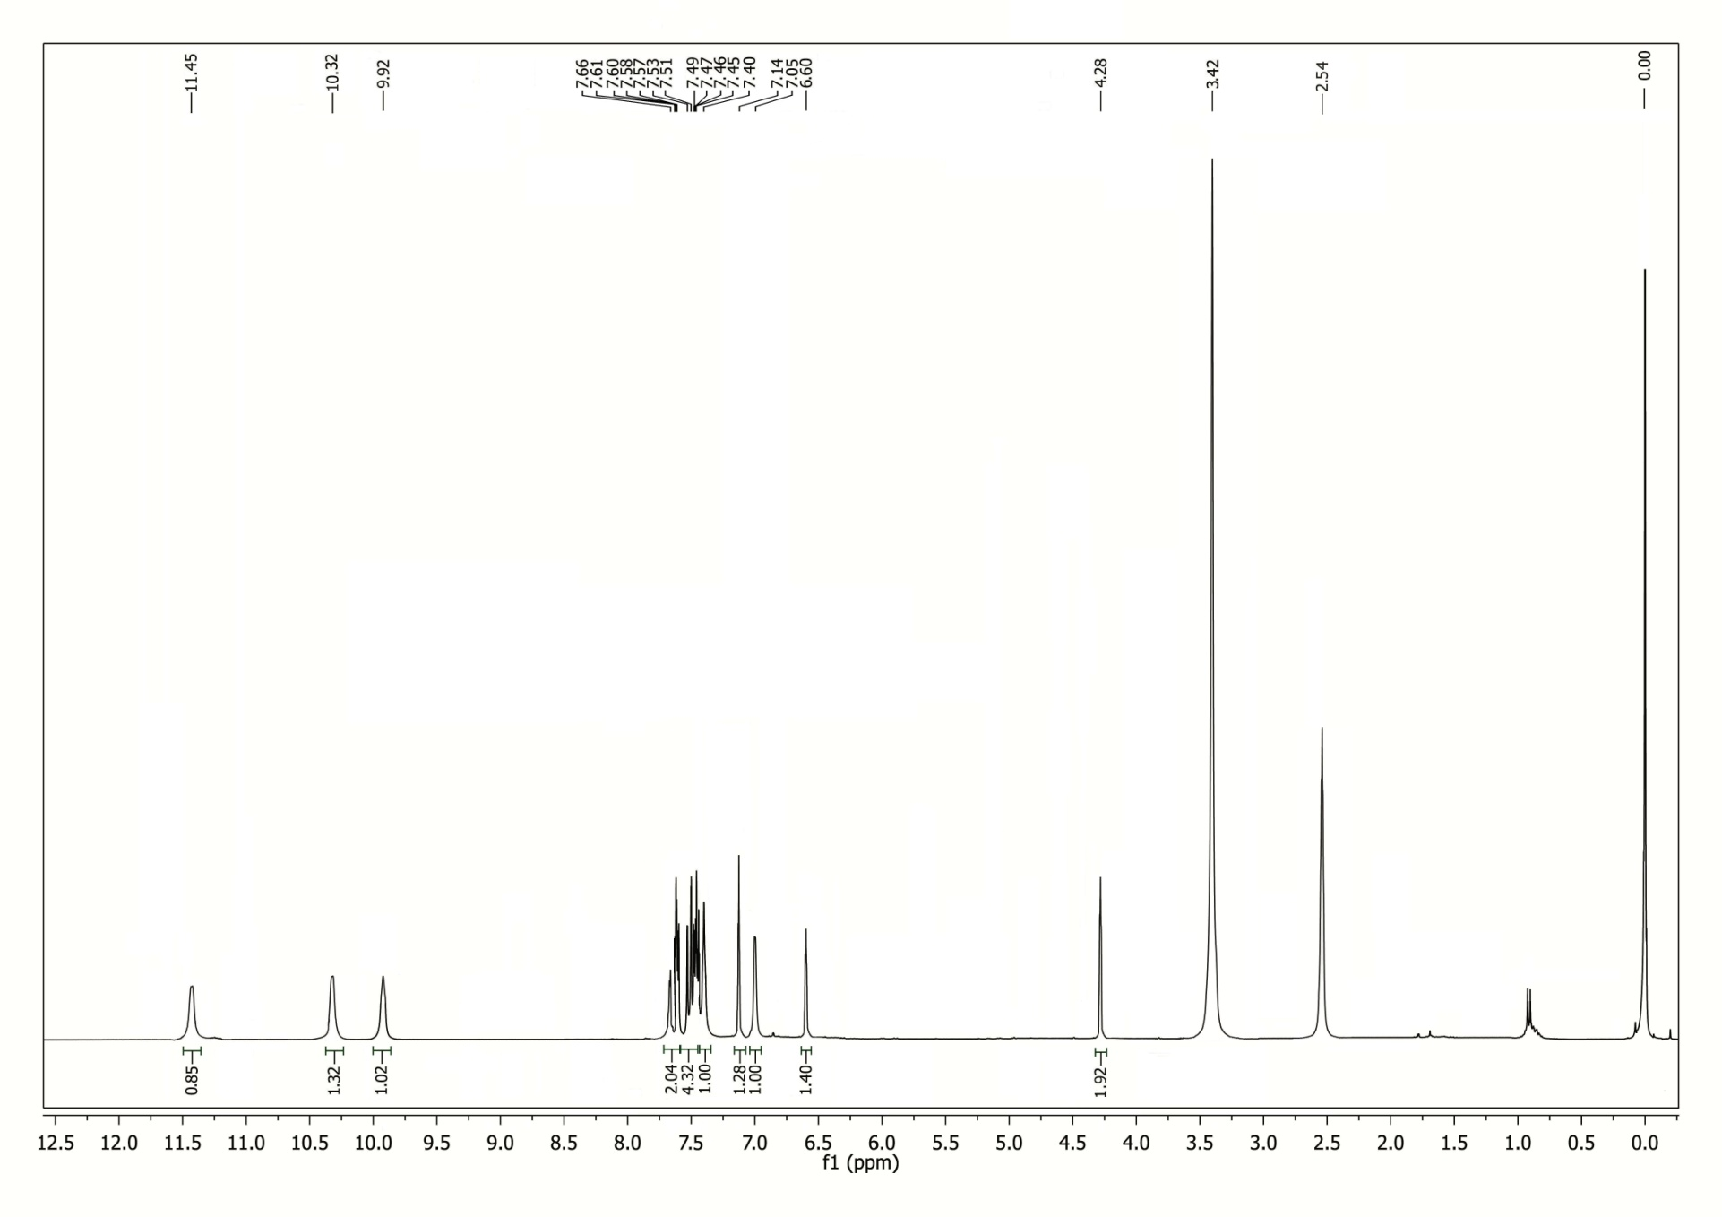
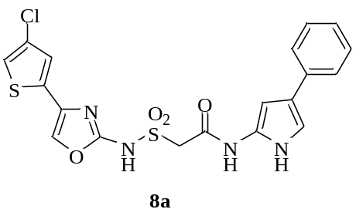¹H NMR spectrum of compound 8a
¹³C NMR spectrum of compound 8a
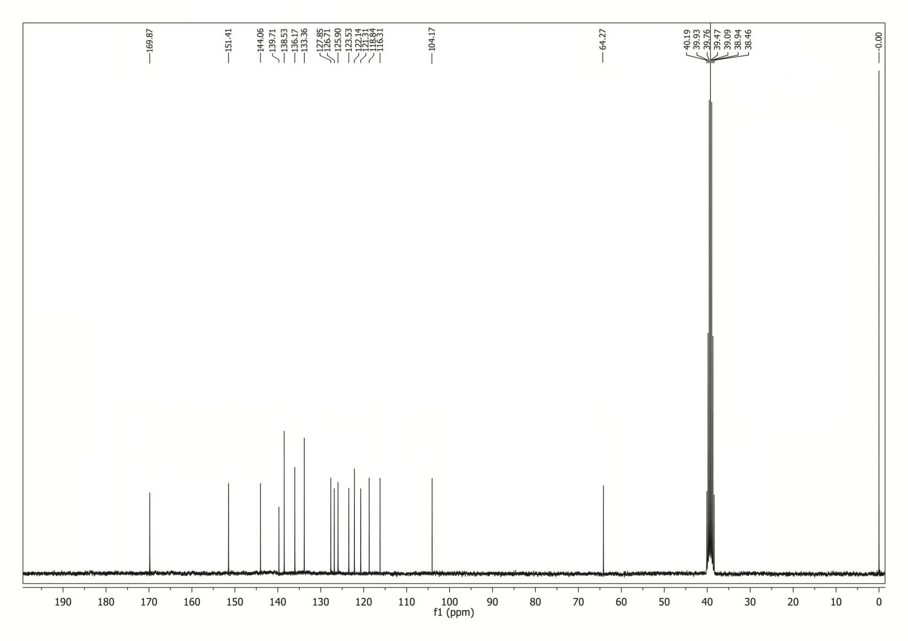
HRMS spectrum of compound 8a

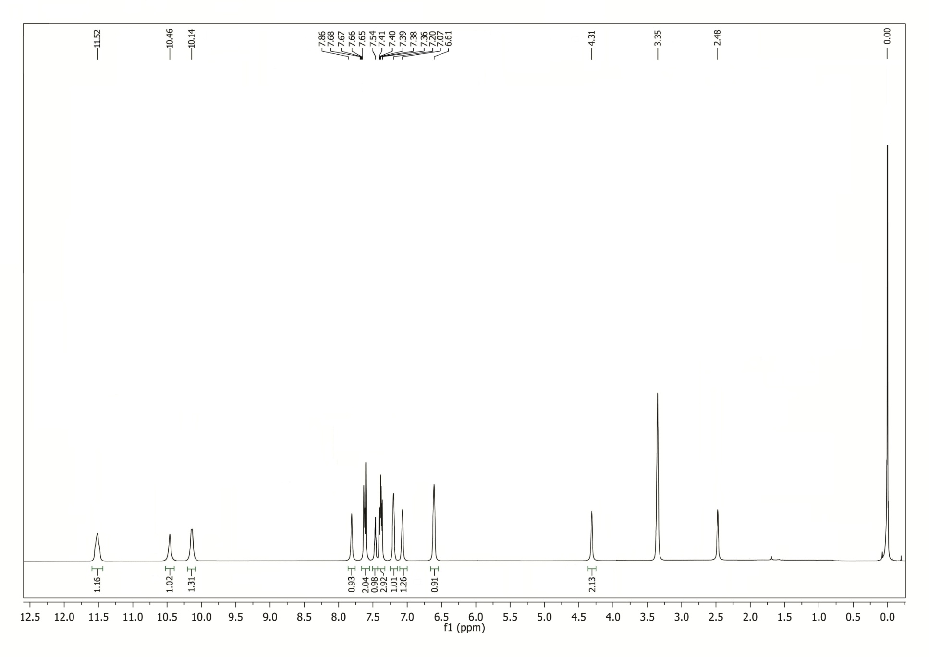
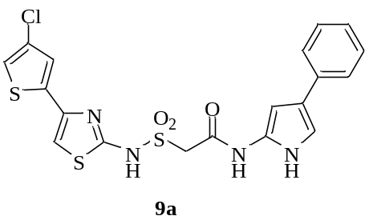¹H NMR spectrum of compound 9a
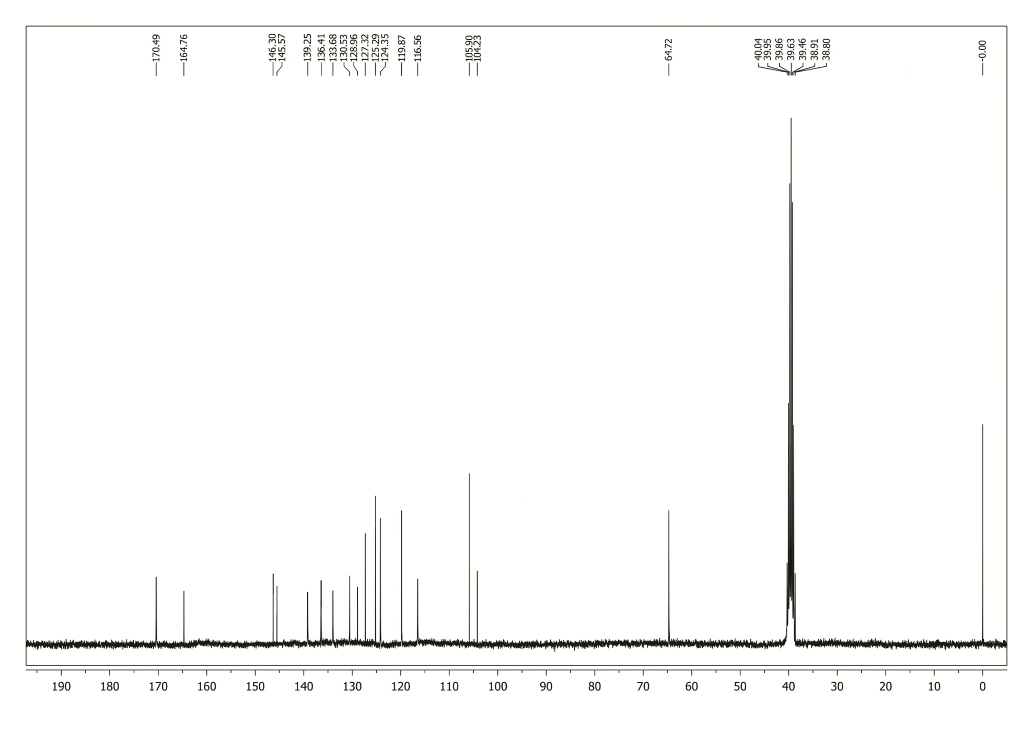
¹³C NMR spectrum of compound 9a
HRMS spectrum of compound 9a

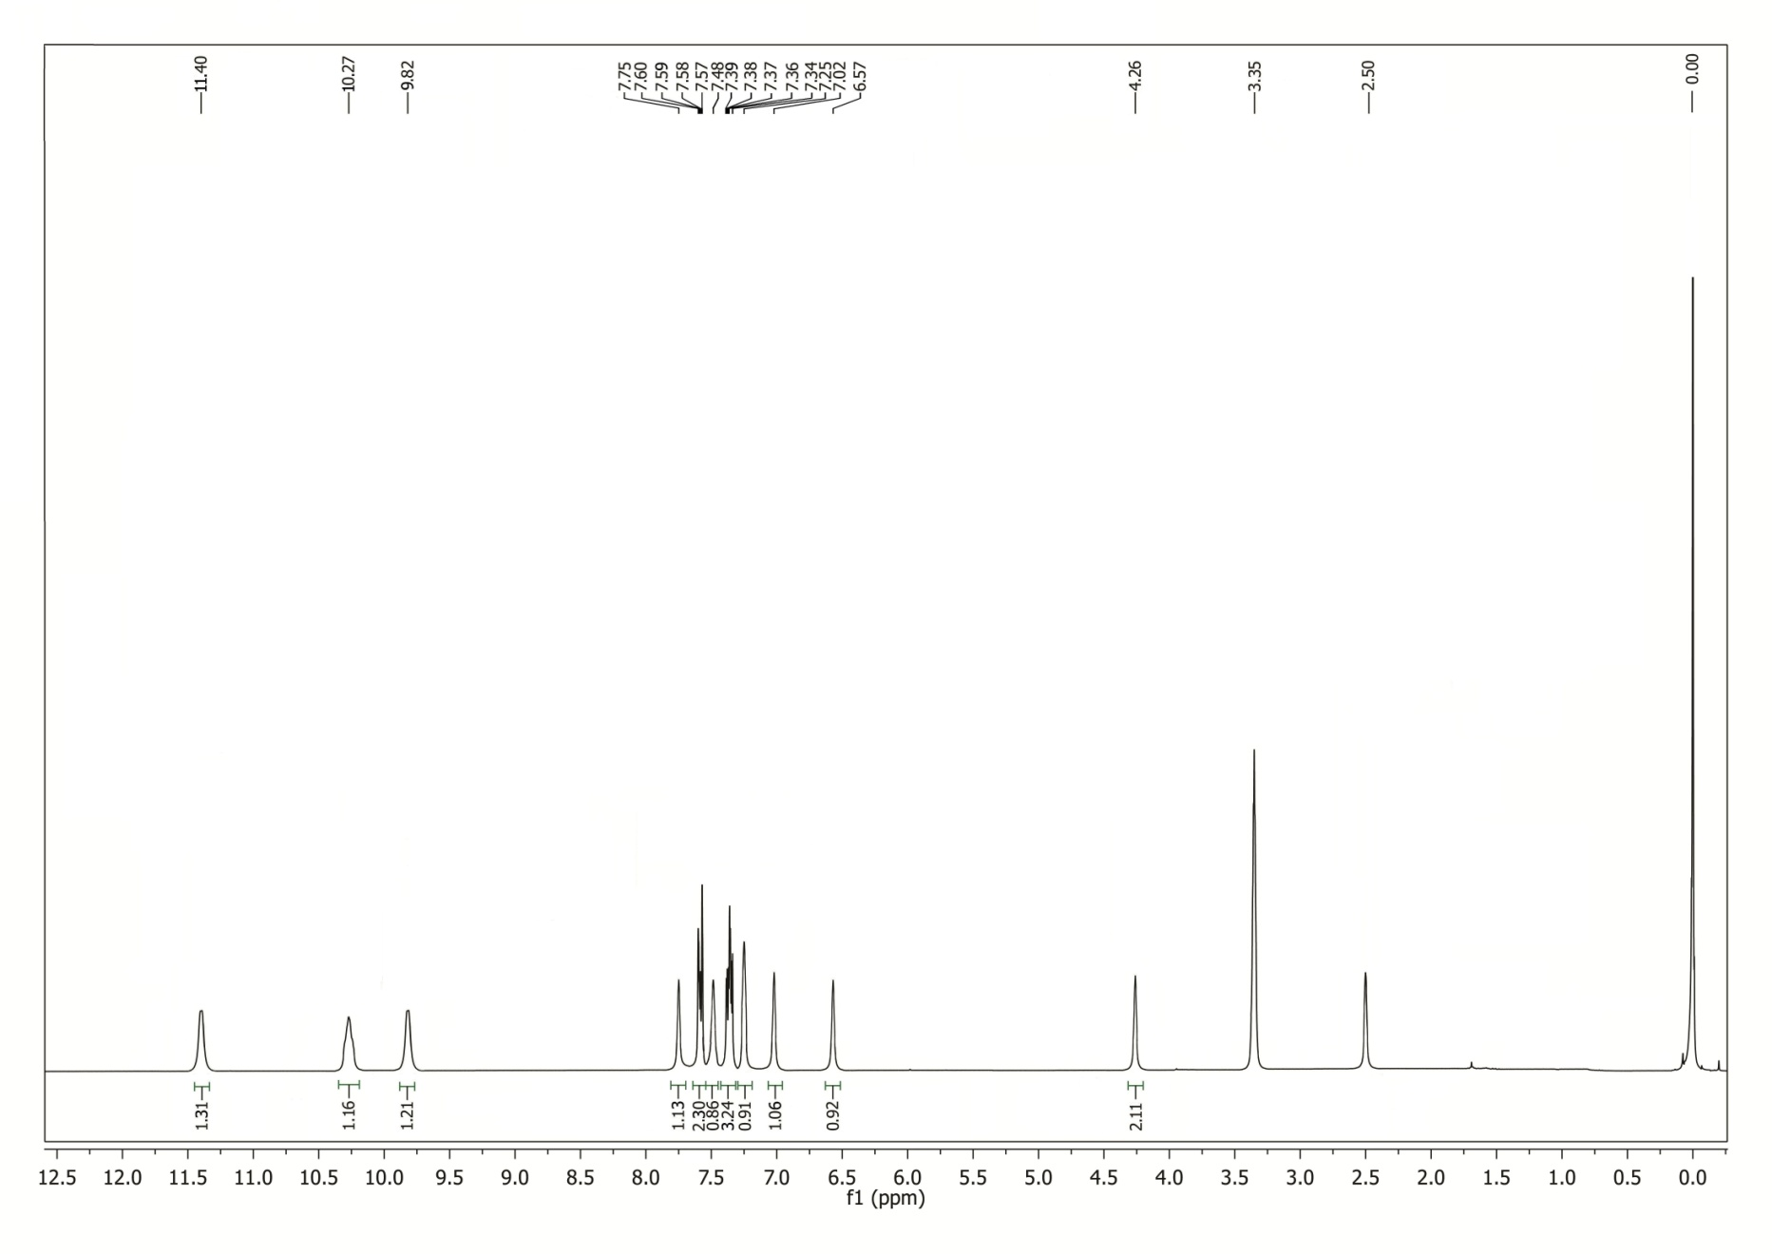
¹H NMR spectrum of compound 10a

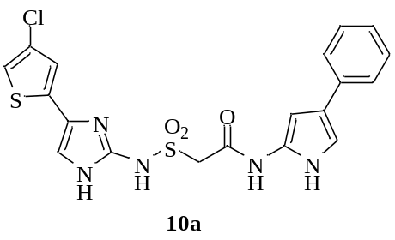

¹³C NMR spectrum of compound 10a
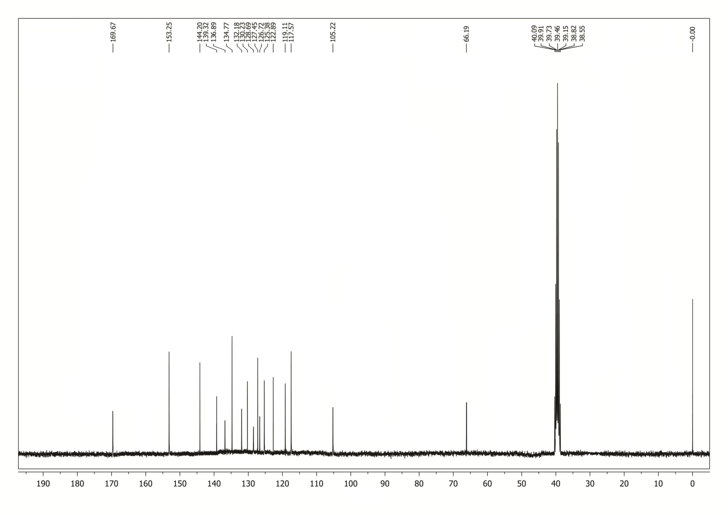
HRMS spectrum of compound 10a

