Supplementary Materials
Figure S1. Variable importance ranked using the Boruta algorithm.
Figure S2. LASSO regression analysis for feature selection.
Figure S 3. Variance inflation factor (VIF) analysis.
Figure S4. SHAP plots of feature contributions to the 28-day mortality prediction model. (A) Representative true negative case. (B) Representative true positive case.
Figure S5. Partial dependence plots of the model based on SHAP for the top nine features.

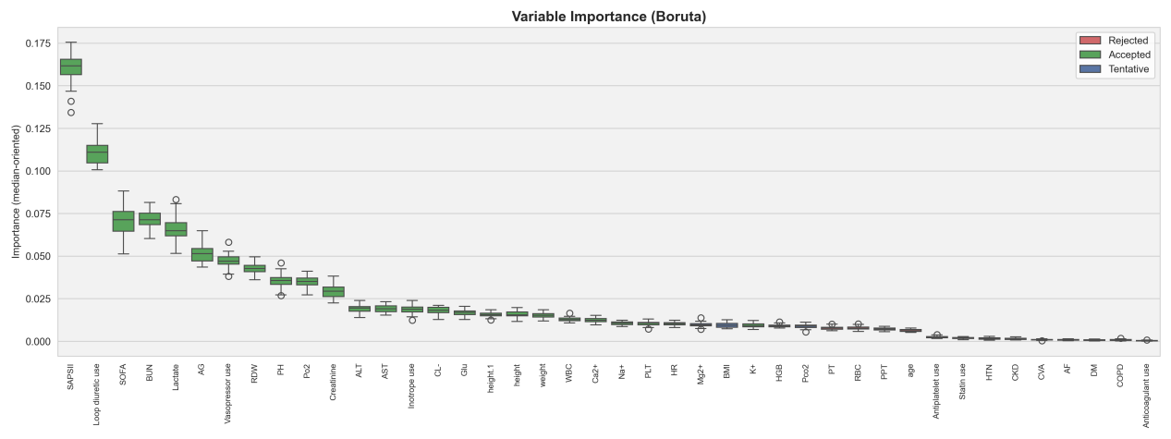Figure S1. Variable importance ranked using the Boruta algorithm.
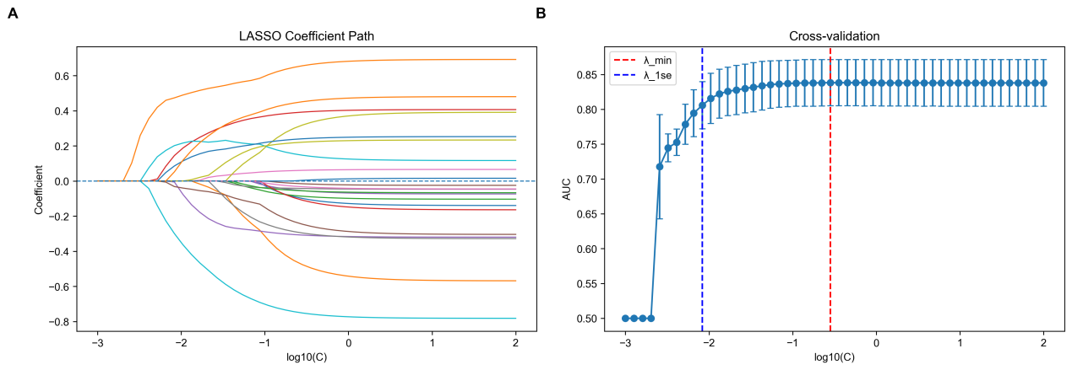
Figure S2. LASSO regression analysis for feature selection.

Figure S 3. Variance inflation factor (VIF) analysis.

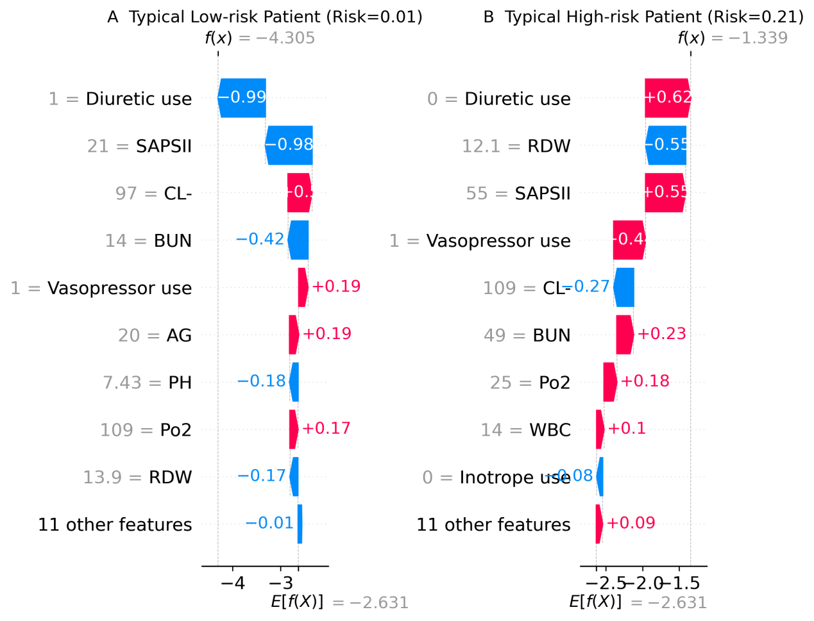
Figure S4. SHAP plots of feature contributions to the 28-day mortality prediction model. (A) Representative true negative case. (B) Representative true positive case.

Figure S5. Partial dependence plots of the model based on SHAP for the top nine features.

