Supplementary figure 1. Flow diagram of patient selection
RFA: radiofrequency ablation; LR: liver resection

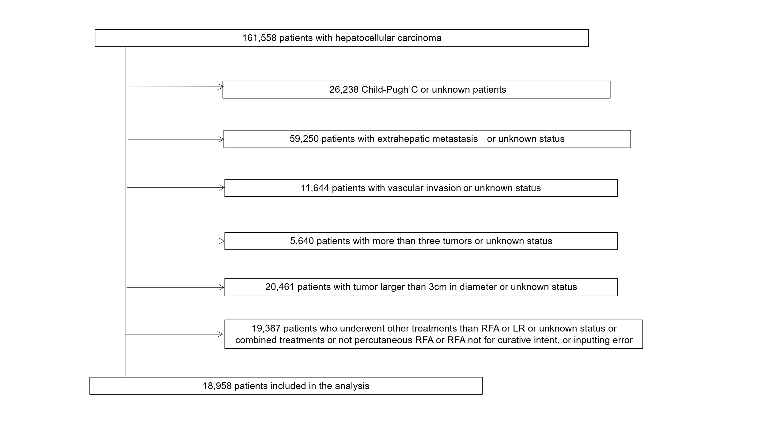
Supplementary figure 2. Overall survival of the entire cohort.
RFA: radiofrequency ablation, LR: liver resection.
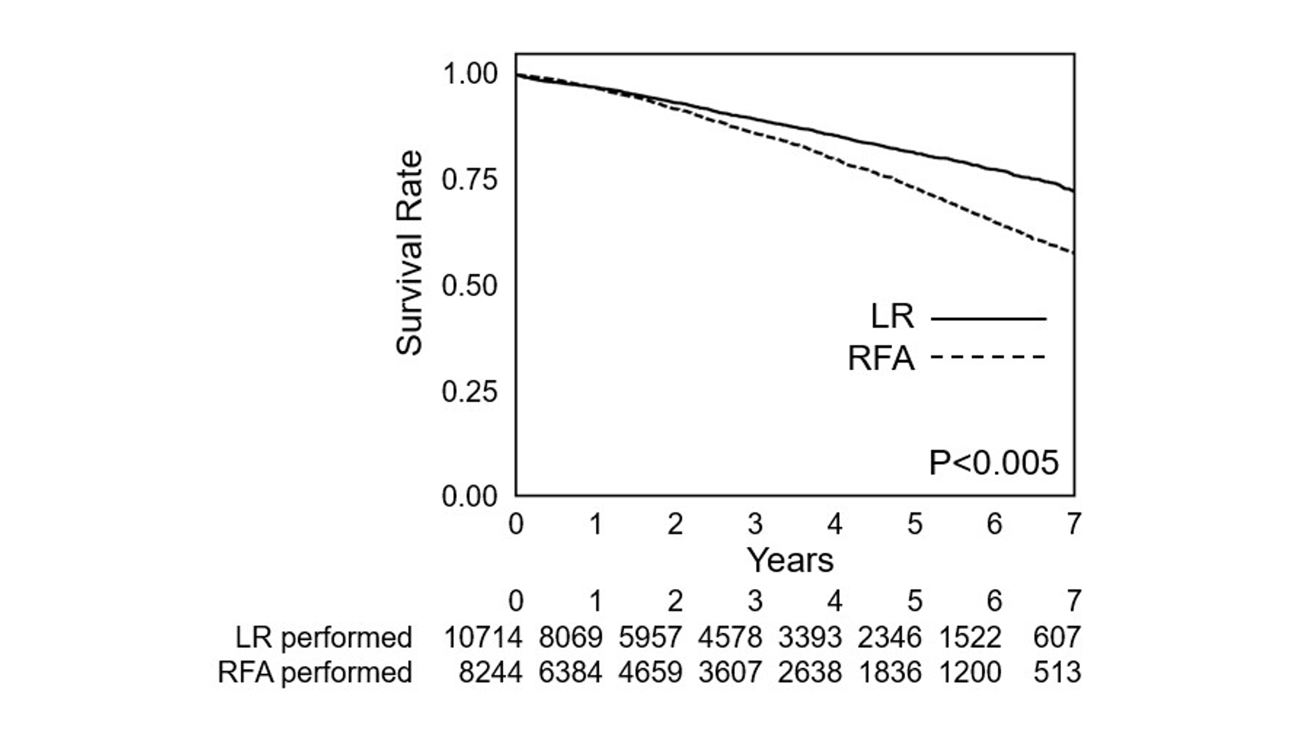
Supplementary table 1. Baseline characteristics according to recommended treatment type among Child–Pugh A patients
Treatment | RFA recommended  (n = 3,174) | LR recommended  (n = 13,464) | Difference* [95% CI]
Age | 66.1 (10.6) | 70.0 (9.3) | −3.9 [−16.0, 8.2]
Sex (Male/Female) | 2,036/1,138 (64.1/35.9) | 9,271/4,193 (68.9/31.1) | −4.7 [−6.6, −2.9]  /4.7 [2.9, 6.6]
mALBI grade 1 | 3,015 (95.0) | 6,949 (51.6) | 43.4 [42.2, 44.5]
Single tumor | 2899 (91.3) | 11,091 (82.4) | 9.0 [7.8, 10.1]
Maximum tumor diameter (cm) | 1.8 (0.6) | 2.0 (0.6) | −0.2 [−1.0, 0.6]
HCV-Ab-positive | 1490 (46.9) | 7521 (55.9) | −8.9 [−10.8, −7.0]
HBsAg-positive | 1,074 (33.8) | 1,616 (12.0) | 21.8 [20.1, 23.6]
AFP (ng/mL) | 14.3 (6.2) | 16.0 (5.6) | 0.9 [0.1, 8.1]
Platelet count (×10⁴/mm³) | 14.1 (1.6) | 12.7 (1.6) | 1.1 [0.6, 2.0]
Serum albumin (g/dL) | 4.3 (0.3) | 3.9 (0.4) | 0.3 [−0.2, 0.9]
Serum bilirubin (mg/dL) | 0.7 (1.5) | 0.8 (1.5) | 0.9 [0.5, 1.6]
Prothrombin activity (%) | 92.9 (12.8) | 88.5 (13.7) | 4.4 [−12.7, 21.5]
Early enhancement** | 2,271 (71.6) | 12,271 (91.1) | −19.6 [−21.2, −17.9]
Washout *** | 2,387 (75.2) | 11,537 (85.7) | −10.5 [−12.1, −8.9]
Data other than AFP, platelet count, and serum bilirubin levels are reported as mean values with standard deviations or as numbers (%). AFP, platelet count, and serum bilirubin levels are reported as geometric mean with geometric standard deviation.
LR, liver resection; RFA, radiofrequency ablation; mALBI, modified albumin–bilirubin; HCV-Ab, hepatitis C virus antibody; HBsAg, hepatitis B virus antigen; AFP, alpha-fetoprotein.
* The geometric mean ratios were used for AFP, platelet count, and serum bilirubin, whereas mean differences were used for all other variables,** arterial phase in contrast-enhanced computed tomography, *** portal phase in contrast-enhanced computed tomography

Supplementary table 2. Baseline characteristics according to recommended treatment or not recommended treatment among Child–Pugh A patients
Treatment | Recommended treatment  (n = 9,305) | Not recommended treatment  (n = 7,333) | Difference* [95% CI]
Age | 69.0 (9.4) | 69.4 (10.0) | −0.4 [−10.0, 9.3]
Sex (Male/Female) | 6,629/4,678  (71.2/28.8) | 4,678/2,655  (63.8/36.2) | 7.4 [6.0, 8.9]  /−7.4 [−8.9, −6.0]
mALBI grade 1 | 5,967 (64.1) | 3,997 (54.5) | 9.6 [8.1, 11.1]
Single tumor | 7,895 (84.8) | 6,095 (83.1) | 1.7 [0.6, 2.9]
Maximum tumor diameter (cm) | 2.0 (0.6) | 1.8 (0.6) | 0.3 [−0.3, 0.9]
HCV-Ab-positive | 4,798 (51.6) | 4,213 (57.5) | −5.9 [−7.4, −4.4]
HBsAg-positive | 1,445 (15.5) | 1,245 (17.0) | 0.3 [−0.3, 0.9]
AFP (ng/mL) | 15.3 (6.1) | 16.0 (5.3) | 1.0 [0.6, 1.5]
Platelet count (10⁴/mm³) | 13.6 (1.6) | 12.1 (1.6) | 1.1 [0.7, 1.8]
Serum albumin (g/dL) | 4.0 (0.4) | 4.0 (0.5) | 0.1 [−0., 0.5]
Serum bilirubin (mg/dL) | 0.7 (1.5) | 0.8 (1.5) | 1.0 [0.6, 1.5]
Prothrombin activity (%) | 89.8 (13.6) | 88.6 (13.6) | 1.2 [−12.4, 14.9]
Early enhancement** | 8,366 (89.9) | 6,176 (84.2) | 5.7 [4.7, 6.7]
Washout *** | 7,596 (84.9) | 6,028 (82.2) | 2.7 [1.5, 3.8]
Data other than AFP, platelet count, and serum bilirubin levels are reported as mean values with standard deviations or as numbers (%). AFP, platelet count, and serum bilirubin levels are reported as geometric mean with geometric standard deviation. LR, liver resection; RFA, radiofrequency ablation; mALBI, modified albumin–bilirubin; HCV-Ab, hepatitis C virus antibody; HBsAg, hepatitis B virus antigen.
* The geometric mean ratios were used for AFP, platelet count, and serum bilirubin, whereas mean differences were used for all other variables, ** arterial phase in contrast-enhanced computed tomography, *** portal phase in contrast-enhanced computed tomography.

Supplementary table 3. Baseline characteristics of 9,150 patients with hepatocellular carcinoma matched by propensity score according to recommended treatment or not recommended treatment among Child–Pugh A patients
Treatment | Recommended treatment  (n = 4,575) | Not recommended treatment  (n = 4,575) | Mean difference [95% CI] | SMD
Age | 68.9 (9.5) | 69.0 (10.1) | −0.1 [−9.9, 9.7] | 0.012
Sex (Male/Female) | 3,087/1488  (67.5/32.5) | 3,034/1541  (66.3/33.7) | 1.2 [−0.8, 3.1]  /−1.2 [−3.1, 0.8] | −0.025/0.025
mALBI grade 1 | 2,782 (60.8) | 2,767 (60.5) | 0.3 [−1.7, 2.3] | −0.007
Number of tumors | 1.2 (0.5) | 1.2 (0.5) | −0.0 [−0.5, 0.5] | 0.016
Maximum tumor diameter (cm) | 1.9 (0.6) | 1.9 (0.6) | 0.0 [−0.6, 0.6] | −0.015
HCV-Ab-positive | 2,495 (54.5) | 2,601 (56.9) | −2.3 [−4.4, −0.3] | 0.047
HBsAg-positive | 838 (18.3) | 849 (18.6) | −0.2 [−1.8, 1.3] | 0.006
Data other than AFP, platelet count, and serum bilirubin levels are reported as mean values with standard deviations or as numbers (%). AFP, platelet count, and serum bilirubin levels are reported as geometric mean with geometric standard deviation. LR, liver resection; RFA, radiofrequency ablation; mALBI, modified albumin–bilirubin; HCV-Ab, hepatitis C virus antibody; HBsAg, hepatitis B virus antigen.
* The geometric mean ratios were used for AFP, platelet count, and serum bilirubin, whereas mean differences were used for all other variables, ** arterial phase in contrast-enhanced computed tomography, *** portal phase in contrast-enhanced computed tomography.

