A stable catalyst for simultaneous catalytic removal of nitrogen oxide and toluene at low temperature

Yu Yan,¹ Linmin Lao,¹ Chengyan Li,^{*,2} Yang Yue,^{1,3} Guangren Qian,³ Jia Zhang ^{1,3,**}

¹ SHU Center of Green Urban Mining & Industry Ecology, School of Environmental and Chemical Engineering, Shanghai University, No. 381 Nanchen Road, Shanghai 200444, P. R. China
² Nanjing Institute of Environmental Sciences, Ministry of Ecology and Environment of the People's Republic of China, Nanjing 210042, China
³ MGI of Shanghai University, Xiapu Town, Xiangdong District, Pingxiang City, Jiangxi, 337022, P. R. China;

Corresponding authors
* E-mail: irujam@t.shu.edu.cn

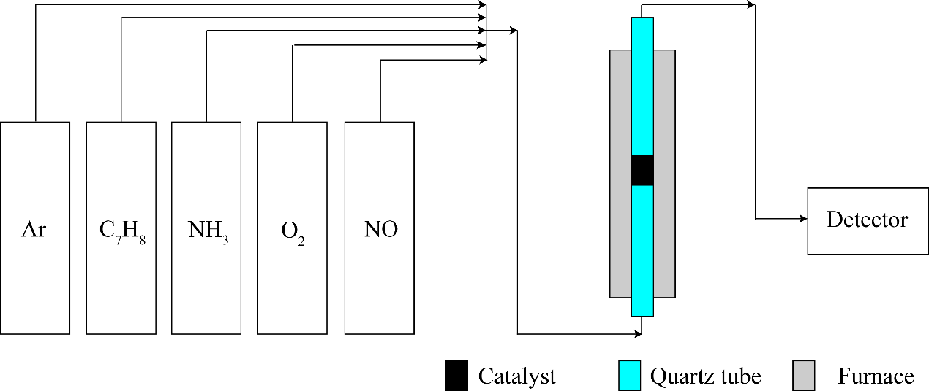
Fig. S1. Experimental setup.
Catalyst (1 g) was set in a quartz reactor (inner diameter = 15 mm), which was heated by a tube furnace. Then, Ar flushed the pipe system to clean residual air before a mixture gas flowed through the catalyst at a rate of 1000 mL·min⁻¹. The mixture gas contained 1000-ppm pollutant gas (toluene, NO, or both were 500 ppm), 1000/500-ppm NH₃, and 10% O₂ (Ar balance), which were controlled by mass flowmeters (Beijing Seven-star Electronics Co., Ltd.). After the furnace increased to a designed temperature, residual concentrations (toluene, NH₃, NO, NO₂, and N₂O) were detected by an MKS MultiGas infrared (IR) spectrometer.

Fig. S2. Conversions of NOx and toluene by V/TiO₂ in the absence of O₂.

