Supplementary Material
Defect–Interface Engineering of Machine Learning-Enhanced Au–VSe₂–MXene Nanocomposites with Tuned Electronic States for Trace Antibiotic Sensing

Ezhil Vilian^{a*}, Sujina Tamang^{b}, Elangovan Sarathkumar^{c}, Ramapurath S. Jayasree^{c} , Yun Suk Huh^{b*}, Young-Kyu Han^{a*}

ªDepartment of Energy and Materials Engineering, Dongguk University-Seoul, Seoul 04620, Republic of Korea.
^{b}Department of Biological Engineering, Inha University, Incheon 22212, Republic of Korea.
^{c}Division of Biophotonics and Imaging, Biomedical Technology Wing, Sree Chitra Tirunal Institute for Medical Sciences and Technology, Poojappura, Thiruvananthapuram, 695012, Kerala, India

Corresponding authors*:
Department of Energy and Materials Engineering, Dongguk University-Seoul, Seoul 04620, Republic of Korea. E-mail: ezhil2040@dongguk.edu (E.Vilian)
Department of Biological Engineering, Inha University, Incheon 22212, Republic of Korea. E-mail: yunsuk.huh@inha.ac.kr (Y.S. Huh)
Department of Energy and Materials Engineering, Dongguk University-Seoul, Seoul 04620, Republic of Korea. E-mail: ykenergy@dongguk.edu (Y.-K. Han)

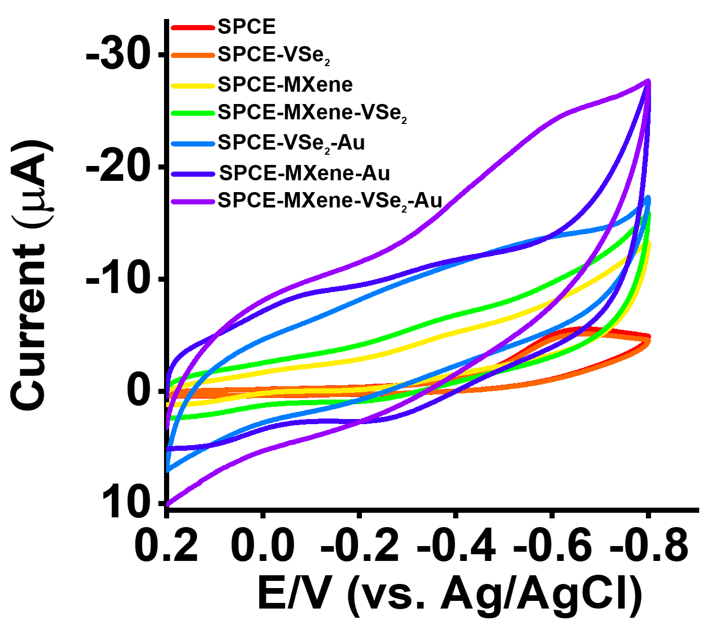
Figure S1. CV profiles obtained at various composites modified SPCE in the 0.05 M PB solutions (pH = 7.0) without 500 µM FZD.

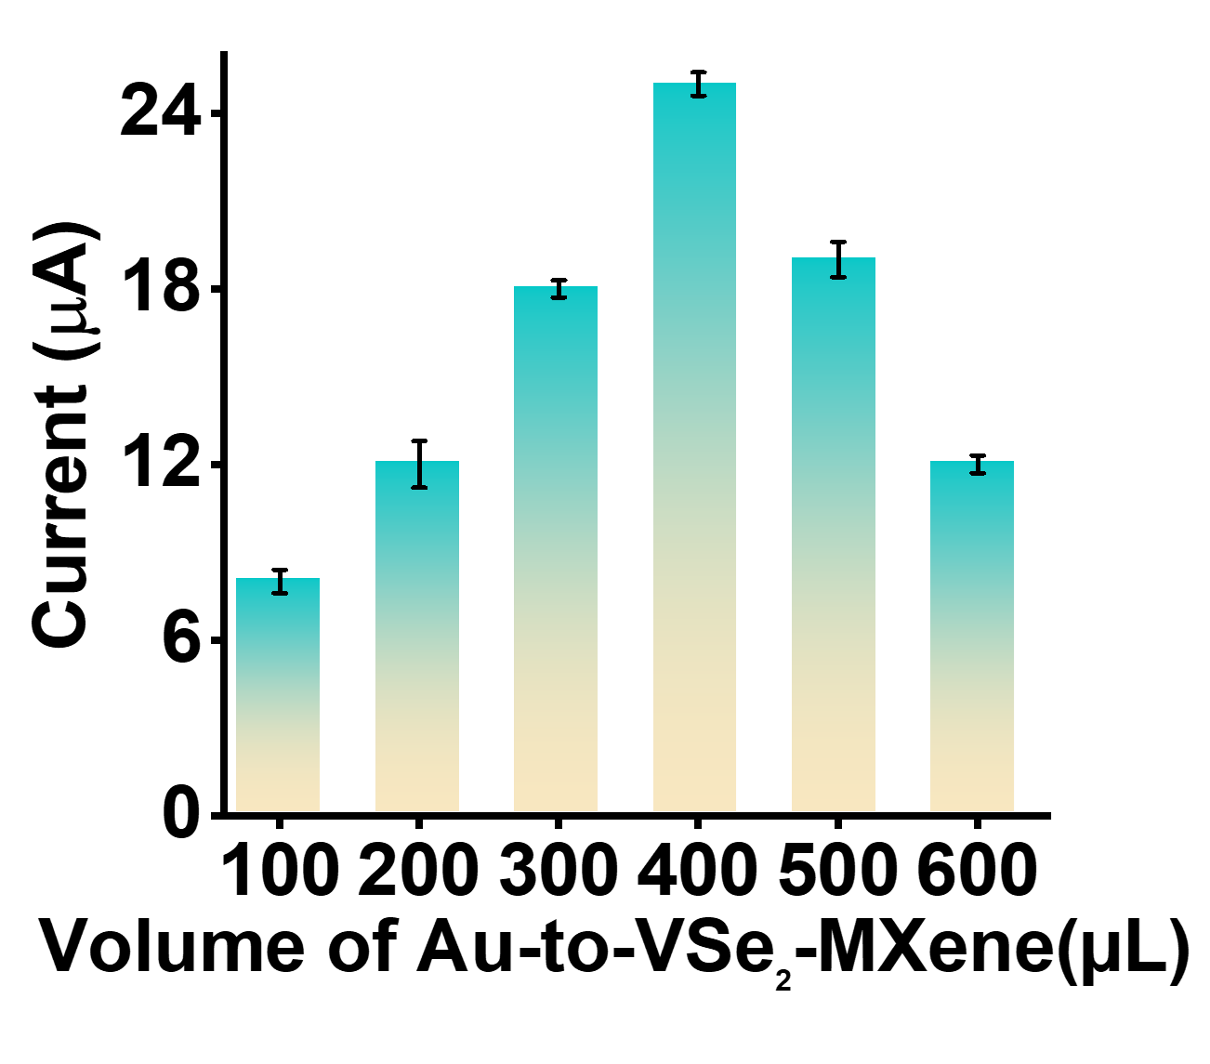
Figure S2. Electrochemical activity of the Au-VSe₂-MXene composite-modified SPCE recorded using different Au precursor volumes (100-600 μL) in 0.05 M phosphate buffer (pH 7.0) containing 500 µM FZD.

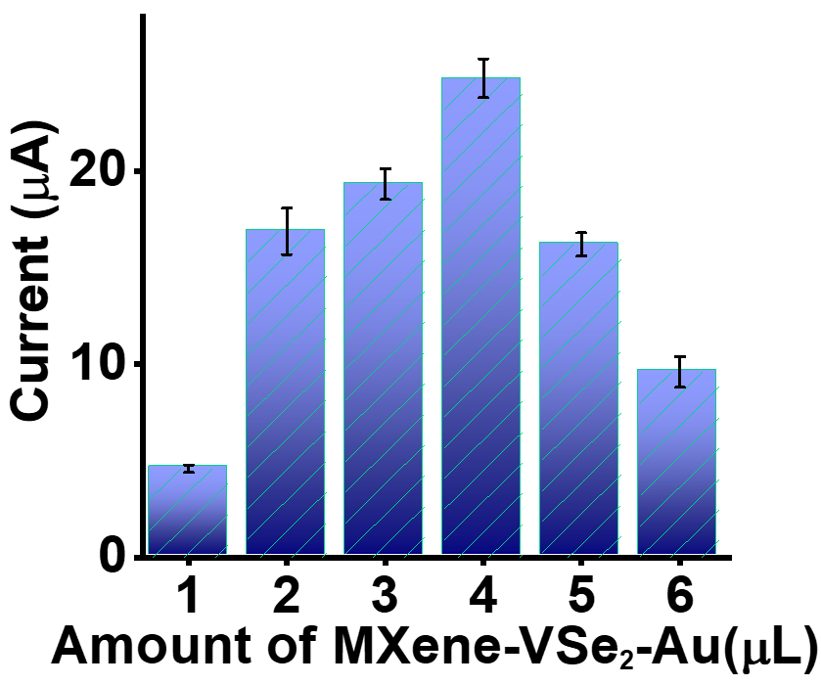
Figure S3. Electrochemical activity of the Au-VSe₂-MXene composite-modified SPCE at different composite loadings (1-6 μL) in 0.05 M phosphate buffer (pH 7.0) containing 500 µM FZD.

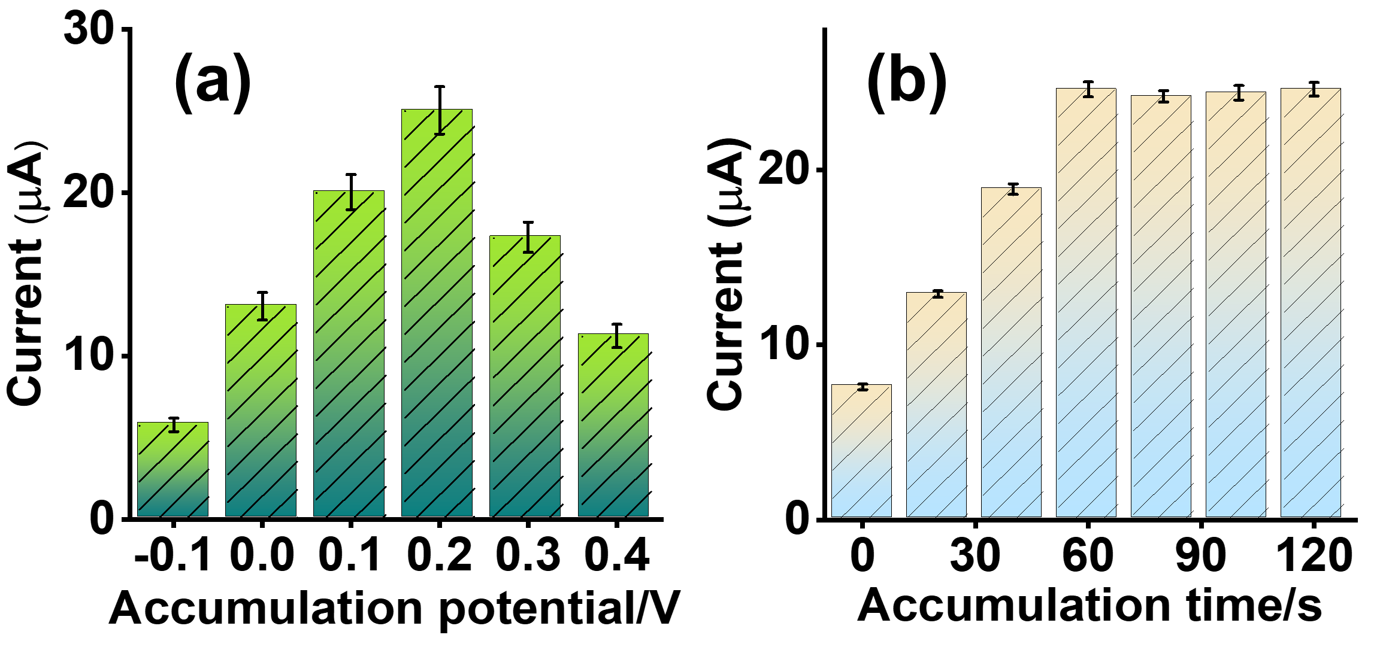
Figure S4. Impact of accumulation potential and accumulation time on the response of Au-VSe₂-MXene composites modified SPCE in the 0.05 M PB solutions (pH = 7.0) containing 100 nM FZD.

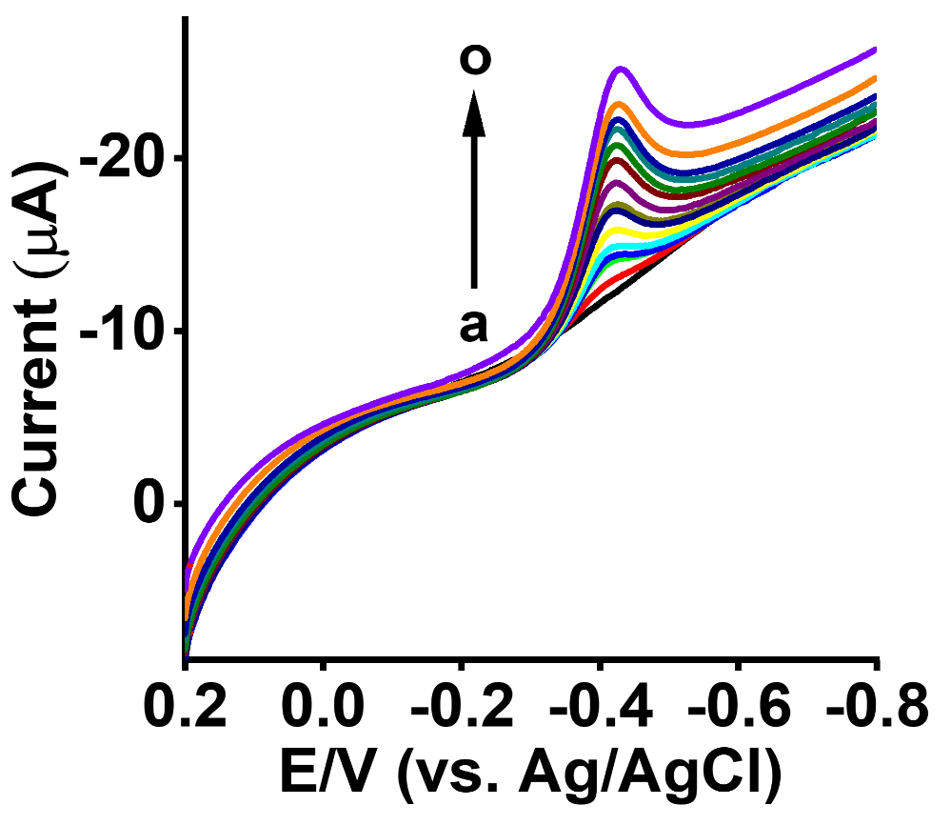
Figure S5. LSV profiles for Au-VSe₂-MXene-SPCE in 0.05 M PBS in the presence of different concentrations of FZD at a scan speed of 30 mV/s.
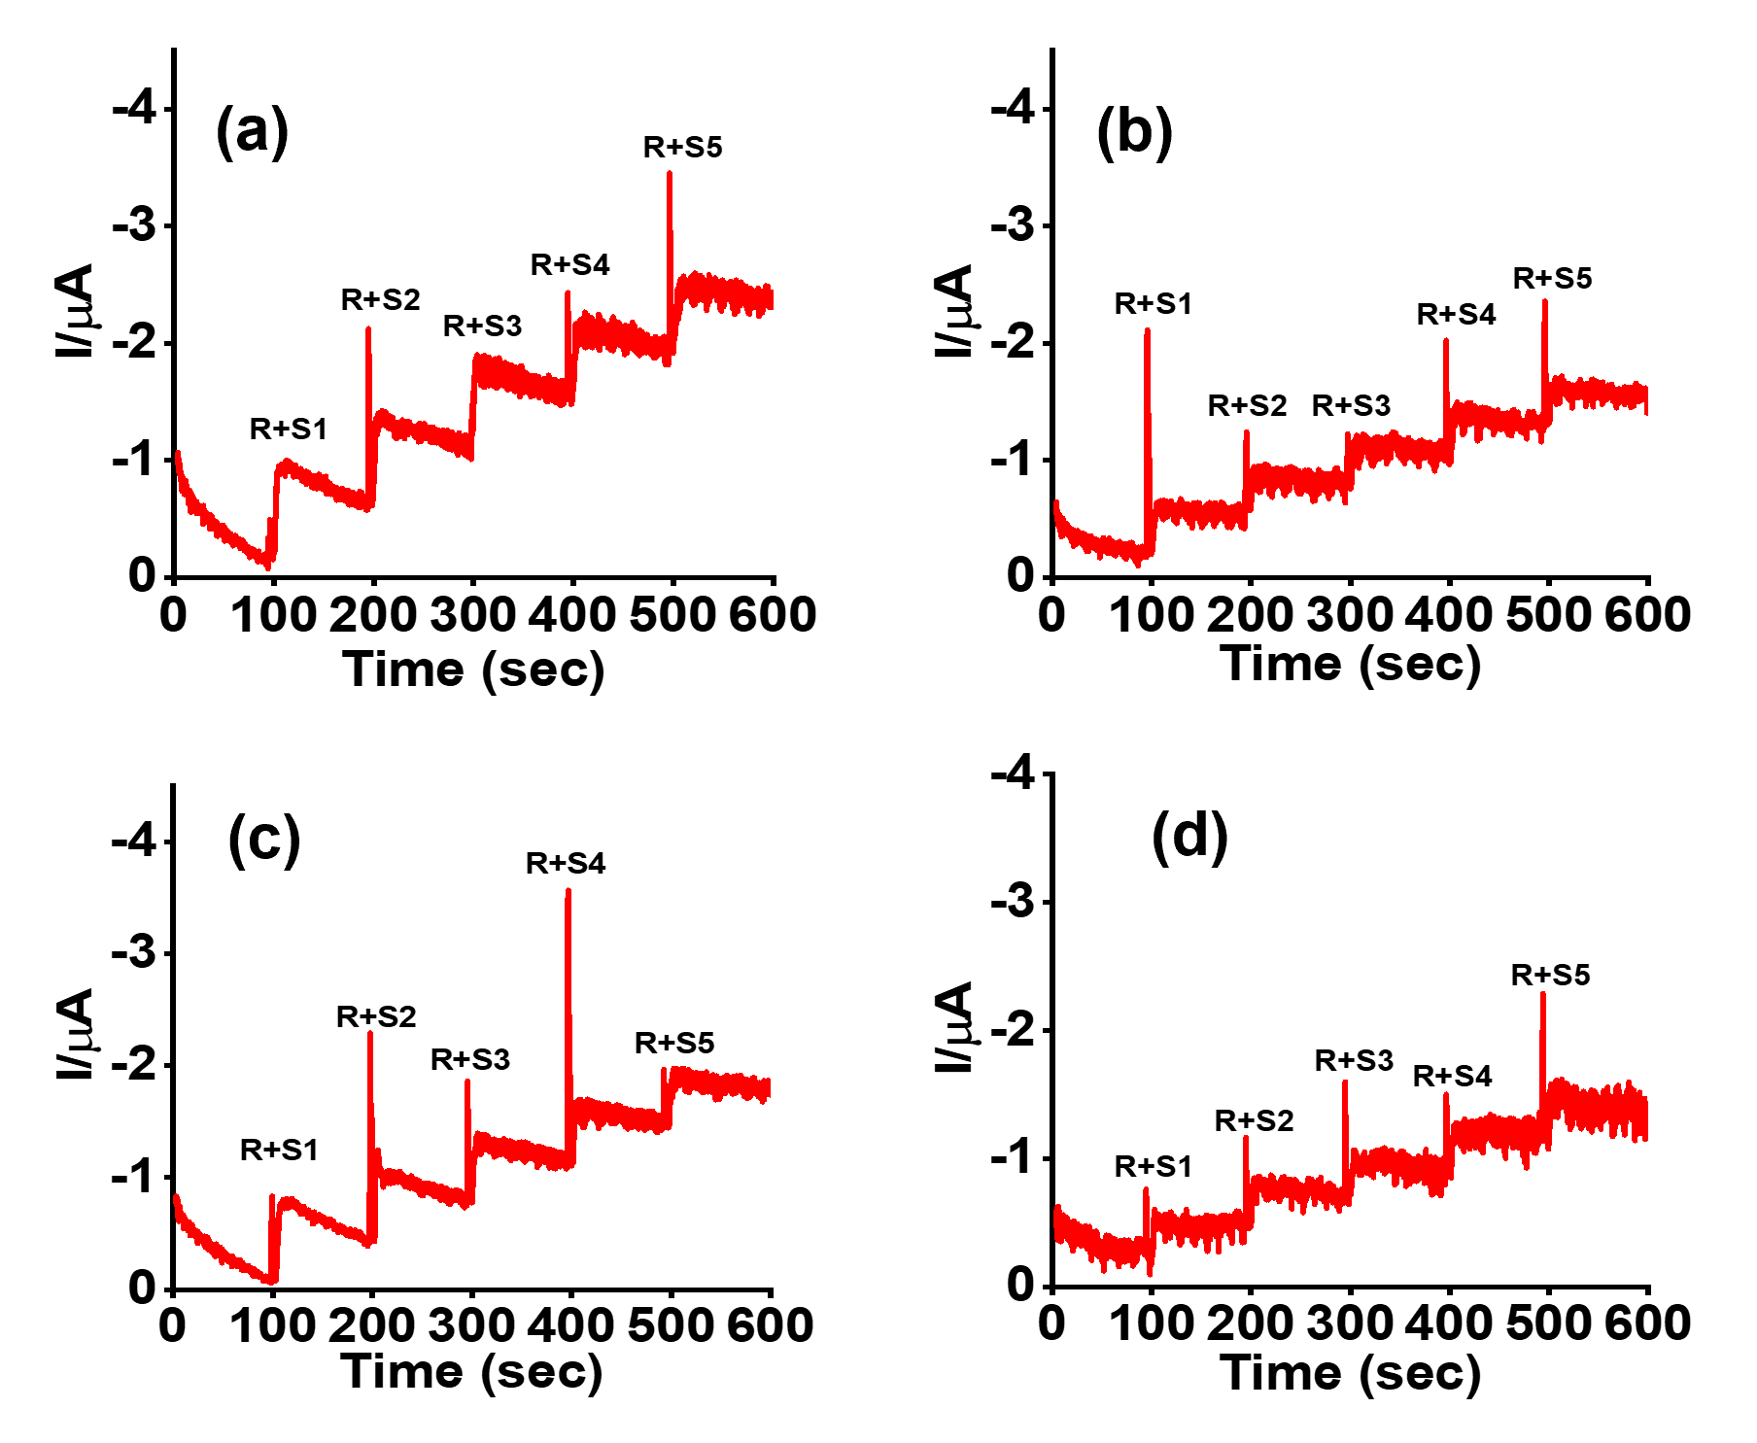

Figure S6. (a-d) Amperometric i-t response profiles of the Au-VSe₂-MXene-SPCE sensor for successive FZD additions in four environmental water matrices: hospital wastewater, pond water, river water, and lake water (in N₂‑saturated 0.05 M PBS, pH 7).

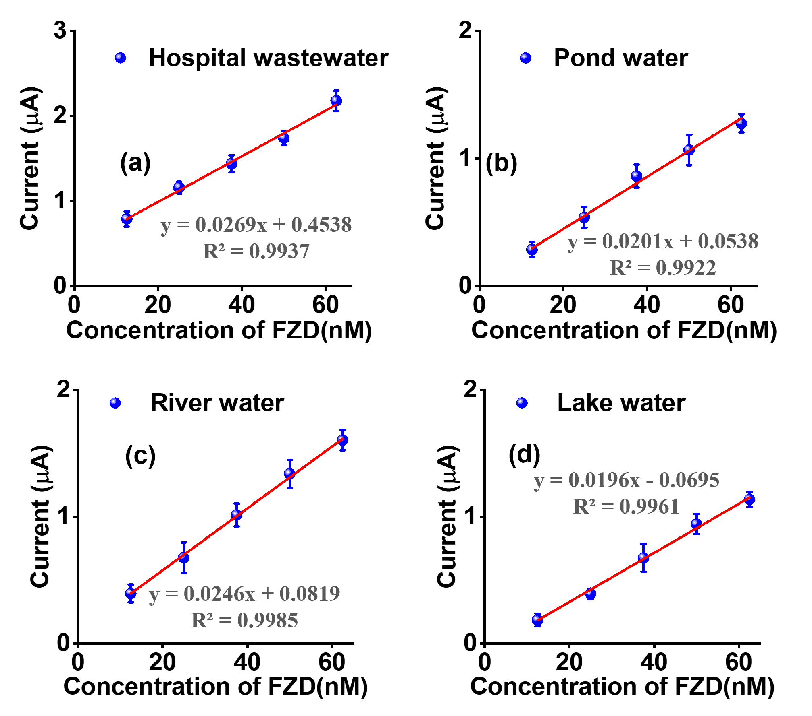
Figure S7. Linear calibration of FZD concentration vs. cathodic peak current for the Au‑VSe₂‑MXene/SPCE sensor in N₂‑saturated PBS (pH 7), applied to four environmental water matrices: hospital wastewater, pond water, river water, and lake water.

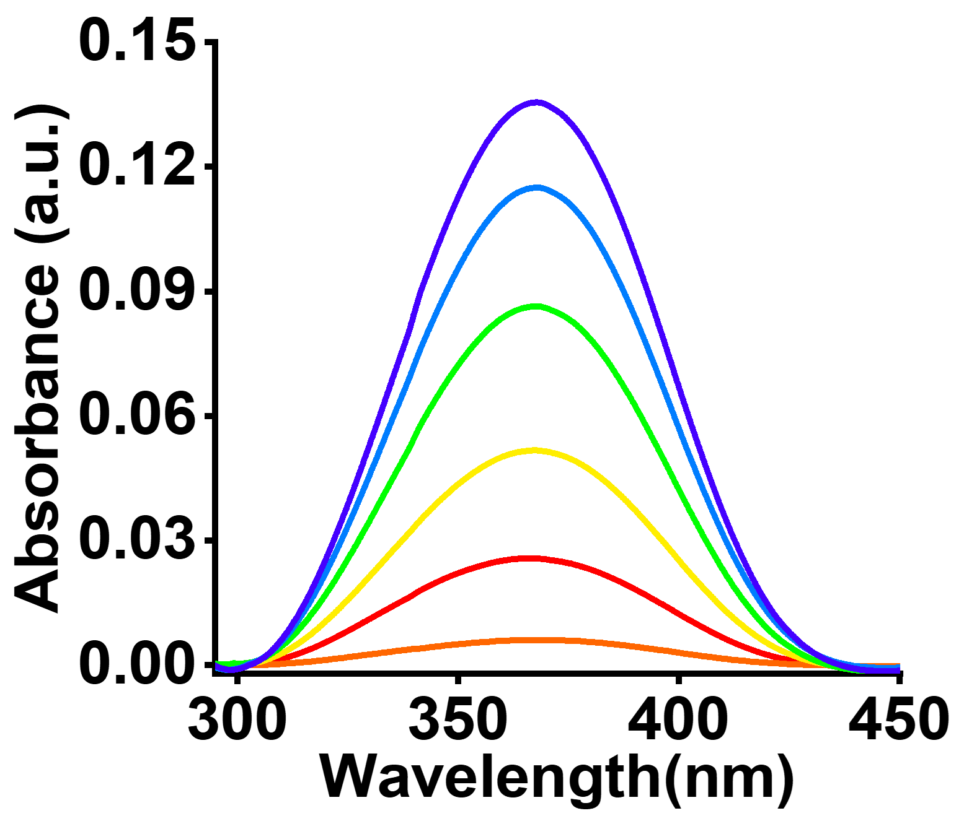
Figure S8. UV-vis spectra of different FZD concentrations (12, 24, 37, 49, and 62 nM).

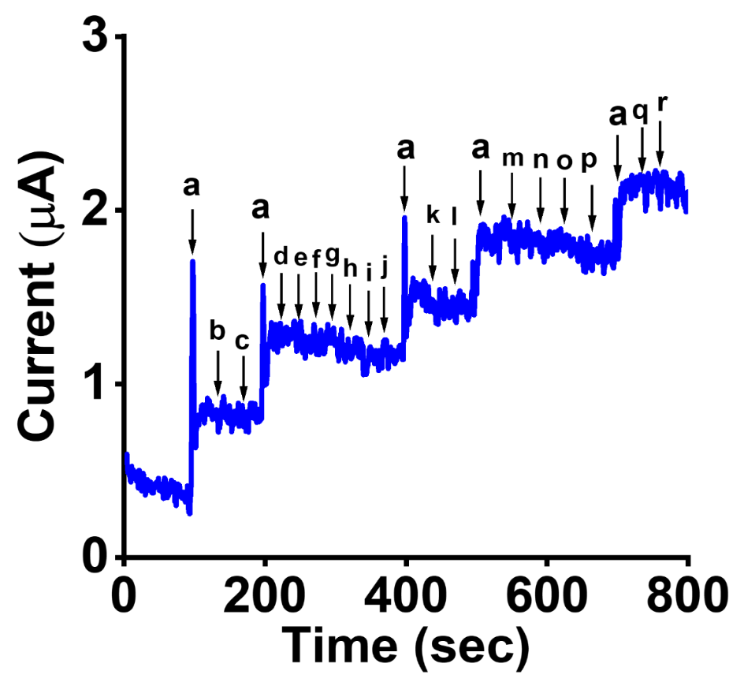
Figure S9. Amperometric responses of Au-VSe₂-MXene-RDE at -0.4 V to incremental injections of (a) FZD in the presence of (b-d) pharmaceutical drugs (metronidazole, nitrofurantoin, and chloramphenicol), (e-h) nitro compounds (nitrobenzene, catechol, hydroquinone and 4-nitrophenol),(i-m) interfering metal ions (Cd²⁺,K⁺,Pb²⁺, NO₃⁻ and SO₄²⁻), (n-p) biological compounds (UA, DA,AA), (q-r) organic interfering species (nutrient agar and casein-peptone).
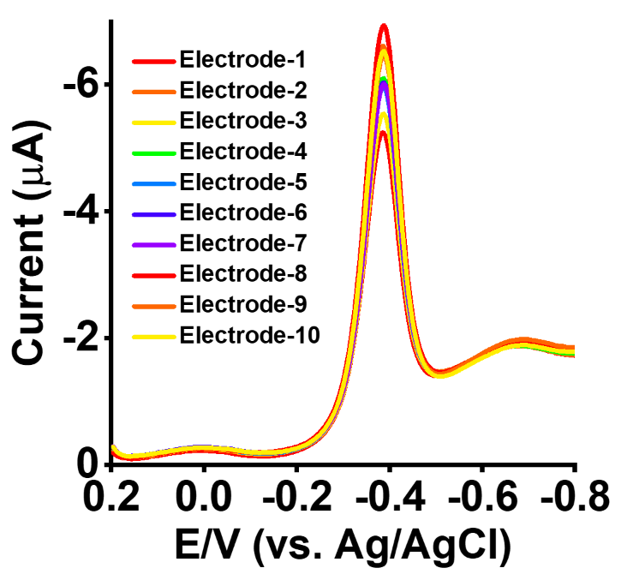
Figure S10. Reproducibility of Au-VSe₂-MXenecomposites modified SPCE in the 0.05 M PB solutions (pH = 7.0) containing 20 nM FZD.

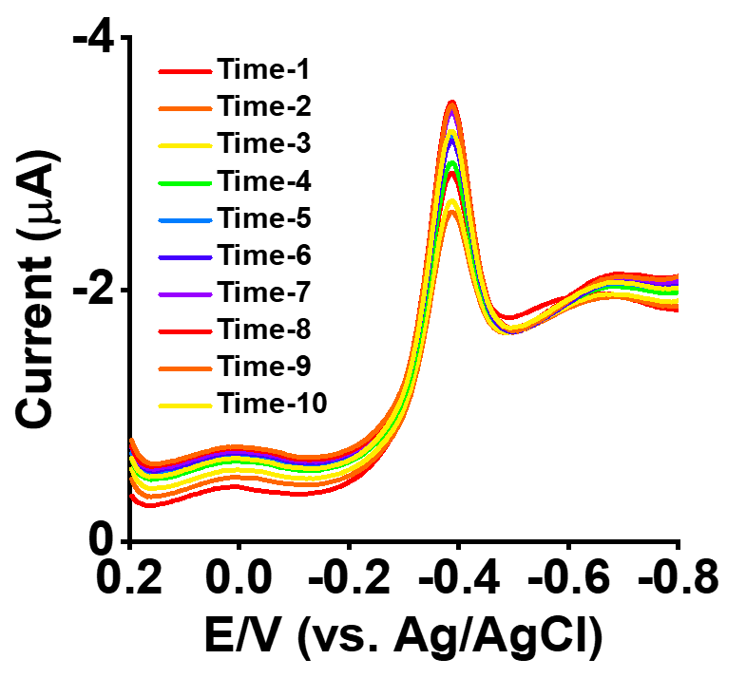
Figure S11. Repeatability of Au-VSe₂-MXenecomposites modified SPCE in the 0.05 M PB solutions (pH = 7.0) containing 20 nM FZD.

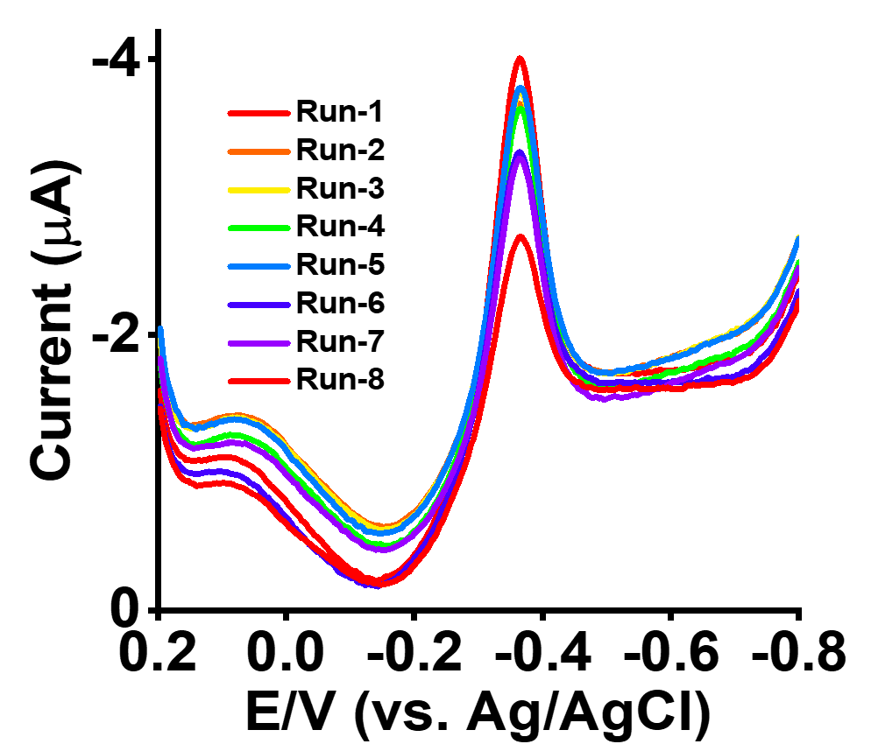
Figure S12. Reusability of Au-VSe₂-MXene composites modified SPCE in the 0.05 M PB solutions (pH = 7.0) containing 20 nM FZD.

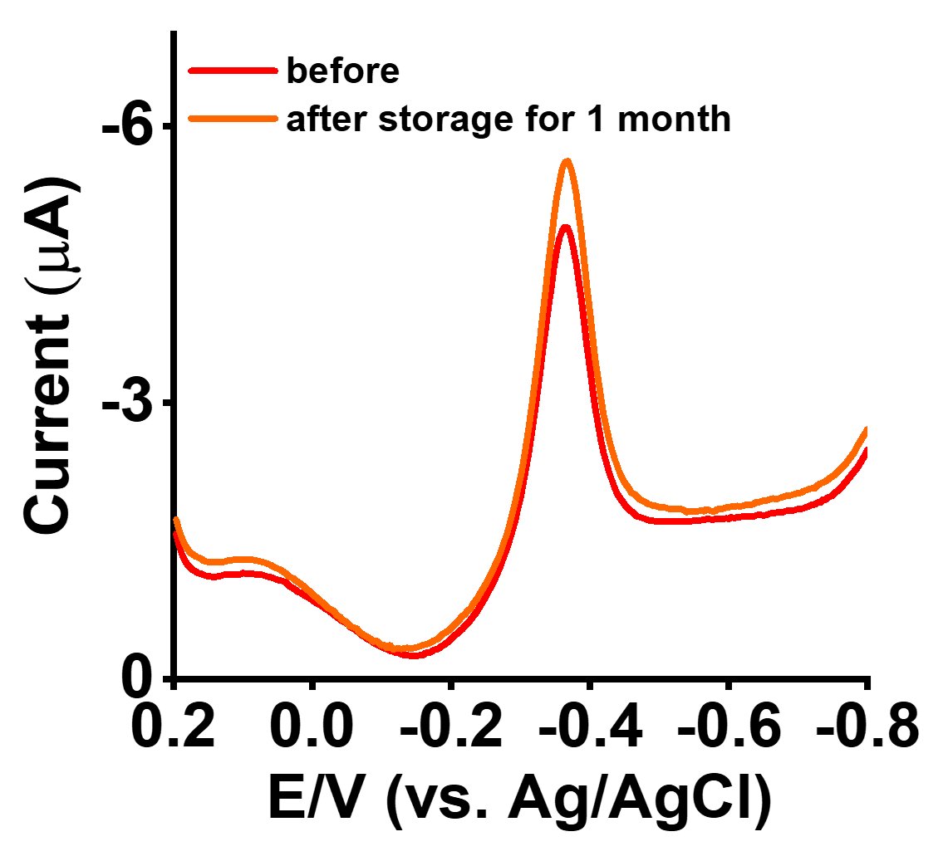
Figure S13.Sability of Au-VSe₂-MXene composites modified SPCE in the 0.05 M PB solutions (pH = 7.0) contain 20 nM FZD.

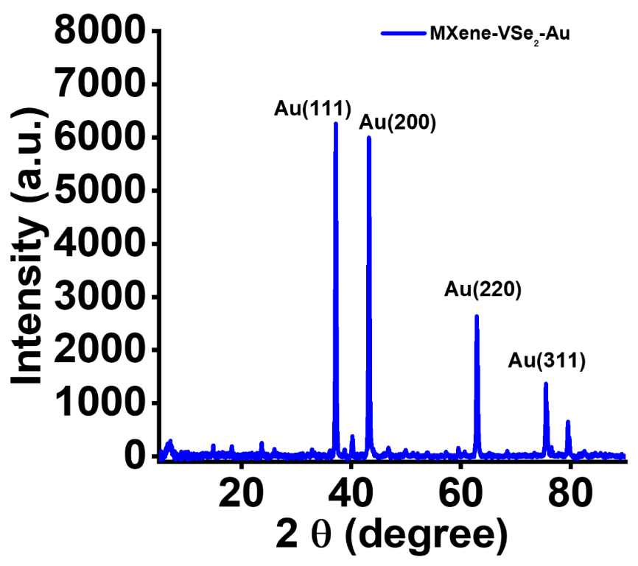
Figure S14.XRD spectra of Au-VSe₂-MXene-SPCE electrode after stability tests.
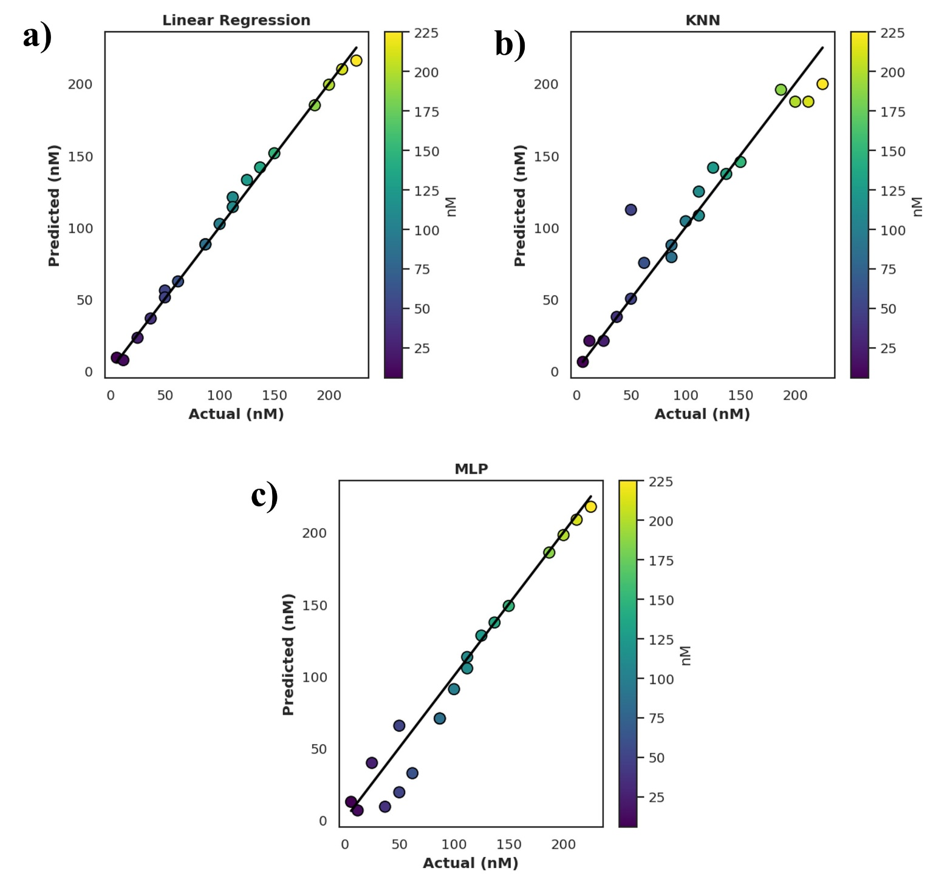
Figure S15. (a-c) Predicted versus actual concentration plots obtained using Linear Regression, KNN, and MLP models.

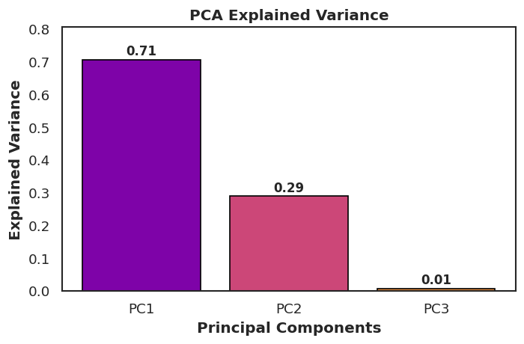
Figure S16. PCA explained variance distribution.

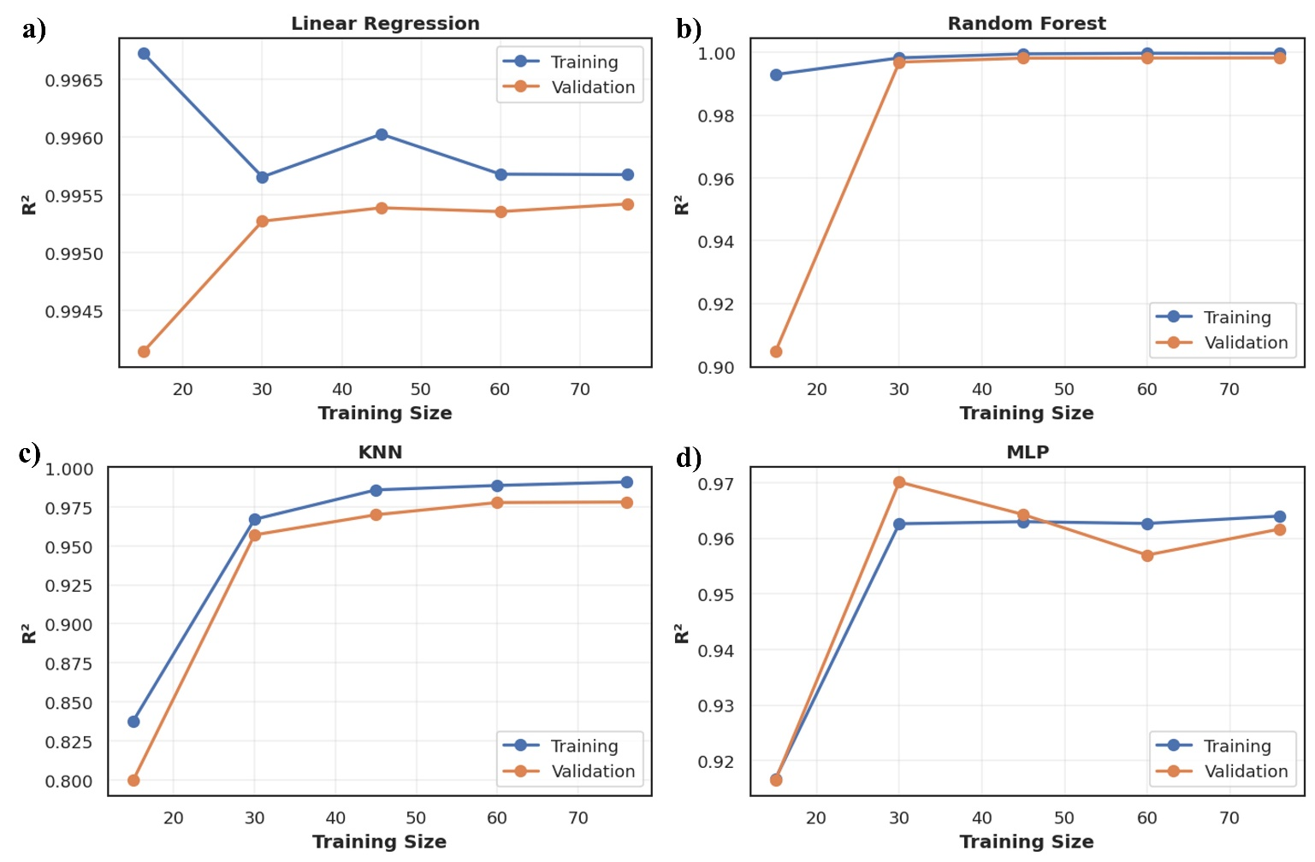
Figure. S17. Training and validation curves for (a) Linear Regression, (b) Random Forest, (c) KNN, and (d) MLP models showing model generalization behaviour

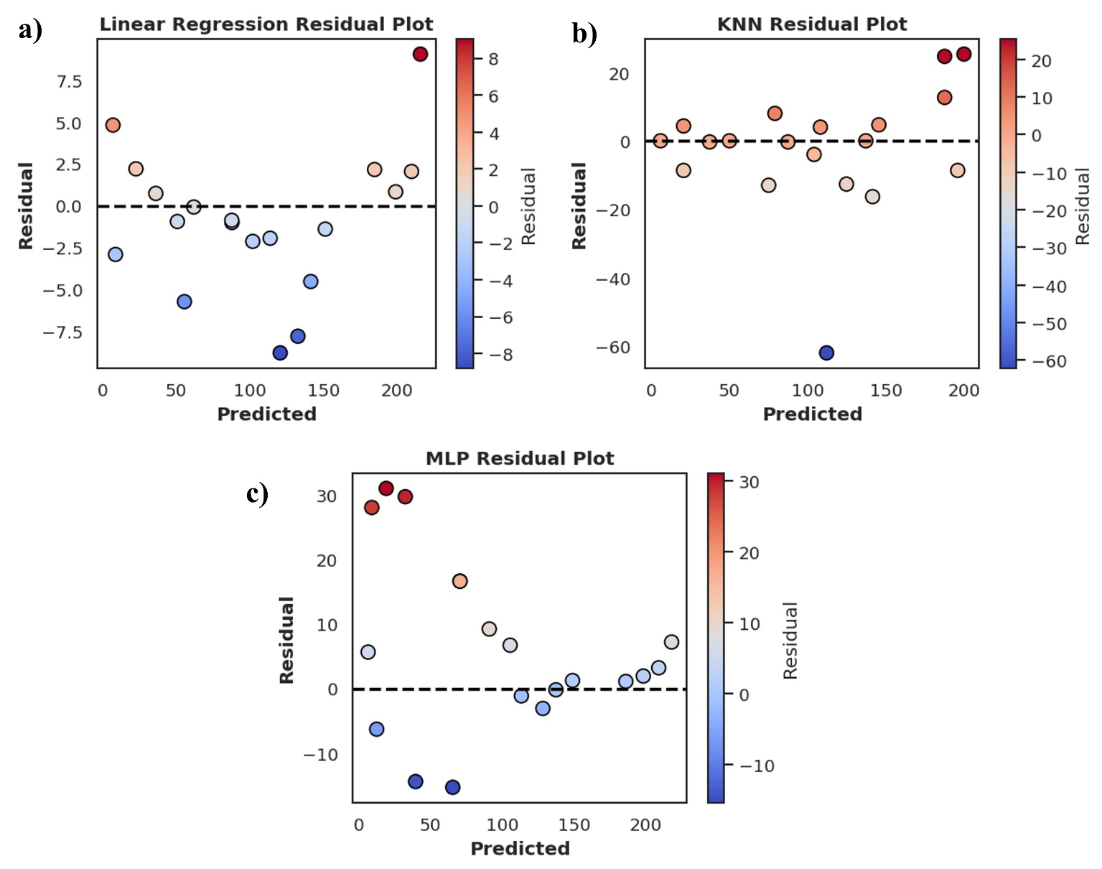
Figure. S18. Residual plots for (a) Linear Regression, (b) Random Forest, (c) KNN, and (d) MLP models

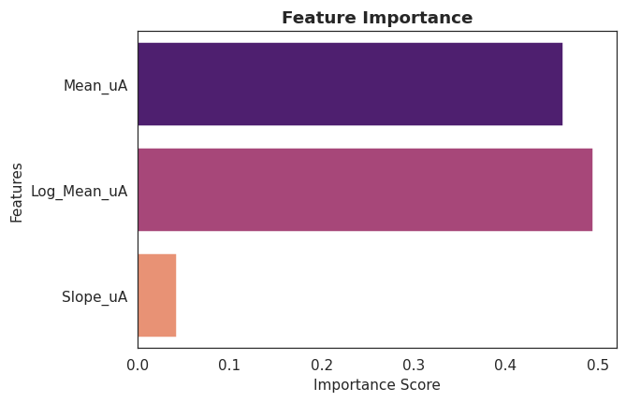
Figure. S19. Feature importance showing the contribution of electrochemical parameters to model prediction.

Table S1. Comparison of electrochemical parameters of different modified electrodes
Electrodes | R_{ct} (Ω) | Electron transfer rate (k°) constant (cm s⁻¹) | Cathodic peak potential (E_{pc} (V vs. Ag/AgCl)) | ΔEp in mV
Bare SPCE | 218 | 2.23 × 10⁻³ | -0.56 V | 262
VSe₂-SPCE | 332 | 3.39 × 10⁻³ | -0.63 V | 388
MXene-SPCE | 159 | 4.65 × 10⁻³ | -0.47 V | 250
VSe₂-MXene-SPCE | 108 | 6.85 × 10⁻³ | -0.45 V | 205
Au-VSe₂-SPCE | 80 | 9.44 × 10⁻³ | -0.43 V | 178
Au-MXene-SPCE | 60 | 1.26 × 10⁻² | -0.42V | 169
Au-VSe₂-MXene-SPCE | 45 | 1.68 × 10⁻² | -0.40 V | 150

Table S2. Performance comparison of Au-VSe₂-MXene sensor and other electrodes in FZD detection
Working electrode | Method | Linear range (µM) | LOD (nM) | Real sample | Refs.
NiCo₂O₄/GCE | DPV | 0.01-150 | 29.13 | FZD tablets and Serum | [1]
LaV/F-BN/GCE | Amperometry | 0.015-300 | 3 | human serum, and human urine | [2]
Pt-Re NP/PAC/GCE | DPV | 0.2-117.7 | 20.8 | human blood serum and human urine | [3]
Fe/NiMOFs/CNTs/rGO/GCE | CA | 0.5 -250 | 80 | eggs, milk and lake water | [4]
ZrMOF/CNT/nanocellulose/GCE | SWV | 10 -140 | 1.37 | Honey, milk and Paraxin | [5]
Co-MOF@CB/GCE | DPV | 0.4-610 | 87.5 | Milk, Honey, and Chicken | [6]
NFO/N-CNTs/GCE | Amperometry | 0.0025-152.76 | 8 | veterinary feed, human urine | [7]
GM-P/GCE | DPV | 0.2-78.2 | 0.27 | Piped water and River water | [8]
CuS-rGO/g-C₃N₄/GCE | DPV | 0.1-336.4 | 10.8 | Lake water | [9]
Au-VSe₂-MXene-SPCE | Amperometry | 6.0-225 | 0.21 | Hospital wastewater, pond water, river water, and lake water | This work
Fe/Ni-MOFs/CNTs/rGO/GCE = iron/nickel metal-organic framework/carbon nanotubes/reduced graphene oxide glassy carbon electrode; .ZrMOF/CNT/nanocellulose = zirconium-based metal–organic frameworks (Zr-MOFs), carbon nanotubes (CNTs), and nanocellulose; LaV/F-BN= lanthanum vanadate/functionalized boron nitride; Co-MOF@CB = cobalt-based metal-organic framework (Co-MOF) and carbon black; NFO/N-CNTs= NdFeO₃ nanoparticles decorated on porous nitrogen-doped carbon nanotubes; Pt-Re NP/PAC = platinum–rhenium nanoparticles decorated on a porous activated carbon; GM-P = poly(diallyldimethyl-ammonium chloride) (PDDA) assembled GO and MXene composite

Table S3. Determination of FZD in actual samples using Au-VSe₂-MXene sensor
Real sample | Spiked (nM) | Found (nM) | Recovery (%) | RSD (%) | Average recovery (%)
Hospital wastewater | 12 | 12.48 | 100.0 | 2.4 | 99.9
Hospital wastewater | 24 | 26.21 | 95.36 | 3.8
Hospital wastewater | 37 | 36.62 | 102.39 | 3.2
Hospital wastewater | 49 | 47.77 | 104.65 | 4.6
Hospital wastewater | 62 | 64.13 | 97.45 | 2.2
Pond water | 12 | 11.55 | 108.2 | 3.8 | 101.37
Pond water | 24 | 24.13 | 103.56 | 4.2
Pond water | 37 | 40.25 | 93.14 | 3.4
Pond water | 49 | 50.41 | 99.19 | 3.6
Pond water | 62 | 60.81 | 102.78 | 2.8
River water | 12 | 11.72 | 98.21 | 4.8 | 100.8
River water | 24 | 23.76 | 105.2 | 2.6
River water | 37 | 36.84 | 101.8 | 3.2
River water | 49 | 50.12 | 99.7 | 4.2
River water | 62 | 63.01 | 99.2 | 3.8

Table S4. Determination of FZD in actual samples using Au-VSe₂-MXene composites modified SPCE.
Real sample | Spiked (nM) | Found (nM) | Recovery (%) | RSD (%) | Average recovery (%)
lake water | 12 | 12.26 | 102.12 | 3.6 | 101.6
 | 24 | 24.18 | 103.3 | 3.2
 | 37 | 37.36 | 100.3 | 1.8
 | 49 | 49.17 | 101.6 | 1.4
 | 62 | 62.22 | 100.4 | 4.2

Table S5. Evaluation of regression-based ML models for electrochemical FZD detection
Model | RMSE | MAE | Test R²
Linear Regression | 4.1757 | 3.1488 | 0.9960
Random Forest | 1.0725 | 0.6105 | 0.9997
KNN | 17.9735 | 11.0351 | 0.9262
MLP | 14.3550 | 10.4705 | 0.9529

Table S6. Optimized hyperparameters of Various ML Models
Model | Hyperparameter | Optimized Value
Random Forest | n_estimators | 50
Random Forest | max_depth | 5
KNN | n_neighbors | 3
MLP | hidden_layer_sizes | 100
MLP | alpha | 0.0001
Linear Regression | – | Default

References
1. Liu R, Wu B, Xu C, Zhang C, Han M, Zhao M, et al. Ultrasonically assisted synthesis of Co-Ni bimetallic oxides for simultaneous detection of furazolidone and metronidazole. Ultrasonics Sonochemistry. 2025;120:107433. doi: https://doi.org/10.1016/j.ultsonch.2025.107433.
2. Kokulnathan T, Almutairi G, Chen S-M, Chen T-W, Ahmed F, Arshi N, et al. Construction of Lanthanum Vanadate/Functionalized Boron Nitride Nanocomposite: The Electrochemical Sensor for Monitoring of Furazolidone. ACS Sustainable Chemistry & Engineering. 2021;9(7):2784-94. doi: 10.1021/acssuschemeng.0c08340.
3. Veerakumar P, Sangili A, Chen S-M, Pandikumar A, Lin K-C. Fabrication of Platinum–Rhenium Nanoparticle-Decorated Porous Carbons: Voltammetric Sensing of Furazolidone. ACS Sustainable Chemistry & Engineering. 2020;8(9):3591-605. doi: 10.1021/acssuschemeng.9b06058.
4. Pan Y, Zhang T, Jin Y, Li S, Hu J, Li L. Rapid and selective detection of furazolidone, chloramphenicol and dimetridazole using a multi-dimensional heterojunction electrochemical sensor. Microchemical Journal. 2025;219:115807. doi: https://doi.org/10.1016/j.microc.2025.115807.
5. K. J. A, Reddy S, Swamy BEK, M P, B. S. M, Muralidhara HB. A Hybrid Zr-MOF/CNT/Nanocellulose Electrochemical Sensor for Dual Detection of Furazolidone and Chloramphenicol in Food Samples. ACS Applied Nano Materials. 2025;8(41):19968-82. doi: 10.1021/acsanm.5c03653.
6. Selvam A, Gopika MG, Kuo C-Y, Saraswathyamma B, Yusuf K, Govindasamy M. Co-MOF-67/carbon black composite: A novel electrochemical platform for furazolidone detection for food analysis. Food Chemistry. 2025;489:145023. doi: https://doi.org/10.1016/j.foodchem.2025.145023.
7. Pandiyan R, Vinothkumar V, Chen S-M, Veerakumar P, Kim TH. Polyol-assisted synthesis of NdFeO3 nanoparticles decorated porous N-CNTs for voltammetric sensing of furazolidone in veterinary feeds and urine samples. Surfaces and Interfaces. 2024;49:104365. doi: https://doi.org/10.1016/j.surfin.2024.104365.
8. Wei K, Pan K, Qu G, Qin J, Lv J, Liang Y. Self-assembly of GO-MXene hybrid composites by polyelectrolyte: As an efficient electrocatalyst for selective electrochemical detection of the antibiotic furazolidone. Journal of Environmental Chemical Engineering. 2024;12(2):112319. doi: https://doi.org/10.1016/j.jece.2024.112319.
9. Bhuvaneswari C, Ganesh Babu S. Nanoarchitecture and surface engineering strategy for the construction of 3D hierarchical CuS-rGO/g-C3N4 nanostructure: An ultrasensitive and highly selective electrochemical sensor for the detection of furazolidone drug. Journal of Electroanalytical Chemistry. 2022;907:116080. doi: https://doi.org/10.1016/j.jelechem.2022.116080.

