A cross-sectional study about the use of non-pharmacological strategies for chemotherapy-induced diarrhoea and constipation management among patients with cancer undergoing chemotherapy.
This survey aims to obtain information about you and your cancer treatment and experiences with constipation or diarrhoea. We will use the information to develop services. Please take the time to complete this survey. All replies will be strictly confidential, and you will not be identified in any way.
Patient code: (filled by the researcher)…………………………………………..
Section 1: Demographic questionnaire and clinical data
1, Age
2, Diagnosis
3, How long since have you started to receive chemotherapy treatment:………………………months.
4, What is your gender:
- Male
- Female
- Prefer not to say
5, What is your marital status?
- Never married/partnered
- Married/partnered.
- Divorced/separated
- Widowed
6, What is your highest educational level?
- None
- Primary
- Secondary
- High school
- Certificate / Diploma
- Bachelor or Postgraduate
7, What is your living status?
- I live with my partner/spouse/family/friends
- I live alone
- I live in a nursing home, hospital or other long-term care home
- Other, please specify …………………………………………………………………………………..
8, Which is your place of residence?
- Rural
- Regional
- Urban
9, What is your employment?
- Farmer
- Self-Employed
- Employed by organisation
- Retired
10, Please describe your current household incomes compared with expenses:
- Incomes are equal to expenses
- Incomes are higher than expenses
- Incomes are lower than expenses
11, Do you have health insurance?
- No
- Yes
If Yes, please specify: 1. Medical insurance 2. Private insurance
12, What types of treatment do you receive for your cancer?
- Chemotherapy only
- Combination (surgery, chemotherapy and radiotherapy)
13, How many chemotherapy cycles have you received?………………………………….
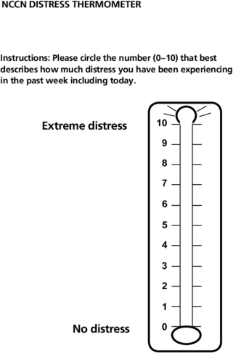
14, Please circle the number of that best describes how much distress you have been experiencing in the past week including today:

Section 2: The use of non-pharmacological strategies for constipation or diarrhoea management
15, During your chemotherapy cycles, do you experience:
- Diarrhoea
- Constipation
- Both diarrhoea and constipation
16, If you experienced diarrhoea, how much does diarrhoea distress or bother you?
- Not at all
- A little bit
- Somewhat
- Quite a bit
- Very much
17, If you experienced diarrhoea, how much does constipation distress or bother you?
- Not at all
- A little bit
- Somewhat
- Quite a bit
- Very much
18, What did you do when you had diarrhoea: (you can choose many answers as your wish)
- Notify physicians and get advice/ prescriptions
- Did not notify physicians, took self-prescribed anti-diarrhoeal medicines
- Use non-pharmacological strategies such as diet modifications, herbs, massages to relieve diarrhoea
- Did nothing and wait for diarrhoea stop
- Other, please specify………………………………………………………………………………………………
19, What did you do when you had constipation: (you can choose many answers as your wish)
- Notify physicians and get advice/ prescriptions
- Did not notify physicians, took self-prescribed anti-constipation medicines
- Use non-pharmacological strategies such as diet modifications, herbs, massages etc to relieve constipation
- Did nothing and wait for constipation stop
- Other, please specify………………………………………………………………………………………………

20, Non-pharmacological strategies (NPS) for diarrhoea
Please document non-pharmacological strategies for diarrhoea management you have used |  | Dose  (if any) | Frequency  (if any) | 21, Your perceived usefulness  0, Did not help.  1, Help a little  2, Help a lot | 22, Side effect of each NPS (if any) | 23, Sources of information for your used non-pharmacological strategies  (choose many answers as your wish)
NPS1 |  |  |  |  |  | 1, Healthcare professional staff  2, Internet or social network  3, Magazines  4, Scientific books  5, Family/friends/relatives  6, Other patients
NPS 2
NPS 3
NPS 4
NPS 5
NPS 5
NPS 6
NPS 7
NPS 8
24, Non-pharmacological strategies (NPS) for constipation
Please document non-pharmacological strategies for constipation management you have used |  | Dose  (if any) | Frequency  (if any) | 25, Your perceived usefulness  0, Did not help.  1, Help a little  2, Help a lot | 26, Side effect of each NPS (if any) | 27, Sources of information for your used non-pharmacological strategies  (choose many answers as your wish)
NPS1 |  |  |  |  |  | 1, Healthcare professional staff  2, Internet or social network  3, Magazines  4, Scientific books  5, Family/friends/relatives  6, Other patients
NPS 2
NPS 3
NPS 4
NPS 5
NPS 5
NPS 6
NPS 7
NPS 8

