《Network Analysis of Positive Mental Characters, Depression , and Non-Suicidal Self-Injury Among Chinese Adolescents》Supplementary Materials

Xinxin Yu^{1,2}, Xiaofei Liu¹, Meifang Tan¹, Fengjuan Zhang^{1,2}*
(1 Department of Psychology, Faculty of Education, Guangxi Normal University, Guilin 541004, Guangxi Zhuang Autonomous Region, China；2 Guangxi Key Laboratory of Cognitive Science and Mental Health, Guilin 541004, Guangxi Zhuang Autonomous Region, China)

- Table S1. All edges weights within the network
- Figure S2. Bootstrapped difference test for edge weights
- Figure S3. Bootstrapped difference test for strength and expected Influence
- Figure S4. Bootstrapped difference test for bridge Strength and bridge expected Influence
- Figure S5.CS
- Figure S6. Accuracy of edge weights
- Figure S7. Network comparisons of network in female(left) and male(right)

 | P1 | P2 | P3 | P4 | P5 | P6 | P7 | P8 | P9 | P10 | P11 | P12 | P13 | P14 | P15 | D1 | D2 | D3 | D4 | NSSI
P1 | 0.00 | 0.34 | 0.28 | 0.00 | 0.10 | 0.00 | 0.04 | 0.07 | 0.00 | 0.00 | 0.00 | 0.00 | 0.00 | 0.06 | 0.00 | 0.05 | 0.00 | 0.00 | 0.00 | 0.00
P2 | 0.34 | 0.00 | 0.08 | 0.00 | 0.12 | 0.03 | 0.00 | 0.04 | 0.00 | 0.04 | 0.00 | 0.00 | 0.07 | 0.00 | 0.03 | 0.00 | 0.00 | 0.00 | 0.00 | 0.00
P3 | 0.28 | 0.08 | 0.00 | 0.00 | 0.02 | 0.00 | 0.16 | 0.11 | 0.07 | -0.10 | 0.00 | 0.07 | 0.00 | 0.08 | 0.00 | 0.00 | 0.00 | 0.00 | -0.06 | 0.00
P4 | 0.00 | 0.00 | 0.00 | 0.00 | 0.06 | 0.00 | 0.00 | 0.00 | 0.08 | 0.00 | 0.00 | 0.00 | 0.00 | -0.04 | 0.00 | -0.04 | 0.00 | -0.03 | -0.04 | 0.00
P5 | 0.10 | 0.12 | 0.02 | 0.06 | 0.00 | 0.16 | 0.34 | 0.12 | 0.14 | 0.00 | 0.00 | 0.04 | 0.00 | 0.08 | 0.30 | 0.00 | -0.03 | -0.04 | 0.00 | 0.00
P6 | 0.00 | 0.03 | 0.00 | 0.00 | 0.16 | 0.00 | 0.14 | 0.00 | 0.00 | 0.08 | 0.00 | 0.00 | 0.00 | 0.00 | 0.07 | -0.05 | -0.10 | 0.00 | 0.00 | -0.05
P7 | 0.04 | 0.00 | 0.16 | 0.00 | 0.34 | 0.14 | 0.00 | 0.03 | 0.15 | 0.12 | 0.04 | 0.10 | 0.07 | 0.10 | 0.00 | 0.00 | 0.00 | 0.00 | -0.03 | 0.00
P8 | 0.07 | 0.04 | 0.11 | 0.00 | 0.12 | 0.00 | 0.03 | 0.00 | 0.19 | 0.00 | 0.00 | 0.00 | -0.17 | 0.20 | 0.04 | 0.00 | 0.00 | 0.00 | 0.00 | 0.00
P9 | 0.00 | 0.00 | 0.07 | 0.08 | 0.14 | 0.00 | 0.15 | 0.19 | 0.00 | 0.17 | 0.18 | 0.10 | 0.22 | 0.00 | 0.07 | 0.00 | 0.00 | 0.00 | 0.00 | 0.00
P10 | 0.00 | 0.04 | -0.10 | 0.00 | 0.00 | 0.08 | 0.12 | 0.00 | 0.17 | 0.00 | 0.15 | 0.10 | 0.00 | 0.05 | 0.00 | 0.00 | 0.00 | 0.00 | 0.00 | 0.00
P11 | 0.00 | 0.00 | 0.00 | 0.00 | 0.00 | 0.00 | 0.04 | 0.00 | 0.18 | 0.15 | 0.00 | 0.25 | 0.09 | 0.00 | -0.03 | 0.02 | 0.00 | 0.04 | 0.00 | 0.00
P12 | 0.00 | 0.00 | 0.07 | 0.00 | 0.04 | 0.00 | 0.10 | 0.00 | 0.10 | 0.10 | 0.25 | 0.00 | 0.05 | -0.06 | 0.08 | 0.00 | 0.00 | 0.00 | 0.00 | 0.00
P13 | 0.00 | 0.07 | 0.00 | 0.00 | 0.00 | 0.00 | 0.07 | -0.17 | 0.22 | 0.00 | 0.09 | 0.05 | 0.00 | 0.14 | 0.16 | 0.08 | 0.00 | 0.00 | 0.00 | 0.00
P14 | 0.06 | 0.00 | 0.08 | -0.04 | 0.08 | 0.00 | 0.10 | 0.20 | 0.00 | 0.05 | 0.00 | -0.06 | 0.14 | 0.00 | 0.03 | 0.03 | 0.00 | 0.00 | 0.00 | 0.00
P15 | 0.00 | 0.03 | 0.00 | 0.00 | 0.30 | 0.07 | 0.00 | 0.04 | 0.07 | 0.00 | -0.03 | 0.08 | 0.16 | 0.03 | 0.00 | -0.08 | -0.12 | -0.03 | 0.00 | -0.04
D1 | 0.05 | 0.00 | 0.00 | -0.04 | 0.00 | -0.05 | 0.00 | 0.00 | 0.00 | 0.00 | 0.02 | 0.00 | 0.08 | 0.03 | -0.08 | 0.00 | 0.09 | 0.57 | 0.36 | 0.24
D2 | 0.00 | 0.00 | 0.00 | 0.00 | -0.03 | -0.10 | 0.00 | 0.00 | 0.00 | 0.00 | 0.00 | 0.00 | 0.00 | 0.00 | -0.12 | 0.09 | 0.00 | 0.00 | 0.00 | 0.00
D3 | 0.00 | 0.00 | 0.00 | -0.03 | -0.04 | 0.00 | 0.00 | 0.00 | 0.00 | 0.00 | 0.04 | 0.00 | 0.00 | 0.00 | -0.03 | 0.57 | 0.00 | 0.00 | 0.13 | 0.05
D4 | 0.00 | 0.00 | -0.06 | -0.04 | 0.00 | 0.00 | -0.03 | 0.00 | 0.00 | 0.00 | 0.00 | 0.00 | 0.00 | 0.00 | 0.00 | 0.36 | 0.00 | 0.13 | 0.00 | 0.08
NSSI | 0.00 | 0.00 | 0.00 | 0.00 | 0.00 | -0.05 | 0.00 | 0.00 | 0.00 | 0.00 | 0.00 | 0.00 | 0.00 | 0.00 | -0.04 | 0.24 | 0.00 | 0.05 | 0.08 | 0.00
Supplementary Table 1. All edges weights within the network

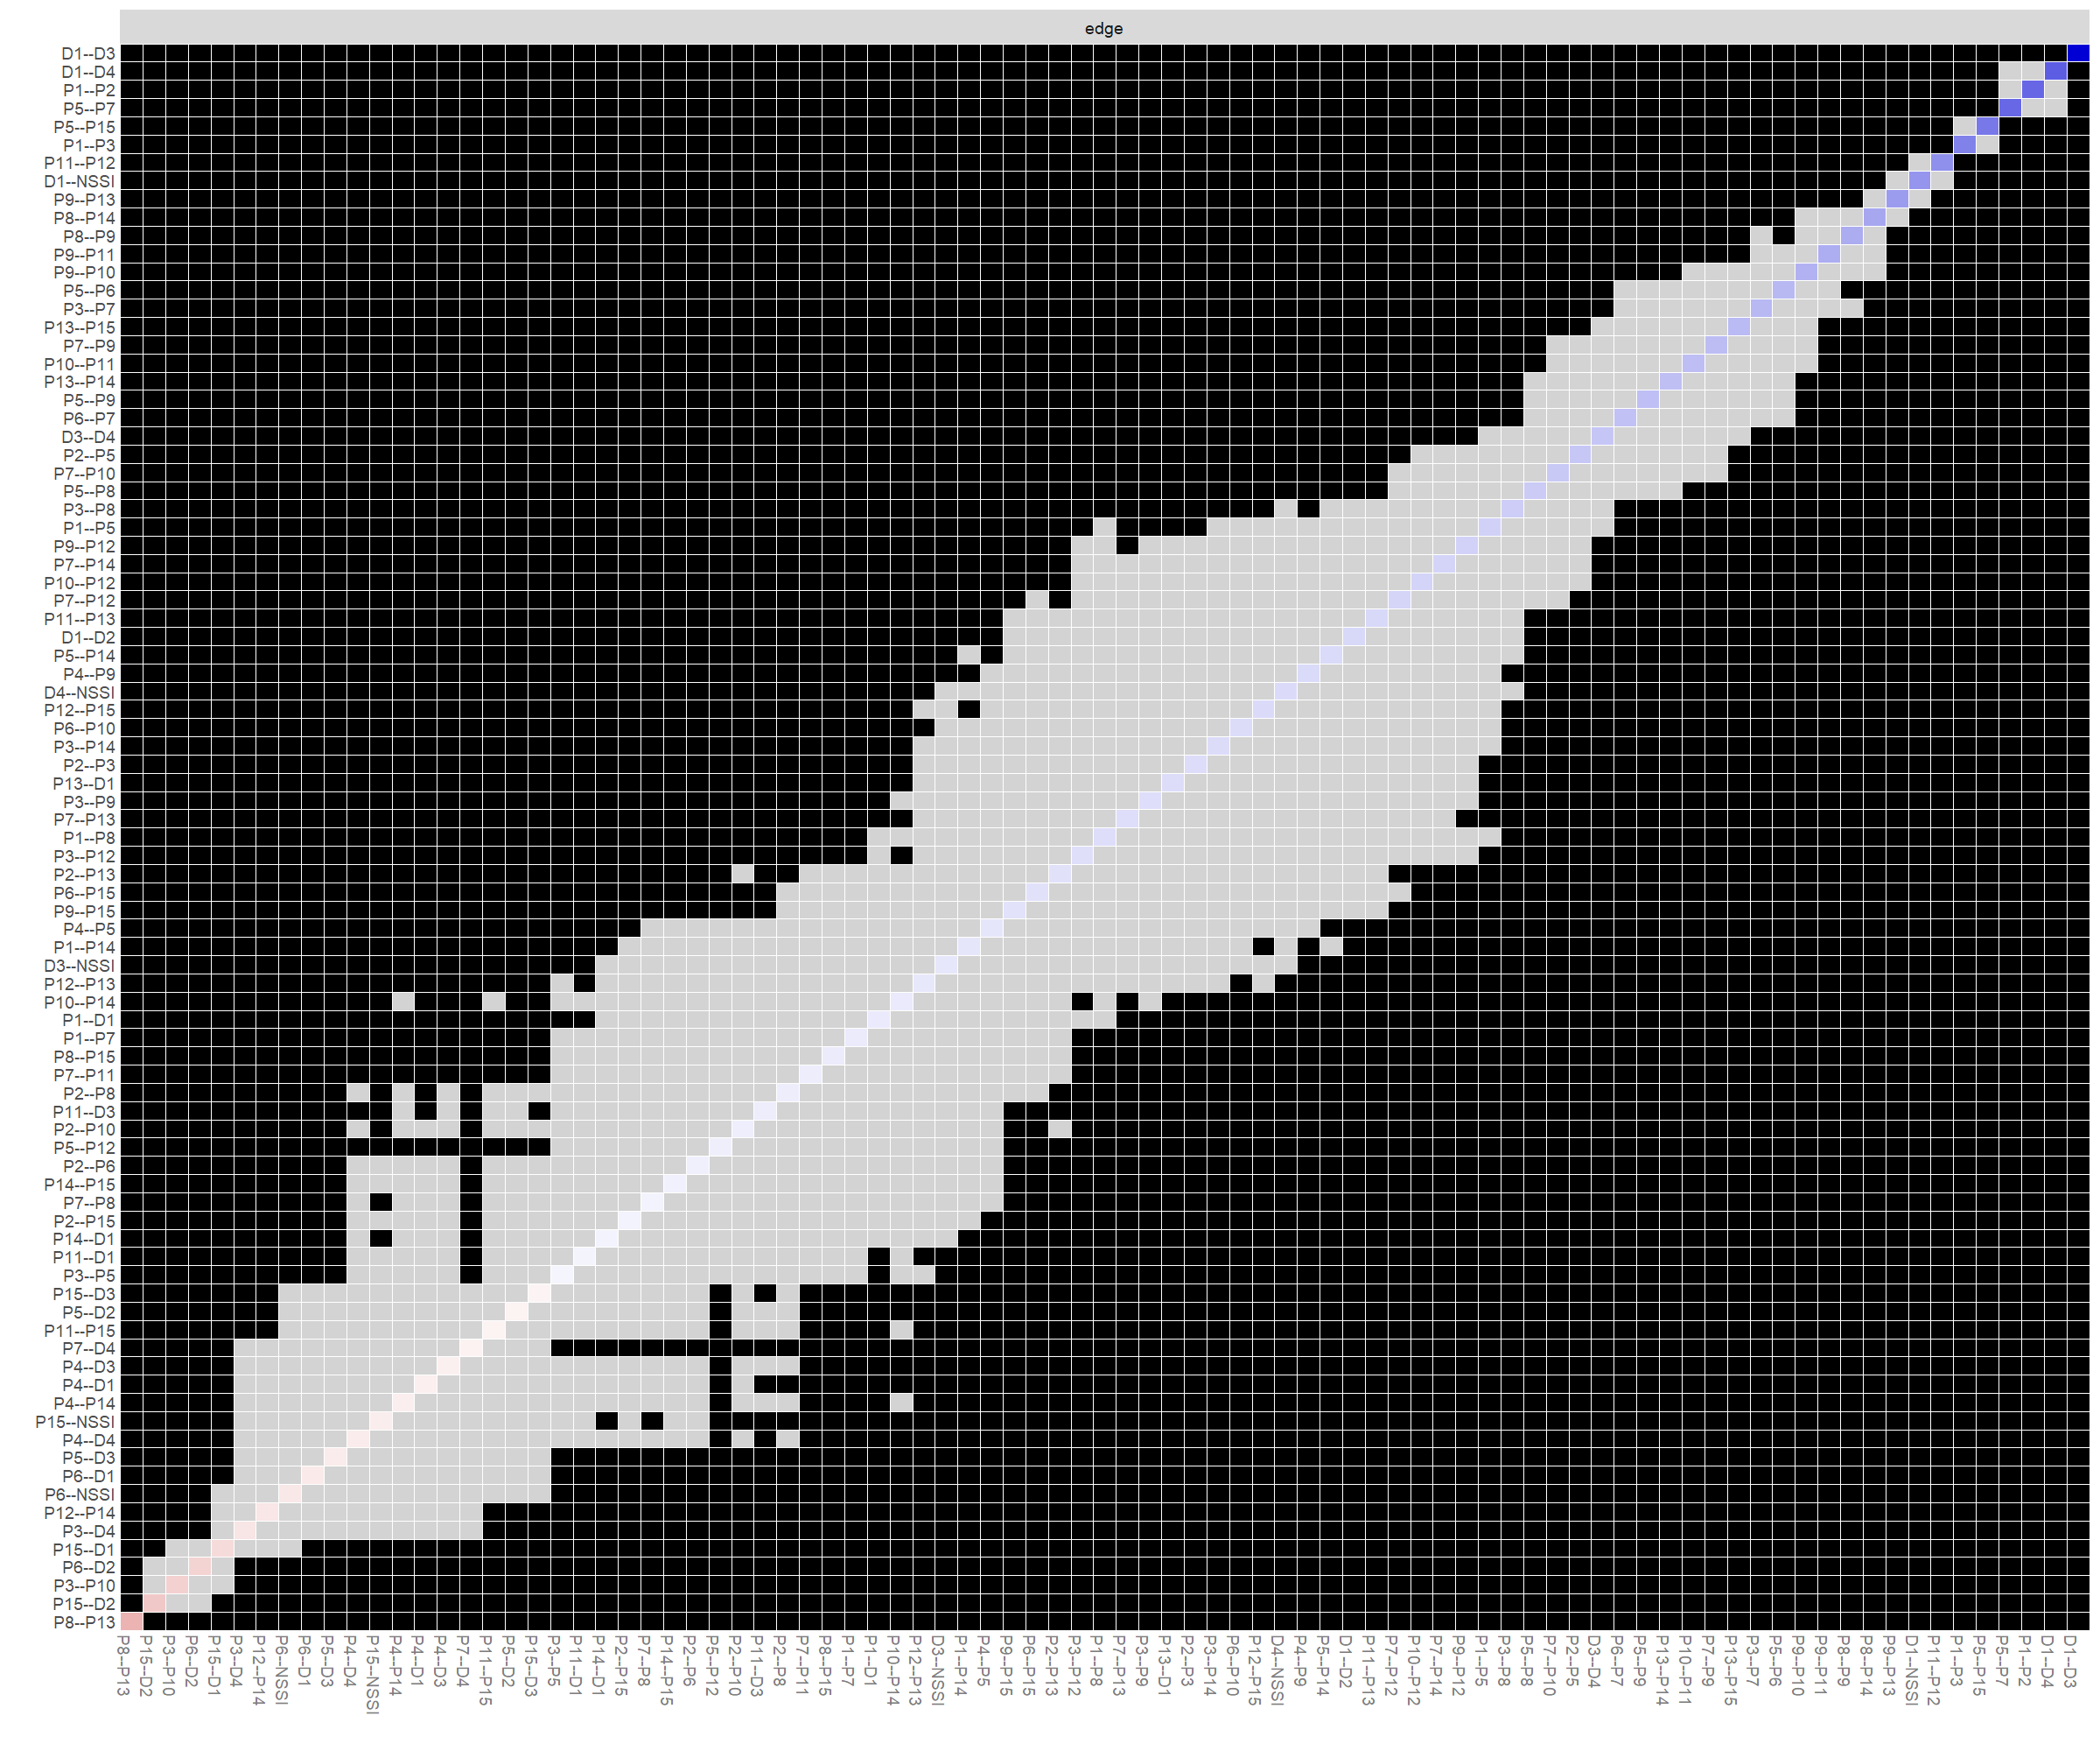
Fig. S2. Difference test of edge weights
Note: Gray boxes indicate edge weights that do not differ significantly from one another, while black boxes indicate edge weights that do differ significantly. Blue and red boxes on the diagonal correspond to edge weights with positive and negative correlations, respectively.

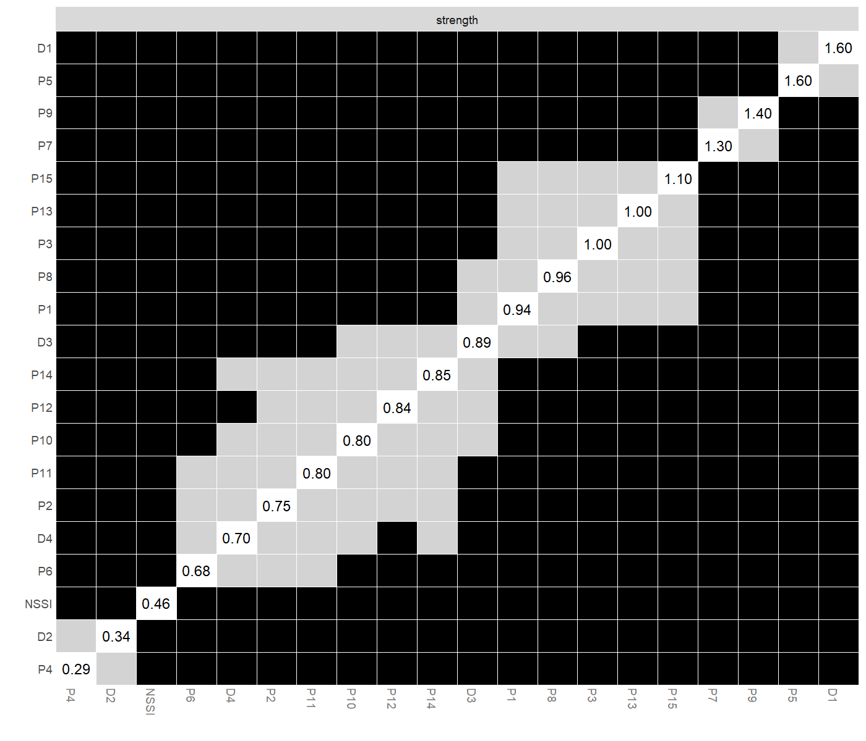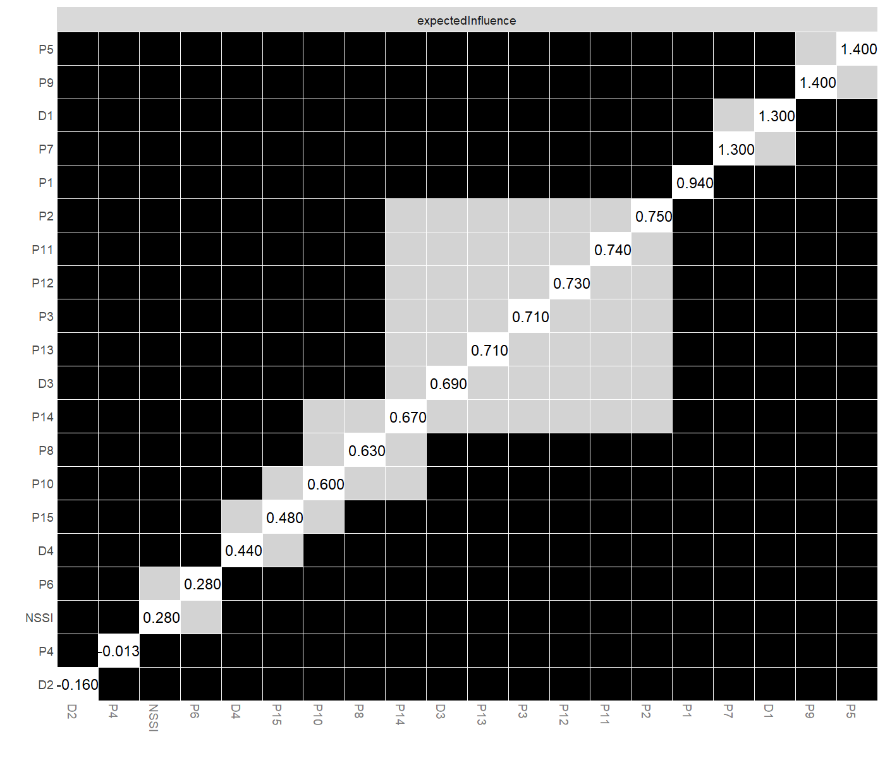
Fig. S3. Bootstrapped difference test for Strength and expected Influence

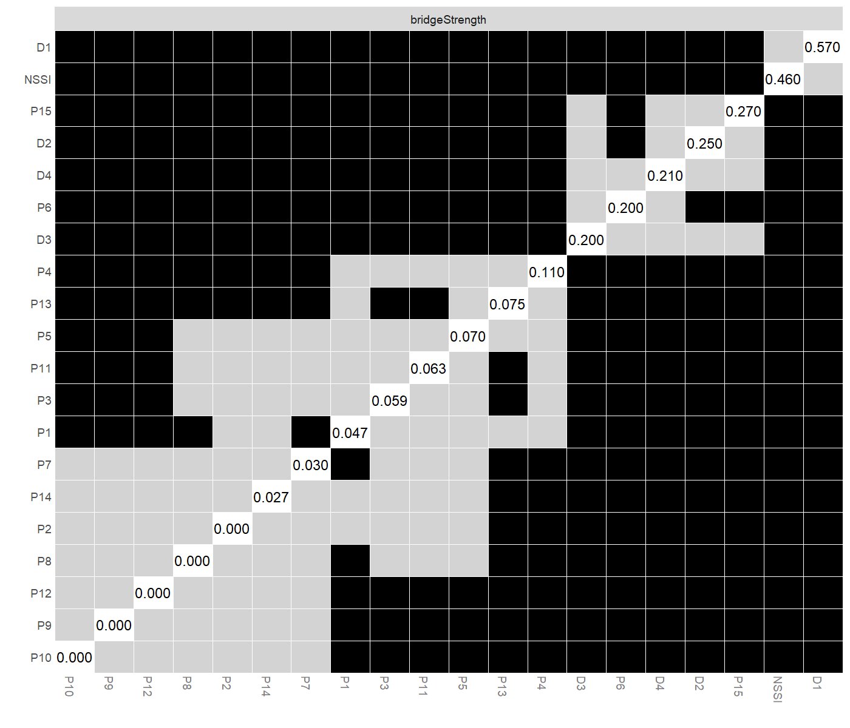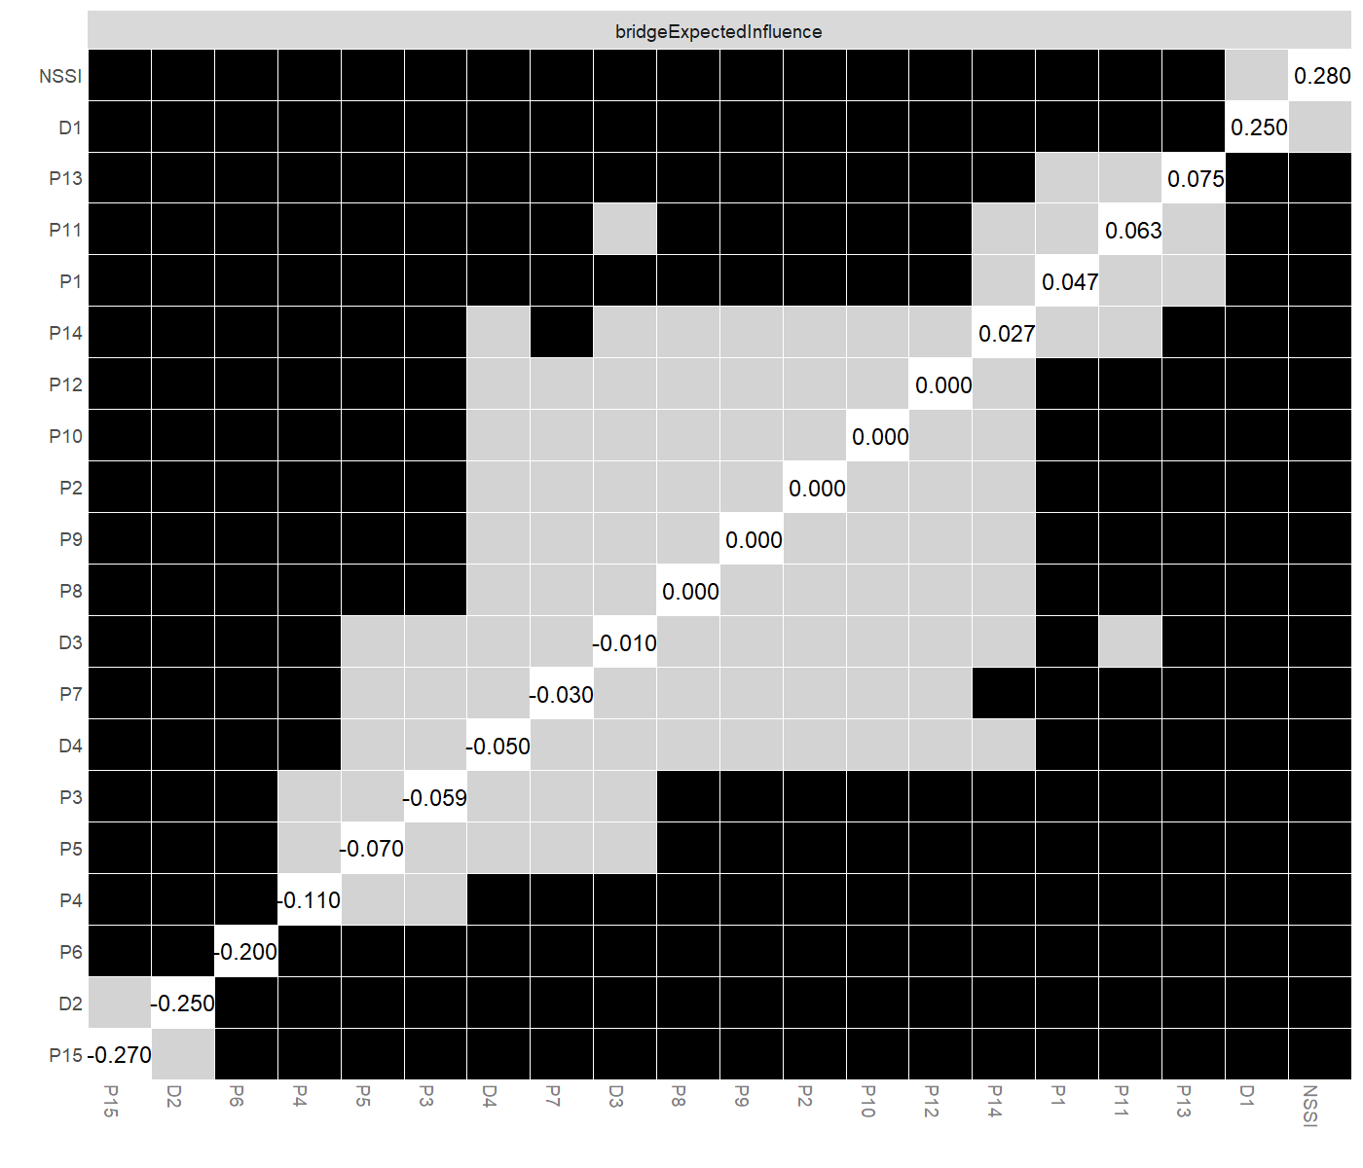
Fig. S4. Bootstrapped difference test for bridge Strength and bridge expected Influence

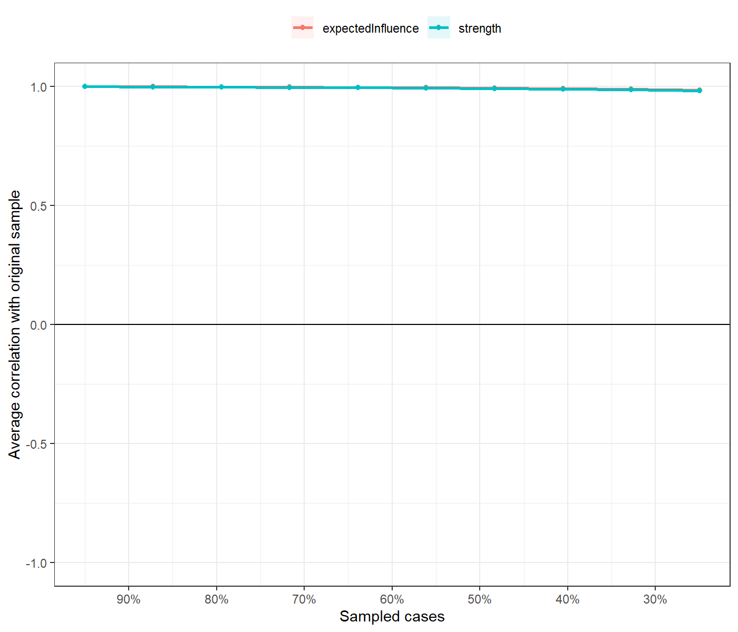
Fig. S5. The stability of centrality index-expected influence and Strength using case dropping bootstrap.

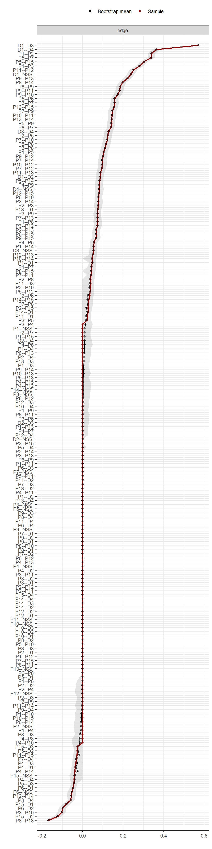
Fig. S6. Accuracy of edge weights

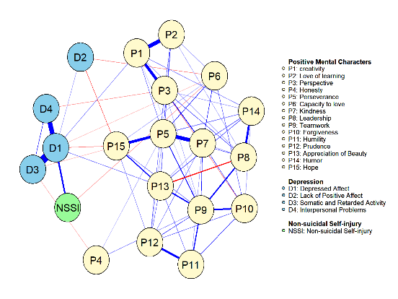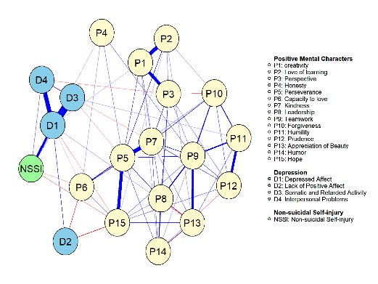
Fig. S7. Network comparisons of female(left) and male(right).

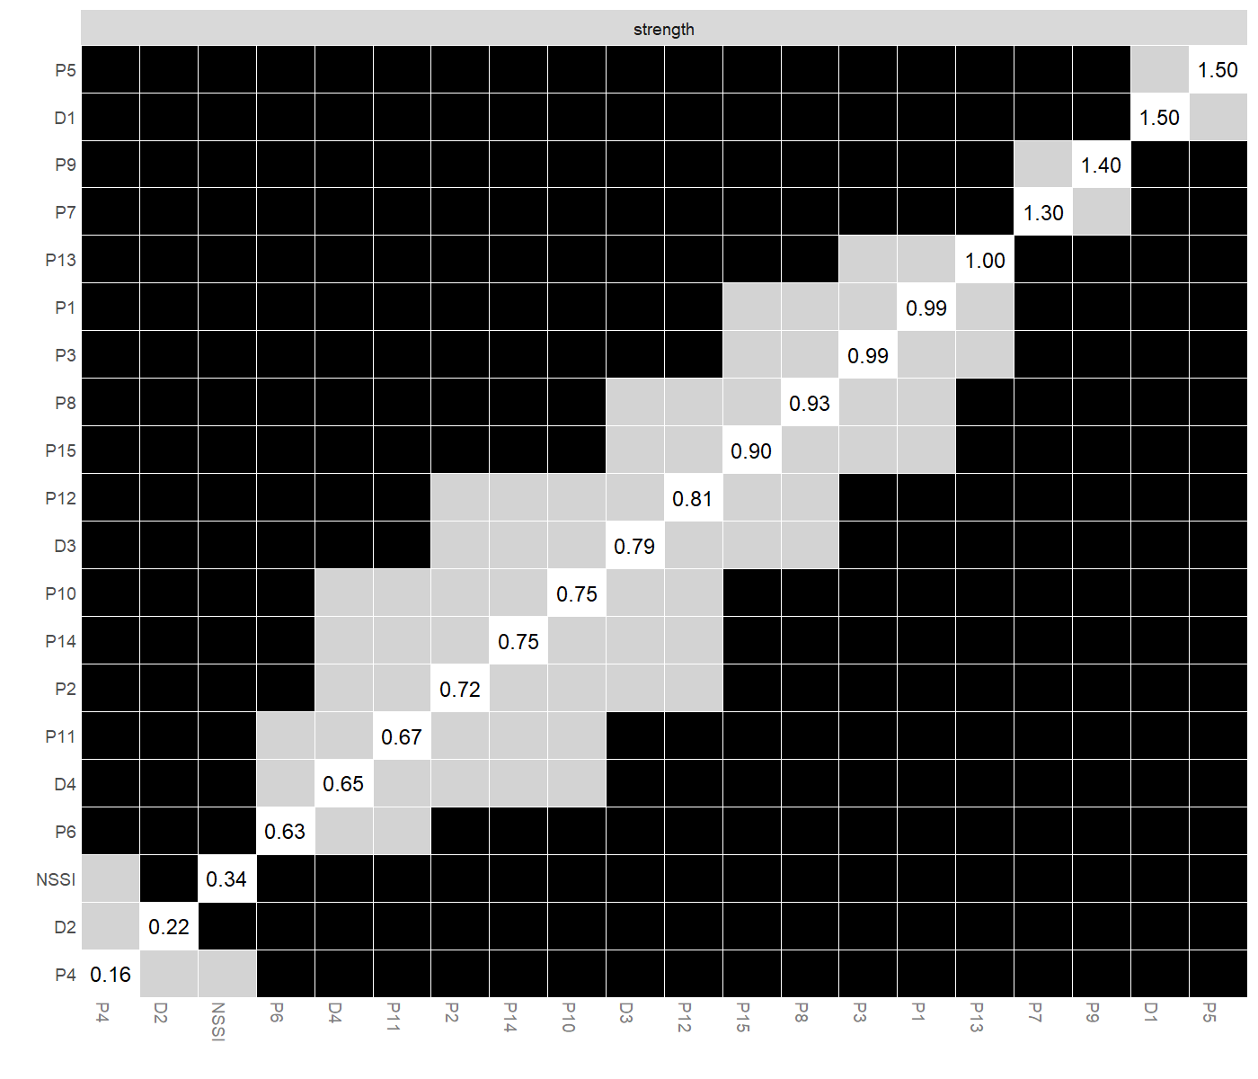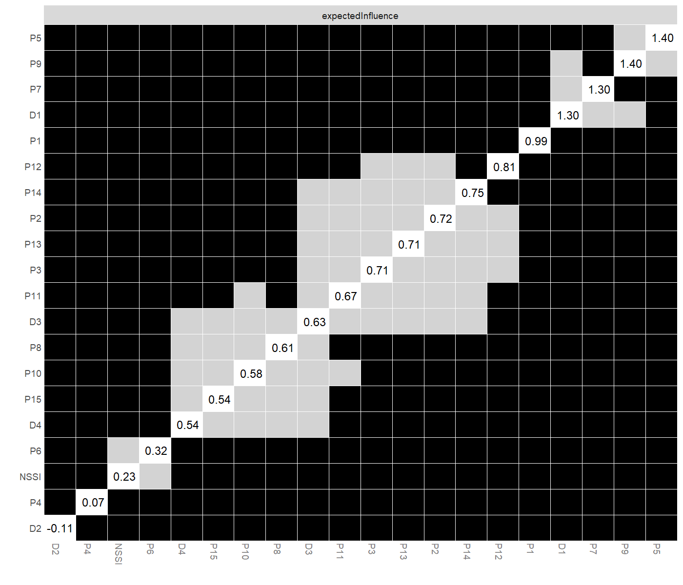
Fig. S8. Difference test of strength and expected influence indices in the male group network
Note: Gray boxes indicate node bridge Strength that do not differ significantly from one another, while black boxes indicate node bridge Strength that do differ significantly.

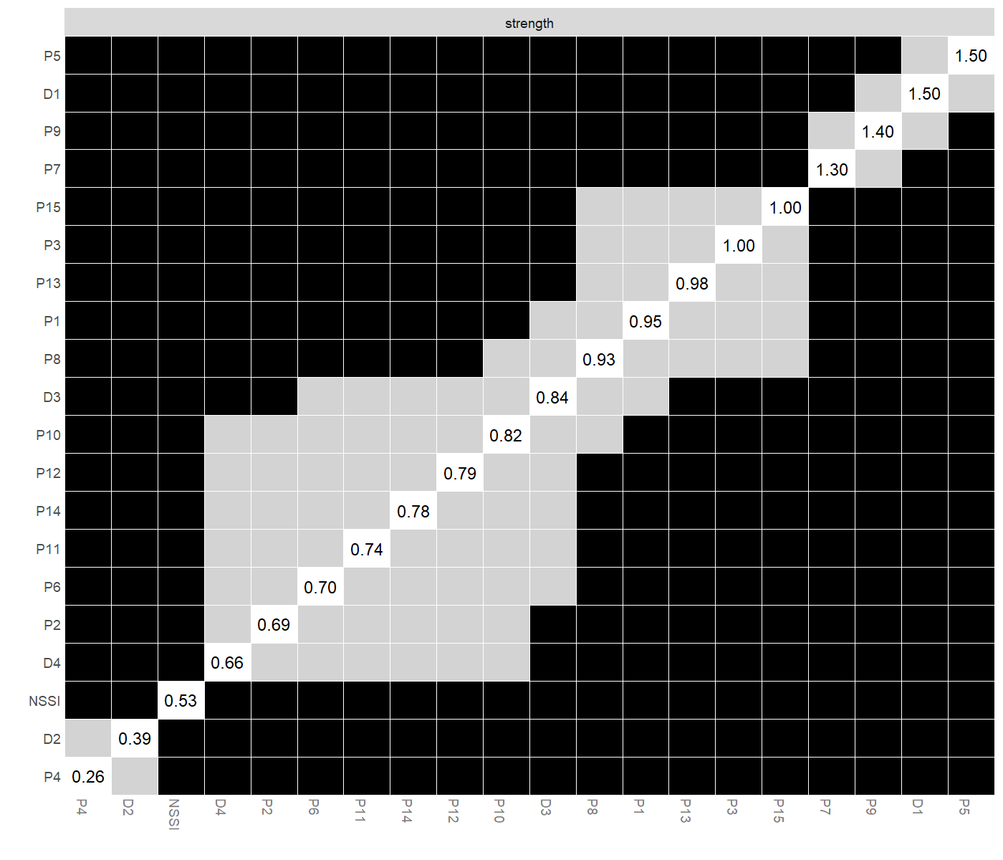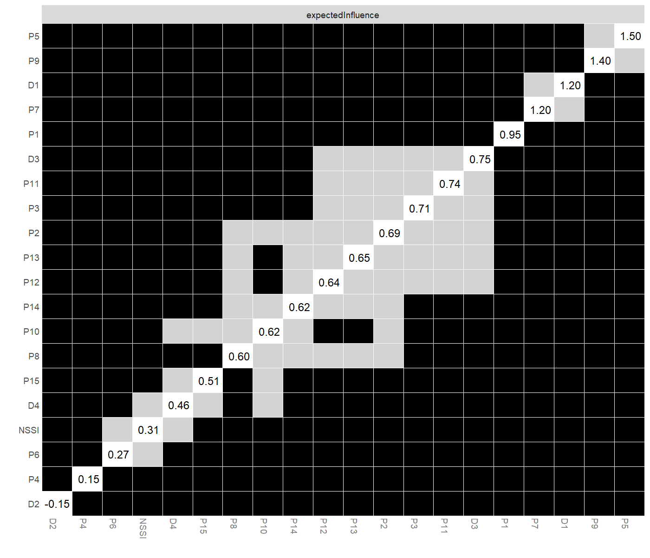
Fig. S9. Difference test of strength and expected influence indices in the female group network.

