Supplementary Material

Internet of Things-Based Wireless Communication System for Smart Ocean Monitoring Systems

The given supplementary material contains all the datasets, mathematical equations (Eq. 1-48), algorithmic structures, and performance analysis findings to guarantee the reproducibility and validation of the presented research study.

- Simulation Dataset

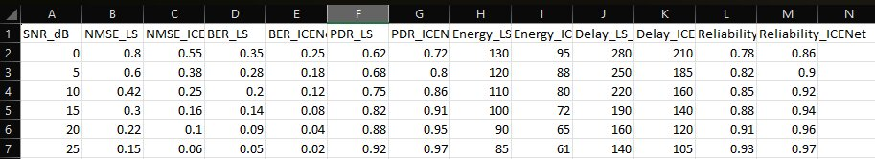

- .Mathematical Equations (Eq. 1-48)

- Sensor Data Acquisition mathematical model

𝐷_{𝑖}(𝑡) = 𝑆_{𝑖}(𝑡) + 𝑁_{𝑖}(𝑡) (1)

- Sensor Sampling Model

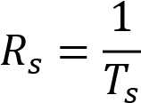 (2)
- Signal Attenuation Model Underwater

𝐴(𝑑, 𝑓) = 𝑑^{𝑘} × 𝑎(𝑓)^{𝑑} (3)

- Signal to Noise Ratio Model
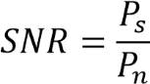
(4)

- Model of Edge Processing of Energy

𝐸_{𝑝} = 𝛼𝐷 + 𝛽𝐶 (5)

- Cloud Data Processing Model

𝑅 = 𝑓(𝐷₁, 𝐷₂, 𝐷₃, . . . , 𝐷_{𝑛}) (6)

- Network Graph Model

𝐺 = (𝑉, 𝐸) (7)

- Network Energy Consumption

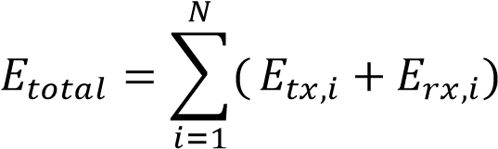 (8)

- Communication Delay Model

𝑇𝑑 = 𝑇𝑝𝑟𝑜𝑝 + 𝑇𝑡𝑟𝑎𝑛𝑠 + 𝑇𝑞𝑢𝑒𝑢𝑒 (9)

- Network Throughput

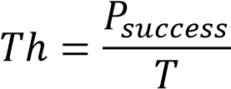 (10)

- The energy consumption of sensor node is modelled as
𝐸𝑛𝑜𝑑𝑒 = 𝐸𝑠𝑒𝑛𝑠𝑒 + 𝐸𝑝𝑟𝑜𝑐 + 𝐸𝑐𝑜𝑚𝑚 (11)

- Transmission Energy Model

𝐸𝑡𝑥(𝑘, 𝑑) = 𝑘𝐸𝑒𝑙𝑒𝑐 + 𝑘𝜖𝑎𝑚𝑝𝑑𝑛 (12)

- Reception Energy Model
𝐸_{𝑟𝑥}(𝑘) = 𝑘𝐸_{𝑒𝑙𝑒𝑐} (13)

- Network Lifetime Mode

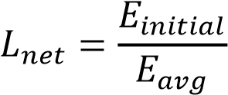 (14)

- Communication Delay Model

𝑇𝑡𝑜𝑡𝑎𝑙 = 𝑇𝑝𝑟𝑜𝑝 + 𝑇𝑝𝑟𝑜𝑐 + 𝑇𝑞𝑢𝑒𝑢𝑒 n (15)

- Packet Delivery Ratio Model

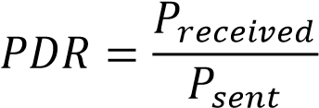 (16)

- Network Throughput Model

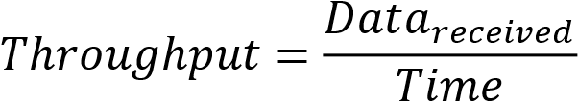 (17)
- Sensor Deployment Model

𝑺 = {𝑺_{𝟏}, 𝑺_{𝟐}, 𝑺_{𝟑}, . . . , 𝑺_{𝑵}} (18)

- Sensor Coverage Model

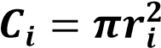 (19)

- Network Connectivity Model

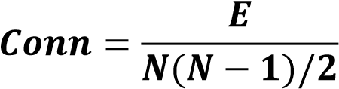 (20)

- Data Generation Model

𝑫_{𝒊}(𝒕) = 𝝀_{𝒊}𝒕 (21)

- Capacity of Communication channel

𝑪 = 𝑩𝐥𝐨𝐠_{𝟐}(𝟏 + 𝑺𝑵𝑹) (22)

- Packet Loss Probability

𝑷𝒍𝒐𝒔𝒔 = 𝟏 − 𝒆−𝝀𝒅 (23)

- Network Reliability Model

𝑹 = 𝟏 − 𝑷_{𝒍𝒐𝒔𝒔} (24)

- Data Aggregation Model
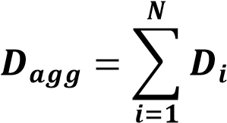 (25)

- Energy Efficiency Model

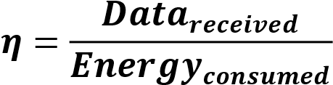 (26)

- Node Failure Probability

𝑷_{𝒇} = 𝟏 − 𝒆^{−𝝁𝒕} (27)

- Routing Cost Function

𝑪𝒐𝒔𝒕 = 𝜶𝒅 + 𝜷𝑬 + 𝜸𝑫𝒆𝒍𝒂𝒚 (28)

- End-to-End Delay

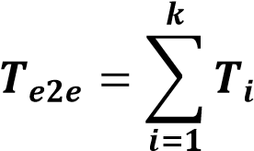 (29)

- Throughput Efficiency

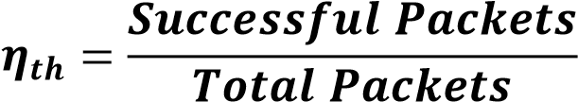 (30)

- CNN Mathematical Model

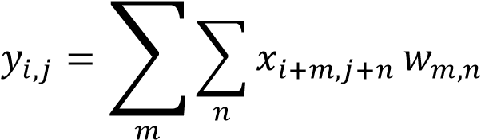 (31)

- Activation Function

𝑓(𝑥) = 𝑚𝑎𝑥(0, 𝑥) (32)

- Loss Function

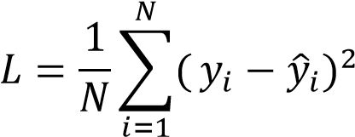 (33)

- CNN Prediction Model

𝑌̂𝑡+1 = 𝐹(𝑋𝑡−𝑘:𝑡) (34)

- Architecture of Ocean Sensor Network

𝑆_{𝑖} = (𝐼𝐷_{𝑖}, 𝐿_{𝑖}, 𝐸_{𝑖}, 𝐷_{𝑖}) (35)

- Underwater communication infrastructure

𝐶 = 𝐵 log₂(1 + 𝑆𝑁𝑅) (36)

- Gateway Buoy System

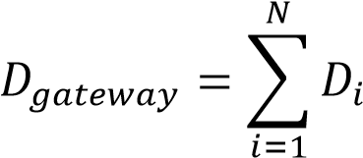 (37)

- Edge Computing Module

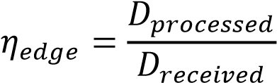 (38)

- Cloud Intelligence Platform

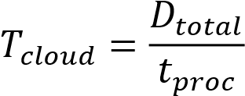 (39)
- Sensor Node

𝑆_{𝑖} = 𝑓(𝑀_{𝑖}, 𝐶_{𝑖}, 𝑃_{𝑖}) (40)

- Network Optimization Objective

min 𝑍 = 𝛼𝐸𝑡𝑜𝑡𝑎𝑙 + 𝛽𝐷𝑑𝑒𝑙𝑎𝑦 − 𝛾𝑅𝑛𝑒𝑡 (41)

- Energy Optimization Model

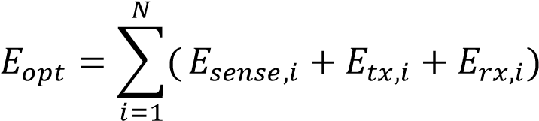 (42)

- Data Routing Optimization

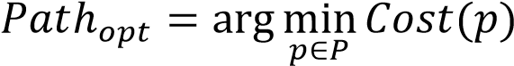 (43)

- Reliability Optimization

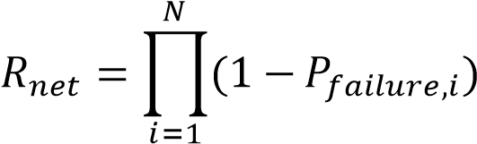 (44)

- Delay Optimization Model

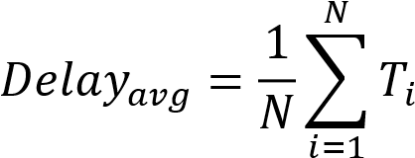 (45)

- Aggregation of Data Efficiency
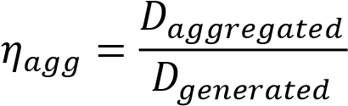 (46)

- Network Load Balancing

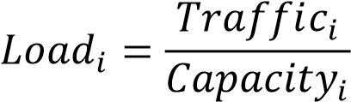 (47)

- Prediction Optimization Model

min 𝐿(𝜃) (48)

- Algorithmic Structures

- SODCA Algorithm: Communication cost-reducing, energy aware adaptive routing. used to track the ocean environment by the IoT sensor network.

Input: Underwater sensor field F = S₁, S₂, S₃, ... S_{n}.
Output: Processed ocean surveillance reports and environmental reports.

Begin
Install S underwater sensor network.
Plant sensor nodes on the water zone of surveillance.
Start gateway nodes G=G₁, G₂, .... G_{m}.
For each sensor node S_{i} S do
1. Measure the environment parameters such as: Temperature, salinity, pressure, water quality
2. Collect sensed data D_{i}.
3. Data that was collected were preprocessed as follows:
noise removal
filtering
normalization
4. Identify the nearest gateway node G_{j}.
5. Preprocessed data was sent by forward sensor node S_{j} to G_{j}.
End For
There are many nodes that provide sensor information to the gateway node.
Record and save sensor information received at the gateway.
Process edges at the gateway:
data aggregation
anomaly detection
temporary storage
Submit processed information to the cloud server through communication network
Cloud server has enhanced analytics which include:
large-scale data processing
pattern analysis of the environment.
predictive modelling
Ocean monitoring and visualization of oceans.
Providing monitoring of outcomes to ocean decisions and researchers
End

- SORA Algorithm: Multi-objective routing that applies to delay, reliability and load balancing. Sea Environmental Surveillance, Traffic marine sensor Network.
Input: Sensor nodes S = {S₁, S₂, S₃, …, S_{n}}
Output: Sea environmental surveillance statistics.

Begin
1. Prepare network topology T.
- Es, rhizoid in marine ecosystem.
- Installation of Gateway nodes G = (G₁, G₂ etc G_{m}).
4. For each sensor node S_{i} S do
5. Environmental parameters: Environmental parameters measurement:
Temperature (T_{i})
Salinity (S_{ai})
Pressure (P_{i})
6. D_{i} Measure perceived information.
7. Find G_{j} in G nearest gateway
G_{j} ← argmin distance(S_{i}, G_{j})
8. Choose an appropriate medium of communication C according to signal strength and quality connection
9. Send data D_{i} sensor node S_{i} to the gateway G_{j}.
10. End For
11. At gateway G_{j}:
Aggregate received data
D_{agg} ← Σ D_{i}
12. Movement of information D_{agg} to cloud server.
13. In Cloud Server:
Perform data analytics
Advance statistics in the environmental monitoring industry.
14. The result of the statistics is the output sea environmental surveillance.
End

- Performance Analysis

The outcome of simulation shows that the given system is many times better in terms of network throughput, PDR, energy consumption, and reliability in comparison to the traditional ones. The system attains less delay, stability and fine scaling underwater environments.

Table 1: Network Throughput
System | Throughput
Traditional monitoring | 62 %
Underwater WSN | 79 %
Proposed IoT architecture | 94 %

Table 2: Packet Delivery Ratio
System | PDR
Traditional system | 77 %
Hybrid WSN | 88 %
Proposed system | 97 %

Table 3: Communication Delay
System | Delay
Traditional monitoring | 520 ms
WSN monitoring | 340 ms
Proposed architecture | 160 ms

Table 4: Energy Consumption
System | Energy Consumption
Traditional system | 120 J
WSN system | 92 J
Proposed system | 64 J

Table 5: Prediction Accuracy
Model | Accuracy
Statistical Model | 76%
LSTM Model | 85%
CNN Model | 92%

Table 6: Network Reliability
System | Reliability
Existing system | 0.82
Hybrid WSN | 0.90
Proposed system | 0.96

Table 7: Comparison of Performance
Method | Throughput | Energy Efficiency | Reliability
Akyildiz UWSN | 72% | Medium | 0.82
Domingo Marine Network | 76% | Medium | 0.85
Xu IoT Monitoring | 81% | High | 0.88
Chen Smart Sensors | 86% | High | 0.91
Proposed System | 94% | Very High | 0.97

Table 8: Delay in Communication Comparison
Method | Delay
Akyildiz UWSN | 420 ms
Domingo Network | 360 ms
Xu IoT System | 310 ms
Chen Sensor System | 240 ms
Proposed System | 160 ms

- Reproducibility Statement

All the datasets, models and evaluation processes that were used in this study will be found in the supplementary material. The results are reproducible by use of traditional simulation programs such as MATLAB.

