Supplementary data

Figure S1. Correlation analysis of air pollutants and meteorological factors with the number of AECOPD hospitalizations

Figure S2. Subgroup analysis of the association between air pollutants and the risk of AECOPD hospitalization
Figure S3. Three-dimensional plot of pollutants (df=6)

Figure S4. Three-dimensional plot of pollutants (df=8)

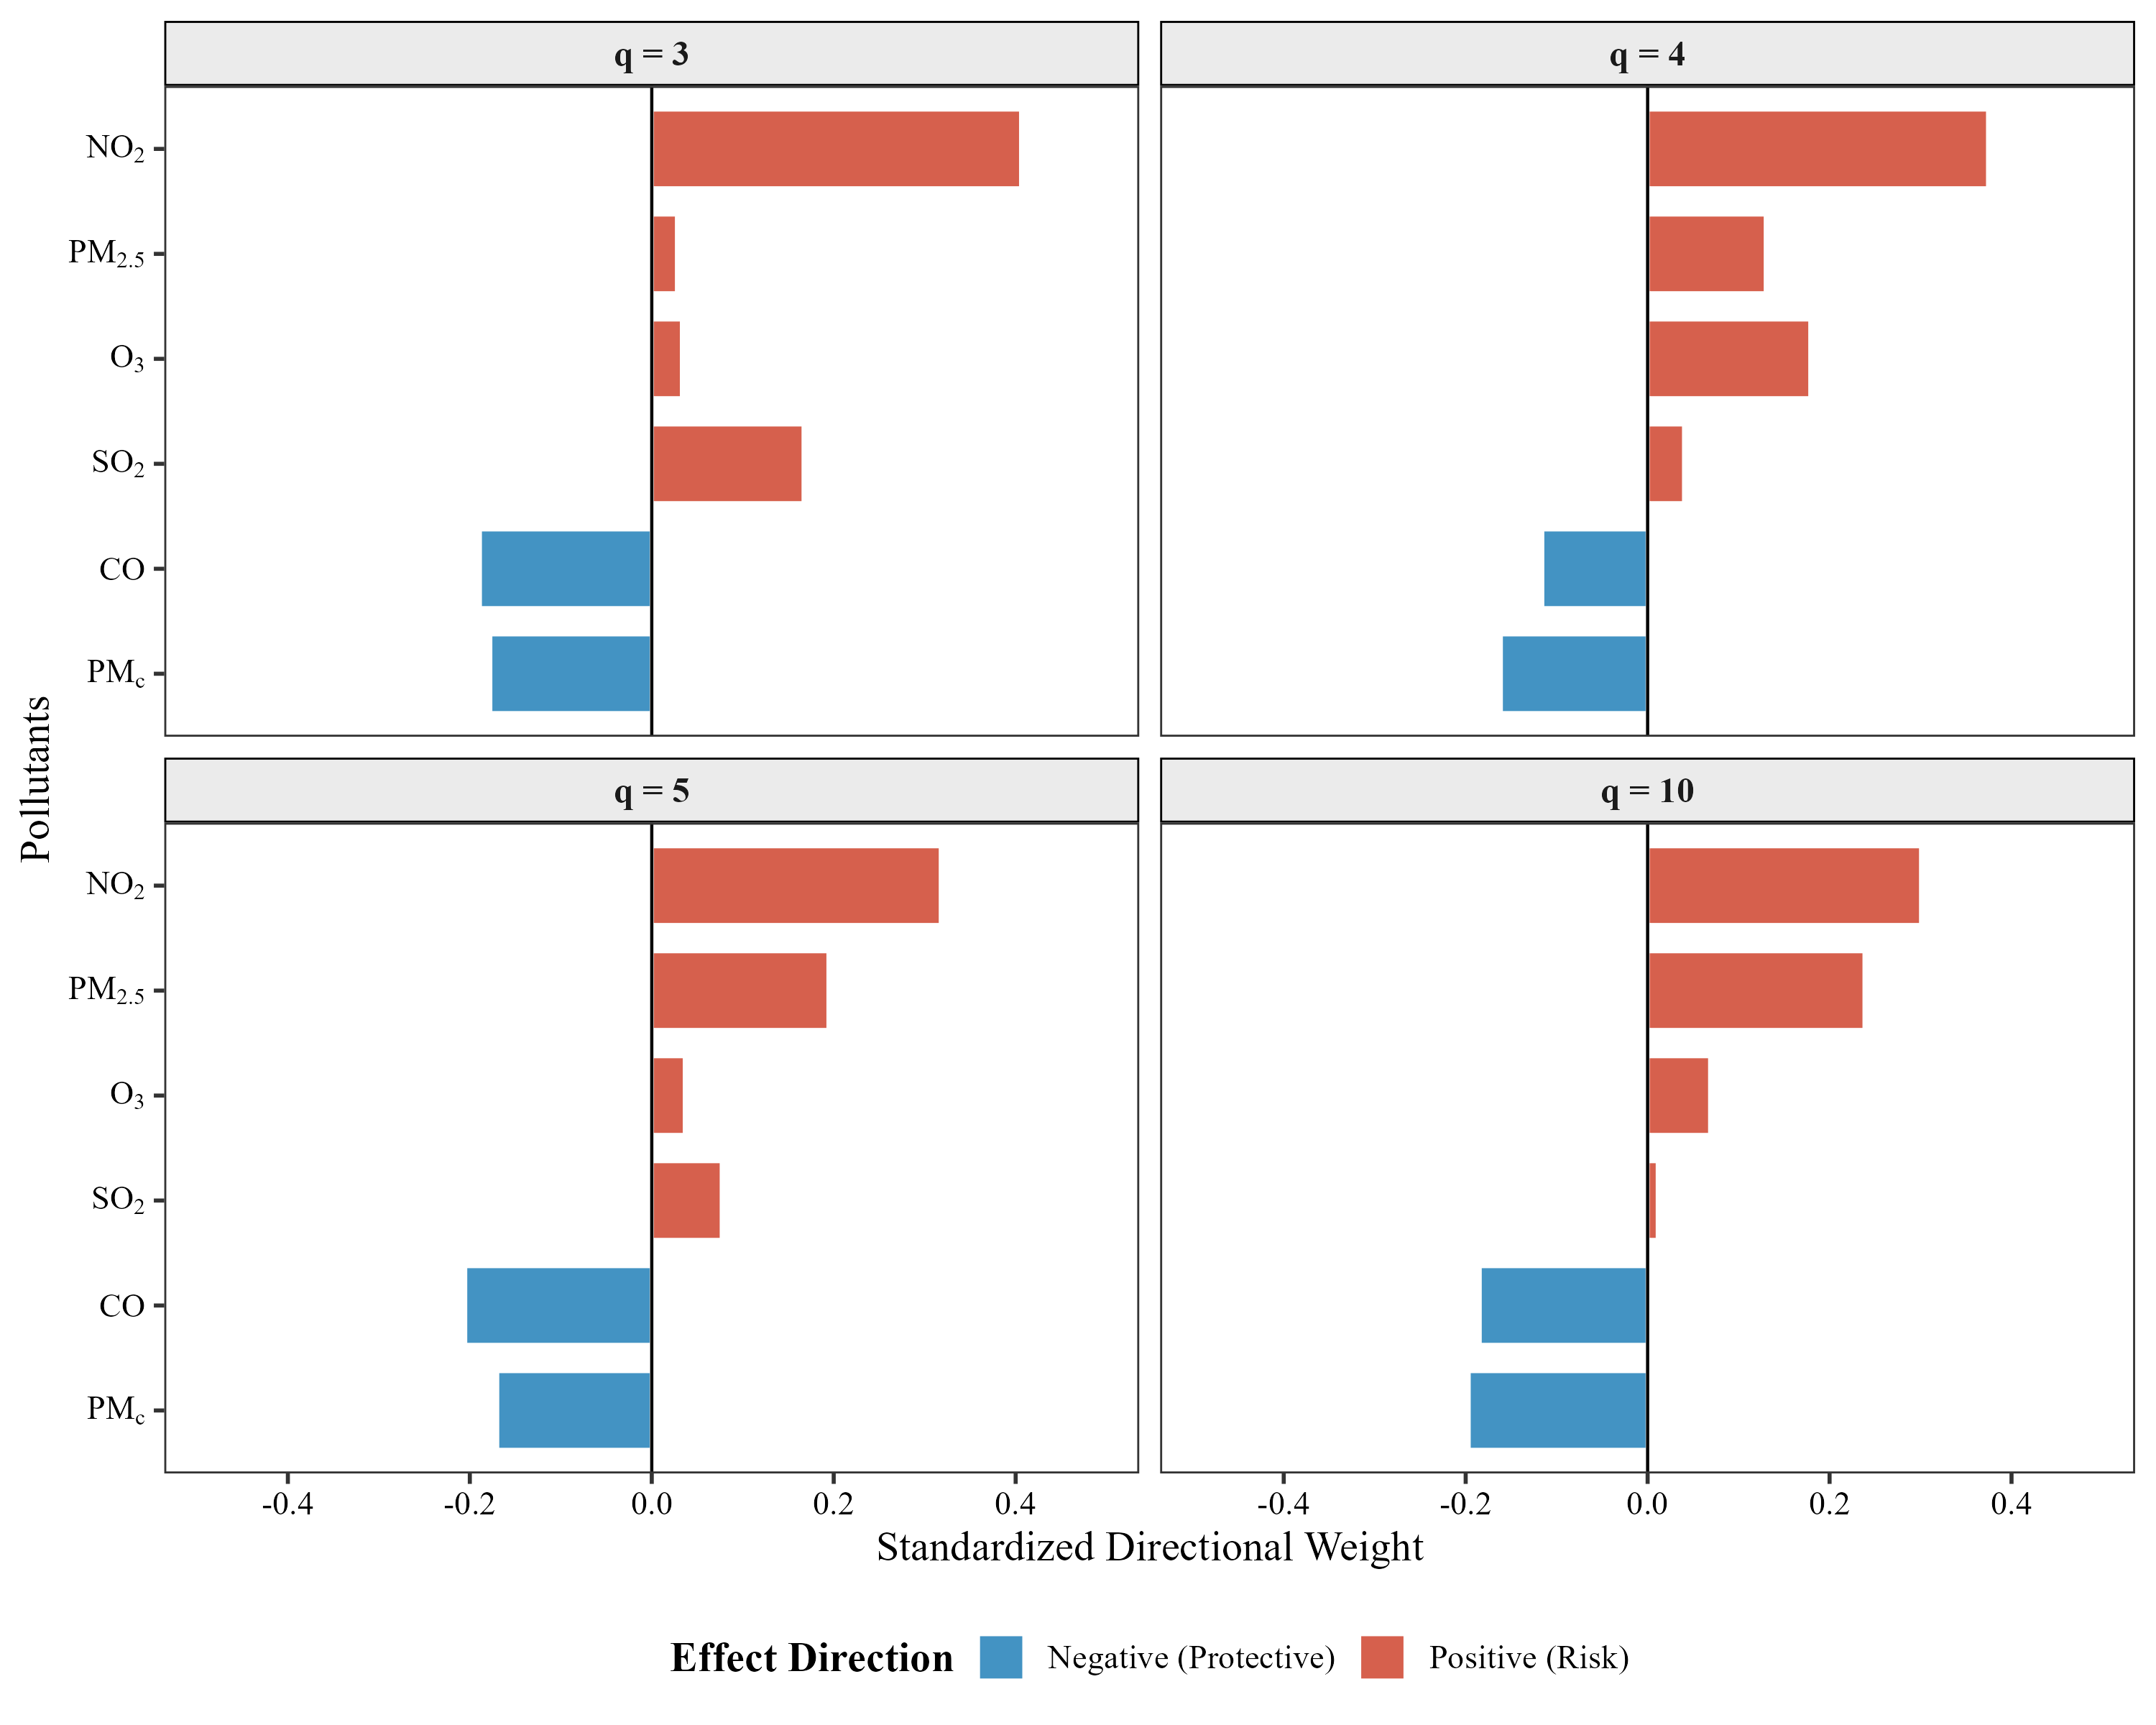
Figure S5. Qgcomp quantile test weight plot (q = 3, 4, 5, 10)

Figure S6. Joint exposure-response relationship for AECOPD hospital admissions

TableS1. Two-pollutant model
Adjustment item | PM_{2.5} | PM₁₀ | NO₂ | CO | O₃ | SO₂
Single-pollutant model | 1.028 (1.008-1.049) | 1.025 (0.998-1.053) | 1.004 (0.953-1.057) | 1.000 (0.948-1.056) | 1.010 (0.956-1.067) | 1.042 (1.013-1.073)
+ PM_{2.5} | - | 1.126 (1.023-1.239) | 1.011 (0.953-1.073) | 0.974 (0.918-1.034) | 0.987 (0.932-1.045) | 1.036 (1.004-1.068)
+ PM₁₀ | 1.027 (0.970-1.088) | - | 1.020 (0.959-1.084) | 0.972 (0.915-1.032) | 0.978 (0.923-1.036) | 1.031 (1.000-1.064)
+ NO₂ | 0.999 (0.970-1.029) | 0.971 (0.933-1.012) | - | 0.952 (0.895-1.013) | 0.990 (0.935-1.048) | 1.029 (0.999-1.061)
+ CO | 1.035 (1.013-1.058) | 1.035 (1.004-1.066) | 1.020 (0.966-1.077) | - | 1.003 (0.948-1.061) | 1.041 (1.011-1.072)
+ O₃ | 1.035 (1.014-1.057) | 1.056 (1.023-1.089) | 1.027 (0.974-1.082) | 1.019 (0.963-1.077) | - | 1.043 (1.013-1.074)
+ SO₂ | 1.030 (1.008-1.052) | 1.022 (0.992-1.052) | 1.001 (0.950-1.055) | 0.992 (0.939-1.048) | 0.998 (0.944-1.055) | -

