Supporting Information for

Observation of glutathione intra- and extracellular membrane with probe modified by long alkyl chains

Lin Li,^{a*} Shao-Bin Sun,^{b} Dan Qiao,ª Jing Zhou,^{b} Lin-qing Wang,ª Jian-Yong Wang ^{b*}
ª School of Life Sciences，Henan Province Engineering Technology Research Center of Antibody Screening and Diagnostic, Zhengzhou Normal University, Zhengzhou, 450004, P. R., China.No.16, Yingcai Street, Huiji District, Zhengzhou, Henan Province, PR China.
^{b} Faculty of Light Industry, State Key Laboratory of Green Papermaking and Resource Recycling, Key Laboratory of Paper Science and Technology of Ministry of Education, Qi Lu University of Technology (Shandong Academy of Sciences), Jinan, 250353, P. R., China
E-mail: lilin29pumc@163.com; wjy@qlu.edu.cn

*Correspondence to: Jian-Yong Wang, Faculty of Light Industry, State Key Laboratory of Biobased Material and Green Papermaking, Key Laboratory of Pulp and Paper Science & Technology of Ministry of Education, Qi Lu University of Technology (Shandong Academy of Sciences), Jinan, 250353, P. R., China. No.3501,Daxue Road, Changqing District, Jinan, 250353, Shandong Province, PR China. E-mail: wjy@qlu.edu.cn

Table of contents

General Information………………………………………….…....…S3
Cell Culture……………………………………………………………S3
Living Cell Imaging…………………………………………..….……S3
MTT assay experiment……………………………………….…………S4
Procedure for GSH Sensing…………………………………………….S4
Supplementary optical spectra………………………………………….S5
Cytotoxicity test….…………………………………….……………...S6
¹H NMR spectra of Nap-Mem-GSH………………….……………...S6
¹³C NMR spectra of Nap-Mem-GSH………………….……………...S7
ESI-MS of Nap-Mem-GSH………………………………………....S7

General Information
All reagents were purchased from commercial suppliers and used without further puriﬁcation. Solvents used were puriﬁed by standard methods prior to use. Acetonitrile in chromatographic purity and deionized water were used in detection.

Cell Culture
HeLa cells were incubated in DMEM with 10% (v/v) fetal bovine serum, 1% penicillin/streptomycin at 37 ℃ in 5% CO₂. HeLa cells were seeded at a density of 5 × 10⁴ cells per well (200 μL) in a 6-well plate.

Living Cell Imaging
The cells were imaged by using a confocal laser scanning microscope (λ_{ex} = 568 nm). Nap-Mem-GSH (5 mM, 2 μL) in DMSO was added to HeLa cells in a six-compartment cell culture plate that contained 1.0 mL culture medium, and was incubated at 37 ℃ for 20 min. After removing the culture medium and washing with PBS twice, the fluorescence images of cells were taken. For the control experiment, the cells in a six-compartment cell culture plate that contained 1.0 mL culture medium were treated with 5 mM Nethylmaleimide (NEM) in culture media for 30 min at 37 ℃ in a humidified incubator. After washing with PBS for twice, the cells were further incubated with 10 μM of Nap-Mem-GSH for 20 min. After washing with PBS for twice, the fluorescence images of cells were taken. The other two groups were incubated in a humidified incubator at 37 ℃ for 20 min with the addition of GSH (5 mM), and the cells were further incubated with 10 μM of Nap-Mem-GSH for 20 min. After washing twice with PBS, fluorescent images of the cells were taken. Another group was incubated with the addition of H₂O₂ (5 mM) for 20 min, and the cells were further incubated with 10 μM of Nap-Mem-GSH for 20 min. After washing twice with PBS, fluorescence images of the cells were taken.

MTT assay experiment
MTT experiment was performed in 96-well plate to assess the cytotoxicity of Nap-Mem-GSH. The MTT assay in HeLa cells with Nap-Mem-GSH concentrations from 0 to 20 μM in comparison with the blank and negative control. Cells were plated on cell plates at 4 × 10³ cells per well and allowed to incubate for 24 h. Nap-Mem-GSH in various concentrations was added to the well and incubated for 24 h followed by classical MTT treatment and data acquiring.

Procedure for GSH Sensing
A stock solution of Nap-Mem-GSH (1 mM) was prepared in 100% DMSO and was subsequently diluted to prepare appropriate concentration solutions of Nap-Mem-GSH in DMSO/PBS buffer (1:1, v/v, 10 mM, pH=7.4). GSH stock solutions were freshly prepared prior to each experiment. For the calibration curve, solutions of Nap-Mem-GSH were incubated with different concentrations of GSH at 25 ℃ for 10 min, and spectral data were recorded. Excitation was at 390 nm and emission was detected at 545 nm. The excitation and emission slit widths were set at 5 nm.

Supplementary optical spectra

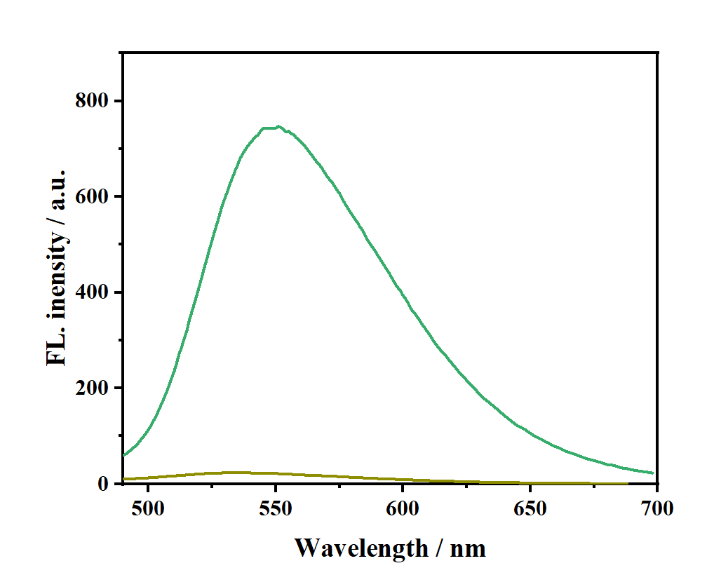
Fig. S1 Fluorescence intensity of the fluorescent probe in reaction with GSH.

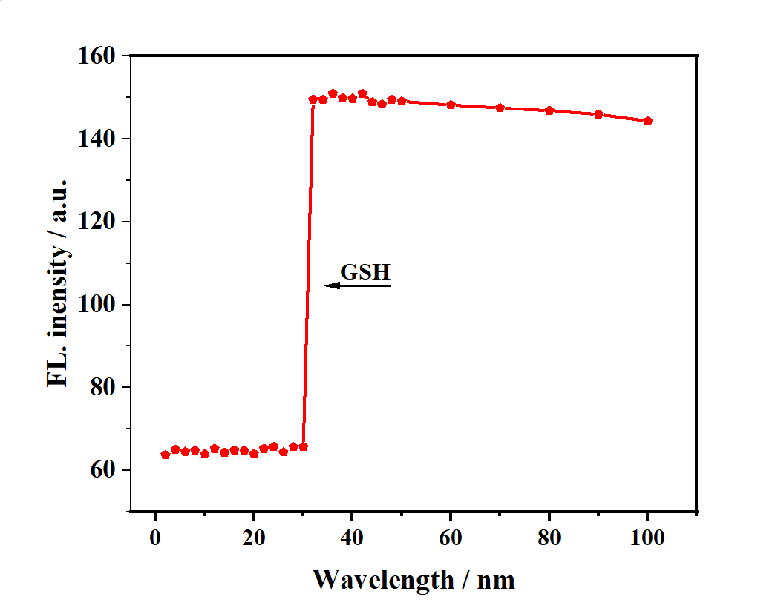
Fig. S2 Time stability diagram of Nap-Mem-GSH in the presence and absence of GSH.
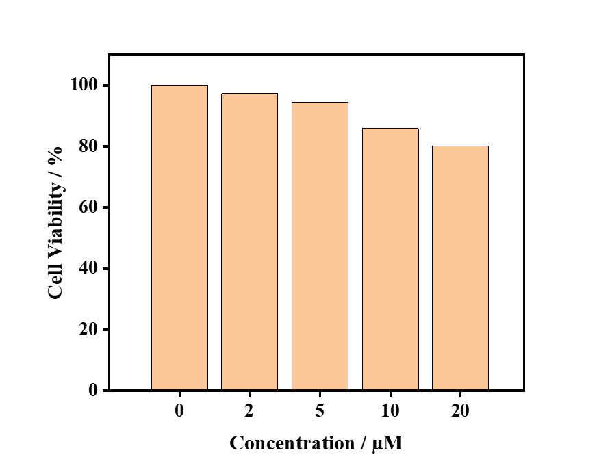
Fig. S3. Cell viability assay of Nap-Mem-GSH in Hela Cells, all compounds were incubated with the cells for 24 h, and the cell viability was observed via MTT assays.
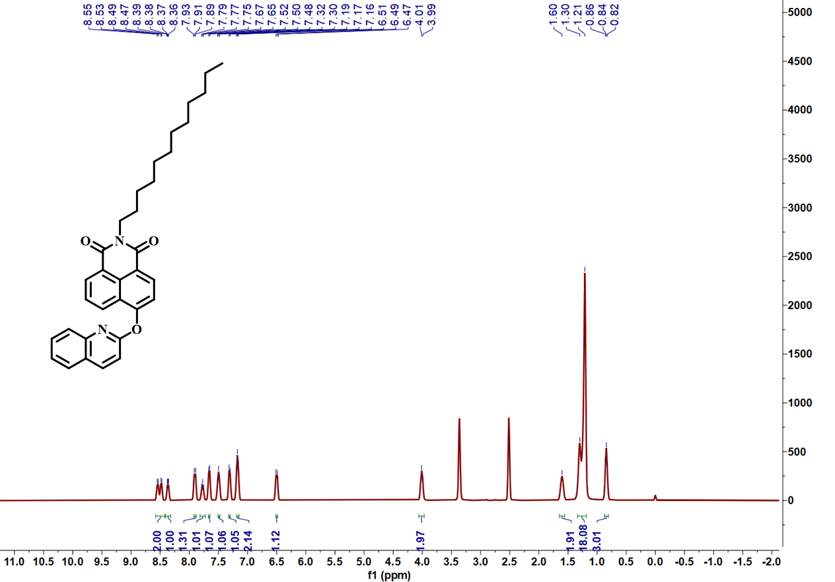
Fig. S4. ¹H NMR of Nap-Mem-GSH.
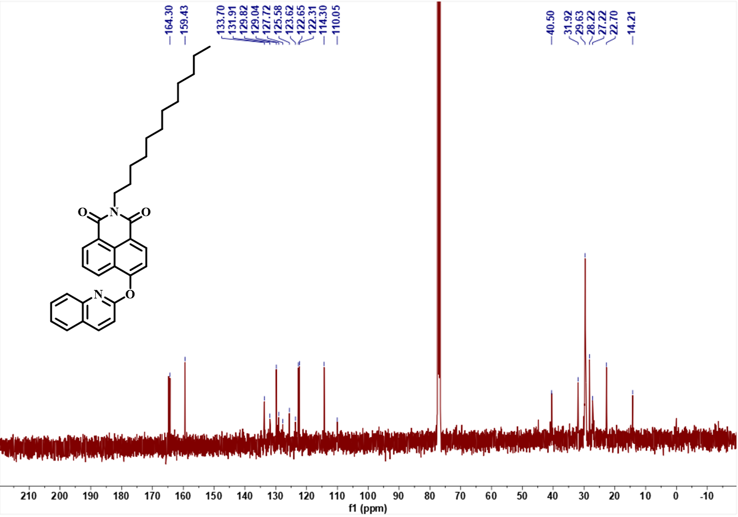
Fig. S5. ¹³C NMR of Nap-Mem-GSH.

.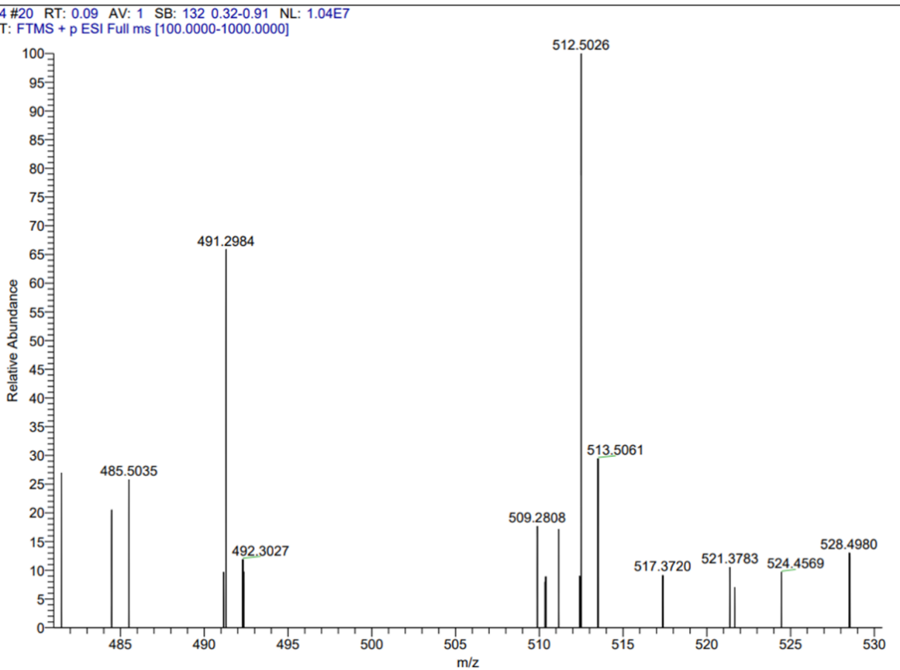
Fig. S6. HRMS spectrum of the probe Nap-Mem-GSH.

