Supplementary Information

Cep192 insufficiency underlies haploid instability in human cells
Koya Yoshizawa^{1,2}, Hemang Raj Singh³, Kathirvel Paramasivam³, Jin Zhu³, and Ryota Uehara^{1,2}

¹Graduate School of Life Science, Hokkaido University, Japan
²Faculty of Advanced Life Science, Hokkaido University, Japan
³Mechanobiology Institute, National University of Singapore, Singapore 117411, Singapore

Corresponding author:
Ryota Uehara, Faculty of Advanced Life Science, Hokkaido University, Kita 21, Nishi 11, Kita-Ku, Sapporo 001-0021, Japan
E-mail: ruehara@sci.hokudai.ac.jp
Phone: 81-11-706-9238

This word file includes:

Figures S1 to S8
Legends for Dataset S1 to S6
Legends for Supplemental materials S1

Other supporting materials for this manuscript include the following:

Datasets S1 to S6
Supplemental materials S1
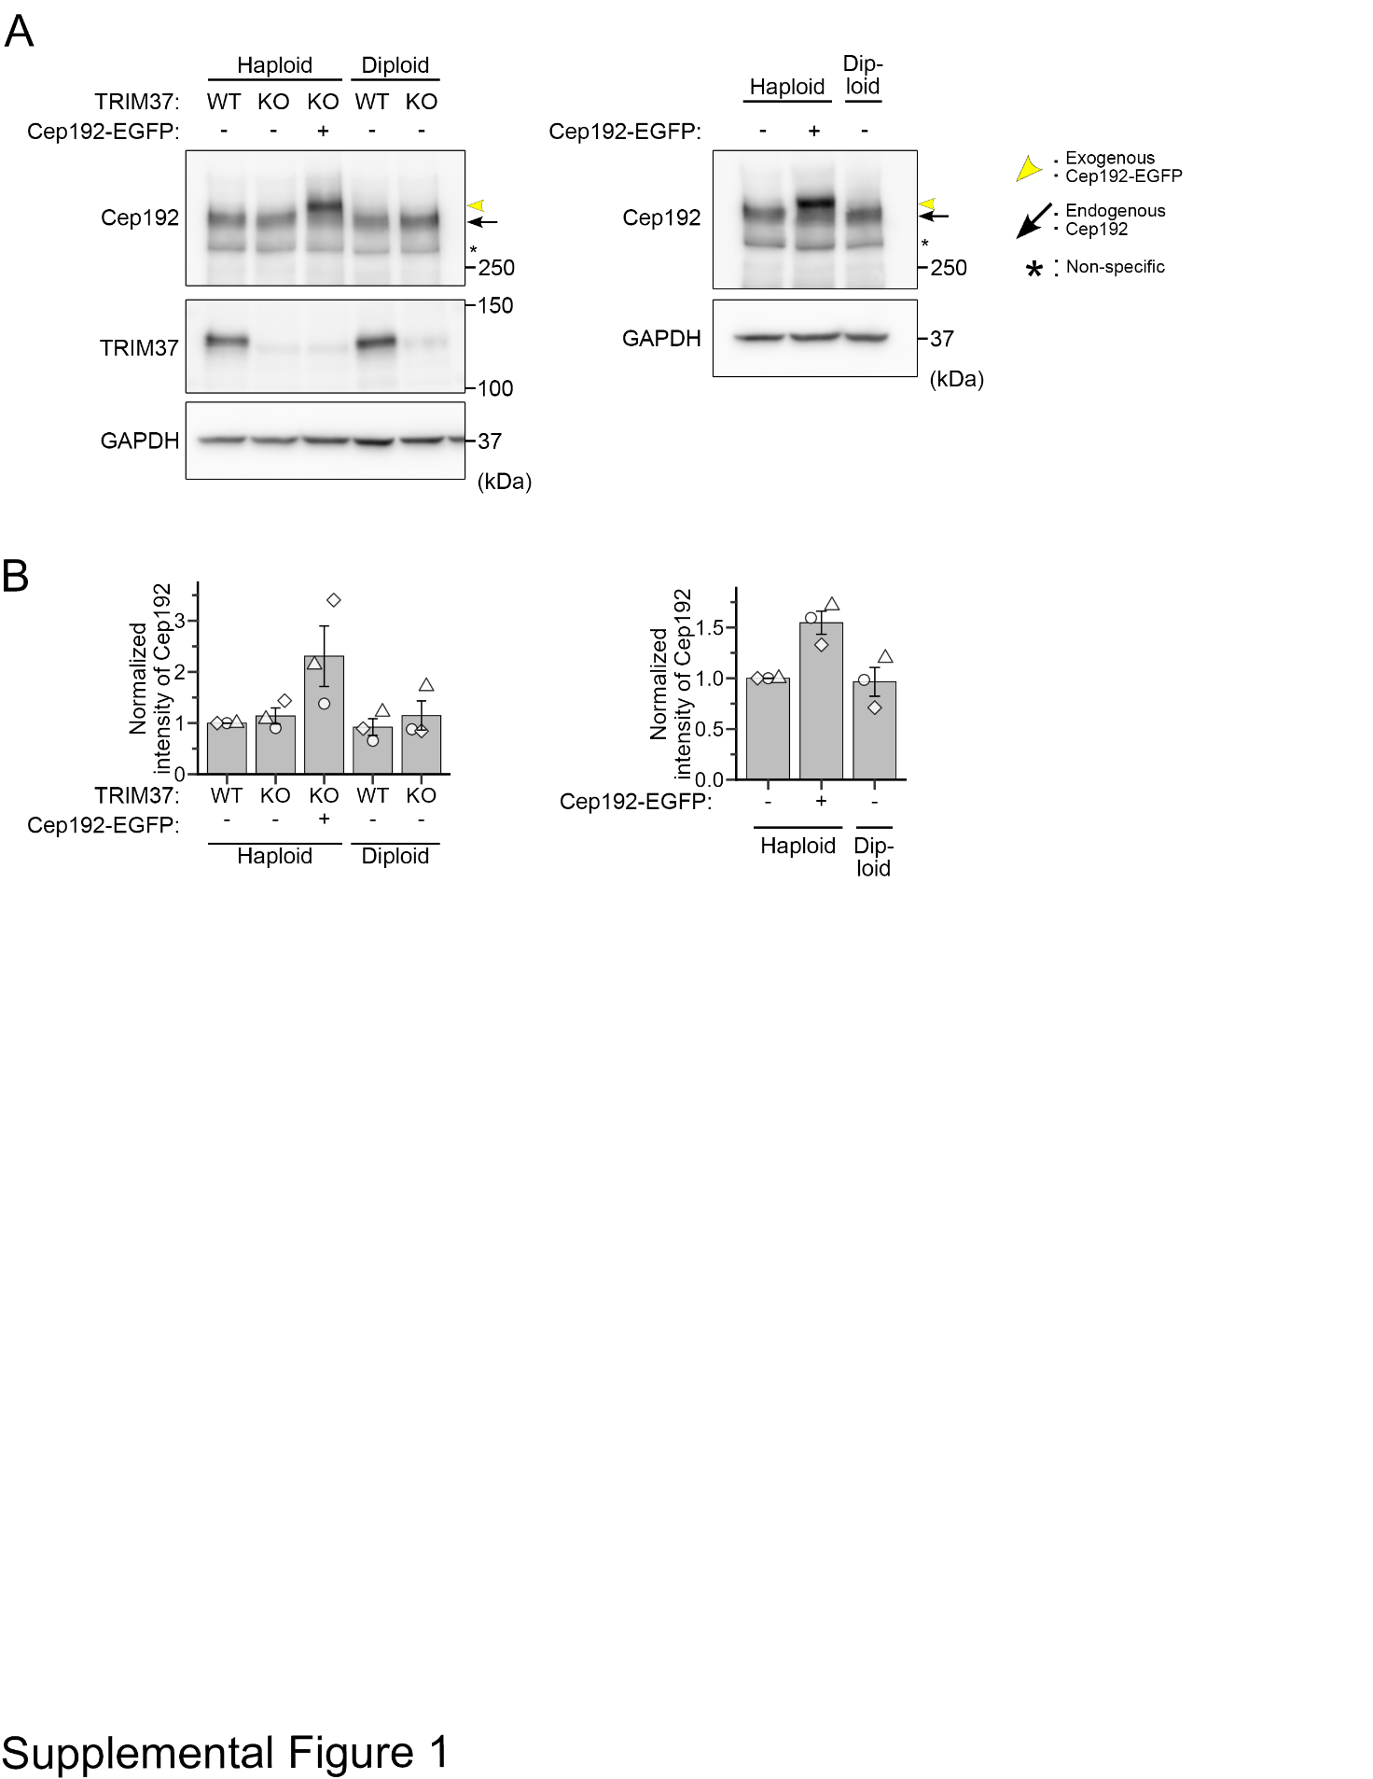

Fig. S1: Immunoblotting analysis of TRIM37 or Cep192 expression in HAP1 cells
(A) Immunoblotting of TRIM37 or Cep192 in haploid or diploid cells with the indicated backgrounds. GAPDH was detected as a loading control. (B) Quantification of the relative intensity of Cep192 in A. Protein loading differences were corrected based on GAPDH signals.

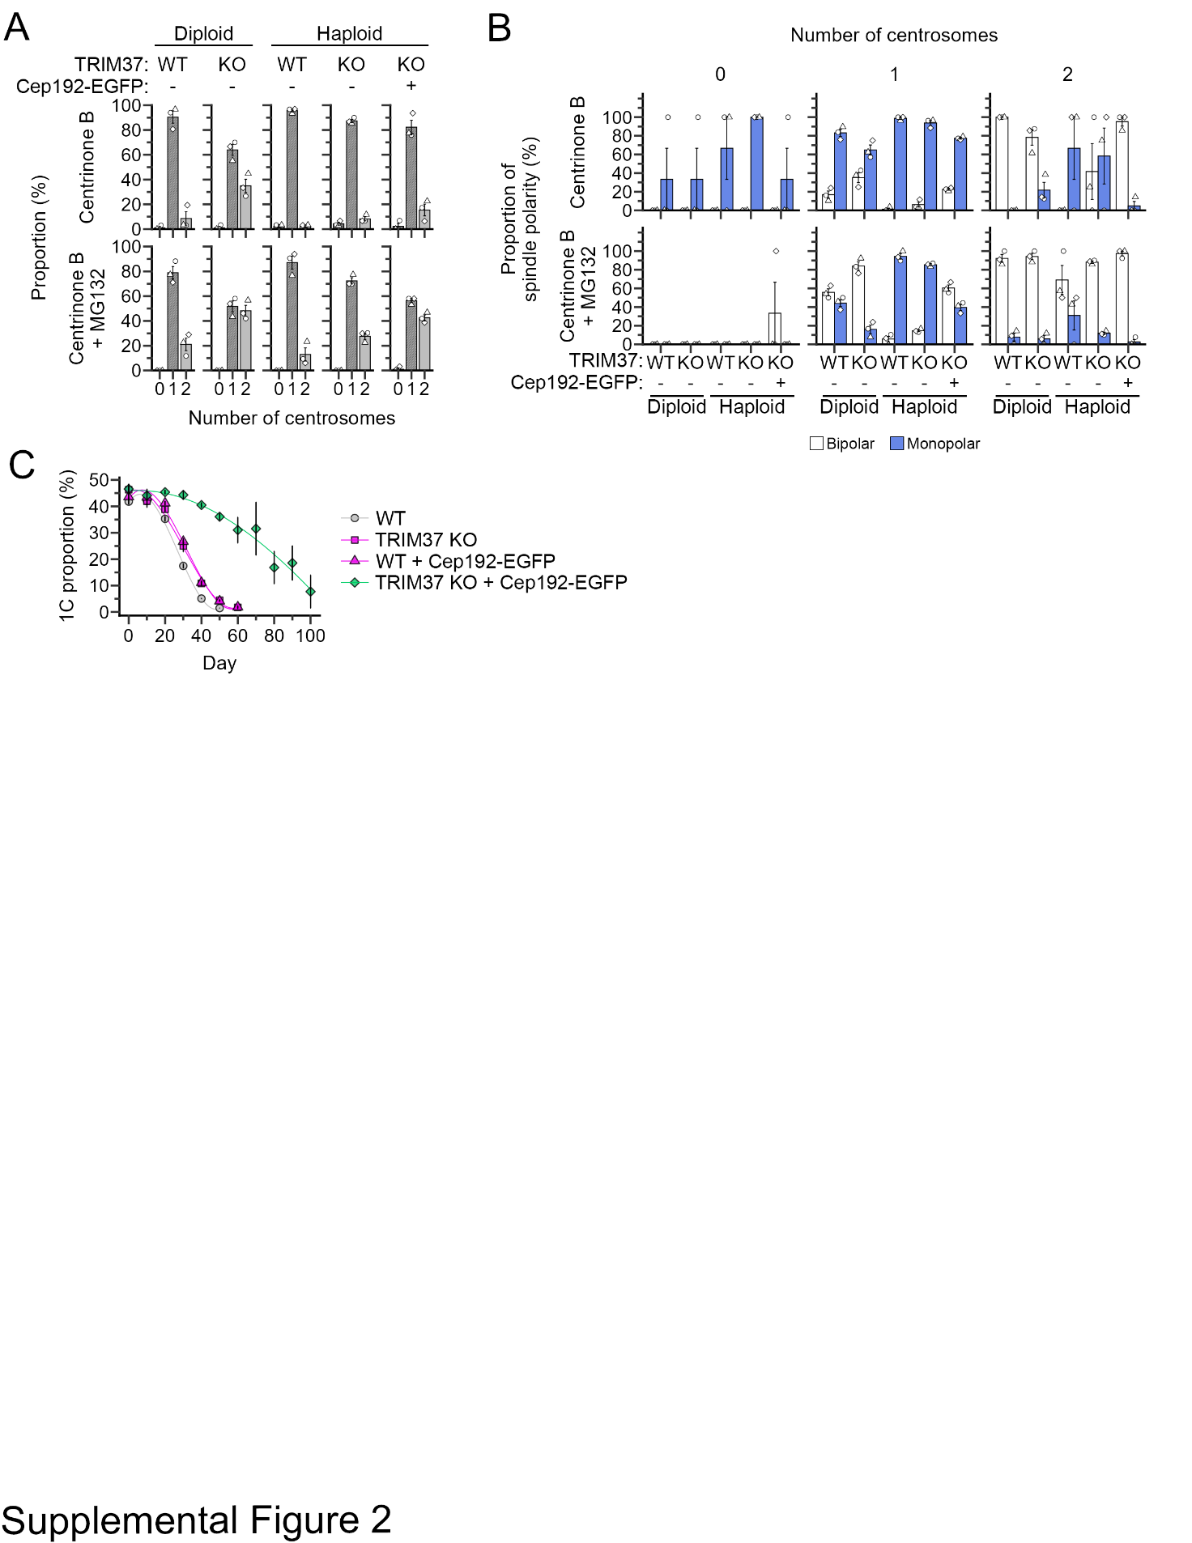

Fig. S2: Effects of Cep192 supplementation on centrosome number, spindle polarity, and long-term stability in haploids
(A) Proportion of centrosome numbers in Fig. 2C and D. Mean ± SE of 3 independent experiments. At least 91 cells from 3 independent experiments were analyzed for each condition. (B) Proportion of spindle polarity in Fig. 2C, sorted by centrosome number. Mean ± SE of 3 independent experiments. At least 91 cells were analyzed for each condition. Identical data for the “1 centrosome” sample are shown in Fig. 2D. (C) Time course of 1C proportion in Fig. 3C. Mean ± SE of 3 independent experiments.

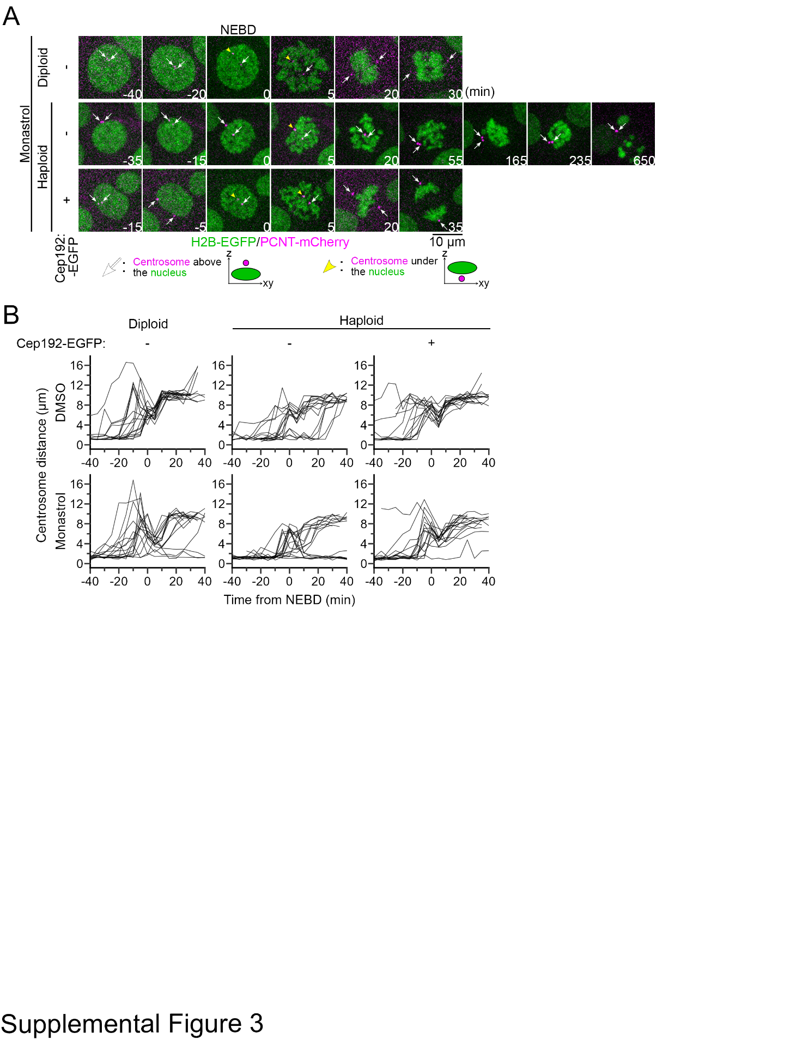

Fig. S3: Live imaging of centrosome separation during mitosis
(A) Time-lapse images of mitotic progression in haploids or diploids with indicated backgrounds, treated with 12.5 μM monastrol. Centrosomes or chromosomes were labeled with endogenous PCNT-mCherry or with transgenic H2B-EGFP, respectively. (B) Time course of inter-centrosomal distance before and after NEBD in all individual cells in Fig. 4A or S3A. Data from at least 16 cells from 2 independent experiments are shown.

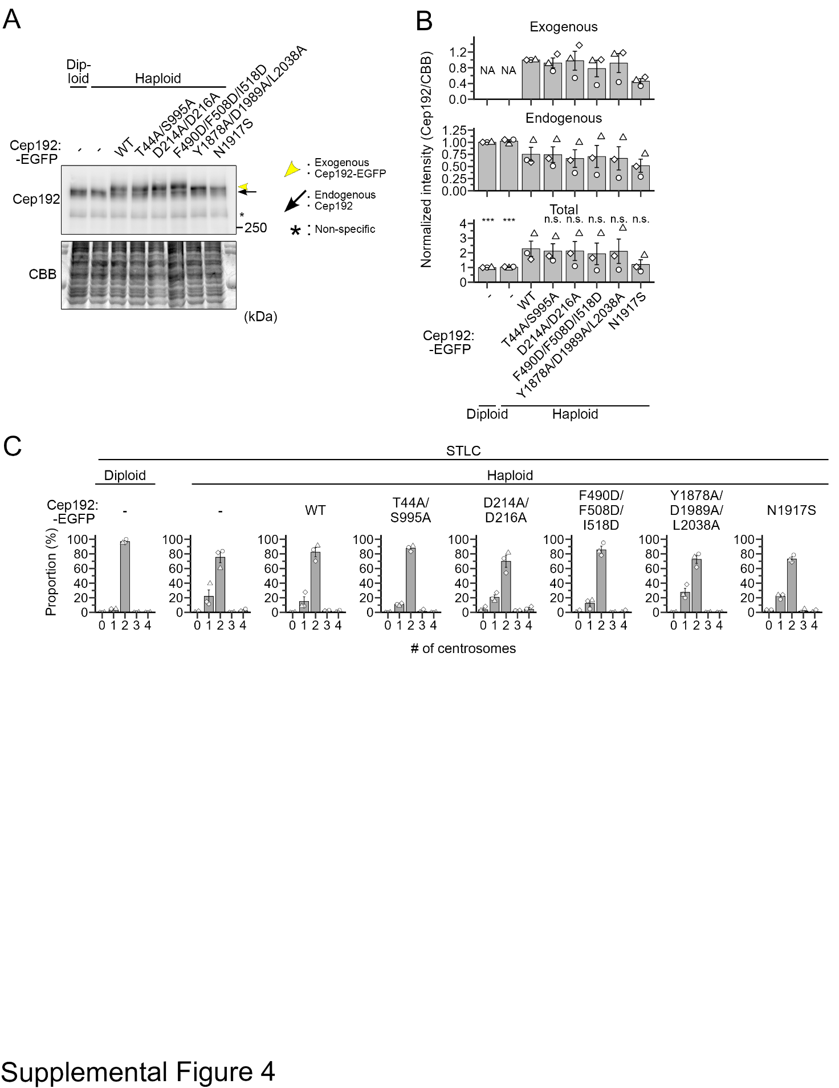

Fig. S4: Exogenous expression of transgenic Cep192 mutants in haploids
(A) Immunoblotting of Cep192 in haploid or diploid cells with the indicated backgrounds. CBB-stained total protein was quantified as the loading control. (B) Quantification of the relative intensity of total Cep192 (i.e., summation of endogenous and exogenous transgenic Cep192 signals) in A. Protein loading differences were corrected based on CBB signals. Asterisks indicate statistically significant differences from haploid Cep192 (WT)-EGFP control (*** p<0.001, the Steel test). (C) Proportion of centrosome number in Fig. 5C. Mean ± SE of 3 independent experiments. At least 63 cells were analyzed for each condition.

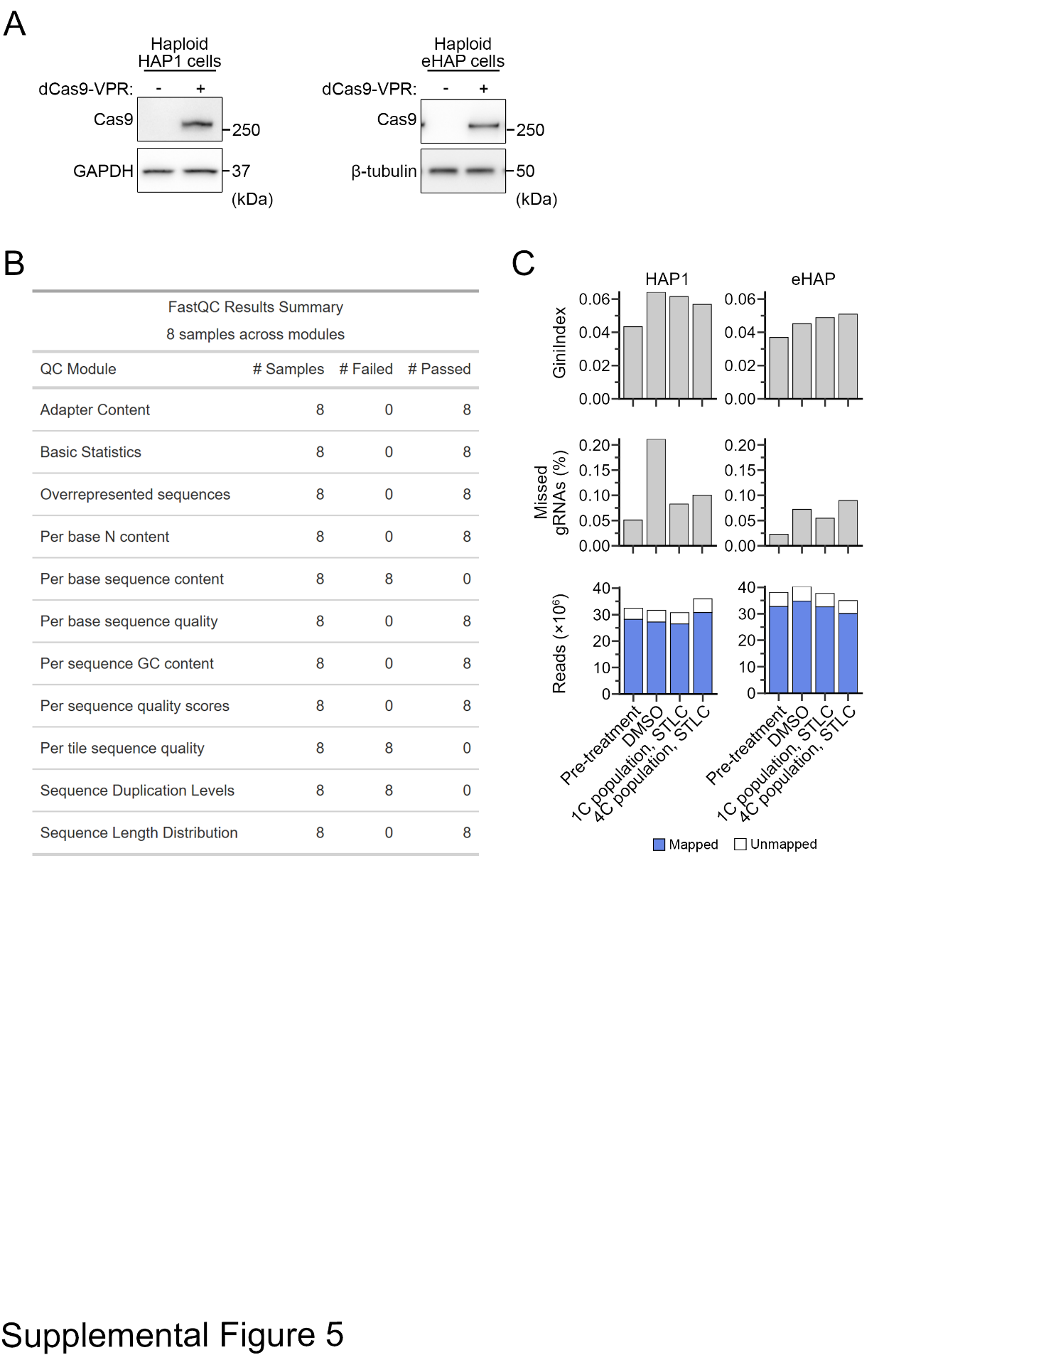

Fig. S5: Quality check of the genome-wide CRISPRa screen
(A) Immunoblotting of dCas9-VPR using anti-Cas9 antibody in haploid HAP1 or eHAP cells with the indicated backgrounds. GAPDH or β-tubulin was detected as a loading control. (B, C) Summary of quality check for gRNA sequencing.

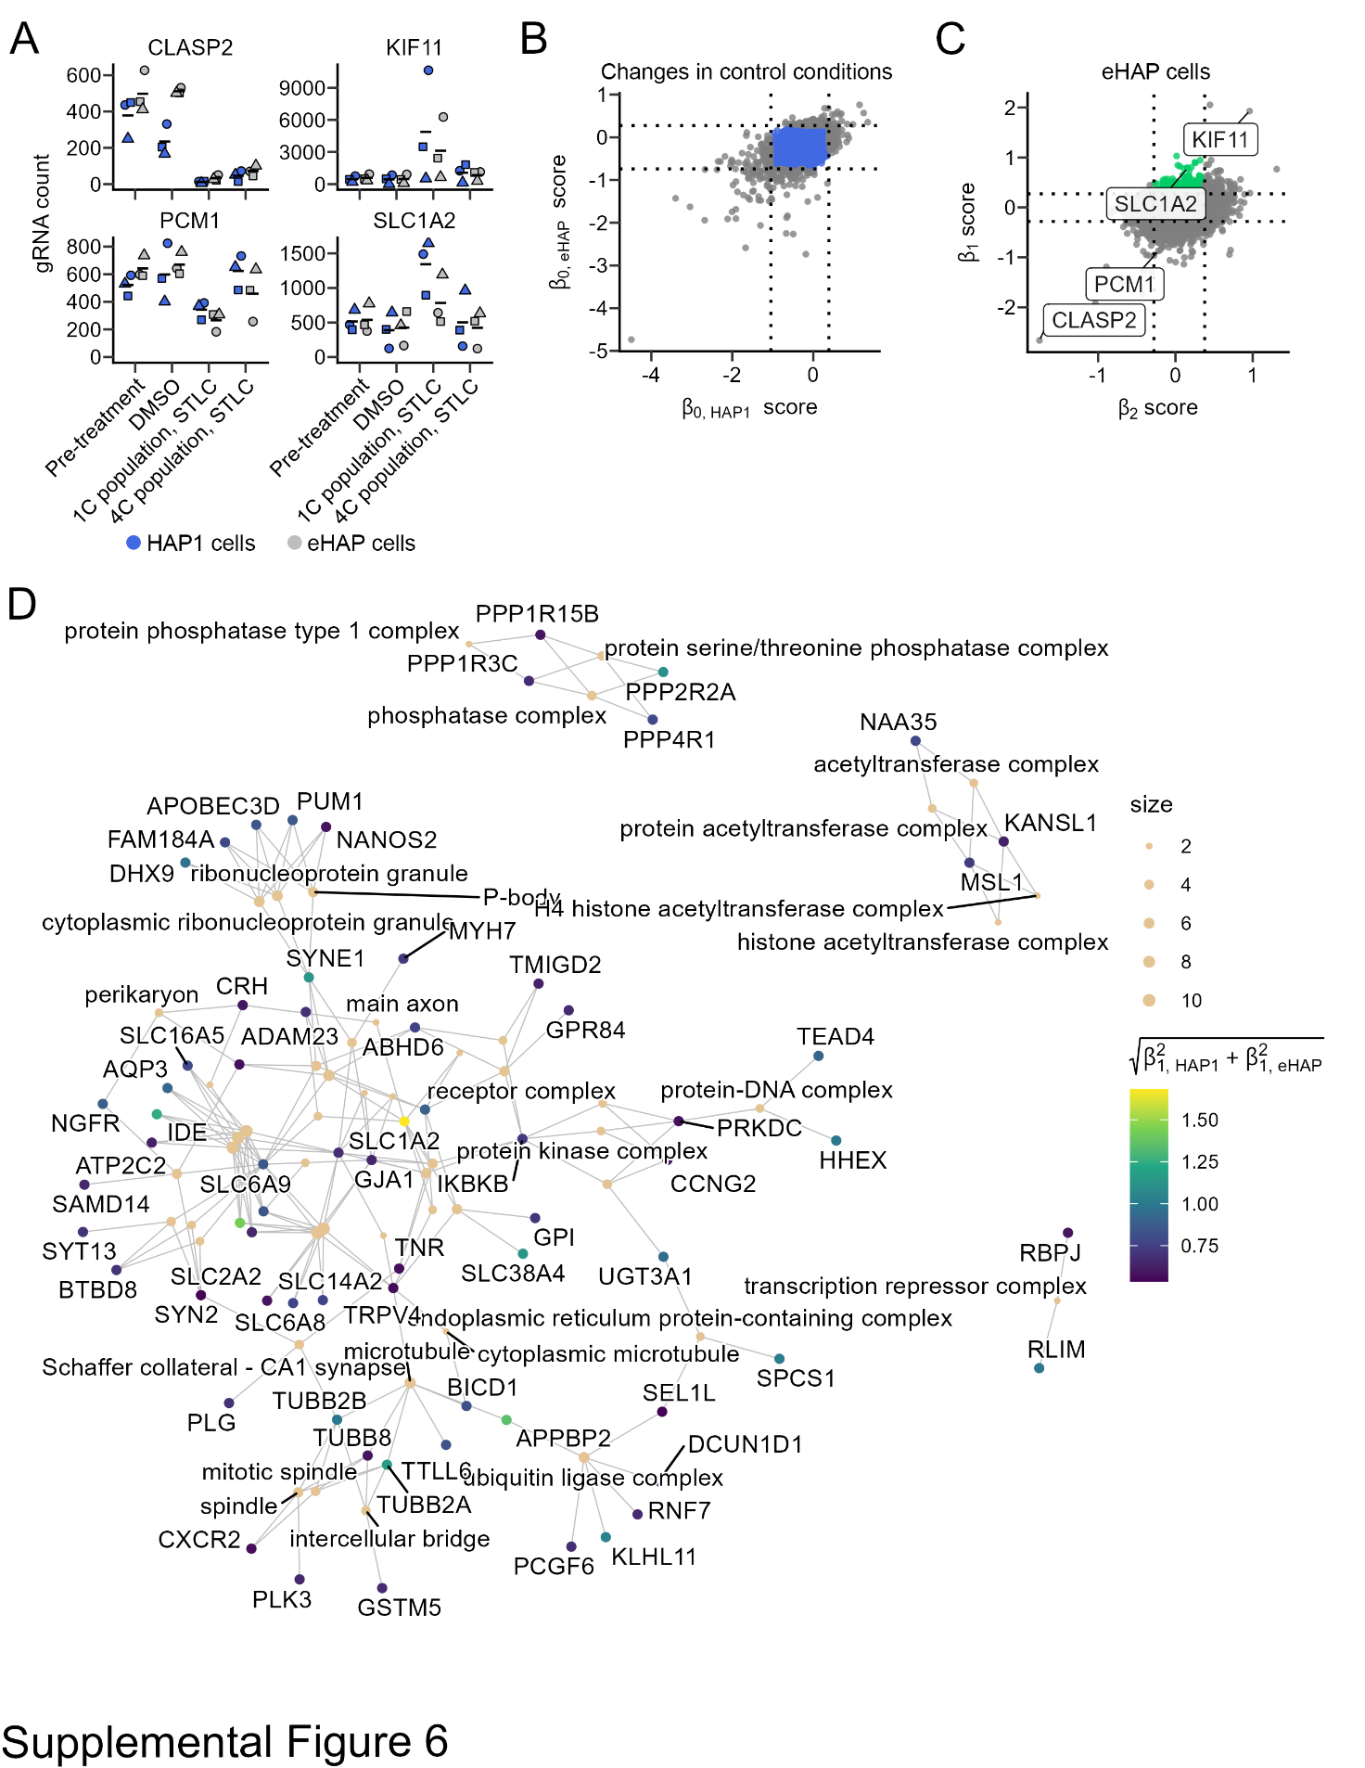

Fig. S6: Result summary of the genome-wide CRISPRa screen
(A) Examples of gRNA count for several genes with distinct patterns of distribution in four different cell populations in the CRISPRa screen. (B) Graphical representation of the filtering out of genes with prominent fluctuations in their retention between pre-treated and vehicle control cell populations. Removed genes are indicated as grey dots. (C) A 2-D scatter plot of β₁ vs β₂ scores in eHAP cells. Hit genes selectively concentrated in the haploid G1 population under modest Eg5 inhibition were indicated in green. (D) GO terms of cellular component shared among at least 2 of 133 hit genes in Fig. 7C.

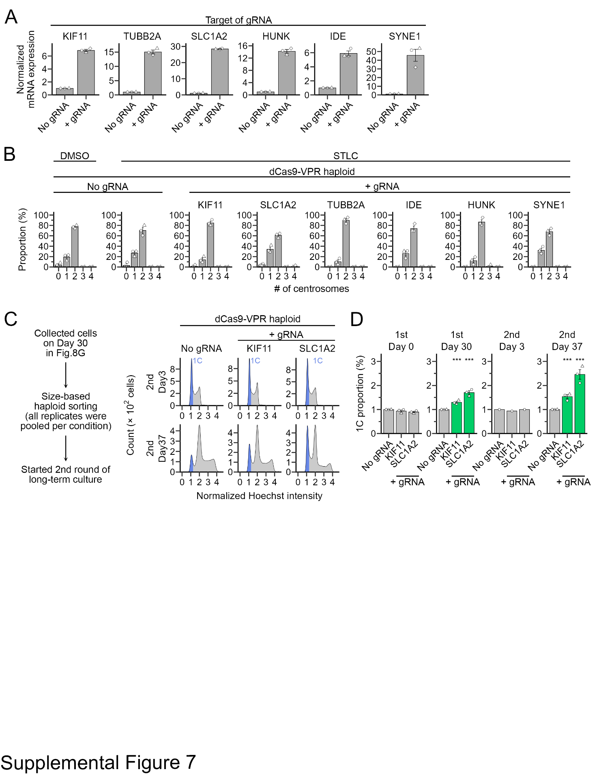

Fig. S7: Identification of haploid-stabilizing genes
(A) Relative expression levels of gRNA target genes (normalized to that of β-actin) quantified by qPCR. Mean ± SE of 3 independent experiments. (B) Proportion of centrosome numbers in Fig. 8C. Mean ± SE of 3 independent experiments. At least 68 cells from 3 independent experiments were analyzed. (C) Flow cytometric analysis of DNA content in haploid dCas9-VPR cells expressing gRNA for the indicated genes during the second round of consecutive passages (the experimental flow is shown on the left). DNA was stained with Hoechst 33342. (D) Proportion of 1C populations in C. Mean ± SE of 3 independent experiments. Asterisks indicate statistically significant differences from the untransfected control (*** p<0.001, the Steel test). Identical data for the “1st Day 30” sample are shown in Fig. 8H.

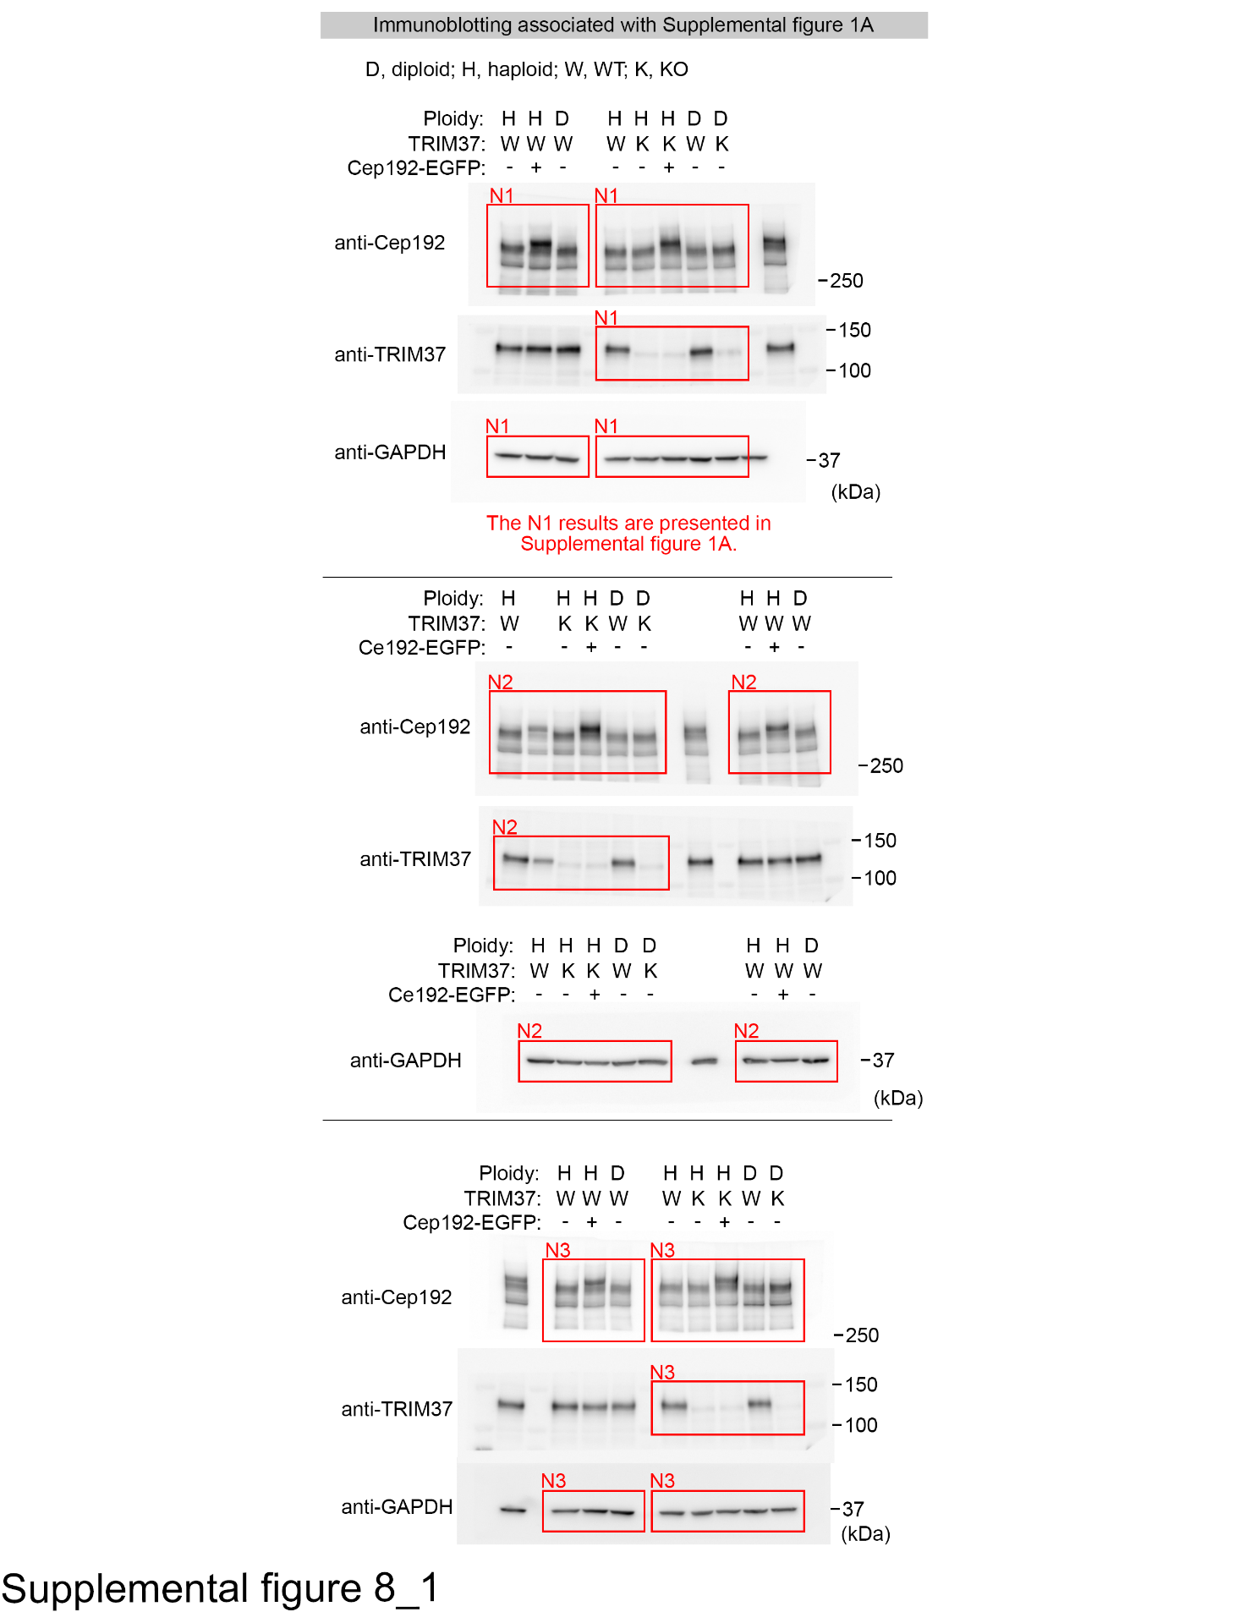

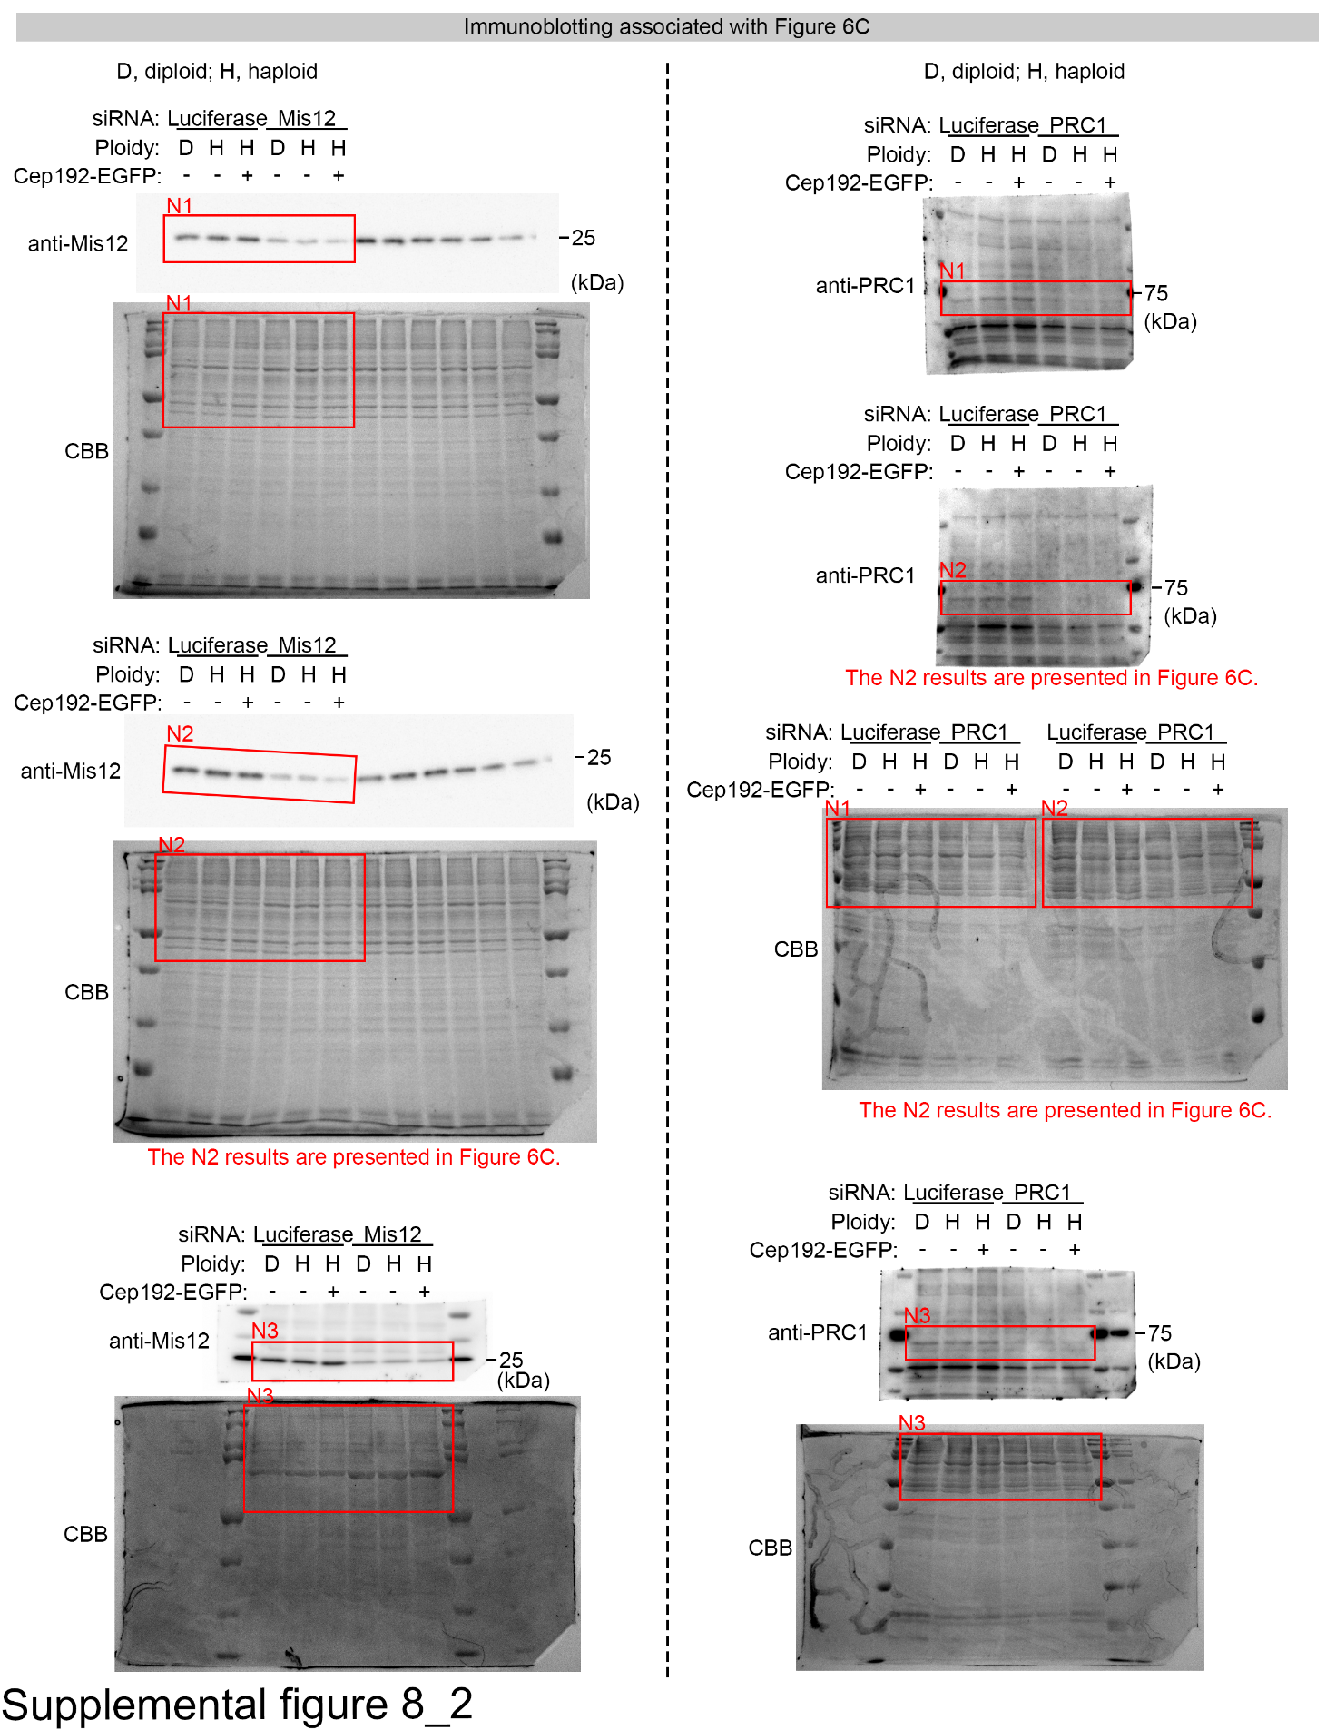

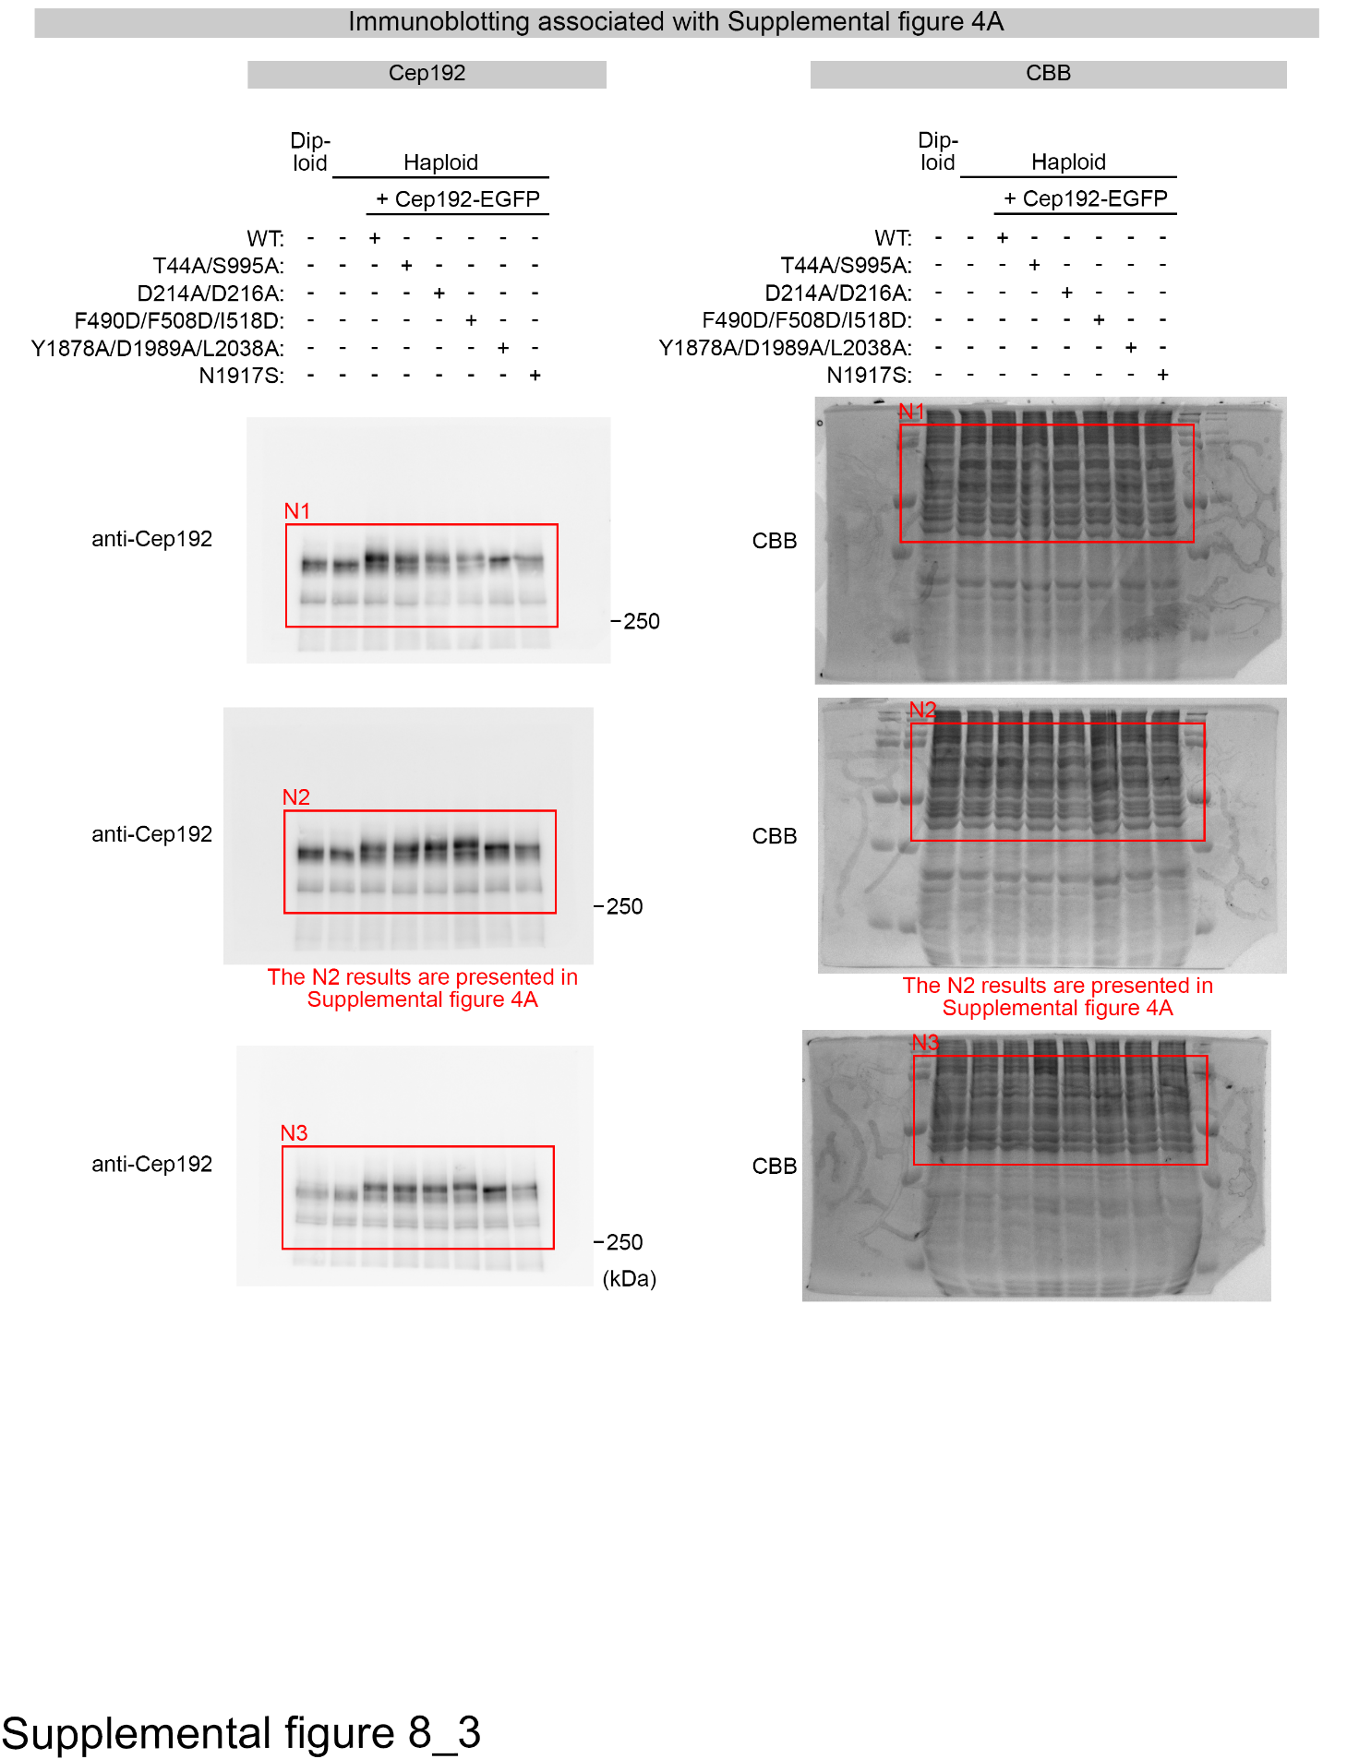

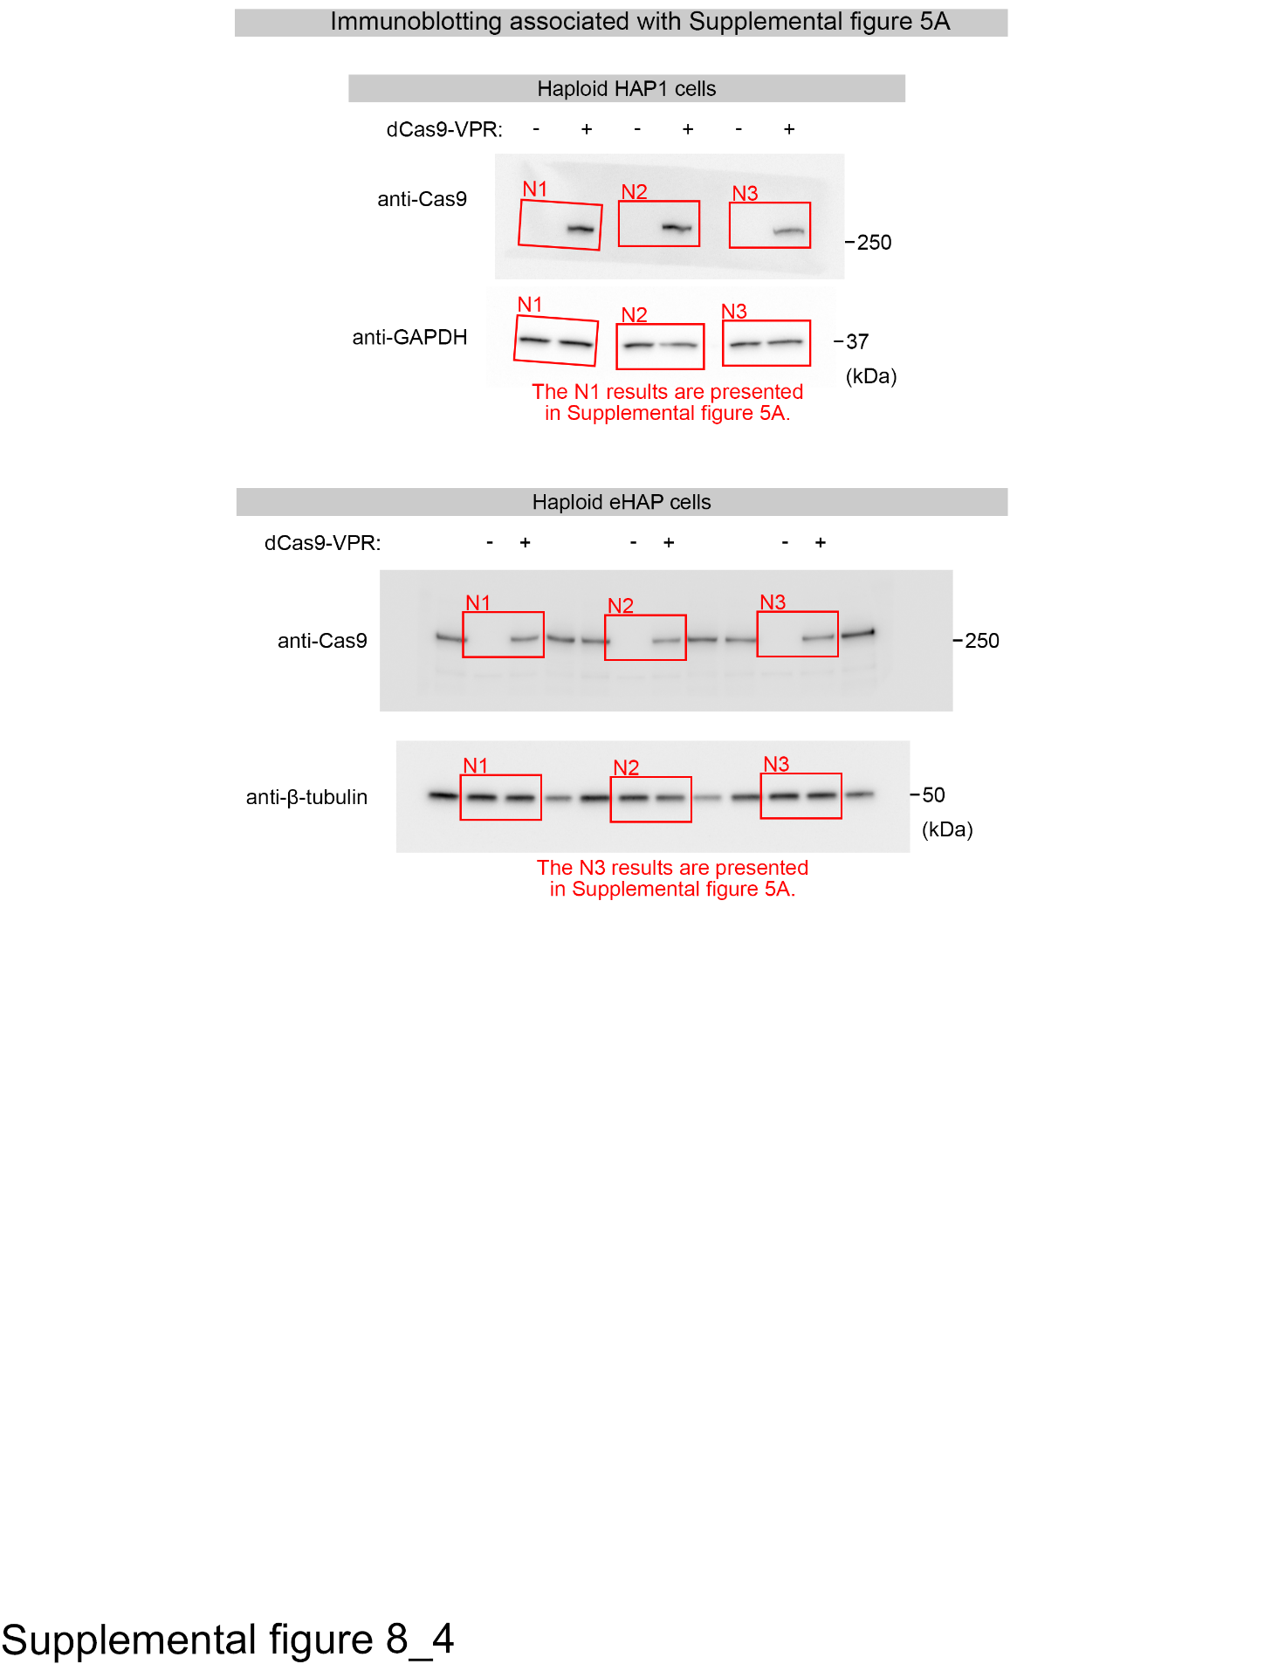

Fig. S8: Original immunoblot membranes used for the analyses
Uncropped images of all immunoblots are shown, with the approximate indications of the cropped regions.

Dataset S1: gRNA count in the genome-wide CRISPRa screen

Dataset S2: β scores and pHaplo score for all genes analyzed in the genome-wide CRISPRa screen

Dataset S3: Cell lines established or used in this study

Dataset S4: Plasmids constructed or used in this study

Dataset S5: Primers used in this study

Dataset S6: Antibodies and compounds used in this study

Supplementary Material S1: R script for the automated cell population quantification from flow cytometry data

