Appendix A: Survey Questions 2
Appendix B: Construction of common text 3
Appendix C: Full text stimuli 5
The Neutral text: 5
The Current UN messaging text 6
The Public Health text 7
The Social Norms text 7
The Patriotism text 8
Appendix D: Analytical Strategy 10
Appendix E: Full Sample, Total support for each question 10
Appendix F: Margin of error 12
Appendix G: ANOVAs by country 13
Appendix H: Logistic Regression Models (Policy Support) 16
Appendix I: Graphs 17
Q1: 17
Q2: 18
Brazil 21
China 22
India 23
Indonesia 24
Poland 25
United Kingdom 26
United States 30
Appendix J: Acknowledgements, Funding and Author contributions 34
Appendix K: Additional references 35

Appendix A: Survey Questions

After reading one of the five texts (see below), participants were asked the following questions:

Q1:
Do you agree or disagree that all national governments should do more to protect the environment?
Note: This question was worded specifically to reflect the dynamics facing leaders at COP26 when governments will be taking decisions collectively. It was also designed to allow participants to express support for environmental action without implicitly criticising their own government.
Q2:
At an international meeting in November next year, governments will be asked to make commitments to protect the environment. Which of the following commitments, if any, do you think they should support:
- To protect and preserve wildlife, marine life and plants
- To plant more trees to absorb the gases that cause climate change
- To spend more on developing clean technologies
- To reduce the production over thirty years of the gases that cause climate change
- To make businesses pay for the damage they do when their activities contribute to climate change
- To give businesses a fair timetable to stop activities that contribute to climate change
- None of these, governments are already doing all they should
Note: The policy options were deliberately framed in simple, non-scientific language. A recent paper (Bruine de Bruin et al., 2021) suggests that public understanding of climate change terminology is relatively poor.

Appendix B: Construction of the common text
Each of the texts contained common elements to ensure maximum comparability. In addition to the references mentioned in the literature review, they drew on the following studies.
The saying: Each text began with a saying that was intended to be familiar, translatable and easy to agree with. In his book Pre-Suasion, Robert Cialdini (2016, pp.23-25) discusses a marketing technique called ‘target chuting’, whereby a salesperson will ask a question before starting their sales pitch in order to get the respondent in the right frame of mind. Bolkan and Andersen (2009) found that preceding a request with an image-inducing question can create a salient self-image and increase the likelihood that a respondent will behave consistently with that image.
Availability bias: Each text uses availability bias, asking participants to think of personal examples of something that has happened (or could happen) to them. Broockman & Kalla (2016) successfully reduced transphobia after an intervention in which participants were encouraged to talk about their own experience of discrimination. Dr Heather Rolfe, Head of Social Policy at the National Institute for Economic and Social Research, said in a 2018 blog that focus group participants discussing immigration tended to rely on a “hierarchy of evidence” whereby the most persuasive was personal experience, followed by media evidence, followed by statistics.
Fire, flood, storms; animals, birds and trees: Each text has references to fire, floods, storms and the risk to animals, birds and trees in that country. Van der Linden (2014) suggests that associating more frequent extreme weather events with climate change can change perceptions, while Jones et al. (2017) say that communicators should consider using messaging that reduces the psychological distance between individuals and the impacts of climate change. Bloodhart and Swim (2104) say that pictures that encourage empathy for animals in danger, such as polar bears, are effective. Loss aversion (Kahneman, Tversky 1979) is used to suggest that we may lose valued animals.
Scientists: Each text mentions scientists, but in the “Social Norms” text, it is framed as the “gateway” belief that “at least 97% of climate scientists say that climate change is happening and humans are responsible.”
Solvable problem: Each text suggests climate change is a solvable problem. Hart et al. (2016) suggest that messages that promote efficacy increase political participation, while Feldman et al. (2016) say they foster hope.
Call to action: Given the context of this project, which comes in the run-up to November’s COP26 conference, the final line is deliberately non-confrontational and is drafted to suggest increasing support for leaders in taking ambitious action now.

Appendix C: Full text stimuli

Preamble

Before reading the texts, participants were exposed to the following preamble:

You are being invited to take part in an international academic study that is asking people for their views on global issues. All responses will be anonymised and will contribute to an article in an academic journal. Please tick the box below to indicate whether you agree to participate and to the use of your data for the purposes specified above.

I consent to take part in this survey
I do not consent to take part in this survey.

Texts

They were then exposed to one of the following five texts. The texts were presented in English in India, the UK and the USA. In Brazil, China, Indonesia and Poland, they were translated (translations available on request - please contact tmb72@cam.ac.uk).

The “Neutral” text:
Have you ever heard people talk about being “as busy as a bee”? Some people have pastimes that keep them fully absorbed.
Think for a moment about the things you enjoy doing with your hands. Some people like being creative, making art or music; while others like being practical, fixing things around the house.
Scientists say that people benefit from concentrating on a challenging activity that requires a certain level of skill to complete. It can bring about what’s called a “flow” state.
Consider the thinking that goes into the creation of an art work showing dramatic scenes of fire, floods or storms. You need to choose the colours and textures to represent the various elements, and you need to have the skill to make your vision a reality. Or what about working on a piece of quilting that depicts a story involving animals, birds and trees? You can plan it all out, although it’s also fair to say that some people just start working and see where they end up.
Practical challenges can be equally absorbing. It can be deeply satisfying to fix a tap that has been dripping, or to paint a room that has needed redecorating for some time.
People who have time on their hands can benefit from finding a handicraft or hobby that challenges them. There are many activities that can keep people’s interest engaged in ways that are deeply satisfying.
Note: This text drew on the concept of flow - an experience in which an individual is completely absorbed in the current moment (Csikszentmihalyi, 2014).

The “Current UN messaging” text
Have you ever heard people say “our fate is in our hands”? Global heating is accelerating. Think back to last year. 2019 was the second hottest year on record, with the past decade the hottest in human history.
Scientists say that greenhouse gas concentrations are at the highest levels in 3 million years – when the Earth’s temperature was as much as 3 degrees hotter and sea levels some 15 metres higher.
Ocean heat is at a record level, with temperatures rising at the equivalent to dropping five Hiroshima bombs a second.
We count the cost in human lives and livelihoods as droughts, wildfires, floods and extreme storms take their deadly toll. Biodiversity is in steep decline, and we risk losing some species of animals, birds and trees forever.
We have no time to lose if we are to avert climate catastrophe. This is a pivotal year for how we address the climate emergency.
All countries need to demonstrate that we can achieve emissions reductions of 45 per cent from 2010 levels this decade, and that we will reach net-zero emissions by mid-century. This is the only way to limit global heating to 1.5 degrees Celsius.
Our success will depend on countries, the private sector and civil society demonstrating that they are taking significant steps towards a sustainable future.
We must support our leaders in taking ambitious action now and commit to meaningful climate action before it is too late.
Notes: This draws on a speech given by UN Secretary General Antonio Guterres on 10 March 2020. Additional remarks are included from a speech he gave on 23 September 2019 at the UN Climate Action Summit. The speeches were available on the UN website, accessed 8 September 2021.

The “Public Health” text

Have you ever heard people say that “Health is wealth”? Think how much it means to step outside your front door and take a deep breath of cool, fresh air. When fewer vehicles are on the road, you notice that the air feels cleaner, and the smell of toxic exhaust fumes is gone.
Scientists say that nine out of ten people worldwide are affected by air pollution, which kills millions every year. Some particles are so small they can pass through the lungs into the bloodstream.
Pollution is even changing the climate. People have seen their homes battered by storms; been choked by smoke from wildfires; or had their communities flooded with filthy, disease-ridden sewage.
Perhaps you know someone who suffers from cancer, a heart condition or breathing problems? The World Health Organization says that people with these conditions are especially vulnerable.
Pollution-caused deaths are avoidable, as is the loss of the animals, birds and trees that are being strangled by our litter, poisoned by our plastic waste or parched by human-caused drought. There are some species we risk losing forever.
This is a problem we know how to solve. We can restore our outdoor spaces to full health by introducing well-crafted regulation.
We must support our leaders in taking ambitious action now. The sooner we can clean up pollution, the sooner we make the world a better and healthier place to live.
Note: This draws on air pollution data from the World Health Organisation, accessible on the WHO website on 8 September 2021.

The “Social Norms” text

Have you ever heard people talk about “the weight of public opinion”? Sometimes you find that everyone agrees on the course we should take.
Right now, most people think it’s time to turn our attention to climate change. According to a recent international survey, a large majority (65%) think governments should prioritise environmental measures in the years ahead.
Increasingly, people are talking about the climate with their friends and family. Think back to the last time you discussed an extreme weather event with them. The same conversation is happening on every continent.
The scientific evidence is clear. At least 97% of climate scientists say that human-caused climate change is happening and, in this country, most people (x%) (replace x with the figure from Table 1) agree with them. We’ve all experienced terrible storms, wildfires and floods; and we have been upset by the death of animals, birds and trees that are universally cherished. Some species we risk losing forever.
Many of us do what we can by recycling plastic, glass or tins, but increasingly, we have come to realise that individuals can only do so much. What’s needed is collective action and common solutions. There is strong support for government-led activities such as planting more trees, protecting wildlife and investing in clean technology.
The weight of public opinion is behind our governments on this. We must support our leaders in taking ambitious action now. These are practical, popular policies that everyone can rally behind.

Notes: The “recent international survey” was a poll carried out by Ipsos Mori in April 2020.

Table 1 figures were sourced from a poll carried out by YouGov in July/August 2020. They were as follows: UK (86%), USA (69%), China (87%), India (78%), Indonesia (71%), Brazil (88%), Poland (82%).

The “Patriotism” text

Have you ever heard people say that they are “proud to be (insert nationality)”? Our country was built by generation upon generation who worked hard to ensure their children could enjoy a better life than they did. The values they passed on lie at the heart of our national character.
Think of examples where people in your neighbourhood rallied together and supported each other. We want our children to experience that same sense of pride in their country and community when they grow up. But they are entitled to a more tangible heritage too - our beautiful landscapes and national parks. Right now, these are under threat.
Scientists have established that human activity is changing the world’s climate. Much of the damage has been done in the last 25 years. We’ve seen terrible storms devastate towns and villages in this country. Our soldiers, firemen and national rescue services have fought bravely against wildfires and floods, while animals, birds and trees that we cherished as children – (insert species from Table 2) – risk being lost forever.
We have a duty to protect and preserve this land. When the time comes, we will want to tell our children that we played our part in conserving their natural heritage. It’s not too late to turn back the clock.
We must support our leaders in taking ambitious action now to stop climate change causing further damage to (insert country) for the sake of generations to come.
Note: Table 2 is below. The species were selected from the World Wildlife Fund website, and chosen since they were said to be at risk from climate change.
UK | USA | China | India | Indonesia | Brazil | Poland
Like Britain’s horse-chestnut, or conker, tree | Like polar bears in the US state of Alaska | Like China’s Giant Pandas | Like India’s tigers | Like the jaguars in Brazil’s Amazon jungle | Like Indonesia’s orangutan | Like the bisons in Poland’s Białowieża Forest

Appendix D: Analytical Strategy

The survey had two outcomes, overall support for government action, and support for particular policy outcomes. For both outcomes, we tested for a main effect of message and population, and the interaction between these. The first outcome (support for government action) was not normally distributed, showing a strong ceiling effect so a non-parametric alternative (the Kruskal-Wallis test) was used to test main effects. Wilcoxon rank sum tests and t-tests were used for follow-up comparisons between conditions.

The interaction was not significant in the parametric ANOVA (F(24,14592)=1.49, p=0.059, η²=0.002). A trimmed-means ANOVA was used to compensate for the ceiling effect with varying levels of trim (from 2%-20% in 2% increments). The interaction was statistically significant in only three of these 10 iterations, so it was deemed to be not worthy of further investigation.

Logistic regression modelling was used to test support for policy outcomes. Models were built to predict the binary outcome variable (policy support) by independent dummy variables for country and message-framing condition.

The data and code for this analysis can be found on: https://osf.io/pvrdn/?view_only=ba533f4418f04ad39c58e9994aaa9d54

Appendix E: Full Sample, Total support for each question

Policy | Unweighted Support (%) | Weighted Support (%)
Do you agree or disagree that all national governments should do more to protect the environment? | 92.2 [95%CI: 91.8-92.6] | 92.0 [95%CI: 91.5-92.4]
To protect and preserve wildlife, marine life and plants. | 76.1 [95%CI: 75.4-76.8] | 75.8 [95%CI: 75.1-76.5]
To plant more trees to absorb the gases that cause climate change. | 74.1 [95%CI: 73.4-74.8] | 73.6 [95%CI: 72.9-74.3]
To spend more on developing clean technologies. | 67.3 [95%CI: 66.6-68.1] | 66.8 [95%CI: 66.1-67.6]
To make businesses pay for the damage they do when their activities contribute to climate change. | 58.3 [95%CI: 57.5-59.1] | 57.7 [95%CI: 56.9-58.5]
To reduce production over thirty years of the gases that cause climate change | 61.1 [95%CI: 60.3-61.9] | 60.7 [95%CI: 59.9-61.5]
To give businesses a fair timetable to stop activities that contribute to climate change. | 50.7 [95%CI: 49.9-51.5] | 50.0 [95%CI: 49.2-50.8]
None of these, governments are already doing all they should. | 4.1 [95%CI: 3.8-4.5] | 4.3 [95%CI: 4.0-4.7]

Appendix F: Margin of error

The Savanta-ComRes calculator was used to estimate the margin of error for the polling figures. It can be accessed on this link. https://comresglobal.com/our-work/margin-of-error-calculator/

While not all the samples are representative of the country’s population overall, we have been conservative by calculating the margin of error based on 2020 population estimates, as provided by the World Bank website World Bank Open Data | Data (accessed 8 September 2021).

 | Population (‘000s) | Sample | Sample size | Polling margin of error %
Overall | 3,702,849 |  | 14,627 | +/- 0.81
Brazil | 212,559 | Nationally representative | 2,003 | +/- 2.18
China | 1,402,112 | Representative of online community | 2,169 | +/- 2.10
India | 1,380,004 | Representative of urban community | 1,805 | +/- 2.31
Indonesia | 273,524 | Nationally representative | 2,199 | +/- 2.08
Poland | 37,951 | Nationally and politically representative | 1,977 | +/- 2.20
United Kingdom | 67,215 | Nationally and politically representative | 2,097 | +/- 2.14
United States | 329,484 | Nationally and politically representative | 2,377 | +/- 2.01

Appendix G: Paired Comparisons for Main Effect of Message

Due to the main effect of message, the following comparisons to the neutral condition were run. The Wilcoxon rank sum test was the primary analysis, the t-tests are illustrated for transparency, but should be treated skeptically due to the highly non-normal distribution of data. Similarly, both parametric (Cohen’s d) and non-parametric (Probability of superiority) effect sizes are reported. The p-values are Holm-Bonferroni corrected within test types.

Neutral condition contrasted with: | Independent samples t-test | Cohen’s d | Wilcoxon rank sum test (continuity correction) | Probability of Superiority
Current Messaging | t(5943) = -1.77,  p = 0.154 | d = -0.05  [95%CI: -0.10,0.00] | W = 4274559,  p = 0.024 | A_{w} = 0.483
Public Health | t(5873) = -2.84,  p = 0.018 | d = -0.07  [95%CI: -0.13,-0.02] | W = 4135367,  p = 0.009 | A_{w} = 0.479
Social Norms | t(5802) = -0.09,  p = 0.925 | d = -0.00  [95%CI: -0.05,0.05] | W = 4240307,  p = 0.181 | A_{w} = 0.491
Patriotism | t(5903) = -2.60,  p = 0.028 | d = -0.07  [95%CI: -0.12,0.02] | W = 4180116,  p = 0.009 | A_{w} = 0.479

Appendix H: Logistic Regression Models (Policy Support)
Support for policies is measured by logistic regression models, which predict binary support variables based on independent variables.

The model used included country and condition as a series of dummy variables, because the inclusion of each to a model containing only the other represented a significant improvement in fit (as measured by a Likelihood Ratio Test). The addition of an interaction term of country and condition did not produce a significant improvement in fit, so the interaction term was withdrawn from the final model.

Full regression tables are as follows, created by the stargazer package in R. Please note the p-values indicated in these tables are not Holm-Bonferroni corrected, but such corrections can be run in the main code, and the p-values quoted in the main text are these corrected values. Bracketed values are standard errors.

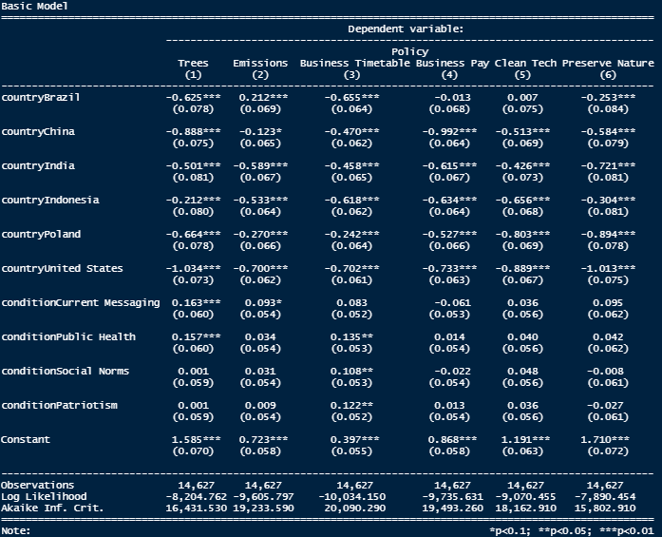

Note, two secondary models were run, the first using YouGov-supplied weightings and the second using demographic control variables. These replicated effect significance and directionality of the effects reported in the main text, with minor changes in effect sizes. The “Public Health” text resulted in a small increase in support for giving businesses a fair timetable to adapt in the basic model (above), but this was not robustly significant in the model with YouGov weightings, so this was not reported in the main text.

Appendix I: Graphs

Q1:
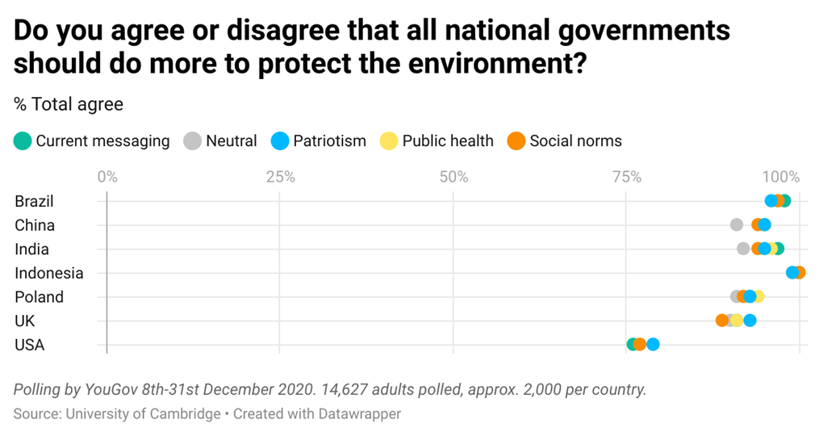
Interactive graph: //www.datawrapper.de/_/i7W9F/

Q2:
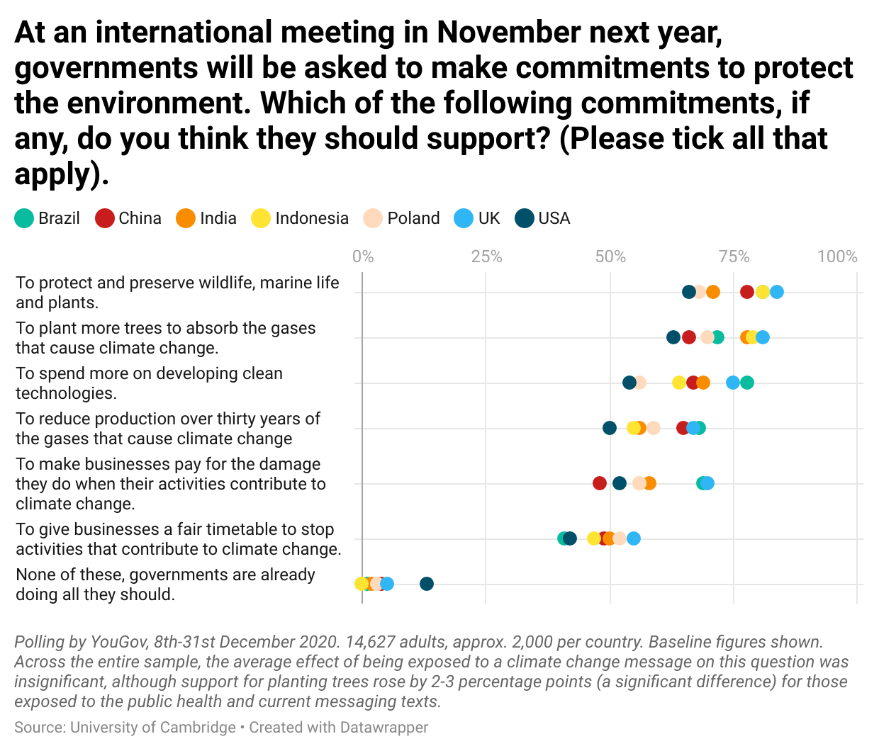Interactive graph: https://www.datawrapper.de/_/RudzZ/
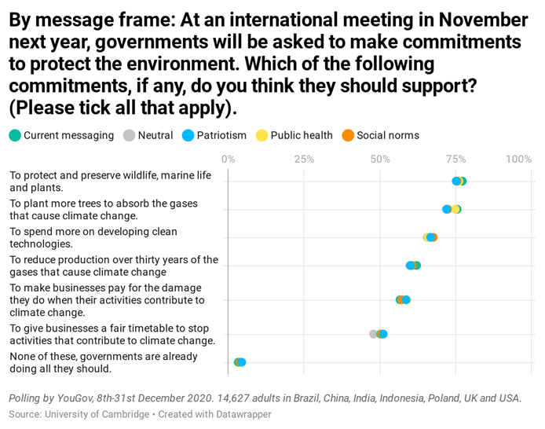
Interactive graph: ///www.datawrapper.de/_/FdC5G/

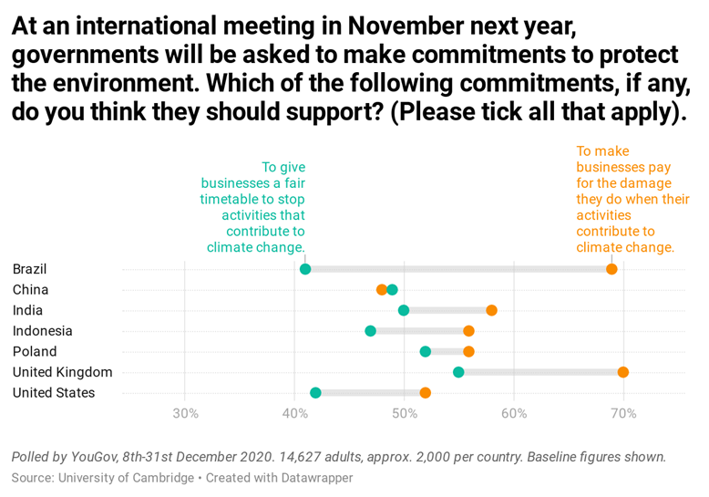
Interactive graph: https://www.datawrapper.de/_/AoSln/

Brazil

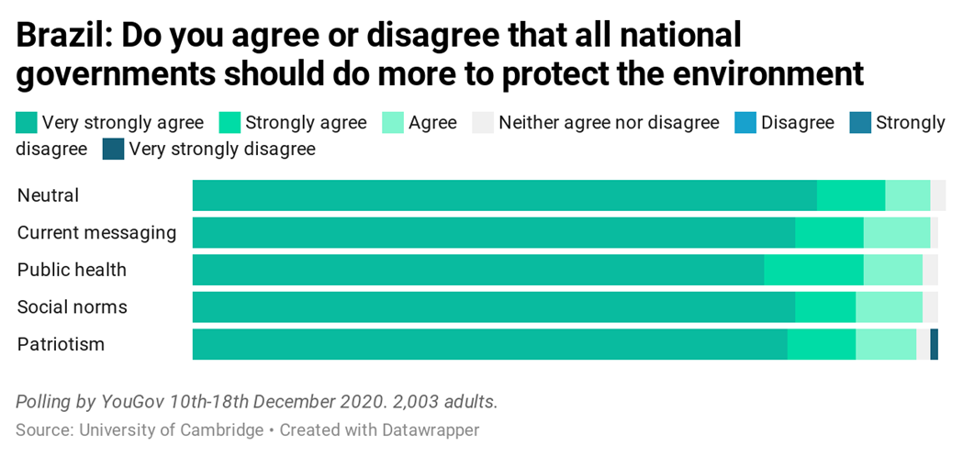
Interactive graph: https://www.datawrapper.de/_/U8sOm/

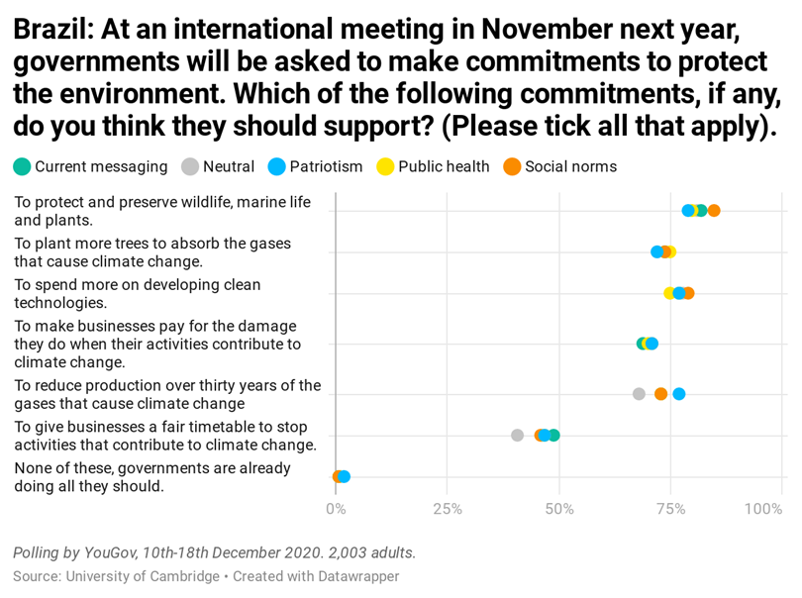
Interactive graph: //www.datawrapper.de/_/ECSF4/

China

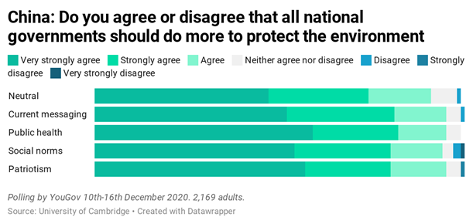
Interactive graph: //www.datawrapper.de/_/sF0Gn/

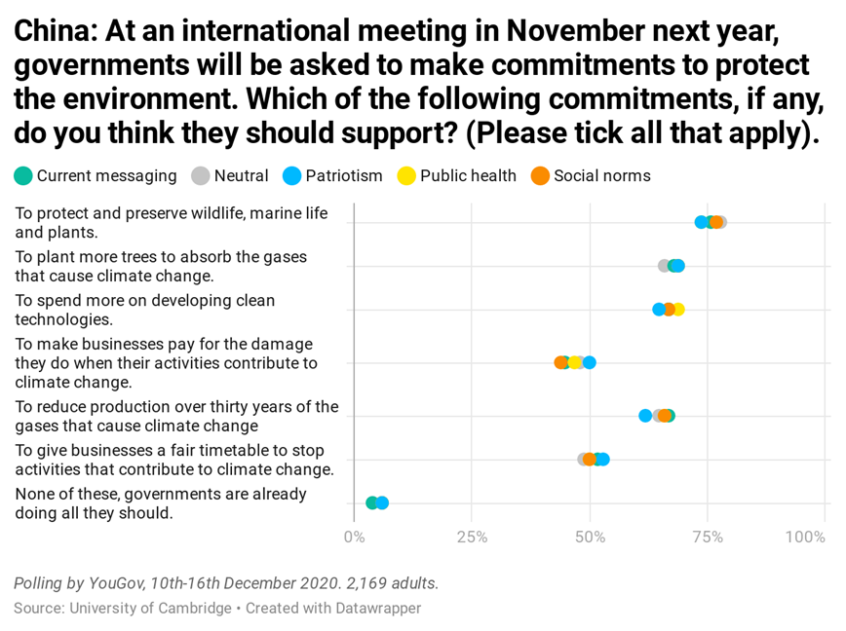
Interactive graph: //www.datawrapper.de/_/X10CU/

India

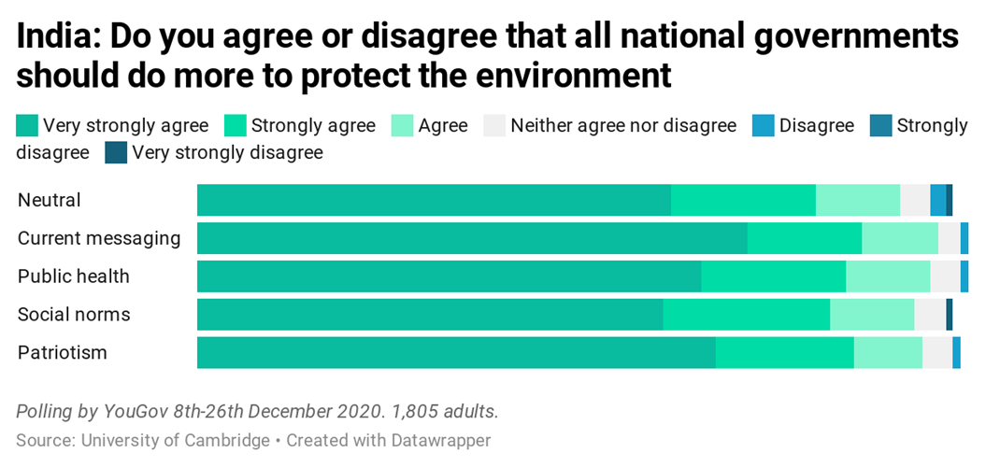
Interactive graph: //www.datawrapper.de/_/prYBj/

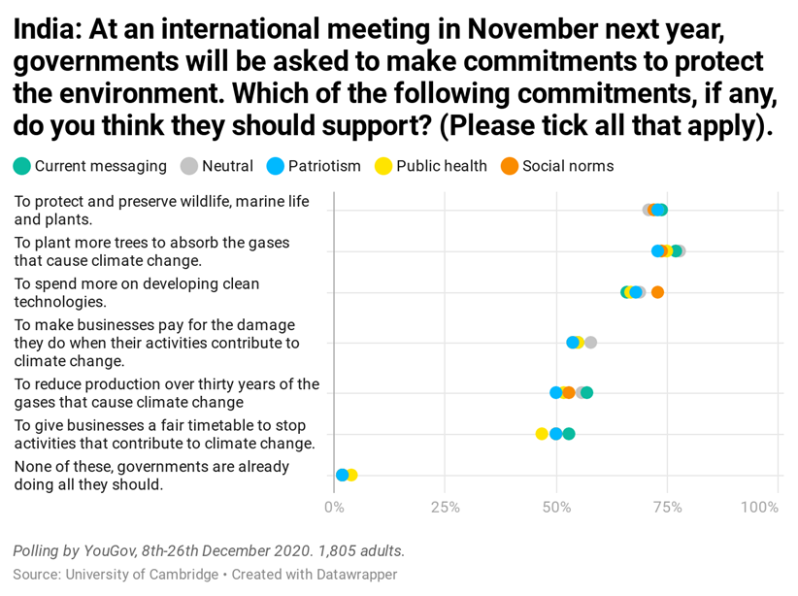
Interactive graph: //www.datawrapper.de/_/C0r04/

Indonesia

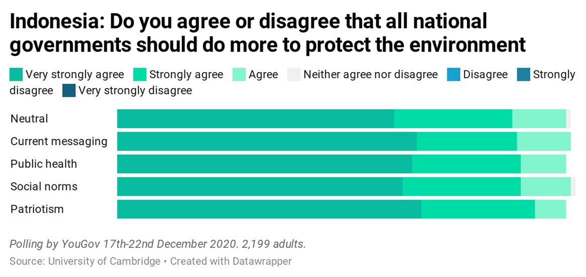

Interactive graph: //www.datawrapper.de/_/FOGgj/

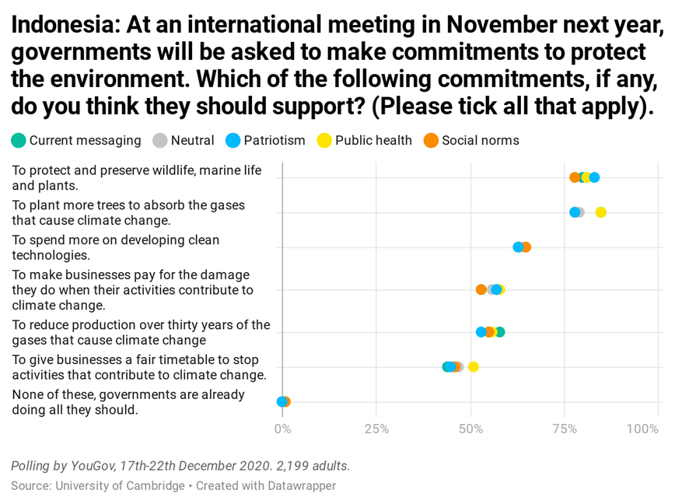
Interactive graph: //www.datawrapper.de/_/4vwyj/

Poland

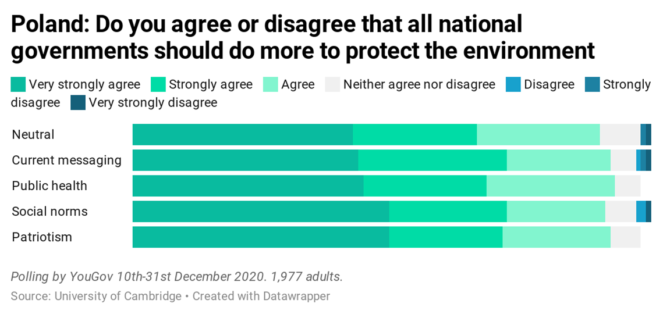

Interactive graph: //www.datawrapper.de/_/wh66Q/

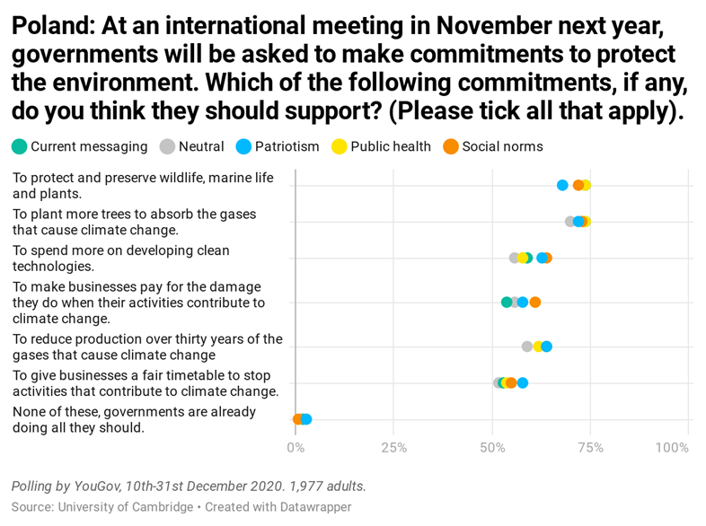
Interactive graph: //www.datawrapper.de/_/1b1XI/

United Kingdom

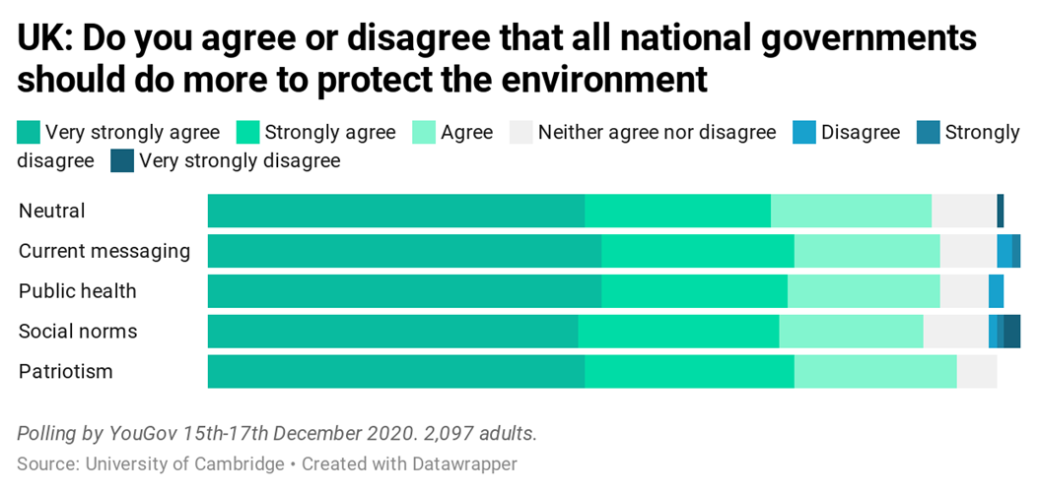
Interactive graph: //www.datawrapper.de/_/bFDM8/

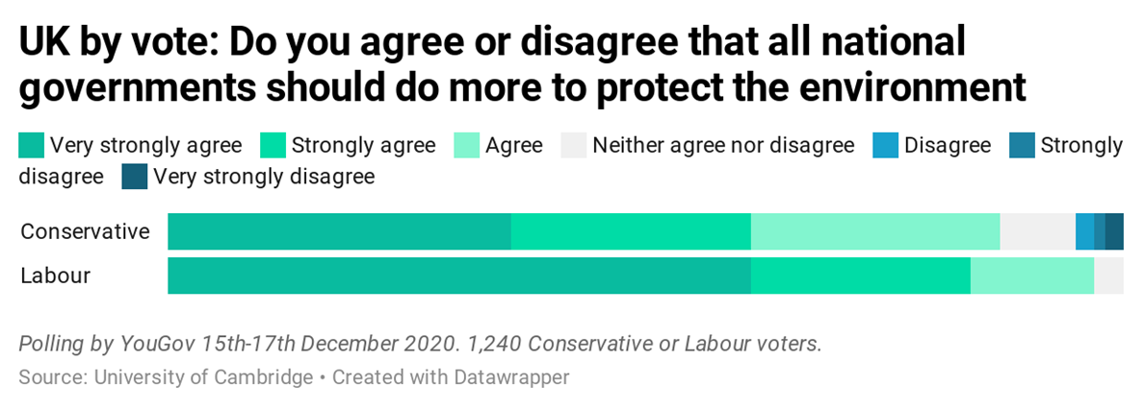
Interactive graph: //www.datawrapper.de/_/FgziA/

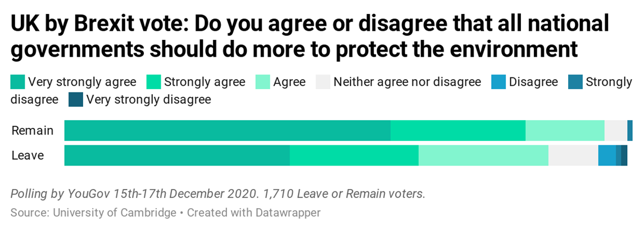
Interactive graph: //www.datawrapper.de/_/zSMWA/
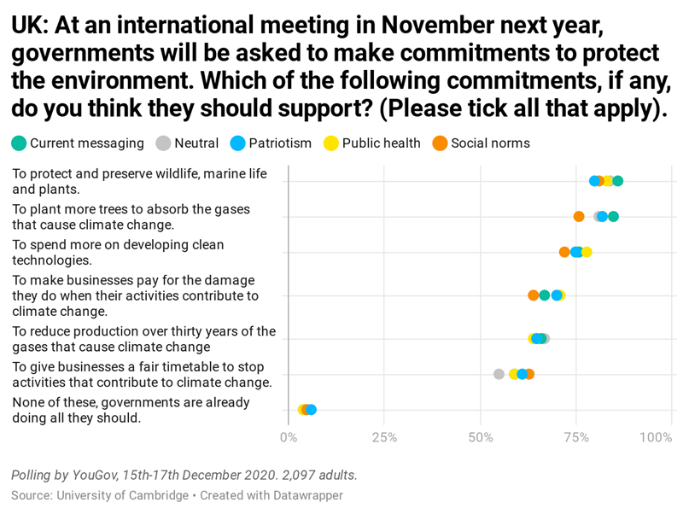Interactive graph: //www.datawrapper.de/_/3d8cH/
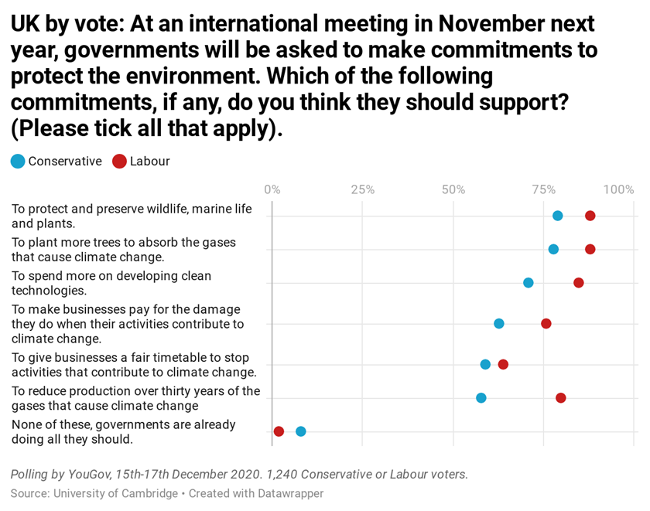
Interactive graph: //www.datawrapper.de/_/n9JBZ/

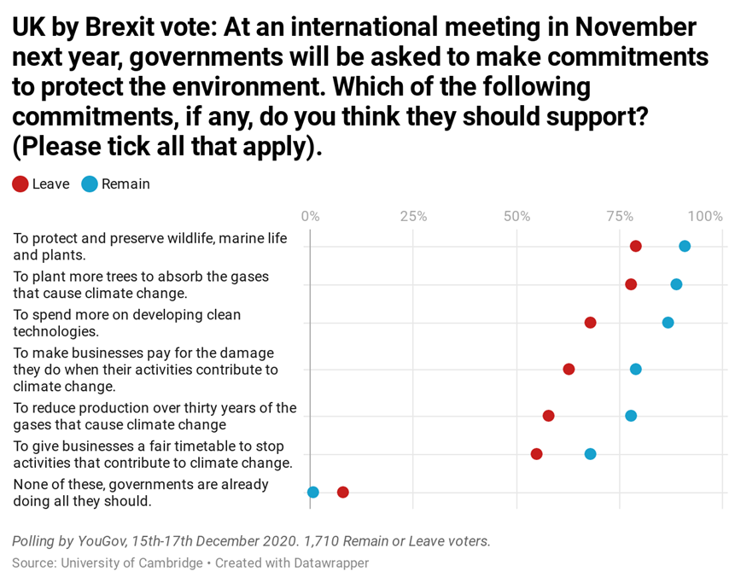
Interactive graph: //www.datawrapper.de/_/aE931/

United States

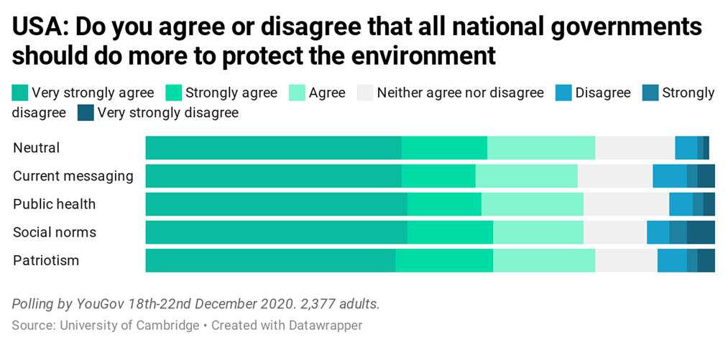
Interactive graph: //www.datawrapper.de/_/FCTdr/

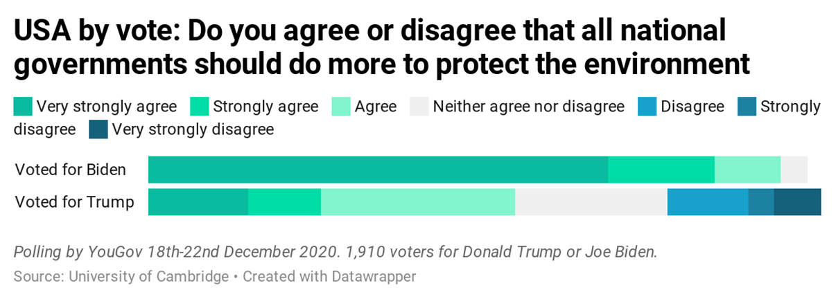
Interactive graph: //www.datawrapper.de/_/kdpko/

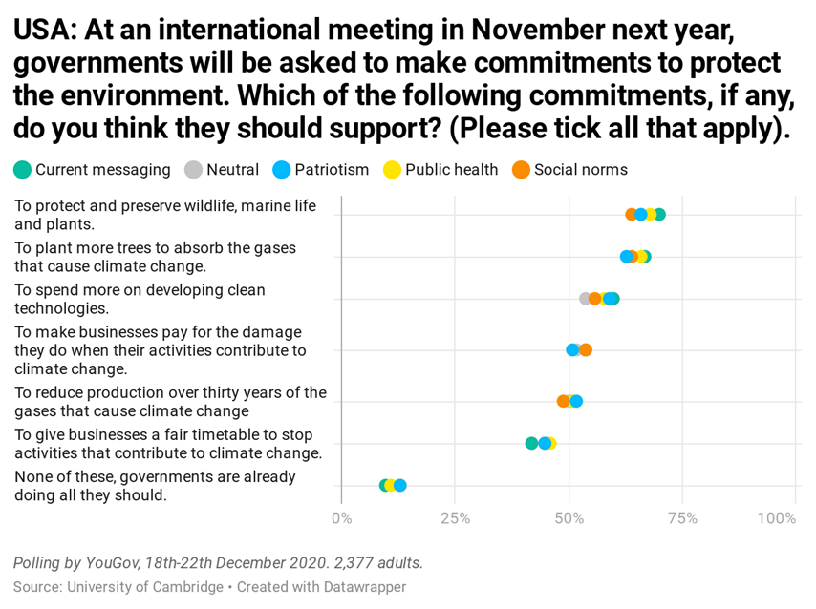
Interactive graph: //www.datawrapper.de/_/PrurQ/
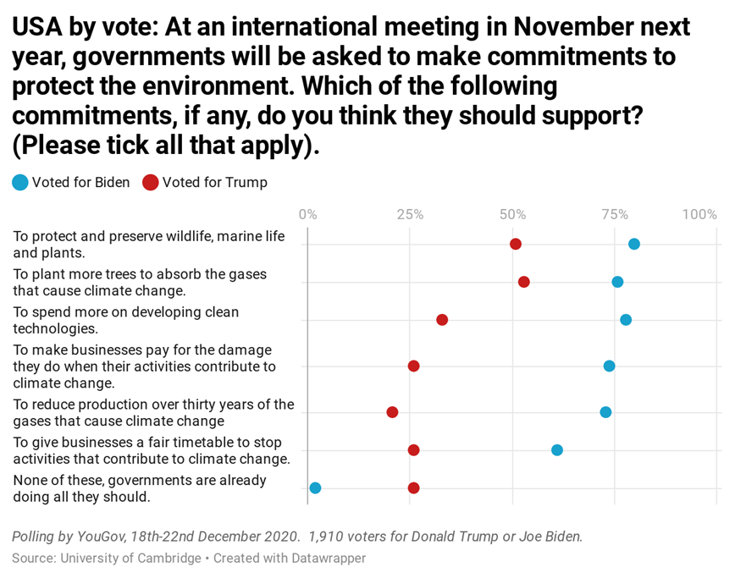
Interactive graph: //www.datawrapper.de/_/dWrpV/

YouGov

Summary tables of the results have been published by YouGov and can be found on their website on this link, accessed on 8 September 2021. Note there are small discrepancies between the data reported in the manuscript and the figures in the YouGov summary that are due to differences in how YouGov round and sum data. https://docs.cdn.yougov.com/wtfpr14xro/UniversityOfCambridge_7CountryClimateChangeMessageTesting_Dec2020_W.pdf

Appendix J: Acknowledgements, Funding and Author contributions

Many thanks for their support and encouragement go to: Professor Cornelia Sorabji (UCL), who first suggested this line of research; Saveena Mangat and Christina Bell; and to colleagues who took part in a research hackathon in December 2019 - Patrick McClanahan, Liza Karmannaya, Ondrej Kacha, Ana Sabherwal, Melisa Basol, Elif Naz Coker, Vanessa Bieg and Cecilie Olesen. Polling was carried out by YouGov. Thanks are due to Jemma Conner for her help.
TB conceived and initiated this project. TB drafted the message-framing texts, which were revised and edited with LdW and SvdL. JA and SL analysed the results. LdW drafted the manuscript which was revised and edited by TB, SvdL and JA.
Funding was provided by a grant from the Cambridge ESRC Impact Acceleration Account. We are grateful to Dr Tina Basi for her support.

Appendix K: Additional references

Bloodhart, B., & Swim, J. (2014). Portraying the Perils to Polar Bears: The Role of Empathic and Objective Perspective-taking Toward Animals in Climate Change Communication. Environmental Communication A Journal of Nature and Culture, 9. DOI: 10.1080/17524032.2014.987304

Bolkan, S., Andersen, P.A., (2009) Image Induction and Social Influence: Explication and Initial Tests, Basic and Applied Social Psychology, 31:4, 317-324, DOI: 10.1080/01973530903316898

Broockman, D., & Kalla, J. (2016). Durably reducing transphobia: A field experiment on door-to-door canvassing. Science, 352(6282), 220–224. https://doi.org/10.1126/science.aad9713.

Bruine de Bruin, W., Rabinovich, L., Weber, K., Babboni, M., Dean, M., & Ignon, L. (2021). Public understanding of climate change terminology. Climatic Change, 167(3-4), Climatic change, 2021-08-01, Vol.167 (3-4).

Cialdini, R. (2016). Pre-Suasion: A revolutionary way to influence and persuade. Simon & Schuster.

Csikszentmihalyi, M. (2014). Flow and the Foundations of Positive Psychology (2014 ed.). Dordrecht: Springer Netherlands.

Feldman, L., & Hart, P. S. (2016). Using Political Efficacy Messages to Increase Climate Activism: The Mediating Role of Emotions. Science Communication, 38(1), 99–127. https://doi.org/10.1177/1075547015617941

Hart PS, Feldman L (2016) The Influence of Climate Change Efficacy Messages and Efficacy Beliefs on Intended Political Participation. PLoS ONE 11(8): e0157658. https://doi.org/10.1371/journal.pone.0157658

Kahneman, D., & Tversky, A. (1979). Prospect Theory: An Analysis of Decision under Risk. Econometrica, 47(2), 263-291. doi:10.2307/1914185.

Jones, C., Hine, D.W. and Marks, A.D.G. (2017), The Future is Now: Reducing Psychological Distance to Increase Public Engagement with Climate Change. Risk Analysis, 37: 331-341. doi:10.1111/risa.12601.

Rolfe, H. (2018), The power of negative thinking: why perceptions of immigration are resistant to facts, LSE Brexit blog, 12 Oct 2018 (Accessed 8 September 2021).

Van der Linden, S. (2014), On the relationship between personal experience, affect and risk perception: The case of climate change, Eur. J. Soc. Psychol., 44; pages 430– 440, doi: 10.1002/ejsp.2008.

Van der Linden, S. L., Leiserowitz, A. A., Feinberg, G. D., & Maibach, E. W. (2015). The scientific consensus on climate change as a gateway belief: experimental evidence. PloS one, 10(2), e0118489. doi:10.1371/journal.pone.0118489.

