SUPPLEMENTARY INFORMATION
To determine how mutations affect the net charge of the EcMscL periplasmic loop, we used the Bachem software (https://www.bachem.com/knowledge-center/peptide-calculator/) to calculate changes in the net properties of the periplasmic loop as presented in Table S1. Most of our mutations affects the hydrophilicity, molecular weight, isoelectric point and net charge of the periplasmic loop.

Table S1. The effect of mutations on the biochemistry of the amino acid residues of EcMscL periplasmic loop
MscL periplasmic mutations | Molecular Weight (g/mol) | Isoelectric point | Net charge at pH 7.0 | Average hydrophilicity | Ratio of hydrophilic residues / total number of residues (%)
Wild type | 3081.63 | 7.88 | 0.09 | -0.30 | 24
A64E | 3139.67 | 5.36 | -0.91 | -0.18 | 28
A64R | 3166.74 | 10.11 | 1.09 | -0.18 | 28
Q65R | 3109.69 | 10.11 | 1.09 | -0.20 | 24
Q65E | 3082.62 | 5.36 | -0.91 | -0.20 | 24
G66E | 3153.70 | 5.36 | -0.91 | -0.19 | 28
G66R | 3180.77 | 10.11 | 1.09 | -0.19 | 28
D67R | 3122.73 | 11.34 | 2.09 | -0.30 | 24
D67E | 3095.66 | 7.88 | 0.09 | -0.30 | 24
D67+4G | 3194.75 | 10.12 | 1.09 | -0.36 | 19

Table S2: Results of the EPR spectra analysis. Mobility, oxygen and NiEDDA accessibility in the closed and the open state determined for each residue of the periplasmic loop.

Residue | Closed state |  |  | 25% LPC
Residue | Mobility  ∆H−1  0 | Oxygen  ΠO₂ | Nickel  ΠNiEDDA | Mobility  ∆H−1  0 | Oxygen  ΠO₂ | Nickel  ΠNiEDDA
P44 | 0.24 | 1.03 | 0.00 | 0.26 | 0.66 | 0.16
L45 | 0.23 | 0.30 | 0.21 | 0.30 | 0.71 | 0.15
G46 | 0.22 | 0.48 | 0.33 | 0.30 | 0.67 | 0.42
L47 | 0.25 | 0.69 | 0.19 | 0.31 | 0.72 | 0.35
L48 | 0.21 | 0.60 | 0.08 | 0.29 | 0.80 | 0.27
I49 | 0.20 | 0.88 | 0.00 | 0.28 | 0.81 | 0.17
G50 | 0.21 | 0.64 | 0.12 | 0.27 | 0.50 | 0.42
G51 | 0.23 | 0.36 | 0.74 | 0.28 | 0.72 | 0.24
I52 | 0.21 | 0.46 | 0.31 | 0.27 | 0.74 | 0.22
D53 | 0.20 | 0.39 | 0.18 | 0.27 | 0.80 | 0.07
F54 | 0.21 | 0.65 | 0.05 | 0.26 | 0.83 | 0.25
K55 | 0.23 | 0.32 | 0.78 | 0.25 | 0.62 | 0.40
Q56 | 0.27 | 0.51 | 0.92 | 0.30 | 0.73 | 0.49
F57 | 0.20 | 0.62 | 0.02 | 0.27 | 0.65 | 0.17
A58 | 0.23 | 0.30 | 2.28 | 0.26 | 0.77 | 0.37
V59 | 0.21 | 0.73 | 0.03 | 0.29 | 0.66 | 0.41
T60 | 0.23 | 0.32 | 0.57 | 0.29 | 0.88 | 0.27
L61 | 0.23 | 0.43 | 0.19 | 0.27 | 0.58 | 0.13
R62 | 0.24 | 0.25 | 0.54 | 0.32 | 0.59 | 0.57
D63 | 0.27 | 0.43 | 0.79 | 0.28 | 0.92 | 0.23
A64 | 0.38 | 0.65 | 2.04 | 0.32 | 0.75 | 0.17
Q65 | 0.38 | 1.05 | 0.87 | 0.27 | 0.63 | 0.26
G66 | 0.39 | 0.62 | 1.47 | 0.27 | 0.68 | 0.24
D67 | 0.29 | 0.59 | 0.77 | 0.34 | 0.51 | 0.23
I68 | 0.35 | 0.38 | 2.17 | 0.34 | 0.58 | 0.47
P69 | 0.26 | 0.59 | 0.48 | 0.26 | 0.63 | 0.19
A70 | 0.25 | 0.40 | 0.53 | 0.29 | 0.59 | 0.55
V71 | 0.23 | 0.42 | 0.38 | 0.30 | 0.74 | 0.56

a  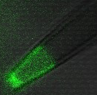 | b  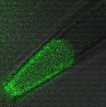 | c | d  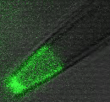

Fig S1. Representative confocal microscopy image of an excised inside-out liposome patch membrane (azolectin +0.01% Rhodamine PE). Patch membrane in the absence (A) and presence of increasing negative pressure (B). (C) The patch membrane diameter is calculated from the area of the dotted white circle, which together with the corresponding negative pressure measurements was used to estimate the membrane tension. (D) Video recording showing changing membrane patch geometry with increasing negative pressure (Scale bar: 2µm). Recordings were done at +30mV pipette potential.

a  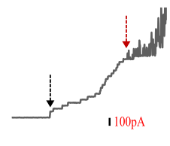 | b  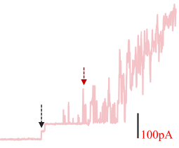 | c  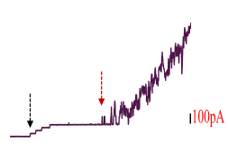

Fig S2. Representative current traces of the first opening of MscS (dotted black arrow) and MscL (dotted red arrow) co-reconstituted in 100% azolectin lipid (A-C). The ratio of the first opening of WT and mutants were calculated relative to the first opening of MscS. Q65R mutation increased the pressure sensitivity of the channel (B), leading to a lower ratio of its first opening compared to WT-MscL (A). The addition of extra glycine at D67 (D67+4G) reduced the pressure sensitivity of the channel, resulting in a higher first opening ratio (C). Recordings were done at +30mV pipette potential in an inside-out patch configuration.

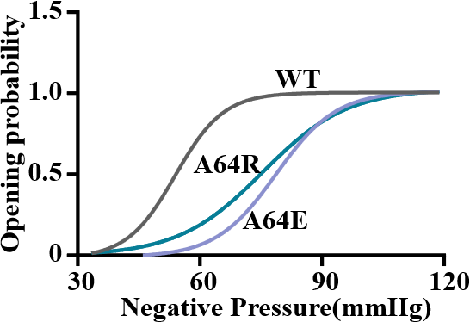
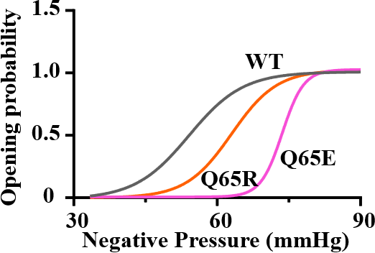
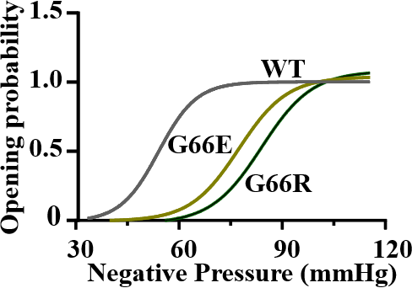
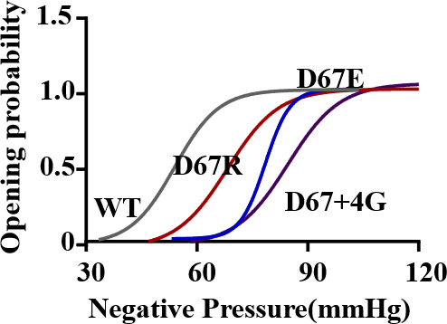
a
b
c
d

Fig S3. Boltzmann distribution functions of the mechanosensitivity profile of WT and mutant MscL channels. Opening probability values for WT and mutants MscL reconstituted into negatively charged lipids, comprising of DOPC 70 % and DOPG 30% (representative Boltzmann curves WT and mutants; a-d). Note that all mutations resulted in a right shift of the opening probability of the channel, which indicates that mutant channels showed decreased pressure sensitivity, thus requiring more pressure to open compared to WT-MscL (a-d). The average midpoint activation pressure in mmHg of WT and mutant channels are thus (mean±s.d): 53.81±11.76 (WT), 73.21±11.83 (A64E), 78.05±12.70 (A64R), 74.43±14.25 (Q65E), 58.82±14.16 (Q65R), 75.92±16.90 (G66E), 88.60±25.10 (G66R), 77.23±14.08 (D67E), 70.74±11.80 (D67R), 86.21±10.54 (D67+4G). Recordings were done at +30mV pipette potential in an inside-out patch configuration.

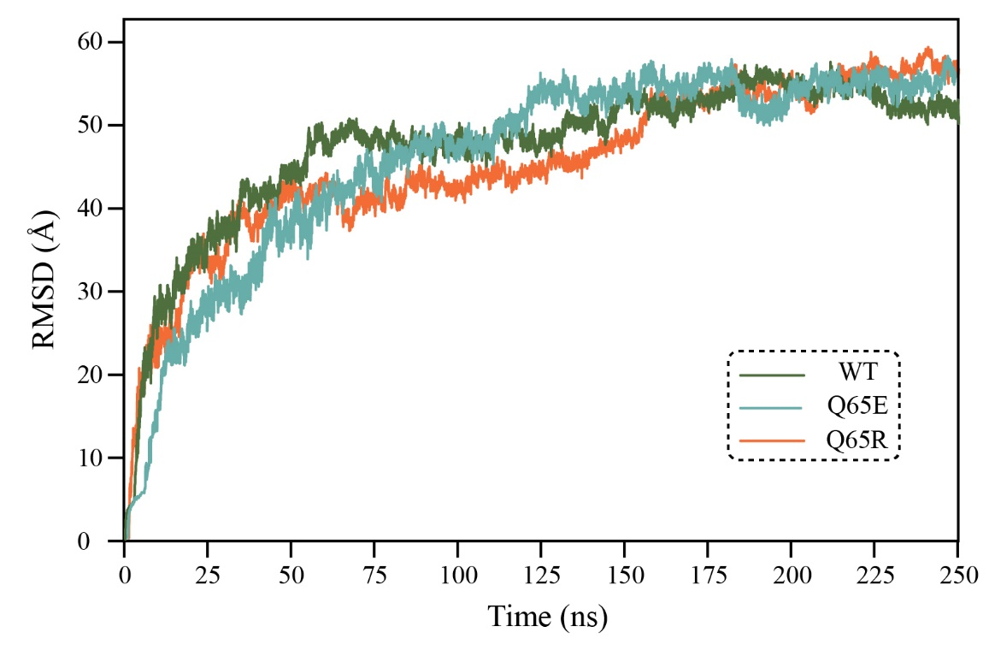
Fig S4. RMSD during equilibration. Root-mean-square deviation (RMSD) of WT, Q65E, and Q65R EcMscL embedded in a 70% DOPC / 30% DOPG bilayer. RMSD plateaus indicate that all systems reached a stable equilibrium state used as the starting point for subsequent tension/pulling simulations

a  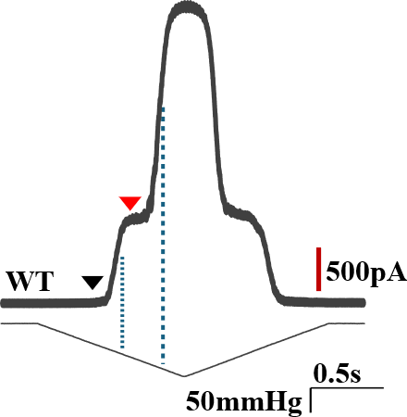 | b  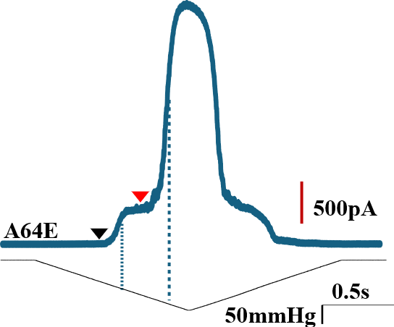
c  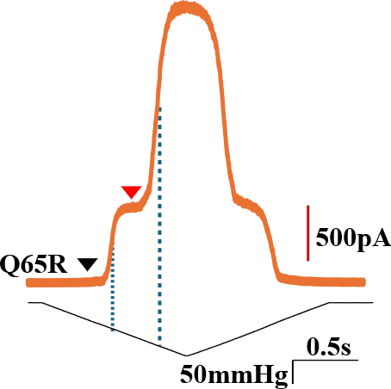 | d  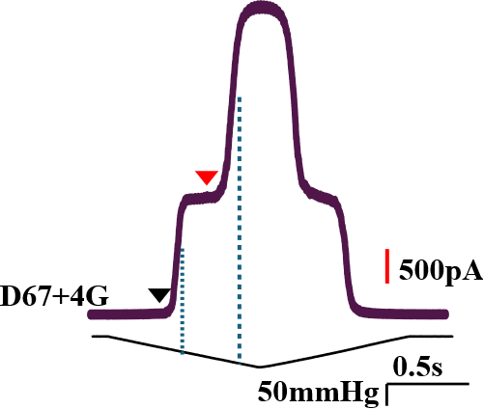
e  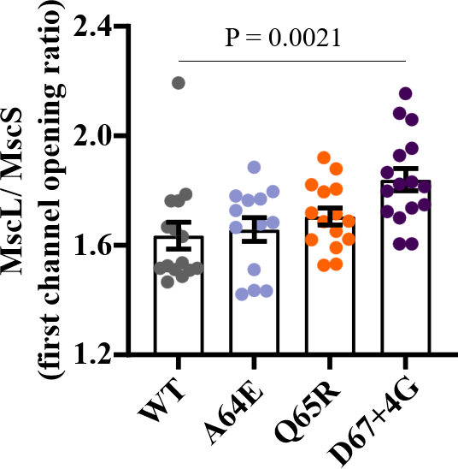 | f  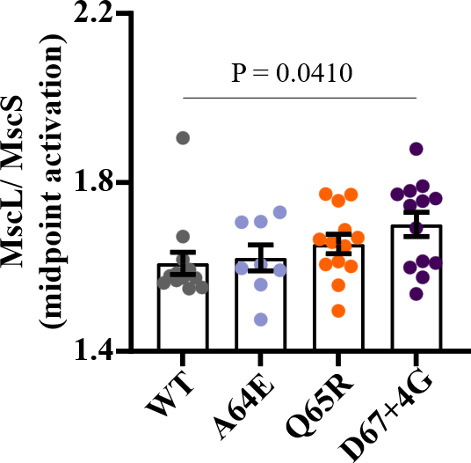

Fig S5. Channel activity MscS and MscL expressed in WT and mutant E. coli giant spheroplast. Representative current traces of MscS and MscL recorded at +10 mV pipette potential (a-d). MscL/MscS first opening ratio was calculated based on the corresponding pressure measurements of the first opening of MscL (red arrowhead) and MscS (black arrowheads). The vertical dashed line shows the midpoint activation threshold of MscS and MscL, and these values were used to determine midpoint activation ratios of WT and mutants. (e, f) The comparison between the first opening and midpoint activation ratios of WT, A64E, Q65R, and D67+4G. Note the addition of extra 4 glycine to D67 (D67+4G) decreased the pressure sensitivity of the channel, leading to channel opening at a higher pressure compared to WT MscL.

a  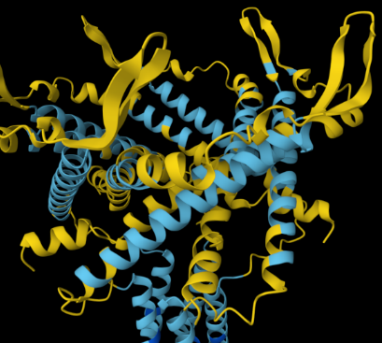 | d  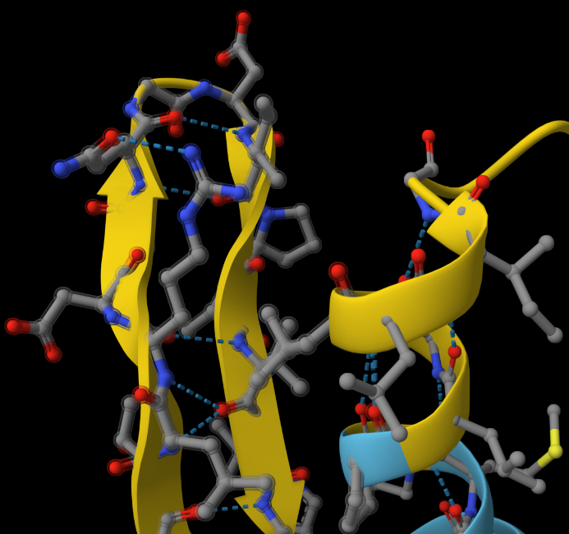 | g  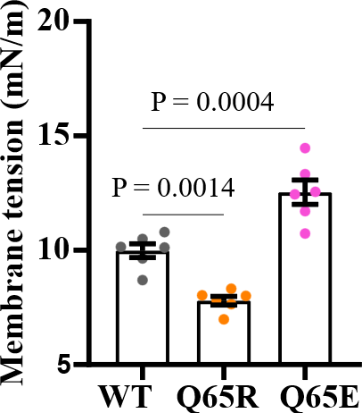
b  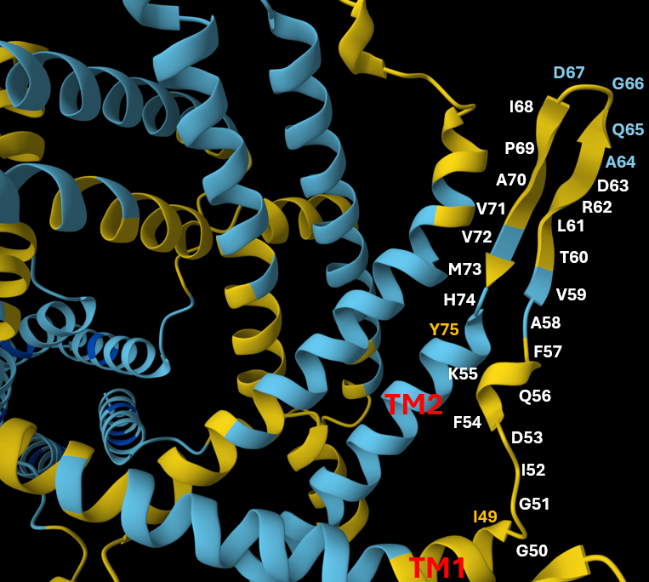 | 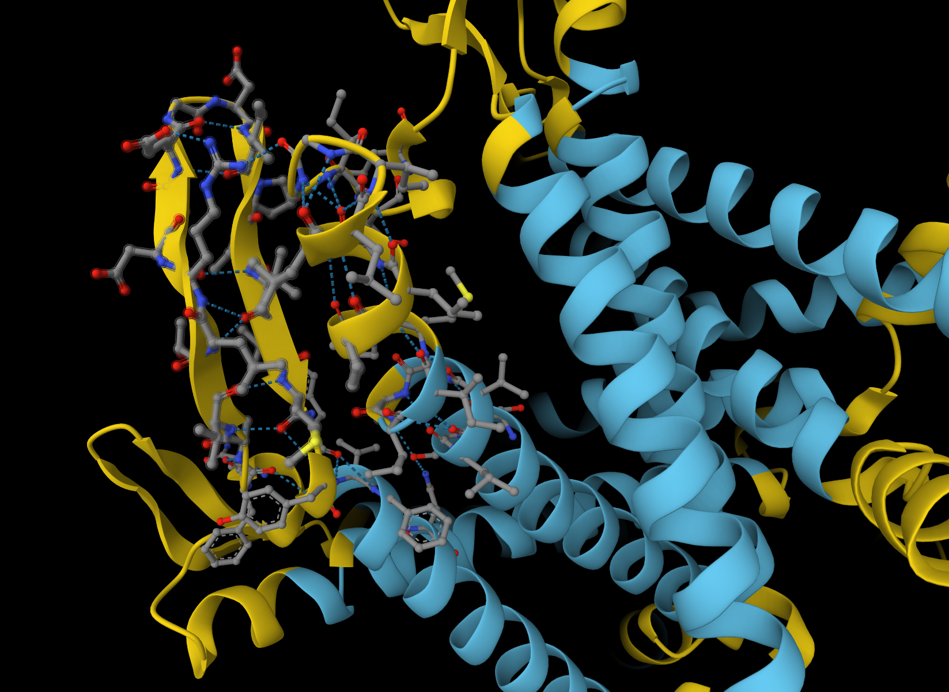  e  + | h  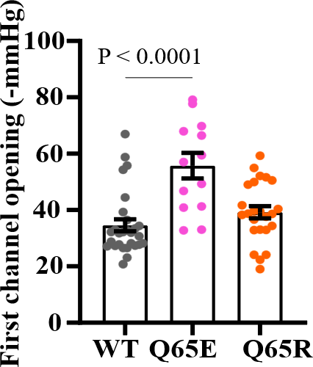
c  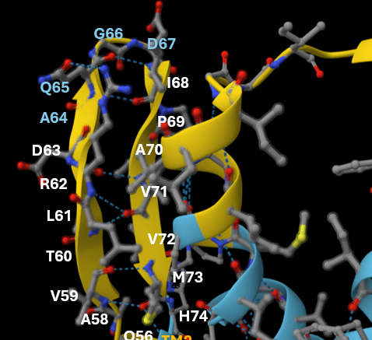 | 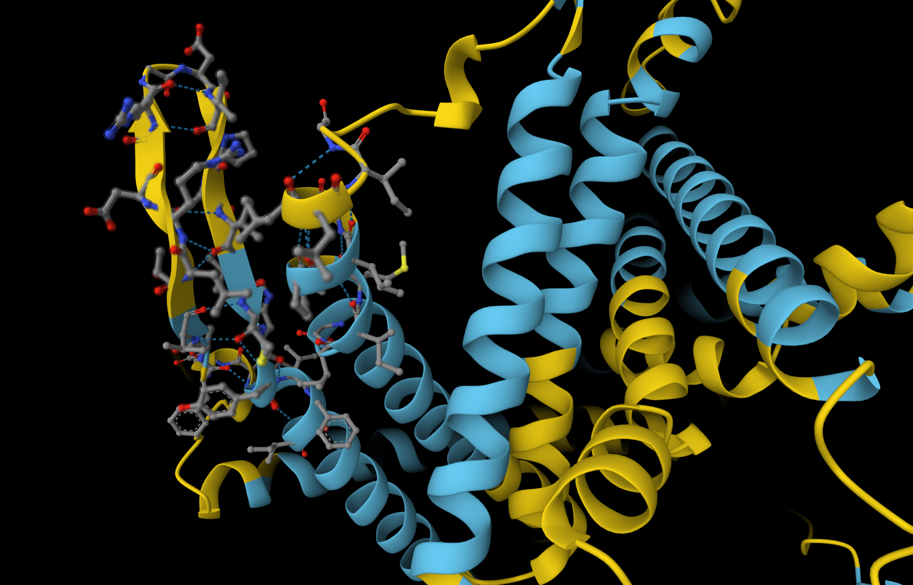  f  - | I  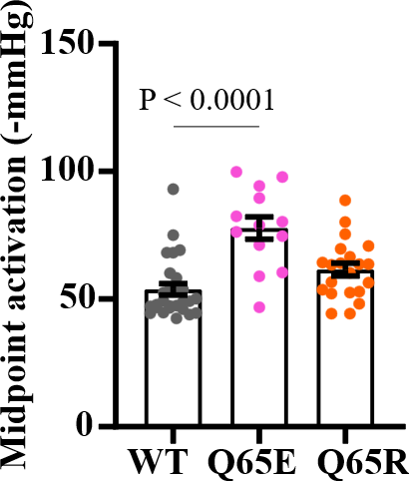

Fig S6. AlphaFold predictions of the EcMscL periplasmic loop showing the presence of the beta-hairpin and hydrogen bond which might affect the gating of the channel. (a-c) showing the presence of beta-hairpin between Val59 to Gln65 and Ile68 to Met73 of the periplasmic loop of EcMscL (a, b), and corresponding hydrogen bonds at each periplasmic loop residues (c). (d-f) WT MscL (d), the substitution of Q65 to E introduced an extra intra-strand hydrogen bond at position Q65E side-chain oxygen to R62side-chain eta(η)-nitrogen, as well as a possible R62side-chain eta(η)-nitrogen to G50carbonyl oxygen of an adjacent subunit. (e), while mutating Q65 to R removed the intra-strand hydrogen bond between Q65side-chain oxygen to R62 side-chain eta(η)-nitrogen (f). (g-i) The varying number of hydrogen bond of Q65E and Q65R compared to WT MscL might account for the difference in the sensitivity of the mutants in azolectin (g) and pressure sensitivity in negatively charged lipids (DOPC 70 % and DOPG 30%) (h&i).

Data availability
All data generated or analysed during this study are included in this published article [and its supplementary information files].

