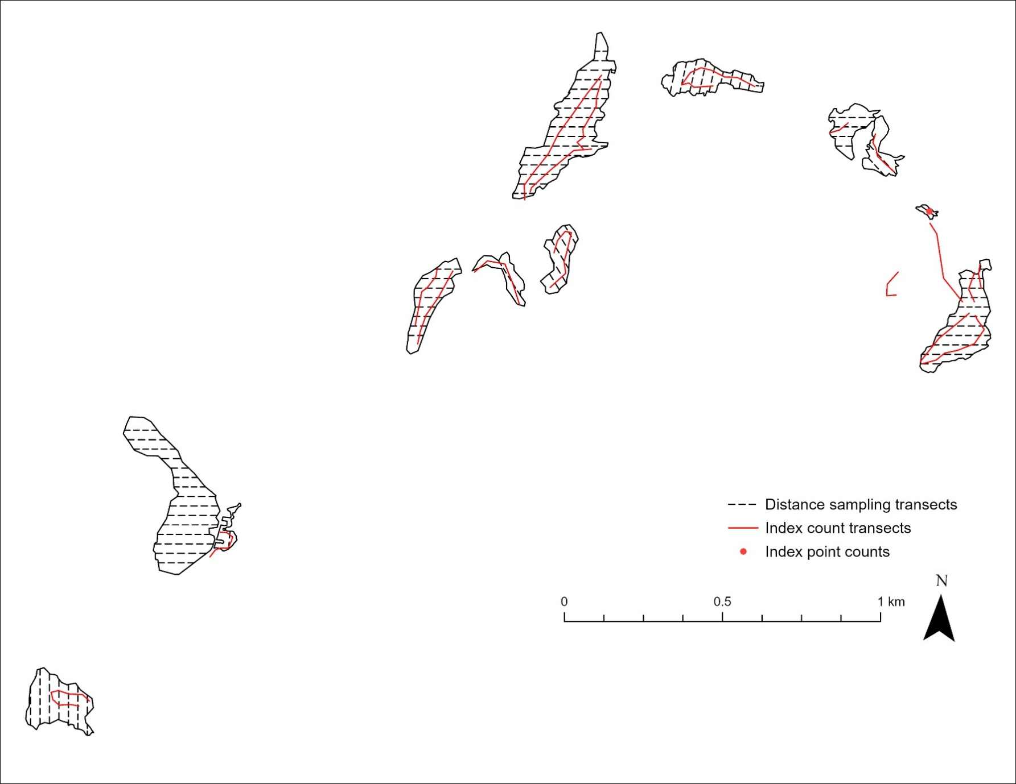
Fig. SI Locations of distance sampling transects, index count transects, and point counts at Mt. Hebo
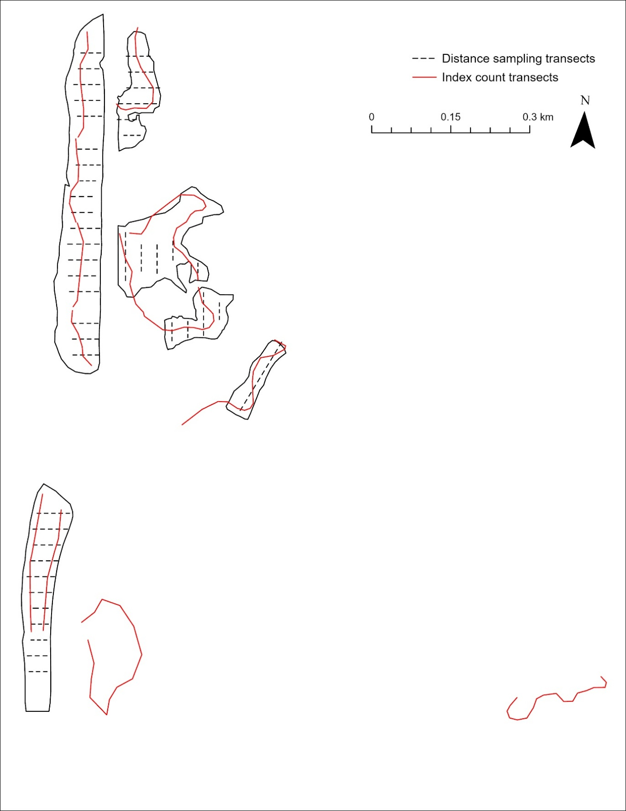
Fig. SII Locations of distance sampling and index count transects at Rock Creek

Methods SI Mark-release-recapture survey effort allocation protocol
In the 2023 and 2024 mark-release-recapture surveys at Mt. Hebo and Nestucca, we developed a survey protocol to allocate time based on meadow area (ha), violet cover, butterfly density and available staff time. Violet cover data were generated by the U.S. Forest Service (USFS) in a large-scale meadow mapping project conducted across Mt. Hebo in 2022 (Ashford et al. 2022, unpublished). We re-classified the USFS violet interpolation and binned violet cover into two categories: present (>1% violet cover, with raster cell values between 1 and 3) and absent (<1% or no violet cover, with raster cell values between 0 and <1). We used this re-classified raster to coarsely estimate violet cover in meadows, then generated survey times using meadow area * 25 mins/ha in meadows ≤ 4 ha with minimum violet cover of <20% * 15 mins/ha in all other meadows. Over the first week, the weighting of survey times were adjusted to account for a greater abundance of butterflies in smaller meadows with lower violet cover. There were five full-time staff available for surveys from July through late August, four from late August through mid-September, and two from mid to late September. Staff availability played a role in the development of the survey scheme. During peak flight, the final survey scheme often needed to be split into 1.5 survey days with 3-4 surveyors, and areas missed one day were surveyed the following day. Meadow survey times were adjusted later in the flight period due to fewer available staff, to reflect declining butterfly activity and, during peak female flight, to maximize female captures and fit all survey areas into the primary window of female activity of ~11am-3pm.

Table SI Modifications to distance sampling schemes across sites (2022-2024)
Site | Year | Total transects | Survey area (ha) | Changes detailed | Total detections on new transects (%)
Nestucca | 2022 | 25 | 14.7 | None | NA
Nestucca | 2023 | 25 | 14.7 | None | NA
Nestucca | 2024 | 25 | 14.7 | None | NA
Mt. Hebo | 2022 | 80 | 27.8
Mt. Hebo | 2023 | 81 | 27.9 | Added one transect in MH6c | 3/465 (0.6%)
Mt. Hebo | 2024 | 81 | 27.9
Rock Creek | 2022 | 41 | 11.8 |  | NA
Rock Creek | 2023 | 44 | 11.8 | Revised transect layout and added 3 new transects in RC8 following habitat restoration | 2023: 0/19 (0%)  2024: 10/76 (13%)
Rock Creek | 2024 | 45 | 11.8 | Added one new transect in SE corner of RC5 | 3/76 (4%)

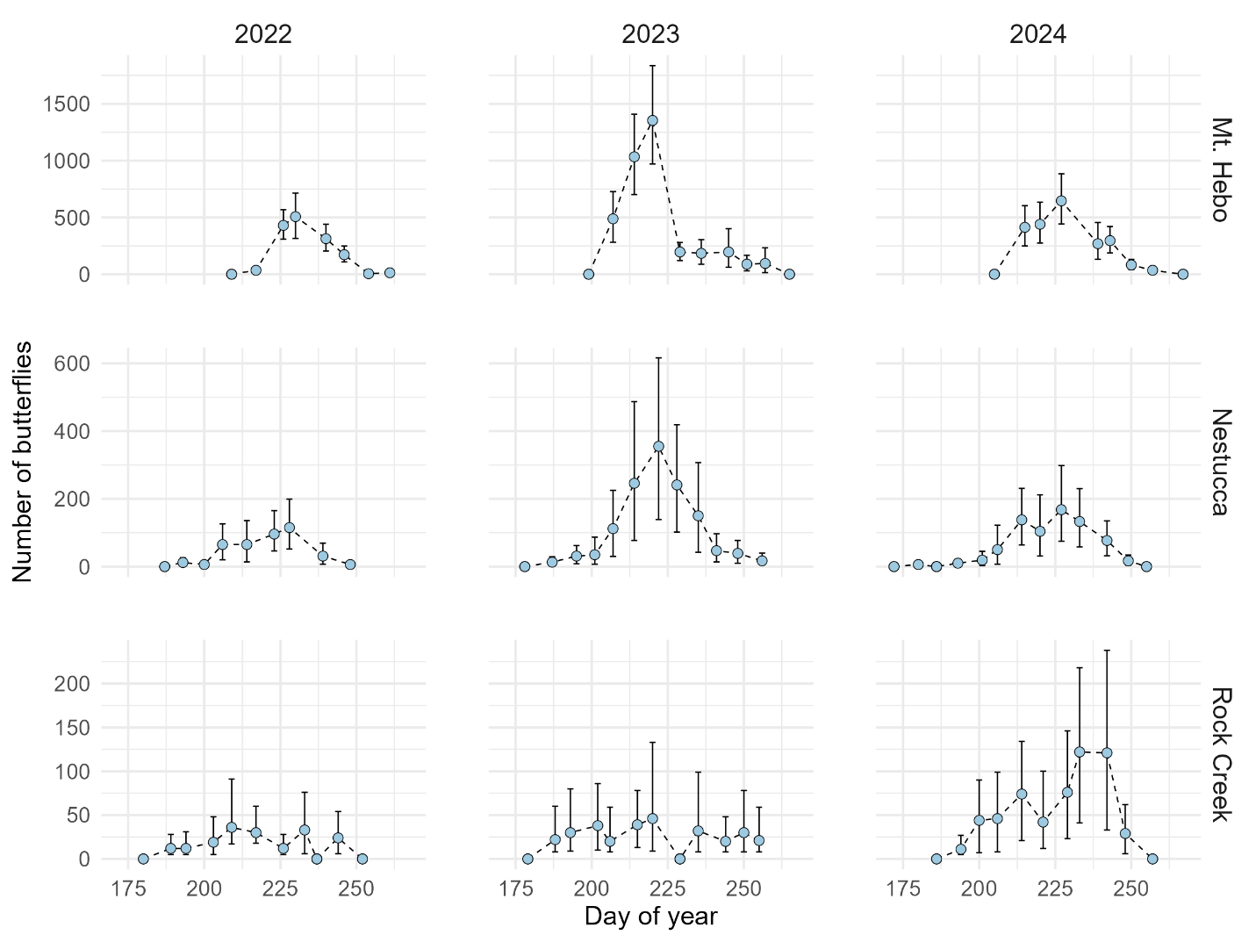
Fig. SIII Weekly abundance estimates from distance sampling (2022-2024). Estimates without confidence intervals reflect insufficient sample sizes
Table SII Population size and detectability estimates by site and year from mark-release-recapture, distance sampling, and index counts
Site | Year | MRR |  |  |  | Distance sampling |  |  | Index count detections
Site | Year | Marked | Resighted | Population size | Detection probability | Detections | Population size | Detection probability | Index count detections
Rock Creek | 2022 | 119 | 77 | 126  (120-132) | 0.16 | 18 | 39  (15-67) | 0.23* | 50
Rock Creek | 2023 | NA | NA | NA | NA | 19 | 77  (36-147) | 0.23* | 15
Rock Creek | 2024 | NA | NA | NA | NA | 76 | 187  (109-269) | 0.24 | NA
Mt. Hebo | 2022 | NA | NA | NA | NA | 465 | 1132  (886-1387) | 0.41 | 453
Mt. Hebo | 2023 | 1312 | 766 | 2154  (2064-2246) | 0.15 | 499 | 2462  (1950-3073) | 0.18 | 546
Mt. Hebo | 2024 | NA | NA | NA | NA | 370 | 1476  (1140-1847) | 0.22 | NA
Nestucca | 2022 | NA | NA | NA | NA | 103 | 175  (108-260) | 0.27 | 59
Nestucca | 2023 | NA | NA | NA | NA | 162 | 511  (288-735) | 0.12 | 72
Nestucca | 2024 | 525 | 315 | 543  (530-557) | 0.19 | 174 | 288  (201-396) | 0.25 | 107
*Global detection function pooling Rock Creek data from 2022-2024

