Supplementary Information
Clean water pathways under devolved water provision: Access, affordability and decentralized innovations in Kenya
Daniel King^{1,†}, Deidra Miniard^{,2,†}, Abby Chapman³, Joseph Cobos Portillo Jr.³, Prachi Ramkrishna Mehendale³, RJ Vogler¹, Faith Nzilu⁴, Sylvia Mutunga⁴, Tabitha Kimeu⁴, Joy Muriungi⁴, David Kimaili⁴, Jennifer Mae Pierce¹, Carly R. Barnett¹, Aarya Manoj Nair⁵, Isabella Lynn Tran⁶, Kelsey Kemunto Nyandusi⁵, Shriya Sai Mukkavilli⁶, Suhani Nimesh Gajera⁶, Jayline Garza⁶, Davina Tran⁷, Carter Belle Heslam³, Shrika Paramasivam⁸, Elena Talarico Ribeiro⁸, Amit Maheswari⁹, Habsa Mohamed Aydid⁸, Anya Choudhary³, Sana Zahra Haider¹, Nadya Alon Harris³, Juliet Frances Ippolito¹, Arnav Karnik⁶, Shelly Nizza Kleinerman¹, Satvik Raghunathan³, Natalie Sherman³, Desmond Obala⁴, Mercy Cheruto⁴, Matheaus Kauti^{4, *}, Manish Kumar^{1,3,*}, R. Patrick Bixler^{2,*}
¹McKetta Department of Chemical Engineering, The University of Texas at Austin, Austin, Texas 78712, United States.
²Lyndon B. Johnson School of Public Affairs, The University of Texas at Austin, Austin, Texas 78712, United States.
³Maseeh Department of Civil, Architectural and Environmental Engineering, The University of Texas at Austin, Austin, Texas 78712, United States.
⁴ Department of Environment and Land Resources Management, Southeastern Kenya University, Kitui, Kenya
⁵McCombs School of Business, The University of Texas at Austin, Austin, Texas 78712, United States.
⁶College of Natural Sciences, The University of Texas at Austin, Austin, Texas 78712, United States.
⁷Department of Biomedical Engineering, The University of Texas at Austin, Austin, Texas 78712, United States.
⁸Walker Department of Mechanical Engineering, The University of Texas at Austin, Austin, Texas 78712, United States.
⁸Department of Geography & the Environment, The University of Texas at Austin, Austin, Texas 78712, United States.
⁹Tower Fellows Program, The University of Texas at Austin, Austin, Texas 78712, United States.

†Authors contributed equally to this work.
*Corresponding authors

Table of Contents
1. Study Sample Information 4
2. Water Source Descriptive Statistics 6
3. Missing Data Estimation 7
4. Participant Demographics 8
5. Calculations for cost of water in Texas. 9
5. Citations 10

1. Study Sample Information

SI Table 1 below shows the number of observations by location and survey wave. The unit of analysis is water source (as participants could list more than one water source). The SWF column indicates which locations have SWF access.

SI Table 1. Sample size by survey wave and study location, using water source as unit of analysis. Towns with solar water farms (SWF) are identified.
 | Water Source as Unit of Analysis
Town | 2023 | 2024 | 2025 |  | Sample | SWF
Wote | 214 | 253 |  |  | 467 | Yes
Kitengela | 104 |  |  |  | 104 | Yes
Kwa Vonza |  | 201 |  |  | 201 | No
Wamunyu |  | 96 |  |  | 96 | No
Ukunda (Diani) |  |  | 82 |  | 82 | Yes
Bamburi (Mombasa) |  |  | 93 |  | 93 | Yes
Jomvu (Mombasa) |  |  | 50 |  | 50 | No
Likoni (Mombasa) |  |  | 91 |  | 91 | No
Mikindani (Mombasa) |  |  | 159 |  | 158 | Yes
Miritini (Mombasa) |  |  | 110 |  | 110 | No
Mshomoroni (Mombasa) |  |  | 82 |  | 82 | Yes
Mtongwe (Mombasa) |  |  | 80 |  | 80 | Yes
Tudor (Mombasa) |  |  | 25 |  | 25 | No
Total | 318 | 550 | 772 |  | 1640

SI Figure 1 shows the distribution of water sources by location across all three survey waves. All neighborhoods in Mombasa were combined into 1 category. In SI Figure 2, we show only the neighborhoods in Mombasa.
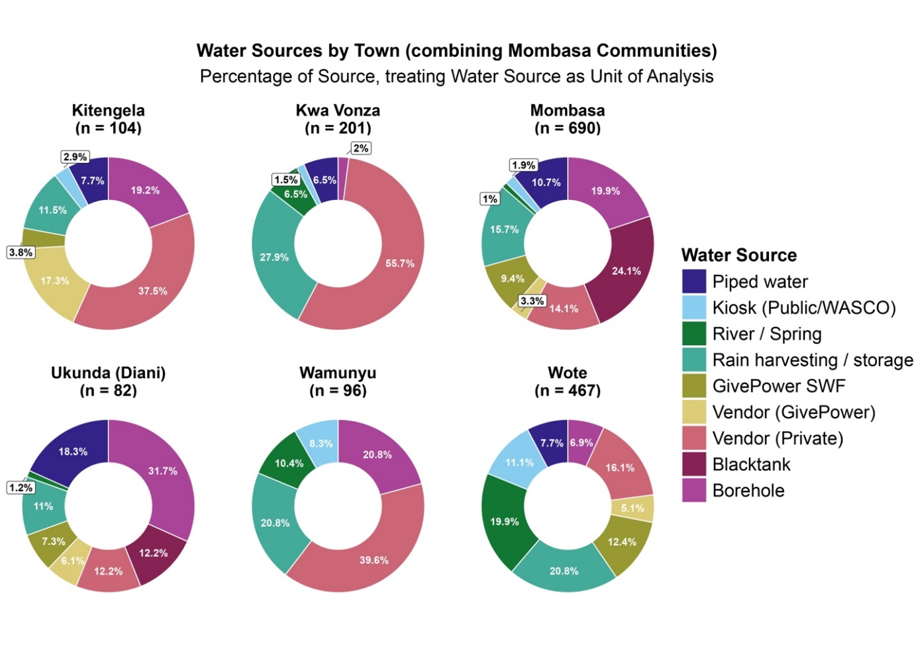
SI Figure 1. Distribution of water sources accessed by city across 2023,2024, and 2025.
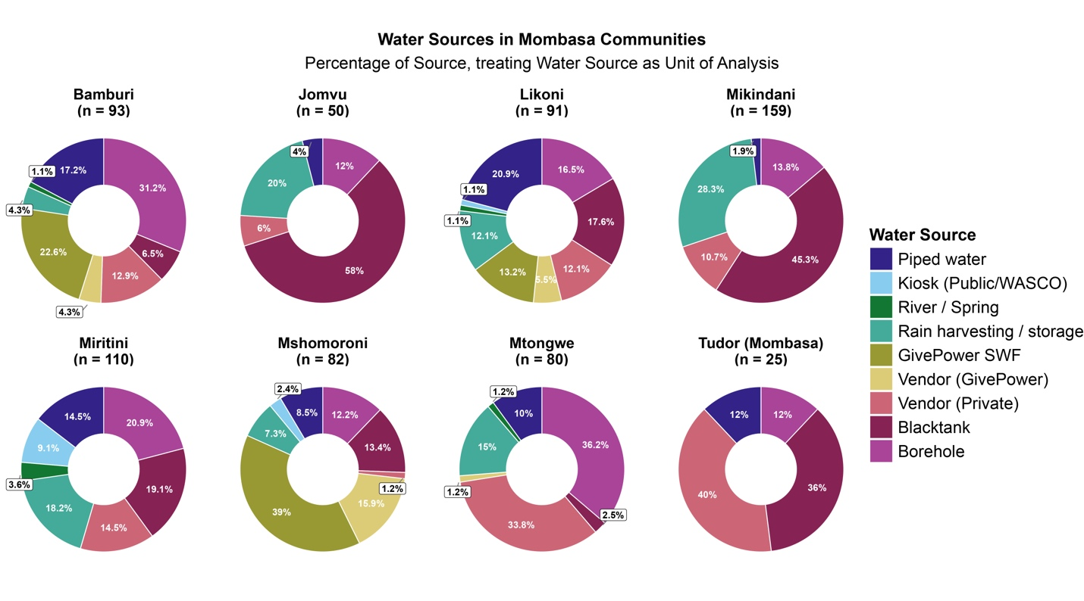
SI Figure 2 Distribution of water sources accessed within Mombasa by district in 2025.

2. Water Source Descriptive Statistics

Table 2 below provides descriptive statistics for each water source. Percent of participants is the percentage of survey takers who indicated each water source. Percent of total observations is percentage based on water source as unit of analysis. Percent reporting illness is the percentage of observations that were associated with at least one reported illness. Average cost, distance, and time are shown with the standard deviation in parentheses. Trust source is the percentage of observations for which participants indicated they trusted the water source.

SI Table 2. sample size for each water source treating water source as unit of analysis. Descriptive statistics are provided for cost, distance, and time.
Water source | N | % of partici-pants | % of obser-vations | % Reporting Illness | Avg Cost (KES per 20 liters) | Avg Distance (km) | Avg Time (min) | % Trust Source
Rain harvesting / storage | 302 | 37.3% | 18.4% | 34.1% | 5.71  (14.69) | 0.00  (0.06) | 0.05  (0.86) | 39.3%
Vendor (Private) | 371 | 39.5% | 22.6% | 31.8% | 48.95  (63.86) | 0.65  (1.80) | 7.90  (15.17) | 43.8%
Vendor (GivePower) | 70 | 8.7% | 4.3% | 24.3% | 49.94  (33.76) | 0.78  (1.60) | 7.45  (10.83) | 84.9%
GivePower SWF | 133 | 16.1% | 8.1% | 12.0% | 25.65  (15.12) | 2.45  (10.00) | 13.92  (16.23) | 95.8%
Borehole | 239 | 29.2% | 14.6% | 31.4% | 10.14  (11.77) | 0.99  (2.50) | 13.49  (33.10) | 42.7%
Blacktank | 176 | 19.1% | 10.7% | 40.9% | 16.86  (13.73) | 0.50  (0.98) | 7.08  (9.55) | 37.4%
River / spring | 124 | 15.6% | 7.6% | 25.8% | 13.63  (18.72) | 1.81  (2.83) | 26.47  (49.84) | 45.2%
Piped water | 146 | 17.9% | 8.9% | 20.6% | 14.18 (19.54) | 0.19  (0.97) | 2.83  (7.11) | 50.4%
Kiosk / WASCO | 79 | 9.9% | 4.8% | 22.8% | 15.70  (24.08) | 5.31  (28.14) | 9.81  (11.92) | 48.2%

3. Missing Data Estimation

The table below compares the imputed datasets to the original datasets using the mean and standard deviation for cost, distance, and time. We compared K-Nearest Neighbor estimates to predictive mean matching via the MICE package, as well as original data. The mean and standard deviation were comparable across both imputation methods; however, K-Nearest Neighbor resulted in more confident estimates.

This comparison shows that imputed datasets do not differ much from the original data that includes missing observations - with the exception of rain harvesting which has a higher average cost in the imputed datasets. The cost for piped water that is substantially lower under KNN (14.18) was also cleaned by removing a set of outliers that significantly increased the mean; where the median was approximately 10 KES, with the majority of observations below 35 KES, a value of 2000, and a subset of values above 250 pulled the average up considerably and were re-estimated using KNN methods.

Predictive mean matching estimates missing values by fitting a regression model using complete cases to predict the variable that is missing. Twenty datasets were imputed, and estimates were pooled to create one final dataset. KNN predicts values for a missing observation based on its k-closest neighbors (we used 5) which identifies similar data points and predicts a value based on those similar observations.

SI Table 2: Compare mean and standard deviation of cost, time, and distance by source across PMM, KNN, and original data with listwise deletion for missing values.
 | Cost |  |  | Distance |  |  | Time
Water Source | Cost Original | Cost KNN | Cost PMM | Distance Original | Distance KNN | Distance PMM | Time Original | Time KNN | Time PMM
Piped water | 76.55 (217.46) | 14.18 (19.54) | 74.96 (204.2) | 0.19  (0.97) | 0.2  (0.93) | 0.22 (0.94) | 2.83 (7.11) | 2.83 (7.06) | 2.84 (7.06)
Kiosk (Public /WASCO) | 15.83 (24.2) | 15.7 (24.08) | 15.89 (24.05) | 5.31 (28.14) | 4.25 (24.97) | 4.83 (24.93) | 9.81 (11.92) | 9.53 (11.6) | 9.84 (11.58)
River / Spring | 13.49 (19.02) | 13.63 (18.72) | 13.43 (18.63) | 1.81  (2.83) | 1.71  (2.72) | 1.79 (2.71) | 26.47 (49.84) | 25.57 (48.56) | 27.21 (48.91)
Rain harvesting / storage | 0.62 (5.88) | 5.71 (14.69) | 4.31 (10.71) | 0  (0.06) | 0  (0.06) | 0  (0.06) | 0.05 (0.86) | 0.05 (0.86) | 0.05 (0.86)
GivePower SWF | 25.79 (15.33) | 25.65 (15.12) | 25.86 (15.18) | 2.45  (10) | 2.27  (9.11) | 2.5  (9.15) | 13.92 (16.23) | 13.99 (15.79) | 15.37 (17.13)
Vendor (GivePower) | 49.94 (33.76) | 49.94 (33.76) | 49.94 (33.76) | 0.78  (1.6) | 0.74  (1.5) | 0.91 (1.64) | 7.45 (10.83) | 7.48 (10.41) | 7.84 (10.52)
Vendor (Private) | 48.9 (64.26) | 48.95 (63.86) | 49.27 (64.21) | 0.65  (1.8) | 0.64  (1.74) | 0.66 (1.77) | 7.9 (15.17) | 7.97 (14.84) | 8.06 (14.97)
Blacktank | 16.93 (13.74) | 16.86 (13.73) | 16.89 (13.71) | 0.5  (0.98) | 0.5  (0.92) | 0.54 (0.94) | 7.08 (9.55) | 7.1 (9.49) | 7.17 (9.56)
Borehole | 10.21 (12.06) | 10.14 (11.77) | 10.61 (11.93) | 0.99  (2.5) | 0.94  (2.36) | 1  (2.37) | 13.49 (33.1) | 13.13 (32.23) | 13.5 (32.26)

4. Participant Demographics

SI Tables 3, 4, and 5 below provide information about participants across all three survey waves.

SI Table 3. Descriptive statistics for participants’ monthly income, rent, and household size.
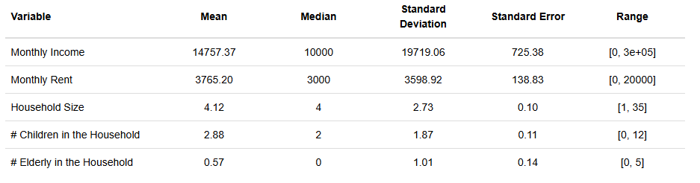

SI Table 4. Distribution of monthly income range.
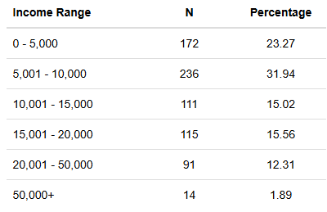

SI Table 5. Gender distribution of survey takers and head of household.
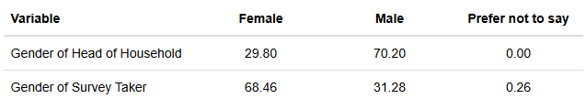

5. Calculations for cost of water in Texas.

The average monthly consumption in the state of Texas is 6006 gallons at the cost of $52.91 per month¹. 6006 gallons = 22,735.17 L. Using a conversion of 128.9 KSH to USD, $51.91 = 6,820.1 KSH. Cost per Liter = \frac{6,820.10}{22,735.17 } \approx 0.29998 \text{ KSH/L}

5. Citations

[1] Texas Municipal League. (2023). 2023 Water & wastewater survey results. https://www.tml.org/229/Water-Wastewater-Survey-Results

