Supplementary Information for
Mapping Glycan Binding Profiles of the Gut Microbes using Liquid Glycan Array (LiGA)

Pravina Yadav^{1†}, Chuanhao Peng^{2†}, Mirat Sojitra², Shreyas Gupta², Ben Willing¹*, and Ratmir Derda²*

¹Department of Agricultural, University of Alberta, Edmonton, AB T6G 2P5, Canada
²Department of Chemistry, University of Alberta, Edmonton, AB T6G 2G2, Canada

† These authors contributed equally.
*Corresponding authors: willing@ualberta.ca and ratmir@ualberta.ca

Table of Contents
1. List of abbrevations 2
2. Supplementary Methods 2
2.1 Bacterial culturing 2
2.2 Sanger sequencing 2
2.3 Quantifying phage titer by quantitative PCR 2
2.4 Glycosylation of DNA-barcoded M13 bacteriophages 3
2.5 LiGA preparation 3
2.6 Profiling glycan binding of bacterial cells using LiGA 3
2.7 PCR amplification of the bacteria-binding glycophages 3
2.8 Processing of Illumina data 4
2.9 Deep sequencing data analysis 4
3. Supplementary Figures and Tables 5
Supplementary Figure S1. Glycan binding profile of the poultry L. reuteri strains. 5
Supplementary Figure S2. Glycan binding profile of the porcine L. reuteri strains. 6
Supplementary Figure S3. Glycan binding profile of the human L. reuteri strains. 7
Supplementary Figure S4. Glycan binding profile of the rodent L. reuteri strains. 8
Supplementary Figure S5. Glycan binding profile of the Bacteroides strains. 9
Supplementary Figure S6. Glycan binding profile of C. freudii and C. ramosum. 10
Supplementary Table S1. List of L. reuteri strains used in this study. 11
Supplementary Table S2. Other bacterial strains used in this study. 12
Supplementary Table S3. CFU and OD600 enumeration. 13
Supplementary Table S4. List of glycans in LiGA-ED and LiGA-NOA used in this paper. 19
Supplementary Table S5. LiGA data used in this work 21
References 22

1. List of abbrevations
BH correction Benjamini-Hochberg correction
BSA Bovine Serum Albumin
DNA Deoxyribonucleic acid
EDC 1-Ethyl-3-(3-dimethylaminopropyl)carbodiimide hydrochloride
FC Fold Change
FDR False-Discovery Rate
HEPES Hydroxyethyl piperazineethanesulfonic acid
LiGA Liquid Glycan Array – mixture of glycan labelled phages
LB Lysogeny Broth
MALDI-TOF Matrix-assisted Laser Desorption/Ionization-Time of Flight
MS Mass Spectrometry
MWCO Molecular Weight Cutoff
NHS N-hydroxysuccinimide
PCR Polymerase Chain Reaction
PDB RCSB Protein Data Bank (https://www.rcsb.org/)
SDB Silent Double Barcods
TMM Trimmed Mean of M-values

2. Supplementary Methods

2.1 Bacterial culturing
To determine whether glycan-binding profiles were similar among L. reuteri strains from the same host, we analyzed glycan binding in 16 L. reuteri strains, comprising four isolates each from murine, porcine, poultry, and human lineages (Supplementary Table S1). All bacteria were grown in the media indicated in Supplementary Table S2. L. reuteri strains were cultured in de Man, Rogosa, and Sharpe (MRS) medium (Difco) supplemented with 5% maltose and 10% fructose under anaerobic conditions (5% CO₂, 5% H₂, and 90% N₂) in anaerobic chamber. All E. coli strains were grown in Luria-Bertani (LB) broth with agitation. Each strain was cultured, and optical density at 600 nm (OD600) was measured using NanoDrop (Thermo Fisher Scientific), with CFU·ml⁻¹ determined at 12, 18, and 24 h (Supplementary Table S3).

2.2 Sanger sequencing
Each bacterial strain was tested by the colony PCR of 16S rRNA gene regions using 8F and 926R primers, followed by Sanger sequencing¹. PCR reactions (50 µl) contained 2 µl of each primer (10 µM), 2 µl dNTP mix (10 mM; Invitrogen), 5 µl 10× Taq polymerase buffer (Invitrogen), 2 µl MgCl₂ (50 mM; Invitrogen), 0.5 µl Taq polymerase (1 U·µl⁻¹; Invitrogen), and a small amount of bacterial colony. Thermal cycling consisted of an initial denaturation at 94 °C for 10 min, followed by 40 cycles of 94 °C for 30 s, 56 °C for 30 s, and 72 °C for 1 min, with a final extension at 72 °C for 7 min. PCR products were resolved by 1% agarose gel electrophoresis and visualized using SYBR Safe DNA gel stain (Invitrogen). Sequence identities were confirmed using nucleotide BLAST.

2.3 Quantifying phage titer by quantitative PCR
Phage sample (2 µl) was mixed with universal qPCR mix (10 µl, product of the MBSU at University of Alberta), qPCR primer mix (5.5 uL, 2 µM each), and nuclease-free water (2.5 µl, IDT), followed by quantification using the CFX96 Touch Real-Time PCR Detection System (Bio-Rad). The phage titer was converted from Cq value using a calibration curve which determined by qPCR quantifying serial diluted phage sample with a known initial titer.

2.4 Glycosylation of DNA-barcoded M13 bacteriophages
Two main reactions, strain-promoted alkyne-azide cycloaddition (SPAAC) and EDC/NHS coupling, were used to generate individual LiGA components (i.e., glycosylated SDB phages). The procedure for conjugating azido glycans to DNA-barcoded bacteriophages via SPAAC has been described previously²⁻⁴.
The procedure for conjugating carboxylate-containing glycans to SDB phages was adapted from Gildersleeve and co-workers⁵. Briefly, a solution of carboxylate glycan (10 mM in water) was combined with EDC (1 equiv.) and NHS (1 equiv.) and incubated at room temperature for 1 hour to generate the corresponding amine-reactive glycan-NHS ester. The resulting glycan-NHS solution was then transferred to a phage solution (10¹²–10¹³ PFU·ml⁻¹ in 1× borate buffer, pH 8.0) and incubated at room temperature for 1 hour to allow glycosylation of phage capsid proteins. The extent of pVIII glycosylation (i.e., glycan display density) was controlled by adjusting the final concentration of glycan-NHS ester, and the reaction progress was monitored by MALDI-TOF MS. After the reaction, phages were purified using a PBS-equilibrated Zeba™ spin desalting column (0.5 ml, MWCO 7.0 kDa, ThermoFisher, Catalog# 89882) according to the manufacturer’s instructions. The glycosylated SDB phages were stored at 4°C or at -20 °C in PBS/glycerol (1:1, v/v).

2.5 LiGA preparation
LiGA was prepared by mixing equal volume of each clonal glycophages in one tube and the LiGA composition was quantified by deep sequencing prior to any glycan-binding assay². Glycan structures present in the LiGA-ED and LiGA-NOA are listed in Supplementary Table S4.

2.6 Profiling glycan binding of bacterial cells using LiGA
The LiGA-binding assay was performed following a protocol adapted from our previous publications^{2,3}. For each bacterial strain, biological replicates were prepared by inoculating single colony in 5 ml of broth media (e.g., five colonies were cultured individually for five downstream LiGA-binding assays). After culturing, the OD600 of each bacterial culture was quantified using a Nanodrop spectrophotometer (Thermo Fisher Scientific), and a volume of culture containing 1×10⁸ CFU of bacteria were pelleted (5 min, 9,391 ×g). Bacteria pellet was washed once with 1 ml HEPES buffer to remove residual medium.
For LiGA binding, washed bacterial pellets were gently resuspended in 100 µl HEPES binding buffer containing LiGA at a final concentration of 1×10⁹ PFU·ml⁻¹. Samples were incubated on ice for 1 hour with gentle mixing every 15 min. Following incubation, bacteria were pelleted by centrifugation (2 min, 9,391 ×g) and washed three times with 1 ml ice-cold HEPES binding buffer. After the final wash, phage DNA was extracted and purified using the GeneJET Plasmid Miniprep Kit (Thermo Fisher Scientific). Purified DNA was used directly for qPCR and indexing PCR.

2.7 PCR amplification of the bacteria-binding glycophages
The extracted DNA was subjected to a two-step PCR amplification procedure immediately after LiGA binding assay. In the first-step PCR, the DNA template (20 µl) was amplified in a total reaction volume of 50 μl containing 5× HF buffer (10 µl, NEB, Catalog# M0530S), 10 mM dNTP mix (1 µl, ThermoFisher Scientific), PCR primer mix (5 µl, 10 µM each), DMSO (1 µl), PhusionTM High-Fidelity DNA Polymerase (0.5 µl, NEB, Catalog# M0530S), and nuclease-free water (12.5 µl). In amplification of naïve LiGA, volume of DNA template was 2 μl. Thermal cycling was performed using the following settings: a) 95 °C for 5 min, b) 95 °C for 10 s, c) 50 °C for 30 s, d) 72 °C for 20 s, e) repeat b-d for 30 cycles, f) 4 °C hold.
The second-step PCR adds Illumina indexing barcodes to the DNA product of the first-step PCR. The DNA template (5 µl) was amplified in a total reaction volume of 50 μl containing 5× HF buffer (10 µl, NEB, Catalog# M0530S), 10 mM dNTP mix (1 µl, ThermoFisher Scientific), forward SDB indexing primer (2.5 µl, 10 µM), reverse SDB indexing primer (2.5 µl, 10 µM), PhusionTM High-Fidelity DNA Polymerase (0.5 µl, NEB, Catalog# M0530S), and nuclease-free water (28.5 µl). Thermal cycling was performed using the following settings: a) 95 °C for 5 min, b) 95 °C for 10 s, c) 50 °C for 30 s, d) 72 °C for 20 s, e) repeat b-d for 15 cycles, f) 4 °C hold. PCR products were resolved by 2% agarose gel electrophoresis to confirm complete of PCR amplification, and indexed-DNA samples were submitted for deep sequencing². Processing of the data is described below.

2.8 Processing of Illumina data
The procedure of Illumina data processing was adapted from our previous publication². The Gzip compressed FASTQ files were downloaded from BaseSpaceTM Sequence Hub. The files were converted into tables of DNA sequences and their counts per experiment. Briefly, FASTQ files were parsed into separate files based on unique multiplexing barcodes within the reads. Reads that did not contain an identifiable multiplex barcode were discarded. Several quality control steps were performed based on i) reads that contained a Phred quality score = 0 in any position were also discarded (ii) mapping the forward and reverse primer regions was done allowing no more than one base substitution each, (iii) alignment of the forward and reverse read-end overlap was performed allowing no mismatches between forward and reverse read in the overlap region. Reads that did not match criteria (ii) and (iii) were discarded. The two ends of read-pairs that pass the filtering criteria were joined and trimmed to the DNA sequences located between the priming regions; the reads were organized in a tab-delimited text file containing the unique DNA sequences and their copy numbers. Technical replicates were combined in the same file. Using an SDB-lookup table, DNA sequences were mapped to SDB and were translated to glycans using a LiGA-specific lookup table (“LiGA dictionary”). The file with DNA reads, raw counts, and mapped glycans, were uploaded to https://48hd.cloud/ server. Each experiment has a unique alphanumeric name (e.g., 20210813-87EDcsfGT-OB). All LiGA binding data used in this study has been listed in Supplementary Table S5.

2.9 Deep sequencing data analysis
Data analysis was performed in R–Bioconductor and was adapted from our previous publication^{2,3}. Comparisons and testing differences for significance in the LiGA data were performed as described in publication⁶ using DE analysis implemented in edgeR⁷. During the DE analysis, three factors were considered: (1) modeling of the observed counts using a negative binomial model, (2) BH adjustment to control the FDR at α = 0.05⁸, and (3) normalization of data across multiple samples using TMM normalization⁹. To assess the significance of glycan binding in a specific experiment, the DE of the levels of the DNA barcode associated with that glycan in ‘test’ sets of the DNA read was compared to that of the levels of the same read in ‘control’ sets. For example, in bacterial cells, the ‘test’ dataset was association of the LiGA with the cells, whereas the control was naïve library. For binding to lectins, the ‘control’ dataset was association of the LiGA with blank carriers (blank wells in plates). Before DE analysis, ‘test’ and ‘control’ datasets were retrieved from the server at https://48hd.cloud/ as tables of glycans, DNA and raw sequencing counts (Supplementary Table S5).

3. Supplementary Figures and Tables

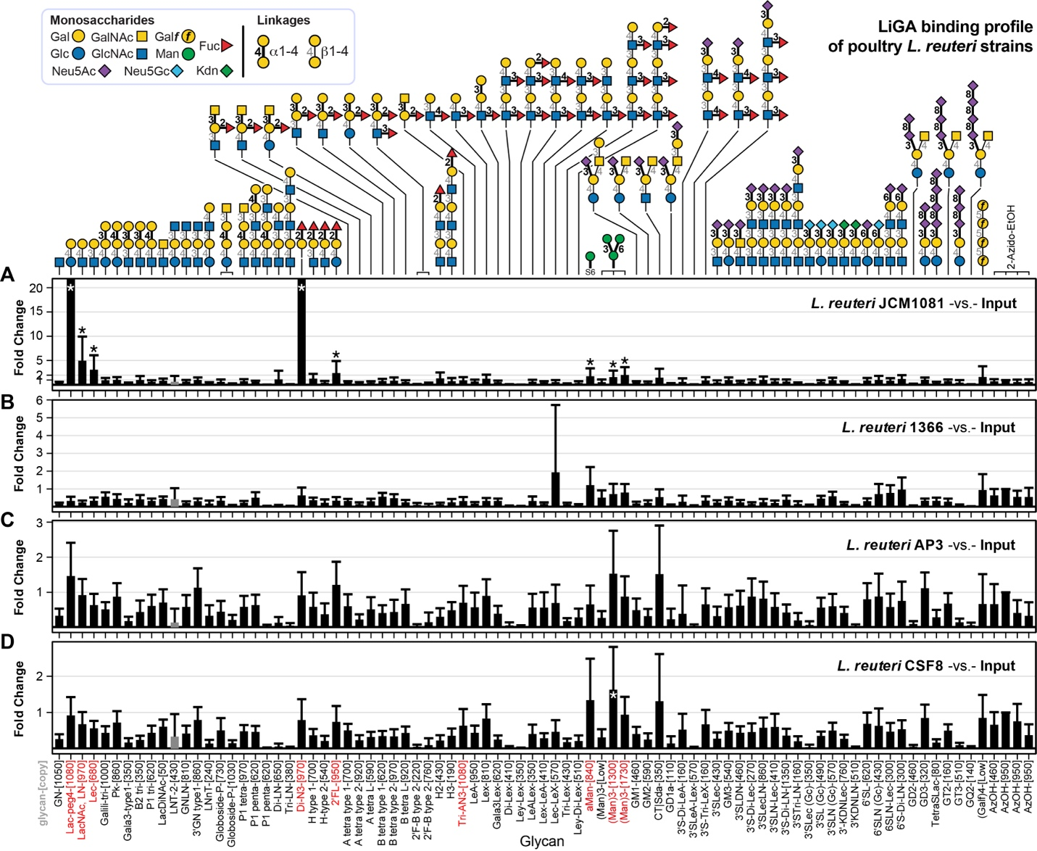

Supplementary Figure S1. Glycan binding profile of the poultry L. reuteri strains.
Significantly enriched glycans on bacteria were highlighted in red on the x-axis. Fold change (FC) was calculated by Bioconductor edgeR DE analysis using the negative binomial model, TMM normalization and BH correction for False-Discovery Rate (FDR). Error bars represent s.d. propagated from the variance of the TMM-normalized sequencing data. Glycan notations and color codes of α and β linkages are shown in the legend. * represents FDR ≤ 0.05, n = 7.
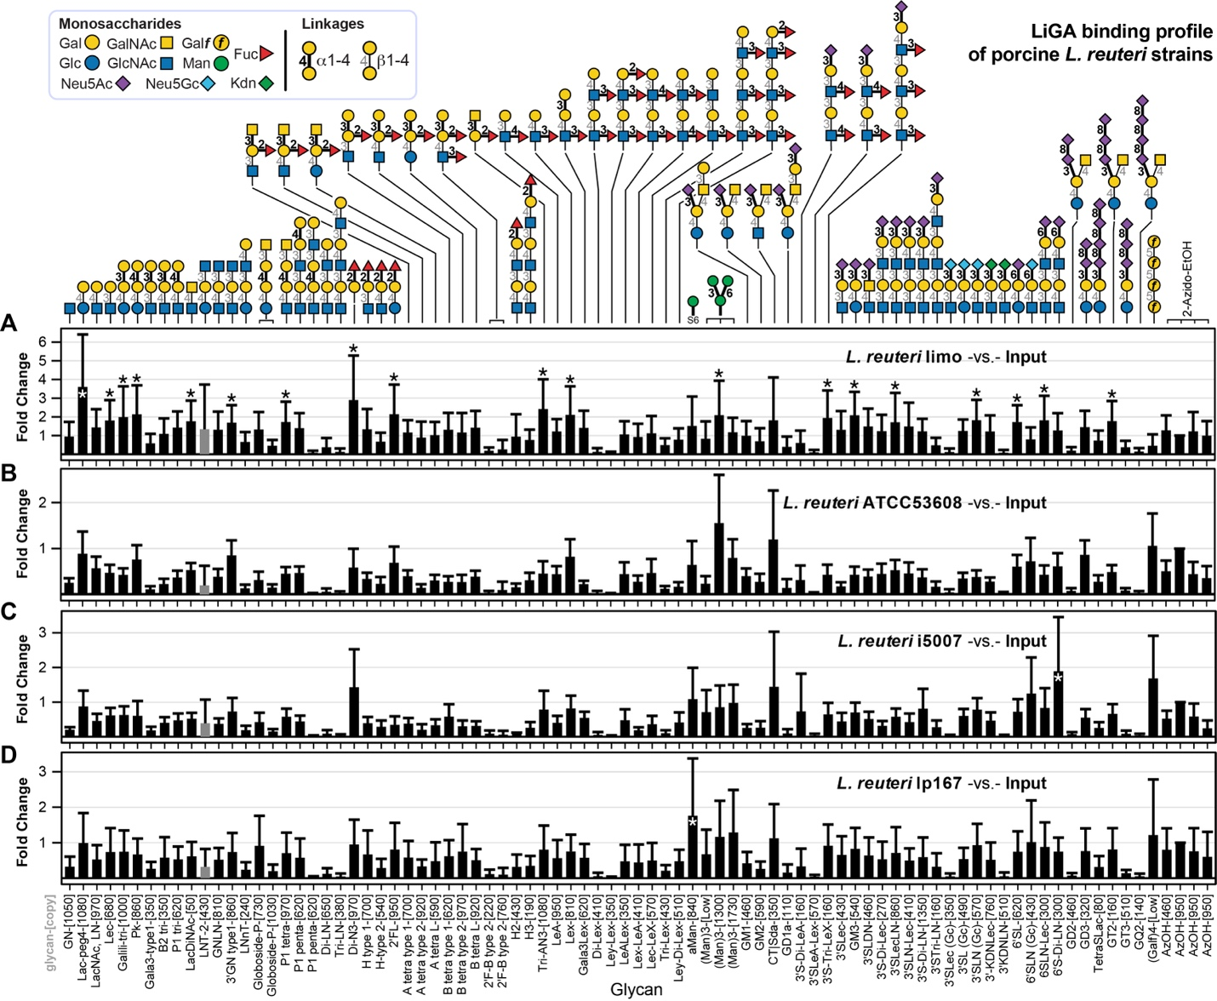

Supplementary Figure S2. Glycan binding profile of the porcine L. reuteri strains.
FC was calculated by Bioconductor edgeR DE analysis using the negative binomial model, TMM normalization and BH correction for FDR. Error bars represent s.d. propagated from the variance of the TMM-normalized sequencing data. Glycan notations and color codes of α and β linkages are shown in the legend. * represents ﻿FDR ≤ 0.05, n = 7.

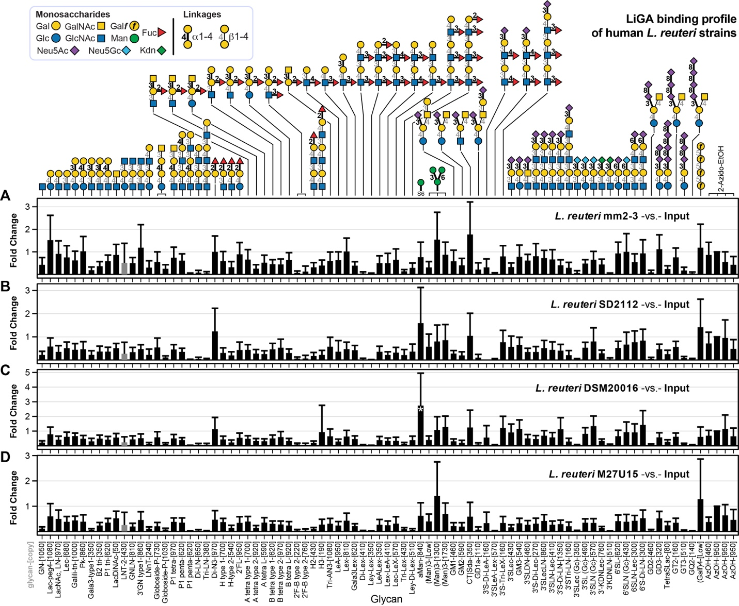

Supplementary Figure S3. Glycan binding profile of the human L. reuteri strains.
FC was calculated by Bioconductor edgeR DE analysis using the negative binomial model, TMM normalization and BH correction for FDR. Error bars represent s.d. propagated from the variance of the TMM-normalized sequencing data. Glycan notations and color codes of α and β linkages are shown in the legend. * represents ﻿FDR ≤ 0.05, n = 7.

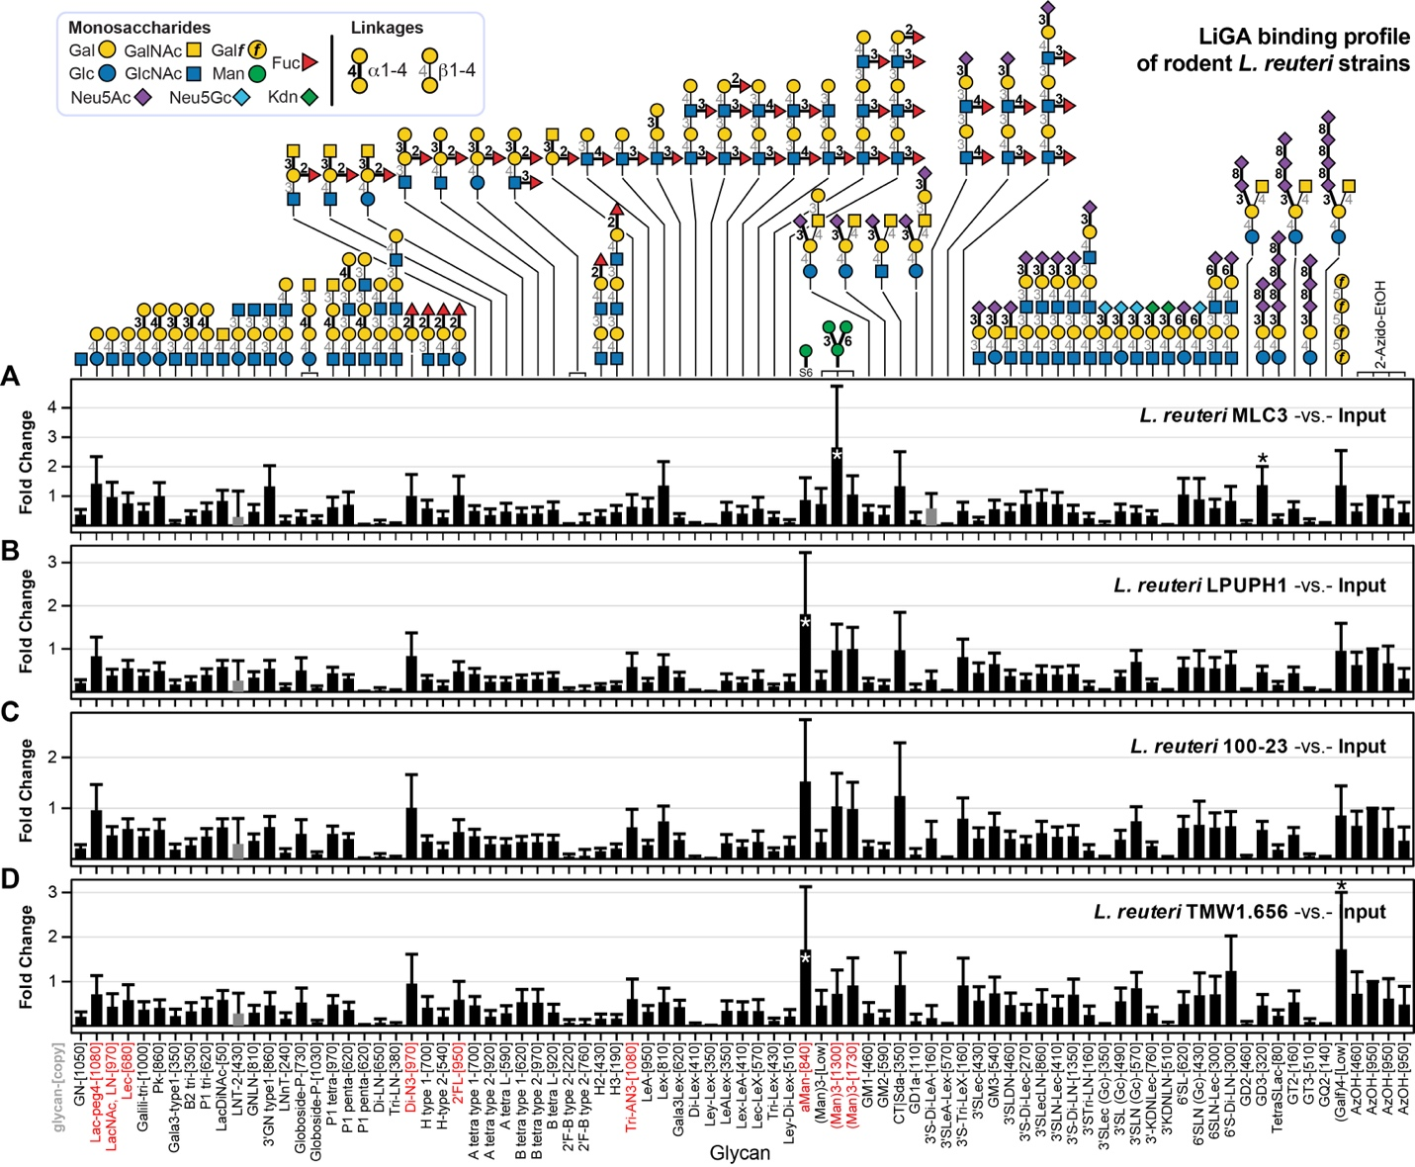

Supplementary Figure S4. Glycan binding profile of the rodent L. reuteri strains.
Significantly enriched glycans on bacteria were highlighted in red on the x-axis. FC was calculated by Bioconductor edgeR DE analysis using the negative binomial model, TMM normalization and BH correction for FDR. Error bars represent s.d. propagated from the variance of the TMM-normalized sequencing data. Glycan notations and color codes of α and β linkages are shown in the legend. * represents ﻿FDR ≤ 0.05, n = 7.

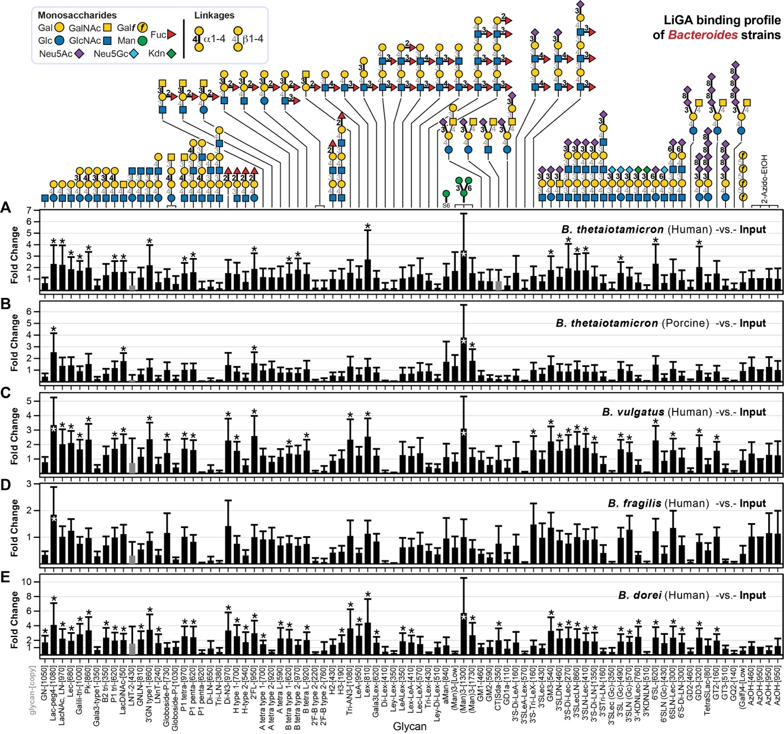

Supplementary Figure S5. Glycan binding profile of the Bacteroides strains.
FC was calculated by Bioconductor edgeR DE analysis using the negative binomial model, TMM normalization and BH correction for FDR. Error bars represent s.d. propagated from the variance of the TMM-normalized sequencing data. * represents ﻿FDR ≤ 0.05, n = 7. a) Bacteroides theiotamicron human strain, b) Bacteroides theiotamicron pig strain c) Bacteroides vulgatus human strain, d) Bacteroides fragilis and e) Bacteroides dorei human strain.

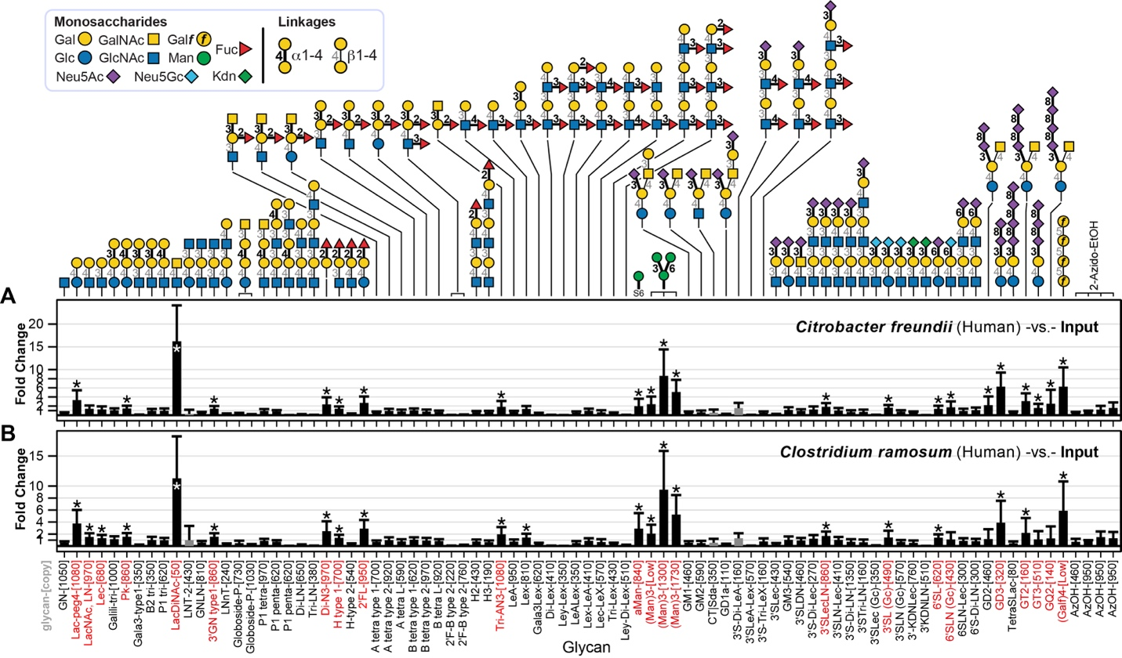

Supplementary Figure S6. Glycan binding profile of C. freudii and C. ramosum.
Significantly enriched glycans on bacteria were highlighted in red on the x-axis. FC was calculated by Bioconductor edgeR DE analysis using the negative binomial model, TMM normalization and BH correction for FDR. Error bars represent s.d. propagated from the variance of the TMM-normalized sequencing data. * represents ﻿FDR ≤ 0.05, n = 7. a) Citrobacter freundii human strain, b) Clostridium ramosum (Erysipelatoclostridium ramosum) human strain.
Strain | Host Origin | Source
L. reuteri DSM20016. Human | Human | JGI 2671180761
L. reuteri mm2-3. Human | Human | JGI 2502171171
L. reuteri SD2112.human | Human | JGI 650716048
L. reuteri M27U15.human | Human | JGI 2687453659
L. reuteri i5007.pig | Porcine | JGI 2554235423
L. reuteri lp167. Pig | Porcine | JGI 2599185361
L. reuteri ATCC53608. Pig | Porcine | EMBL LN906634
L. reuteri limo.pig | Porcine | Willing’s lab
L. reuteri JCM 1081.poultry | Poultry | JGI 2684623011
L. reuteri 1366.poultry | Poultry | JGI 2684623010
L. reuteri AP3.Poultry | Poultry | GCA_014145445
L. reuteri CSF8.poultry | Poultry | JGI 2684623009
L. reuteri MLC3.mouse | Rodent | JGI 2506381016
L. reuteri TMW1.656. rat | Rodent | JGI 2534682350
L. reuteri LPUPH1.rat | Rodent | JGI 2506381017
L. reuteri 100-23. rat | Rodent | JGI 2500069000

Supplementary Table S1. List of L. reuteri strains used in this study.
Culturing conditions and procedures can be found in the maintext Method section.
Bacteria | Growth media | Host
B. vulgatus | BHI + 0.5 L-cysteine + 5% yeast extract | Human
B. fragilis | BHI + 0.5 L-cysteine + 5% yeast extract | Human
B. dorei | BHI + 0.5 L-cysteine + 5% yeast extract | Human
Mice E. coli (commensal) | LB | Mice
Rat E. coli (commensal) | LB | Rat
Clotridium ramosum | BHI + 0.5 L-cysteine/ FAA | Human
Citrobacter freundii | BHI + 0.5 L-cysteine/ FAA | Human
AIEC | LB | Human
ETEC | LB | Human
Bacteroides thetaiotamicron | BHI + 0.5 L-cysteine + yeast extract | Porcine
Bacteroides thetaiotamicron | BHI+0.5 L-cysteine + yeast extract | Human
Lactobacillus mucosae | MRS + 5% maltose + 10% fructose | Porcine

Supplementary Table S2. Other bacterial strains and culturing conditions used in this study.
BHI, brain heart infusion medium; LB, Luria-Bertani medium; FAA, fastidious anaerobe agar; MRS, de Man, Rogosa, and Sharpe medium.
Bacteria | CFU ml⁻¹ of broth | OD600 | Incubation time (growth time)
L. reuteri | 1.6 × 10⁹ | 1.11 | 18 h
E. coli | 1.8 × 10⁹ | 1.10 | 18 h
B. vulgatus | 3.0 × 10⁸ | 1.00 | 48 h
B. fragilis | 6.0 × 10⁸ | 1.00 | 48 h
B. dorei | 5.0 × 10⁸ | 1.20 | 48 h
Mice E. coli (commensal) | 1.8 × 10⁹ | 1.10 | 18 h
Rat E. coli (commensal) | 1.8 × 10⁹ | 1.10 | 18 h
Clotridium ramosum | 1.6 × 10⁸ | 1.07 | 18 h
Citrobacter freundii | 5.0 × 10⁸ | 1.09 | 18 h
AIEC (E. coli from Human) | 1.8 × 10⁹ | 1.10 | 18 h
ETEC (E. coli from Human) | 1.8 × 10⁹ | 1.10 | 18 h
Bacteroides thetaiotamicron | 1.8 × 10⁹ | 1.08 | 24 h
Lactobacillus mucosae | 1.8 × 10⁹ | 1.09 | 18 h

Supplementary Table S3. CFU and OD600 enumeration.
CFU, colony-forming unit; OD600, optical density at 600 nm.
Common name | Display densities (glycan per phage) | Glycan chemical structure | LiGA-ED | LiGA-NOA
a-GalNAc-COOH | [135], [540], [1350] | GalNAcα-O-butyl-COOH
b-GalNAc-Az | [10], [20], [50], [100], [500], [1000] | GalNAc(β-P3
b-GalNAc-COOH | [10], [20], [50], [100], [500], [1000] | GalNAcβ-O-PEG4-COOH
Tri-GalNAc-COOH | [100], [500], [1000] | (β-D-GalNAc-sp)₃-NHCO-PEG5-COOH
GN | [1050] | GlcNAc(β-Sp
Lac-peg4 | [1080] | Galβ1-4Glc(β-P4
LacNAc, LN | [970] | Galβ1-4GlcNAc(β-Sp
Lec | [680] | Galβ1-3GlcNAc(β-Sp
Galili-tri | [1000] | Galα1-3Galβ1-4Glc(β-Sp
Pk | [860] | Galα1-4Galβ1-4Glc(β-Sp
Gala3-type1 | [350] | Galα1-3Galβ1-3GlcNAc(β-Sp
B2 tri | [350] | Galα1-3Galβ1-4GlcNAc(β-Sp
P1 tri | [620] | Galα1-4Galβ1-4GlcNAc(β-Sp
LacDiNAc | [50] | GalNAcβ1-4GlcNAc(β-Sp
LNT-2 | [430] | GlcNAcβ1-3Galβ1-4Glc(β-Sp
GNLN | [810] | GlcNAcβ1-3Galβ1-4GlcNAc(β-Sp
3'GN type1 | [860] | GlcNAcβ1-3Galβ1-3GlcNAc(β-Sp
LNnT | [240] | Galβ1-4GlcNAcβ1-3Galβ1-4Glc(β-Sp
Globoside-P | [730], [1030] | GalNAcβ1-3Galα1-4Galβ1-4Glc(β-Sp
P1 tetra | [970] | GalNAcβ1-3Galα1-4Galβ1-4GlcNAc(β-Sp
P1 penta | [620] | Galα1-4Galβ1-4GlcNAcβ1-3Galβ1-4Glc(β-Sp
P1x penta | [620] | Galβ1-3GalNAcβ1-3Galα1-4Galβ1-4GlcNAc(β-Sp
Di-LN | [650] | Galβ1-4GlcNAcβ1-3Galβ1-4GlcNAcβ1-3(β-Sp
Tri-LN | [380] | Galβ1-4GlcNAcβ1-3Galβ1-4GlcNAcβ1-3Galβ1-4GlcNAcβ1-3(β-Sp
Di-N3 | [970] | Fucα1-2Gal(β-Sp
H type 1 | [700] | Fucα1-2Galβ1-3GlcNAc(β-Sp
H-type-1-COOH | [135], [1350] | Fucα1-2Galβ1-3GlcNAc(β-X-COOH
H-type-2-[540] | [540] | Fucα1-2Galβ1-4GlcNAc(β-Sp
H-type-2-COOH | [135], [540], [1350] | Fucα1-2Galβ1-4GlcNAc(β-X-COOH
H-type-3-COOH | [100], [500], [1000] | Fucα1-2Galβ1-3GalNAc(α-X-COOH
H-type-4-COOH | [100], [500], [1000] | Fucα1-2Galβ1-3GalNAc(β-X-COOH
H-type-5-COOH | [100], [500], [1000] | Fucα1-2Galβ1-3Gal(β-X-COOH
2'FL | [950] | Fucα1-2Galβ1-4Glc(β-Sp
H-type-6-COOH | [100], [500], [1000] | Fucα1-2Galβ1-4Glc(β-X-COOH
A tetra type 1 | [700] | GalNAcα1-3[Fucα1-2]Galβ1-3GlcNAc(β-Sp
A-type-1-COOH | [135], [540], [1350] | GalNAcα1-3[Fucα1-2]Galβ1-3GlcNAc(β-X-COOH
A tetra type 2 | [920] | GalNAcα1-3[Fucα1-2]Galβ1-4GlcNAc(β-Sp
A-type-2-COOH | [135], [540], [1350] | GalNAcα1-3[Fucα1-2]Galβ1-4GlcNAc(β-X-COOH
A-type-3-COOH | [135], [540], [1350] | GalNAcα1-3[Fucα1-2]Galβ1-3GalNAc(α-X-COOH
A-type-4-COOH | [100], [500], [1000] | GalNAcα1-3[Fucα1-2]Galβ1-3GalNAc(β-X-COOH
A-type-5-COOH | [135], [540], [1350] | GalNAcα1-3[Fucα1-2]Galβ1-4Gal(β-X-COOH
A tetra type 6 | [590] | GalNAcα1-3[Fucα1-2]Galβ1-4Glc(β-Sp
A-type-6-COOH | [135], [540], [1350] | GalNAcα1-3[Fucα1-2]Galβ1-4Glc(β-X-COOH
B tetra type 1 | B tetra type 1-[620] | Galα1-3[Fucα1-2]Galβ1-3GlcNAc(β-Sp
B-type-1-COOH | [135], [540], [1350] | Galα1-3[Fucα1-2]Galβ1-3GlcNAc(β-X-COOH
B tetra type 2 | [970] | Galα1-3[Fucα1-2]Galβ1-4GlcNAc(β-Sp
B-type-2-COOH | [540] | Galα1-3[Fucα1-2]Galβ1-4GlcNAc(β-X-COOH
B-type-3-COOH | [100], [500], [1000] | Galα1-3[Fucα1-2]Galβ1-3GalNAc(α-X-COOH
B-type-4-COOH | [135], [540], [1350] | Galα1-3[Fucα1-2]Galβ1-3GalNAc(β-X-COOH
B-type-5-COOH | [540], [1350] | Galα1-3[Fucα1-2]Galβ1-3Gal(β-X-COOH
B tetra type 6 | [920] | Galα1-3[Fucα1-2]Galβ1-4Glc(β-Sp
B-type-6-COOH | [135], [540], [1350] | Galα1-3[Fucα1-2]Galβ1-4Glc(β-X-COOH
2'F-B type 2 | [220], [760] | Galα1-3[Fucα1-2]Galβ1-4[Fucα1-3]GlcNAc(β-Sp
H2 | [430] | Fucα1-2Galβ1-4GlcNAcβ1-3Galβ1-4GlcNAc(β-Sp
H3 | [190] | Fucα1-2Galβ1-4GlcNAcβ1-3Galβ1-4GlcNAcβ1-3Galβ1-4GlcNAc(β-Sp
Tri-AN3 | [1080] | GalNAcα1-3[Fucα1-2]Gal(β-Sp
LeA | [950] | Galβ1-3[Fucα1-4]GlcNAc(β-Sp
Lex | [810] | Galβ1-4[Fucα1-3]GlcNAc(β-Sp
Gala3Lex | [620] | Galα1-3Galβ1-4[Fucα1-3]GlcNAc(β-Sp
Di-Lex | [410] | Galβ1-4[Fucα1-3]GlcNAcβ1-3Galβ1-4[Fucα1-3]GlcNAcβ1-Sp
Ley-Lex | [350] | Fucα1-2Galβ1-4[Fucα1-3]GlcNAcβ1-3Galβ1-4[Fucα1-3]GlcNAc(β-Sp
LeALex | [350] | Galβ1-3[Fucα1-4]GlcNAcβ1-3Galβ1-4[Fucα1-3]GlcNAc(β-Sp
Lex-LeA | [410] | Galβ1-4[Fucα1-3]GlcNAcβ1-3Galβ1-3[Fucα1-4]GlcNAc(β-Sp
Lec-LeX | [570] | Galβ1-3GlcNAcβ1-3Galβ1-4[Fucα1-3]GlcNAc(β-Sp
Tri-Lex | [430] | Galβ1-4[Fucα1-3]GlcNAcβ1-3Galβ1-4[Fucα1-3]GlcNAcβ1-3Galβ1-4  [Fucα1-3]GlcNAc(β-Sp
Ley-Di-Lex | [510] | Fucα1-2Galβ1-4[Fucα1-3]GlcNAcβ1-3Galβ1-4[Fucα1-3]GlcNAcβ1-3  Galβ1-4[Fucα1-3]GlcNAc(β-Sp
aMan | [840] | Man(α-S6
(Man)3 | [<8] | Manα1-6[Manα1-3]Man(α-S6
(Man)3 | [1300] | Manα1-6[Manα1-3]Man(α-S6
(Man)3 | [1730] | Manα1-6[Manα1-3]Man(α-S6
11 | [50], [150], [500], [750], [780] | Manα1-6[Manα1-3]Manβ1-4GlcNAcβ1-4GlcNAc(β1-Sp
6 | [50], [150], [500], [750], [810], [1000] | GlcNAcβ1-2Manα1-6[GlcNAcβ1-2Manα1-3]Manβ1-4GlcNAcβ1-4GlcNAc(β1-Sp
10 | [150], [500], [540], [1000] | Galβ1-4GlcNAcβ1-2Manα1-6[Galβ1-4GlcNAcβ1-2Manα1-3]Manβ1-4GlcNAcβ1-4GlcNAc(β1-Sp
9 | [50], [510], [730], [950], [970] | Neu5Acα2-6Galβ1-4GlcNAcβ1-2Manα1-6[Neu5Acα2-6Galβ1-4GlcNAcβ1-2  Manα1-3]Manβ1-4GlcNAcβ1-4GlcNAc(β1-Sp
GM1 | [460] | Neu5Acα2-3[Galβ1-3GalNAcβ1-4]Galβ1-4Glc(β-Sp
GM2 | [190] | Neu5Acα2-3[GalNAcβ1-4]Galβ1-4Glc(β-Sp
CT|Sda | [350] | Neu5Acα2-3[GalNAcβ1-4]Galβ1-4GlcNAc(β-Sp
GD1a | [110] | Neu5Acα2-3[Neu5Acα2-3Galβ1-3GalNAcβ1-4]Galβ1-4Glc(β-Sp
3'S-Di-LeA | [160] | Neu5Acα2-3Galβ1-3[Fucα1-4]GlcNAcβ1-32(β-Sp
3'SLeA-Lex | [570] | Neu5Acα2-3Galβ1-3[Fucα1-4]GlcNAcβ1-3Galβ1-4[Fucα1-3]GlcNAc(β-Sp
3'S-Tri-LeX | [160] | Neu5Acα2-3Galβ1-4[Fucα1-3]GlcNAcβ1-3Galβ1-4[Fucα1-3]  GlcNAcβ1-3Galβ1-4[Fucα1-3]GlcNAc(β-Sp
3'Slec | [430] | Neu5Acα2-3Galβ1-3GlcNAc(β-Sp
GM3 | [190] | Neu5Acα2-3Galβ1-4Glc(β-Sp
GM3 | [540] | Neu5Acα2-3Galβ1-4Glc(β-Sp
3'SLDN | [460] | Neu5Acα2-3GalNAcβ1-4GlcNAc(β-Sp
3'S-Di-Lec | [270] | Neu5Acα2-3Galβ1-3GlcNAcβ1-3Galβ1-3GlcNAc(β-Sp
3'SLecLN | [860] | Neu5Acα2-3Galβ1-3GlcNAcβ1-3Galβ1-4GlcNAc(β-Sp
3'SLN-Lec | [410] | Neu5Acα2-3Galβ1-4GlcNAcβ1-3Galβ1-3GlcNAc(β-Sp
3'S-Di-LN | [1350] | Neu5Acα2-3Galβ1-4GlcNAcβ1-3Galβ1-4GlcNAcβ1-Sp
3'STri-LN | [160] | Neu5Acα2-3Galβ1-4GlcNAcβ1-3Galβ1-4GlcNAcβ1-3Galβ1-4GlcNAc(β-Sp
3'SLec (Gc) | [350] | Neu5Gcα2-3Galβ1-3GlcNAc(β-Sp
3'SL (Gc) | [490] | Neu5Gcα2-3Galβ1-4Glc(β-Sp
3'SLN (Gc) | [570] | Neu5Gcα2-3Galβ1-4GlcNAc(β-Sp
3'-KDNLec | [760] | Kdnα2-3Galβ1-3GlcNAc(β-Sp
3'KDNLN | [510] | Kdnα2-3Galβ1-4GlcNAc(β-Sp
6'SL | [620] | Neu5Acα2-6Galβ1-4Glc(β-Sp
6'SLN (Gc) | [430] | Neu5Gcα2-6Galβ1-4GlcNAc(β-Sp
6'SLDN | [620] | Neu5Acα2-6GalNAcβ1-4GlcNAc(β-Sp
6'SLN-Lec | [300] | Neu5Acα2-6Galβ1-4GlcNAcβ1-3Galβ1-3GlcNAc(β-Sp
6'S-Di-LN | [300] | Neu5Acα2-6Galβ1-4GlcNAcβ1-3Galβ1-4GlcNAcβ1-Sp
GD2 | [460] | Neu5Acα2-8Neu5Acα2-3[GalNAcβ1-4]Galβ1-4Glc(β-Sp
GD3 | [320] | Neu5Acα2-8Neu5Acα2-3Galβ1-4Glc(β-Sp
TetraSLac | [80] | Neu5Acα2-8Neu5Acα2-8Neu5Acα2-8Neu5Acα2-3Galβ1-4Glc(β-Sp
GT2 | [160] | Neu5Acα2-8Neu5Acα2-8Neu5Acα2-3[GalNAcβ1-4]Galβ1-4Glc(β-Sp
GT3 | [510] | Neu5Acα2-8Neu5Acα2-8Neu5Acα2-3Galβ1-4Glc(β-Sp
GQ2 | [140] | Neu5Acα2-8Neu5Acα2-8Neu5Acα2-8Neu5Acα2-3[GalNAcβ1-4]Galβ1-4Glc(β-Sp
(Galf)4 | [<8] | Galfβ1-5Galfβ1-5Galfβ1-5Galf(β-S8
α-L-Glc | [25], [50], [150], [500], [4000] | L-Glc(α-O-octyl-COOH
β-L-Glc | [25], [50], [150], [500], [4000] | L-Glc(β-O-octyl-COOH
β-D-Glc | [25], [50], [150], [500], [4000] | D-Glc(β-O-butyl-COOH
α-L-Gal | [25], [50], [150], [500], [4000] | L-Gal(α-O-octyl-COOH
β-L-Gal | [25], [50], [150], [500], [4000] | L-Gal(β-O-octyl-COOH
β-D-Gal | [25], [50], [150], [500], [4000] | D-Gal(β-O-butyl-COOH
α-L-Man | [25], [50], [150], [500], [4000] | L-Man(α-O-octyl-COOH
α-D-Man | [25], [50], [150], [500], [4000] | D-Man(α-O-butyl-COOH
α-L-Fuc | [25], [50], [150], [500], [4000] | L-Fuc(α-O-octyl-COOH
β-L-Fuc | [25], [50], [150], [500], [4000] | L-Fuc(β-O-octyl-COOH
α-D-Fuc | [25], [50], [150], [500], [4000] | D-Fuc(α-O-octyl-COOH
β-D-Fuc | [25], [50], [150], [500], [4000] | D-Fuc(β-O-octyl-COOH
AzOH | [460] | 2-Azidoethanol
AzOH | [500] | 2-Azidoethanol
AzOH | [950] | 2-Azidoethanol
blank | [0] | Wild-type phage  (no modification)

Supplementary Table S4. List of glycans in LiGA-ED and LiGA-NOA used in this paper.
Glycans that are presented in LiGA were highlighted in green. Linker abbreviations: Sp: -O-(CH₂)₂-N₃; S5: -O-(CH₂)₅-N₃; S6: -O-(CH₂)₆-N₃; S8 -O-(CH₂)₈-N₃; P3: -(O-CH₂-CH₂)₃-N₃; P4: -(O-CH₂-CH₂)₄-N₃; X: -O-(CH₂)₈-S-(CH₂)₂-NHCO-(CH₂)₄-.
LiGA | Datasets | Target | Comment
LiGA-ED | 20210813-87EDbwpnGT-OB | w.t. E. coli BW25113 | Used in  Fig. 1d-f
LiGA-ED | 20210813-87EDbwnnGT-OB | ΔFimH E. coli BW25113 | Used in  Fig. 1d-f
LiGA-ED | 20210813-87EDnsdGT-OB | No target (LiGA input) | Used in  Fig. 1d-f
LiGA-ED | 20211004-87EDnsdGT-OB | No target (LiGA input) | Used in  Fig. 1d-f
LiGA-ED | 20211115-87EDnsdGT-OB | No target (LiGA input) | Used in  Fig. 1d-f
LiGA-ED | 20211216-87EDnsdGT-OB | No target (LiGA input) | Used in  Fig. 1d-f
LiGA-ED | 20210813-87EDjcmGT-OB | L. reuteri JCM1081 (Poultry) | Used in  Fig. 2-3 and  Supplementary Fig. S1-S4
LiGA-ED | 20211004-87EDjcmGT-OB | L. reuteri JCM1081 (Poultry) | Used in  Fig. 2-3 and  Supplementary Fig. S1-S4
LiGA-ED | 20211115-87EDjcmGT-OB | L. reuteri JCM1081 (Poultry) | Used in  Fig. 2-3 and  Supplementary Fig. S1-S4
LiGA-ED | 20211115-87EDlimrGT-OB | L. reuteri limo (Porcine) | Used in  Fig. 2-3 and  Supplementary Fig. S1-S4
LiGA-ED | 20210813-87EDrapGT-OB | L. reuteri AP3 (Poultry) | Used in  Fig. 2-3 and  Supplementary Fig. S1-S4
LiGA-ED | 20210813-87EDmmGT-OB | L. reuteri mm2-3 (Human) | Used in  Fig. 2-3 and  Supplementary Fig. S1-S4
LiGA-ED | 20210813-87EDlratGT-OB | L. reuteri ATCC53608 (Porcine) | Used in  Fig. 2-3 and  Supplementary Fig. S1-S4
LiGA-ED | 20210813-87EDcsfGT-OB | L. reuteri CSF8 (Poultry) | Used in  Fig. 2-3 and  Supplementary Fig. S1-S4
LiGA-ED | 20210813-87EDmlGT-OB | L. reuteri MLC3 (Rodent) | Used in  Fig. 2-3 and  Supplementary Fig. S1-S4
LiGA-ED | 20210813-87EDsdlrGT-OB | L. reuteri SD2112 (Human) | Used in  Fig. 2-3 and  Supplementary Fig. S1-S4
LiGA-ED | 20210813-87EDfaaGT-OB | L. reuteri 1366 (Poultry) | Used in  Fig. 2-3 and  Supplementary Fig. S1-S4
LiGA-ED | 20210813-87EDgaaGT-OB | L. reuteri i5007 (Porcine) | Used in  Fig. 2-3 and  Supplementary Fig. S1-S4
LiGA-ED | 20210813-87EDdsmGT-OB | L. reuteri DSM 20016 (Human) | Used in  Fig. 2-3 and  Supplementary Fig. S1-S4
LiGA-ED | 20210813-87EDlplrGT-OB | L. reuteri lp167 (Porcine) | Used in  Fig. 2-3 and  Supplementary Fig. S1-S4
LiGA-ED | 20210813-87EDlpuphGT-OB | L. reuteri LPUPH1 (Rodent) | Used in  Fig. 2-3 and  Supplementary Fig. S1-S4
LiGA-ED | 20210813-87EDrodGT-OB | L. reuteri 100-23 (Rodent) | Used in  Fig. 2-3 and  Supplementary Fig. S1-S4
LiGA-ED | 20210813-87EDtmwGT-OB | L. reuteri TMW1.656 (Rodent) | Used in  Fig. 2-3 and  Supplementary Fig. S1-S4
LiGA-ED | 20210813-87EDdaaGT-OB | L. reuteri M27U15 (Human) | Used in  Fig. 2-3 and  Supplementary Fig. S1-S4
LiGA-ED | 20211115-87EDcfhGT-OB | C. fruendii (Human) | Used in Fig. 3  and  Supplementary Fig. S5-S6
LiGA-ED | 20211216-87EDcfhGT-OB | C. fruendii (Human) | Used in Fig. 3  and  Supplementary Fig. S5-S6
LiGA-ED | 20211115-87EDcrhGT-OB | C. ramosum (Human) | Used in Fig. 3  and  Supplementary Fig. S5-S6
LiGA-ED | 20211216-87EDcrhGT-OB | C. ramosum (Human) | Used in Fig. 3  and  Supplementary Fig. S5-S6
LiGA-ED | 20211115-87EDlmucGT-OB | L. mucosae (Porcine) | Used in Fig. 3  and  Supplementary Fig. S5-S6
LiGA-ED | 20211115-87EDbfraGT-OB | B. fragilis (Human) | Used in Fig. 3  and  Supplementary Fig. S5-S6
LiGA-ED | 20211115-87EDbtpGT-OB | B. thetaiotamicron (Porcine) | Used in Fig. 3  and  Supplementary Fig. S5-S6
LiGA-ED | 20211216-87EDbtpGT-OB | B. thetaiotamicron (Porcine) | Used in Fig. 3  and  Supplementary Fig. S5-S6
LiGA-ED | 20211115-87EDbvulGT-OB | B. vulgatus (Human) | Used in Fig. 3  and  Supplementary Fig. S5-S6
LiGA-ED | 20211216-87EDbvulGT-OB | B. vulgatus (Human) | Used in Fig. 3  and  Supplementary Fig. S5-S6
LiGA-ED | 20211115-87EDbtheGT-OB | B. thetaiotamicron (Human) | Used in Fig. 3  and  Supplementary Fig. S5-S6
LiGA-ED | 20211216-87EDbtheGT-OB | B. thetaiotamicron (Human) | Used in Fig. 3  and  Supplementary Fig. S5-S6
LiGA-ED | 20211115-87EDbdorGT-OB | B. dorei (Human) | Used in Fig. 3  and  Supplementary Fig. S5-S6
LiGA-ED | 20211115-87EDrateGT-OB | Rat E. coli (commensal) | Used in  Fig. 3 and Fig. 4
LiGA-ED | 20211216-87EDrateGT-OB | Rat E. coli (commensal) | Used in  Fig. 3 and Fig. 4
LiGA-ED | 20211115-87EDmcenGT-OB | Mice E. coli (commensal) | Used in  Fig. 3 and Fig. 4
 | 20211216-87EDmcenGT-OB | Mice E. coli (commensal)
 | 20211115-87EDaiecGT-OB | AIEC (E. coli from Human)
 | 20211115-87EDetecGT-OB | ETEC (E. coli from Human)
LiGA-NOA | 20251218-87NOAoraCAAA-EG | L. reuteri JCM 1081 | Used in Fig. 5a
LiGA-NOA | 20251218-87NOAooCAAA-EG | No target (LiGA input) | Used in Fig. 5a
LiGA-NOA | 20251218-87NOAepaDC-IF | w.t. E. coli BW25113 | Used in  Fig. 5b-c
LiGA-NOA | 20251218-87NOAeqaDC-IF | ΔFimH E. coli BW25113 | Used in  Fig. 5b-c
LiGA-NOA | 20251218-87NOAooNA-IF | No target (LiGA input) | Used in  Fig. 5b-c

Supplementary Table S5. LiGA data used in this work
The listed datasets are publicly available at https://48hd.cloud/.

References

1 Coolen, M. J., Post, E., Davis, C. C. & Forney, L. J. Characterization of microbial communities found in the human vagina by analysis of terminal restriction fragment length polymorphisms of 16S rRNA genes. Appl. Environ. Microbiol. 71, 8729–8737 (2005).
2 Sojitra, M. et al. Genetically encoded multivalent liquid glycan array displayed on M13 bacteriophage. Nat. Chem. Biol. 17, 806–816 (2021).
3 Sojitra, M. et al. Measuring carbohydrate recognition profile of lectins on live cells using liquid glycan array (LiGA). Nat. Protoc. 20, 989–1019 (2025).
4 Lin, C.-L. et al. Chemoenzymatic synthesis of genetically-encoded multivalent liquid N-glycan arrays. Nat. Commun. 14, 5237 (2023).
5 Manimala, J. C., Li, Z., Jain, A., VedBrat, S. & Gildersleeve, J. C. Carbohydrate array analysis of anti‐Tn antibodies and lectins reveals unexpected specificities: Implications for diagnostic and vaccine development. ChemBioChem 6, 2229–2241 (2005).
6 Matochko, W. L., Cory Li, S., Tang, S. K. & Derda, R. Prospective identification of parasitic sequences in phage display screens. Nucleic Acids Res. 42, 1784–1798 (2014).
7 Robinson, M. D. & Smyth, G. K. Small-sample estimation of negative binomial dispersion, with applications to SAGE data. Biostatistics 9, 321–332 (2008).
8 Benjamini, Y. & Hochberg, Y. Controlling the false discovery rate: a practical and powerful approach to multiple testing. J. R. Stat. Soc. Ser. B 57, 289–300 (1995).
9 Robinson, M. D. & Oshlack, A. A scaling normalization method for differential expression analysis of RNA-seq data. Genome Biol. 11, R25 (2010).

