Appendix I. Patient-Facing Recruitment and Study Information Materials
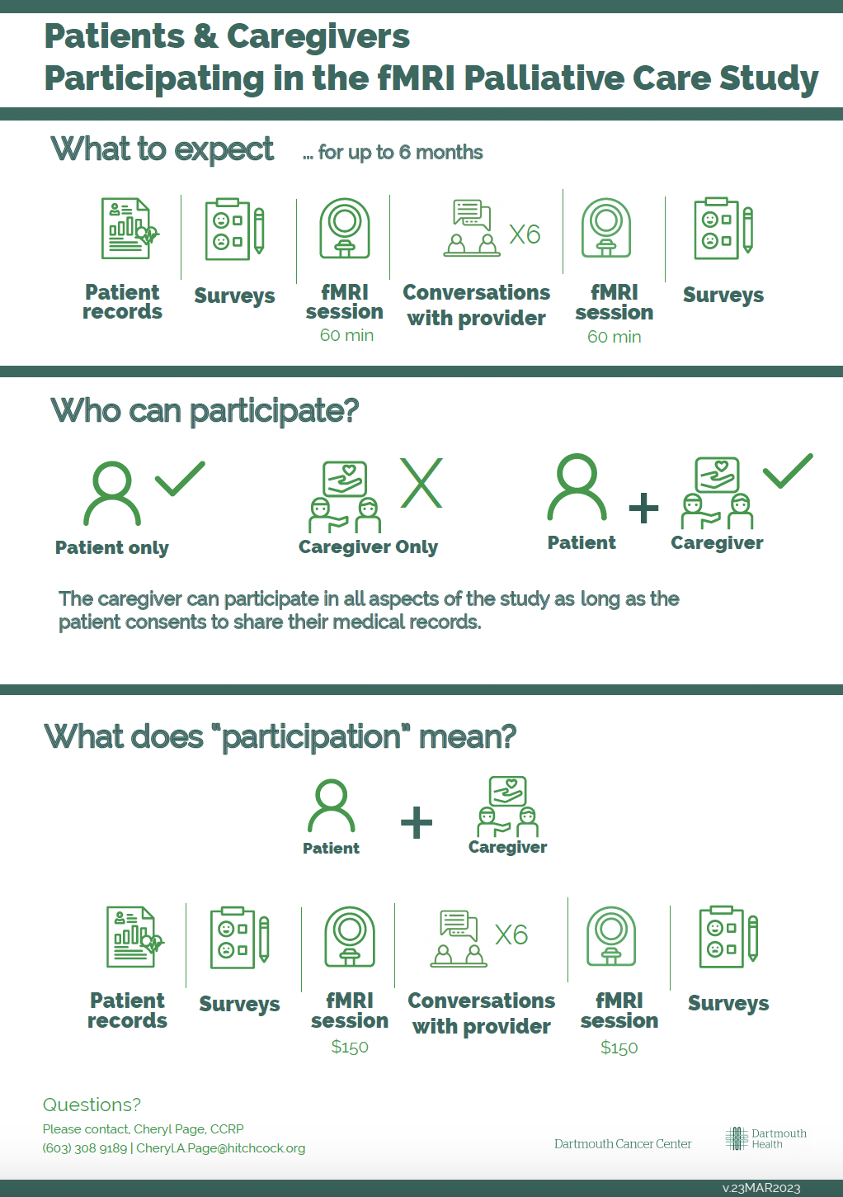
Appendix II. Standard Operating Procedure for Researcher-Facing Informed Consent and Post-Participation Debriefing

OVERALL PROCESS
What was the duration of the interaction? | <15 min >15 min >30 min
Was the research coordinator present when the patient was asked for permission to approach? | Yes No
Was “palliative care” introduced to the patient prior to the consent process?
By whom? How?
How do you think the patient would describe the stage of their diagnosis?
Only beginning to process
Already processed
Other, please explain below:
Was the patient accompanied by a caregiver? | Yes No
Was the patient or the caregiver more interested in the study? | Patient Caregiver
Please note any specific questions the patient and/or caregiver asked about the study.

Did you notice any specific things that the patient and/or the caregiver were receptive or concerned about? If yes, please explain below.

PATIENT-RESEARCHER INTERACTION
How would you describe the patient’s psychosynthesis (mood, attitude, expressions, body language etc.) when first introduced?
How would you describe the patient’s psychosynthesis at the end of the meeting?
What went well/ what did you like about the interaction?
What went bad/what did you not like about the interaction?
What would you change about the interaction?
Did the patient sign the consent form? | Yes No
It is helpful to ask patients whether they would like to contribute by providing the reason(s) of choosing to participate or not in this study.
If the patient shared the reasons of participating or not, please explain below.
emotional reasons  burdensome procedure  symptom management  specific to fMRI  location  research interest  already a participant in a research study | other; please explain below
Did the caregiver sign the consent form? | Yes No
If the caregiver shared the reasons of participating or not, please explain below.

emotional reasons  burdensome procedure  symptom management  specific to fMRI  location  research interest  already a participant in a research study | other; please explain below
If you chose “location” in one or more of the previous questions, based on what the patient said, would it make a difference if the fMRI scans were being done at Dartmouth Health rather than at Dartmouth College? | Yes, it would make a difference  No, it would not have made a difference
Please provide any additional notes below.

