Additional Information
A multi-epitope peptide rOmp22 encapsulated in chitosan-PLGA nanoparticles as vaccine candidate against Acinetobacter baumannii infection
Xingran Du^{1†}, Jianpeng Xue^{2†}, Mingzi Jiang³, Shaoqing Lin⁴, Yuzhen Huang⁴, Kaili Deng⁵, Lei Shu⁵, Hanmei Xu², Zeqing Li², Jing Yao⁴, Sixia Chen⁴, Ziyan Shen⁴ and Ganzhu Feng^{4*}
¹ Department of Infectious Disease, The Second Affiliated Hospital of Nanjing Medical University, Nanjing, Jiangsu 210011, China.
² State Key Laboratory of Natural Medicines, The Engineering Research Center of Synthetic Polypeptide Discovery and Evaluation of Jiangsu Province, China Pharmaceutical University, Nanjing, Jiangsu 211198, China.
³ Department of Respiratory and Critical Care Medicine, The First People’s Hospital of Kunshan, Jiangsu 215300, China.
⁴ Department of Respiratory and Critical Care Medicine, The Second Affiliated Hospital of Nanjing Medical University, Nanjing, Jiangsu 210011, China.
⁵ Department of Respiratory Medicine, Sir Run Run Hospital, Nanjing, Jiangsu 211100, China.
†These authors contributed equally to this work
*Corresponding author: Ganzhu Feng, E-mail: zhu1635253@163.com, telephone: 025-58509837, fax number:025-58509994.

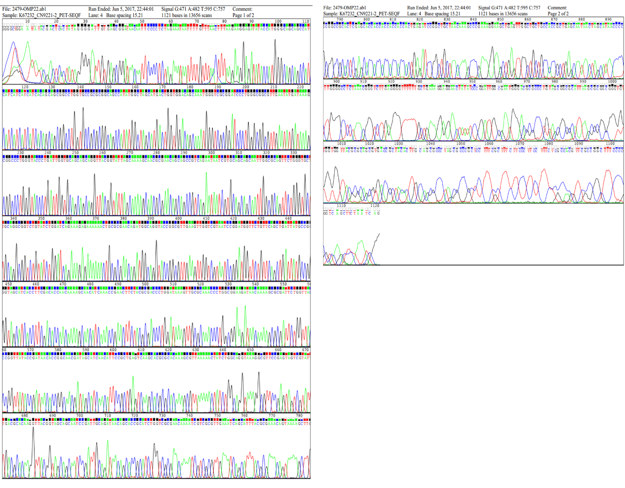
Fig. S1 Recombinant plasmid pET-28a-omp22 sequencing.

Fig. S2 Liquid chromatography and mass spectrometry of multi-epitope peptide rOmp22. a Liquid chromatography of rOmp22. b Mass spectrometry shows rOmp22 with the molecular weight of 6535.48 Da.
Table S1 Drug sensitivity test of A. baumannii ATCC19606 and three clinical strains
 | ATCC19606 | CS-MDR-AB | CRAB | PDR-AB
ampicillin | R (>=32) | R (>=32) | R (>=32) | R (>=32)
piperacillin tazobactam | S (<=4) | I (64) | R (>=128) | I (64)
ceftriaxone | I (32) | R (>=64) | R (>=64) | R (>=64)
aztreonam | R (32) | R (>=64) | R (>=64) | R (>=64)
gentamicin | S (4) | S (<=1) | R (>=16) | R (>=16)
ciprofloxacin | S (1) | R (>=4) | R (>=4) | R (>=4)
Tigecycline | S (<=0.5) | S (<=0.5) | S (2) | R (>=8)
cefperazone-sulbactam | / | S (KB 21) | R (KB 10) | S (KB 22)
amoxicillin-clavulanic acid | R (>=32) | R (>=32) | R (>=32) | R (>=32)
cefazolin | R (>=64) | R (>=64) | R (>=64) | R (>=64)
cefepime | I (16) | R (>=64) | R (>=64) | R (>=64)
imipenem | S (<=1) | S (2) | R (>=16) | R (>=16)
tobramycin | S (<=1) | S (<=1) | R (>=16) | R (>=16)
levofloxacin | S (1) | I (4) | I (4) | R (>=8)
sulfamethoxazole | R (160) | R (160) | S (<=20) | R (>=320)
colistin | / | / | S (1) | S (0.5)
cefatadine avibatan | / | / | / | R (>=16)
Note: The antibiotic resistance cut-off value is determined according to CLSI M100. Except cefoperazone sulbactam, the sensitivity of other drugs was detected by microbroth method. R, resistance; S, sensitive; I, intermediate；KB, Disk diffusion method (K-B method).

