Supplementary Information

Title: Parsimonious machine learning models to estimate environmental footprints of crop production

Authors: Farhang Raymand¹, Koen J.J. Kuipers¹, Sarah Sim^{1,2}, P. James Joyce², Aafke M. Schipper¹, Mark A.J. Huijbregts¹
¹ Department of Environmental Science, Radboud Institute for Biological and Environmental Sciences (RIBES), Radboud University, P.O. Box 9010, 6525 XZ Nijmegen, The Netherlands
² Safety, Environmental and Regulatory Sciences (SERS), Unilever, Colworth Science Park, Sharnbrook, MK44 1LQ, United Kingdom
Corresponding author: Farhang Raymand - farhang.raymand@ru.nl
Journal name: Journal of Industrial Ecology

S1 – Crop production Life Cycle Inventories (LCIs) used in this work, breakdown by crop group and country. In cases where more than one LCI is present for the same crop-country combination, multiple cases/management practices are covered.

food/non-food crop | crop group | crop | country | number of activities
food | fruit | acai berry | BR | 1
food | beverage and spice | agave | MX | 1
non-food | fodder | alfalfa | FR | 7
food | nut | almond | CN | 1
food | other | aloe vera | MX | 1
food | fruit | apple | CH | 5
food | fruit | apple | CL | 1
food | fruit | apple | CN | 1
food | fruit | apple | CR | 1
food | fruit | apple | FR | 9
food | fruit | apple | IT | 1
food | fruit | apple | RE | 1
food | fruit | apple | US | 1
food | fruit | apple | ZA | 1
food | fruit | apricot | ES | 1
food | fruit | apricot | FR | 1
food | fruit | apricot | IT | 1
food | fruit | apricot | TR | 1
food | vegetable | asparagus | CN | 1
food | vegetable | asparagus | FR | 1
food | vegetable | asparagus | PE | 1
food | vegetable | aubergine | IN | 1
food | fruit | avocado | CL | 1
food | fruit | avocado | MX | 1
food | fruit | avocado | US | 1
food | fruit | banana | CO | 1
food | fruit | banana | CR | 1
food | fruit | banana | EC | 1
food | fruit | banana | IN | 1
food | fruit | banana | MX | 1
food | fruit | banana | WI | 1
food | cereal | barley | AR | 1
food | cereal | barley | AU | 8
food | cereal | barley | CA | 3
food | cereal | barley | CH | 8
food | cereal | barley | DE | 3
food | cereal | barley | ES | 1
food | cereal | barley | FR | 19
food | cereal | barley | GB | 2
food | cereal | barley | IT | 2
food | cereal | barley | PL | 2
food | cereal | barley | RU | 2
food | cereal | barley | UA | 2
food | legume | bean | CH | 2
food | legume | bean | CN | 1
food | legume | bean | FR | 1
food | root | beet root | ES | 1
food | root | beet root | FR | 1
food | root | beet root | IT | 1
food | root | beet root | MX | 1
food | root | beet root | NL | 1
food | vegetable | bell pepper | IN | 2
food | vegetable | bell pepper | VN | 1
food | fruit | blackberry | MX | 1
food | fruit | blackberry | RS | 1
food | fruit | blueberry | CA | 1
food | fruit | blueberry | ES | 1
food | fruit | blueberry | US | 1
food | vegetable | broccoli | CH | 2
food | root | carrot | CH | 2
food | root | carrot | CN | 1
food | root | carrot | ES | 1
food | root | carrot | FR | 11
food | root | carrot | IL | 1
food | root | carrot | NL | 1
food | nut | cashew | CI | 1
food | nut | cashew | IN | 2
food | nut | cashew | VN | 1
food | root | cassava | BR | 1
non-food | oil crop | castor bean | IN | 1
food | vegetable | cauliflower | CH | 2
food | vegetable | cauliflower | FR | 9
food | fruit | cherry | CL | 1
food | fruit | cherry | FR | 1
food | fruit | cherry | IT | 1
food | fruit | cherry | TR | 1
food | fruit | cherry | US | 1
food | legume | chickpea | FR | 1
food | legume | chickpea | IN | 2
food | legume | chickpea | MX | 1
food | legume | chickpea | RU | 1
food | root | chicory root | BE | 1
food | root | chicory root | FR | 2
food | root | chicory root | NL | 1
food | vegetable | chicory witloof | FR | 10
food | beverage and spice | chilli | ES | 1
food | beverage and spice | chilli | IN | 2
food | beverage and spice | chilli | MX | 1
food | fruit | clementine | MA | 1
food | beverage and spice | cocoa | BR | 5
food | beverage and spice | cocoa | CI | 4
food | beverage and spice | cocoa | CM | 4
food | beverage and spice | cocoa | EC | 4
food | beverage and spice | cocoa | GH | 3
food | beverage and spice | cocoa | ID | 4
food | nut | coconut | BR | 1
food | nut | coconut | ID | 1
food | nut | coconut | IN | 1
food | nut | coconut | PH | 1
food | beverage and spice | coffee arabica | BR | 7
food | beverage and spice | coffee arabica | CO | 1
food | beverage and spice | coffee arabica | GT | 1
food | beverage and spice | coffee arabica | HN | 1
food | beverage and spice | coffee arabica | IN | 1
food | beverage and spice | coffee arabica | MX | 1
food | beverage and spice | coffee arabica | TZ | 1
foodprev | beverage and spice | coffee robusta | BR | 2
foodprev | beverage and spice | coffee robusta | ID | 1
foodprev | beverage and spice | coffee robusta | IN | 1
foodprev | beverage and spice | coffee robusta | VN | 1
food | beverage and spice | coriander | BR | 1
food | beverage and spice | coriander | IN | 1
non-food | fiber crop | cotton | MX | 1
food | fruit | cranberry | CL | 1
food | fruit | cranberry | US | 1
food | legume | dry pea | CA | 1
food | legume | dry pea | FR | 4
food | cereal | durum wheat grain | AU | 1
food | cereal | durum wheat grain | CA | 1
food | cereal | durum wheat grain | ES | 1
food | cereal | durum wheat grain | FR | 1
food | cereal | durum wheat grain | GR | 1
food | cereal | durum wheat grain | IT | 1
food | cereal | durum wheat grain | US | 1
food | fruit | elderberry | PL | 1
food | legume | faba bean | AU | 1
food | legume | faba bean | CA | 3
food | legume | faba bean | CH | 6
food | legume | faba bean | CL | 1
food | legume | faba bean | CN | 1
food | legume | faba bean | ES | 2
food | legume | faba bean | FR | 11
food | legume | faba bean | GR | 1
food | legume | faba bean | IN | 1
food | legume | faba bean | IT | 1
food | legume | faba bean | MA | 1
food | legume | faba bean | MX | 2
food | legume | faba bean | PT | 1
food | legume | faba bean | US | 2
non-food | fiber crop | flax | IN | 1
food | oil crop | flaxseed | FR | 1
non-food | fodder | fodder beet | CH | 1
food | vegetable | garlic | US | 1
food | beverage and spice | ginger | CN | 1
food | fruit | grapefruit | US | 3
non-food | fodder | grass | CH | 4
non-food | fodder | grass | FR | 29
food | legume | green pea | CH | 6
food | legume | green pea | DE | 1
food | legume | green pea | FR | 2
food | legume | green pea | MX | 1
food | legume | green pea | RU | 1
food | fruit | guava | BR | 1
non-food | fodder | hay | FR | 17
food | nut | hazelnut | IT | 1
food | nut | hazelnut | TR | 1
food | nut | hazelnut | US | 1
food | fiber crop | hemp | FR | 1
food | beverage and spice | hibiscus | MX | 1
non-food | fiber crop | jute | BD | 1
non-food | fiber crop | jute | IN | 1
non-food | fiber crop | kenaf | IN | 1
food | fruit | kiwi | CL | 1
food | fruit | kiwi | FR | 1
food | vegetable | leek | FR | 4
food | fruit | lemon | ES | 1
food | fruit | lemon | MX | 1
food | fruit | lemon | TR | 1
food | legume | lentil | CA | 2
food | vegetable | lettuce | FR | 3
food | oil crop | linseed | CA | 1
food | oil crop | linseed | RU | 1
food | legume | lupine | FR | 5
food | nut | macadamia nut | ZA | 1
food | cereal | maize | AR | 2
food | cereal | maize | AU | 3
food | cereal | maize | BR | 17
food | cereal | maize | CA | 4
food | cereal | maize | CH | 12
food | cereal | maize | CL | 1
food | cereal | maize | CN | 2
food | cereal | maize | CO | 1
food | cereal | maize | EC | 1
food | cereal | maize | EG | 1
food | cereal | maize | ES | 2
food | cereal | maize | FR | 10
food | cereal | maize | HU | 2
food | cereal | maize | IN | 1
food | cereal | maize | MX | 2
food | cereal | maize | PE | 1
food | cereal | maize | PL | 1
food | cereal | maize | TH | 1
food | cereal | maize | TR | 1
food | cereal | maize | UA | 2
food | cereal | maize | US | 17
food | cereal | maize | ZA | 3
food | fruit | mandarin | CN | 1
food | fruit | mandarin | ES | 1
food | fruit | mandarin | ZA | 1
food | fruit | mango | BR | 3
food | fruit | mango | CI | 1
food | fruit | mango | ES | 1
food | fruit | mango | IN | 1
food | fruit | mango | MX | 1
food | fruit | mango | PE | 1
food | fruit | mango | TH | 1
food | vegetable | melon | FR | 4
food | cereal | millet | IN | 1
food | beverage and spice | mint | IN | 1
food | beverage and spice | mint | US | 1
non-food | other | miscanthus | DE | 3
food | fruit | mulberry | IN | 1
food | beverage and spice | mustard | IN | 1
food | legume | navy bean | CA | 2
food | cereal | oat | AR | 1
food | cereal | oat | AU | 6
food | cereal | oat | BE | 1
food | cereal | oat | BR | 1
food | cereal | oat | CA | 2
food | cereal | oat | CH | 6
food | cereal | oat | DE | 1
food | cereal | oat | FI | 1
food | cereal | oat | FR | 5
food | cereal | oat | RU | 1
food | oil crop | olive | ES | 1
food | oil crop | olive | IT | 1
food | vegetable | onion | CH | 2
food | vegetable | onion | CL | 1
food | vegetable | onion | CN | 1
food | vegetable | onion | ES | 1
food | vegetable | onion | FR | 3
food | vegetable | onion | IN | 2
food | vegetable | onion | MX | 1
food | vegetable | onion | NL | 1
food | vegetable | onion | NZ | 1
food | vegetable | onion | US | 1
food | fruit | orange | BR | 1
food | fruit | orange | ES | 1
food | fruit | orange | US | 2
food | fruit | orange | ZA | 2
food | oil crop | palm fruit bunch | ID | 2
food | oil crop | palm fruit bunch | MY | 3
food | beverage and spice | parsley, fresh | US | 1
food | fruit | passion fruit | BR | 1
food | fruit | peach | CN | 1
food | fruit | peach | ES | 1
food | fruit | peach | FR | 2
food | fruit | peach | IT | 1
food | fruit | peach | US | 1
food | oil crop | peanut | AR | 1
food | oil crop | peanut | BR | 1
food | oil crop | peanut | CN | 1
food | oil crop | peanut | IN | 1
food | oil crop | peanut | MX | 1
food | oil crop | peanut | US | 1
food | fruit | pear | AR | 1
food | fruit | pear | BE | 1
food | fruit | pear | CH | 5
food | fruit | pear | CL | 1
food | fruit | pear | CN | 1
food | fruit | pear | FR | 2
food | fruit | pear | US | 1
food | fruit | pear | ZA | 1
non-food | fodder | phacelia | CH | 1
food | legume | pinto bean | CA | 2
food | nut | pistachio | IR | 1
food | nut | pistachio | US | 1
food | fruit | pomegranate | IN | 1
food | fruit | pomegranate | PE | 2
food | fruit | pomegranate | TR | 1
food | root | potato | AR | 1
food | root | potato | BE | 1
food | root | potato | BR | 1
food | root | potato | CA | 1
food | root | potato | CH | 7
food | root | potato | CL | 1
food | root | potato | CN | 1
food | root | potato | CO | 1
food | root | potato | DE | 1
food | root | potato | EC | 1
food | root | potato | ES | 1
food | root | potato | FR | 5
food | root | potato | GT | 1
food | root | potato | IN | 1
food | root | potato | MX | 1
food | root | potato | NL | 1
food | root | potato | PE | 1
food | root | potato | PK | 1
food | root | potato | RU | 1
food | root | potato | UA | 1
food | root | potato | US | 8
food | root | potato | VN | 1
food | root | potato | ZA | 1
food | legume | protein pea | CA | 3
food | legume | protein pea | CH | 8
food | legume | protein pea | DE | 1
food | legume | protein pea | ES | 1
food | legume | protein pea | FR | 1
food | vegetable | pumpkin | ES | 1
food | vegetable | pumpkin | MX | 1
food | vegetable | pumpkin | NL | 1
food | vegetable | pumpkin | TR | 1
food | vegetable | pumpkin | US | 1
food | cereal | quinoa | FR | 1
food | cereal | quinoa | PE | 2
food | oil crop | rapeseed | CA | 1
food | oil crop | rapeseed | CN | 1
food | oil crop | rapeseed | DE | 1
food | oil crop | rapeseed | FR | 6
food | oil crop | rapeseed | GB | 1
food | oil crop | rapeseed | MX | 1
food | oil crop | rapeseed | PL | 1
food | oil crop | rapeseed | SE | 1
food | oil crop | rapeseed | TR | 1
food | oil crop | rapeseed | US | 1
food | fruit | raspberry | RS | 1
food | fruit | raspberry | RU | 1
food | fruit | raspberry | US | 1
food | legume | red kidney bean | CA | 2
food | cereal | rice | BR | 1
food | cereal | rice | CL | 1
food | cereal | rice | CN | 1
food | cereal | rice | IN | 3
food | cereal | rice | IT | 1
food | cereal | rice | MX | 1
food | cereal | rice | PK | 1
food | cereal | rice | TH | 7
food | cereal | rice | US | 2
food | beverage and spice | rooibos | ZA | 1
food | cereal | rye | CH | 8
food | oil crop | shea fruit | BF | 1
non-food | fodder | silage maize | FR | 2
food | cereal | sorghum | CN | 1
food | cereal | sorghum | FR | 3
food | cereal | sorghum | US | 2
food | oil crop | soybean | AR | 1
food | oil crop | soybean | BR | 13
food | oil crop | soybean | CA | 1
food | oil crop | soybean | CH | 4
food | oil crop | soybean | CN | 1
food | oil crop | soybean | FR | 7
food | oil crop | soybean | IN | 2
food | oil crop | soybean | IT | 1
food | oil crop | soybean | US | 9
food | cereal | spelt | CH | 6
food | cereal | spelt | FR | 1
food | vegetable | spinach | CH | 2
food | vegetable | spinach | US | 1
food | vegetable | squash | FR | 3
food | beverage and spice | stevia | CN | 1
food | beverage and spice | stevia | IN | 1
food | beverage and spice | stevia | IT | 1
food | beverage and spice | stevia | PY | 1
food | beverage and spice | stevia | US | 1
food | fruit | strawberry | CH | 2
food | fruit | strawberry | ES | 1
food | fruit | strawberry | FR | 5
food | fruit | strawberry | MA | 1
food | fruit | strawberry | PL | 1
food | sugar crop | sugar beet | CA | 1
food | sugar crop | sugar beet | CH | 2
food | sugar crop | sugar beet | CN | 1
food | sugar crop | sugar beet | DE | 1
food | sugar crop | sugar beet | ES | 1
food | sugar crop | sugar beet | FR | 6
food | sugar crop | sugar beet | RU | 1
food | sugar crop | sugar beet | US | 1
food | sugar crop | sugarcane | AU | 1
food | sugar crop | sugarcane | BR | 12
food | sugar crop | sugarcane | CN | 1
food | sugar crop | sugarcane | CO | 1
food | sugar crop | sugarcane | IN | 8
food | sugar crop | sugarcane | MX | 1
food | sugar crop | sugarcane | TH | 1
 | oil crop | sunflower | CH | 7
 | oil crop | sunflower | ES | 1
 | oil crop | sunflower | FR | 11
 | oil crop | sunflower | HU | 1
 | oil crop | sunflower | RU | 1
 | oil crop | sunflower | UA | 2
non-food | fiber crop | sunnhemp | IN | 1
food | root | sweet potato | ZA | 1
food | fruit | table grape | CH | 6
food | fruit | table grape | CL | 1
food | fruit | table grape | IN | 1
food | beverage and spice | tea | CN | 1
food | beverage and spice | tea | KE | 1
food | beverage and spice | tea | LK | 1
food | vegetable | tomato | ES | 1
food | vegetable | tomato | FR | 13
food | vegetable | tomato | IN | 2
food | vegetable | tomato | MX | 1
food | vegetable | tomato | NL | 1
food | cereal | triticale | CH | 6
food | cereal | triticale | FR | 5
food | beverage and spice | vanilla | MG | 1
food | nut | walnut | CL | 1
food | nut | walnut | FR | 4
food | nut | walnut | US | 1
food | cereal | wheat grain | AR | 2
food | cereal | wheat grain | AU | 7
food | cereal | wheat grain | BR | 1
food | cereal | wheat grain | CA | 3
food | cereal | wheat grain | CH | 20
food | cereal | wheat grain | CN | 1
food | cereal | wheat grain | DE | 3
food | cereal | wheat grain | ES | 1
food | cereal | wheat grain | FR | 28
food | cereal | wheat grain | GB | 3
food | cereal | wheat grain | HU | 2
food | cereal | wheat grain | IN | 1
food | cereal | wheat grain | PL | 1
food | cereal | wheat grain | RU | 2
food | cereal | wheat grain | US | 3
food | cereal | wheat grain | ZA | 1
food | vegetable | white asparagus | CH | 2
food | vegetable | white asparagus | IN | 2
food | fruit | wine grape | ES | 1
food | fruit | wine grape | FR | 24
food | fruit | wine grape | IT | 1
food | fruit | wine grape | US | 1
food | vegetable | zucchini | CH | 2

S2 – crop production LCIs used in this work, sorted by crops with the most LCIs

food/non-food crop | crop group | Crop species | Number of crop production  LCIs for crop
food | cereal | maize | 87
food | cereal | wheat grain | 79
food | cereal | barley | 53
food | root | potato | 40
food | oil crop | soybean | 39
food | legume | faba bean | 34
non-food | fodder | grass | 33
food | fruit | wine grape | 27
food | cereal | oat | 25
food | sugar crop | sugarcane | 25
food | beverage and spice | cocoa | 24
 | oil crop | sunflower | 23
food | fruit | apple | 21
food | cereal | rice | 18
food | vegetable | tomato | 18
food | root | carrot | 17
non-food | fodder | hay | 17
food | oil crop | rapeseed | 15
food | vegetable | onion | 14
food | legume | protein pea | 14
food | sugar crop | sugar beet | 14
food | beverage and spice | coffee arabica | 13
food | fruit | pear | 13
food | vegetable | cauliflower | 11
food | legume | green pea | 11
food | cereal | triticale | 11
food | vegetable | chicory witloof | 10
food | fruit | strawberry | 10
food | fruit | mango | 9
food | cereal | rye | 8
food | fruit | table grape | 8
non-food | fodder | alfalfa | 7
food | cereal | durum wheat grain | 7
food | cereal | spelt | 7
food | fruit | banana | 6
food | fruit | orange | 6
food | fruit | peach | 6
food | oil crop | peanut | 6
food | cereal | sorghum | 6
food | nut | walnut | 6
food | root | beet root | 5
food | fruit | cherry | 5
food | legume | chickpea | 5
food | beverage and spice | coffee robusta | 5
food | legume | dry pea | 5
food | legume | lupine | 5
food | oil crop | palm fruit bunch | 5
food | vegetable | pumpkin | 5
food | beverage and spice | stevia | 5
food | fruit | apricot | 4
food | legume | bean | 4
food | nut | cashew | 4
food | root | chicory root | 4
food | beverage and spice | chilli | 4
food | nut | coconut | 4
food | vegetable | leek | 4
food | vegetable | melon | 4
food | fruit | pomegranate | 4
food | vegetable | white asparagus | 4
food | vegetable | asparagus | 3
food | fruit | avocado | 3
food | vegetable | bell pepper | 3
food | fruit | blueberry | 3
food | fruit | grapefruit | 3
food | nut | hazelnut | 3
food | fruit | lemon | 3
food | vegetable | lettuce | 3
food | fruit | mandarin | 3
non-food | other | miscanthus | 3
food | cereal | quinoa | 3
food | fruit | raspberry | 3
food | vegetable | spinach | 3
food | vegetable | squash | 3
food | beverage and spice | tea | 3
food | fruit | blackberry | 2
food | vegetable | broccoli | 2
food | beverage and spice | coriander | 2
food | fruit | cranberry | 2
non-food | fiber crop | jute | 2
food | fruit | kiwi | 2
food | legume | lentil | 2
food | oil crop | linseed | 2
food | beverage and spice | mint | 2
food | legume | navy bean | 2
food | oil crop | olive | 2
food | legume | pinto bean | 2
food | nut | pistachio | 2
food | legume | red kidney bean | 2
non-food | fodder | silage maize | 2
food | vegetable | zucchini | 2
food | fruit | acai berry | 1
food | beverage and spice | agave | 1
food | nut | almond | 1
food | other | aloe vera | 1
food | vegetable | aubergine | 1
food | root | cassava | 1
non-food | oil crop | castor bean | 1
food | fruit | clementine | 1
non-food | fiber crop | cotton | 1
food | fruit | elderberry | 1
non-food | fiber crop | flax | 1
food | oil crop | flaxseed | 1
non-food | fodder | fodder beet | 1
food | vegetable | garlic | 1
food | beverage and spice | ginger | 1
food | fruit | guava | 1
food | fiber crop | hemp | 1
food | beverage and spice | hibiscus | 1
non-food | fiber crop | kenaf | 1
food | nut | macadamia nut | 1
food | cereal | millet | 1
food | fruit | mulberry | 1
food | beverage and spice | mustard | 1
food | beverage and spice | parsley, fresh | 1
food | fruit | passion fruit | 1
non-food | fodder | phacelia | 1
food | beverage and spice | rooibos | 1
food | oil crop | shea fruit | 1
non-food | fiber crop | sunnhemp | 1
food | root | sweet potato | 1
food | beverage and spice | vanilla | 1

S3 – Map of coverage of crop production LCIs used in this work

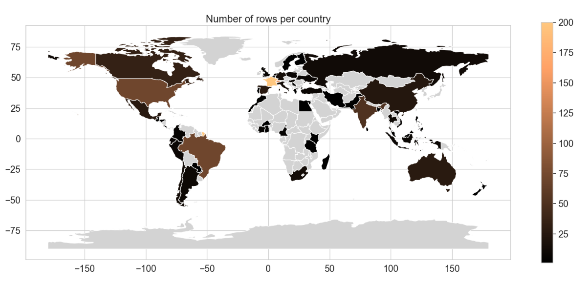

S4 - Assigning categorical variables
The climate footprint of most crop production activities within our dataset is influenced by land use change emissions. These land use change emissions are calculated through formulas based on geographical information about the crop as well as whether it is perennial or annual. Therefore, we included two categorical predictors in our work to account for this.
For geoclimatic information, we included the Köppen-Geiger class (i.e. tropical, arid, temperate, continental and polar) corresponding to the country of origin for each crop production activity (Beck et al., 2018). In cases where a country spans more than a single climate class, we took the class covering more than 50% of the country as representative.

S5 – Description of Predictor Groups

Predictor Theme | Predictor | Unit | Number of activities with this predictor as input | Description | Inputs to crop production that were grouped within this predictor group
Energy | Electricity | kWh | 379 | electricity used to run greenhouses and supporting activities in other productions | electricity, low voltage  electricity, medium voltage
 | Fuel | MJ | 872 | diesel fuel burned in agricultural machinery | diesel, burned in agricultural machinery  diesel low-sulfur  diesel, burned in water pump  kerosene, burned in airplane  fatty acid methyl ester  petrol, unleaded, burned in machinery  petrol, low-sulfur  petrol, two-stroke blend
 | Heat | MJ | 75 | heat used in greenhouses | heat, central or small-scale, natural gas  heat, central or small-scale, other than natural gas  heat, district or industrial, other than natural gas  logs, softwood, burned in furnace of greenhouse  natural gas, burned in furnace of greenhouse
Fertilisers & Soil Ammendment | Potassium fertilisers | Kg active ingredient ( K₂O) | 754 | Potassium rich fertilisers such as potassium chloride, potassium sulfite, vinasse, etc, measured in kilograms | average mineral fertiliser, as K₂O  excretion during grazing, as K₂O  inorganic potassium fertiliser, as K₂O  mineral fertiliser, as K₂O  NPK (15-15-15) as K₂O  potassium chloride, as K₂O  potassium nitrate, as K₂O  potassium sulfate, as K₂O  vinasse, from fermentation of sugar beet, as K₂O  vinasse, from fermentation of sugarcane, as K₂O
 | Nitrogen fertilisers | kg active ingredient (N) | 813 | nitrogen rich fertilisers such as urea, ammonia, ammonium nitrate, calcium nitrate, etc, measured in kilograms | ammonia (with 100% NH3), production mix  ammonia (with 100% NH3), steam reforming process  ammonia, anhydrous, liquid  ammonium nitrate (AN), as N  ammonium nitrate phosphate (ANP), as N  ammonium sulfate  average mineral fertiliser, as N  calcium ammonium nitrate (CAN), as N  calcium nitrate  diammonium phosphate (DAP), as N  excretion during grazing, as N  inorganic nitrogen fertiliser, as N  monoammonium phosphate (MAP), as N  organic nitrogen fertiliser, as N  organic manure mix, as N  organic or farm manure, as N  rendered animal by-products, as fertiliser  urea  urea ammonium nitrate mix
 | Phosphorus fertilisers | kg active ingredient (P₂O₅) | 809 | Phosphorus rich fertilisers such as superphosphates, P2O5, filter cake, etc, measured in kilograms | Ammonium nitrate phosphate (ANP), as P₂O₅  diammonium phosphate (DAP), as P₂O₅  filter cake, from sugarcane juice filtration, as P₂O₅  inorganic phosphorus fertiliser, as P₂O₅  mineral fertiliser, as P₂O₅  monoammonium phosphate, as P₂O₅  organic phosphorus fertiliser, as P₂O₅  phosphate rock, beneficiated, as P₂O₅  single superphosphate, as P₂O₅  triple superphosphate, as P₂O₅
 | Manure | kg manure | 226 | manure used for fertilization, measured in kilograms | green manure, Swiss integrated production, until April  green manure, Swiss integrated production, until February  green manure, Swiss integrated production, until January  green manure, Swiss integrated production, until March  green manure, organic, until April  green manure, organic, until February  green manure, organic, until January  green manure, organic, until March  manure, liquid, cattle  manure, liquid, swine  manure, solid, cattle  poultry manure, dried  poultry manure, fresh
 | soil_improvement | kg soil conditioner | 336 | materials used to correct soil pH and condition soil, such as lime, gypsum, dolomite | ash, from combustion of bagasse from sugarcane  calcium carbonate, precipitated  calcium chloride  calcium nitrate  compost  dolomite  expanded perlite  gypsum, mineral  lime  organic amendment, granulate  peat  peat moss  quicklime, milled, loose  sludge, limed
 | micronutrients | kg micronutrient | 262 | materials that supply micronutirents (Fe, Mo, Ni, Zn, Cu, …) to the crop such as calcium borates, zinc, manganese sulfate, etc - measured in kilograms | boron trifluoride  calcium borates  cobalt  copper  copper oxide  copper sulfate  iron sulfate  magnesium  magnesium oxide  magnesium sulfate  manganese concentrate  manganese sulfate  manganese(III) oxide  molybdenum  molybdenum trioxide  nickel, class 1  portafer  stone meal  sulfite  sulfur  zinc  zinc monosulfate  zinc oxide  zinc sulfide
 | stimulant_kg | kg stimulant | 18 | Materials that enhance growth, such as biostimulants, growth regulators | fodder yeast  algae  carbon dioxide, liquid
Plant Protection | Plant protection material | Kg active ingredient | 714 | pesticide, herbicide, fungicides and other materials used for protecting the crops and plants, measured in kilogram | 2,4-dichlorophenol[sulfonyl]  urea-compound[thio]carbamate-compound  acetamide-anillide-compound  aclonifen  alkylbenzene, linear  anthranilic acid  atrazine  benzimidazole-compound  benzo[thia]diazole-compound  benzoic-compound  bipyridylium-compound  borax, anhydrous, powder  boric acid, anhydrous, powder  captan  chemical, organic  chlorine dioxide  chlorothalonil  cyclic N-compound  diazine-compound  diazole-compound  dimethenamide  dinitroaniline-compound  diphenylether-compound  dithiocarbamate-compound  fosetyl-Al  fungicide  glyphosate  herbicide  insecticide  isoproturon  kaolin  mancozeb  metaldehyde  metamitron  metolachlor  naphtha  nitrile-compound  paraffin  pendimethalin  pesticide  phenol  phenoxy-compound  phthalimide-compound  propylene glycol, liquid  pyrethroid-compound  pyridazine-compound  sodium borates  triazine-compound, unspecified  trichloromethane
Water Use | irrigation | m3 | 517 | water used for irrigation | irrigation
 | tap_water | kg | 12 | water used for dilution of pesticide | tap water
Yield | yield | kg/ha | 896 | yield of each crop calculated based on land occupation (for permanent crops) and land transformation (for annual crops) flows | yield

S6 – Hyperparameters tuned in Grid search

Model | Parameter | Parameter Values
RF | n_stimators | 50, 60, 70, …, 1500
RF | criterion | squared_error, absolute_error, friedman_mse, poisson
RF | min_sample_leaf | 1, 2, 3, …, 10
RF | max_features | 0.2, 0.25, 0.30, …, 1
RF | max_samples | 0.5, 0.6, 0.7, .., 1
KNN | n_neighbors | 3,4,5,…, 100
KNN | leaf_size | 10, 11, 12, …, 50
KNN | p | 1, 1.1, 1.2, …, 5
 | Weights | Uniform, distance
GLM | alpha | 0, 0.01, 0.02, …, 10.00
ANN | hidden_layer_size | (5, 6, …, 100), (0, 5, 6, 7, …, 75), (0, 5, 6, 7, …, 50)
 | solver | Adam, sgd
 | activation | Identity, logistic, tanh, relu
 | Learning_rate | Constant, invscaling, adaptive
 | alpha | 0.0001, 0.0002, …, 0.1000
GBM | Learning_rate | 0.1, 0.15, 0.2, …., 1
 | Loss | absolute_error, squared_error
 | Max_features | 0.5, 0.6, …, 1
 | Min_samples_leaf | 5, 6, …., 25
 | Max_leaf_nodes | 20, 21, …., 40
 | L2_regularization | 0,0.1, 0.2, …, 0.5

S7.1 - Hyperparameters of optimized modelling techniques per impact indicator to be predicted (Hierarchist perspective)
- Biodiversity footprint
- Water footprint

- GHG footprint

S7.2 - Hyperparameters of optimized modelling techniques per impact indicator to be predicted (Egaletarian perspective)
- Biodiversity footprint
- Water footprint

- GHG footprint

S7.3 - Hyperparameters of optimized modelling techniques per impact indicator to be predicted (Individualist perspective)
- Biodiversity footprint
- Water footprint

- GHG footprint

S8 – Effect of number of predictors used on performance across modelling techniques for the Egaletarian perspective (vertical dashed lines indicate most parsimonious model for each footprint)

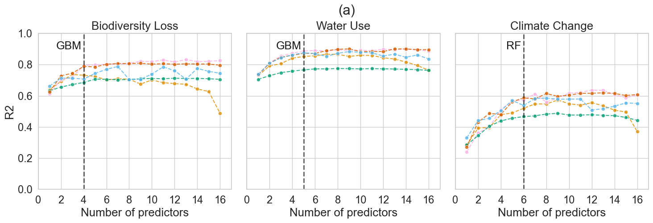
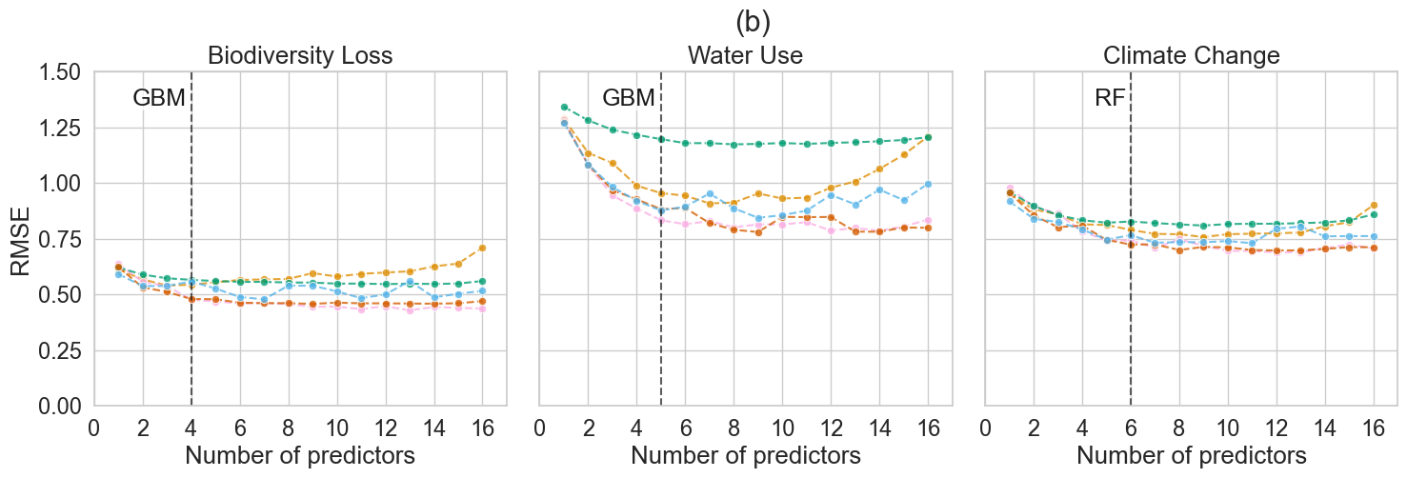

S9 – Effect of number of predictors used on performance across modelling techniques for the Individualist perspective (vertical dashed lines indicate most parsimonious model for each footprint)
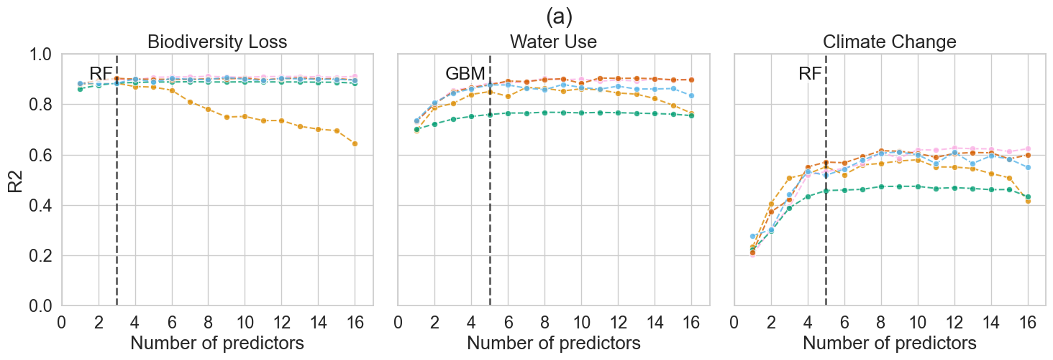
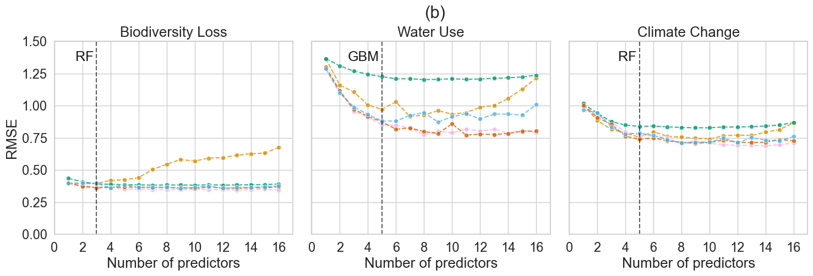

S10 – Predictor importance for most parsimonious model for the prediction of biodiversity, water and climate footprints, for the Egalitarian perspective
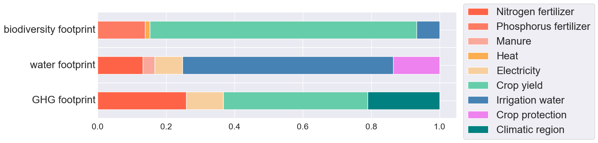

S11 – Predictor importance for most parsimonious model for the prediction of biodiversity, water and climate, for the Individualist perspective

S12 – Model predictive performance for the (a) biodiversity, (b) water and (c) climate footprints of crop production quantified based on the Hierarchist perspective and using only categorical, or categorical + yield predictors. Predictive performance is expressed as R2 and RMSE in natural-log space.

- Biodiversity footprint
 | ANN |  | GBM |  | GLM |  | KNN |  | RF
Predictors / Metrics | R2 | RMSE | R2 | RMSE | R2 | RMSE | R2 | RMSE | R2 | RMSE
Categorical only | -0.69 | 1.33 | -0.23 | 4.46 | -0.33 | 1.25 | -0.48 | 1.27 | -0.23 | 1.19
Categorical + yield | 0.84 | 0.43 | 0.81 | 0.46 | 0.81 | 0.47 | 0.77 | 0.51 | 0.77 | 0.5

- Water footprint
 | ANN |  | GBM |  | GLM |  | KNN |  | RF
Predictors / Metrics | R2 | RMSE | R2 | RMSE | R2 | RMSE | R2 | RMSE | R2 | RMSE
Categorical only | 0 | 2.50 | 0 | 2.52 | 0.02 | 2.47 | -0.24 | 2.76 | 0 | 2.51
Categorical + yield | 0.01 | 2.48 | -0.45 | 3.00 | 0.05 | 2.45 | -0.26 | 2.80 | -0.29 | 2.84

- Climate footprint
 | ANN |  | GBM |  | GLM |  | KNN |  | RF
Predictors / Metrics | R2 | RMSE | R2 | RMSE | R2 | RMSE | R2 | RMSE | R2 | RMSE
Categorical only | -0.23 | 1.22 | -0.18 | 1.21 | -0.22 | 1.24 | -0.72 | 1.36 | -0.18 | 1.2
Categorical + yield | 0.29 | 0.91 | 0.23 | 0.94 | 0.33 | 0.89 | 0.12 | 0.99 | 0.05 | 1.03

S13 - Categorical-only model inputs
crop | country | Climate region (Koppen Geiger) | prennial/annual (0/1) | count | crop | country | Climate region (Koppen Geiger) | prennial/annual (0/1) | count
grass | FR | C | 1 | 29 | rapeseed | CA | D | 1 | 1
wheat grain | FR | C | 1 | 28 | rapeseed | CN | C | 1 | 1
wine grape | FR | C | 0 | 24 | rapeseed | DE | C | 1 | 1
wheat grain | CH | C | 1 | 20 | sugarcane | MX | B | 1 | 1
barley | FR | C | 1 | 19 | rapeseed | GB | C | 1 | 1
maize | US | C | 1 | 17 | rapeseed | MX | B | 1 | 1
hay | FR | C | 1 | 17 | rapeseed | PL | D | 1 | 1
maize | BR | A | 1 | 17 | rapeseed | SE | D | 1 | 1
tomato | FR | C | 1 | 13 | rapeseed | TR | C | 1 | 1
soybean | BR | A | 1 | 13 | rapeseed | US | C | 1 | 1
sugarcane | BR | A | 1 | 12 | raspberry | RS | C | 0 | 1
maize | CH | C | 1 | 12 | raspberry | RU | D | 0 | 1
carrot | FR | C | 1 | 11 | raspberry | US | C | 0 | 1
sunflower | FR | C | 1 | 11 | peanut | IN | A | 1 | 1
faba bean | FR | C | 1 | 11 | acai berry | BR | A | 0 | 1
maize | FR | C | 1 | 10 | peanut | BR | A | 1 | 1
chicory witloof | FR | C | 0 | 10 | cherry | TR | C | 0 | 1
cauliflower | FR | C | 1 | 9 | chilli | MX | B | 0 | 1
soybean | US | C | 1 | 9 | chilli | ES | C | 0 | 1
apple | FR | C | 0 | 9 | chicory root | NL | C | 0 | 1
sugarcane | IN | A | 1 | 8 | chicory root | BE | C | 0 | 1
potato | US | C | 1 | 8 | chickpea | RU | D | 1 | 1
barley | CH | C | 1 | 8 | chickpea | MX | B | 1 | 1
barley | AU | B | 1 | 8 | chickpea | FR | C | 1 | 1
protein pea | CH | C | 1 | 8 | cherry | US | C | 0 | 1
rye | CH | C | 1 | 8 | cherry | IT | C | 0 | 1
soybean | FR | C | 1 | 7 | carrot | CN | C | 1 | 1
potato | CH | C | 1 | 7 | cherry | FR | C | 0 | 1
rice | TH | A | 1 | 7 | cherry | CL | B | 0 | 1
wheat grain | AU | B | 1 | 7 | castor bean | IN | A | 1 | 1
sunflower | CH | C | 1 | 7 | cassava | BR | A | 1 | 1
alfalfa | FR | C | 1 | 7 | cashew | VN | A | 0 | 1
coffee arabica | BR | A | 0 | 7 | cashew | CI | A | 0 | 1
green pea | CH | C | 1 | 6 | carrot | NL | C | 1 | 1
faba bean | CH | C | 1 | 6 | carrot | IL | C | 1 | 1
rapeseed | FR | C | 1 | 6 | clementine | MA | B | 0 | 1
triticale | CH | C | 1 | 6 | coconut | BR | A | 0 | 1
oat | AU | B | 1 | 6 | coconut | ID | A | 0 | 1
sugar beet | FR | C | 1 | 6 | coconut | IN | A | 0 | 1
oat | CH | C | 1 | 6 | durum wheat grain | AU | B | 1 | 1
table grape | CH | C | 0 | 6 | dry pea | CA | D | 1 | 1
spelt | CH | C | 1 | 6 | cranberry | US | C | 0 | 1
potato | FR | C | 1 | 5 | cranberry | CL | B | 0 | 1
triticale | FR | C | 1 | 5 | cotton | MX | B | 1 | 1
pear | CH | C | 0 | 5 | coriander | IN | A | 1 | 1
cocoa | BR | A | 0 | 5 | coriander | BR | A | 1 | 1
strawberry | FR | C | 0 | 5 | coffee robusta | VN | A | 0 | 1
lupine | FR | C | 0 | 5 | coffee robusta | IN | A | 0 | 1
oat | FR | C | 1 | 5 | coffee robusta | ID | A | 0 | 1
apple | CH | C | 0 | 5 | coffee arabica | TZ | A | 0 | 1
leek | FR | C | 1 | 4 | coffee arabica | MX | B | 0 | 1
maize | CA | D | 1 | 4 | coffee arabica | IN | A | 0 | 1
dry pea | FR | C | 1 | 4 | coffee arabica | HN | A | 0 | 1
cocoa | EC | A | 0 | 4 | coffee arabica | GT | A | 0 | 1
cocoa | CM | A | 0 | 4 | coffee arabica | CO | A | 0 | 1
cocoa | ID | A | 0 | 4 | coconut | PH | A | 0 | 1
soybean | CH | C | 1 | 4 | carrot | ES | C | 1 | 1
cocoa | CI | A | 0 | 4 | blueberry | US | C | 0 | 1
melon | FR | C | 1 | 4 | durum wheat grain | ES | C | 1 | 1
grass | CH | C | 1 | 4 | apricot | ES | C | 0 | 1
walnut | FR | C | 0 | 4 | avocado | CL | B | 0 | 1
palm fruit bunch | MY | A | 0 | 3 | aubergine | IN | A | 1 | 1
squash | FR | C | 1 | 3 | asparagus | PE | A | 1 | 1
grapefruit | US | C | 0 | 3 | asparagus | FR | C | 1 | 1
rice | IN | A | 1 | 3 | asparagus | CN | C | 1 | 1
sorghum | FR | C | 1 | 3 | apricot | TR | C | 0 | 1
wheat grain | US | C | 1 | 3 | apricot | IT | C | 0 | 1
miscanthus | DE | C | 0 | 3 | apricot | FR | C | 0 | 1
lettuce | FR | C | 1 | 3 | apple | ZA | B | 0 | 1
wheat grain | GB | C | 1 | 3 | blueberry | ES | C | 0 | 1
wheat grain | CA | D | 1 | 3 | apple | US | C | 0 | 1
faba bean | CA | D | 1 | 3 | apple | RE | A | 0 | 1
barley | CA | D | 1 | 3 | apple | IT | C | 0 | 1
barley | DE | C | 1 | 3 | apple | CR | C | 0 | 1
onion | FR | C | 1 | 3 | apple | CN | C | 0 | 1
mango | BR | A | 0 | 3 | apple | CL | B | 0 | 1
maize | ZA | B | 1 | 3 | aloe vera | MX | B | 0 | 1
protein pea | CA | D | 1 | 3 | almond | CN | C | 0 | 1
wheat grain | DE | C | 1 | 3 | avocado | MX | B | 0 | 1
cocoa | GH | A | 0 | 3 | avocado | US | C | 0 | 1
maize | AU | B | 1 | 3 | banana | CO | A | 0 | 1
faba bean | ES | C | 1 | 2 | banana | CR | C | 0 | 1
sorghum | US | C | 1 | 2 | blueberry | CA | D | 0 | 1
rice | US | C | 1 | 2 | blackberry | RS | C | 0 | 1
soybean | IN | A | 1 | 2 | blackberry | MX | B | 0 | 1
zucchini | CH | C | 1 | 2 | bell pepper | VN | A | 0 | 1
faba bean | MX | B | 1 | 2 | beet root | NL | C | 1 | 1
oat | CA | D | 1 | 2 | beet root | MX | B | 1 | 1
peach | FR | C | 0 | 2 | beet root | IT | C | 1 | 1
palm fruit bunch | ID | A | 0 | 2 | beet root | FR | C | 1 | 1
orange | ZA | B | 0 | 2 | beet root | ES | C | 1 | 1
orange | US | C | 0 | 2 | bean | FR | C | 1 | 1
pear | FR | C | 0 | 2 | bean | CN | C | 1 | 1
pinto bean | CA | D | 1 | 2 | barley | ES | C | 1 | 1
onion | IN | A | 1 | 2 | barley | AR | B | 1 | 1
onion | CH | C | 1 | 2 | banana | WI | A | 0 | 1
pomegranate | PE | A | 0 | 2 | banana | MX | B | 0 | 1
navy bean | CA | D | 1 | 2 | banana | IN | A | 0 | 1
faba bean | US | C | 1 | 2 | banana | EC | A | 0 | 1
maize | UA | D | 1 | 2 | durum wheat grain | CA | D | 1 | 1
maize | MX | B | 1 | 2 | durum wheat grain | FR | C | 1 | 1
maize | HU | C | 1 | 2 | peanut | AR | B | 1 | 1
maize | ES | C | 1 | 2 | mango | PE | A | 0 | 1
maize | AR | B | 1 | 2 | oat | BE | C | 1 | 1
lentil | CA | D | 1 | 2 | oat | AR | B | 1 | 1
quinoa | PE | A | 1 | 2 | mustard | IN | A | 1 | 1
green pea | FR | C | 1 | 2 | agave | MX | B | 0 | 1
red kidney bean | CA | D | 1 | 2 | mint | US | C | 0 | 1
maize | CN | C | 1 | 2 | mint | IN | A | 0 | 1
silage maize | FR | C | 1 | 2 | millet | IN | A | 1 | 1
barley | GB | C | 1 | 2 | mango | TH | A | 0 | 1
broccoli | CH | C | 1 | 2 | mango | MX | B | 0 | 1
chicory root | FR | C | 0 | 2 | maize | PE | A | 1 | 1
barley | RU | D | 1 | 2 | mango | IN | A | 0 | 1
barley | PL | D | 1 | 2 | mango | ES | C | 0 | 1
barley | UA | D | 1 | 2 | mango | CI | A | 0 | 1
wheat grain | HU | C | 1 | 2 | mandarin | ZA | B | 0 | 1
chilli | IN | A | 0 | 2 | mandarin | ES | C | 0 | 1
chickpea | IN | A | 1 | 2 | mandarin | CN | C | 0 | 1
sugar beet | CH | C | 1 | 2 | maize | TR | C | 1 | 1
wheat grain | AR | B | 1 | 2 | maize | TH | A | 1 | 1
bean | CH | C | 1 | 2 | oat | BR | A | 1 | 1
sunflower | UA | D | 1 | 2 | oat | DE | C | 1 | 1
wheat grain | RU | D | 1 | 2 | oat | FI | D | 1 | 1
carrot | CH | C | 1 | 2 | oat | RU | D | 1 | 1
strawberry | CH | C | 0 | 2 | peach | US | C | 0 | 1
white asparagus | CH | C | 1 | 2 | peach | IT | C | 0 | 1
white asparagus | IN | A | 1 | 2 | peach | ES | C | 0 | 1
bell pepper | IN | A | 0 | 2 | peach | CN | C | 0 | 1
tomato | IN | A | 1 | 2 | passion fruit | BR | A | 0 | 1
spinach | CH | C | 1 | 2 | parsley, fresh | US | C | 1 | 1
barley | IT | C | 1 | 2 | orange | ES | C | 0 | 1
coffee robusta | BR | A | 0 | 2 | orange | BR | A | 0 | 1
cauliflower | CH | C | 1 | 2 | onion | US | C | 1 | 1
cashew | IN | A | 0 | 2 | onion | NZ | C | 1 | 1
potato | IN | A | 1 | 1 | onion | NL | C | 1 | 1
potato | ES | C | 1 | 1 | onion | MX | B | 1 | 1
potato | EC | A | 1 | 1 | onion | ES | C | 1 | 1
potato | DE | C | 1 | 1 | onion | CN | C | 1 | 1
potato | CO | A | 1 | 1 | onion | CL | B | 1 | 1
potato | GT | A | 1 | 1 | olive | IT | C | 0 | 1
spelt | FR | C | 1 | 1 | olive | ES | C | 0 | 1
potato | MX | B | 1 | 1 | maize | PL | D | 1 | 1
potato | NL | C | 1 | 1 | maize | IN | A | 1 | 1
potato | PE | A | 1 | 1 | durum wheat grain | GR | C | 1 | 1
potato | CN | C | 1 | 1 | faba bean | MA | B | 1 | 1
potato | RU | D | 1 | 1 | green pea | MX | B | 1 | 1
potato | UA | D | 1 | 1 | green pea | DE | C | 1 | 1
tomato | NL | C | 1 | 1 | ginger | CN | C | 0 | 1
tomato | MX | B | 1 | 1 | garlic | US | C | 0 | 1
potato | VN | A | 1 | 1 | fodder beet | CH | C | 1 | 1
potato | ZA | B | 1 | 1 | flaxseed | FR | C | 0 | 1
tomato | ES | C | 1 | 1 | flax | IN | A | 1 | 1
tea | LK | A | 0 | 1 | faba bean | PT | C | 1 | 1
potato | PK | B | 1 | 1 | faba bean | IT | C | 1 | 1
walnut | US | C | 0 | 1 | maize | EG | B | 1 | 1
potato | CL | B | 1 | 1 | faba bean | IN | A | 1 | 1
vanilla | MG | A | 0 | 1 | faba bean | GR | C | 1 | 1
peanut | MX | B | 1 | 1 | faba bean | CN | C | 1 | 1
peanut | US | C | 1 | 1 | faba bean | CL | B | 1 | 1
wine grape | US | C | 0 | 1 | faba bean | AU | B | 1 | 1
pear | AR | B | 0 | 1 | elderberry | PL | D | 0 | 1
pear | BE | C | 0 | 1 | durum wheat grain | US | C | 1 | 1
wine grape | IT | C | 0 | 1 | durum wheat grain | IT | C | 1 | 1
pear | CL | B | 0 | 1 | green pea | RU | D | 1 | 1
wine grape | ES | C | 0 | 1 | guava | BR | A | 0 | 1
wheat grain | ZA | B | 1 | 1 | hazelnut | IT | C | 0 | 1
pear | CN | C | 0 | 1 | hazelnut | TR | C | 0 | 1
pear | US | C | 0 | 1 | maize | EC | A | 1 | 1
pear | ZA | B | 0 | 1 | maize | CO | A | 1 | 1
phacelia | CH | C | 1 | 1 | maize | CL | B | 1 | 1
wheat grain | PL | D | 1 | 1 | macadamia nut | ZA | B | 0 | 1
wheat grain | IN | A | 1 | 1 | linseed | RU | D | 1 | 1
pistachio | IR | B | 0 | 1 | linseed | CA | D | 1 | 1
pistachio | US | C | 0 | 1 | lemon | TR | C | 0 | 1
pomegranate | IN | A | 0 | 1 | lemon | MX | B | 0 | 1
wheat grain | ES | C | 1 | 1 | lemon | ES | C | 0 | 1
wheat grain | CN | C | 1 | 1 | kiwi | FR | C | 0 | 1
pomegranate | TR | C | 0 | 1 | kiwi | CL | B | 0 | 1
potato | AR | B | 1 | 1 | kenaf | IN | A | 1 | 1
wheat grain | BR | A | 1 | 1 | jute | IN | A | 1 | 1
potato | BE | C | 1 | 1 | jute | BD | C | 1 | 1
potato | BR | A | 1 | 1 | hibiscus | MX | B | 0 | 1
potato | CA | D | 1 | 1 | hemp | FR | C | 1 | 1
walnut | CL | B | 0 | 1 | hazelnut | US | C | 0 | 1
tea | KE | B | 0 | 1 | mulberry | IN | A | 0 | 1
table grape | CL | B | 0 | 1 | soybean | AR | B | 1 | 1
tea | CN | C | 0 | 1 | stevia | PY | A | 0 | 1
shea fruit | BF | A | 0 | 1 | soybean | CA | D | 1 | 1
sugar beet | RU | D | 1 | 1 | stevia | IT | C | 0 | 1
rice | BR | A | 1 | 1 | soybean | CN | C | 1 | 1
rice | CL | B | 1 | 1 | stevia | IN | A | 0 | 1
rice | CN | C | 1 | 1 | stevia | CN | C | 0 | 1
sugar beet | ES | C | 1 | 1 | soybean | IT | C | 1 | 1
rice | IT | C | 1 | 1 | spinach | US | C | 1 | 1
rice | MX | B | 1 | 1 | sugar beet | US | C | 1 | 1
sugar beet | DE | C | 1 | 1 | sugarcane | CN | C | 1 | 1
rice | PK | B | 1 | 1 | table grape | IN | A | 0 | 1
sugar beet | CN | C | 1 | 1 | quinoa | FR | C | 1 | 1
rooibos | ZA | B | 0 | 1 | protein pea | DE | C | 1 | 1
sugar beet | CA | D | 1 | 1 | protein pea | ES | C | 1 | 1
strawberry | PL | D | 0 | 1 | protein pea | FR | C | 1 | 1
strawberry | MA | B | 0 | 1 | pumpkin | ES | C | 1 | 1
sugarcane | AU | B | 1 | 1 | sweet potato | ZA | B | 1 | 1
strawberry | ES | C | 0 | 1 | sunnhemp | IN | A | 1 | 1
peanut | CN | C | 1 | 1 | pumpkin | MX | B | 1 | 1
sorghum | CN | C | 1 | 1 | sunflower | RU | D | 1 | 1
stevia | US | C | 0 | 1 | pumpkin | NL | C | 1 | 1
sunflower | HU | C | 1 | 1 | pumpkin | TR | C | 1 | 1
sunflower | ES | C | 1 | 1 | sugarcane | TH | A | 1 | 1
pumpkin | US | C | 1 | 1 | sugarcane | CO | A | 1 | 1

References
Beck, H.E., Zimmermann, N.E., McVicar, T.R., Vergopolan, N., Berg, A. and Wood, E.F., 2018. Present and future Köppen-Geiger climate classification maps at 1-km resolution. Scientific data, 5(1), pp.1-12.

