SUPPORTING INFORMATION FOR:

Miguel L. H. Hernández, Francis I. Barre, Nils M. Dittrich, Thomas Galea, Marceau Cormery, Avijit Pandit, Romain G. Billy, Anna E. Lunde, Anne F. Øgaard, Daniel B. Müller. Multi-scale analysis of the agricultural phosphorus cycle in Norway to inform farm, regional, and national resource efficiency strategies. Journal of Industrial Ecology.
This supporting information provides additional information on (i) the main sources for production statistics, (ii) details on the model development, particularly the animal and farm module, and the design of manure utilization strategies, (iii) the individual farm Sankey diagrams presented in the manuscript, and (iv) maps of manure surplus/deficit at county level.

Contents
Production statistics 1
Modelling of the P cycle in Norwegian agriculture 2
The Animal 2
The Farm 5
Status Quo and National Strategies for circular use of P 6
Sankey diagrams 8
P distribution in Norwegian Agriculture at county level 8
Bibliography 9

Production statistics

Production statistics at farm level that were considered in the agricultural model were retrieved from https://data.norge.no/, from the datasets cited below.

- Leveranser til eggpakkeri i landbruket i 20XX, featuring for each year a list of farms that delivered eggs to the egg packaging industry. Each farm has an associated organization number, name, municipality number and total quantity of eggs sold in kg.
- Leveranser til kornkjøper eller såvareforretning i landbruket i kornåret juli 20XX til juni 20YY, featuring for each year a list of farms that delivered cereals, oilseeds and peas to different food processors. Each farm has an associated organization number, name, municipality number as well as, for each crop product, the quantity in kg sold to animal feed producers (_for_kg), human food processers (_mat_kg) and seed industry (_saakorn_kg). For simplicity reasons, the reported production from July [year n] to June [year n+1] was attributed to the modelling year n.
- Leveranser til meieri i landbruket i 20XX, featuring for each year a list of farms that delivered milk to the dairy industry. Each farm has an associated organization number, name, municipality number and total quantity of cow- and goat milk sold in L.
- Produksjons- og avløsertilskudd til jordbruksforetak - Søknadsomgang 20XX, featuring for each year a list of all Norwegian farms that applied for agricultural subsidies. Each farm has an associated organization number, name, municipality number, farm number (gaardsnummer), user number (bruksnummer), as well as a list of variables including crops areas and number of animals of different categories among others.

Modelling of the P cycle in Norwegian agriculture

The model for the Phosphorus cycle in Norwegian Agriculture is built upon 3 main parts, the Animal, the Farm, and the National Strategies. Each section of the model builds on the previous one to calculate P flows at a higher level.

The Animal

We model all phosphorus flows directly related to husbandry with a dynamic Substance Flow Analysis (SFA) model. The system of the model is shown in Figure 1; we account for phosphorus-containing flows only, thereby excluding respiration. The system can therefore only be balanced at the phosphorus layer, while the wet weight and dry matter layers miss water and carbon flows, among others.
concentrate
roughage + grazed grass
milk
slaughter products
manure
calves
Dairy cow
mass of cow

Figure 1: System for phosphorous flows of an animal (here a dairy cow). We use the animal as a balancing volume, with inflows from feed and outflows of milk, embryos (eggs or babies), and manure. The animal's growth can be seen as a positive stock change if looking at parts of the lifetime or as an outflow if seen over the entire lifecycle.
The phosphorus flows related to any animal vary significantly based on its feed, sex, reproductive cycle, age, and size. We therefore track the weight and growth, lactation, gestation, type and share of feed, and total feed demand throughout the entire lifetime of each animal. Based on this information, the growth, lactation, embryo growth, and milk flows get quantified at the wet weight layer each day and subsequently converted to dry matter and phosphorus values. The feed demand depends, among others, on these flows, and is calculated in feed units or mass and split into different types of feed. The values are then converted from feed units or wet weight mass to dry matter and phosphorus. We finally use the excrement of the animal as the balancing flow at the phosphorus layer.

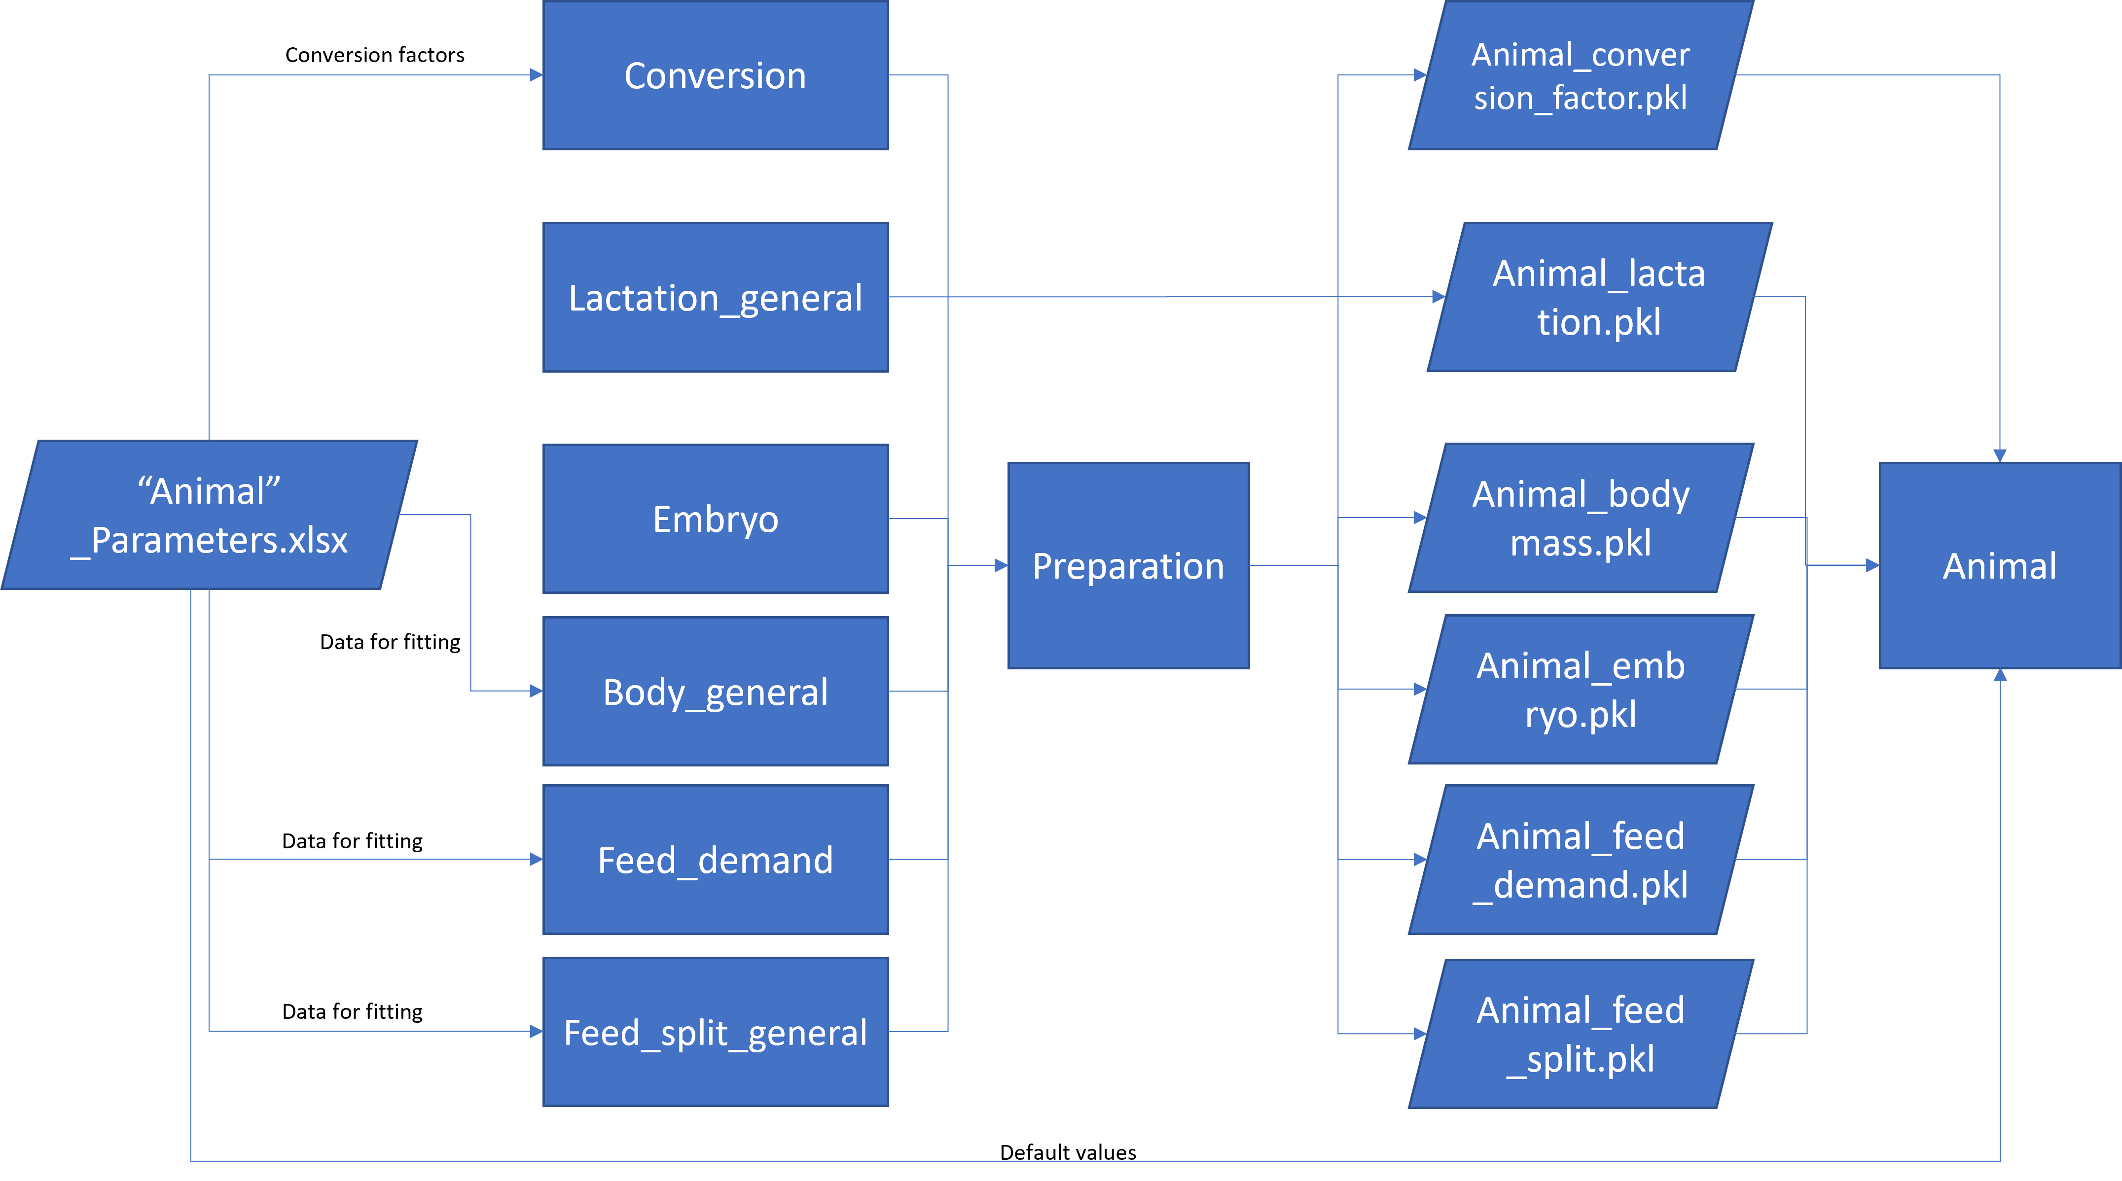
Figure 2: Schematic representation of the implementation of the animal model, from data on the left, via functions that prepare type specific data, and store it in Python binary files (pickles), to the instance of the animal class on the right.
This modeling process requires a lot of data on the traits of an animal. To make this feasible, the implementation of the model relies on animal typologies (e.g., dairy cows, non-dairy cows, horses, goats), for which representative data is gathered. The main data sources can be found in the Supplementary Information document “supporting_information_2.xlsx”. Usually, this data is not available on a day-by-day basis, so curves are fitted to match the temporal resolution of all traits. The type-based traits can then be adapted to the details of the individual animal, for example, by rescaling the body mass curves to match the actual final weight of a given animal or increasing the lactation period of a cow. A schematic representation of the technical model with the preparation of curves (or class instances for the feed split and feed demand) is shown in Figure 2; the full documentation of the code base in Python can be found on the Zenodo repository (https://doi.org/10.5281/zenodo.17853620).

The Farm

The Farm’s purpose is to translate the statistics from the Norwegian Agriculture Agency into Phosphorus flows at farm level. The Farm contains both an Animal Farm, which contains different Animal entities based on the statistics’ numbers, and a Plant Farm, which directly translates the crop areas, as well as the reported exports, into annual P flows.

Production statistics

Statistic reading
Plant parameters

The Animal

Farm animal
Farm
Animal
quantifier
Aggregation
Flow accounting
Farm plant
Animals

Figure 3: The model layout for The Farm. Square boxes refer to functions whereas the parallelograms refer to data sources. The Animal box refers to the whole animal model, as described in the previous section.
The Farm first reads the farm statistics from the Norwegian Agriculture Agency, which reports, for each farm in Norway, numbers for each type of animal, distinguishing age and sex (bull, dairy cow, slaughter pig, piglets…). The statistics also report food exports and crop area. The Farm is divided into two sub entities.

The Animal Farm is made of a succession of functions that calculate P flows in the meat and dairy production:

- Animal quantifier counts the number of every animal type in the farm. We distinguish between animal classes, corresponding to individual animals, and animal types, which correspond to an animal class for a certain age. For example, we have the animal class goat dairy female, which is divided into 2 animal types, young goat dairy female from day 0 to day 548 and adult goat dairy female, from day 548 to end of life. The animal quantifier breaks down the statistics codes and gives the correct amounts of animal types.
- Aggregation then runs a farm specific animal for each animal class that is present in the farm. This animal is farm specific in the sense that it is tailored to the reported numbers in the farm, ie milk production, egg production, number of children per adult… Then for each animal type, typical flows are calculated by averaging the animal class flows over the appropriate time (flows for the animal type piglet are the average of the daily flows from the animal class pig slaughter, from day 0 to day 58). Then the total animal flows in the farm are aggregated by multiplying the number of each animal type by the P flows for that type.
- Flow accounting then reorganizes the animal flows to keep relevant flows for the farm (and higher) level.
- Farm animal organizes all the previous functions, also distinguishing between flows which happen in the farm area, and flows that happen during grazing. It calculates the number of children per adult, the amount of milk per cow and eggs per hen which are given to the aggregation function as a parameter for running the animals.

The Plant Farm then directly calculates Phosphorus embodied in plant flows. For a given farm, the production of each type of food is calculated. To do so, the model prioritizes reported export over crop area.
- If exports are reported, then the flows of cereals used for seeds, animal feed and human food are directly calculated using the P content in the exports.
- If exports are not reported, the total production is calculated from the crop area, and the share for seeds, animal feed and human food are calculated using the default share (share at national level).

For grass production, the situation is slightly different as roughage is eaten by the animals present on the farm. 4 different situations are possible:
- The farm has cultivated meadows but no roughage consumption: production is equal to reported exports, imports are 0.
- The farm has no cultivated meadows but roughage consumption: production is 0 and imports are equal to roughage consumption.
- The farm has cultivated meadows, exports of roughage and roughage consumption. Production is calculated from cultivated meadow area and yield; imports are equal to consumption plus exports minus production (can’t be negative). Exports are adjusted for mass balance.
- The farm has cultivated meadows and roughage consumption but no exports. Imports are consumption minus production, exports production minus consumption (only one is non null).

Status Quo and National Strategies for circular use of P

The national strategies relate to different theoretical strategies for managing manure and P imports. They inform on policies to promote for enabling circular use of P in Norwegian agriculture. To build these different strategies, the model takes the following steps:
- Optimal Farm: First, each farm is individually optimized, prioritizing available manure over imported P (from mineral sources). Based on the P needs for the different crops, manure is used for P fertilization and completed with imported P when not enough manure P is available. This gives us our first strategy (the optimal farm strategy).
- Adjust manure: To model the realistic current situation (Status Quo), the imported mineral P in the optimal farm strategy must be adjusted and is compared to the reported values in each Norwegian region in the statistics. From there, a mineral P overutilization coefficient is calculated for each region r:
$ΔP_{r}=P_{reported, r}-P_{OF,r}$
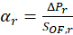$α_{r}=\frac{ΔP_{r}}{S_{OF,r}}$
Where P is the phosphorus in mineral fertilizer and S the phosphorus in Manure, OF refers to the optimal farm strategy calculated in the previous stage.
Similar coefficients are calculated for sludge and biowaste used in fertilization and reported at municipality level in Norwegian Statistics. For municipality m:
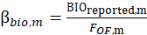$β_{bio,m}=\frac{{\text{BIO}}_{reported,m}}{F_{OF,m}}$
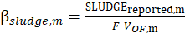$β_{sludge,m}=\frac{{\text{SLUDGE}}_{reported,m}}{{F_V}_{OF,m}}$
Where F is the total fertilization demand from crops (grass + grain + vegetables) and F_V the total fertilization demand excluding vegetables.
The mineral fertilizer, sludge and biowaste uses are then adjusted at farm level using the alpha coefficients. For a given farm f, located in region r:
$P_{SQ,f}=P_{OF,f}+α_{r}⋅S_{OF,f}$
Where SQ refers to status quo strategy (our modelling of the current situation). The assumption is that farms using manure are the ones using more mineral P fertilizer than in the optimal farm strategy because of the barriers to using manure efficiently for crop fertilization (seasonal, technical, NP ratio…). Biowaste and sludge waste use are also calculated at farm level, proportional to total fertilization demand, with and without vegetables. This is because the use of sludge is forbidden on vegetable crops (Forskrift om lagring og bruk av gjødsel mv., 2025). Finally, manure use is adjusted:
$S_{SQ,f}=\left(1-α_{r}\right)⋅S_{OF,f}+\left(1-β_{bio,m}\right)⋅F_{OF,m}+\left(1-β_{sludge,m}\right)⋅F_{OF,m}$
- Market Optimization aims at improving phosphorus utilization by enabling manure trade at municipality, regional and national level. First, we calculate how much manure is remaining at each level by comparing manure use in the Optimal Farm and the Status Quo scenarios. Then, we iterate over all farms in the country and distribute the remaining manure for each administrative level. It is important to note that, in that stage, the farms that receive the remaining manure are the first farms we iterate over in each region, rather than equally trading among all farms. This choice might lead to better optimizing manure use in some farms than others but has no influence on results at regional level.
In a second iteration, we adjust the remaining manure in each farm (not all manure is necessarily used.
- Organic fertilization strategies continue on the market optimization but also adjusting for the biowaste and sludge usage at farm level.

Ultimately, the system is quantified for the Status Quo and four National Strategies, with flows of P at farm level for each of them:
- Status Quo, representative of the current fertilization situation.
- Optimal Farm, where manure is prioritized over mineral fertilizer, without trade between farms.
- Kommune Market, which is Optimal Farm with manure trade at municipality level.
- Fylke Market, which is Optimal Farm with manure trade at regional level.
- NO Market, which is Optimal Farm with manure trade at national level.

Sankey diagrams

The Sankey diagrams at farm level are extracted from the five following farms:

Figure | Farm Type | Organization Number
2a | Mixed farm | 979651929
2b | Sheep farm | 912682838
2c | Pig farm | 997711114
2d | Milk-cow farm | 912888126
2e | Crop farm | 969386399

The P flows for these farms are presented in the Supplementary Data (Excel file).

P distribution in Norwegian Agriculture at county level

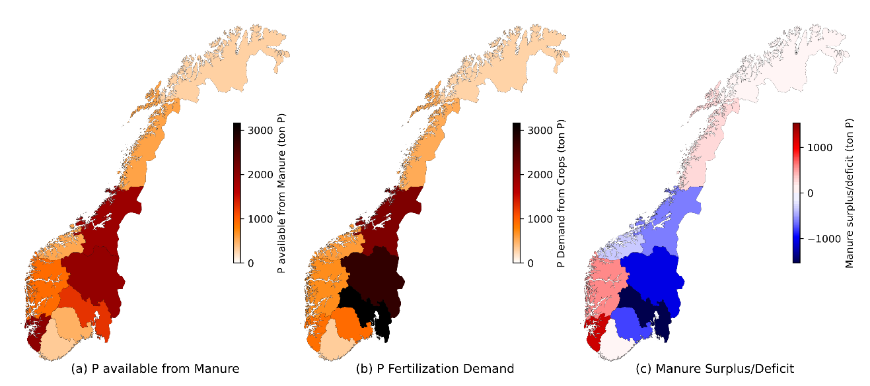

Bibliography

Forskrift om lagring og bruk av gjødsel mv., Pub. L. No. FOR-2025-01-29-115, FOR-2025-01-29-115 (2025). Endrer: FOR-2003-07-04-951 https://lovdata.no/dokument/SF/forskrift/2025-01-29-115

