Independence in activities of daily living for home-based geriatric rehabilitation after shortened inpatient rehabilitation:
The “Better@Home” multicentre prospective cohort study with a matched historical control group.

Acknowledgments:
This work was supported by ZonMw (The Netherlands Organisation for Health Research and Development), grant number 10020032210004. The funding source had no role in the design of the study; data collection, analysis, or interpretation; writing of the manuscript; or in the decision to submit the article for publication.

Authors:
C.J. Gamble MSc^{7,8}, M.Vaz MSc ^{1,2,4}, M.W.M. de Waal PhD^{5,6}, W.G. Groen PhD ^{1,2,4,9}, M.C. Pol PhD^{1,2,3,4}, E.F van Dam van Isselt MD PhD ^{5,6}, F. Innocenti PhD¹⁰, S.M.G Zwakhalen PhD^{7,8}, J.C.M. van Haastregt PhD^{7,8}

Corresponding author: Christopher James Gamble, c.gamble@maastrichtuniversity.nl
ORCID: 0000-0001-5103-134X

Affiliations:
¹ Department of Medicine for Older People, Amsterdam University Medical Center, Location Vrije Universiteit Amsterdam, Amsterdam, The Netherlands
² Amsterdam Public Health Research Institute, Ageing & Later Life, Amsterdam, The Netherlands
³ Amsterdam University of Applied Sciences, Research group occupational therapy: Technology and Participation, Faculty of Health, Centre of Expertise Urban Vitality, Amsterdam, The Netherlands
⁴ University Network of Organizations for Care for Older Adults, Amsterdam University Medical Center, Amsterdam, The Netherlands
⁵ University Network for the Care sector South-Holland, Leiden University Medical Center, Leiden, the Netherlands
⁶ Department of Public Health and Primary Care, Leiden University Medical Center, Leiden, the Netherlands
⁷ Department of Health Services Research, Faculty of Health Medicine and Life Sciences, CAPHRI Care and Public Health Research Institute, Maastricht University, Maastricht, the Netherlands
⁸ Limburg Living lab in Ageing and Long-term Care, Maastricht University, Maastricht, the Netherlands
⁹Amsterdam Movement Sciences, Ageing & Vitality, Rehabilitation & Development, Amsterdam, The Netherlands
¹⁰ Department of Methodology and Statistics, Faculty of Health Medicine and Life Sciences, CAPHRI Care and Public Health Research Institute, Maastricht University, Maastricht, the Netherlands
¹¹Department of Research GRZPLUS; Omring and Zorgcirkel, Hoorn, The Netherlands
¹²Stichting Valkenhof, Valkenswaard, The Netherlands
Appendix A – STROBE Statement checklist

 | Item No | Recommendation | Page No
Title and abstract | 1 | (a) Indicate the study’s design with a commonly used term in the title or the abstract | 1
Title and abstract | 1 | (b) Provide in the abstract an informative and balanced summary of what was done and what was found | 2
Introduction
Background/rationale | 2 | Explain the scientific background and rationale for the investigation being reported | 3
Objectives | 3 | State specific objectives, including any prespecified hypotheses | 3
Methods
Study design | 4 | Present key elements of study design early in the paper | 4
Setting | 5 | Describe the setting, locations, and relevant dates, including periods of recruitment, exposure, follow-up, and data collection | 4-6
Participants | 6 | (a) Give the eligibility criteria, and the sources and methods of selection of participants. Describe methods of follow-up | 4,5
Participants | 6 | (b) For matched studies, give matching criteria and number of exposed and unexposed
Variables | 7 | Clearly define all outcomes, exposures, predictors, potential confounders, and effect modifiers. Give diagnostic criteria, if applicable | 5,6
Data sources/ measurement | 8* | For each variable of interest, give sources of data and details of methods of assessment (measurement). Describe comparability of assessment methods if there is more than one group | 5,6
Bias | 9 | Describe any efforts to address potential sources of bias | 4,5
Study size | 10 | Explain how the study size was arrived at | 7
Quantitative variables | 11 | Explain how quantitative variables were handled in the analyses. If applicable, describe which groupings were chosen and why | 6,7
Statistical methods | 12 | (a) Describe all statistical methods, including those used to control for confounding | 6,7
Statistical methods | 12 | (b) Describe any methods used to examine subgroups and interactions
Statistical methods | 12 | (c) Explain how missing data were addressed
Statistical methods | 12 | (d) If applicable, explain how loss to follow-up was addressed
Statistical methods | 12 | (e) Describe any sensitivity analyses
Results
Participants | 13* | (a) Report numbers of individuals at each stage of study—eg numbers potentially eligible, examined for eligibility, confirmed eligible, included in the study, completing follow-up, and analysed | 7,8
Participants | 13* | (b) Give reasons for non-participation at each stage
Participants | 13* | (c) Consider use of a flow diagram
Descriptive data | 14* | (a) Give characteristics of study participants (eg demographic, clinical, social) and information on exposures and potential confounders | 7-9
Descriptive data | 14* | (b) Indicate number of participants with missing data for each variable of interest
Descriptive data | 14* | (c) Summarise follow-up time (eg, average and total amount)
Outcome data | 15* | Report numbers of outcome events or summary measures over time | 9-11

Main results | 16 | (a) Give unadjusted estimates and, if applicable, confounder-adjusted estimates and their precision (eg, 95% confidence interval). Make clear which confounders were adjusted for and why they were included | 9-11
Main results | 16 | (b) Report category boundaries when continuous variables were categorized
Main results | 16 | (c) If relevant, consider translating estimates of relative risk into absolute risk for a meaningful time period
Other analyses | 17 | Report other analyses done—eg analyses of subgroups and interactions, and sensitivity analyses | 9, Appendix C
Discussion
Key results | 18 | Summarise key results with reference to study objectives | 11
Limitations | 19 | Discuss limitations of the study, taking into account sources of potential bias or imprecision. Discuss both direction and magnitude of any potential bias | 12,13
Interpretation | 20 | Give a cautious overall interpretation of results considering objectives, limitations, multiplicity of analyses, results from similar studies, and other relevant evidence | 13
Generalisability | 21 | Discuss the generalisability (external validity) of the study results | 11,12
Other information
Funding | 22 | Give the source of funding and the role of the funders for the present study and, if applicable, for the original study on which the present article is based | -

Appendix B

Core components Better@Home program
1) Replacing part of inpatient GR by home-based GR
- Each GR facility strives to reduce the duration of the inpatient GR with an average of 5 to 7 days and to replace this by a period of home-based GR.
- The length and intensity of the home-based GR can vary and is tailored to the needs of the patient.
- The home-based GR should at least partly consist of therapy provided at the patients’ home and can be supplemented with outpatient therapy at the GR facility and/or remote therapy using eHealth.
2) Focusing on participation goals during both inpatient GR and home-based GR
- Using the Canadian Occupational Performance Measure (COPM), participation goals are set with the patient within the first two weeks after admission.
- The participation goals should be relevant both in the inpatient and home-based phase of the GR trajectory and regularly evaluated until the end of the GR treatment.
- The participation goals should be easy to understand and made visible to the patients and their informal caregiver(s).
3) Using eHealth to support rehabilitation
- Exploring the available eHealth options, such as video calling (e.g., via a tablet equipped with software specifically designed for individuals with little to no digital experiences), rehabilitation apps for home exercises (e.g. Physitrack, and activity monitoring using a wearable sensor to monitor daily movement, all aimed at supporting remote rehabilitation.
- Assessing the skills of the patient regarding the available eHealth options and providing support and/or training if needed.
- Early introduction and involvement of the patient and the informal caregiver(s) to the eHealth application(s) during the inpatient phase. Aim for continued use of eHealth during the home-based phase of the GR trajectory.
4) Promoting patients’ self-management by applying Reablement strategies
- Enhancing self-management skills and strategies.
- Involving the informal caregiver(s) during the GR trajectory and providing support where necessary.
- Assess the patients’ social network and support the patient to activate the network if desired and/or needed.
- Providing advice and/or training on the use of aids, devices and home adjustments.
- Assess the local or regional social services and organized (leisure) activities and how these could support the patient by participating in meaningful activities in daily life.
5) Close collaboration between all care partners involved during the GR trajectory
- Determine the provisional start date of home-based GR within the first two weeks after admission (if possible).
- Prepare the patient and informal caregiver(s) and discuss possible barriers or limitations for home-based GR.
- Timely organization of the necessary home care with (structural) agreements with the relevant formal caregivers (f.e. home care organizations, general practitioners, allied health professionals and/or medical specialists in secondary care).
- Timely preparation of transfer to follow-up care.
Box 1. Core components of the Better@Home program
Appendix C – Cox regression & LMM analysis

Cox regression & LMM – data analysis

Statistical analyses were performed using the statistical software package IBM SPSS Statistics version 29.0.2.0, R version 4.5.2 and RStudio version 2026.01.0-392. Descriptive statistics were used to describe the baseline characteristics and scores on the Barthel Index (BI) at admission to the GR facility. Unadjusted differences in BI scores between the Better@Home and historical control group were initially examined using independent-samples t-tests. Additionally, two complementary models were used for the main analyses; 1) a Cox regression model to establish factors associated with GR-duration, beyond GR-group assignment. For the historical control group, GR-duration reflected the inpatient length-of-stay; for the Better@Home group, GR-duration reflected the combined duration of inpatient GR and home-based GR. Due to the addition of the home-based phase, GR-duration was expected to be prolonged for the Better@Home group. By modelling GR-duration as the dependent variable, the Cox regression model enabled identification of additional factors associated with GR-duration; and 2) linear mixed-effects model (LMM) to evaluate the treatment effect on BI. The LMM allowed adjustment for relevant confounders and inclusion of participants with missing BI scores at follow-up. All factors that were statistically significant in the Cox regression model were included as covariates in the LMM. With the continuous nature of GR-duration already modelled in the Cox regression, time was treated as a dichotomous variable (admission versus discharge) rather than as a continuous measure in the LMM, which improved interpretability of the treatment effect and avoided inappropriate causal assumptions.
The Cox regression model was fitted with GR-duration (time in days) as the dependent variable, with participants censored if they did not complete GR within the follow-up period (24% of the sample). The following independent variables were included: GR group, age (entered as linear and quadratic terms, both centred at 79 years to reduce collinearity), BI at admission (entered as linear and quadratic terms, centred at its sample mean of 11.44), diagnosis, living situation, sex, and facility. The model also included all possible two-way interactions between GR group and each independent variable (including quadratic terms for age and BI at admission), as well as the interactions GR group x time, facility x time, and BI at admission x time. Interactions with time were added to check the proportional hazards assumption. Quadratic terms for the quantitative predictors were included to assess the linearity assumption. If each of these assumptions were violated, the corresponding interaction or quadratic term was left in the model. The starting Cox model was reduced in two steps: (i) an omnibus likelihood ratio test of all interaction and quadratic terms (LRT χ² = 128.324, df = 26, p < 0.001), followed by (ii) backward elimination of the interaction and quadratic terms using a significance level of 0.01 to account for multiple testing. No variable selection was performed for the main effects.
The LMM was performed to compare the GR groups over time on their BI-scores, accounting for the correlation among repeated BI measurements and adjusting for relevant covariates. The LMM also retains dropouts through a likelihood-based approach to missing outcome data, which is valid under the missing at random (MAR) assumption. The starting LMM was specified as follows: 1) The dependent variable was independence in activities of daily living (BI); 2) The independent variables were: GR group, time (dichotomous: admission versus end of GR), age (linear and quadratic, both centred at 79 years), sex, living situation, diagnosis category, facility; the three-way interaction GR group x time x facility and its associated two-way interactions; and all possible two-way interactions between time and each independent variable; 3) a marginal model with unstructured (UN) covariance matrix for the repeated BI measurements. The starting LMM was simplified in two steps: (i) comparison of the UN covariance structure (two variances, one covariance) with a compound symmetry structure (one variance, one covariance) using a likelihood-ratio test, which indicated that the UN covariance structure fitted the data significantly better (LRT = 25.281, df = 1, p < 0.001); and (ii) backward elimination of non-significant interaction and quadratic terms (α = 0.01), while respecting the hierarchy principle. No variable selection was applied to the main effects or to the GR group × time interaction, the latter being essential for assessing whether GR groups differed in mean BI at the end of GR.
Normality of residuals was assessed at both time points using Q–Q plots. Residuals were approximately normal at T0 but showed mild deviations at T1 due to some outliers. Given the large sample size (N=350) and the focus on testing the treatment effect, the results are considered robust to deviations from normality.[1,2] A sensitivity analysis excluding observations with extreme residuals (i.e., absolute values > 3) yielded comparable results. Collinearity among non–time-varying independent variables was evaluated using variance inflation factors, all of which were below 10, indicating no concerning levels of multicollinearity. Factors associated with dropout were examined through a logistic regression with missing BI at the end of GR as the outcome, and the following predictors: GR group, BI at admission, GR duration, age, sex, living situation, diagnosis category, and facility. Dropout was significantly associated with baseline BI-scores (OR = 0.806) and sex (OR = 0.485, with male sex as reference). To strengthen the plausibility of the MAR assumption, the LMM adjusted for these factors.
The sample size for the historical control group was based on detecting a difference between two independent groups, assuming a two-tailed significance level of 5% and a power of 80%. Depending on the group ratio, the detectable effect size ranged from Cohen’s d=0.51 for a 120:120 comparison to d=0.45 for a 120:240 comparison, corresponding to a small-to-medium effect. To account for potential confounding, a variance inflation factor of 2 was applied. The sample size for the Better@Home cohort was determined by the number of patients admitted to the GR facilities. No separate a priori sample size calculation was performed, as all eligible participants admitted during the study period were enrolled. The achieved sample size therefore reflects feasibility rather than formal power considerations.

Appendix D – Cox regression results

Table 1. Cox regression for factors related to GR-duration (time)

Factor | Hazard ratio | Significance | 95% CI
Factor | Hazard ratio | Significance | Lower | Upper
Group¹ | 39.264 | <.001 | 5.617 | 274.477
Ageª | 1.016 | .107 | .997 | 1.035
Age* | 1.002 | <.001 | 1.001 | 1.004
BI at admission** | 1.358 | <.001 | 1.257 | 1.467
Sex² | 1.250 | .107 | .953 | 1.640
Living situation³ | 1.421 | .015 | 1.071 | 1.887
Facility⁴  - B  - C  - D  - E  - F  - G  - H | 4.234  5.068  14.390  10.825  28.452  .000  2.295 | .008  .323  .225  .051  .092  .022  .009  .529 | .243  .368  .993  .678  1.620  .000  .173 | 73.910  69.749  208.627  172.925  499.674  .057  30.521
Diagnosis⁵  - Trauma  - Respiratory  - Other | 1.340  .806  1.096 | .042  .164  .527  .016 | .887  .414  1.096 | 2.023  1.570  2.440
Interactions
Group * time | .944 | <.001 | .928 | .961
BI at admission * time | .998 | <.001 | .996 | .999
Facility⁴ * time  - B  - C  - D  - E  - F  - G  - H | .967  .991  .996  .960  .964  1.085  .977 | .002  .043  .587  .811  .012  .055  .028  .101 | .935  .961  .961  .930  .928  1.009  .951 | .999  1.023  1.031  .991  1.001  1.167  1.004
Facility⁴ * Group  - B  - C  - D  - E  - F  - G  - H | 2.940  1.791  .520  .976  .424  531.984  2.421 | .003  .312  .530  .480  .981  .398  .004  .344 | .363  .291  .085  .129  .058  7.857  .388 | 23.831  11.013  3.192  7.387  3.104  36018.957  15.087

*=Age centered at 79 years; **=centered at 11.44
1= Control group is used as reference; 2= Female is used as reference; 3= Living alone is used as reference;
4=Facility A is the reference facility; 5=’Other’ is the reference diagnosis.

The following interactions shown here were significant: GR group × time, indicating that the HR (hazard ratio) between GR groups decreased over time; GR group × facility, indicating that GR group differences in completion rates varied across facilities; facility x time, indicating the differences in the hazard of GR completion between facilities varied over time, and baseline BI × time, indicating that the influence of initial functioning on completion rates changed over time.

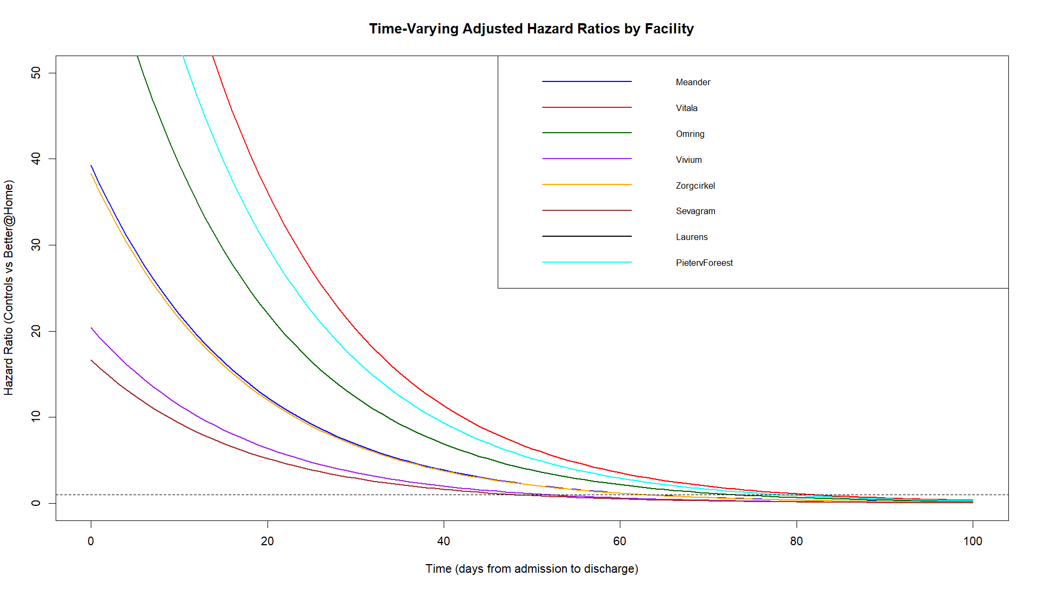
Adjusted HR comparing control vs Better@Home within facility:
Facility A
Facility B
Facility C
Facility D
Facility E
Facility F
Facility G
Facility H

When a curve is above 1 (i.e., dashed horizontal line), the hazard of GR completion is higher in the control group than in the Better@Home group. When a curve is below 1, the hazard of GR completion is higher in the Better@Home group.

For completeness, below are the HR formula comparing GR groups within each facility, where t=time:
HR_Facility_A = exp(3.67 - 0.058 * t)
HR_ Facility_B = exp(3.67 - 0.058 * t + 1.078)
HR_ Facility_C = exp(3.67 - 0.058 * t + 0.583)
HR_ Facility_D = exp(3.67 - 0.058 * t - 0.654)
HR_ Facility_E = exp(3.67 - 0.058 * t - 0.024)
HR_ Facility_F = exp(3.67 - 0.058 * t - 0.858)
HR_ Facility_G = exp(3.67 - 0.058 * t + 6.277)
HR_ Facility_H = exp(3.67 - 0.058 * t + 0.884)

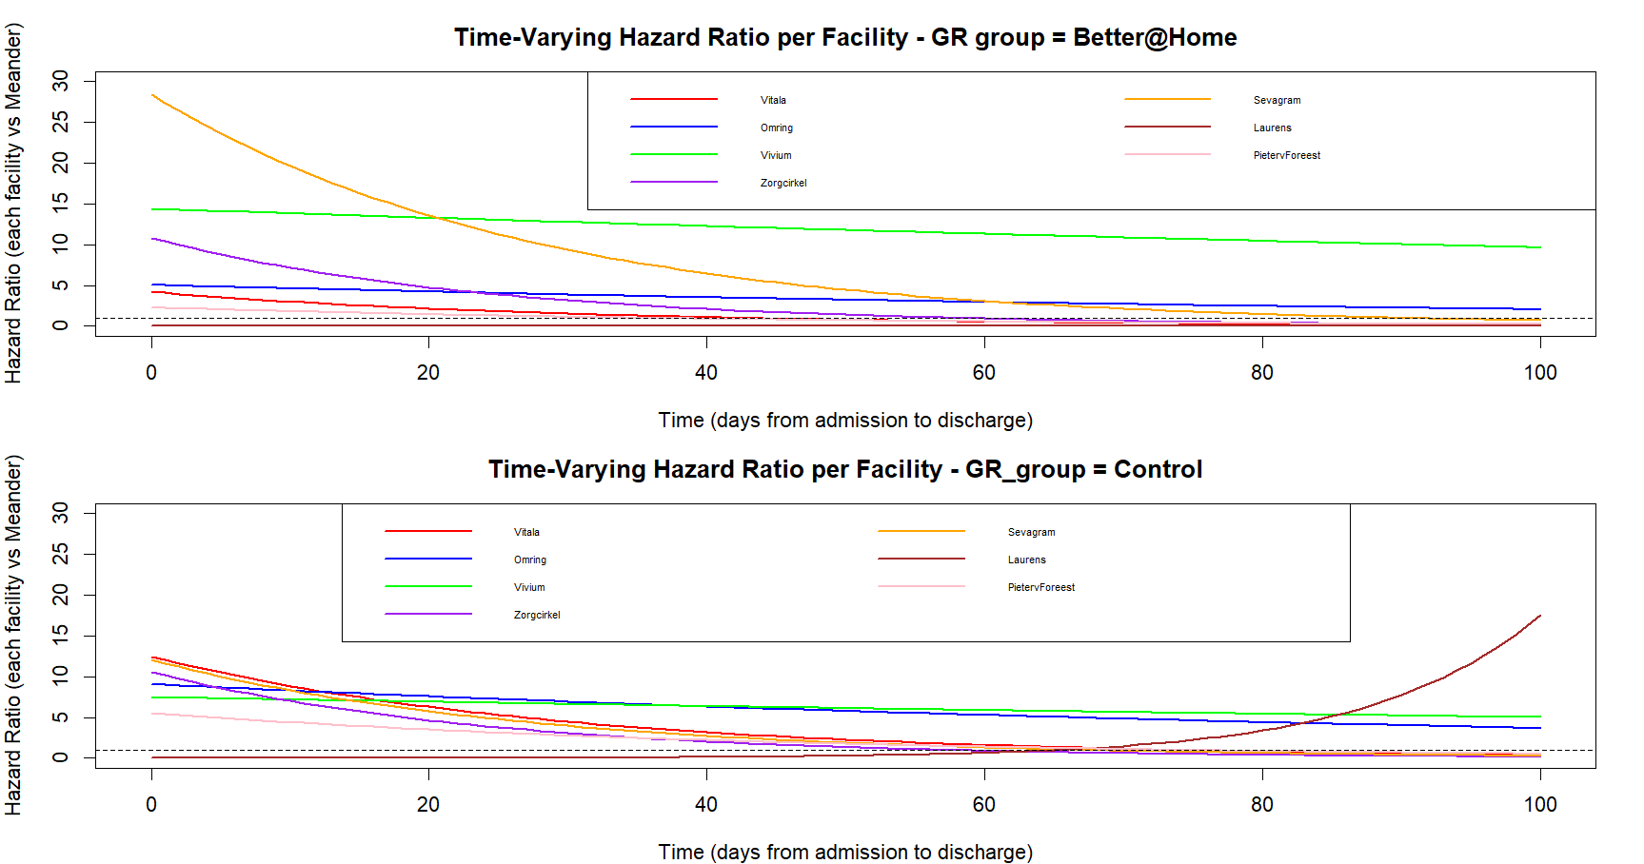
Adjusted hazard ratios comparing each facility (with Facility A as reference) per GR group:
Facility A as reference
Facility A as reference
Facility F
Facility G
Facility H
Facility B
Facility C
Facility D
Facility E

Facility B
Facility C
Facility D
Facility E

Facility F
Facility G
Facility H
A HR greater than 1 indicates that the hazard of GR-completion is higher for the facility compared to Facility_A, whereas an HR less than 1 indicates that Facility_A has a higher hazard of GR completion.

HR formula comparing each facility with Facility_A, where t=time and GR group=1 for control and 0 for Better@Home:
HR_ Facility_B =exp(1.443 - 0.034 * t + 1.078*GR_group)
HR_ Facility_C =exp(1.623 - 0.009 * t + 0.583*GR_group)
HR_ Facility_D = exp(2.667 - 0.004 * t - 0.654*GR_group)
HR_ Facility_E = exp(2.382 - 0.041 * t - 0.024*GR_group)
HR_ Facility_F = exp(3.348 - 0.037 * t - 0.858*GR_group)
HR_ Facility_G = exp(-11.611 + 0.082 * t + 6.277*GR_group)
HR_ Facility_H = exp(0.831 - 0.023 * t + 0.884*GR_group)
Adjusted hazard ratio for BI at T0:
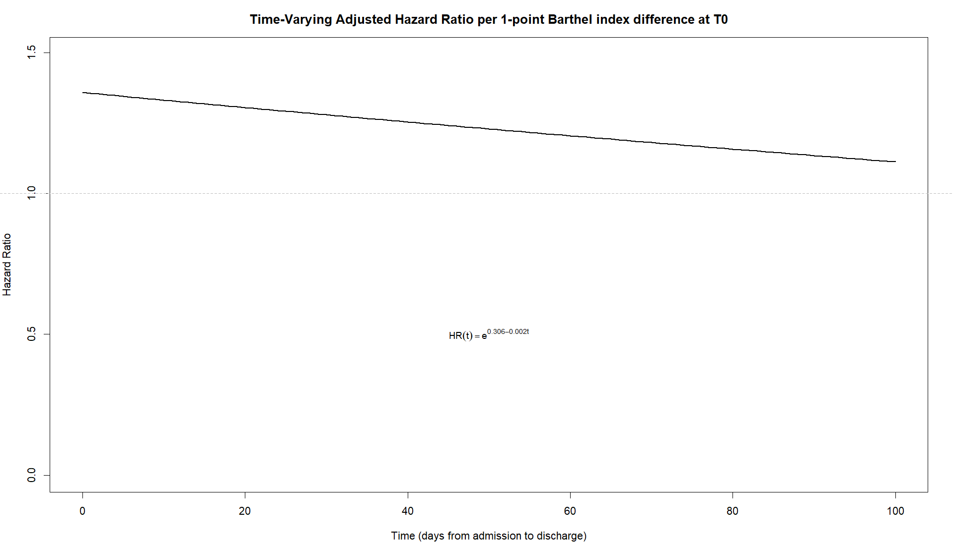

Comparing two patients who differ by 1 point in baseline Barthel Index (BI at T0) and are the same on all other independent variables, a higher BI is associated with a higher hazard of GR completion (HR > 1). However, this effect diminishes over time, indicating that the influence of baseline BI on the hazard of GR completion is attenuated as time progresses.

1. Verbeke G, Lesaffre E. The effect of misspecifying the random-effects distribution in linear mixed models for longitudinal data. Computational Statistics & Data Analysis. 1997/02/06/ 1997;23(4):541-556. doi:https://doi.org/10.1016/S0167-9473(96)00047-3
2. Maas CJM, Hox JJ. Robustness issues in multilevel regression analysis. Statistica Neerlandica. 2004/05/01 2004;58(2):127-137. doi:https://doi.org/10.1046/j.0039-0402.2003.00252.x

