Supplementary materials
Table 1. Definitions and descriptive characteristics of HW and CS exposure variables employed in the present study
Table 2. Descriptive characteristics of study participants at baseline by VI Status
Table 3. Sensitivity analysis of the independent effects of ETEs on VI using mutually adjusted models.
Table 4. Sensitivity analysis excluding participants with less than two years of follow-up.
Table 5. HRs for specific types of incident VI associated with ETEs.
Figure 1. Flowchart of participant selection from the CHARLS cohort (2011–2018)
Figure 2. Associations between ETEs and incident vision impairment
Figure 3. Subgroup analyses of the association between extreme temperature exposure and incident vision impairment
Figure 4. Population attributable fraction of vision impairment associated with CSs by intensity and region
Figure 5. Geographic distribution of vision impairment incidence and ETEs in China
Table 1. Definitions and descriptive characteristics of HW and CS exposure variables employed in the present study.
HW/CS definitions | Threshold percentile (°C) for temperature | Duration (Day) | Intensity categories
CS_P25_2d | Falling below 2.5th percentiles of temperature during 7-year exposure window preceding cohort entry | ≥ 2 | High intensity
CS_P25_3d | Falling below 2.5th percentiles of temperature during 7-year exposure window preceding cohort entry | ≥ 3 | High intensity
CS_P25_4d | Falling below 2.5th percentiles of temperature during 7-year exposure window preceding cohort entry | ≥ 4 | High intensity
CS_P5_2d | Falling below 5th percentiles of temperature during 7-year exposure window preceding cohort entry | ≥ 2 | Middle intensity
CS_P5_3d | Falling below 5th percentiles of temperature during 7-year exposure window preceding cohort entry | ≥ 3 | Middle intensity
CS_P5_4d | Falling below 5th percentiles of temperature during 7-year exposure window preceding cohort entry | ≥ 4 | Middle intensity
CS_P75_2d | Falling below 7.5th percentiles of temperature during 7-year exposure window preceding cohort entry | ≥ 2 | Low intensity
CS_P75_3d | Falling below 7.5th percentiles of temperature during 7-year exposure window preceding cohort entry | ≥ 3 | Low intensity
CS_P75_4d | Falling below 7.5th percentiles of temperature during 7-year exposure window preceding cohort entry | ≥ 4 | Low intensity
HW_P975_2d | Exceeding 97.5th percentiles of temperature during 7-year exposure window preceding cohort entry | ≥ 2 | High intensity
HW_P975_3d | Exceeding 97.5th percentiles of temperature during 7-year exposure window preceding cohort entry | ≥ 3 | High intensity
HW_P975_4d | Exceeding 97.5th percentiles of temperature during 7-year exposure window preceding cohort entry | ≥ 4 | High intensity
HW_P95_2d | Exceeding 95th percentiles of temperature during 7-year exposure window preceding cohort entry | ≥ 2 | Middle intensity
HW_P95_3d | Exceeding 95th percentiles of temperature during 7-year exposure window preceding cohort entry | ≥ 3 | Middle intensity
HW_P95_4d | Exceeding 95th percentiles of temperature during 7-year exposure window preceding cohort entry | ≥ 4 | Middle intensity
HW_P90_2d | Exceeding 90th percentiles of temperature during 7-year exposure window preceding cohort entry | ≥ 2 | Low intensity
HW_P90_3d | Exceeding 90th percentiles of temperature during 7-year exposure window preceding cohort entry | ≥ 3 | Low intensity
HW_P90_4d | Exceeding 90th percentiles of temperature during 7-year exposure window preceding cohort entry | ≥ 4 | Low intensity

Table 2. Descriptive characteristics of participants at baseline by VI Status
Characteristics | Total  N = 13419¹ | No Vision Impairment  N = 12,439¹ |  | Incident Vision Impairment  N = 980¹ | p-value²
Age, years | 59.08 (9.27) | 59.17 (9.30) |  | 57.89 (8.82) | <0.001
Gender |  |  |  |  | <0.001
Female | 7,091 (53%) | 6,645 (53%) |  | 446 (46%)
Male | 6,328 (47%) | 5,794 (47%) |  | 534 (54%)
Residency |  |  |  |  | 0.149
Rural | 8,259 (62%) | 7,677 (62%) |  | 582 (59%)
Urban | 5,160 (38%) | 4,762 (38%) |  | 398 (41%)
Marital Status |  |  |  |  | 0.417
Married | 11,818 (88%) | 10,947 (88%) |  | 871 (89%)
Unmarried/Other | 1,601 (12%) | 1,492 (12%) |  | 109 (11%)
Education Level |  |  |  |  | <0.001
Illiterate | 6,141 (46%) | 5,750 (46%) |  | 391 (40%)
Primary School | 2,893 (22%) | 2,693 (22%) |  | 200 (20%)
Middle School | 2,767 (21%) | 2,527 (20%) |  | 240 (25%)
High School+ | 1,606 (12%) | 1,459 (12%) |  | 147 (15%)
Sleep Duration, h/day | 6.34 (1.88) | 6.32 (1.90) |  | 6.54 (1.72) | 0.001
Smoking Status |  |  |  |  | 0.002
Smoker | 5,219 (39%) | 4,792 (39%) |  | 427 (44%)
Non-smoker | 8,195 (61%) | 7,642 (61%) |  | 553 (56%)
Drinking Status |  |  |  |  | <0.001
Drinker | 4,389 (33%) | 4,021 (32%) |  | 368 (38%)
Non-drinker | 9,024 (67%) | 8,412 (68%) |  | 612 (62%)
Hypertension | 3,419 (26%) | 3,224 (26%) |  | 195 (20%) | <0.001
Diabetes | 806 (6.1%) | 759 (6.2%) |  | 47 (4.8%) | 0.092
Chronic Lung Disease | 1,281 (9.6%) | 1,203 (9.7%) |  | 78 (8.0%) | 0.075
Heart Disease | 1,618 (12%) | 1,518 (12%) |  | 100 (10%) | 0.058
Liver Disease | 461 (3.5%) | 436 (3.5%) |  | 25 (2.6%) | 0.109
Kidney Disease | 758 (5.7%) | 712 (5.8%) |  | 46 (4.7%) | 0.174
¹Mean (SD); n (%)
²Wilcoxon rank sum test; Pearson's Chi-squared test

Table 3. Sensitivity analysis of the independent effects of ETEs on VI using mutually adjusted models.
Model_Pair | Exposure | HR_95CI | P_value
CS_P25_2d & HW_P975_2d | CS_P25_2d | 1.465 (1.356-1.583) | <0.001
CS_P25_2d &HW_P975_2d | HW_P975_2d | 0.922 (0.891-0.953) | <0.001
CS_P25_3d & HW_P975_3d | CS_P25_3d | 1.484 (1.37-1.608) | <0.001
CS_P25_3d & HW_P975_3d | HW_P975_3d | 0.922 (0.891-0.954) | <0.001
CS_P25_4d & HW_P975_4d | CS_P25_4d | 1.387 (1.312-1.467) | <0.001
CS_P25_4d & HW_P975_4d | HW_P975_4d | 0.919 (0.889-0.949) | <0.001
CS_P5_2d & HW_P95_2d | CS_P5_2d | 1.22 (1.18-1.261) | <0.001
CS_P5_2d & HW_P95_2d | HW_P95_2d | 0.917 (0.897-0.937) | <0.001
CS_P5_3d & HW_P95_3d | CS_P5_3d | 1.185 (1.153-1.217) | <0.001
CS_P5_3d & HW_P95_3d | HW_P95_3d | 0.935 (0.918-0.951) | <0.001
CS_P5_4d & HW_P95_4d | CS_P5_4d | 1.192 (1.156-1.229) | <0.001
CS_P5_4d & HW_P95_4d | HW_P95_4d | 0.955 (0.937-0.972) | <0.001

Table 4. Sensitivity analysis excluding participants with less than two years of follow-up.

Exposure | HR_95CI | P_value | Exposure | HR_95CI | P_value
CS_P25_2d | 1.854 (1.602-2.147) | <0.001 | HW_P975_2d | 0.894 (0.861-0.929) | <0.001
CS_P25_3d | 1.856 (1.601-2.152) | <0.001 | HW_P975_3d | 0.873 (0.835-0.914) | <0.001
CS_P25_4d | 1.762 (1.455-2.133) | <0.001 | HW_P975_4d | 0.866 (0.821-0.914) | <0.001
CS_P5_2d | 1.259 (1.191-1.331) | <0.001 | HW_P95_2d | 0.92 (0.896-0.945) | <0.001
CS_P5_3d | 1.246 (1.192-1.302) | <0.001 | HW_P95_3d | 0.924 (0.902-0.947) | <0.001
CS_P5_4d | 1.289 (1.222-1.359) | <0.001 | HW_P95_4d | 0.893 (0.866-0.921) | <0.001
CS_P75_2d | 1.131 (1.101-1.161) | <0.001 | HW_P925_2d | 0.93 (0.907-0.953) | <0.001
CS_P75_3d | 1.091 (1.068-1.114) | <0.001 | HW_P925_3d | 0.927 (0.906-0.948) | <0.001
CS_P75_4d | 1.117 (1.09-1.145) | <0.001 | HW_P925_4d | 0.912 (0.892-0.932) | <0.001

Table 5. HRs for specific types of incident VI associated with ETEs.

Outcome | Exposure | HR_95CI | P-value | Outcome | Exposure | HR_95CI | P-value
DVI | CS_P25_2d | 1.531 (1.43-1.639) | <0.001 | NVI | CS_P25_2d | 1.397 (1.281-1.522) | <0.001
DVI | CS_P25_3d | 1.62 (1.493-1.758) | <0.001 | NVI | CS_P25_3d | 1.422 (1.282-1.576) | <0.001
DVI | CS_P25_4d | 1.409 (1.327-1.496) | <0.001 | NVI | CS_P25_4d | 1.371 (1.27-1.481) | <0.001
DVI | CS_P5_2d | 1.186 (1.143-1.231) | <0.001 | NVI | CS_P5_2d | 1.161 (1.126-1.196) | <0.001
DVI | CS_P5_3d | 1.184 (1.144-1.225) | <0.001 | NVI | CS_P5_3d | 1.146 (1.117-1.176) | <0.001
DVI | CS_P5_4d | 1.212 (1.159-1.267) | <0.001 | NVI | CS_P5_4d | 1.171 (1.132-1.211) | <0.001
DVI | CS_P75_2d | 1.121 (1.092-1.15) | <0.001 | NVI | CS_P75_2d | 1.107 (1.082-1.133) | <0.001
DVI | CS_P75_3d | 1.109 (1.086-1.132) | <0.001 | NVI | CS_P75_3d | 1.095 (1.076-1.115) | <0.001
DVI | CS_P75_4d | 1.127 (1.099-1.156) | <0.001 | NVI | CS_P75_4d | 1.111 (1.088-1.135) | <0.001
DVI | HW_P975_2d | 0.922 (0.901-0.944) | <0.001 | NVI | HW_P975_2d | 0.917 (0.892-0.942) | <0.001
DVI | HW_P975_3d | 0.914 (0.891-0.936) | <0.001 | NVI | HW_P975_3d | 0.909 (0.884-0.935) | <0.001
DVI | HW_P975_4d | 0.913 (0.888-0.938) | <0.001 | NVI | HW_P975_4d | 0.904 (0.876-0.933) | <0.001
DVI | HW_P95_2d | 0.958 (0.945-0.971) | <0.001 | NVI | HW_P95_2d | 0.953 (0.938-0.968) | <0.001
DVI | HW_P95_3d | 0.966 (0.953-0.979) | <0.001 | NVI | HW_P95_3d | 0.962 (0.947-0.976) | <0.001
DVI | HW_P95_4d | 0.963 (0.949-0.978) | <0.001 | NVI | HW_P95_4d | 0.955 (0.939-0.972) | <0.001
DVI | HW_P925_2d | 0.972 (0.962-0.982) | <0.001 | NVI | HW_P925_2d | 0.963 (0.952-0.975) | <0.001
DVI | HW_P925_3d | 0.971 (0.96-0.981) | <0.001 | NVI | HW_P925_3d | 0.963 (0.951-0.975) | <0.001
DVI | HW_P925_4d | 0.971 (0.961-0.982) | <0.001 | NVI | HW_P925_4d | 0.963 (0.951-0.976) | <0.001
DVI: distance visual impairment; NVI: near visual impairment.

Figure 1. Flowchart of participant selection from the CHARLS cohort (2011–2018)
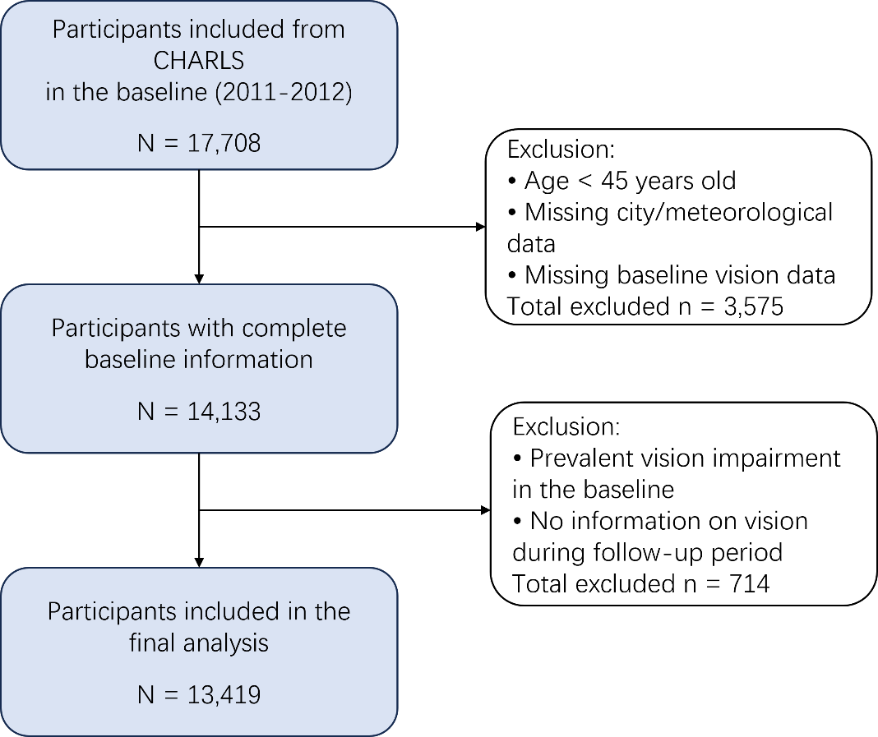

Figure 2. Associations between ETEs and incident vision impairment
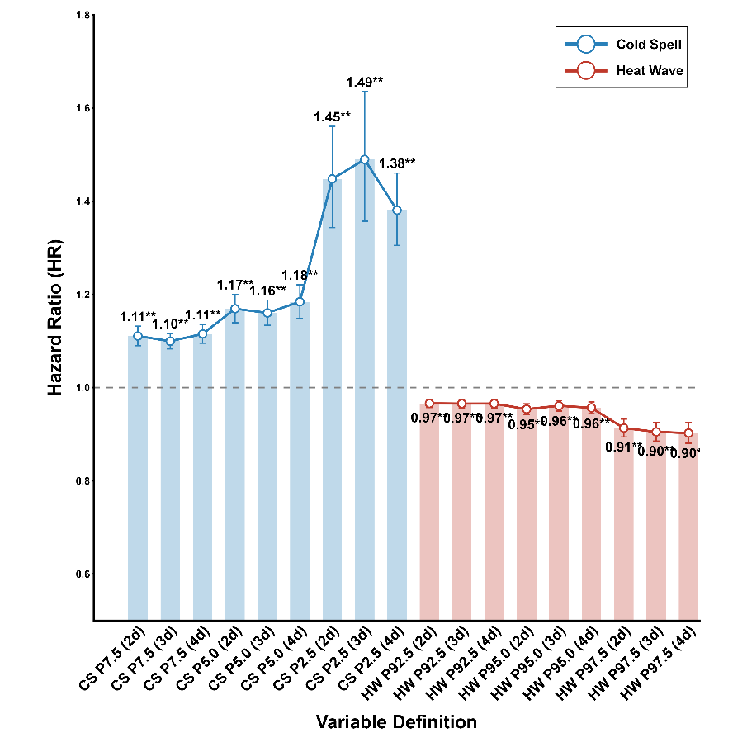

Figure 3. Subgroup analyses of the association between extreme temperature exposure and incident vision impairment

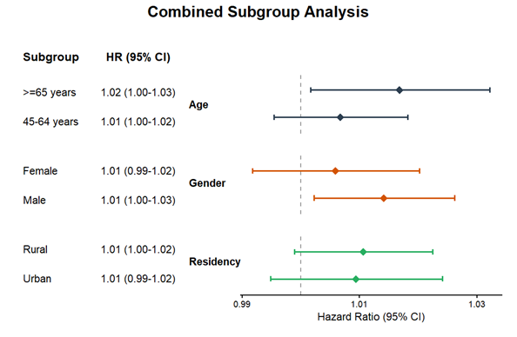

Figure 4. Population attributable fraction of vision impairment associated with CSs by intensity and region
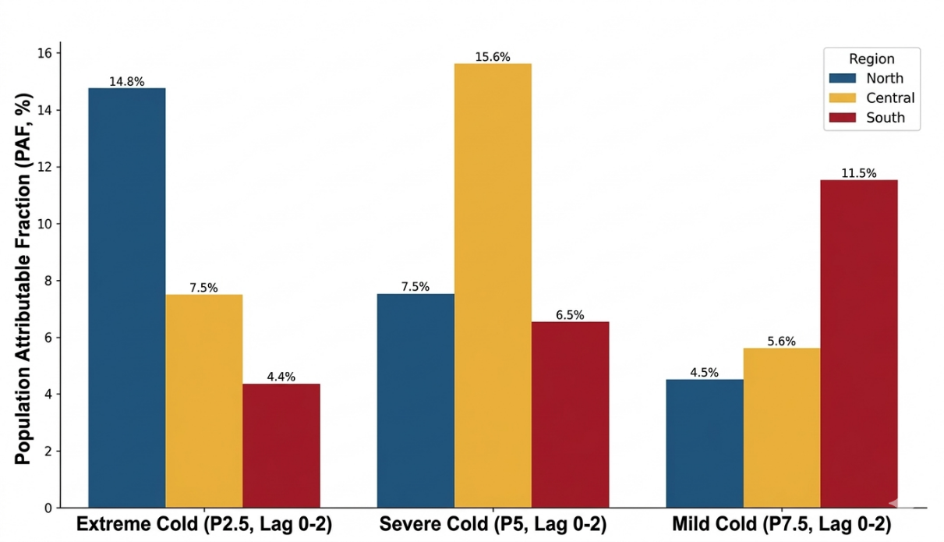

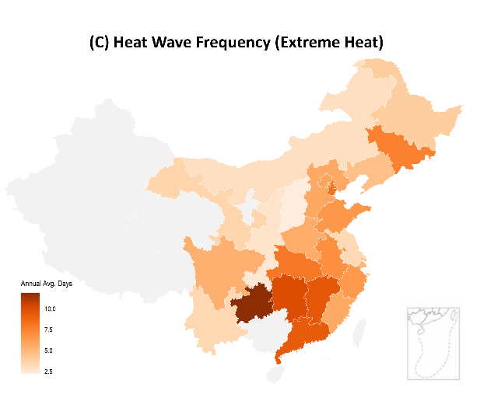
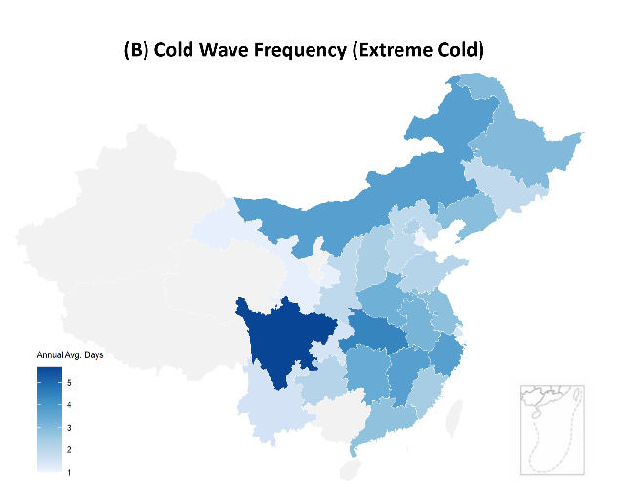
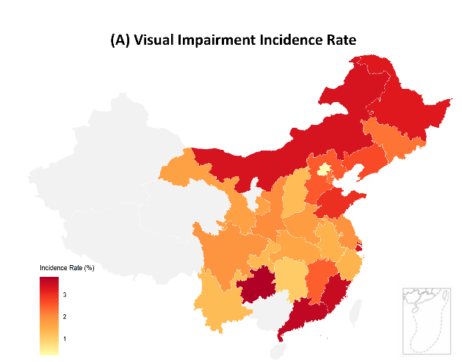
Figure 5. Geographic distribution of vision impairment incidence and ETEs in China

