Supplementary Information
Selective Targeting Through Chemical Remodeling of Protein Neosurfaces
Qinsong Wei¹, Kai Han¹, Xin Wang¹, Jian Zhang¹, Jinge Zhao¹, Xiaowei Zhang¹, Jiaqin Li¹, Wentao Zhang¹, Xiaolu Miao¹, Bing Ma¹*, Limin Zhang¹*, Weizhi Wang^{1, 2}*
- Key Laboratory of Medical Molecule Science and Pharmaceutics Engineering, Ministry of Industry and Information Technology, Key Laboratory of Cluster Science of Ministry of Education, Beijing Key Laboratory of Photoelectronic/Electrophotonic Conversion Materials, School of Chemistry and Chemical Engineering, Beijing Institute of Technology, Beijing 100081, PR China.
- Tangshan Research Institute, Beijing Institute of Technology, 063000.

Content
1. Target peptide screening 4
2. Characterizing the morphological features of the lead peptide assembly using atomic force microscopy (AFM) 4
3. Transmission electron microscopy (TEM) characterization of the morphology of KK assembly 4
4. Dynamic light scattering (DLS) 5
5. Circular dichroism (CD) and Fourier transform infrared (FTIR) spectroscopy characterization of the secondary structure of peptide KK 5
6. The molecular docking of KK to ALR2 5
7. Hydrogen-deuterium exchange mass spectrometry (HDX-MS) 6
8. Bio-TEM 6
9. Molecular Enzyme Assay 7
10. Fluorescein Angiography 8
11. Fundoscopy 8
12. Cryosections and flatmounts 9
13. Retinal H&E staining 9
14. Determination of Neuronal Cell Loss in Retinal Slices 10
15. Retinal VEGF Immunostaining 10
16. Electroretinography (ERG) 10
17. TUNEL staining of retinal sections 11
18. H&E staining and TUNEL staining of mouse major organ sections 11
19. Statistical analysis 12
Supplementary Fig. 1. 13
Supplementary Fig. 2. 14
Supplementary Fig. 3. 15
Supplementary Fig. 4. 16
Supplementary Fig. 5. 17
Supplementary Fig. 6. 18
Supplementary Fig. 7. 19
Supplementary Fig. 8. 20
Supplementary Fig. 9. 21
Supplementary Fig. 10. 22
Supplementary Fig. 11. 23
Supplementary Fig. 12. 24
Supplementary Fig. 13. 25
Supplementary Fig. 14. 26
Supplementary Fig. 15. 27
Supplementary Fig. 16. 28
Supplementary Fig. 17. 29
Supplementary Fig. 18. 30
Supplementary Fig. 19. 31

Methods

1. Target peptide screening
Peptide screening was carried out from 3000 candidate beads. The positive peptide beads were identified by the binding reaction between streptavidin-labeled magnetic beads and biotin on the protein. The surface of the positive peptide beads was coated with a layer of magnetic beads so that they could be captured by magnetic field. The peptide beads at the bottom of the tube were carefully transferred to another tube with a pipetting gun. The single peptide beads were lysed by 30 mg/mL cyanogen bromide (BrCN) solution, and the corresponding sequence information was identified by MALDI-TOF-MS (Matrix assisted laser desorption ionization and time of flight mass spectra) (Bruker Daltonics, Germany).

2. Characterizing the morphological features of the lead peptide assembly using atomic force microscopy (AFM)
AFM imaging was performed in air using a scanning probe microscope (Bruker, Dimension Fast-Scan) to analyze the morphology of the peptide assembly. A 40 μL aliquot of peptide solution (1.67 mg/mL) was deposited onto a mica surface and allowed to incubate for 10 min. After incubation, the excess solution was rinsed off with deionized water and the surface was dried with a stream of nitrogen gas. Imaging was conducted in tapping mode using a ScanAsyst-AIR probe, with a resolution of 512×512 pixels and a scanning speed of 1.0 Hz.

3. Transmission electron microscopy (TEM) characterization of the morphology of KK assembly
Peptide samples (1.67 mg/mL) were deposited onto a holey carbon-coated copper grid for TEM analysis. A 10 µL droplet of the peptide suspension was placed on the carbon side of the grid and allowed to incubate for approximately 7 min. Excess solution was then removed with filter paper to minimize background contamination. The grid was subsequently immersed, carbon side down, in a 1 wt% uranyl acetate solution for 10 min to provide contrast enhancement. After removing the grid from the solution, the excess moisture was blotted off using filter paper. Imaging was performed on a JEM-2100 transmission electron microscope operating at 120 kV to obtain detailed micrographs of the peptide assembly’s structure.

4. Dynamic light scattering (DLS)
Filter 1 mL of a 10 μg/mL KK peptide assembly sample three times through a 0.22 μm sterile filter, then transfer the sample to the sample cell of a dynamic light scattering (DLS) instrument to measure the particle size of the assembled micelles. The measurement parameters were set as follows: excitation wavelength of 633 nm, temperature of 25℃, PBS as the dispersion medium, and polymer as the sample cell type. After repeating the test three times for each sample, the experimental data were analyzed and processed using Zetasizer Software.

5. Circular dichroism (CD) and Fourier transform infrared (FTIR) spectroscopy characterization of the secondary structure of peptide KK
The secondary structure of the assembled peptide solution (500 μM) was analyzed at room temperature using CD spectroscopy with a MOS-450 spectrometer (Bio-logic, France). The measurements were performed in the wavelength range of 190-260 nm with a path length of 0.1 mm. For FTIR analysis, the peptide solution was lyophilized for 48 h to obtain powder samples. The powder was then dissolved in D₂O to prepare a 10 mM solution, followed by more than 48 h of self-assembly. The resulting solution was transferred to the sample cell of a Nicolet 6700 FTIR spectrometer for analysis.

6. The molecular docking of KK to ALR2
The structure of peptide KK was predicted using the PEP-FOLD3 server, while the structure of the ALR2 protein was retrieved from the Protein Data Bank (PDB). Molecular docking of KK to ALR2 was performed using ZDOCK 3.0.2, employing scoring functions based on shape complementarity and hydrogen bond interactions to evaluate the docking pose.

7. Hydrogen-deuterium exchange mass spectrometry (HDX-MS)
Hydrogen-deuterium exchange mass spectrometry (HDX-MS) was performed to characterize the interaction interface between peptide KK and ALR2. ALR2 (10 μM) was incubated with peptide KK at a 1:10 molar ratio at 30℃ for 5 min prior to labeling. Deuterium exchange was initiated by dilution into D₂O-based PBS (pH 7.4) at 15℃ and sampled at 0, 10, 60 and 600 s. Reactions were quenched with ice-cold buffer containing 4 M guanidine hydrochloride, 0.2 M citric acid and 0.2 M TCEP and maintained at 0-1℃ to minimize back-exchange. Samples were digested online using an immobilized pepsin column (Immobilized Pepsin/VIII Cartridge, 2.1 mm × 30 mm) and separated by UPLC (Ultimate NCS-3500 RSLC system, Thermo Fisher Scientific) before analysis on a high-resolution mass spectrometer (Orbitrap Fusion, Thermo Fisher Scientific). Peptides were identified using BioPharm Finder (version 2.0) and deuterium uptake was quantified with HDExaminer (version 2.4.1). Measurements were performed in triplicate, achieving 98.1% sequence coverage. Deuterium uptake values were compared without back-exchange correction, and differences ≥10% were mapped onto the ALR2 structure for structural interpretation. Only peptides with identification scores ＞80 were included in the analysis.

8. Bio-TEM
ARPE-19 cells were treated with KK^{EPA} for 0, 12 and 24 h, respectively. They were then centrifuged and were put into fixative at 4℃. Note that “0 h” refers to immediate fixation upon addition of KK^{EPA}. The cells were then rinsed three times with PBS for 15 min each time and dehydrated with graded concentrations (including five concentrations of 30%, 50%, 70%, 80%, 90% and 95%) of ethanol for 15 min each, then treated with 100% ethanol for 20 min. After that, the samples were treated with a mixture of embedding agent and acetone (v/v=1/1) for 1h; with a mixture of embedding agent and acetone (v/v=3/1) for 3h; pure embedding agent was used to treat the samples overnight. Finally, the samples were embedded overnight to obtain the embedded samples. The samples were sectioned (70-90 nm) and then observed in the transmission electron microscope.

9. Molecular Enzyme Assay
Specifically, in a 1 mL sample tube, 0.25 mL of phosphate buffer solution, 0.15 mL of deionized water, aldose reductase solution, and 0.25 mL of NADPH phosphate buffer solution are added. In the reference tube, 0.5 mL of the same concentration phosphate buffer solution, 0.15 mL of deionized water, aldose reductase solution, and 0.25 mL of NADPH phosphate buffer solution are added. After incubating at 4℃ for 4 min, 0.25 mL of D, L-glyceraldehyde is added to the sample tube, followed by rapid mixing. The enzyme kinetics curve is then recorded within 4 min using a UV-Vis spectrophotometer. A time (x) - absorbance (y) plot is constructed, and linear regression is performed on all data points. The slope of the resulting line represents the enzyme activity (I₀) under natural conditions.
Next, the enzyme activity after drug inhibition is measured. In a 1 mL sample tube, 0.25 mL of phosphate buffer solution, 0.15 mL of deionized water, aldose reductase solution, 0.25 mL of NADPH phosphate buffer solution, and 0.005 mL of EPA/KK^{EPA} solution are added. In the reference tube, the same concentration of 0.5 mL phosphate buffer solution, 0.15 mL deionized water, aldose reductase solution, 0.25 mL NADPH phosphate buffer solution, and 0.005 mL EPA/KK^{EPA} solution are added. After incubating at 4℃ for 4 min, 0.25 mL of D, L-glyceraldehyde is added to the sample tube, followed by rapid mixing. The enzyme kinetics curve is then recorded within 4 min using the UV-Vis spectrophotometer. A time (x) - absorbance (y) plot is constructed, and linear regression is performed on all data points. The slope of the resulting line represents the enzyme activity (I_{x}) after inhibition.
The inhibition rate of EPA/KK^{EPA} is calculated as:
$$\text{I\%}\text{=}\frac{{\text{I}}_{\text{0}}\text{-}{\text{I}}_{\text{X}}}{{\text{I}}_{\text{0}}}\text{×100\%}$$
Calculation of inhibition (IC₅₀)：For the above enzymatic reaction, enzyme activity is measured using EPA and equivalent concentrations of KK^{EPA} at 10^{0.5}, 10, 10^{1.5}, 10², and 10^{2.5} μM. The logarithm of the concentration is plotted on the x-axis, with the inhibition rate on the y-axis. Linear regression analysis is performed to obtain a straight line, and the corresponding equation is derived. Using the equation, the concentration corresponding to 50% IC₅₀ can be calculated by finding the x-coordinate value when the inhibition rate is 50%, followed by anti-logarithmic transformation to obtain the IC₅₀ value of the compound being tested.

10. Fluorescein Angiography
In vivo imaging of the retinal fundus was performed by Heidelberg Retina Angiography (HRA) (Spectralis, Heidelberg Engineering, Vista, CA) using the fluorescein angiograph (FA) modes. pupils were dilated using topical 2.5% phenylephrine hydrochloride and 1% tropicamide (Akorn Inc., Lakeforest, IL). Mice were anesthetized by intraperitoneal injection of ketamine/xylazine as described above. During the procedure, body temperature was maintained at 37℃ using a heating pad. Mice were given intraperitoneal injections (0.1 mL) of 10% sodium fluorescein (Akorn, Inc., Lake Forest, IL) to acquire the FA images. Imaging was obtained at 488 nm absorption and 495 nm emission using a 55° lens. Images of the central retina were taken, with the optic nerve located in the center of the image.

11. Fundoscopy
In vivo microscopy and digital imaging were performed as described previously,21 using an M2Bio fluorescence stereo microscope Stemi SV1 (Carl Zeiss, Oberkochen, Germany). For in vivo observation, mice were anesthetized with 3% isoflurane in oxygen. The eye was lightly proptosed and Viscotears (Novartis, Basel, Switzerland) was applied to the cornea after which a circular 7.5 mm sapphire window (Edmund Optics, Barrington, NJ, USA) was placed over the cornea. Fundus images were collected with a digital camera through a ×1.6 objective and a zoom at ×2 or ×4 magnification (Coolsnap ES, Roper, TX, USA).

12. Cryosections and flatmounts
Animals were euthanized and the eyes were enucleated, fixed in 4% paraformaldehyde (PFA) (Electron Microscopy Sciences, Hatfield, PA) for 2 h at 4℃. The neural retina flatmounts and RPE-Choroid flatmounts were prepared after fixation and PBS washing. For preparing cryosections, eyes were cryoprotected in 30% sucrose overnight and embedded in Tissue-Tek® O.C.T™ Compound (Sakura Finetek USA Inc., Torrance, CA). Sections (1-3 µm) were cut on a cryostat.

13. Retinal H&E staining
Sections were fixed for 2 min in 10% neutral buffered formalin (EMD Chemicals INC. Billerica, MA), rinsed in running water, then immersed for 3 min in hematoxylin solution (Sigma Aldrich, St. Louis, MO), rinsed in running water, immersed in acid alcohol (Thermo Fisher Scientific, Waltham, MA) for 2 min. Rinsed in running water, immersed in 100% ethanol for 2 min, rinsed in running water, immersed in Bluing reagent (0.25 NH4 solution, Richard-Allan Scientific) for 2 min, immersed in Eosin solution (Sigma) for 2 min, immersed in 100% ethanol for 2 min, immersed in xylene three times for 5 min, then mounted with Cytoseal XYL (Thermo Fisher Scientific, Waltham, MA), coverslipped and dried for 24-48 h.

14. Determination of Neuronal Cell Loss in Retinal Slices
The enucleated eyes were fixed in 10% buffered formalin, embedded in paraffin, and 5 mm thick retinal sections were prepared passing through the optic nerve. Sections were stained with periodic acid-Schiff and hematoxylin or hematoxylin-eosin for light microscopy. The neuronal nuclei in the ganglion cell layer (GCL) (not including nuclei in the vessels) were counted using high-resolution (magnification 3400) images of the entire retinal length. Images from each experiment were assessed by a single reviewer, who was masked to experimental group.

15. Retinal VEGF Immunostaining
Sections were permeabilized with 0.1% Triton-X100 (Fisher Scientific, Fair Lawn, NJ, USA) in PBS and blocked in 5% goat serum. Sections were stained using VEGF (1:1000 dilution; Abcam) as the primary antibody. Secondary antibodies were Cy3-conjugated donkey anti-Rat (Jackson Immuno Research Laboratories Inc., Bar Harbor, ME, USA), Alexa Fluor 488 donkey anti-rat (Invitrogen), Alexa Fluor 488 and Alexa Fluor 555 goat antirabbit (Invitrogen), and Alexa Fluor 555 goat anti-mouse (Invitrogen) at 1:500. Sections were imaged using a Leica DM 5000B microscope at ×2.5 and ×40 magnification (Leica Microsystems Inc., Wetzlar, Germany).

16. Electroretinography (ERG)
ERG was performed 10 weeks after the induction of diabetes (18 weeks of age). After overnight dark adaptation, mice were anesthetized with ketamine (87.5 mg/kg) and xylazine (12.5 mg/kg), the cornea was anesthetized with 0.5% proparacaine hydrochloride (Medline, 17478-0263-12), and the pupils were dilated with 2.5% phenylephrine hydrochloride (Medline, 17478-0201-15). Briefly, mice were placed on the temperature-regulated heated ERG instrument (Diagnosys, Lowell, MA), and the retinal responses recorded by placing electrode on each cornea; the subdermal reference was placed on the nose, and ground needle electrodes were placed at the base of the tail. The full-field flash ERG responses from both eyes were recorded on mice dark-adapted overnight followed by light-adaptation; the flash intensities were 0.477 and 2 cd∙s/m² with a 2 to 5 s interstimulus interval. The amplitude of ERG a-wave was measured from the trough of the first corneal negative deflection to the pre-stimulus baseline. The amplitude of the b-wave was calculated from the a-wave amplitude to the peak of the b-wave. All ERG a-wave and b-wave amplitudes were automatically calculated by Espion V6 software (Diagnosys LLC).

17. TUNEL staining of retinal sections
As previously described, retinal sections were prepared and subjected to TUNEL staining using terminal deoxynucleotidyl transferase dUTP nick-end labeling to detect apoptosis levels. Retinal sections were further counterstained with Hoechst 33342 to identify retinal cell layers. Images were captured using a microscope.

18. H&E staining and TUNEL staining of mouse major organ sections
The heart, liver, spleen, lung, kidney and tumor tissues of the mice were collected for immunohistochemical analysis. Hematoxylin & eosin staining (H&E) was used to detect the damage degree of heart, liver, spleen, lung, kidney and tumor tissues. This study was carried out according to the protocol of hematoxylin and eosin staining kits. Low-temperature slides with a thickness of 8 μm were treated with 10% v/v formalin (dissolved in PBS) for half an hour. The slides were then washed with DI (deionized water) and different concentrations of alcohol (100%, 95%, 70%). The hematoxylin was conducted to stain for 3 min. Then the slides were rinsed with DI for about 1 min and dyed with eosin for 1 min. After that, slides were then treated with xylene and mounted with Canadian balsam. The images were collected using a Nikon Eclipse 90i microscope.
The degree of cell apoptosis was detected by terminal deoxynucleotidyl transferase dUTP Nick-End labeling (TUNEL). Tissue sections were treated with TUNEL kit for staining. After TUNEL operation, the cells were returned to 450 μL phosphate buffered normal saline. The images were collected using a Nikon Eclipse 90i microscope.

19. Statistical analysis
For each experiment, the number of replicates is indicated in the figure legends, and P values were determined using a two-tailed t-test.
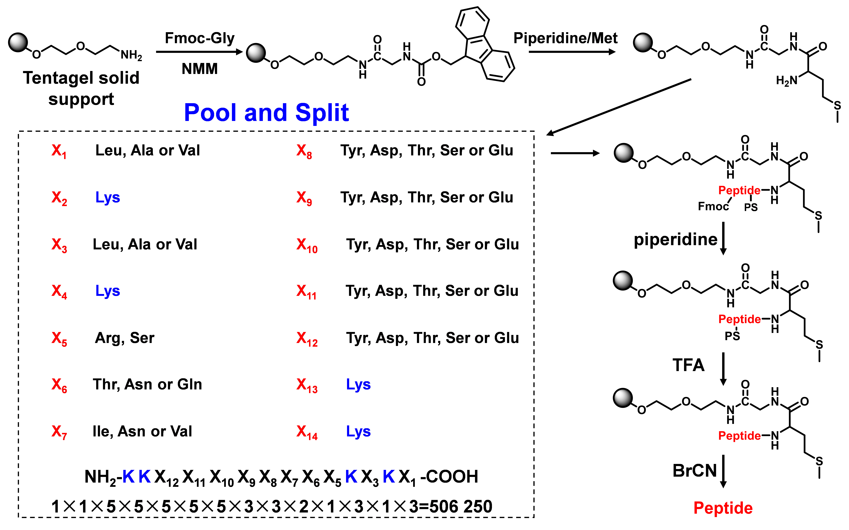
Supplementary Fig. 1. The schematic diagram of the process of peptide library construction by one-bead-one compound (OBOC) strategy.

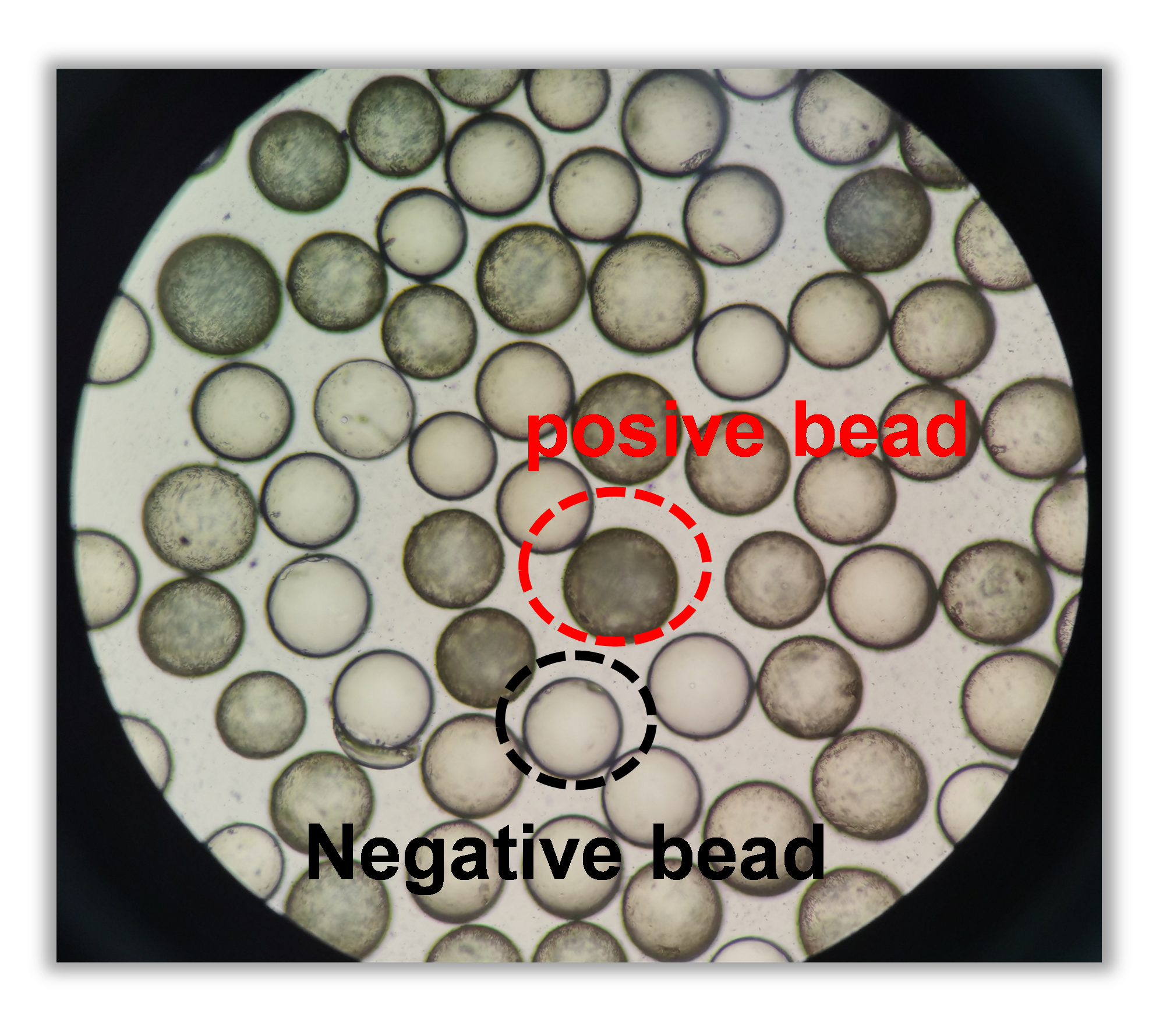
Supplementary Fig. 2. One-bead-one-compound (OBOC) magnetic bead screening.

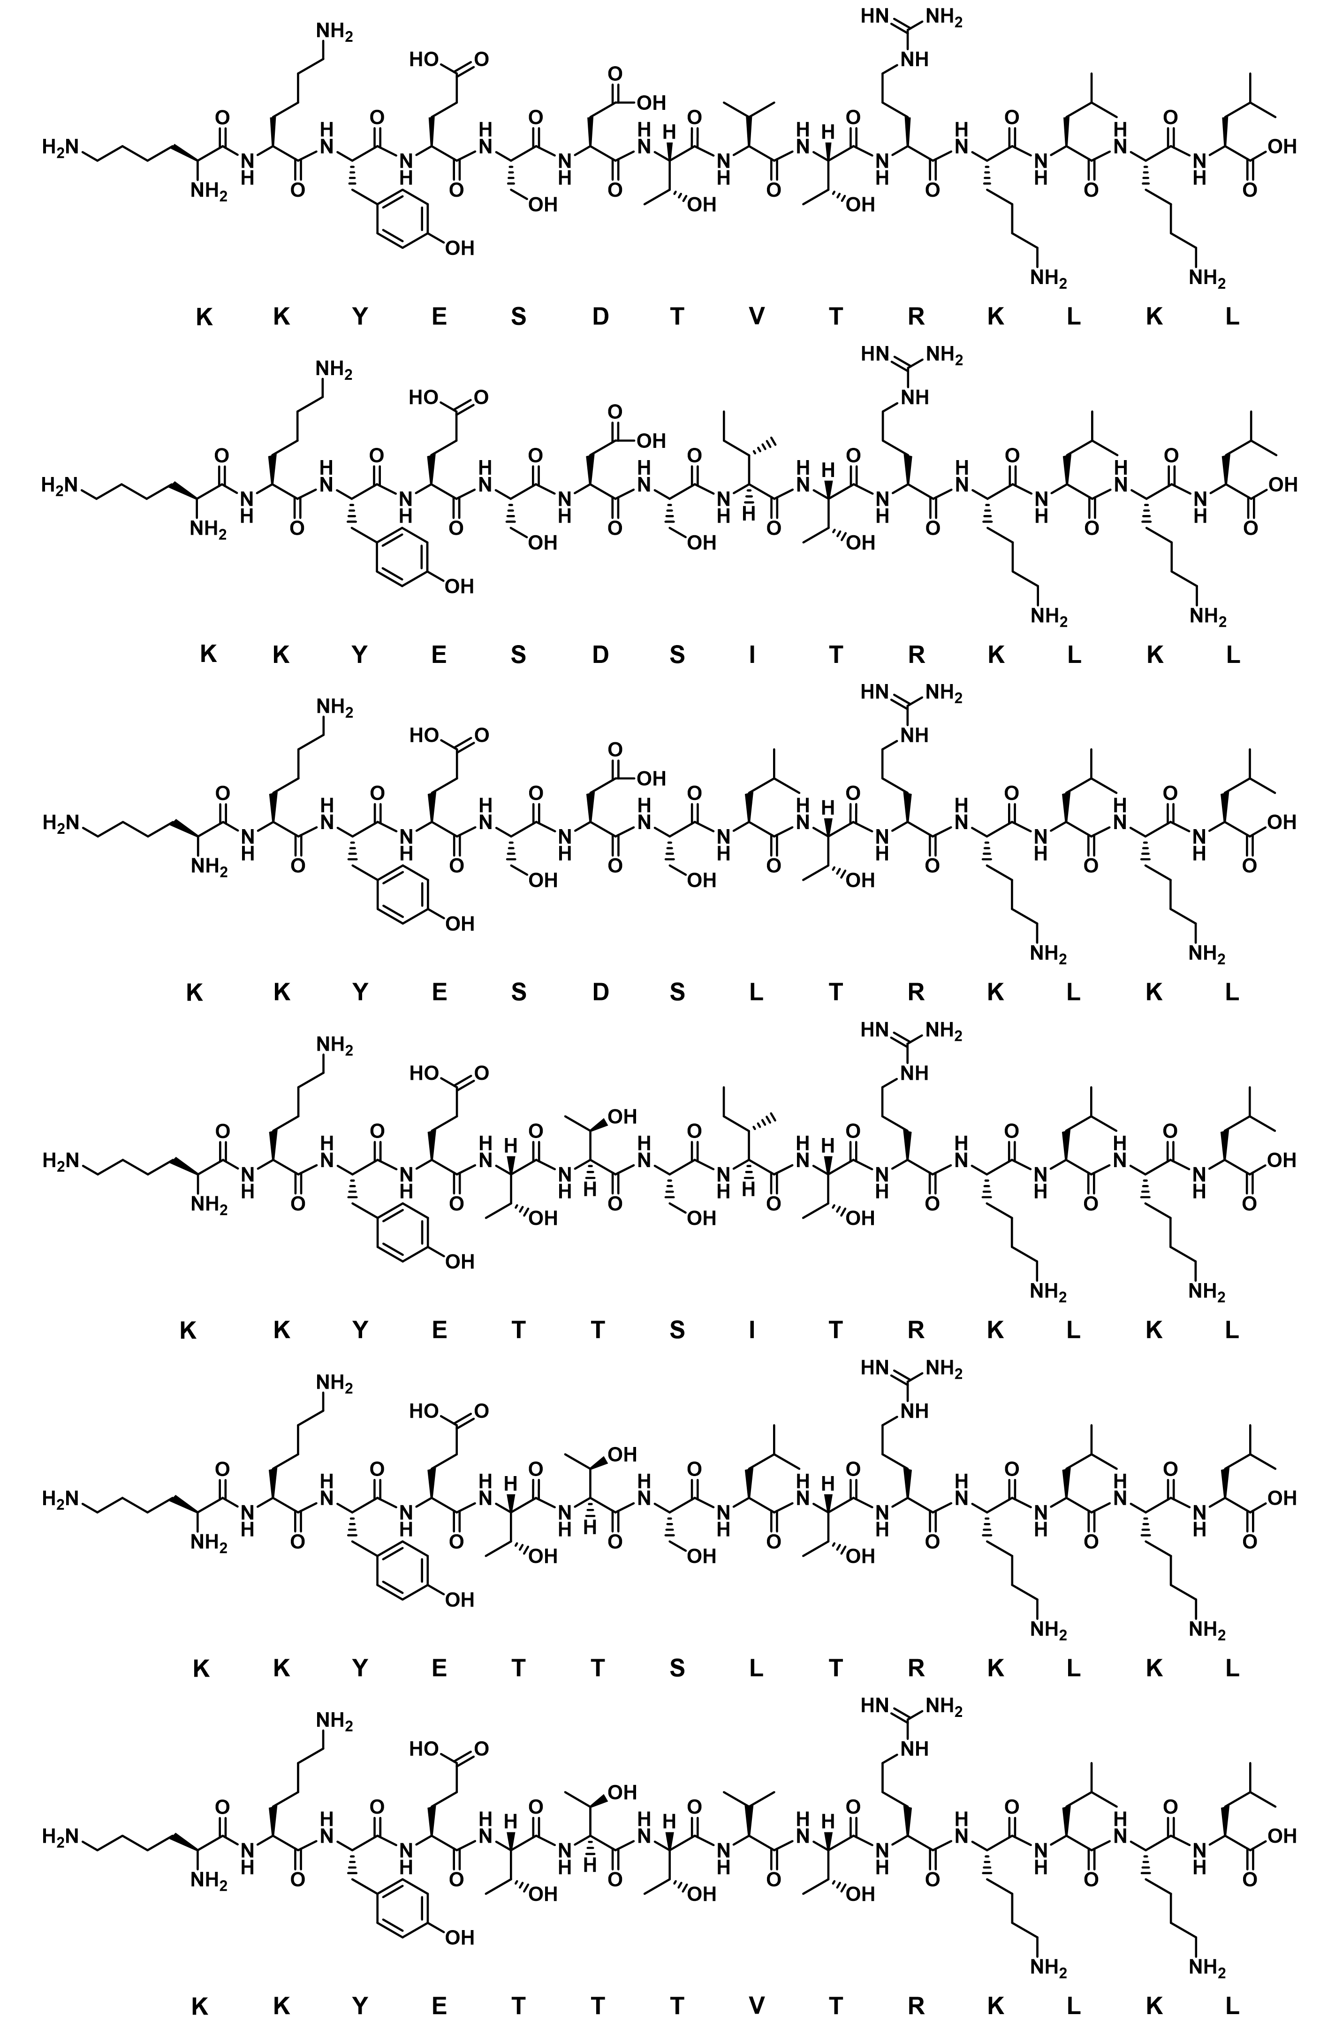
Supplementary Fig. 3. The chemical structure of six lead peptides molecule.
KKYESDTVTRKLKL
KKYESDSITRKLKL
KKYESDSLTRKLKL
KKYETTSITRKLKL
KKYETTSLTRKLKL
KKYETTTVTRKLKL
Supplementary Fig. 4. Measurement of affinity dissociation constants of six lead peptides with AR and ALR1 using Surface Plasmon Resonance Imaging (SPRi).
ALR2
ALR1

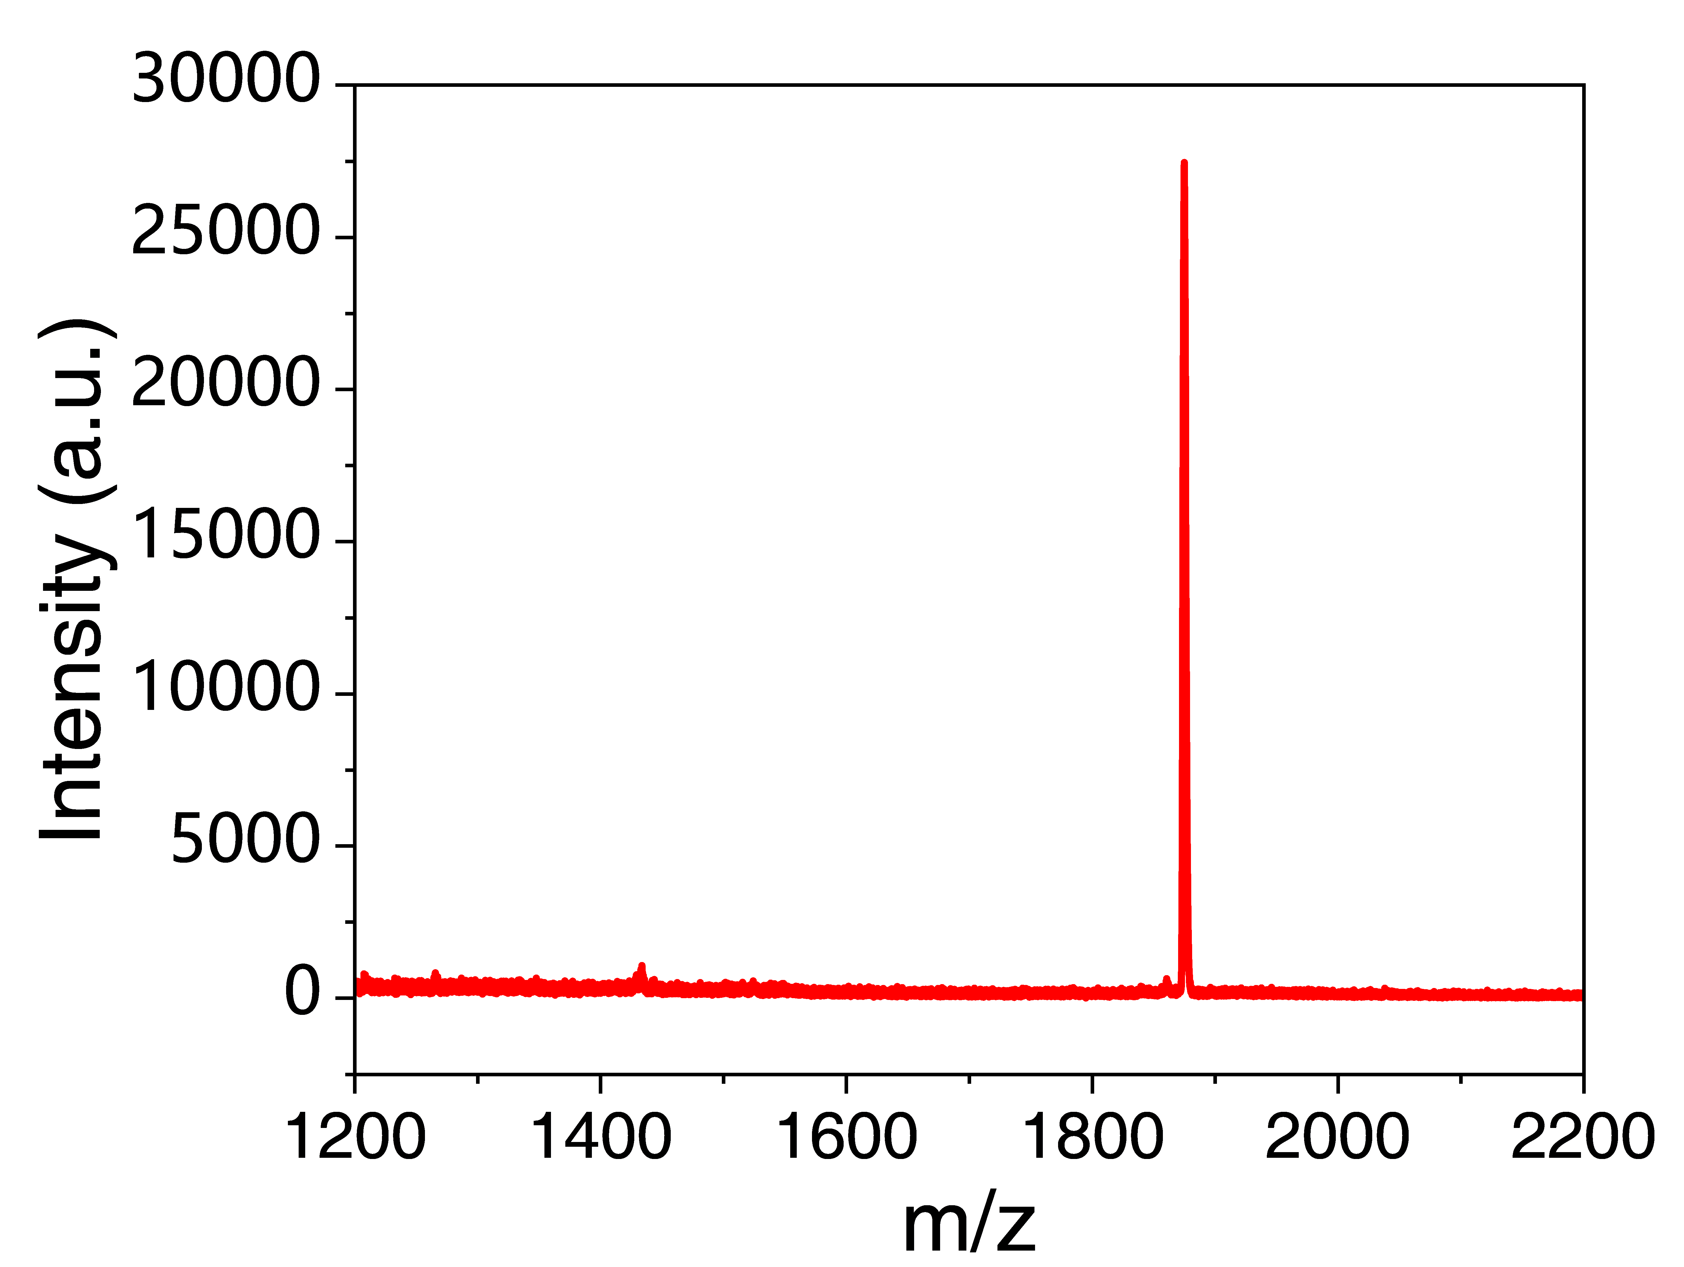
Supplementary Fig. 5. Mass spectrometry (MS) report of KK.

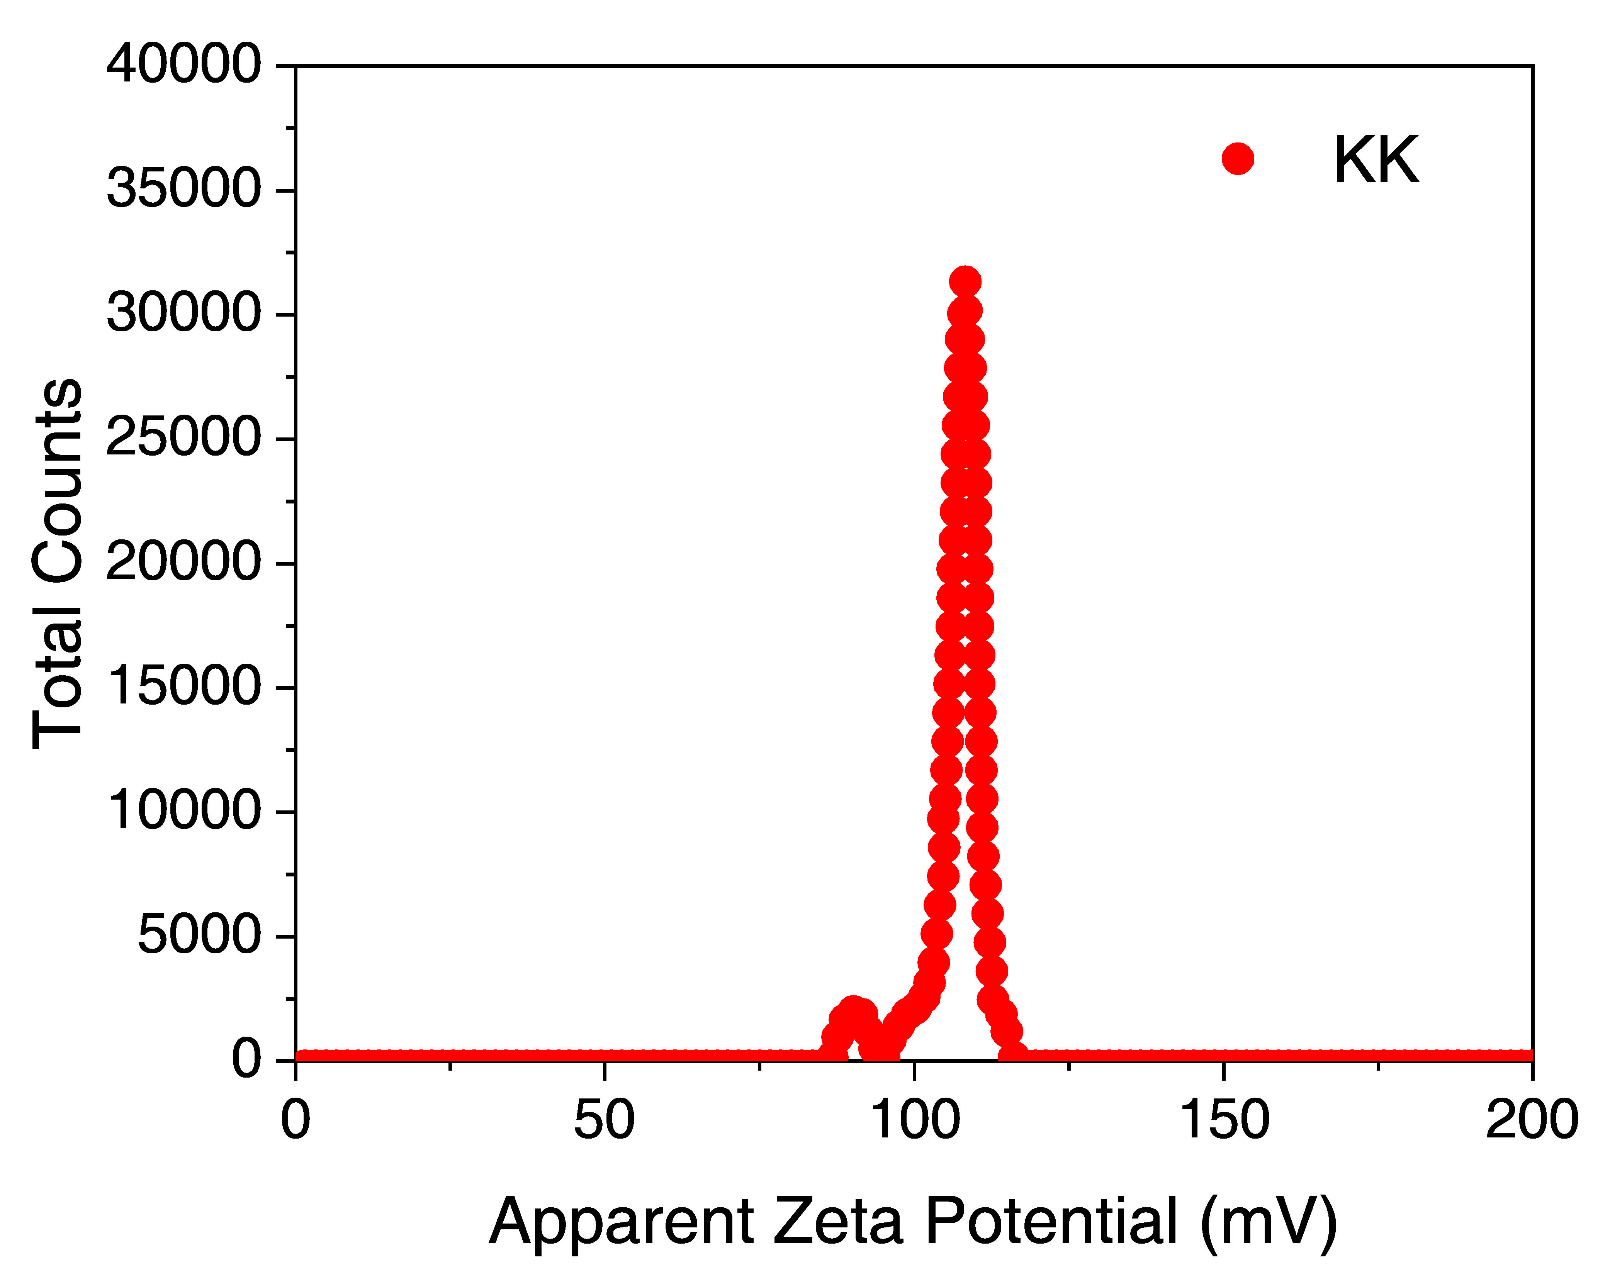
Average Zeta potential: 15.6 mV
Supplementary Fig. 6. Zeta potential of KK and the corresponding raw spectrum.

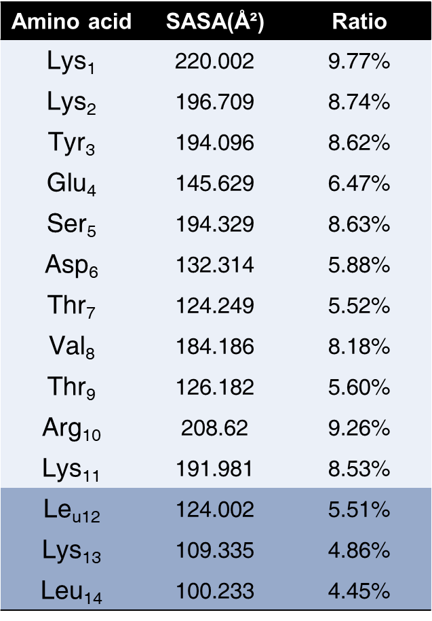 | 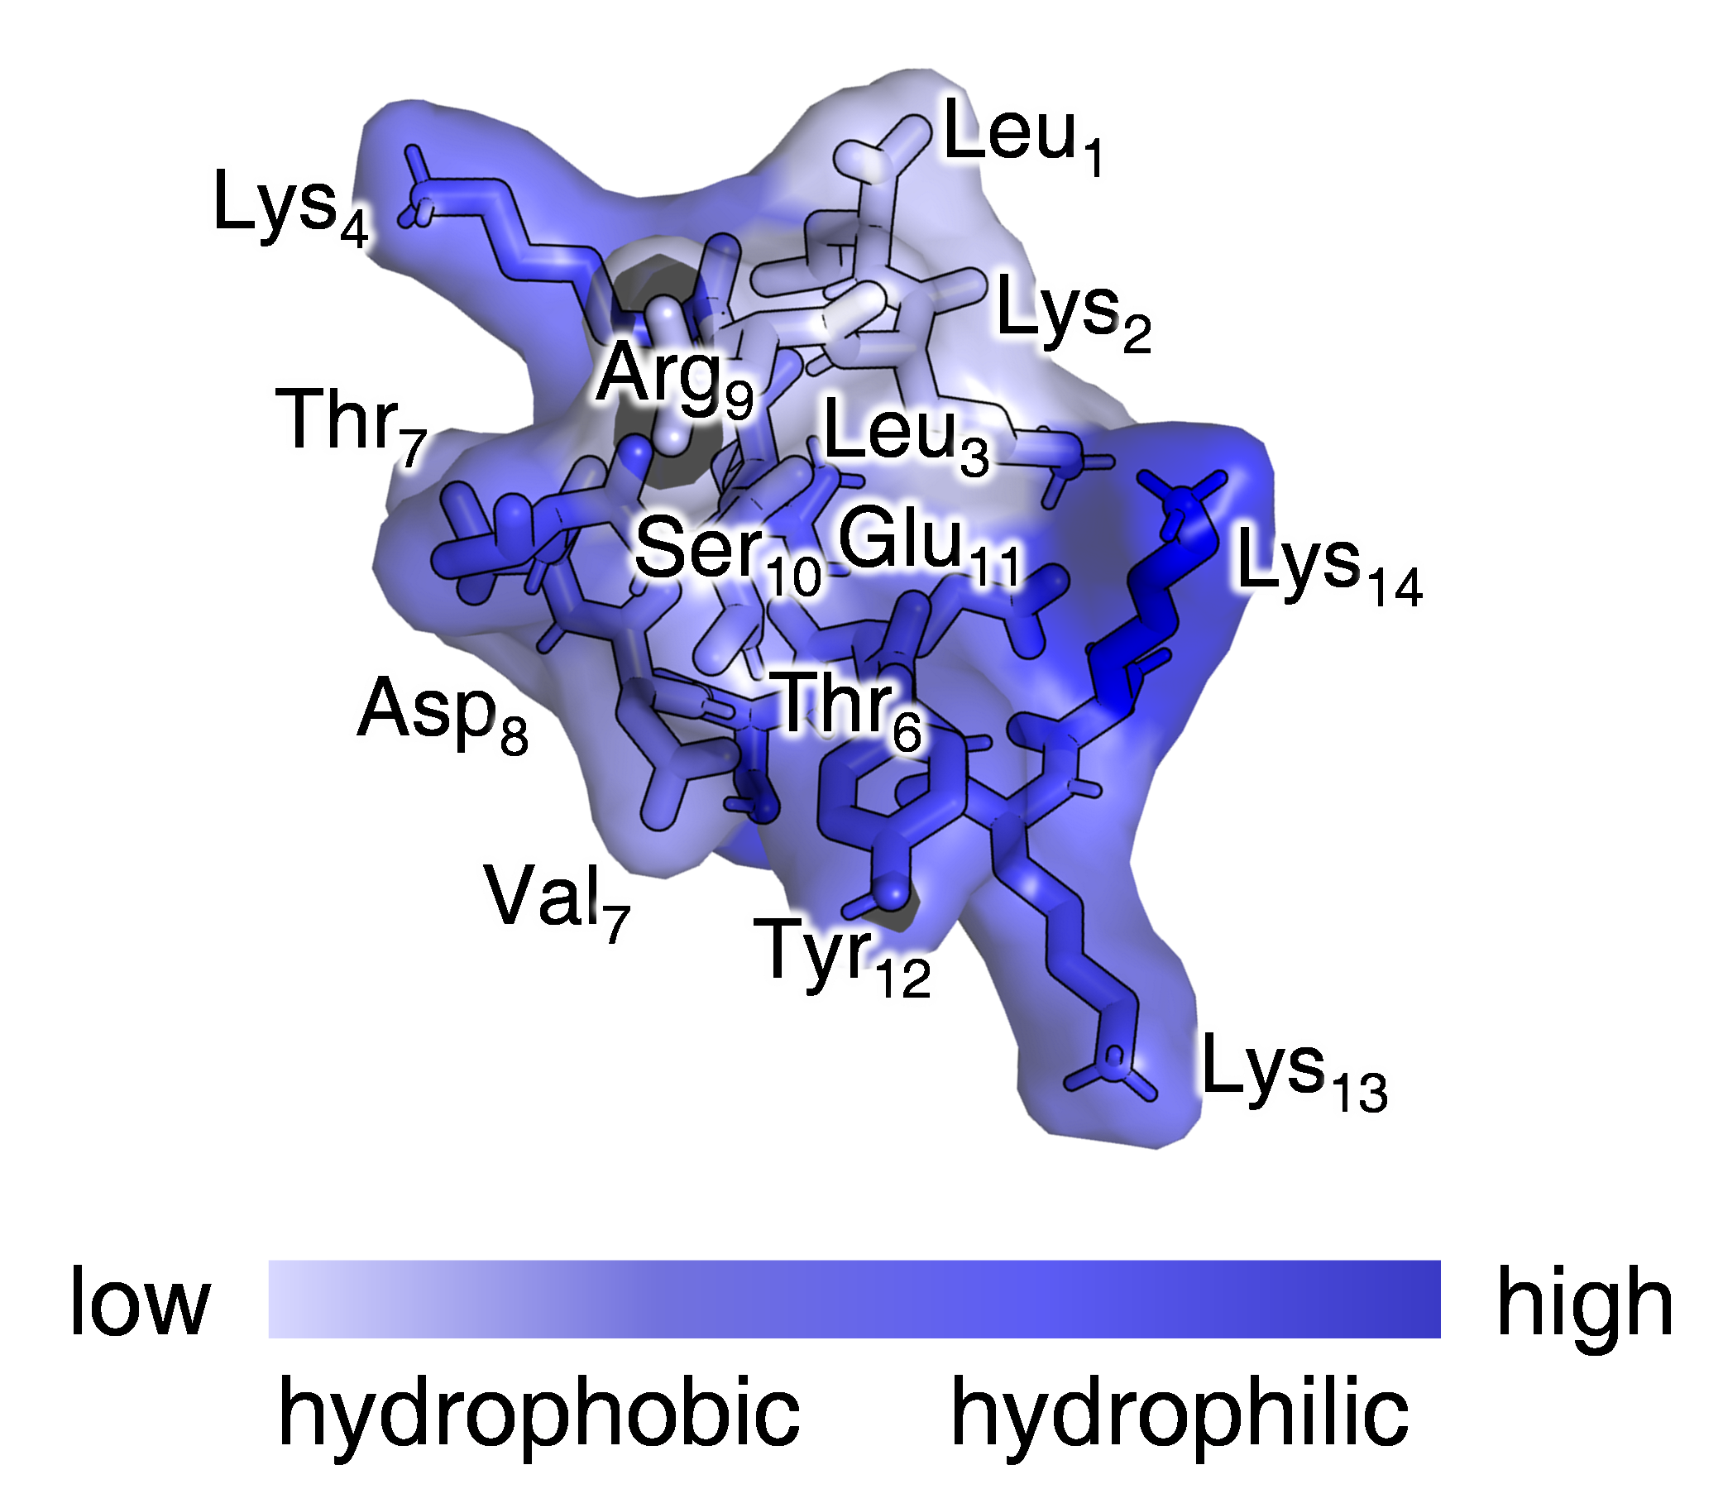
Supplementary Fig. 7. Calculated Solvent-Accessible Surface Area (SASA) of Peptide KK.

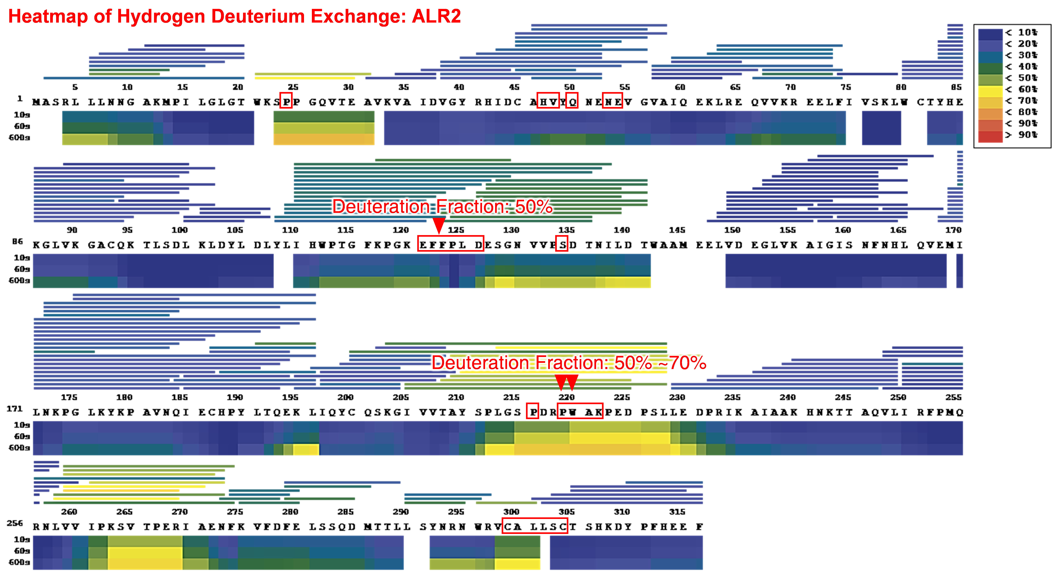
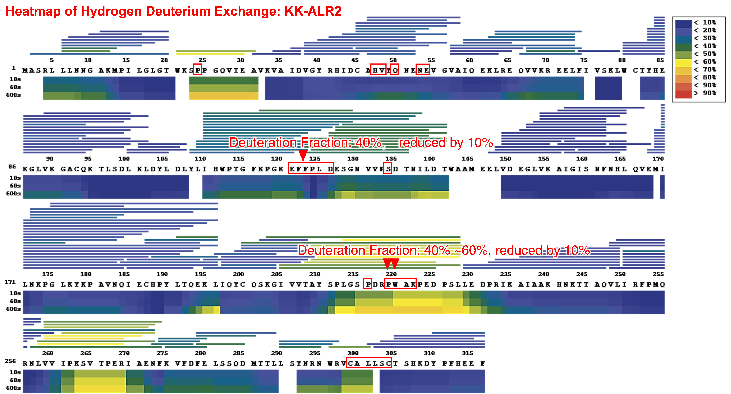
Supplementary Fig. 8. Heatmap representation of hydrogen-deuterium exchange between KK-ALR2 and ALR2.

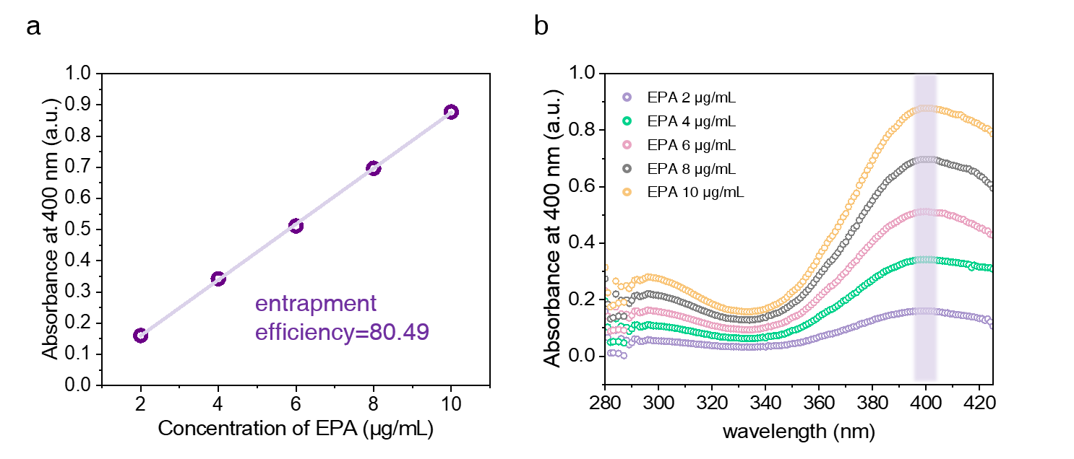
R²=0.99
Supplementary Fig. 9. Encapsulation efficiency of peptide KK for drug EPA. a, Standard curve. b, UV absorption curve.

R²=0.99
Supplementary Fig. 10. Standard Curve for Sorbitol Content Determination (n=3).

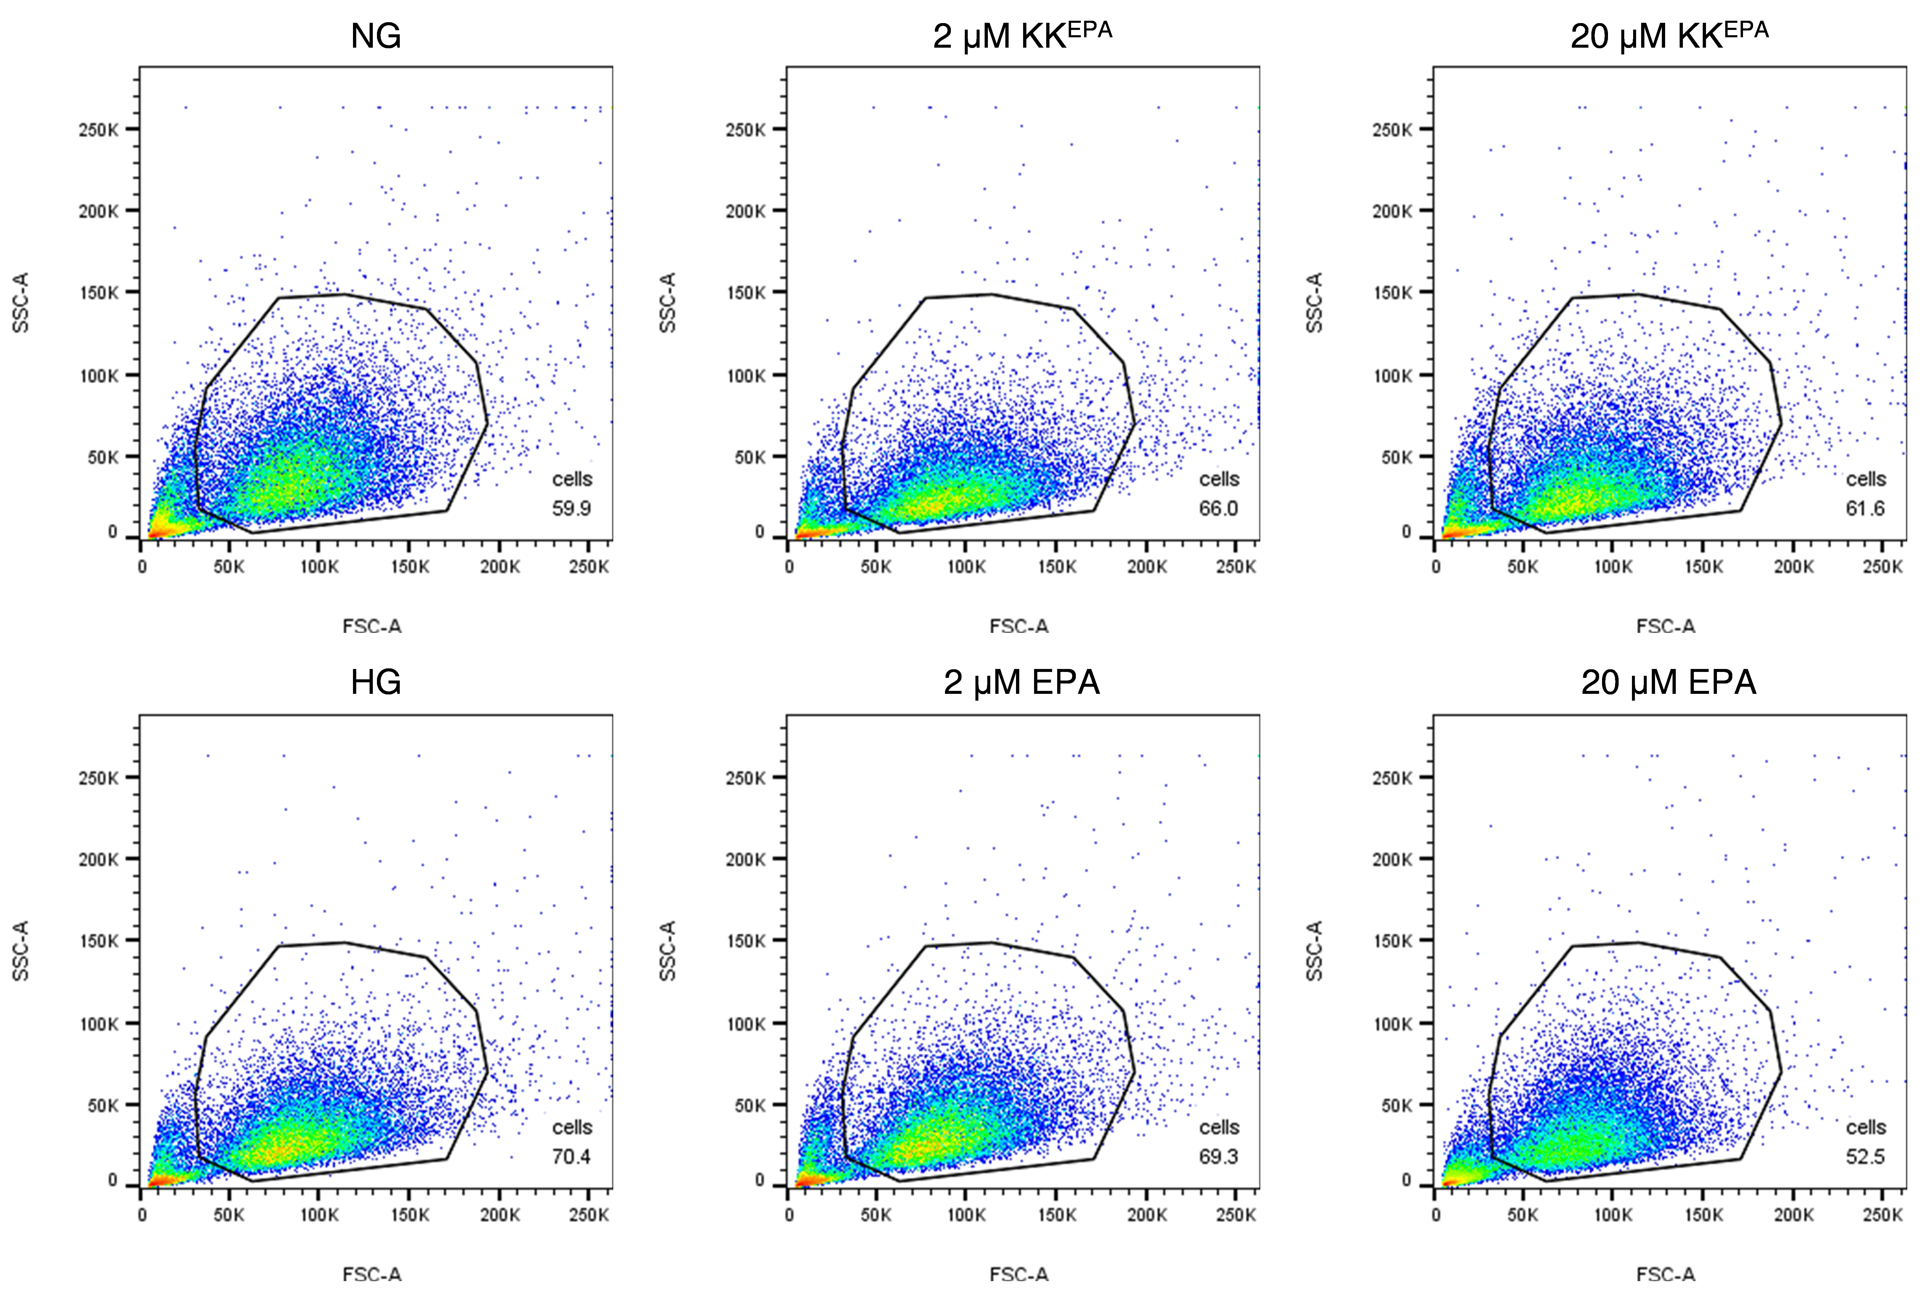
Supplementary Fig. 11. Gating raw data of flow cytometry assay.

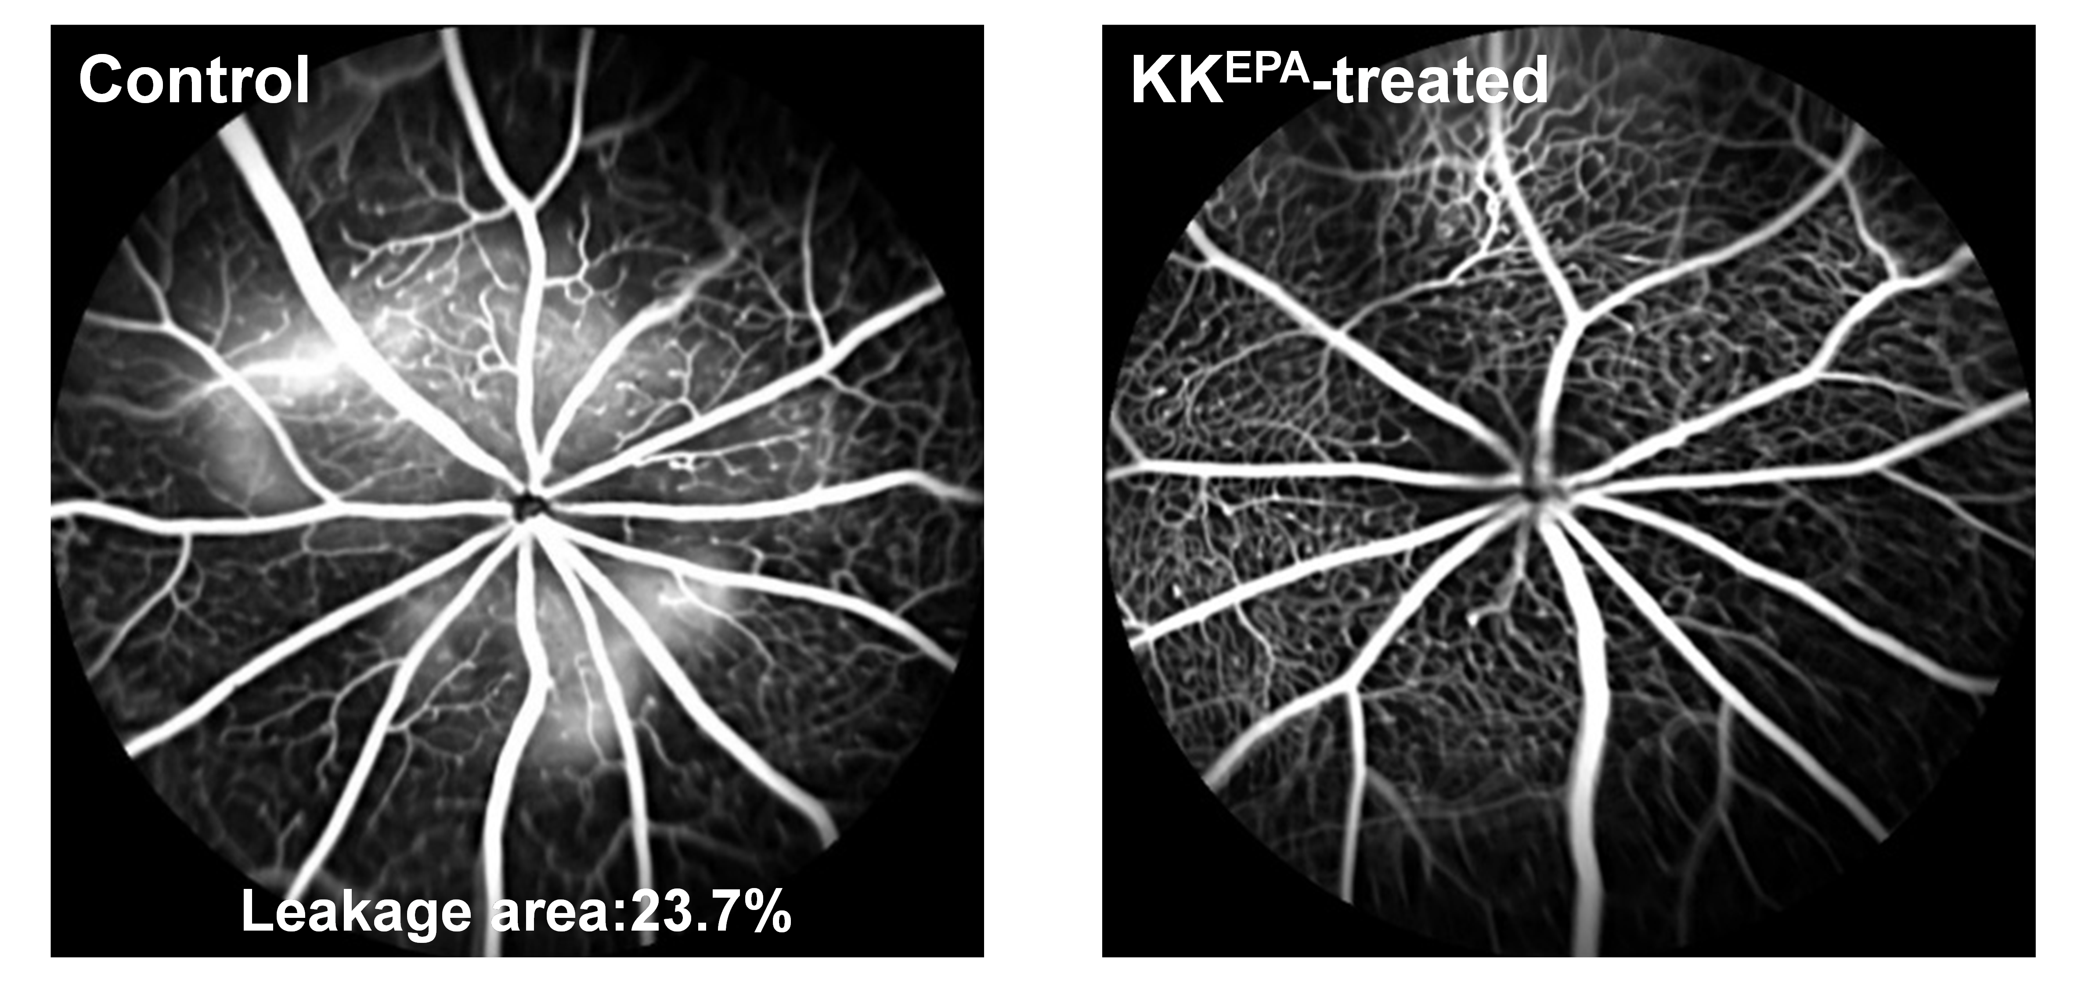
Supplementary Fig. 12. Fluorescein angiography images in Control and KK^{EPA}-treated mice.

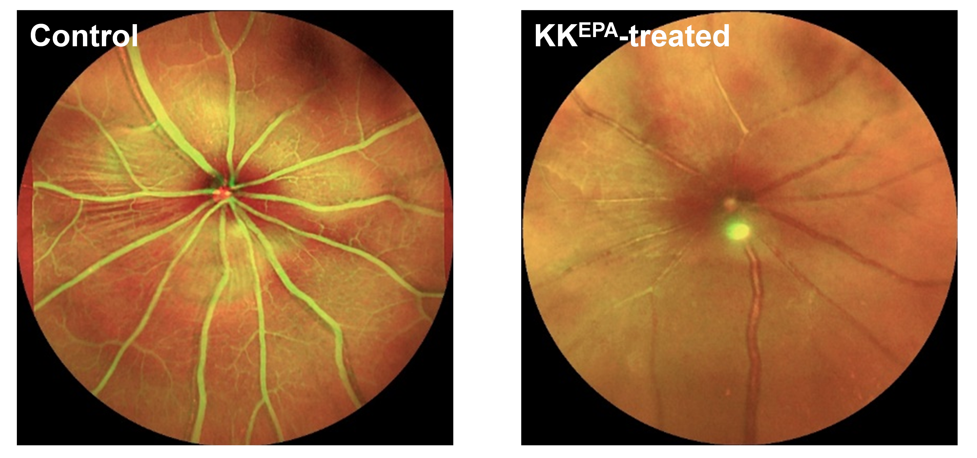
Supplementary Fig. 13. Fundoscopy images in Control and KK^{EPA}-treated mice.

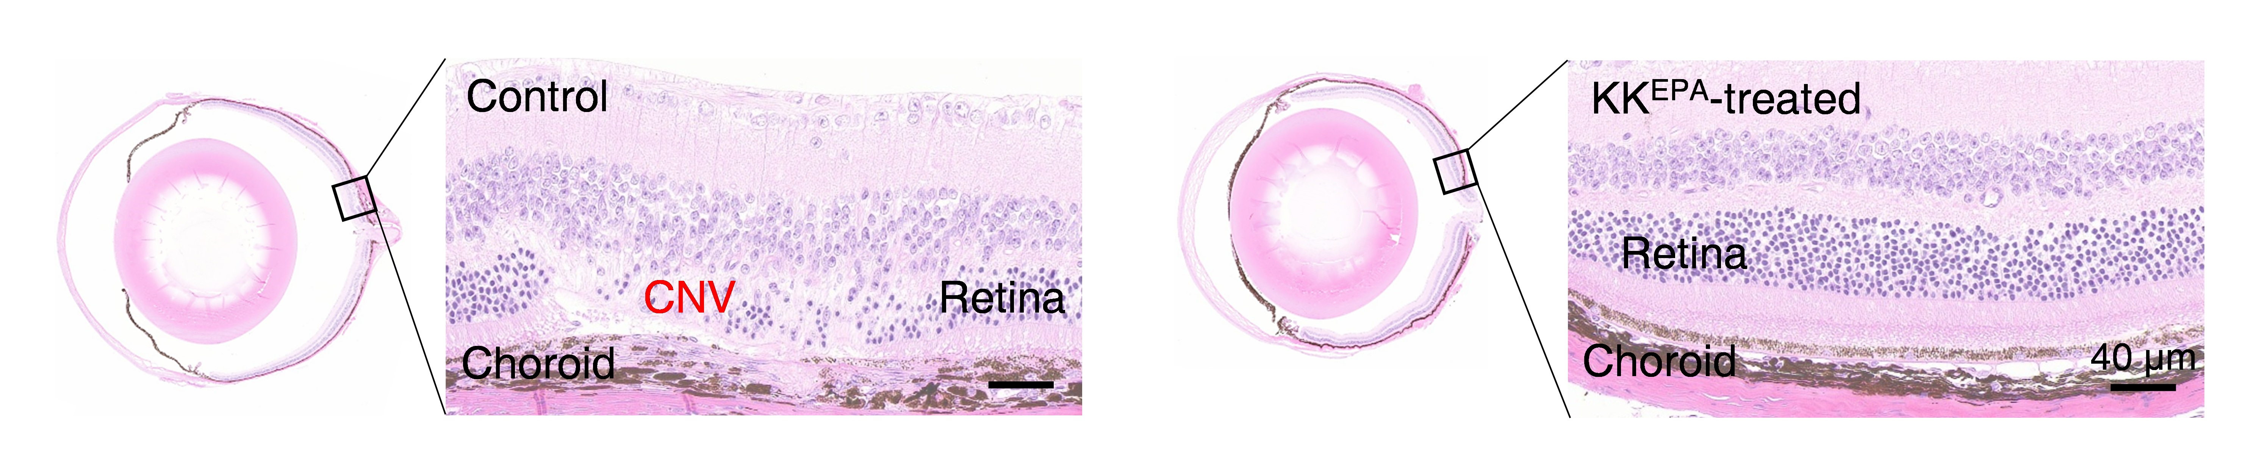
Supplementary Fig. 14. Choroidal neovascularization (CNV) images in Control and KK^{EPA}-treated mice.

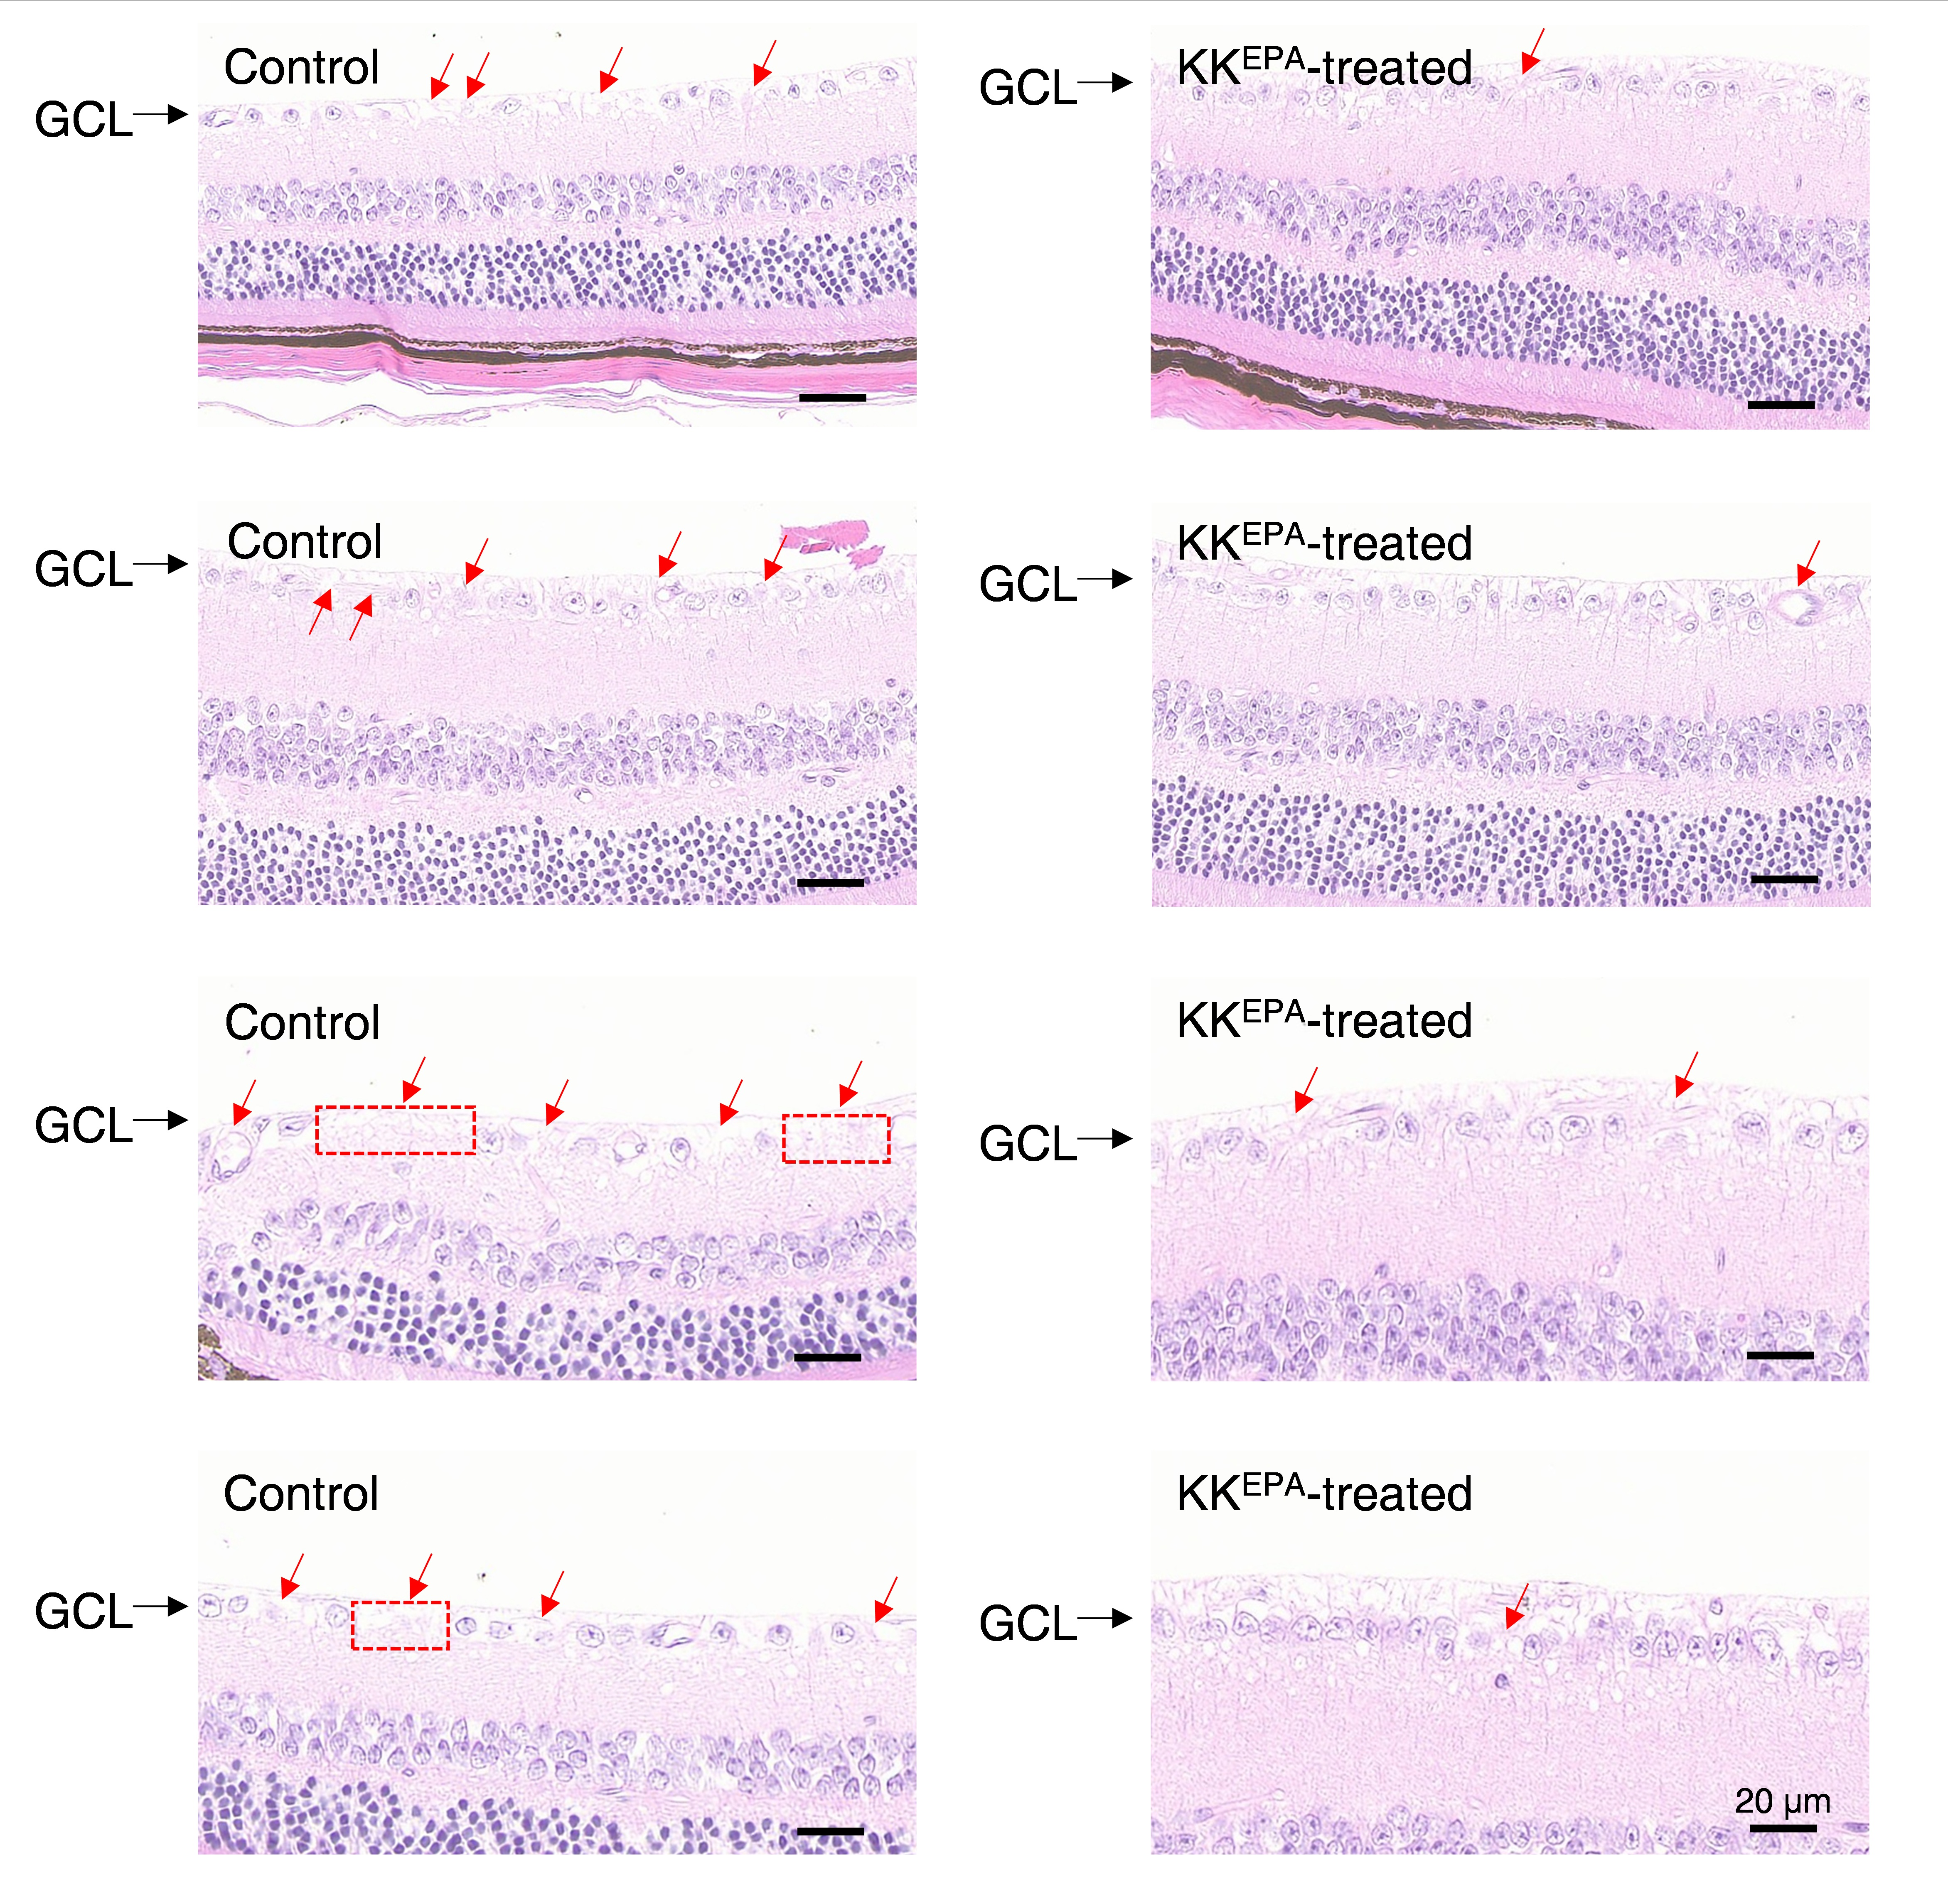
Supplementary Fig. 15. Images showing loss of ganglion cells and ganglion cell nuclei within the ganglion cell layer in Control and KK^{EPA}-treated mice. GCL, ganglion cell layer.

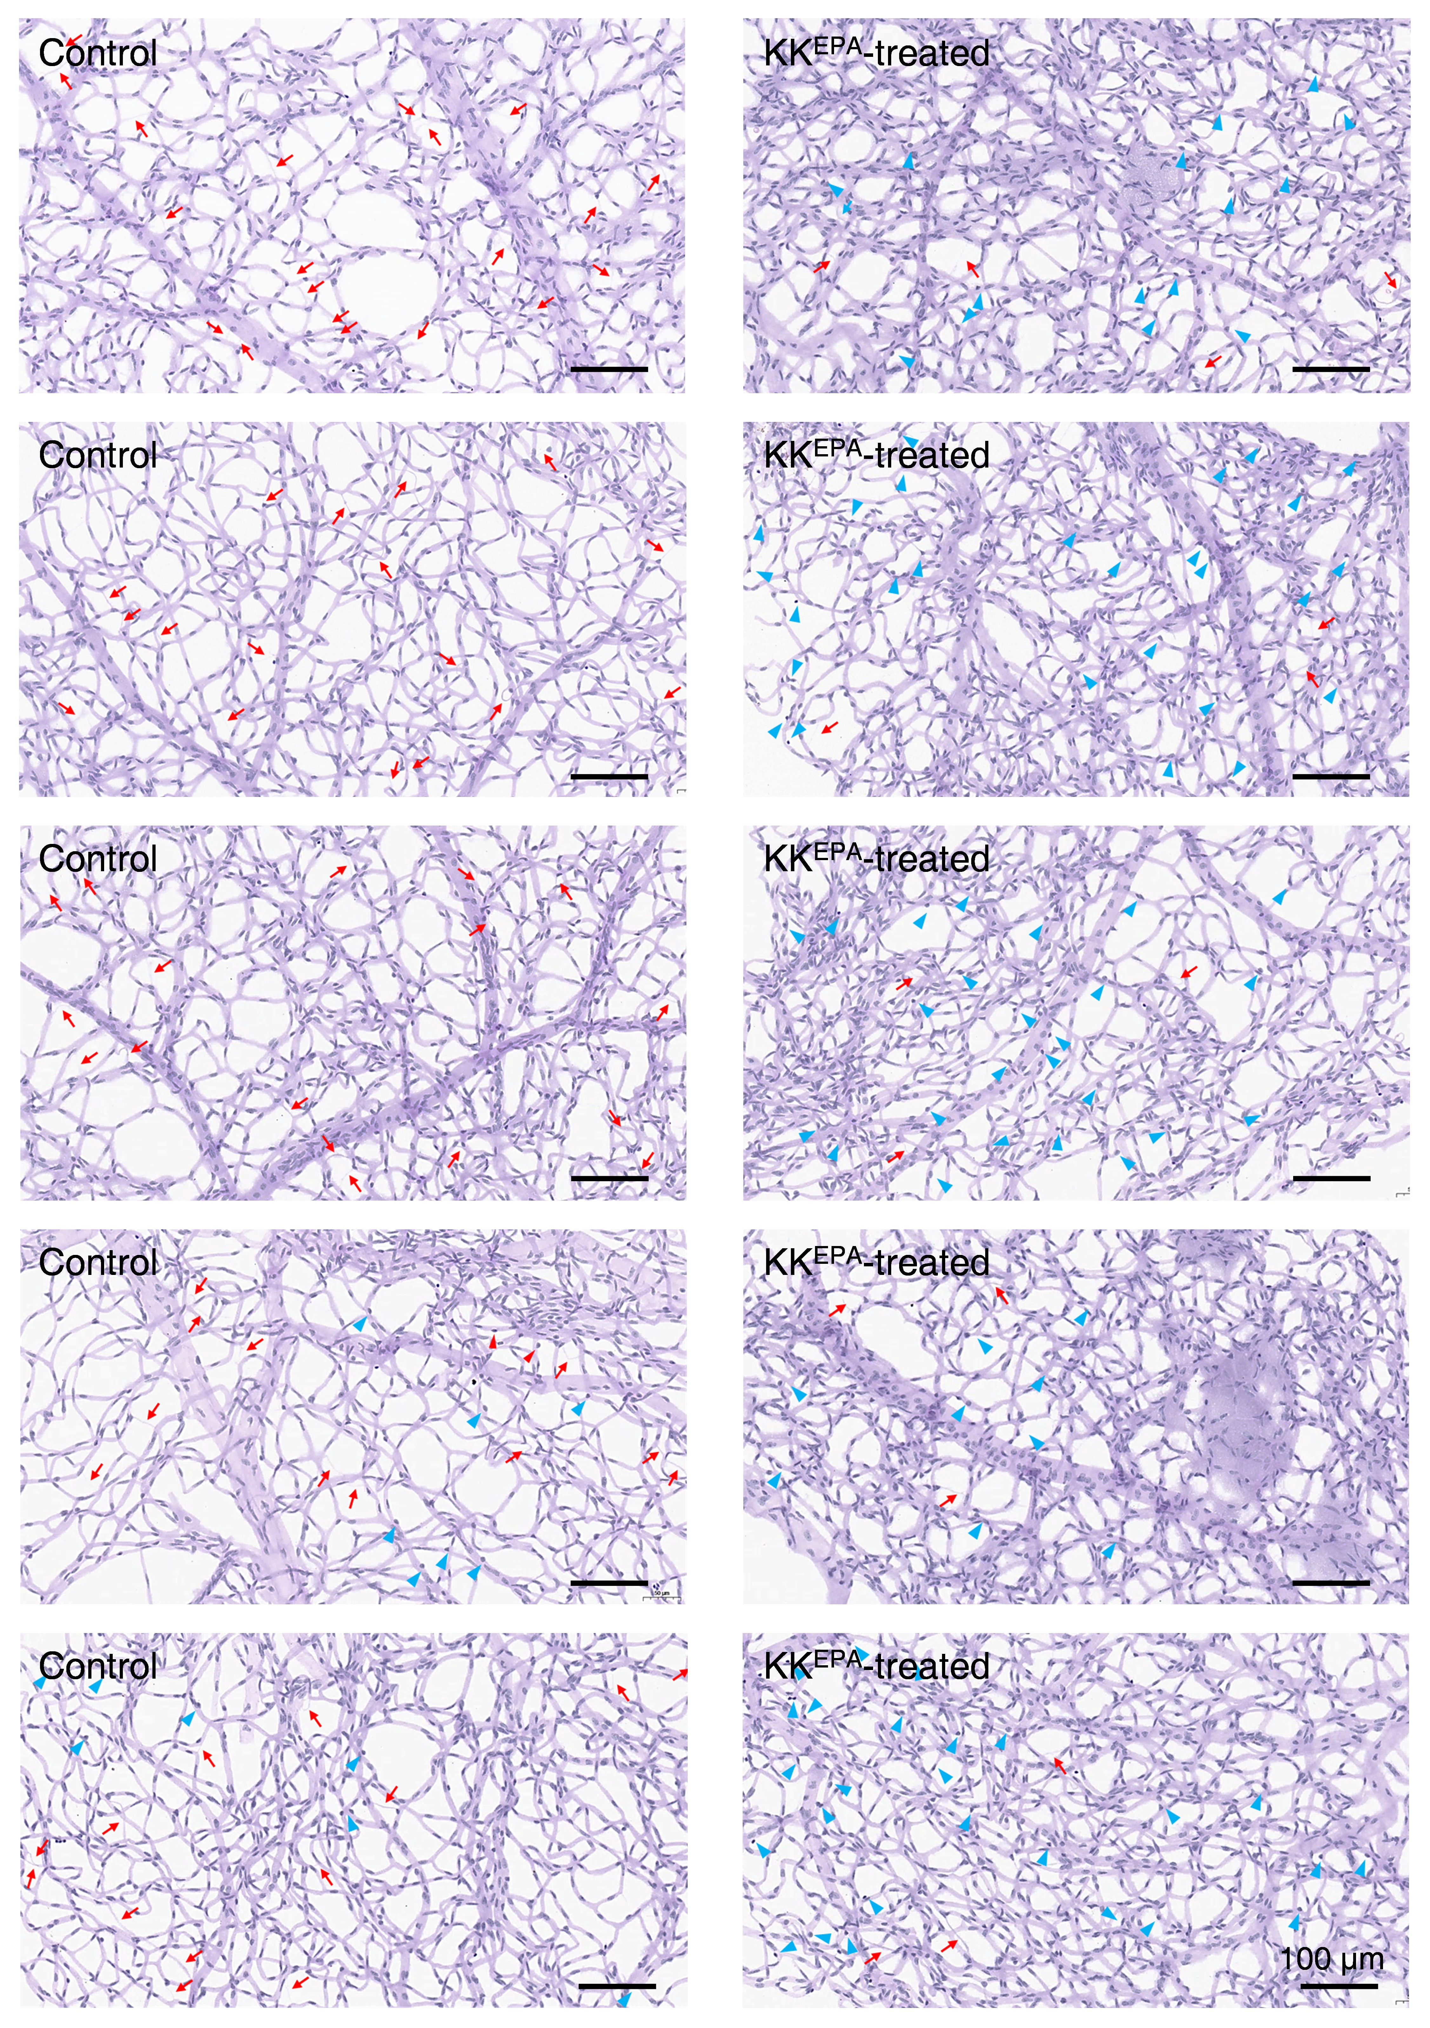
Supplementary Fig. 16. Retinal acellular capillaries images in Control and KK^{EPA}-treated mice.

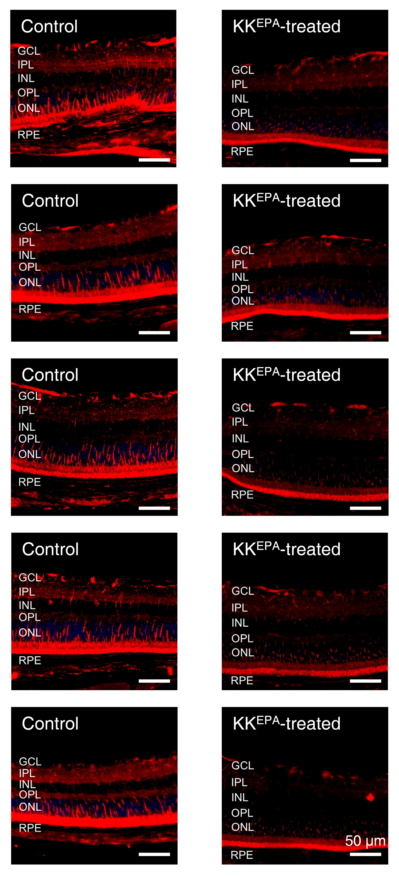
Supplementary Fig. 17. Retinal VEGF immunofluorescence images of Control and KK^{EPA}-treated mice.
Control
KK^{EPA}-treated
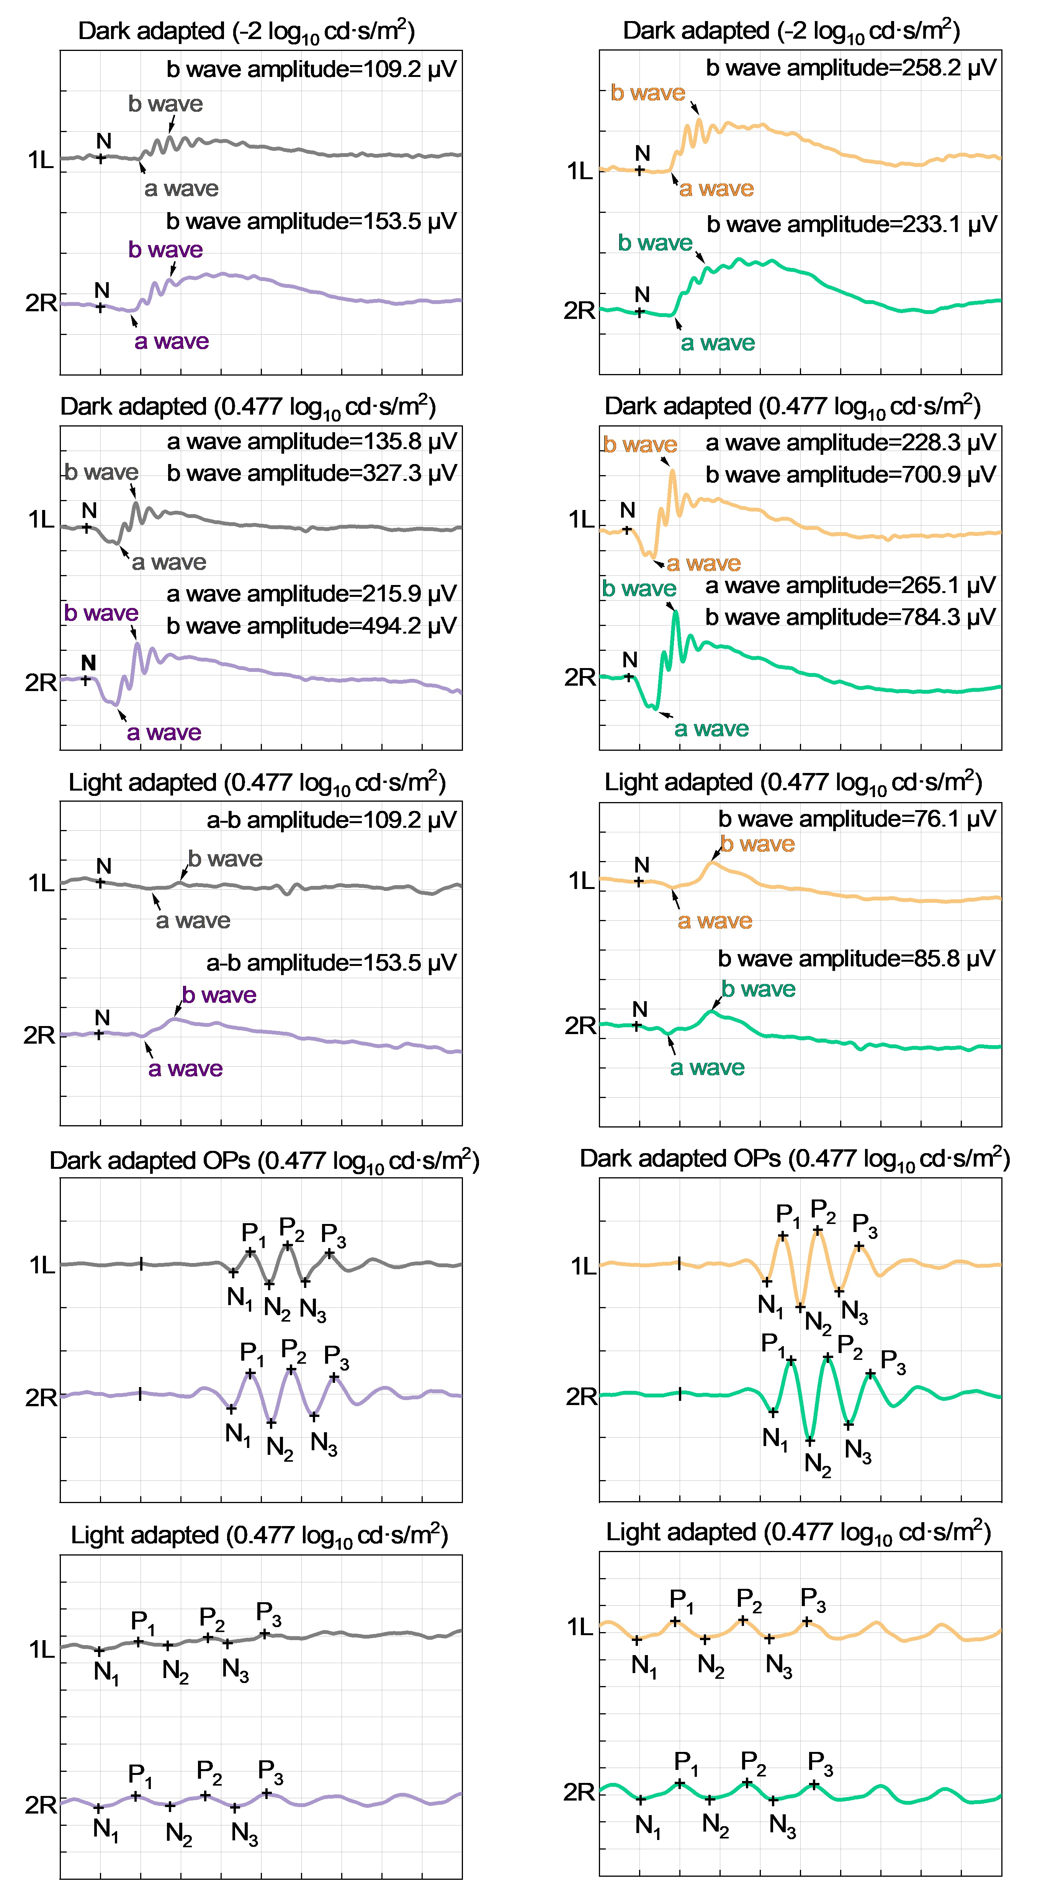
Supplementary Fig. 18. Raw ERG images from Mice.
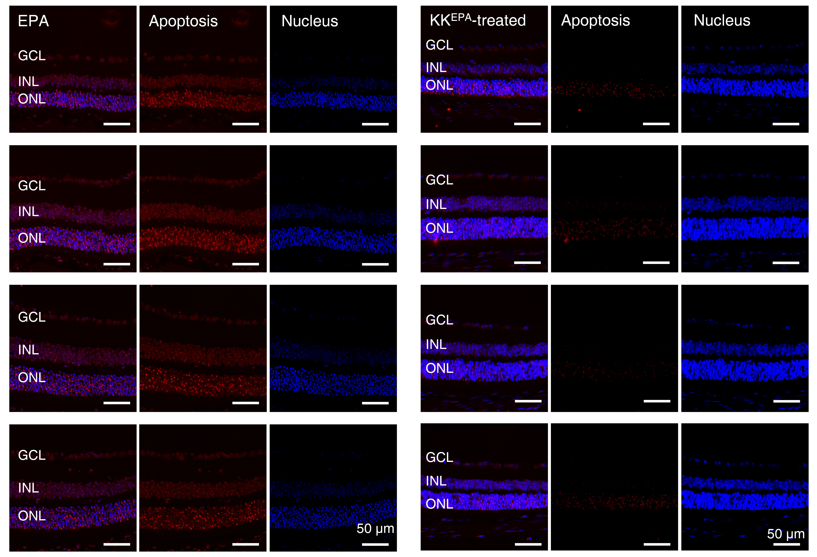
Supplementary Fig. 19. Retinal TUNEL staining images in Control and KK^{EPA}-treated mice.

