Supporting Information
Harnessing Interfacial Polarization in Ultralight Heterostructure Aerogels for High-Efficiency Electromagnetic Dissipation
Kailong Yu^{1#}, Yuelei Pan^{1#}, Zailan Zhang^{2*}, Jinhua Li^{3,4}, Cailong Liu^{5*}, Zhesheng Chen^{1*}
¹School of Material Science and Engineering, Nanjing University of Science and Technology, Nanjing 210094, China
²School of Physics, Nanjing University of Science and Technology, Nanjing 210094, China
³Key Laboratory of Earth and Planetary Physics, Institute of Geology and Geophysics, Chinese Academy of Sciences, Beijing 100029, China
⁴College of Earth and Planetary Sciences, University of Chinese Academy of Sciences, Beijing 100049, China
⁵School of Physics Science & Information Technology, Liaocheng University, Liaocheng, 252000, China

# These authors contributed equally.
*To whom correspondence should be addressed:
zhesheng.chen@njust.edu.cn (Zhesheng Chen)
zhangzailan@njust.edu.cn (Zailan Zhang)
cailong_liu@jlu.edu.cn (C. Liu)

Experimental methods
Chemical Reagents. Nickel (II) nitrate hexahydrate (Ni(NO₃)₂·6H₂O, AR), Ethanol absolute (C₂H₅OH, ≥99.5 %), Sodium citrate (C₆H₅Na₃O₇, 98 %), Potassium hexacyanocobaltate(III) (K₃[Co(CN)₆], 99 %), Single-layer graphene (99 %), Epoxy resin (C₁₁H₁₂O₃, 99 %), Methylhexahydrophthalic anhydride, (MHHPA, C₉H₁₂O₃, 98 %), Deionized (DI) water. All raw materials were purchased from a platform and used without secondary processing.
Preparation of NiCo PBA nanocubes. Measure 1.6 mmol of Ni(NO₃)₂·6H₂O and 2.4 mmol of C₆H₅O₇Na₃ into a beaker, add 60 ml of DI water and stir evenly; Take another beaker, add 1 mmol of K₃[Co(CN)₆] and 40 ml of DI water, and stir evenly. The two beakers were mixed, stirred for 30 min, and then left to stand for 12 h, resulting in a sky-blue precipitate. Wash it several times with deionized water and ethanol, and dry it overnight in a 60°C vacuum dryer.
Preparation of NiCo PBA@GO. Prepare 4 mg of the prepared NiCo PBA nanocubes and place them in 10 ml of a 2 mg/ml graphene dispersion. Ultrasonically stir for 3 h, then freeze-dry at -65°C for 30 h under a vacuum pressure below 0.1 Pa. Store the freeze-dried NiCo PBA@GO in an inert atmosphere for subsequent use.
Preparation of Co₂N_{0.67}/Ni₃C@C (CoN/NiC@C), Co₂N_{0.67}/Ni@rGO (CoN/Ni@C), Co/Ni@rGO (Co/Ni@C). Place 20 mg of the prepared NiCo PBA@GO in a high-temperature tubular furnace, introduce a H₂/Ar mixture with 5 % flow rate, set the heating rate to 2 °C/min. Reaction conditions: 400°C, 2 h. After cooling to room temperature, obtain CoN/NiC@C, and store it in an inert atmosphere for later use. Without changing other conditions, the annealing temperatures were changed to 500 °C and 600 °C to obtain CoN/Ni@C, Ni/Co@C. The synthesis of CoN/NiC@C, CoN/Ni@C and Co/Ni@C heterostructures was carried out in three steps. Firstly, NiCo PBA nanocubes were precipitated from aqueous solutions containing Ni²⁺, citrate, and [Co(CN)₆]³⁻ ions. Subsequently, the NiCo PBA nanocubes were anchored onto GO nanosheets through ultrasonication, forming a composite aerogel after freeze-drying. Finally, the heterostructures were obtained by annealing the aerogel in a H₂/Ar atmosphere at controlled temperatures (400-600 °C).
The core temperature-dependent phase evolution is summarized by the following reaction process:
$$NiCo-PBA\overset{{400}^{∘}C,\frac{H_{2}}{Ar}}{→}{Co}_{2}{\text{N}}_{0.67}+{Ni}_{3}C+{NH}_{3}↑+(CN)_{2}↑+H_{2}O↑ …………(S1)$$
$$Ni_{3}C+H_{2}\overset{{500}^{∘}C,H_{2}/Ar}{→}Ni++(CN)_{4}↑…………………………(S2)$$
$${Co}_{2}{\text{N}}_{0.67}+H_{2}\overset{{600}^{∘}C,H_{2}/Ar}{→}Co+{NH}_{3}↑ …………………………(S3)$$
Characterization. The sample morphology characterization was performed using a scanning electron microscope (SEM, JIB-4700F). Transmission electron microscopy (TEM) imaging, selected area electron diffraction (SAED) and high-resolution transmission electron microscopy (HRTEM) imaging were carried out using a JEOL JEM-2100 TEM (operating at 200 kV) from the Institute of Geology and Geophysics of the Chinese Academy of Sciences (IGGCAS), with electron beams generated by a LaB6 electron gun. The sample microstructure was characterized by using high-power rotating-target X-ray diffraction (XRD, Bruker D8 Discover, Cu-Kα radiation source, λ = 1.5405 Å), X-ray photoelectron spectroscopy (XPS, NEXSA), Raman spectroscopy (HORIBA HR EVO NANO, 532 nm laser), Fourier-transform infrared spectroscopy (FTIR, Bruker Tensor 27) and thermogravimetry (TGA 5500) to clearly analyze the chemical composition and structural evolution. Infrared thermography was performed using a Hikvision 4117 module and an Allwinner T113-S3 system on a chip (SoC). Paraffin was mixed with the samples at a ratio of 5%, which was then machined into concentric rings with an outer diameter of 7.00 mm and an inner diameter of 3.04 mm for testing the electromagnetic parameters. The complex permittivity and complex permeability of the samples were then measured using the coaxial method with a vector network analyzer (VNA, Agilent N5234A).
DFT calculations. All simulations were performed using DFT. The DOS, charge density differences and Mulliken charges were calculated using the Cambridge Serial Total Energy Package (CASTEP) package. DFT calculations were performed using the Perdew–Burke–Ernzerhof (PBE) exchange–correlation functional within the framework of the generalized gradient approximation (GGA). The energy cut-off value of the plane-wave basis group was set to 400 eV for all relaxation, energy and electronic property calculations. A vacuum region of 15.8 Å thickness was set to prevent spurious interactions in the z-axis direction. A 1 × 1 × 1 k-point grid was used for the model single cells. Each model is based on a single-layer graphene basal plane with a supercell size of 3 × 3 × 1. The atomic coordination information of Co/Ni@C, etc., was constructed based on the graphene basal plane structure. The atomic positions, cell volumes and lattice parameters were fully optimized.
Calculations
Debye polarization relaxation: ¹
$$ε^{'}=ε_{∞}+\frac{ε_{s}-ε_{∞}}{1+ω^{2}τ^{2}}………………………..……………(S4)$$
$$ε^{″}=\frac{\left(ε_{s}-ε_{∞}\right)ωτ}{1+ω^{2}τ^{2}}+\frac{σ}{ωε_{0}}≈\frac{1}{πε_{0}ρf}=ε_{p}^{″}+ε_{c}^{″}…………………..…(S5)$$
where ε' represents the real dielectric constant of the medium, ε″ denotes the imaginary dielectric constant of the medium. ε_{p}″ is the polarization loss, and ε_{c}″ is the conductivity loss. σ denotes the conductivity, ω is the angular frequency, and τ is the relaxation time, which is a function of the composition and temperature. ε_{s} and ε∞ are the static and optical frequency permittivity, respectively. ε₀ is the vacuum permittivity, and ρ is the resistivity.
Calculation of C₀: ²
$$C_{0}=μ^{″}(μ^{'})^{-2}f^{-1}=2πσμ_{0}d^{2}……………………………(S6)$$
Calculation of attenuation constant (α): ^{3,4}
$$α=\frac{\sqrt{2}πf}{c}×\sqrt{(μ^{″}ε^{″}-μ^{'}ε^{'})+\sqrt{(μ^{″}ε^{″}-μ^{'}ε^{'})^{2}+(μ^{″}ε^{″}+μ^{'}ε^{'})^{2}}}……………(S7)$$
Here c represents the speed in the vacuum.; f is the frequency; ε′ and ε″ are the real part and imaginary part of the complex permittivity, respectively; μ′ and μ″ are the real part and imaginary part of the complex permeability, respectively.

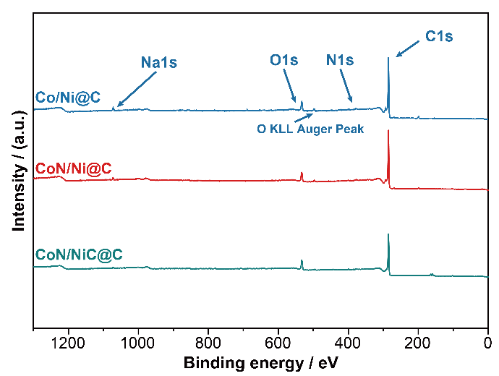
Figure S1. XPS full-scan spectra of CoN/NiC@C, CoN/Ni@C and Co/Ni@C.

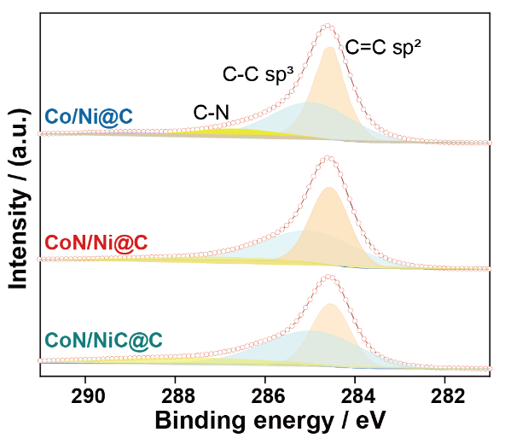
Figure S2. XPS high resolution scan of C 1s region in CoN/NiC@C, CoN/Ni@C and Co/Ni@C.

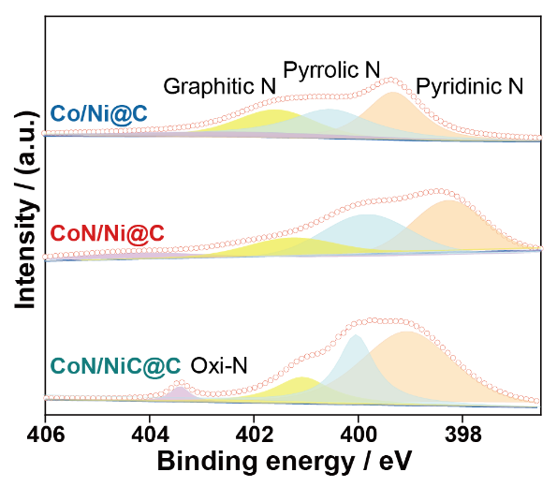
Figure S3. XPS high resolution scan of N 1s region in CoN/NiC@C, CoN/Ni@C and Co/Ni@C.

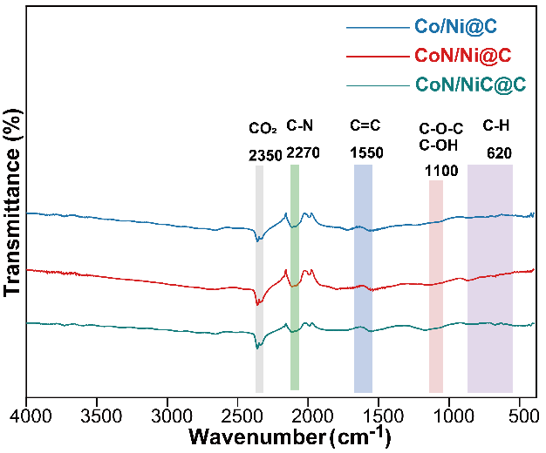
Figure S4. FTIR spectrum of CoN/NiC@C, CoN/Ni@C and Co/Ni@C.

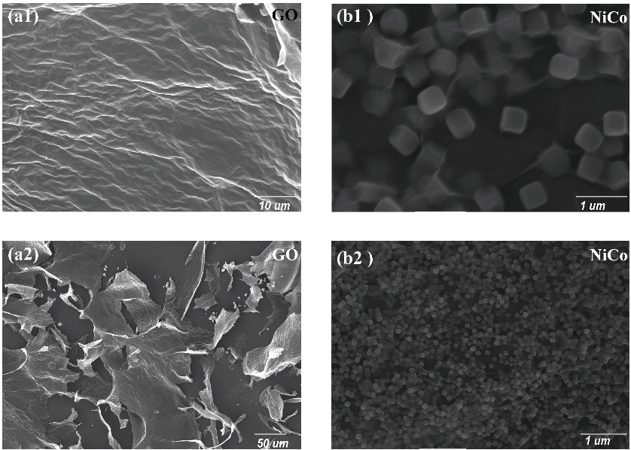
Figure S5. SEM images of (a1-a2) GO, (b1-b2) NiCo PBA.

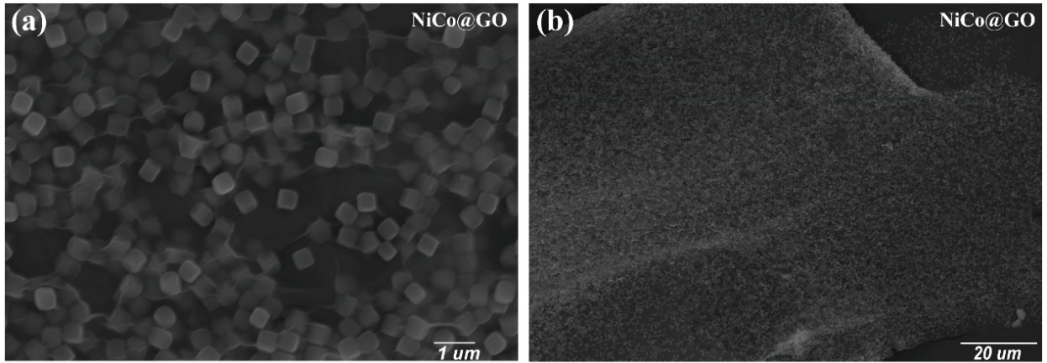
Figure S6. (a-b) SEM images of NiCo PBA@GO.

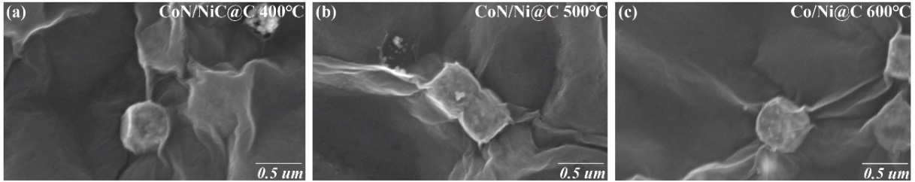
Figure S7. SEM images of (a) CoN/NiC@C, (b) CoN/Ni@C, (c) Co/Ni@C.

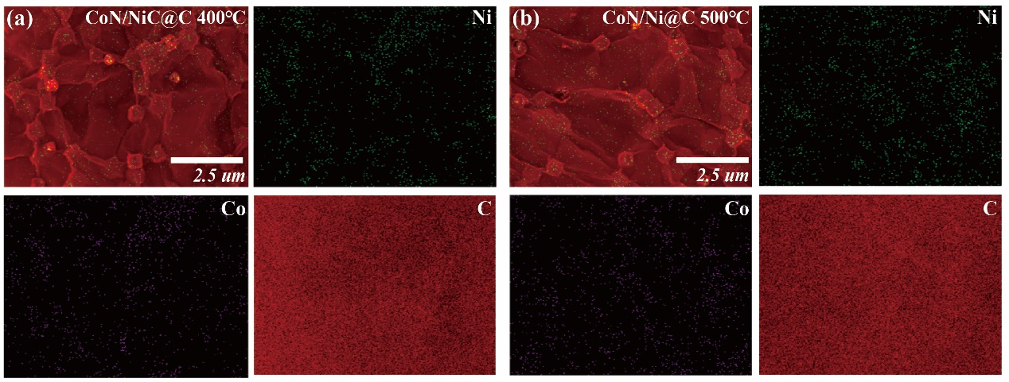
Figure S8. EDS mapping of Ni, Co and C elements of (a) CoN/NiC@C, (b) CoN/Ni@C.

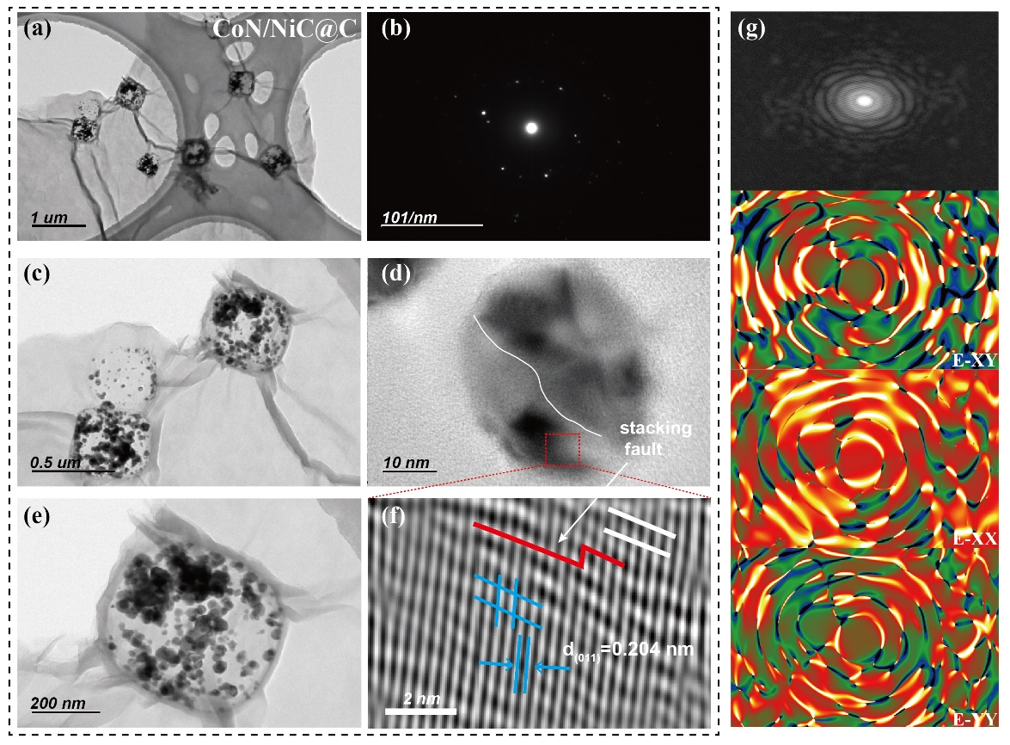
Figure S9. (a) HRTEM of CoN/NiC@C. (b) GPA images and Strain tensor along the E-XY, E-XX, E-YY axis of CoN/NiC@C.

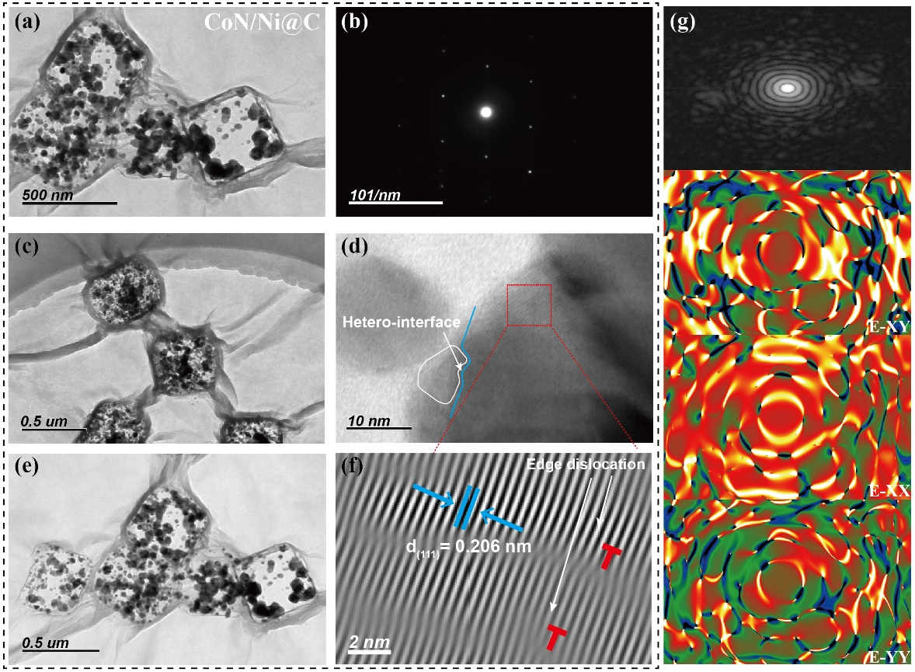
Figure S10. (a-f) HRTEM of CoN/Ni@C. (g) GPA images and Strain tensor along the E-XY, E-XX, E-YY axis of CoN/Ni@C.

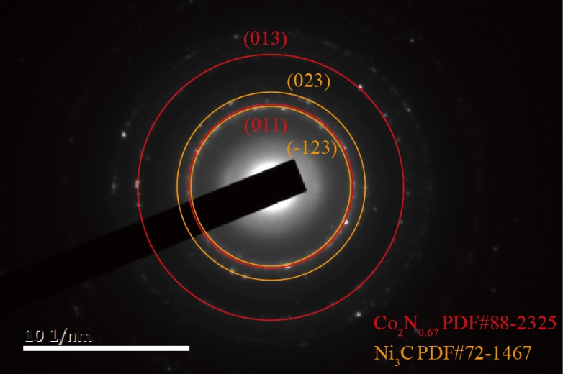
Figure S11. SAED pattern of CoN/Ni@C.

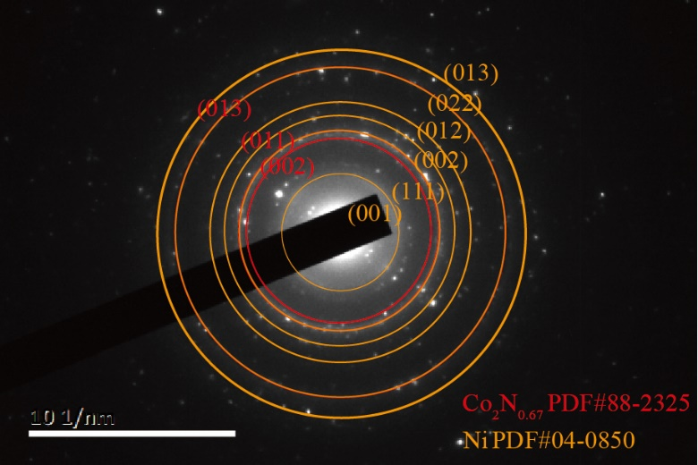
Figure S12. SAED pattern of Co/Ni@C.

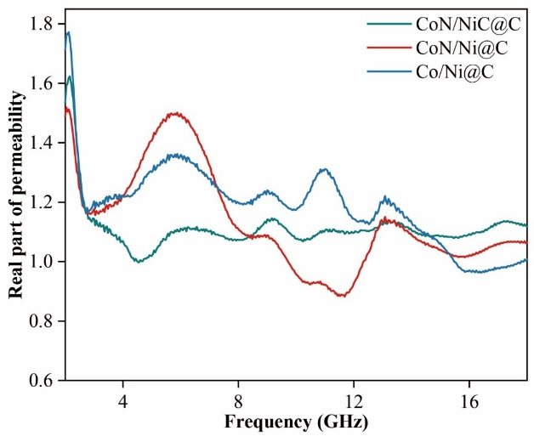
Figure S13. The μ′ curves of CoN/NiC@C, CoN/Ni@C and Co/Ni@C.

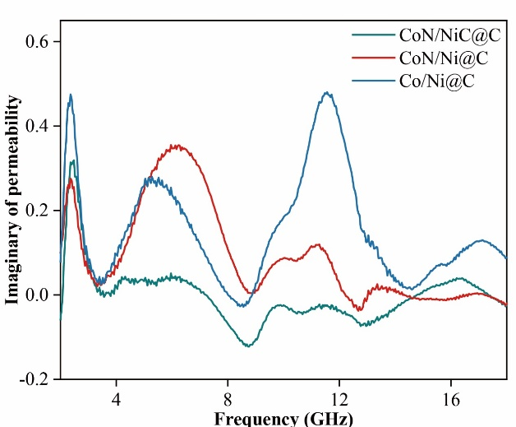
Figure S14. The μ′′ curves of CoN/NiC@C, CoN/Ni@C and Co/Ni@C.

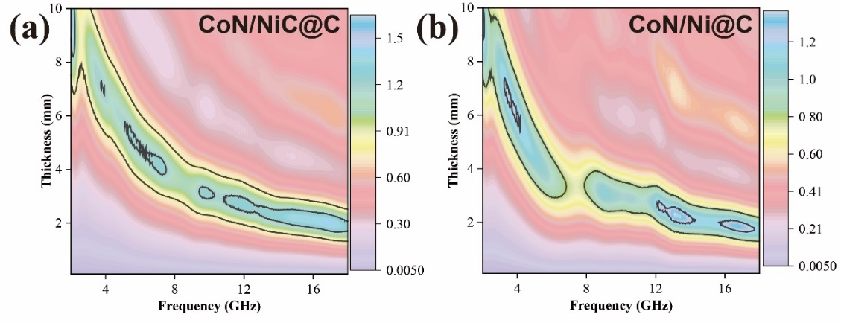
Figure S15. The impedance matching degree of (a) CoN/NiC@C at 400 °C and (b) CoN/Ni@C at 500 °C.

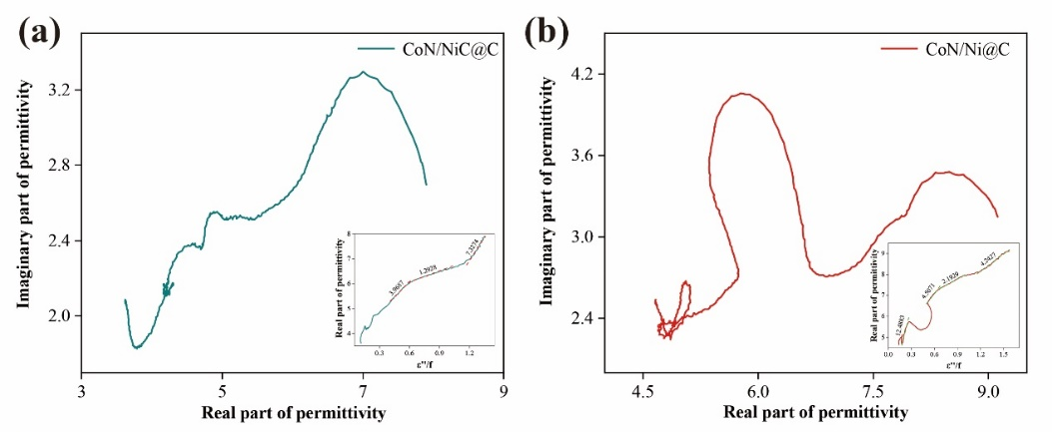
Figure S16. The Cole-Cole curves of (a) CoN/NiC@C at 400 °C and (b) CoN/Ni@C at 500 °C.

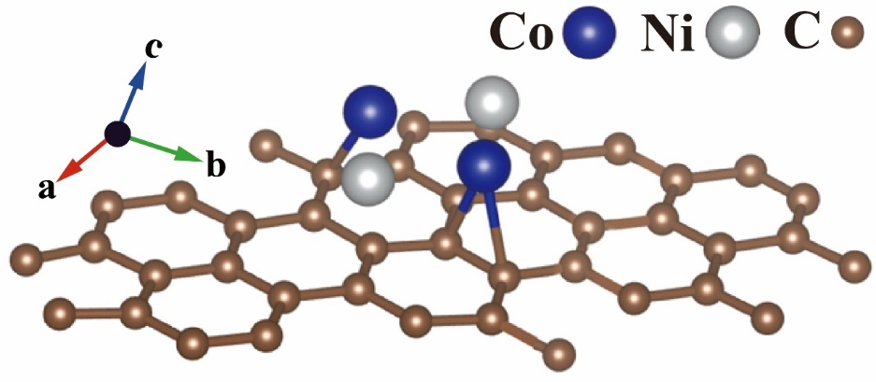
Figure S17. The theoretical DFT model of Co/Ni@C.

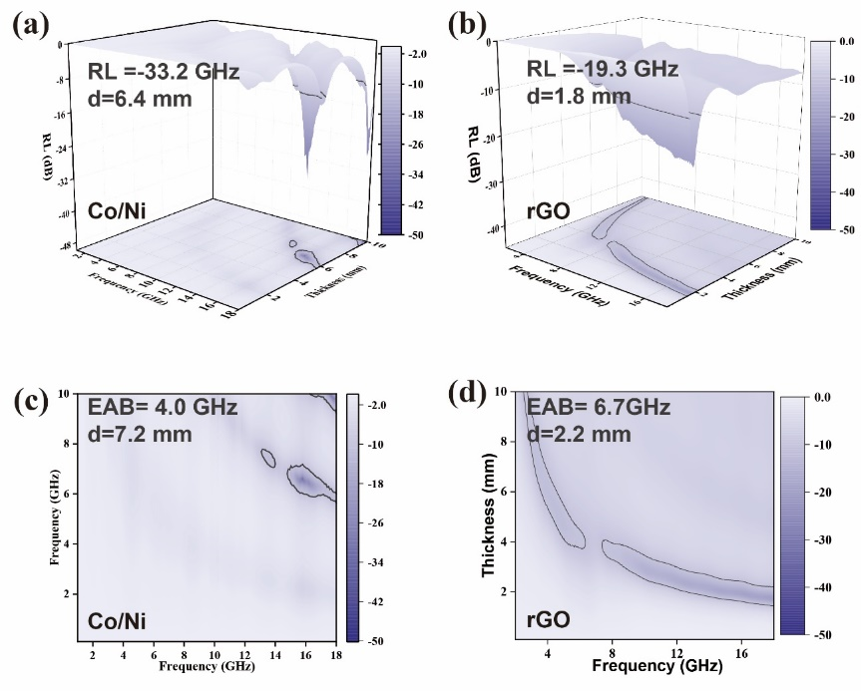
Figure S18. The (a-b) 3D RL plots and (c-d) corresponding 2D EAB maps of Co/Ni and rGO samples.

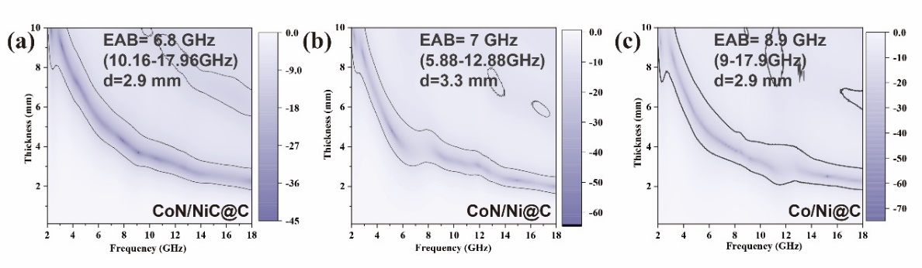
Figure S19. The 2D EAB maps of (a) CoN/NiC@C, (b) CoN/Ni@C and (c) Co/Ni@C.

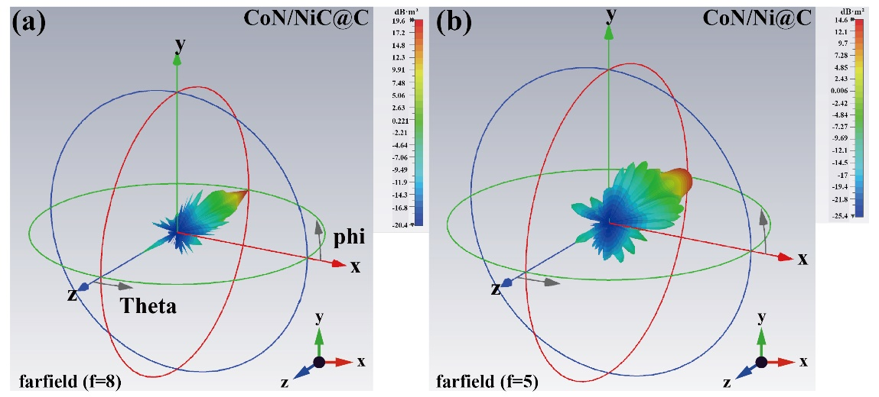
Figure S20. 3D RCS diagrams of (a) CoN/NiC@C, (b) CoN/Ni@C.

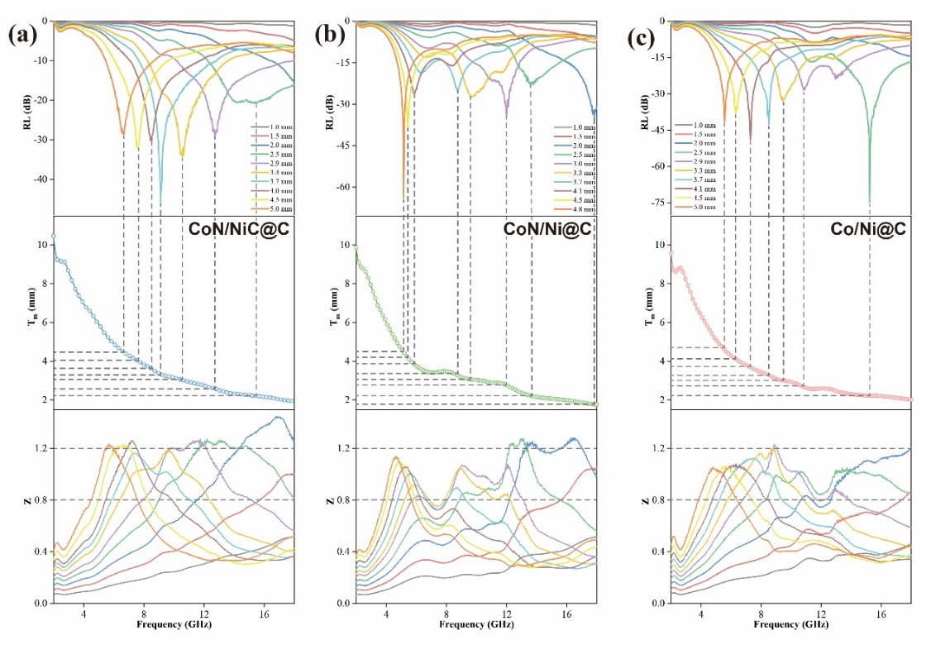
Figure S21. The dependence of RL_{min} on frequency at different thickness; the quarter-wavelength theory model; The dependence of Z on frequency at different thickness of (a) CoN/NiC@C, (b) CoN/Ni@C, of (a) CoN/NiC@C, (c) Co/Ni@C.

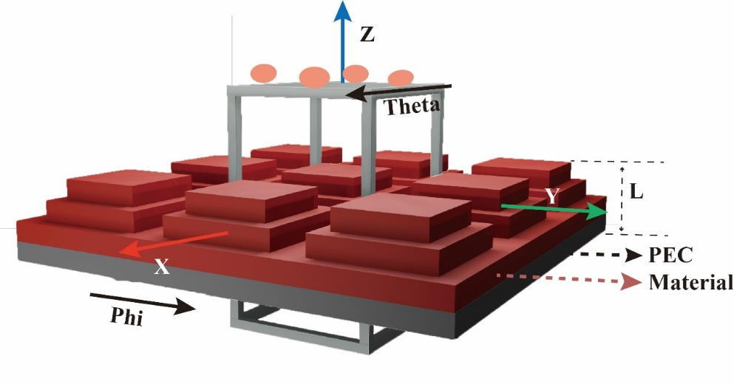
Figure S22. The electric field distribution, and loss density of a specific structure calculated by HFSS module in Ansys software package with following conditions: The boundary condition is set into electric wall; The wave port is set into wave port; The structure is set by peri period arranging 9 identical units.

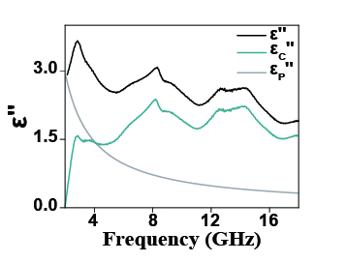
Figure S23. The dynamic proportion analysis of conduction and polarization mechanisms in the Co/Ni@C composite.

References
(1) Wang, Y.; Chen, D.; Yin, X.; Xu, P.; Wu, F.; He, M. Hybrid of MoS₂ and Reduced Graphene Oxide: A Lightweight and Broadband Electromagnetic Wave Absorber. ACS Appl. Mater. Interfaces 2015, 7 (47), 26226–26234.
(2) Zhang, S.; Liu, X.; Jia, C.; Sun, Z.; Jiang, H.; Jia, Z.; Wu, G. Integration of Multiple Heterointerfaces in a Hierarchical 0D@2D@1D Structure for Lightweight, Flexible, and Hydrophobic Multifunctional Electromagnetic Protective Fabrics. Nano-Micro Lett. 2023, 15 (204).
(3) Zhai, N.; Luo, J.; Shu, P.; Mei, J.; Li, X.; Yan, W. 1D/2D CoTe₂@MoS₂ Composites Constructed by CoTe₂ Nanorods and MoS₂ Nanosheets for Efficient Electromagnetic Wave Absorption. Nano Res. 2023, 16 (7), 10698–10706.
(4) Zan, S.; Zhang, W.; Li, H.; Wang, R.; Qi, S. NiSe@MoSe₂ Foam: Synthesis, Characterization and Microwave Absorption Investigation. J. Mater. Sci. Mater. Electron. 2023, 34 (1), 56.

