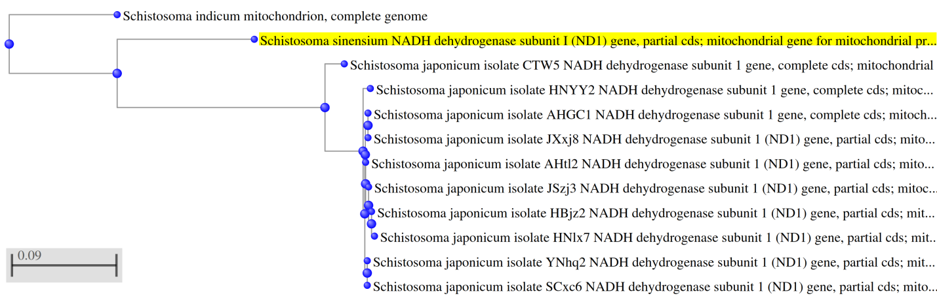
A. Cladogram from NCBI BLAST.
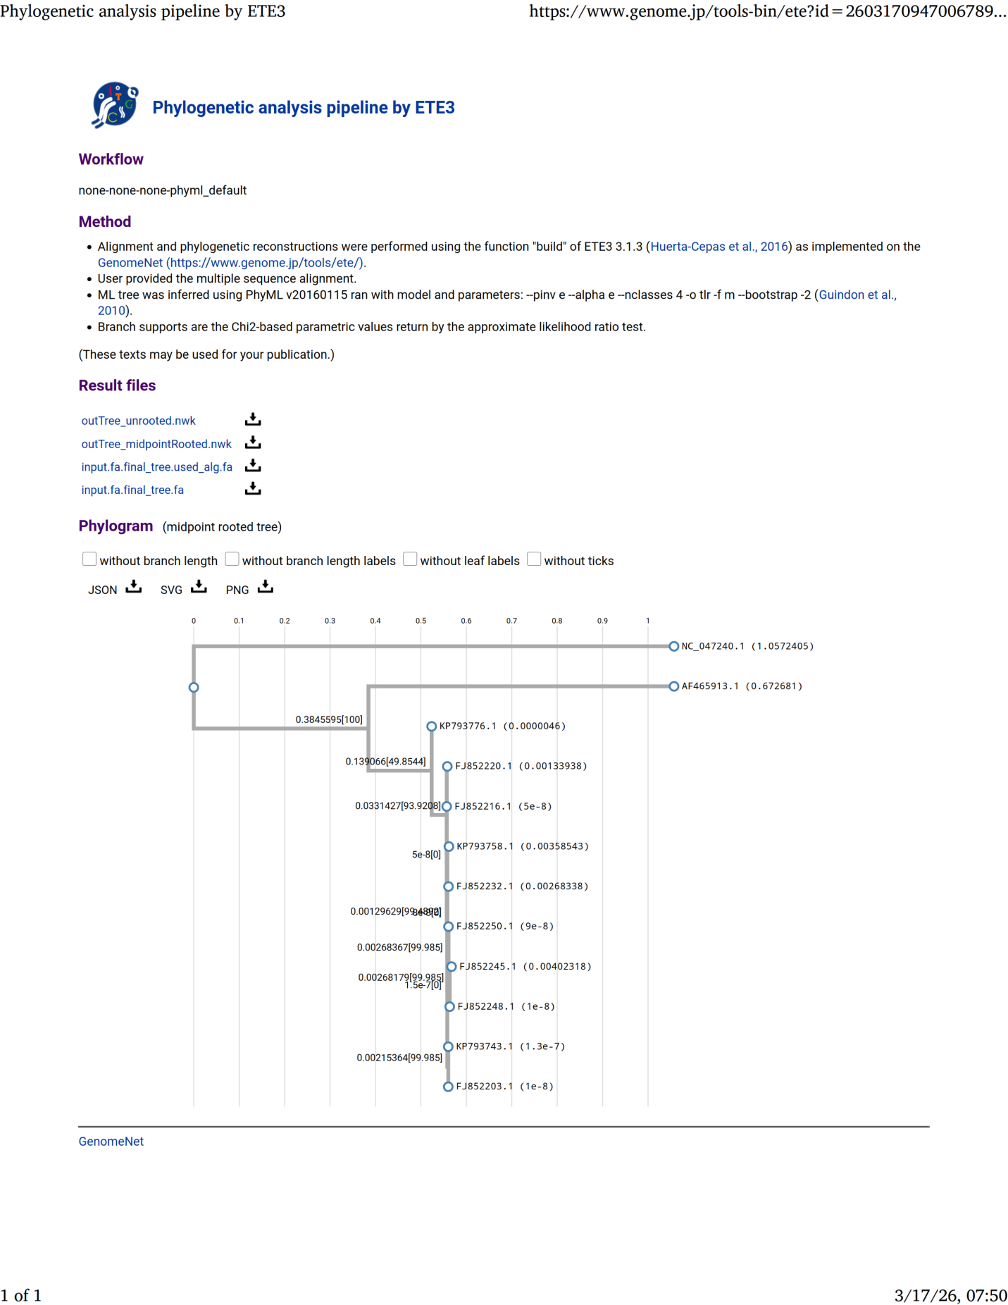B. Cladogram from CLUSTALW and PhyML.
Figure S1. Cladogram A and Cladogram B are almost identic.

