Supplementary Information for
Simultaneous Prediction of Three Key Li-Ion Battery Indicators through Multi-Task Learning
Minjeong Gongª, Yoonjung Choiª, Han Mo Yang^{b}, Sang Bok Ma^{b}, Dong-Hwa Seo*ª

Affiliation
ª Department of Materials Science and Engineering, Korea Advanced Institute of Science and Technology (KAIST), 291 Daehak-ro, Yuseong-gu, Daejeon 34141, Republic of Korea
^{b} Battery Tech Department, SK ecoplant, 19 Yulgok-ro 2-gil, Jongno-gu, Seoul 03143 Republic of Korea

* Corresponding author: dseo@kaist.ac.kr (Prof. D.-H. Seo)
Supplementary Note. 1. Input feature generation from diagnostic protocol data
Features were systematically extracted from voltage response recorded during diagnostic protocol test, categorized into three primary types: instantaneous voltages, resistances, and voltage distribution characteristics. The instantaneous voltages included V_{0.1s} and V_{5s} where V_{x s} denotes the voltage measured x seconds after the onset of a current pulse or rest time. Alongside these values, resistances were derived, namely R_{0-0.1s} and R_{0.1-5s}, to capture both ohmic and polarization behaviors during each step. Resistances were calculated as follows:
$$R_{x-y s}= \frac{\left|V_{x s}-V_{y s}\right|}{current}$$
To further characterize the electrochemical dynamics, the distribution of voltage during each step was quantified using the skewness and kurtosis of the voltage response for every current pulse and rest time. Specifically, skewness measures the asymmetry of the recorded voltages, reflecting the direction and degree of bias in the voltage response, while the kurtosis indicates the tailedness or peakedness of the distribution, capturing the sharpness and intensity of the voltage transitions.
Beyond these step-specific metrics, additional relational features were generated to express dependencies across varying C-rate and current directions. These included the end voltage difference of each pulse to account for hysteresis effect (hyst), as well as the resistance ratio between charging and discharging (R_ratio) at identical C-rates. The sensitivity of the resistance to current magnitude was also incorporated by calculating the resistance ratio between the 1.65 and 2.0 C-rate. Given the high dimensionality of the resulting feature set, a systematic labeling convention—(C-rate)_(current direction)_(pulse or rest)_(value)—was adopted to ensure consistent identification and management of each feature associated with the diverse diagnostic protocols. Specifically, the C-rate component is comprised of two distinct value: 1.65 and 2.0 C, while the current direction is designated as ‘ch’ for charging or ‘dch’ for discharging. To distinguish between operational states, the abbreviations ‘P’ and ‘R’ are used to indicate pulse and rest time, respectively. Finally, the value component specified the type of metric extracted, such as V for instantaneous voltage, R for resistance, hyst for hysteresis effect or R_ratio, allowing for a precies mapping of each feature to its corresponding condition.
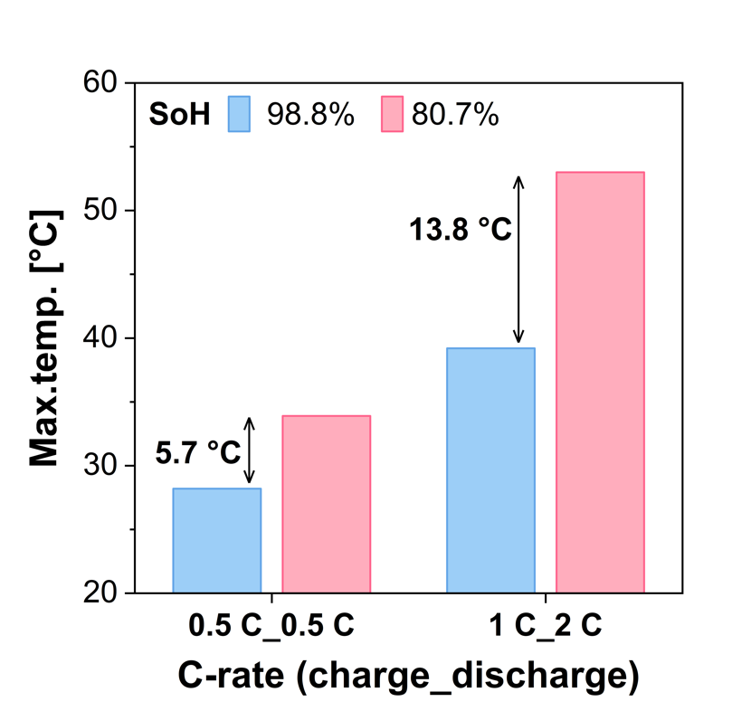
Supplementary Fig 1. The Max. temp. comparison as cell degradation depending on the current density (a) 0.5 C-rate charge and 0.5 C-rate discharge (b) 1 C-rate charge and 2 C-rate discharge
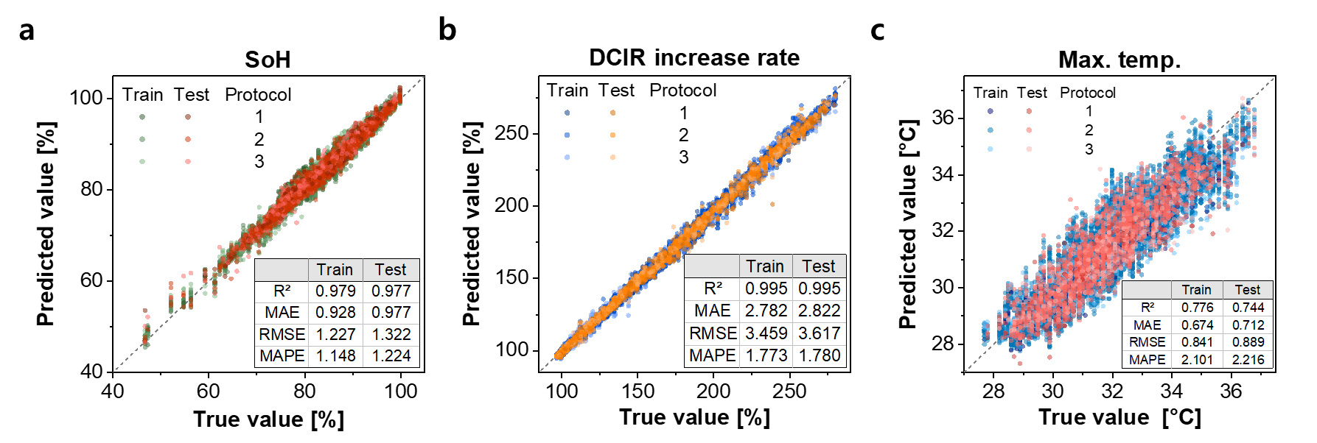
Supplementary Fig 2. The prediction performance of a single-target neural networks model consisting of 5 hidden layers with 256 nodes each (a) SoH, (b) DCIR increase rate, and (c) Max. temp.
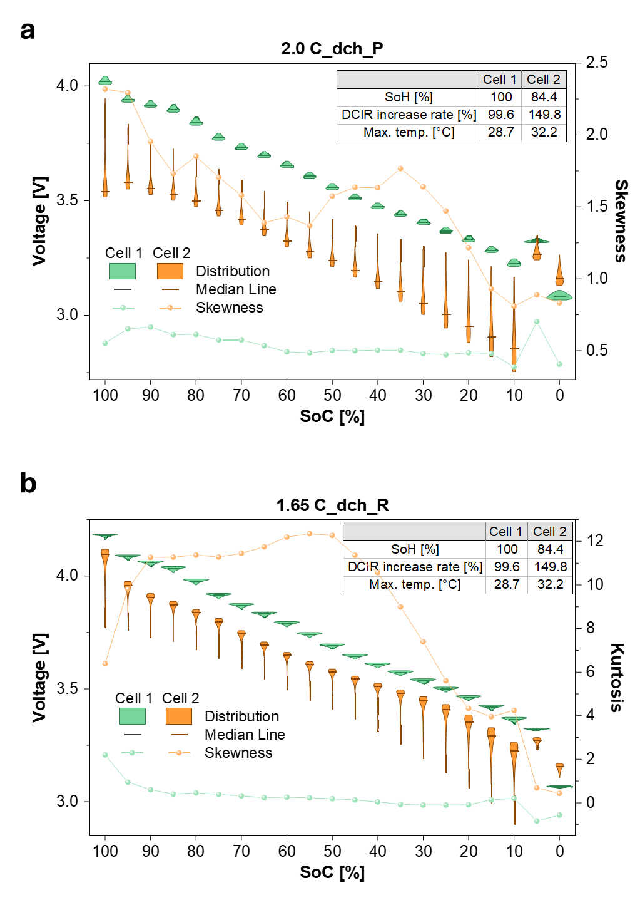
Supplementary Fig 3. Comparison of high-impact features from IG analysis across the SoC (a) 2.0C_dch_P_skew (b) 1.65C_dch_R_kurt

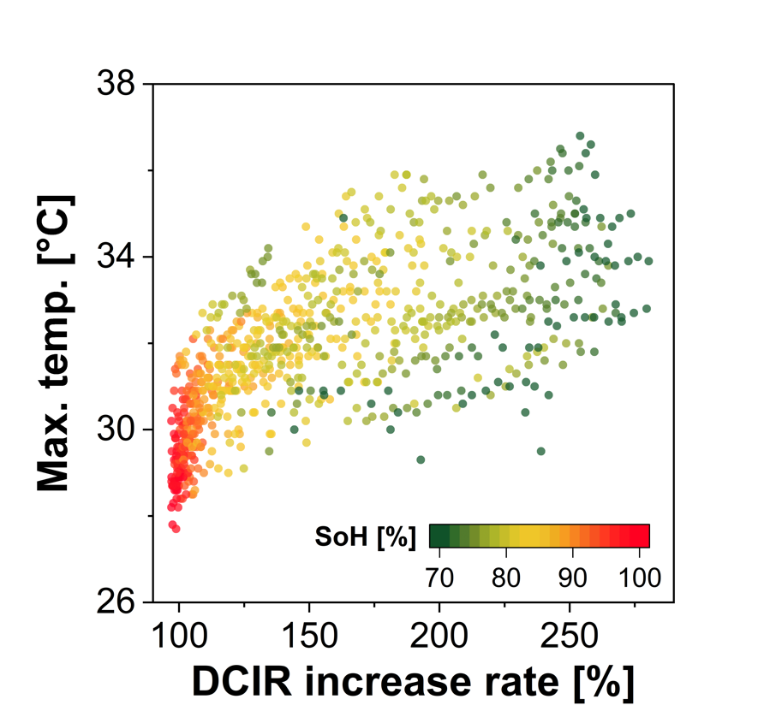
Supplementary Fig 4. The relationship between Max. temp. and DCIR incrase rate with SoH-based color mapping.

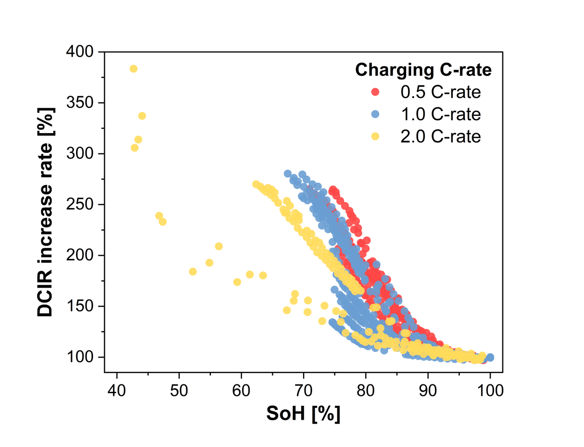
Supplementary Fig 5. The relationship between SoH and DCIR incrase rate depending on the charging C-rate during degradation cycle.

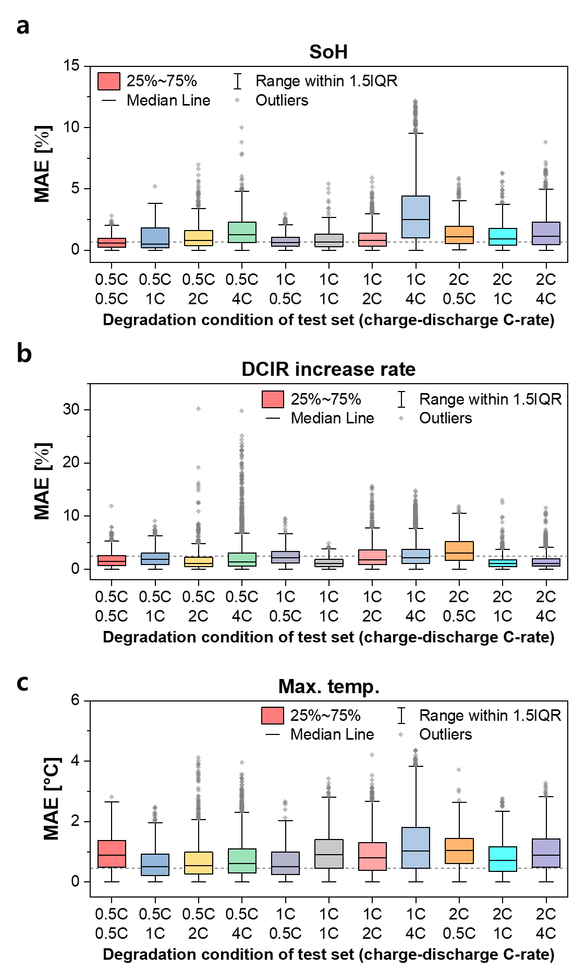
Supplementary Fig 6. The MAE of test dataset on degradation cycles excluded from the training set, which utilized all conditions ecept those on the x-axis. (a) SoH, (b) DCIR increase rate, (c) Max. temp.
Supplementary Table 1. Selected features of STL model for each target prediction
SoH | DCIR increase rate | Max. temp.
2.0C_ch_R_R_{0-0.1s} | 2.0C_ch_R_R_{0-0.1s} | 2.0C_dch_P_skew
2.0C_P_hyst | 1.65C_dch_P_R_{0.1-5s} | 2.0C_ch_R_R_{0-0.1s}
1.65C_dch_R_R_{0-0.1s} | 2.0C_R_hyst | 2.0C_P_hyst
2.0C_ch_P_R_{0.1-5s} | 1.65C_dch_P_R_{0-0.1s} | 1.65C_dch_P_R_{0-0.1s}
2.0C_dch_P_R_{0-0.1s} | 2.0C_ch_P_R_{0.1-5s} | 2.0C_R/1.65C_R_dch_R
1.65C_dch_P_R_{0.1-5s} | 2.0C_P_hyst | 2.0C_ch_P_R_{0.1-5s}
1.65C_dch_P_skew | 2.0C_ch_R_skew | 2.0C_ch_R_skew
2.0C_ch_P_V_{5s} | 2.0C_ch_P_V_{5s} | 1.65C_R_R_ratio
2.0C_ch_R_skew | 2.0C_dch_P_V_{5s} | 2.0C_ch_P_skew
2.0C_dch_R_R_{0-0.1s} | 1.65C_dch_R_skew | 2.0C_dch_P_V_{5s}
1.65C_dch_R_skew | 1.65C_R_hyst | 2.0C_ch_P_V_{5s}
2.0C_ch_P_skew | 2.0C_R/1.65C_R_ch_R | 1.65C_dch_P_R_{0.1-5s}
2.0C_dch_P_V_{5s} | 2.0C_ch_P_skew | 1.65C_R_hyst
1.65C_P_R_ratio | 1.65C_R_R_ratio | 1.65C_P_R_ratio
1.65C_R_R_ratio | 1.65C_dch_P_skew | 1.65C_dch_P_skew
 |  | 2.0C_R_hyst

Supplementary Table 2. Model and hyperparameters for SoH prediction model
Model | RandomForestRegressor
Max_depth | 18
min_samples_leaf | 2
min_samples_split | 2
n_estimators | 261
bootstrap | False
max_features | 0.5

Supplementary Table 3. Model and hyperparameters for DCIR increase rate prediction model
Model | RandomForestRegressor
Max_depth | 18
min_samples_leaf | 10
min_samples_split | 20
n_estimators | 761
bootstrap | True
max_features | 0.7957098983397253

Supplementary Table 4. Model and hyperparameters for Max. temp. prediction model
Model | ExtraTreesRegressor
Max_depth | 28
Max_features | 0.8844947491244998
n_estimators | 240
bootstrap | True
min_samples_leaf | 4
min_samples_split | 12

