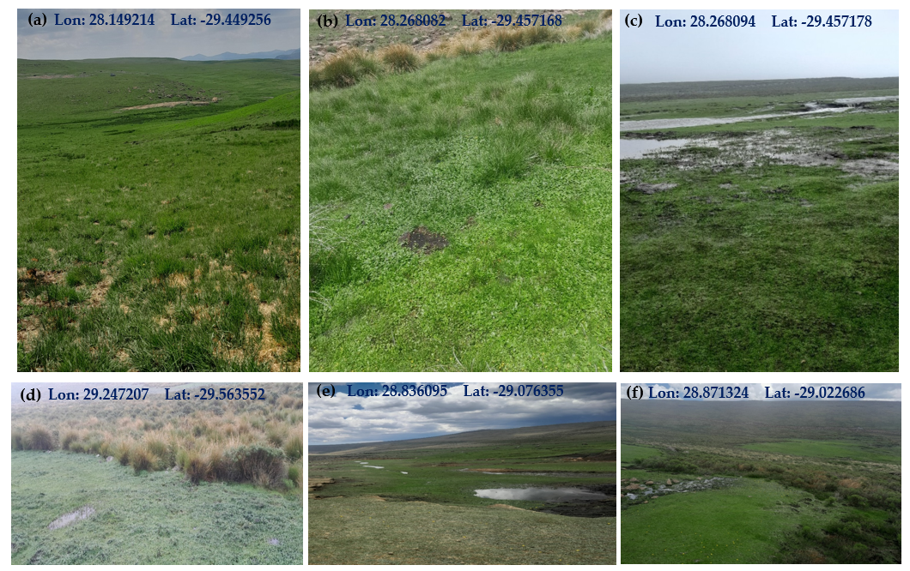
Supplementary Materials
Supplementary Figure 1: Overview of Tenesolo (a), Khorong (b), Khamoqana (c), Khalong-La- Lichete (d), Lets’eng-La-Likhama (e) and Koting-Sa- ha Ramosetsana (f). Lon= Longitude, Lat= Latitude.
Supplementary Table S1. Ecological class utilized for percentage score (PES) evaluations of inland aquatic ecosystems in South Africa, along with the applicable range of PESs for each class (Kleynhans, 1996; Macfarlane et al., 2009) [color coding is per the River Eco-Status Monitoring Programme (REMP) of DWS].
Ecological  Class | Interpretation | PES  (%)
A | Unmodified, natural. | 90-00
B | Largely natural with few modifications. A slight change in ecosystem processes is discernible, and a small loss of natural habitats and biota may have taken place. | 80-89
C | Moderately modified. A moderate change in ecosystem processes and loss of natural habitats have taken place, but the natural habitat remains predominantly intact. | 60-79
D | Largely modified. A large change in ecosystem processes and loss of natural habitat and biota have occurred. | 40-59
E | Seriously modified. The change in ecosystem processes and loss of natural habitat and biota are great, but some remaining natural habitat features are still recognizable. | 20-39
F | Critically modified. Modifications have reached a critical level, and ecosystem processes have been modified completely with an almost complete loss of the natural habitat and biota. | 0-19

