Supplementary information 1
DMU, College of NCS, Dept of Biology, acidity and Soil fertility management practices, Data collection Tools from Aneded, Awabel, Debre Elias, and Dejen
Soil samples collection (Teff and Wheat rhizosphere)
- Previous cropping history: What crop was growing last year on that particular field?
Fertilizer and pesticide application
- Urea----------------------------------------------------------------------------------------yes/no
- DAP-----------------------------------------------------------------------------------------yes/no
- Compost-----------------------------------------------------------------------------------yes/no
- Manure===============================================yes/no
- Pesticide application--------------------------------------------------------------------- yes/no
- Lime application---------------------------------------------------------------------------yes/no
Agricultural practice
- Line sowing------------------------------------------------------------------------------------
- Intercropping---------------------------------------------------------------------------------
- Traditional sowing----------------------------------------------------------------------------
- Mention if any---------------------------------------------------------------------------------
Season when the crop was sown
- Irrigation--------------------------------------------------------------------------------
- Rain feed-------------------------------------------------------------------------------
- Mention if any_________________________________________
Plant/Seeds (wheat, teff)
Seed varieties
1. ------------------ 2. ------------------ 3. ----------------- 4. ---------------------
VI.Soil type
- Black soil -----------------------------------------------------------------------------------
- Red soil ------------------------------------------------------------------------------------

Appendix II
Some of the AMF Species identified from the collected from study districts and some pictures during AMF extraction from soil.
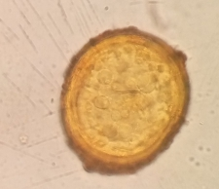
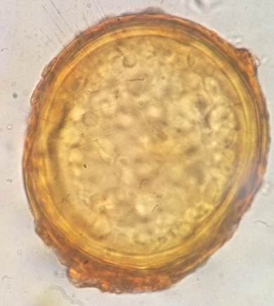

Acaulospora laevis Acaulospora laevis
Acaulospora scrobiculata laevis

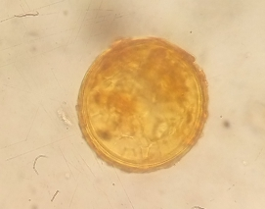

Glomus fulvus
Glomus magnicaule
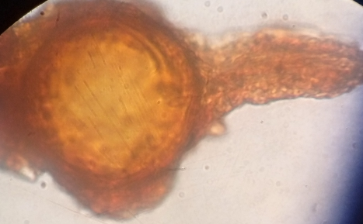
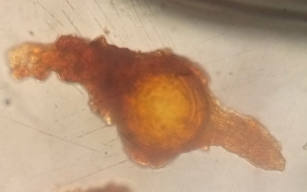

Pacispora corralloidea
Pacispora franciscana

