Supplementary Figure 1
Some of the AMF Species identified from teff and wheat croplands.
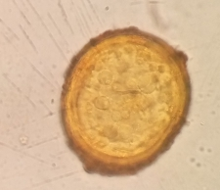
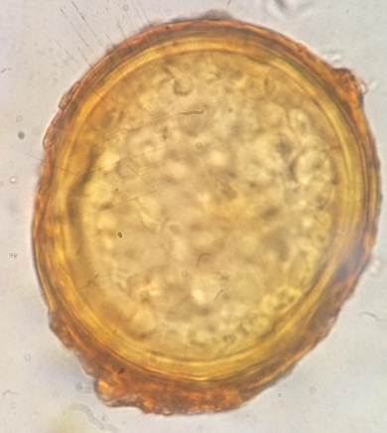

AcaulosporalaevisAcaulosporalaevis
Acaulosporascrobiculatalaevis

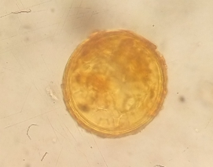

Glomusfulvus
Glomusmagnicaule
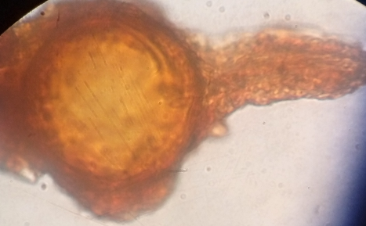
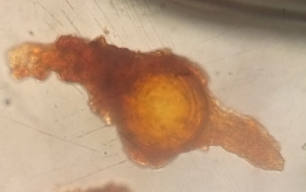

Pacisporacorralloidea
Pacisporafranciscana

